Jones

Round the world trip
Johannesburg - Cairo - Dubai - New Delhi - Bangkok - Sydney - Cancún - Buenos Aires - Cape Town
31 Days / 30 Nights
5 Persons
Reference: CN2648
Date of Issue: 29 March 2018
07 October 2019 - 06 November 2019

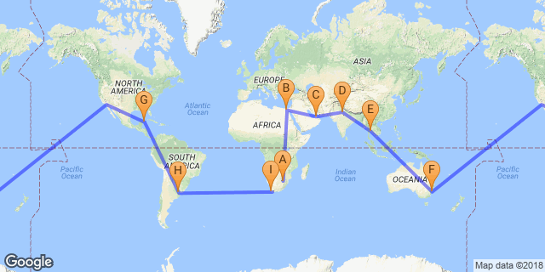

Click here to view your Digital Itinerary

Introduction
The experience of a lifetime! On this trip, you will travel right around the globe visiting Africa, UAE, Asia, Australia, South America and Central America.

"To travel is to inspire and to be inspired"

Accommodation | Destination | Arr. | Dep. | Nights | Basis | Room Type
Hallmark House | Johannesburg | 7 Oct | 8 Oct | 1 | D, B&B | 1x Deluxe, 1x Deluxe
Overnight Travel |  | 8 Oct | 9 Oct | 1
The Nile Ritz-Carlton Cairo | Cairo | 9 Oct | 12 Oct | 3 | D, B&B | 1x Double Room, 1x Triple Room
Avani Deira Dubai Hotel | Dubai | 12 Oct | 16 Oct | 4 | D, B&B | 1x AVANI Superior Room, 1x AVANI Junior Suite
The Leela Palace New Delhi | New Delhi | 16 Oct | 19 Oct | 3 | B&B | 1x Premiere Room, 1x Royal Premiere Room
Century Park Hotel Bangkok | Bangkok | 19 Oct | 22 Oct | 3 | D, B&B | 1x Superior, 1x Deluxe
Overnight Travel |  | 22 Oct | 23 Oct | 1
Pullman Quay Grand Sydney Harbour | Sydney | 23 Oct | 26 Oct | 3 | D, B&B | 1x Bedroom Suite Garden View, 1x Bedroom Suite Garden View
Overnight Travel |  | 26 Oct | 27 Oct | 1
Ramada Cancun City | Cancún | 27 Oct | 30 Oct | 3 | D, B&B | 1x Double Room, 1x Triple Room
CasaSur Recoleta Hotel | Buenos Aires | 30 Oct | 3 Nov | 4 | D, B&B | 1x Suite Deluxe, 1x Suite Deluxe
Own Arrangement | Cape Town | 3 Nov | 6 Nov | 3

Key
B&B: Bed and breakfast
D, B&B: Dinner, bed and breakfast

Price
Price per person sharing: USD123456
Print per single person: USD201234
Prince per child under 12 years: USD12345
Price is subject to exchange rate and price fluctuations.

Included
- All flights (incl airport tax)
- Accommodation as per itinerary
- Activities as per itinerary
- All transfers
- Car Hire for X days

Excluded
- Insurance
- Items of a personal nature
- Gratuities and tips
- Porterage

Day 1: Monday, 7 OctoberHallmark House, Johannesburg

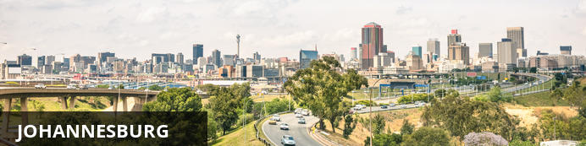
Johannesburg is one of Africa’s biggest and most vibrant cities. It is the economic capital of Africa and the gateway to Southern Africa. Although not as famous as other South African destinations, there is plenty to do in Johannesburg and nearby Pretoria. The old city is a multi-cultural mixture of traditional medicine shops, Chinese restaurants, taxi ranks and ultra modern skyscrapers. There are excellent museums, art galleries and organised tours of historical and political interest. The shopping is Southern Africa’s best and the many restaurants cater for all tastes. The nearby township of Soweto is Johannesburg’s most popular tourist attraction.

Day Itinerary
Welcome to Johannesburg! The first stop on your mind-blowing trip around the globe.

Overnight: Hallmark House View iBrochure
Hallmark House offers residents the opportunity to live a select lifestyle. For investors, it is a unique opportunity to own property designed by David Adjaye, OBE, one of the top architects in the world. The overall concept of the building is to create layers of experience. The luxurious living space offers a combination of fashionable retail stores, a coffee shop, a microbrewery and a boutique hotel with accommodation and small to medium enterprises that support and nurture the unique cultural identity that Johannesburg is known for.
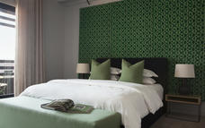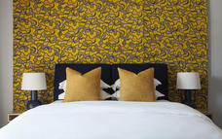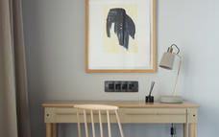

Deluxe
There are 20 Deluxe rooms which face the West (Johannesburg CBD) however most rooms are South facing with views of Turfontein Race Course amongst others.
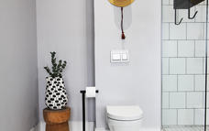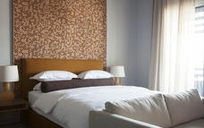

Included
Dinner, Bed and Breakfast

Day 2: Tuesday, 8 OctoberOvernight Travel

Day Itinerary
The Johannesburg (JNB) to Cairo, Egypt (CAI) flight is approximately 7h 50m

Day 3-6: Wednesday, 9 October to Saturday, 12 OctoberThe Nile Ritz-Carlton Cairo, Cairo

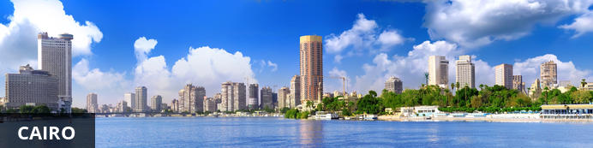
Resting on both banks of the River Nile, Cairo is the capital of Egypt and the largest city in the Arab world. Cairo has been inhabited for over 6000 years and has served as the capital of numerous Egyptian civilisations. At the heart of the city is Tahrir Square, a busy tourist hub which features the world-renowned Egyptian Museum displaying antiquities including royal mummies and gilded King Tutankhamun artefacts. Nearby, Giza is the site of the iconic pyramids and Great Sphinx, dating back to the 26th century BC. While these and countless other ancient treasures are undoubtedly the main draw card, the cosmopolitan Cairo is certainly not lacking in modern attractions. Visitors can get to know the locals at boisterous baladi bars, enjoy excellent shopping at the Khan al-Khalili bazaar, watch the sunset at the impressive Cairo Tower, or catch a show at the stately Cairo Opera House.

Day Itinerary
You will get met by a representative from Egypt Ground and transferred to your hotel. You have been confirmed for an early check in at the The Nile Ritz-Carlton Cairo.
During your 3 nights in Cairo you can experiece a wide variety of activities including the Pyramids of Giza, The Egyptian Museum, Old Cairo, Khan el-Khalili (Souq Quarter) and The Citadel - to name a few.

Meet and Greet
Cairo Meet & Greet
06:00
You will be met outside International Arrivals by a representative from Egypt Ground, who will assist you with your bags and transfer you to your hotel.
Please note that you will need to clear customs and collect your luggage yourself as the meet and greet team is not allowed in the terminal.

Optional
Egyptian Museum
Citadel of Cairo

Recommended
Great Pyramid of Giza
Great Sphinx of Giza

Egyptian Museum
The Egyptian Museum in Cairo is home to an exceptional collection of Egyptian antiquities. The most famous of course is Tutankhamen’s gold mask and treasures from his tomb.

Citadel of Cairo
One of Cairo's most popular attractions the Citadel was built in the 1100s as a fortress against the Crusades.

Great Pyramid of Giza
The oldest of the Seven Wonders of the Ancient World, the Great Pyramid of Giza remains largely intact, making it easier for visitors to imagine life as it was centuries ago during a period known as BC. It is said that that the pyramid, built for an Egyptian pharaoh, took more than 20 years to build by dragging and lifting enormous stones into place. It is the oldest and largest of the three pyramids in the Giza complex.
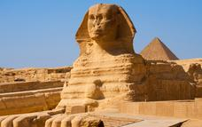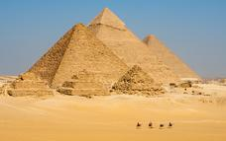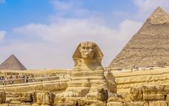

Great Sphinx of Giza
The Great Sphinx of Giza is a world renowned statue in Egypt situated on the west bank of the Nile. The largest monolith statue in the world, the Sphinx, with its human head and lion’s body, is 20,22 metres high, 73.5 metres long and 6 metres wide. The general belief is that the statue was built by the ancient Egyptians of the Old Kingdom between 2558 and 2532 BC.

Overnight: The Nile Ritz-Carlton Cairo
Set in the heart of downtown, between the iconic Nile River and Tahrir Square, The Nile Ritz-Carlton, Cairo is a modern luxury hotel with a storied past. The hotel hosted the likes of Elizabeth Taylor and Frank Sinatra, and today guests will experience the true sense of elegance by the stewardship of The Ritz-Carlton hotels. The hotel's accommodations are in the form of rooms and suites that feature a range of amenities to make your stay more comfortable.
Grilled meat and sweet shisha enjoyed in a lush garden. Traditional Afternoon Tea served on Wedgwood china. A crisp cocktail on the Nile Corniche, with a view of the pyramids in the distance. Every dining experience at the restaurants at The Nile Ritz-Carlton, Cairo offers something unique.
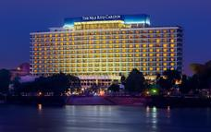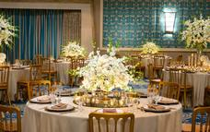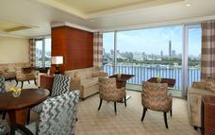

Included
Dinner, Bed and Breakfast

Day 6: Saturday, 12 OctoberAvani Deira Dubai Hotel, Dubai

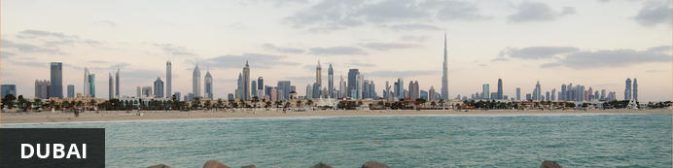
Size is synonymous with Dubai, and it continues to push the limits – first, largest, tallest. Aside from this the pull of Dubai is a dreamy world of attractions and unheard of luxuries; shopping centres, nightlife and cutting edge hotels. Famous constructions include Burj Khalifa, The Palm, Burj Al Arab, The World Island.
Although Dubai strictly safeguards its traditional practices, it allows space for other religions to breathe, a rare quality amongst the conservative Arab world. The combination of all this means Dubai has emerged as a cosmopolitan metropolis, a global city and a travel, business and cultural hub of the Middle East.

Day Itinerary
You will get met by a representative from Egypt Ground and transferred to your hotel. You have been confirmed for an early check in at the Avani Deira Dubai Hotel.
Today you have the day at leisure.

Overnight: Avani Deira Dubai Hotel View iBrochure
With vibrant streets, winding alleys through scent-filled souks and a short drive to Dubai International Airport, AVANI Deira Dubai Hotel is ideally located to combine business and pleasure. A contemporary, comfy haven with all the modern conveniences you wish for. For guests that need to work hard or want to play hard, we take care of the details that matter so you can relax and enjoy your downtime.
Only 4km from Dubai International Airport in a cultural hotspot of the city, AVANI Deira Dubai hotel is perfectly situated for a city break. A ten-minute taxi drive from the central business district with the metro on the doorstep, guests have easy access to a number of malls and attractions. For visitors who wish to explore on foot, Dubai Creek and the world-famous Gold Souk are within walking distance
With five different room types for travellers to choose from and a host of amenities, there’s a place to suit to all guests. Contemporary and stylish with complimentary WiFi in all 216 rooms, escape from the city in comfort. Perfect for business travellers and conference delegates with executive rooms and in-room desks. Couples and families can also benefit from interconnecting rooms and extra suite space.
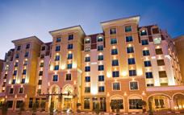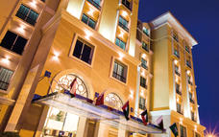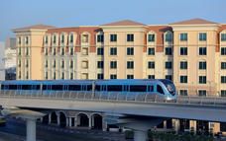

AVANI Superior Room
Spread out in our 42-45 sqm AVANI Superior Rooms. Slip into your robe and chill out on the sofa. Send an email to the office with free connectivity. Wake up and take a rain shower in your marble bathroom.
When looking for the perfect accommodation among hotels in Dubai, Deira is not short of options and this is just the room for work or pleasure.
THE DETAILS THAT MATTER
Choice of king or twin beds
City views
Connecting rooms available
Air conditioning (controlled in the room)
Bathroom with rain shower over bath
Seating area
Work desk
Complimentary WiFi internet
40-inch LCD television
National and international TV channels
Telephone (bedroom & bathroom)
Mini bar
Complimentary bottled water daily
Tea & coffee making facilities
In-room safe
Bathrobe & slippers
Bathroom amenities
Weighing scale
Hairdryer
Iron & ironing board
Extra pillows & blankets in the cupboard
Shoe horn, mitt & brush

AVANI Junior Suite
Added extras. A Nespresso coffee maker. Breakfast on us.
Unwind in our large 64 sqm Junior Suites. Use the terrace to relax and read a book, or catch up on work at your in room desk. Munch on some snacks from the minibar. Take an afternoon nap in your King size bed or stroll on the sand with private beach access and transfers.
THE DETAILS THAT MATTER
King bed
Standing terrace with city views
Access to Executive Lounge and Oceana Beach Club
Air conditioning (controlled in room)
Interconnecting rooms
Bathroom with separate bath & rain shower
Open plan sitting area
Working desk
Complimentary high-speed internet
40-inch LCD television
National and international TV channels
Telephone (bedroom & bathroom)
iPhone/iPod docking station
Feather and hypoallergenic pillows available
Mini bar
Complimentary bottled water daily
Tea & coffee making facilities
In-room safe
Bathrobe & slippers
Bathroom amenities
Weighing scale
Hairdryer
Iron & ironing board
Extra pillows & blankets in the cupboard
Shoe horn, mitt & brush

Included
Dinner, Bed and Breakfast

Day 7: Sunday, 13 OctoberAvani Deira Dubai Hotel, Dubai

Day Itinerary
This morning, you will depart the hotel early in the morning with a packed breakfast from the hotel. After a drive through the bustling city, you will reach the expansive desert and take a 2 hour drive to the camel farm.
On arrival at the farm you can enjoy traditional Arabic coffee or tea before setting off on the camel ride over the breathtaking sand dunes.
After your safari, we will transfer you to the beach for amazing views of the iconic Burj Al Arab.

Activities
07:00 Camel Desert Safari
Burj Al Arab

Burj Al Arab
The distinctive sail-shaped silhouette of Burj Al Arab Jumeirah is more than just a stunning hotel, it is a symbol of modern Dubai.
Yet for all the wonder this stunning structure provides when you finally see it in person, it is the service within that really makes the Burj Al Arab Jumeirah so extraordinary. Repeatedly voted the world's most luxurious hotel, this magnificent destination offers the finest service and facilities throughout – right down to an optional chauffeur-driven Rolls-Royce.
Burj Al Arab Jumeirah suite-only accommodation offers discreet check-in within the rooms, a private reception on every floor and a host of personal butlers, each a warm messenger of the unparalleled hospitality.
The hotel offers 202 luxurious duplex suites, nine world-class restaurants and bars, four swimming pools (two outdoor, two indoor), a private beach, complimentary access to Wild Wadi Waterpark for the duration of your stay, Talise Spa, Talise Fitness and Sinbad's Kids Club.
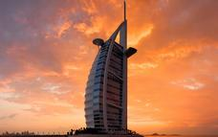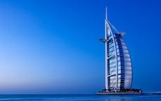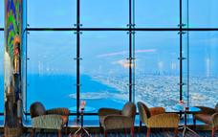

Included
Camel Desert Safari:
- return hotel transfers
- Arabic drinks
- 2 hour camel ride

Excluded
Entrance to Burj Al Arab

Day 8: Monday, 14 OctoberAvani Deira Dubai Hotel, Dubai

Day Itinerary
We are off to the most spectacular structure in Dubai (some day the world)! Starting off with a delicious breakfst at the hotel before your transfer to the Dubai Mall. From here you will check in with your prebooked tickets to Level 124 + 125.
To get to Level 124 you can be thrilled by the world’s fastest double deck elevators, cruising at 10m/s and once "At the Top", you will step out onto the public outdoor observation terrace overlooking the ever growing skyline. After soaking in all you can from Level 124 observations desk, a quick walk up the stairs will take you to 456 meters where Level 125 offers a spacious deck tastefully decorated in Arabic mashrabiya for stunning 360-degree views.
The rest of the afternoon you are free to spend in the Dubai Mall.

Activities
10:00 Burj Khalifa
Dubai Mall

Burj Khalifa
Burj Khalifa, known as Burj Dubai prior to its inauguration, is a skyscraper in Dubai, United Arab Emirates, and is the tallest man-made structure in the world, at 829.8m.

Dubai Mall
The Dubai Mall, also known as the home of the Dubai shopping festival, is one of the world's largest shopping malls in UAE. The Dubai Mall is the region's premier shopping, lifestyle and entertainment destination. With more than 1,200 stores and a host of world-class attractions, The Dubai Mall is revolutionizing the modern shopping experience.

Included
Dinner, Bed and Breakfast

Day 9: Tuesday, 15 OctoberAvani Deira Dubai Hotel, Dubai

Day Itinerary
Today we are off to Adu Dhabi.
After morning hotel pickup in Dubai, travel by air-conditioned vehicle to Abu Dhabi, the UAE’s capital.
Pass the Jebel Ali Free Zone, one of the world’s biggest, and hear about Abu Dhabi’s growth after the discovery of oil in the 1950s. Hear how the city is now recasting itself as a tourist destination by building state-of-the-art leisure attractions.
Take a tour of the Sheikh Zayed Grand Mosque, to admire the white marble courtyards and prayer rooms of this vast, modern masterpiece. Then, head for Yas Island, the city’s entertainment epicenter, to view the exteriors of the Yas Marina F1 Circuit, home to the Abu Dhabi Grand Prix, and Ferrari World theme park.
See the avant-garde cultural buildings rising from Saadiyat Island, and the Al Hosn Palace, once home to the emirate’s ruling family, before enjoying free time for lunch (own expense) at the Marina Mall.
Drive by the palm-fringed Corniche and opulent Emirates Palace hotel, and visit the Heritage Village, a recreated oasis settlement. See the replica falaj irrigation system, souk, and Bedouin tents, and watch the handicraft and glass-making displays for a glimpse into bygone, pre-oil Abu Dhabi. Your tour concludes with an early evening hotel drop-off in Dubai.

Activities
Abu Dhabi
Grand Mosque Abu Dhabi
Yas Marina Circuit

Abu Dhabi
On a wedge-shaped island in the Arab Sea, lies the capital of the United Arab Emirates. The wide end of the wedge forms the city centre, with the picturesque corniche and its family friendly beaches running along the coast. Despite being more conservative than its neighbouring city of Dubai, Abu Dhabi can’t seem to resist a bit of excessively flashy extravagance. Characterised by extreme opulence and unfathomable wealth, it inspires a slew of rather ridiculous superlatives: It is home to the world’s furthest leaning building, the largest indoor theme park, the fastest roller-coaster in the world, and even the largest hand-loomed carpet! What was little more than an obscure fishing village 30 years ago, is now miraculously one of the world’s most modern, state-of-the-art cities featuring rows of glitzy skyscrapers, incredibly upmarket shopping malls and world-class luxury hotels many of which offer pristine private beaches. If over-the-top attractions are what you are seeking, look no further than this mind-blowingly lavish city-state.
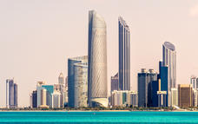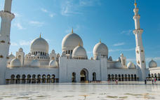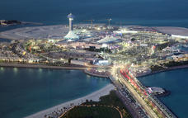

Yas Marina Circuit
Yas Marina Circuit is the United Arab Emirates’ most exciting sporting and entertainment multi-purpose venue. Located on Yas Island, Abu Dhabi, the circuit is home to the annual FORMULA 1 ETIHAD AIRWAYS ABU DHABI GRAND PRIX and much more. In addition to the extensive year-round program of professional and grassroots motorsport events and experiences including Drag and Yas Track Nights, the circuit has emerged as a thriving hub for entertainment and community events in the UAE.
As the region’s most technologically advanced facility, the circuit is also a leading MICE venue, regularly hosting a diverse range of corporate meetings, conferences and events. Whether you want to experience the thrill of karting at our Kartzone, driving an Aston Martin GT4 at over 200km/hour on an F1 circuit, work towards your racing license at the Yas Racing School, get fit at TrainYas or GoYas, participate in one of our many sporting events, or simply catch up with friends at Yas Central, Yas Marina Circuit truly is The Meeting Place of Champions.
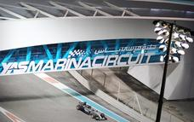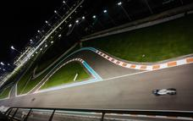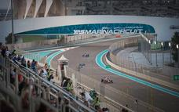

Included
Dinner, Bed and Breakfast

Day 10-13: Wednesday, 16 October to Saturday, 19 OctoberThe Leela Palace New Delhi, New Delhi

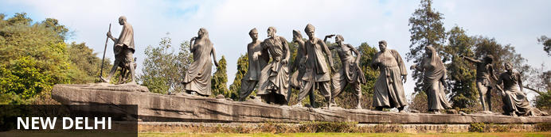
India’s largest city, Delhi, has been one of the country’s commercial and economic hubs for centuries and, as a result, is incredibly rich in culture and history. Made up of the ancient walled city of Old Delhi and the more modern sector, New Delhi, the city encompasses a staggering array of beautiful architecture, notable monuments and age-old temples, including three UNESCO World Heritage Sites – the Red Fort, Qutab Minar and Humayun's Tomb. Other key attractions include the 17th century Chandni Chowk marketplace – still one of the city’s most popular retail centres today, particularly for jewellery and traditional Indian saris; the iconic Bahà’i Lotus Temple – an award-winning architectural gem; and the Jama Masjid, India’s largest mosque.

Day Itinerary
On arrival in Delhi, the countdown starts as there is plenty to do and little time to do it! The city is vast and planning activities by neighborhood is essential to maximizing time and avoiding lengthy traffic jams. While here you will have the opportunity to visit Lal Quila, Jama Masjid, Lodhi Gardens, Janpath Market, India Gate.
If you still have some time, don't miss Dilli Haat, National Gallery of Modern Art, and the Qutub Minar complex.

Activities
Lal Quila
Jama Masjid New Delhi
Lodhi Gardens
Shopping at Janpath Market
India Gate

Jama Masjid New Delhi
The majestic Jama Masjid – meaning ‘world-reflecting’ mosque – is Old Delhi’s principal place of worship, and the largest and most renowned of its kind in India. Built in the 17th century by the Mughal Emperor Shahjahan – who also built the Taj Mahal and the Red Fort – it’s an elaborate structure featuring an expansive geometric base topped with globe-shaped minarets crafted from strips of red sandstone and white marble, and a massive courtyard that can hold up to 25 000 people. Jama Masjid is particularly impressive just before dusk, when its rosy hues intensify in the glow of the setting sun.
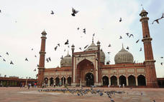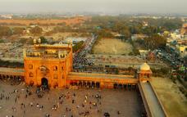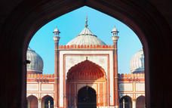

India Gate
Also known as the Delhi Memorial or the All India War Memorial, the India Gate was built in commemoration of the roughly 80 000 Indian soliders who died representing their country in World War One and on various other battlefields, and whose names are inscribed on the structure. Unveiled in 1931, its distinctive arch is reminiscent of the Arc de Triomphe in Paris and the Gateway of India in Bombay, and is one of the trademark sights of New Delhi.

Overnight: The Leela Palace New Delhi View iBrochure
The Leela Palace New Delhi is located at the very heart of the capital’s prestigious Diplomatic Enclave and exemplifies the magnificent architecture, grace and elegance of Lutyens’ Delhi. Earning a distinction of having the largest sized rooms in the capital, the hotel has a total of 254 luxurious guest rooms and suites. The Palace is known for its unparalleled gastronomic wonders and par excellence service. It's culinary offerings include two international fine dining institutions from New York City MEGU and Le Cirque along with The Qube, Jamavar and a sophisticated bar The Library. Located on level nine, The Royal Club is a hotel within the hotel that pampers guests with its highly personalized services and exclusive amenities and is one of the most sought after luxury experiences in the world. With a bouquet of 8 meeting rooms and an elite ballroom, the palace is also an iconic address in Delhi. The hotel also features a temperature controlled rooftop pool with panoramic views of the capital and a spa by ESPA London.
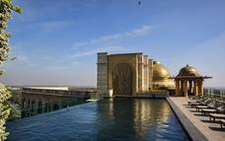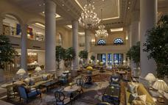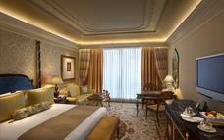

Premiere Room
Relive a royal era here. The vibrant colours of the interiors add to a regal ambience with the primary aim to make guests feel at home. Enjoy the majestic view of ‘Devi’ created by the legendary Satish Gupta, in the lush, gardens of the hotel.
Located on the second to seventh floors of the hotel, these 592 sq ft (55 sq mt) rooms are spacious and a perfect attempt to recreate the drama of the royal past. Some of the amenities in the room include complimentary hair dryer, iron and ironing board, mineral water bottles and a tea and coffee maker.
We understand your need to retreat to a home away from home, especially after a hectic day at work or sightseeing. We designed these rooms keeping that very fact in mind. Here style meets comfort for a memorable stay.

Royal Premiere Room
Bright and well-ventilated to let in sunshine and natural light, these rooms, which are located on the seventh floor, offer the most serene views of the green foliage outside.
Walk into these sprawling rooms spread across 592 sq ft (55 sq mt) and discover your space to get your work done or simply while time away. To add to the feel of uninhibited luxury, our rooms are adorned with intricate royal designs all over. Some of the amenities in the room include complimentary hair dryer, iron and ironing board, mineral water bottles and a tea and coffee maker.
Sumptuously furnished with world class modern-day amenities in the room, stylish marble-finished bathrooms with soaking bath tubs and a sweeping view of the luxuriant greens surrounding the hotel ensure a relaxed and comfortable stay.

Included
Bed & Breakfast

Day 13-16: Saturday, 19 October to Tuesday, 22 OctoberCentury Park Hotel Bangkok, Bangkok

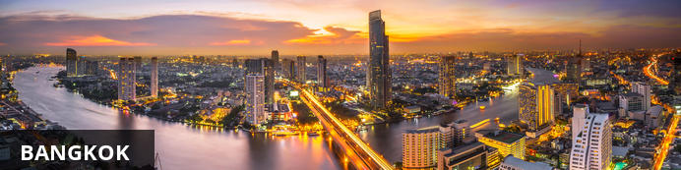
Steamy, frenetic and exhilarating, Thailand’s capital city is a legendary travel destination, equally famous for its rich cultural offerings, effervescent nightlife, superb shopping, and diverse dining options – which range from bustling, fragrant street markets to five-star haute cuisine establishments. The capital’s attractions are almost limitless, but if you only have limited time, not-to-be-missed attractions include the vast Reclining Buddha at Wat Pho, a morning boat trips down the canals to see the floating markets, and the opulent Grand Palace. For shopping, head to the tourist hub of Khaosarn Road, the MBK Centre, Siam Square, or on weekends, the vast Chatuchak market, while for dining and entertainment it’s best to check with your guide on the hottest spots of the moment.

Day Itinerary
Jetting off to Bangkok next! Another destination with so much to see. You could spend a lot more time exploring the city, but 3 days in Bangkok is a good length of time for your first visit.

Activities
The Grand Palace
Wat Pho
Chatuchak Market

The Grand Palace
Bangkok’s most spectacular cultural attraction, The Grand Palace is a vast temple complex of dazzling opulence and intricate detail, sprawling across nearly 220 000 square kilometres of the city. Originally built in 1782, it has served as the primary residence of the Thai monarchy for over 150 years and is a famous religious landmark, incorporating several deeply sacred sites such as Wat Phra Kaew, which houses a small but revered emerald Buddha dating to the 14th century.
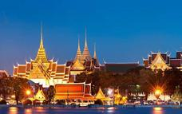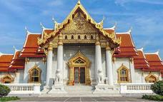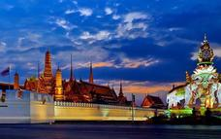

Wat Pho
Wat Pho (the Temple of the Reclining Buddha), or Wat Phra Chetuphon, is located behind the Temple of the Emerald Buddha. The temple is one of the largest temple complexes in the city and is famous for it's giant reclining Buddha that measures 46 metres long and is covered in gold leaf. To enter, you would have to remove your shoes and all visitors must wear appropriate clothing; meaning no exposed shoulders or skin above the knee. This is also a great place to get a traditional Thai massage as Wat Pho is often considered the leading school of massage.
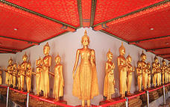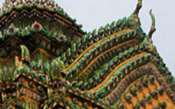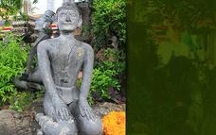

Overnight: Century Park Hotel Bangkok View iBrochure
Owned by a local Thai family, this prime city centre hotel offers warmth and elegance and is ideally located on the bustling intersection of Pratunam and Victory Monument and is located close by to BTS Sky Train, local shopping areas, restaurants and night markets - all within a 5 minute walk or taxi/tuk tuk ride away.
Only 25 minutes from Bangkok Suvarnabhumi Airport, the journey time into the city is shorter than you would normally expect as we are one of the first hotels off the expressway.
With 380 guest rooms spread over 24 floors, the hotel tower stands prominently and offers beautiful facilities and professional friendly service. Key highlights include the hand painted classical Thai floor-to-ceiling mural in the spacious lobby, a large sports bar area with pool tables, the lush green oasis on the rooftop swimming pool and the four star eco-friendly rooms. Opposite the hotel you will find a spacious green park.
La Patisserie coffee shop is ideal to grab breakfast on the go or if you want to fuel up for the day, have a fulfilling breakfast at Jess. Ease into your early arrival or late departure with early check in and/or late check out!
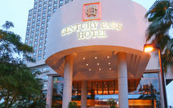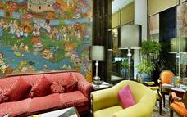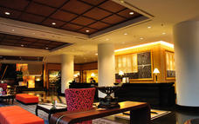

Superior
Superior rooms feature marble paneled bathroom with separate shower stall. Rooms are furnished with flat screen tv with cable channels, individually controlled air conditioning, IDD telephone, in-room safe, coffee/tea maker, fridge, mini bar, hairdryer, and internet access.
Non smoking rooms and connecting rooms may be requested.

Deluxe
Deluxe rooms feature marble paneled bathroom with separate shower stall. Rooms are furnished with flat screen tv with cable channels, individually controlled air conditioning, IDD telephone, in-room safe, coffee/tea maker, fridge, mini bar, hairdryer, and internet access.
Non smoking rooms and connecting rooms may be requested.
Additional benefits for this room include:
Bathrobe or kimono.
Slippers.
Upgraded in-room amenities.
Higher floor.

Included
Dinner, Bed and Breakfast

Day 16: Tuesday, 22 OctoberOvernight Travel

Day Itinerary
Flight from Bangkok, Thailand (BKK) to Sydney, Australia (SYD) is approximately 9h

Day 17-20: Wednesday, 23 October to Saturday, 26 OctoberPullman Quay Grand Sydney Harbour, Sydney

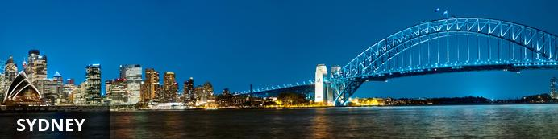
It’s safe to say some planning is required for a visit to a city this impressive, because no matter what you fancy – shopping, the arts, the outdoors – you’re likely to be bewildered by the scope of choice available here. First up, there are the must-sees – Sydney Opera House; Harbour Bridge; the Sydney Tower for its 360-degree views of the city; the waterside hubs of Darling Harbour and Circular Quay; and the Rocks district for shopping. After dark, the glitzy city comes alive with a ‘larger-than-life’ food and music scene that extends into the early hours. For more laid-back diversions, head down to the beach or hop on a ferry for an extensive tour of the Sydney Harbour, the Parramatta River and numerous locations lying waterside.

Day Itinerary
When you arrive in Sydney, the transfer company will take you to the Park Hyatt Sydney for the day where you can freshen up. After lunch, you will be transferred to the Pullman Quay Grand Sydney Harbour Hotel, where you will be staying for the next 3 nights in Sydney.
A plethora of activites have been scheduled during your stay here. Starting off with the Sydney Hop On Hop Off Gerry - Offering an independent and easy way to get around Sydney and view its best attractions, Captain Cook Cruises' hop on hop off 24-hour ferry pass will take you on a journey for the whole day. Visiting 8 of the cities best locations including Darling Harbour, Circular Quay, Manly and Taronga Zoo, you'll have the chance to visit the iconic Sydney Harbour Bridge and Sydney Opera House, which are two of the must-see sights in the city.
The next day, you are off to the Blue Mountains. The tour to the Blue Mountains will let you experience the epic and rugged scenery and stone formations of the region firsthand. With such highlights and spectacles to be seen including the Three Sisters and an array of Aussie bushland and wildlife, a visit to the Blue Mountains makes for a truly memorable experience.
You final day in Sydney is free for you to spend as you wish.

Activities
Sydney Opera House
Taronga Zoo
Blue Mountains National Park
Bondi Beach

Sydney Opera House
Beautiful against the backdrop of Sydney Harbour, the iconic Sydney Opera House is a thriving hub of art, culture and history. It's one of the world's most distinctive buildings, attracting millions of visitors from all over the world. Experience all that the Sydney Opera House has to offer by taking a guided tour, watching a show, and enjoying a cocktail beside the harbour at the Opera Bar as the sun sets over this stunning triumph of architecture and design.
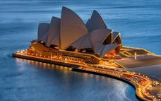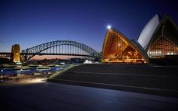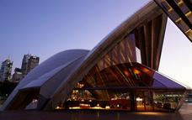

Taronga Zoo
Located just 12 minutes from the city by ferry, with breathtaking views of Sydney Harbour, Taronga Zoo is home to a wide variety of native wildlife and rare exotic animals. A range of tours, free shows, and keeper talks are offered throughout the day and adventurous visitors who wish to see the zoo from a different angle can try the Wild Ropes adventure with its suspension bridges and zip lines. There is also the Roar and Snore adventure where visitors camp overnight in safari-style tents in the heart of the zoo. The zoo is open every day of the year and facilities include a zoo shop, café, and information centre.
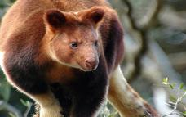

Blue Mountains National Park
This national treasure is part of the Greater Blue Mountains World Heritage Area – listed for its remarkable geographic and botanic features, and rich Aboriginal culture. It’s an easy day trip from Sydney but there are camping areas (Euroka or Blue Gum Forest) if you wish to spend a night or two. The park boasts 140km of scenic hiking tracks, with hundreds of lookout points from which to view hazy blue forests, waterfalls and rock formations – the most famous of which is the Three Sisters. There are opportunities for canyoning, rock climbing, cycling and horse riding. Get your fill of wild flowers and birds on the popular Cliff Top walking track, before settling down for a picnic complemented by beautiful views.
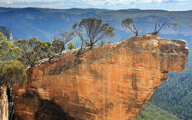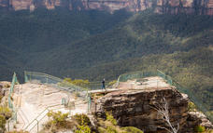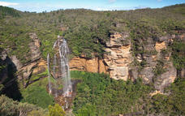

Bondi Beach
Bondi Beach is one of Australia's most famous beaches and well-known worldwide. Each year tens of thousands of people, from backpackers to billionaires, take to the golden sands of this wide, one-kilometre long city beach expanse to walk, jog, or just soak up the sun. Being only 10 kilometres from the city centre, Bondi Beach is one of Sydney's busiest beaches. There's a host of events held here all year round from community art shows to city to surf running marathons.
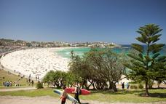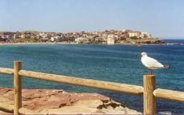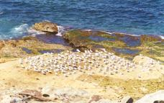

Day Room: Park Hyatt Sydney View iBrochure
Seated majestically on one of the world’s most beautiful harbors, Park Hyatt Sydney perfectly personifies contemporary harbourside luxury with its coveted location between the iconic Sydney Opera House and Harbor Bridge. Reminiscent of an exclusive harbourside residence, Park Hyatt Sydney offers intimate surroundings with architecture, art and design that reflect the Australian landscape. Highlights include 155 spacious guestrooms and luxurious suites with contemporary interiors and floor-to-ceiling glass doors that open to private balconies, 24-hour butler service and a day spa with rooftop pool and sundeck. For a truly memorable Australian stay, Park Hyatt Sydney is an ideal choice.
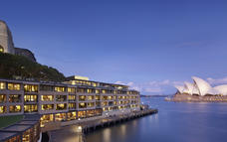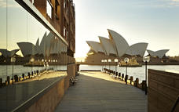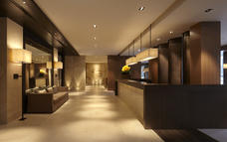

Overnight: Pullman Quay Grand Sydney Harbour View iBrochure
This luxurious 5-star Sydney Hotel offers all suite Sydney accommodation, indulgent cuisine at Q dining and one of Sydney's stylish ECQ overlooking Sydney Harbour.
Located on the edge of bustling Circular Quay, in the heart of Sydney, this 5-star Sydney Hotel features the most spectacular views over the sparkling waters of Sydney Harbour including the Iconic Harbour Bridge and Circular Quay.
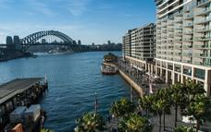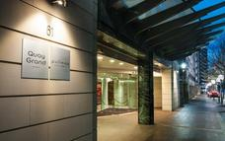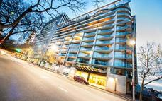

Bedroom Suite Garden View
Fully-equipped suites each with bedroom with king bed ensuite bathrooms with spa bath separate lounge with sofa bed dining fully equipped kitchen and private balcony offering views over the Royal Botanic Gardens

Included
Dinner, Bed and Breakfast

Day 20: Saturday, 26 OctoberOvernight Travel

Day Itinerary
Flight from Sydney, Australia (SYD) to Los Angeles, California (LAX) is approximately 13h 40m.

Day 21-24: Sunday, 27 October to Wednesday, 30 OctoberRamada Cancun City, Cancún

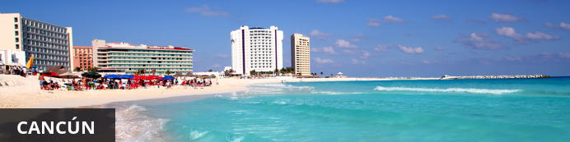
The jewel of Mexico’s beach resort destinations, world-famous Cancun is set on a small sliver of island real estate in the northeast corner of the Yucatan peninsula. The development of the famed beach resort started in the 70s, when the Mexican government built a causeway connecting the island to the mainland. Each year thousands of travellers visit Cancún to enjoy its clubbing, beach parties and bikini contests. Culture seekers should head to the various Mayan ruins in the region, such as the ancient settlements of El Meco and El Rey, and Yamil Lu’um, a Mayan temple dating back to the 14th century.

Day Itinerary
Featuring 14 miles of primaeval coastlines, towering Mayan ruins, delightful eco-parks, and generous bouts of adventure, Cancun is the perfect place to go on a memorable vacation. One of the most-visited destinations in Mexico, this vibrant city is replete with plenty of interesting attractions worth visiting.
While here, there are 3 main things to do - Beaches, Mayan Ruins and the Cancun Underwater Museum.

Consultant Notes
No activities or tours have been pre-booked for you, but if you need any help, drop us a line!

Optional
Chichen Itza
Tulum
Maya Cancun Museum
Secrets The Vine Cancun

Chichen Itza
The most famous Mayan archaeological site in Mexico, Chichen Itza transports visitors back to between the 9th and 12th centuries CE, when the ancient city was at its height. One of the largest Mayan cities in Central America, Chichen Itza’s highlights include the Kukulkan Pyramid and the sacred Cenote (a natural fresh water well that plunges 22 metres and was a key water source for the first settlers and farmers of the city). Kukulkan Pyramid, called “El Castillo” (the castle) by the Spanish, towers 30 metres above the ground, and once served as a temple to the god Kukulkan.
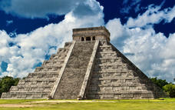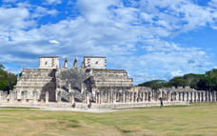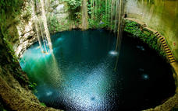

Tulum
In the coastal town of Tulum you will find Mexico’s only archaeological site overlooking the sea. The Tulum Ruins were once an ancient Mayan fortress and now offer tourists the chance to soak up some history before dipping into the water at one of the most beautiful beaches in the Caribbean. While the ruins are the main attraction, there is also plenty to be seen and done in the rest of Tulum. Ocean lovers can spend time diving, snorkelling and exploring cenotes – natural swimming holes that the Mayans considered sacred – and the quaint town offers a selection of small hotels, restaurants and stores that provide dining, shopping and entertainment opportuities.
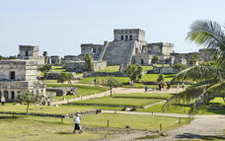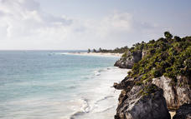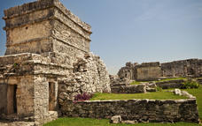

Maya Cancun Museum
Maya Cancun Museum is located next to a small Mayan site called San Miguelito in the town of Cancun. The museum features an excellent introduction to the Mayan culture, consisting of 2 main parts which are the onsite ruins and the gallery within the complex.
There are three large spaces within the complex. The first area focuses on exhibits of the local region of Quintana Roo. The second has general Mayan exhibitions with some outstanding pieces, including stonework pieces from Chichen Itza and various ceramic objects. The third is a space for temporary exhibitions. Interpretations of the exhibits are written in both English and Spanish.

Secrets The Vine Cancun
Defining elegance, Secrets The Vine Cancun is framed by the crystal-clear Caribbean and powder-white sand beaches in stunning Cancun. This chic, contemporary adults-only haven combines the natural beauty of the Yucatan Peninsula with the elegance and Unlimited-Luxury® of a world-class resort.
Featured at the Secrets The Vine Cancun resort are chic accommodations with stunning views of the sparkling Caribbean Sea, endless gourmet dining at 7 restaurants and infinity pools and an outdoor Jacuzzi to name a few.
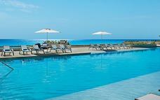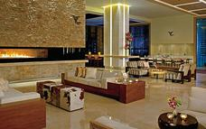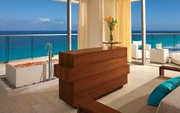

Overnight: Ramada Cancun City
Less than a mile from the beach off Route 15A and under 12 miles from Cancun International Airport, lies the Ramada Cancun. The property's convenient location provides everything guests need for an unforgettable Mexican adventure. The on-site restaurant at the Ramada Cancun City serves breakfast, lunch, and dinner. Rooms range from standard to standard king, each with their own set of amenities. Amenities at the hotel include free Wi-Fi, fitness centre, swimming pool, and shuttle service.
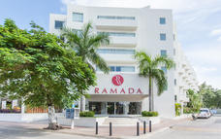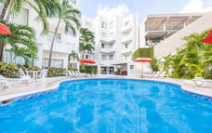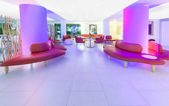

Included
Dinner, Bed and Breakfast

Day 24-28: Wednesday, 30 October to Sunday, 3 NovemberCasaSur Recoleta Hotel, Buenos Aires

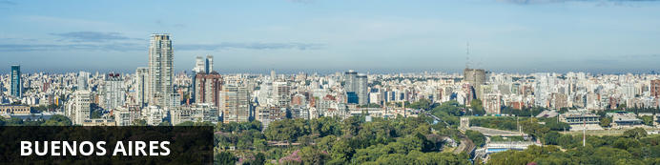
Argentina’s capital is a thriving portside metropolis defined by a rich history, vibrant culture and strong European influence, with the result that it’s sometimes called The Paris of South America. Countless museums covering a cornucopia of subjects; an active theatre culture; carnivorous buffets second to none; sensuous tango performances; a mosaic of architecture; and shops to fit all fancies – all these facets and more make up the seductive blend that is Buenos Aires.

Day Itinerary
After some to rest, we will take on Buenos Aires!
In the morning, after breakfast, we start our city tour to give you a sense of the diversity of one of South America’s most cosmopolitan cities. We start at the symbol of the city center: The Obelisk. We visit important city squares like Plaza de Mayo, San Martin, Alvear, Plaza del Congreso, and the city’s main thoroughfares like Corrientes, De Mayo and 9 de July, among others. The tour also takes in the historic neighborhoods or “barrios” La Boca and San Telmo, the high end of town in leafy suburbs like Palermo and Recoleta, and modern districts like Puerto Madero, the parks, Lezama, Tres de Febrero, the Ecological Reserve, the city’s commercial and financial districts, and La Bombanera football stadium, home of the famous Boca Juniors. Afternoon free to exlore on your own.
The next morning is free, where it’s possible to take one of our optional tours of the city or the surrounding area. At night we hit the town to enjoy an excellent Dinner Show, featuring the city’s beloved Tango in one of Buenos Aires’ famous nightspots.

Activities
Plaza de Mayo Buenos Aires
Alvear Icon

Plaza de Mayo Buenos Aires
This is the civic centre of Buenos Aires which has witnessed many historic events. Landmarks flank the square as do churches, convents and tango shows making it an indispensable tourist attraction.

Alvear Icon
Alvear Icon Hotel & Residences offers a trendy proposal, inspired by those iconic characters who transcend time leaving their mark in various areas. Protagonists passionate, provocative, free and perfectionists, looking for exceptional experiences.
Alvear Icon Hotel & Residences captures the brilliance of these references and reflects it in its proposal, incorporating to the excellence of the hospitality, innovating tendencies of design and technology of vanguard.
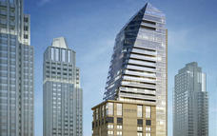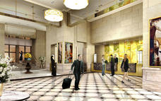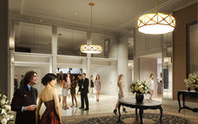

Overnight: CasaSur Recoleta Hotel View iBrochure
Located in one of the most refined spots of the city, CasaSur Recoleta welcomes you in the historical heart of Buenos Aires. With the signature sophistication and elegance of this neighborhood, on the symbolic Callao Avenue, the cosmopolitan essence of the city can be felt at every step. Surrounded by art galleries, national and international famous fashion brands, green areas and tourist circuits that are a must for every visitor, CasaSur Recoleta is your home in Buenos Aires, offering you the experience of a luxury boutique hotel, with a five star hotel service.
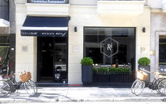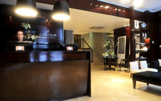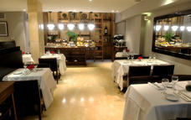

Suite Deluxe
Two rooms distributed in 60m2, a generously sized balcony, en suite bathroom and toilette with a separate shower. These rooms have a space which is perfect for business meetings.

Included
Dinner, Bed and Breakfast

Day 28-31: Sunday, 3 November to Wednesday, 6 NovemberOwn Arrangement, Cape Town

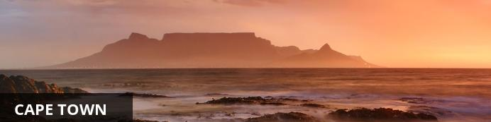
Resting at the confluence of the Indian and Atlantic Ocean, sandwiched between the slopes of the iconic Table Mountain and the glistening sapphire waters of Table Bay, the exceptionally scenic city of Cape Town is in a class of its own. Some cities boast rich culture, vibrant nightlife, a cosmopolitan atmosphere and extraordinary architecture, while others boast breathtaking landscapes and extraordinary natural wonders. Cape Town is lucky enough to be blessed with all of these attractions and so much more. With its bustling harbour, world-class beaches, top-notch vineyards, and its mountainous surroundings brimming with diverse flora and fauna, Cape Town consistently captivates the hearts of all who visit.

Day Itinerary
Your Own Arrangements start after you check out of the hotel in Buenos Aires. We have confirmed your car hire on arrival in Cape Town.

Consultant Notes
If you need assistance with bookings of any activities or day tours, we are happy to help.

Overnight: Own Arrangement

Included
4 Day Avis Car Rental - Nissan X -Trail Auto 4x4 or similar group L car

Day 31: Wednesday, 6 NovemberEnd of Itinerary

Day Itinerary
Every good thing must come to an end.

Transport

Flight Information
Date | Flight | Airline | Departure Airport | Time | Arrival Airport | Time | Class | Ref
08 Oct | MS840 (Scheduled) | Egypt Air | OR Tambo International Airport [JNB] | 21:45 | Cairo International Airport [CAI] | 05:35  (09 Oct) | Economy
12 Oct | MS912 (Scheduled) | Egypt Air | Cairo International Airport [CAI] | 09:30 | Dubai International Airport [DXB] | 15:00 | Economy
16 Oct | EM510 (Scheduled) | Emirates Airline | Dubai International Airport [DXB] | 03:55 | Indira Gandhi International Airport [DEL] | 09:05 | Economy
19 Oct | 332 (Scheduled) | Air India | Indira Gandhi International Airport [DEL] | 13:50 | Suvarnabhumi Airport [BKK] | 19:35 | Economy
23 Oct | 24 (Scheduled) | Quantas | Suvarnabhumi Airport [BKK] | 18:10 | Sydney International Airport [SYD] | 06:25 | Economy
26 Oct | United840 (Scheduled) | United Airlines | Sydney International Airport [SYD] | 09:30 | Los Angeles International Airport [LAX] | 06:10  (27 Oct) | Economy
27 Oct | United 1276 (Scheduled) | United Airlines | Los Angeles International Airport [LAX] | 09:30 | Cancun International Airport [CUN] | 16:15 | Economy
30 Oct | 1371 (Scheduled) | Aerolineas Argentinas | Cancun International Airport [CUN] | 08:30 | Ezeiza International Airport [EZE] | 19:10 | Economy
03 Nov | Scheduled |  | Ezeiza International Airport [EZE] |  | Cape Town International Airport [CPT]

Transfers
Date | Company | Pick Up | Drop Off | Time | Vehicle
07 Oct | Hallmark House | OR Tambo International Airport [JNB] | Hallmark House | 10:00 | People Carrier (Private Transfer)
08 Oct | Hallmark House | Hallmark House | OR Tambo International Airport [JNB] | 10:00 | People Carrier (Private Transfer)
09 Oct | Egypt Ground | Cairo International Airport [CAI] | The Nile Ritz-Carlton Cairo | 06:00 | People Carrier (Scheduled Transfer)
12 Oct | Egypt Ground Handler | The Nile Ritz-Carlton Cairo | Cairo International Airport [CAI] | 05:30 | People Carrier (Private Transfer)
12 Oct | Uber | Dubai International Airport [DXB] | Avani Deira Dubai Hotel | 15:30 | UberXL (Private Transfer)
16 Oct | Avani | Avani Deira Dubai Hotel | Dubai International Airport [DXB] | 01:00 | People Carrier (Private Transfer)
16 Oct | Hi-Tours | Indira Gandhi International Airport [DEL] | The Leela Palace New Delhi | 10:00 | People Carrier (Transfer)
19 Oct | Hi-Tours | The Leela Palace New Delhi | Indira Gandhi International Airport [DEL] | 10:00 | People Carrier (Scheduled Transfer)
19 Oct | Bangkok Ground Handler | Suvarnabhumi Airport [BKK] | Century Park Hotel Bangkok | 20:00 | SUV (Scheduled Transfer)
22 Oct | Bangkok Ground Handler | Century Park Hotel Bangkok | Suvarnabhumi Airport [BKK] | 07:00 | SUV (Private Transfer)
23 Oct | Sydney Tours | Sydney International Airport [SYD] | Park Hyatt Sydney | 07:00 | People Carrier (Scheduled Transfer)
23 Oct | Sydney Tours | Park Hyatt Sydney | Pullman Quay Grand Sydney Harbour | 13:00 | People Carrier (Private Transfer)
26 Oct | Sydney Tours | Pullman Quay Grand Sydney Harbour | Sydney International Airport [SYD] | 06:30 | People Carrier (Transfer)
27 Oct | Ramada Transfers | Cancun International Airport [CUN] | Ramada Cancun City | 17:00 | Shuttle Bus (Shuttle)
30 Oct | Ramada Transfers | Ramada Cancun City | Cancun International Airport [CUN] | 05:00 | Shuttle Bus (Shuttle)
30 Oct | CasaSur Tours | Ezeiza International Airport [EZE] | CasaSur Recoleta Hotel | 20:00 | People Carrier (Private Transfer)
03 Nov | CasaSur Tours | CasaSur Recoleta Hotel | Ezeiza International Airport [EZE] | 09:00 | People Carrier (Private Transfer)

Car Rentals
Date | Pick Up |  | Length | Company | Category | Vehicle | Drop Off
03 Nov | Cape Town International Airport | 10:00 | 4 Days | Avis | Group L | Nissan X -Trail Auto 4x4 or similar | Cape Town International Airport | 13:00

Driving Directions

Directions - Twelve Apostles Hotel & Spa to Cape Town International Airport [CPT]
Distance: 28.71km Travel Time: 0:35 hours
GPS co-ordinates for Cape Town International Airport [CPT]: S 33° 58' 9.980" E 18° 35' 47.171"
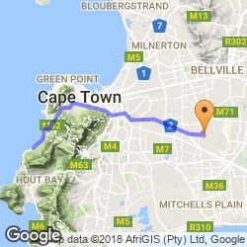
- Head northwest toward Victoria Rd/M6 (11 m)
- Turn right onto Victoria Rd/M6 (3.2 km)
- Turn right onto Houghton Rd (0.5 km)
- Turn right onto Camps Bay Dr/M62Continue to follow M62 (4.2 km)
- Turn right onto Bellevue St (63 m)
- Turn left to stay on Bellevue St (0.6 km)
- Turn left onto Kloof St (26 m)
- Turn right onto Hof St (0.4 km)
- Turn left to stay on Hof St (0.8 km)
- Turn right onto Orange St/M3Continue to follow M3 (0.5 km)
- Keep right to continue on Mill St/M3Continue to follow M3 (1.0 km)
- Keep right to continue on Philip Kgosana Dr/M3 (2.6 km)
- Keep right at the fork, follow signs for M3/Muizenberg and merge onto N2 (1.0 km)
- Keep left at the fork to continue on Settlers Way/N2, follow signs for ⛉ N2/Cape Town International Airport/Somerset W (11.2 km)
- Take exit 16 toward Lughawe Airport (0.5 km)
- Merge onto Airport Approach Rd (0.7 km)
- Keep right to stay on Airport Approach Rd (0.5 km)
- Keep left to continue toward Freight Rd (0.2 km)
- Continue onto Freight Rd (0.3 km)
- Keep right to continue on Airport Ring Rd (0.5 km)

Service Provider Directory
Service Provider | Ref. Number | Telephone | Address
Avani | AvaniT326589
Avani Deira Dubai Hotel | avani34567 | +971 4 601 3999 | Corner Abu Baker Al Siddique and Sallahudin Road, PO Box 234344, Dubai, United Arab Emirates
Avis | Jones98421632626
Bangkok Ground Handler | bang9874
Bangkok Ground Handler | Bang123456
Cape Town International Airport [CPT] |  | 3333333
CasaSur Recoleta Hotel | casa963852 | +54 11 4515-0085 | Av. Callao 1823, CABA, ARG
CasaSur Tours | Casa98514
CasaSur Tours | Casa123
Century Park Hotel Bangkok | cen24688 | +66 2 246 7800 | 9 Ratchaprarop Road, Pratunam-Victory Monument Bangkok 10400
Egypt Ground | Nile65897
Egypt Ground Handler | Nile3216
Hallmark House | hall123456 | +27 11 402 0220 | 54 Siemert Road, New Doornfontein, Johannesburg
Hallmark House | hall123456
Hi-Tours | hi546987
Hi-Tours | hi123456
Park Hyatt Sydney |  | +61 2 9256 1234 | 7 Hickson Road, The Rocks  Sydney, New South Wales,  Australia, 2000
Pullman Quay Grand Sydney Harbour | pull654987
Ramada Cancun City | ramada9876 | +52 998 881 7870 | Av. Yaxchilan 41 SM 22, Cancun, 77500
Ramada Transfers | Jones family
Ramada Transfers | Jones Family
Suvarnabhumi Airport [BKK] |  | +66 2 132 1888 | 999 Moo 1,  Bangna - Trad Rd.,  Km 15 Rachathewa, BangPli  Samut Prakan 10540,  Thailand
Sydney Tours | syd8521
Sydney Tours | Syd985647
Sydney Tours | syd9865
The Leela Palace New Delhi | leela987456 | +91 11 3933 1234 | The Leela Palace New Delhi, Diplomatic Enclave, Chanakyapuri, New Delhi 110023, India
The Nile Ritz-Carlton Cairo | nile1234
Twelve Apostles Hotel & Spa |  | +27 21 437 9000 | Victoria Road  Camps Bay  South Africa
Uber | n/a

Travel Information
This is where Travel Guidance displays
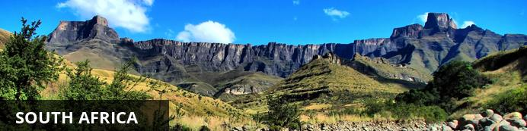
This vast country is undoubtedly one of the most culturally and geographically diverse places on earth. Fondly known by locals as the 'Rainbow Nation', South Africa has 11 official languages and its multicultural inhabitants are influenced by a fascinating mix of African, Asian and European cultures. Spend your days: discovering the gourmet restaurants, impressive art and nightlife scenes and fine beaches of Cape Town; enjoying a typical local braai (barbecue) in the Soweto township; browsing the bustling Indian markets in Durban; or sampling some of the world’s finest wines at the myriad wine estates dotted around the picturesque Cape Winelands. Due to its rich and turbulent history there are plenty of historical attractions to explore including the Zululand battlefields of KwaZulu-Natal, the Apartheid Museum in Johannesburg and Robben Island, just off the coast of Cape Town. Above all else, South Africa’s attraction lies in its remarkably untamed wilderness with its astonishing range of wildlife roaming freely across massive unfenced game reserves such as the world famous Kruger National Park. With all of this variety on offer, it is little wonder that South Africa has fast become Africa’s most popular tourist destination.

Banking and Currency
Currency
The currency is the Rand, which is divided into 100 cents. There are R200, R100, R50, R20 and R10 notes. Coins come in R5, R2, R1, 50c, 20c, 10c and 5c.
Banking
Banks are found in most towns, and are generally open from 09h00 to 15h30 on weekdays and 08h30 to 11h00 on Saturdays (Closed Sundays and Public Holidays). Most of them offer foreign exchange services - with cash, bank & credit cards as well as travellers cheques. You can also obtain cash from automatic teller machines (ATMs). Several international banks have branches in the main city centres. Always advise your bank that you are travelling outside of the country as they might block your purchases if they are not informed.

Travel, Transport and Getting Around
Travelling around South Africa is relatively easy by air, road and rail.
Principal air routes are serviced by SAA and British Airways, operated by Comair. There are 2 low-cost carriers on main routes, namely Kulula.com and Mango.
Facilitating travel around South Africa are 10 airports managed by the Airports Company South Africa (Acsa). In addition, there are some 90 regional airports, including the Kruger Mpumalanga International Airport in Nelspruit and the Skukuza Airport, offering access to the Kruger National Park.
An extensive tarred road system makes travelling in South Africa by vehicle convenient and easy. You will find gravel roads in rural areas though. Note:
- A valid international driver's licence is required.
- We drive on the left hand side of the road.
- Wearing seat belts is compulsory and cellphones can only be used ‘hands free'.
- Speed limits are generally set at 120km on freeways, 100km on secondary roads and 60km in urban areas.
- Toll fees apply on certain national roads.
- Petrol stations are widespread.
- Most global car hire firms have branches in South Africa
Another means of getting around South Africa are luxury inter-city bus services such as Greyhound and Trans-Lux. Metrobus buses are available for in-city transport. Metered taxis must be ordered by telephone. There is a hop-on-hop-off bus in Cape Town and Johannesburg.
Our rail system includes the long-haul, inexpensive Shosholoza Meyl Metrorail trains. More luxurious options are the Blue Train, Premier Classe and the steam train Rovos Rail. There is also the new Gautrain rapid transit railway system in Gauteng Province which links Johannesburg, Pretoria, Ekhuruleni and OR Tambo International Airport.

Food, Drink and Cuisine Advice
Standards of hygiene in relation to food health and safety in South Africa, are generally high in hotels, restaurants, pubs and nightspots. Tap water in South Africa is safe to drink and cook with when taken from taps in urban areas. Not all tap water in rural areas is safe for consumption, so take precautions if necessary.
It is safe to eat fresh fruit, vegetables and salads, and put ice in your drinks. South Africa's fish, meat and chicken are of excellent quality, so there is no need to limit yourself when enjoying the local cuisine.
Restaurants are subject to South Africa's food safety control legislation, which is implemented by local government. Regulations include certification and regular inspections by health inspectors to ensure hygienic standards are maintained.
Street food is not as common in South Africa as it is in other countries, although vendors selling traditional snacks and meals can be found in city centres and townships. Food safety in such instances cannot always be guaranteed.

Climate and Weather
South African temperatures, which are measured in centigrade, average at highs of 28°C to average lows of 8°C in the summer months while winter temperatures range from 1°C at night to around 18°C in the day. Average annual rainfall is on the low side at under 500mm a year, making the country somewhat dry. Much of the rain falls in the Western Cape in the winter, differing from the rest of the country, which experiences summer rainfall. On the plus side, the South African climate boasts more than its fair share of sunshine, recording an average of 8.5 hours a day.

Clothing and Dress Recommendations
Summer
Bring clothes that are cool, light and comfortable because summer temperatures can get well into the 30 - 40 degree Celsius range in some areas.Also bring an umbrella or raincoat during summer as this is when most of the country gets its rain, but don't forget a swimming costume (bathing suit).
Winter
The winters are generally mild, comparing favourably with European summers. But there are days when temperatures dive, especially in high-lying areas such as the Drakensberg, so be prepared with jerseys and jackets. Cape Town gets its rain during the winter season so it’s advisable to bring rain gear along.
General
Always bring a hat, sunglasses and sunblock as the sun can be strong even in the winter months.
Walking shoes are a good idea all year-round, with warm socks in the winter.
If you are doing business in the country, business attire (suit and tie) is generally called for in the corporate sector, but media for example generally dress more casually.
For game viewing, a couple of neutral-toned items will be useful, but there's no need to go overboard. A good pair of walking shoes is also advisable.
For the evening, if you are dining at an upmarket restaurant or seeing a show, smart-casual attire is recommended.

Electricity and Plug Standards
Current is 220/240 volts at 50 cycles per second. A three-point round-pin adapter plug should be brought for your electrical appliances - such adapters are also available at major airports.

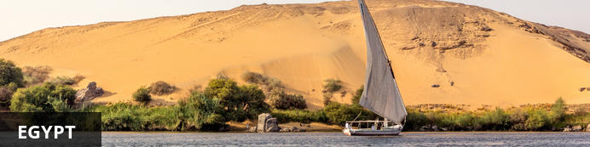
Egypt is one of Africa’s major tourism destinations with the main draw cards being the Red Sea, Egyptology and the Nile. The Pyramids of Giza, the Sphinx and the Valley of the Kings need no introduction in the world of antiquity, the sun soaked beaches of the Red Sea with their scuba diving are a massive attraction to those from colder climes and a cruise on the Nile floods back memories of Cleopatra. Aside from these famous attractions, this desert country houses ancient ruins and mystical Oases and in Cairo ancient cultures remain, blending with the very modern. Egypt offers so much more than its world-famous pyramids. Visitors can go desert trekking, scuba diving, golfing, fishing, bird watching or floating along the Red Sea.

Banking and Currency
Currency
Egyptian Pound or ginee (LE; symbol E£) = 100 piastres. Notes are in denominations of E£200, 100, 50, 20, 10, 5, 1, 50 piastres and 25 piastres. Coins are in denominations of 25, 20, 10 and 5 piastres.
British pounds sterling, Euros and the US Dollar are accepted everywhere although change may be given in Egyptian pounds.
The import and export of local currency is limited to E£5,000. The import and export of foreign currency is limited to US$10,000 or equivalent.
The Egyptian pound is available outside Egypt and you can change money before you leave for your trip. Alternatively, 24-hour currency exchange is available at Cairo airport. It is worth exchanging at least a small amount for incidentals during your first day or two in Egypt. Keep small denomination notes for taxis fares as drivers rarely seem to have any change, and for tips, known as baksheesh, which are a way of life in Egypt.
Banking
Banking hours: Sun-Thurs 08h30-14h00. Bureaux de change are generally also open in the evening 18h00-21h00.
American Express, Diners Club, MasterCard and Visa credit cards are widely accepted in all but the smallest hotels and restaurants throughout the country, except in the Western oases. It is wise to keep your credit card in view when you make purchases or pay a restaurant bill, and to keep receipts for checking exchange rates and charges on your statement.
ATMS can be found in all major towns and cities.
Travellers cheques are becoming less useful now that international ATMs are prevalent throughout the country. To avoid additional exchange rate charges, travellers are advised to take traveller's cheques in US Dollars, Euros or Pounds Sterling. You will need to show your passport when you change traveller’s cheques.
Currency exchange is also available at banks, official bureaux de change outlets and most hotels. Banks often have better exchange rates than bureaux de change or hotels. All common international currencies are accepted. It is wise to divide your currency between you if there is more than one person in your party and keep it secure to guard against theft. It is advisable to take only what you will need for a day’s excursion and keep the remainder of your money in your hotel safe.

Travel, Transport and Getting Around
The Egyptian national airline, Egyptair, operates all domestic flights in Egypt and serves 11 major airports: Abu Simbel, Alexandria, Assiut, Aswan, Cairo, Hurghada, Luxor, Marsa Alam, Marsa Matruh, Sharm el-Sheikh, and Taba.
The easiest way to move around major Egyptian cities is by using the always abundant public taxis; each city has its own colour of public taxi; yellow and black in Alexandria, and black and white in Cairo, for instance. Cairo has also a fleet of metered, air-conditioned Yellow and White Taxis with which you should book your taxi one hour before a journey.
There's an extensive network of buses running between the major cities in Egypt. Bus companies such as Superjet, Delta and Upper Egypt – only to name a few – usually provide air-conditioned buses, with some refreshments, toilets and an in-ride movie. Buses are by far the best transportation mean for day trips. They are very affordable, but you have to think of making your reservations at least one day in advance.
Renting a car in Egypt is easy; most major international car hire agencies have offices in Egypt’s airports and towns. Rates are comparable to international car hire charges and many companies offer online reservation facilities. In order to rent a vehicle and drive in Egypt, you’ll be asked to provide an International Driving License. Egyptians drive on the right-hand side of the road, and the official out-of-town speed limit is 90 km/h.

Food, Drink and Cuisine Advice
You should avoid uncooked vegetables and peeled fruit that may have been washed in tap water, and make sure any poultry or egg-based dishes, and any seafood or shellfish, is thoroughly cooked. Hotels and restaurants are generally safe to eat and drink in, but it is advisable to avoid street vendors.
Use only bottled water for drinking and, to be on the safe side, when brushing teeth. When buying bottled water, check the seal of the bottle is intact. A popular scam is for unscrupulous individuals to collect used bottles from rubbish bins, refill them with tap water, attempt a reseal and sell them as genuine clean bottled water. Also, avoid unbottled beverages and ice except in top hotels and restaurants. Milk is unpasteurised and should be boiled.
Egyptian food reflects the country's melting-pot history; native cooks using local ingredients have modified Greek, Turkish, Lebanese, Palestinian, and Syrian traditions to suit Egyptian budgets, customs, and tastes. The dishes are simple; made with naturally ripened fruits and vegetables and seasoned with fresh spices, they're good and hearty. Food in the south, closely linked to North African cuisine, is more zesty than that found in the north, but neither is especially hot. The best cooking is often found in the smaller towns. Although Egyptian cooking can be bland and oily when poorly done, most of the cuisine is delicious.
Although Egyptian eating habits may seem erratic, most natives begin the day with a light breakfast of beans (or bean cakes), eggs, and/or pickles, cheeses, and jams. Most families eat their large, starchy lunch around 14h00-17h00 and follow it with a siesta. They may take a British-style tea at 17h00 or 18h00 and eat a light supper (often leftovers from lunch) late in the evening. Dinner parties, however, are scheduled late, often no earlier than 21h00, with the meal served an hour or two later. In restaurants lunch is normally 13h00-16h00, dinner 20h00-24h00.
A 10-12% service charge is typically added to hotel and restaurant bills but an extra tip of 5% is normal.

Climate and Weather
With the small exception of its strip of Mediterranean coastline, the whole of Egypt has an arid desert climate. Throughout Egypt, days are commonly warm or hot, and nights are cool. Egypt has only two seasons: a mild winter from November to April and a hot summer from May to October. Egypt receives fewer than eighty millimeters of precipitation annually in most areas. Most rain falls along the coast, but even the wettest area (around Alexandria), receives only about 200 millimeters of precipitation per year. The best time to travel to Egypt is during the winter, between December and February, when temperatures range between 20 to 26 degrees Celsius (68 to 79 degrees Fahrenheit).

Clothing and Dress Recommendations
What you wear will depend a little on whether you are staying solely in the tourist beach resorts, or exploring the wider country. However always remember it is a Muslim country so you should respect their conservative values at all times. Local people like to dress up in the evening, so if you're going out to dinner it's a great opportunity to dress with more care than usual. Also on cruise boats it's nice to have something smart to wear in the evening. Egypt is a Muslim country, and although its cities are modern and local women may wear make-up now, they always dress conservatively.
Egyptians find it very inappropriate to reveal even the slightest amount of stomach or hips, so short tops, short skirts or shorts, or tight clothes should be avoided completely when away from tourist hotels. Cotton or other natural fiber long-sleeved shirts or t-shirts, worn with long pants or ankle length skirts are a good choice, and keep your shoulders covered too. Keep clothing loose - it will keep you cooler and you'll get less unwanted attention. Although the dress code is more relaxed in hotels and tourist resorts like Sharm el Sheikh, you will find that you will get more respect if you dress modestly - a pashmina or wrap can be useful for times when you need to cover up.

Electricity and Plug Standards
Electrical sockets (outlets) in Egypt are one of the two European standard electrical socket types: The "Type C" Europlug and the "Type E" and "Type F" Schuko. If your appliance's plug doesn't match the shape of these sockets, you will need a travel plug adapter in order to plug in. Travel plug adapters simply change the shape of your appliance's plug to match whatever type of socket you need to plug into. If it's crucial to be able to plug in no matter what, bring an adapter for both types.
Electrical sockets (outlets) in Egypt usually supply electricity at between 220 and 240 volts AC. If you're plugging in an appliance that was built for 220-240 volt electrical input, or an appliance that is compatible with multiple voltages, then an adapter is all you need.
But travel plug adapters do not change the voltage, so the electricity coming through the adapter will still be the same 220-240 volts the socket is supplying. If your appliances are not compatible with 220-240 volt electrical output, a voltage converter will be necessary.

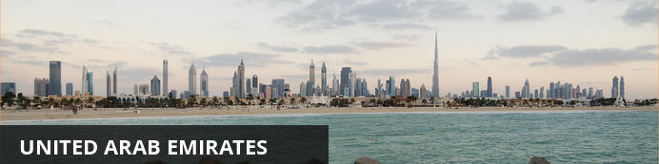
The United Arab Emirates, in the eastern part of the Arabian Peninsula, extends along part of the Gulf of Oman and the southern coast of the Persian Gulf. The nation is the size of Maine. Its neighbors are Saudi Arabia to the west and south, Qatar to the north, and Oman to the east. Most of the land is barren and sandy.

Banking and Currency
The UAE dirham (AED) is divided into 100 fils. Coins are in 5, 10, 25 and 50 fils and AED1. Notes are in denominations of AED5, 10, 20, 50, 100, 200, 500 and 1,000. $1 = AED3.6727 and currently £1 = AED5.9465.
It’s wise to have some local currency when you arrive to cover small purchases and taxi fares, although you might well be met at the airport by your sponsor’s staff or your new colleagues.
Currency exchanges and banking facilities are available at most major airports and many are open 24 hours a day. Exchange rates, however, are unlikely to be favourable at these outlets. More competitive rates can be obtained from city-centre financial establishments. You should avoid changing money at your hotel, as hotel rates are probably the worst on offer.

Travel, Transport and Getting Around
The main hub for air transport in the United Arab Emirates is Dubai airport, which is served by several major airlines, most notably Dubai-based Emirates. Direct flights connect Dubai to Durban, Johannesburg, Cape Town , London,Sydney, Melbourne, Karachi, Tehran, Riyadh, Mumbai, Kolkata, Hong Kong, Paris, Zurich, Frankfurt, Houston, Milan,Madrid, New York City, Los Angeles, San Francisco, Seattle, Toronto, São Paulo and many other major cities in Europe,Asia, Australia, North America and Africa.
After Dubai, the airport at Abu Dhabi has the next best international connections. Abu Dhabi-based Etihad Airways now offers direct flights from New York, Toronto and many other airports in Europe and Asia.
Other major airlines serving Abu Dhabi include British Airways from London-Heathrow, KLM from Amsterdam, Lufthansa from Frankfurt and Singapore Airlines from Singapore and Jeddah.
For low-cost flights, Air Arabia has set up a hub at Sharjah airport (which is very close to Dubai), and flies there from many cities in the Middle East and India.
There is road access to the United Arab Emirates from Saudi Arabia in the south and Oman in the east. All highways in the UAE are in excellent condition, but there is a huge amount of traffic between Sharjah and Dubai, as well as a 4 AED charge to cross the Salik toll gate. A prepaid Salik Tag is required for this.
There is a large network of dhows which transport goods throughout the Gulf and India. It may be possible to buy passage on one of these boats. They call at all coastal cities in the UAE, including Dubai and Abu Dhabi.
Public transportation within most cities remains rudimentary. Dubai is building extensive Metro, monorail and tram networks, and has invested heavily in the local bus network in recent years. The other emirates offer very little public transportation. Abu Dhabi has a network of city buses that cost Dh2 per trip and are fairly reliable, but can be overcrowded for male passengers. Intercity bus services are fast, comfortable and reasonably frequent.
In the cities of Dubai, Abu Dhabi, and Sharjah, taxis are widely available. They are relatively cheap in Abu Dhabi and Sharjah. A ride to anywhere within the city of Abu Dhabi will cost approximately US$10, as they charge solely by distance traveled. A night surcharge of US$3 may be added after 10PM, depending on your driver.
The legal driving age in the United Arab Emirates is 18. The UAE has a modern road system. Renting a car or driving in the UAE requires an international driver's license, which is simply a translation of your standard license and can be acquired at a local automobile association. If you have UAE residency status, you must obtain a local driver's license. This can be a simple process that must be completed and can be done in 20 min but only if you are from a specific list of countries (predominantly Western). If you are from an Asian country, you currently have to undergo 40 classes at a local driving school and get through a pretty tough license exam. This is changing, though, and it may apply to all nationalities soon.
Car rentals are slightly cheaper than in the US There is a flat fee per day for renting a car, based upon the car's size. Petrol (gasoline) is, by US and European standards, inexpensive. The road system is based along European standards, with many roundabouts and highly channeled traffic. But the signs are readily understandable and are, in most places, clear and coherent. Drivers in the UAE, particularly in the urban areas, tend to be highly aggressive and often use tactics that range from the stupid to the disastrous. This may perhaps stem from the traffic, which can be extremely congested in the urban areas, or from other factors.
People in the UAE drive extremely fast, and some are completely reckless: overtaking by the right is the rule, speed limits are ignored by many, even heavy trucks. Last-second lane change seems to be a national sport. The UAE has the third-highest death rate from traffic accidents in the world (just behind Saudi and Oman).
Be especially careful when you spot a tinted-window SUV at night: the black windows make the driver not see you and change lanes. Theoretically forbidden, tinting windows is widespread among young Arabs and is generally associated with poor driving skills and fast driving.
There are now some good local city maps, particularly for Dubai (the Explorer series of books). Be aware that construction is on-going, sometimes rapidly changing the road networks, so maps capture only a "point in time." Sharjah remains poorly mapped. A website offered the first decent online maps of the UAE. Google Earth does offer solid satellite pictures but at a level of detail good mainly for broad reference purposes. The lack of good maps or signage makes the use of a compass or GPS sometimes useful if you want to get off the highway.
Desert safaris or "wadi bashing" are good attractions in the vicinity of Dubai, but great care needs to be taken while choosing a hired vehicle; it should be a four wheel drive. Desert safaris are also generally pre-designed with travel agents and can give you good deal as well on quantity.

Health and Medical Information
General medical care in Dubai, Abu Dhabi, and Sharjah is quite good, with clinics for general and specialized care widely available, including some which are now open 24 h. Hospitals in the major centers are well-equipped to deal with any medical emergencies. There is an ambulance system in all major population centres; however, coverage can be patchy in the more remote areas. Ambulances are designed for transportation rather than providing care as first responders, so don't expect top-flight on-site care.
The main government hospital in Abu Dhabi is one of the best in the Middle East; as is the Sheikh Khalifa Medical City, now managed by Cleveland Clinic.
In Dubai, the government hospitals are Rashid hospital, which has a new Trauma Centre and Dubai Hospital which are very good. Welcare Hospital American Hospital Zulekha Hospital NMC Hospital, and Belhoul Hospital in the private sector all have a good reputation. The country is free of malaria and prophylaxis is not needed. In Sharjah, the Kuwaiti (Goverrnment) Hospital accepts expatriates. The private hospitals in Sharjah are the Zahra hospital, Zulekha Hospital and Central Private Hospital. Prices including healthcare are generally cheaper in Sharjah and although all hospitals meet the Ministry of Health standards the Central Private Hospital and Zulekha Hospitals are considered more affordable.
Al Ain is served by a number of modern hospitals and care centers: Tawam Hospital, now managed by Johns Hopkins, and host to the UAE University Faculty of Medicine and Health Science; Al Ain Hospital (also called Al Jimi Hospital as it is in the district of Al Jimi), now managed by the Vienna Medical University; and the private Oasis Hospital, previously known as Kennedy Hospital, which was founded and run by Christian missionaries, and which was the first hospital in the city.
The water is safe to drink in the UAE, although most people prefer bottled water for its taste. The food is clean and in most restaurants is served to Western standards, particularly in tourist areas; however, hygeine can be an issue in some establishments outside, particularly roadside stalls. That said, food poisoning does happen, so use your common sense!
The heat in summer can reach 50°C (122°F), so avoid outdoors activity at the height of the day and watch out for signs of heat stroke. Be sure to drink lots of water as dehydration happens easily in such heat. If travelling off road (most of the country is desert), ensure you carry sufficient water to allow you to walk to the road should vehicles become bogged.
Although the UAE is somewhat more accommodating to handicapped travellers than other countries in the Mideast, it would nonetheless be a difficult country to navigate in a wheelchair. Curbs are high and there are few, if any, ramps or other accommodations.

Food, Drink and Cuisine Advice
Dubai and, to a lesser extent, Abu Dhabi offer a vast spread of food from most of the world's major cuisines. By Western standards most restaurants are quite affordable although it is easy to find extremely expensive food too. Most upper-end restaurants are located in hotels.
Due to the large expat populations, Indian and Pakistani restaurants abound, offering affordable and succulent choices. Also popular are Lebanese, Syrian and Jordanian cuisine restaurants.
A popular favorite is grilled chicken, available at most of the open-air cafeterias by the roadside which can be relished with other accompaniments like Khubz (Arabic Bread), hummus, etc., and the most popular rice dish is Biriyani, with grilled chicken or fish or lamb. Traditional Shawarma and falafel sandwiches are readily available and are quite cheap and delicious.
Very few traditional Emirati dishes are served at restaurants; and the closest is the Mendi-style cuisine of Yemen, in which platters of fragrant rice are topped with lamb, chicken or fish that has been slow-roasted in a pit
The legal drinking/purchasing age of alcoholic beverages is 21.
Dubai has a burgeoning nightlife scene and even formerly straitlaced Abu Dhabi has loosened up and tried to catch up. Alcohol is available in alcohol stores, 5-star hotel restaurants and bars in all emirates except Sharjah, where you can only drink in your home or in an expat hangout called the Sharjah Wanderers. As a tourist, you are permitted to buy alcohol in bars and restaurants to drink there. If you are a resident, you're supposed to have a alcohol license (never asked for in bars) which also allows you to buy alcohol at alcohol stores (they do check).
During Ramadan, no alcohol is served during daylight (fasting) hours. Dubai and Abu Dhabi permit bars to serve alcohol at night, but bands stop playing, background music is off or quiet, no dancing is allowed and nightclubs are usually closed. On certain holy days in the Islamic calendar, no alcohol is served publicly in any of the UAE.
Do not under any circumstance drink and drive in the UAE. If by chance you are in an accident, this becomes a card for going directly to jail — especially during Ramadan. Taxis are widely available if you have been drinking and are a much safer and wiser option given the insane driving habits in the region.

Climate and Weather
The country is extraordinarily dry, getting only a few days of rain a year. Despite that, Emiratis use water at an alarming rate: there are broad swaths of grass in the major public parks, for example, and landscaping can be extensive in the resorts or other public places. The majority of this water comes from desalinisation. Visitors do not pay for their water use. The weather from late October through mid-March is quite pleasant, with high temperatures ranging from around 27 °C (85 °F) to lows around 15°C (63 °F). It is almost always sunny. Rain can happen between November and February, and can cause road hazards when it does. In the summer, the temperatures soar and humidity is close to unbearable — it is widely suspected that the officially reported temperatures are "tweaked" to cut off the true summer highs, which can reach 50 °C (122 °F), or even higher!

Clothing and Dress Recommendations
Dubai and the UAE have varying degrees of tolerance to clothing styles from around the world and how to dress in the UAE. There are legal guidelines as to what is not acceptable, especially in Sharjah which has its own decency laws, but in general, residents, visitors, and tourists can mostly wear what they like within reason. If you like to reveal more flesh than commonly accepted in the office place, or like to wear what many would regard as extreme, offensive, or off-beat clothing, then it would be wise to tone down your dress code in the UAE, especially outside Dubai, and especially areas with a greater proportion of nationalities likely to be offended, and especially during Ramadan.
Consequenses of not following the dress code in UAE:
- If you are wearing something in Dubai that offends someone else who makes a point of telling you, we would suggest you very politely apologise, fix the offending item or at least say you will go and fix it immediately, and thank the person for pointing out the error of your ways.
- If instead you want to make a point of telling them to poke their sticky beak somewhere else, then you should expect to end up in an argument which will quite possibly or probably result in the police being called.
- It is unlikely they will arrest you for having an argument (unless it gets physical and/or obscene language is used), but they can arrest you for "offending public decency." Especially if the complainer is Muslim, and even more especially if they are Emirati (you are in the UAE after all, and Emiratis are citizens, not visitors).
- The resulting outcome could well be a month or so in jail, followed by deportation.
- As far as we can tell, the Dubai Police do not walk around shopping malls in Dubai looking for under-dressed visitors to arrest, but they are likely to respond to complaints (which is exactly what you'd expect the police to do anywhere).
What to wear and what not to wear in UAE:
- In general, most "normal" clothing is tolerated as long as it is not too outrageous, however to be respectful of the UAE culture, it is better to cover knees and shoulders and everything in between. For example, t-shirts are fine but spaghetti tops for women might be frowned upon in more public areas (and on men will possibly get them arrested - for cross-dressing rather than it being too revealing). Very tight and/or low-cut tee-shirts are also more likely to offend some people. Females wearing strappy tops in Dubai shopping malls might get a warning although you'll see it's commonplace depending a bit on the shopping center. Mall of the Emirates seems to be more conservative than The Dubai Mall for example.
- Women do not have to cover their hair, faces, heads with a scarf or similar in public. Some Muslim women do cover their hair and/or face, especially Gulf Arabs, but that is because of cultural and religious reasons, not because UAE law requires them to. However, when visiting a mosque, females do have to cover their hair, but it's not necessary for the face to be covered.
- It is also not required for women to cover their bodies to hide their figure, such as in Iran and Saudi Arabia.
- Skirt length below or too the knee is fine. As skirts get shorter, the potential to cause offence increases. If short enough to reveal underwear (or that no underwear is being worn), the risk of male attention, police attention, arrest and fine increases.
- Men wearing normal shorts might get an odd look in some places but are unlikely to get into trouble. Ideally, shorts should be down to the knee to be sure of causing no offence. Very short shorts (stubbies?), cycling shorts that reveal certain contours, boxer shorts, etc are possibly going to result in a warning from the authorities. Cycling while wearing cycling shorts should be fine.
- Men should not wear women's clothing, being arrested is quite possible. Wearing a Scottish kilt however is probably acceptable on special occasions. It would probably be wise not to wear one as everyday clothing to work, to a shopping center, a walk around the block etc.
- Sports clothing appropriate to the sport being played is fine at the sports venue. And combinations like shorts and tshirts are not likely to be a problem if worn elsewhere on the way to or from the sports location.
- At the beach and swimming pools (hotel or private), wear what you like as long as breasts (for women), genital area, and bum is covered. Bikinis are fine, topless is not, thongs are not. Also unacceptable is wearing see-through swimsuits and/or underwear.
- If going from beach to a more public area such as a shopping mall, cover up, at least between knees and shoulders.
- Young children can wear what they like for the most part but don't have them running around naked in public. Teenage girls and boys should be more circumspect with what they wear. Mothers and fathers with 16 year old daughters are probably going to have more disagreements about clothing than they would if they were living somewhere in Europe or North America.
- Don't wear anything that might be regarded as offensive. For example tee shirts with offensive slogans or pictures, obscene language or gestures, anything that might cause religious or cultural offence, etc. If you have to ask whether it's acceptable or not, assume it isn't. And if you genuinely think something is not offensive to UAE culture when it is, then it probably isn't a good idea for you to live in or visit the UAE - you're bound to annoy the authorities one way or another sooner or later, resulting in a combination of arrest, fine, jail, deportation.

Electricity and Plug Standards
For the most part, electrical sockets (outlets) in the United Arab Emirates (Al-Imārāt al-‘Arabīya al-Muttaḥida) are one of three types: the "Type C" European CEE 7/16 Europlug, the "Type G" British BS-1363 or the "Type D" Indian 5 amp BS-546. It's just anybody's guess as to which of the three types will be installed at any given specific location. If your appliance's plug doesn't match the shape of these sockets, you will need a travel plug adapter in order to plug in. Travel plug adapters simply change the shape of your appliance's plug to match whatever type of socket you need to plug into. If it's crucial to be able to plug in no matter what, bring an adapter for all three types.

Vast, diverse, deeply spiritual and utterly unforgettable, India is unlike anywhere else on earth – a melting pot of ethnicities and religions, a treasure trove of history and culture, and a curious mixture of chaos and serenity. Stretching across more than three million square kilometres, it encompasses a staggering array of landscapes, vistas and environs, and offers unparalled travel experiences – from the beautiful beaches of Goa, to the compelling craziness of Kolkata, the sacred Ganges river banks of Varanasi, the snow-capped peaks of the Himalayas in Kashmir and the ancient, exquisitely crafted temples dotted across the entire country. Not to mention the vibrant, friendly people, and the incredible cuisine.

Banking and Currency
Currency
The Indian rupee is the official currency of the Republic of India. The modern rupee is subdivided into 100 paise (singular paisa), though as of 2011 only 50-paise coins are legal tender. Banknotes in circulation come in denominations of ₹5, ₹10, ₹20, ₹50, ₹100, ₹500 and ₹2000. Please note that as of November 2016, the older ₹500 note is no longer valid legal tender and only new ₹500 notes will be accepted.
The older Rupee coins are available in denominations of ₹1, ₹2, ₹5, ₹10, ₹20,₹25, ₹50, ₹100, ₹500 and ₹1000; the coins for 20 and above are for commemorative purposes only; the only other rupee coin has a nominal value of 50 paise, since lower denominations have been officially withdrawn.
The import and export of local currency is prohibited. The import of foreign currency is unlimited. However, amounts exceeding US$5,000 or equivalent in cash, or US$10,000 or equivalent in all forms of currency must be declared. The export of foreign currency is allowed up to the amount imported and declared.
Currency can be changed at banks, airports or authorised money changers. Many hotels also have facilities to change money but this is a more expensive option. It is illegal to exchange money through unauthorised money changers. US Dollars and Pounds Sterling are the easiest currencies to exchange.
Banking
Banking hours: Monday-Friday 10h30-15h30; Sat 10h30-13h00.
Strictly speaking, you can neither import nor export Indian currency, but you can get some at the airport straight away to at least get you transport to your accommodation. There are Authorized Foreign Exchange dealers in most big cities, and banks will also change your currency at a fair rate if you have time for the paperwork.
A good way of getting your travellers currency is via an ATM but beware of hidden bank charges, both from the bank providing the ATM and the card-issuing bank - you also do not know what exchange rate you are getting.ATMs are found in most towns and are recommended for cash withdrawals.
Visa, MasterCard and American Express are usually accepted in tourist hotels and many other shops. Debit cards are also widely accepted.
Travellers cheques are widely accepted and may be changed at banks and larger hotels. The most widely accepted currencies include US Dollars and Pounds Sterling. Some banks may refuse to change certain brands of traveller's cheques whilst others may exchange quite happily.

Travel, Transport and Getting Around
India is big and there are lots of interesting ways to travel around it, most of which could not very well be described as efficient or punctual. Allow considerable buffer time for any journey with a fixed deadline (eg. your flight back), and try to remember that getting there should be half the fun.
India's large size and uncertain roads make flying a viable option, especially as prices have tumbled in the last few years. Even India's offshore islands and remote mountain states are served by flights, the main exceptions being Sikkim and Arunachal Pradesh (although crossing over from neighbouring states is fairly easy). Due to the aviation boom over the last few years, airports have not been able to keep up with the air traffic. Most Indian airports continue to function with one runway and a handful of boarding gates. Check in and security queues can be terribly long, especially in Delhi and Mumbai.
Railways were introduced in India in 1853, more than one and half a centuries ago, by the British, and today India boasts of the biggest network of railway lines in the world, and the rail system is very efficient, if not always on schedule. Travelling on Indian Railways gives you the opportunity to discover the Indian landscape and scenic beauty first hand and is generally more economical than flying domestic. It is one of the safest ways of travel in India. With classes ranging from luxurious to regular, it's the best way to get to know the country and its people. Most train passengers will be curious about you and happy to pass the time with a chat.
In central locations of big cities like airports or stations reliable pre-paid taxis are available and will save you money as well as the bargaining hassle. However beware of touts who would claim themselves to be running pre-paid taxis. Always collect the receipt from the counter first. The receipt has two parts - one part is for your reference and the other part you will need to handover to the taxi driver only after you reach your desired destination. The taxi driver will get his payment by submitting or producing this other part to the pre-paid taxi counter. Normal taxis running by meter are usually more common. In many non Metro Cities (or even in Metros depending on time) taxies or autos may ply without the usual meter.
While you can't take a cross-country bus-ride across India, buses are the second most popular way of travelling across states and the only cheap way of reaching many places not on the rail network (eg. Dharamsala).

Food, Drink and Cuisine Advice
Water for drinking, brushing teeth or making ice should first be boiled or otherwise sterilised. Milk is often unpasteurised and should be boiled. Avoid dairy products likely to have been made from non-boiled milk. Only eat well-cooked meat and fish. Do not eat salads, vegetables should be cooked and peel your own fruit. Don’t eat street vendor food unless it is piping hot. Tap water is not safe to drink, rely on bottled water which is widely available. However, do check the seal on bottled water.
Indian food is world-renowned for its tantalising flavours, spiciness and enormous variety. Curries are created from the subtle and delicate blending of spices such as cumin, turmeric, cardamom, ginger, coriander, nutmeg and poppy seed although these vary from region to region and every spice has medicinal properties and use.
Vegetable dishes are more common than in Europe, particularly in the fruity, coconutty dishes of southern India, while northern India has an entirely different but equally satisfying cuisine to sample. Breads like paranthas, chapatis, naans and rotis are also part of the main diet in several states like Punjab, Haryana and Uttar Pradesh. Achars (pickles), relishes and chutneys again vary by region and add more resonance to amazing meals.
Sweets or mithai too have regional specialities. They tend to be milk based and some are syrupy and fried. Well-known northern sweets are gulab jamun, jalebi (it’s worth watching how these syprup-based confections are made in the street), kulfi, kheer, halwa and laddu. From the east are rasgulla and rasmalai. The south has several burfi and halwa-type desserts like coconut burfi and badam halwa made from almonds.
While care should be taken in where one eats, exceptional food can be had in the most humble surroundings such as food at ashrams as can be found in 5-star restaurants. Non-vegetarians will find fabulously spiced mutton dishes according to regional specialities including fish dishes typical to coastal areas.
10 to 15% is usual in restaurants that impose no service fee; optional where service fee is added to bill.

Climate and Weather
The weather is mainly hot most of the year with significant variations from region to region. The coolest weather lasts from around the end of November to the beginning of March, with fresh mornings and evenings, and mostly sunny days. The really hot weather, when it is dry, dusty and unpleasant, is between March and June. Monsoon rains occur in most regions in summer anywhere between June and early October.

Clothing and Dress Recommendations
Male or female, one rule covers all visitors to India: don't leave the house with your arms or legs bare. You'll naturally get attention as a foreigner, as full-on staring is common and accepted on Indian streets, but you'll suffer far less negative attention if you remain covered up. For most locations and seasons in India, thin, loose linen or cotton pants and button-down shirts will keep you comfortable in hot, humid weather and help you blend in. While you may see Indian young adults sporting tight jeans and fitted brand-name tops, you'd stand out significantly more in the same outfit. If you visit anywhere in northern India - not just the mountains, Delhi too - during the winter, prepare for seriously cold weather. Bring jeans and heavy shirts and pick up an Indian wool wrap.
What you can get away with at an Indian beach depends entirely on which beach you visit. In the state of Goa, a popular beach and club getaway destination, locals are accustomed to seeing tourists in bikinis on the beach and Indian men often sport Speedos. But skimpy clothes need to stay on the beach. Don't walk around town or your hotel in nothing but a bikini and sarong. In less Western-frequented beach destinations, such as the beaches around Bombay, Alibag and Chowpatty, or anywhere in the south, hit the beach in light pants and a tunic.
When visiting temples and other religious sites on your own or part of a tour, be on the lookout for signs advising visitors to dress in a specific way to enter the temple. The government of India advises that some religious institutions require visitors to cover their heads or remove their shoes, and covering your legs and arms in respect goes without saying. Certain sites may carry more specific requirements, such as donning a certain colored sash or sarong-like covering. Take your cue from other visitors exiting the site.

Electricity and Plug Standards
For the most part, electrical sockets (outlets) in India are the "Type D" 5 amp BS-546 sockets. This is actually an old British standard. The "Type D" Indian plug and socket is not to be confused with the "Type M" South African plug and socket. In pictures, they look very similar, but the South African type is much larger than the Indian type, and they are physically incompatible. If your appliance's plug doesn't match the shape of these sockets, you will need a travel plug adapter in order to plug in.
Electrical sockets (outlets) in India usually supply electricity at between 220 and 240 volts AC. If you're plugging in an appliance that was built for 220-240 volt electrical input, or an appliance that is compatible with multiple voltages, then an adapter is all you need. If your appliances are not compatible with 220-240 volt electrical output, a voltage converter will be necessary.

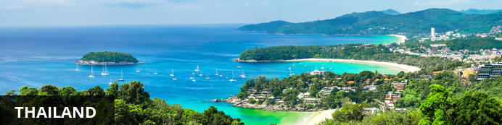
Fondly known as “the land of smiles”, Thailand is commonly associated with gorgeous golden sand, palm-lined beaches, warm aquamarine waters, glorious temples and verdant jungle-clad mountains. With sixteen million foreigners flying into the country each year, Thailand is the primary travel hub of Southeast Asia, offering a diverse range attractions and activities to suit all tastes and budgets. Whether exploring the teeming metropolis of Bangkok, relaxing on the tropical beaches of the southern islands, scuba diving in the underwater wonderland off the coast of Koh Tao, jungle trekking in the North, or discovering the ancient cities of Chiang Mai, Thailand is filled with attractions to satisfy any interest.

Banking and Currency
Currency
Baht (THB; symbol ฿) = 100 satang. Notes are in denominations of ฿1,000, 500, 100, 50, 20 and 10. Coins are in denominations of ฿10, 5, 2 and 1, and 50, 25, 10, 5 and 1 satang.
The import and export of local currency is limited to ฿50,000. The import and export of foreign currency is unlimited, but amounts over US$20,000 must be declared.
Foreign currencies can be exchanged at banks (which have the best rates), hotels (which charge high commissions) and bureaux de changes can be found in larger towns (generally open 0800-2000). Outside large towns and tourist areas, high value notes may be difficult to exchange, so visitors are advised to carry small change.
Banking
Banking hours: Mon-Fri 0830-1530.
American Express, MasterCard and Visa credit cards are widely accepted. ATMs are found in all major cities and almost all provincial banks.
Travellers cheques are accepted by almost all banks and large hotels and shops. To avoid additional exchange rate charges, travellers are advised to take traveller's cheques in US Dollars, Euros or Pounds Sterling.

Travel, Transport and Getting Around
Thai Airways International (TG) (www.thaiairways.com) runs services to all major towns, a total of 12 domestic destinations including Phuket and Chiang Mai. Bangkok Airways (PG) (www.bangkokair.com) flies several additional routes including Ko Samui. Discounts are available during off-peak seasons and during special promotional periods. Orient Thai Airlines, formerly known as One-Two-Go Airlines (www.flyorientthai.com) and Nok Air (www.nokair.co.th) also offer domestic flights.
Roads in Thailand range from multi-lane freeways around Bangkok to tiny lanes known as sois. Popular routes in the provinces are often four lanes.There is a reasonable road network comprising many highways, which are designated by numbers, and 52,000km (32,300 miles) of national and provincial roads. All major roads are paved.
Car hire services are available in all main towns and cities from both international and local companies. The minimum age for driving in Thailand is 18 years and the wearing of seat belts is compulsory. The speed limit is 50kph (31mph) to 60kph (35mph) in towns and cities and 90 to 120kph (52 to 74mph) on expressways and country roads. A national licence and International Driving Permit (IDP) are required. IDPs are valid for three months, after which a Thai driving licence is required. Cars are driven on the left side of the road in Thailand.
Taxis are easy to find and cheap to use in Bangkok. In other cities, such as Chiang Mai, local transport such as tuk tuks are much cheaper and more common.
Bike hire is available at most tourist locations throughout the country but, due to the erratic nature of driving standards and the heavy traffic, caution must be observed. It is however an excellent form of transport for those wishing to travel the quieter areas of the country.
There are many intercity bus services, which range from uncomfortable and crowded buses to luxury, air conditioned coaches. Prices are quite cheap but the appalling traffic in some areas of Thailand makes travelling by bus quite slow.
Conventional bus services in Bangkok are operated by the Bangkok Mass Transit Authority, but there are also extensive private minibus operations. Premium fares are charged for air-conditioned (cream and blue buses) and express buses. The ordinary buses are cream and red or white and blue and charge a flat rate regardless of distance travelled. Fares are generally low and are collected by conductors.
In Bangkok, taxis displaying the TAXI-METER sign are metered. Samlors or tuk-tuks are three-wheeled taxis without a meter; the fare must be negotiated before the journey commences. These are cheaper than taxis but are only suitable for short distances.
There are express, rapid and ordinary motorboat services operated by the Chao Phraya Express Boat on the Chao Phraya River between Nonthaburi pier to the north of Bangkok to Rajburana pier in southern Bangkok. The express boats, marked with yellow, blue or green and yellow flags, are more expensive than the rapid orange-flag-flying boats. The ordinary flagless boats are the cheapest.
The Skytrain (BTS), an elevated mass transit system in Bangkok, runs from 0600-2400. The Metro runs from Hualamphong to Bang Sue. Trains leave every five to nine minutes between 0600 and 2400.
Chiang Mai public transport is limited to red songtaew (minibuses), tuk-tuks, rickshaws and distinctive yellow metered taxis mainly operating from the airport. There is now a limited bus service in operation.
The excellent railway network extends over 4,600km (2,860 miles), linking all major towns with the exception of Phuket. It is run by State Railways of Thailand (tel: 1690; www.railway.co.th; online booking: www.thairailticket.com). There are four main routes to the northern, eastern, southern and northeastern regions, and also a western line serving Thon Buri, River Kwai Bridge and Nam Tok.
There are several daily services on each route, with air-conditioned sleeping and restaurant cars on the principal trains. The journeys are leisurely and comfortable, and travelling by train is certainly one of the best ways to get around the country. The Southern Line Express stops at Surat Thani for those who wish to continue by bus and ferry to the islands off the east coast. Most railway timetables are published in English.
Ferry services operate between the mainland and several islands including Surat Thani to Ko Samui, Phuket to Phi Phi, Pattaya to Ko Samet and Trat to Ko Chang, and can be booked in person at the dock. Strong competition on all of the major routes ensures that fares are kept low. Reduced services operate during the monsoon season from May through to October along the east coast and Andaman coast, and from November until January on the Gulf coast. The more remote spots become inaccessible during these periods.

Food, Drink and Cuisine Advice
Use only bottled or boiled water for drinking, brushing teeth or making ice. Unpasteurised milk should also be boiled, although pasteurised or homogenised milk is available. Tinned or powdered milk is safe as long as it is reconstituted with sterile water. Beware of dairy products that may have been made with unboiled milk. Stick to meat and fish that have been well cooked, preferably served hot, but not reheated. Avoid raw vegetables and unpeeled fruit.
Thai food is traditionally fairly hot and spicy, but most tourist restaurants tend to tone down the heat for the more fragile Western palate. Most Thai food is prepared with fresh ingredients such as lemon grass and coriander and rice is commonly eaten with most meals. Popular fruits are papaya, jackfruit, mangosteens, rambutans, pomelos (similar to grapefruits) and, above all, durians, which farangs (foreigners) either love or hate. The thorny fruits have a rather malodorous scent which has even resulted in many hotels banning them from their premises.
Excellent food can be found at the stalls of the many street vendors around the country as well as top-notch eateries. There are also many Asian and European restaurants throughout the major cities and smaller towns.

Climate and Weather
The weather in Thailand is generally very hot and humid, particularly between March and May. The monsoon season runs from June to October, when the climate is still hot and humid with torrential rains. The best time for travelling is November to February (cool season), although the southern islands are best from June to September.

Clothing and Dress Recommendations
Lightweight cotton or linen clothing and lightweight rainwear are advised year round. A bathing suit, sunscreen, sunhat and beach wear are essential. A good pair of walking shoes is recommended.

Electricity and Plug Standards
Electricity in Thailand is 220 Volts, alternating at 50 cycles per second. If you travel to Thailand with a device that does not accept 220 Volts at 50 Hertz, you will need a voltage converter. Outlets in Thailand generally accept 2 types of plug: type A and Type C. Plug adapters are available in Thailand but it is advisable to buy one before you leave home to avoid the hassle of trying to find one when you arrive.

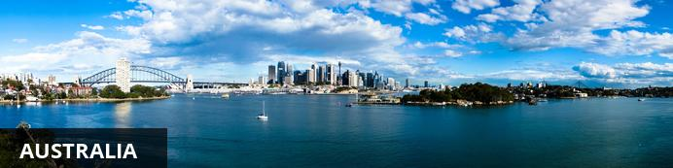
Australia immediately conjures images of the Sydney Opera House, the Great Barrier Reef, big-wave surfing, miles of Outback and a rather strange – and endearing – assortment of animals. While the country’s main cities offer charm, glamour, unique festivals, a well-preserved historical heritage, fabulous beaches and fun events, it’s also a land of immense contrast and captivating nature. The nation offers something for just about everyone – from water lovers, desert wanderers and canyon climbers, to arts and culture buffs, historians, and foodies. The country’s vast size makes it almost impossible to take it all in during a single visit, but you can pick and choose a perfect holiday according to your personal preferences.

Banking and Currency
Currency
Australia’s national currency is the Australian dollar which comes in denominations of $5, $10, $20, $50 and $100 notes. Coins come in 5, 10, 20 and 50 cent and one and two dollar denominations.
Banking
Banks are normally only open weekdays 9.30-4pm Monday - Friday, some stay open until 5pm on Fridays. In larger metropolitan suburban centres, major banks are increasingly opening on the weekend, too. Bank staff stick to these times rigorously, so don't be late/early.
Credit cards such as American Express, Bankcard, Diners Club, MasterCard, Visa and JCB are accepted in Australia. Traveller's cheques are not as widely accepted in Australia as in many other countries. ATMs are numerous in both city and country areas. ATMs in the walls of buildings on streets and inside the lobbies of banks, shopping centres and other buildings are numerous. At night, service stations and convenience stores are good places to look for ATMs away from the street. Pubs, especially in city areas, will usually have an ATM located on the premises. Some ATMs may require you to swipe your card to gain entry to a secure area.

Travel, Transport and Getting Around
Australia is the sixth-largest country in the world − so how you get from A to B requires some thought.
Hire cars are readily available in all major towns. Australians drive on the left and all cars are right hand drive. Having access to your own car has the advantages of being able travel at your own pace, explore remote areas and visit regions with no public transport. However, as the country is so vast, this form of transport can be time consuming.
A faster option would be to make use of the numerous affordable, frequent, fast flights between major centres. Carbon offset your flights if you're feeling guilty!
Reliable, frequent long-haul coach services are available countrywide but they are not always cheaper than flying and are time consuming.
Trains in Australia are slow, expensive and infrequent but the scenery is great! Opt for a sleeper carriage rather than an 'overnighter' seat.

Food, Drink and Cuisine Advice
Standards of hygiene in food preparation are very high. Milk is pasteurised and meat and vegetables are considered safe to eat. Care should be taken, however, if preparing 'bush tucker' in outback areas as some insects and fauna are highly poisonous unless properly cooked.
'Bush tucker' is food from Australia's endemic flora and fauna and can be lean and quite delicious; kangaroo meat in particular is growing in popularity since being made legal to trade to eat only in the past two decades. For all the advent of fine dining and exotic menu items, however, the humble barbecue remains for many the quintessential Australian food experience. Various beaches and parks have barbecue stations that can be used by the public. Steak, prawns and beer tend to feature prominently.
Seafood is an integral part of the cuisine scene in all its shelled and scaled forms. Production of organic foods is increasing to meet demand and is these days widely available in the cities and larger towns. There are fine dining restaurants throughout the larger cities, particularly in Melbourne and Sydney, where big-name chefs have helped to give Australian cuisine an international reputation for bright, creative gastronomy. Regional food markets and increasing numbers of food festivals across the states are a great way to sample fresh produce. Look out for things like farmhouse cheese, speciality sausages and local fruits.
The major vineyards (wineries) are outside Perth, Sydney, Melbourne, Hobart and Adelaide. The largest single wine-growing region is in the Barossa Valley, South Australia, two hours' drive from Adelaide, where high-quality red and white wines are produced. Various wineries, breweries and distilleries are open for public visits.

Climate and Weather
Australia experiences temperate weather for most of the year but the climate can vary due to the size of the continent. The northern states typically experience warm weather much of the time, with the southern states experiencing cooler winters. Australia is also one of the driest continents on earth with an average annual rainfall of less than 600 millimetres. Like all countries in the southern hemisphere, Australia's seasons are opposite to those in the northern hemisphere. December to February is summer; March to May is autumn; June to August is winter; and September to November is spring.

Clothing and Dress Recommendations
It really is casual all the way in Australia. Outside of the main cities, our advice would be not to bother with dressy clothes.
However if you plan to visit upmarket city restaurants then you may feel more comfortable in smart casual wear.
Clothes in natural fibers will work better in the heat and it is worth popping in a lightweight sweater, cardigan or pashmina wrap for cooler weather or overly fierce air conditioning.
Travel light and buy your toiletries there. Must haves include sunglasses and wear plenty of high factor sunscreen.
If you are planning to visit very hot areas then k a shirt with long sleeves and a higher neckline to prevent burning is recommended. A sunhat is also very useful in the intense sunshine .

Electricity and Plug Standards
Mains voltage in Australia is 230V 50Hz. Travellers from most nations in Asia, Africa and Europe should have appliances that work on the same mains voltage as Australia - therefore you will not need a voltage converter. The plugs in Australia have 2 flat metal pins shaped live a "V" and some may contain a third flat pin in the centre.

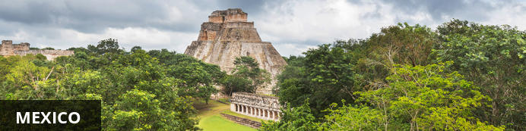
Mexico offers travellers a tantalising smorgasbord of nature, history, cuisine and culture. Aztec and Mayan archaeology, tequila, charming colonial cities, Mexican food and beach culture. All these features and more make up this tourist and historical hub. Culture vultures will be bowled over by the impressive sites of ancient civilizations that moulded Mexico’s great pre-Columbian history, while nature lovers will be in their element on the pristine beaches along its 10 000-kilometre coastline, or exploring the country’s rainforests, mountain peaks and mangrove lagoons. And for foodies, there’s of course the distinctive and flavourful cuisine that has become famous the world over.

Banking and Currency
The national currency of Mexico is the Mexican Peso; and Banco de Mexico is the nation’s central bank, issuing coin and paper money which is legal tender. Prices throughout the country are commonly shown with a dollar-sign ($) in front of the Peso amount; and although in some parts of the country businesses willingly accept U.S. dollars, it's almost always more advantageous (less expensive) for travelers to pay with Mexican Pesos. Likewise, certain people on the receiving end of your payment (e.g. waitstaff, bartenders, chambermaids, et cetera) generally prefer Mexican currency, to save them the inconvenience of a trip to the bank or a stop at a Cambio on their day off. Remember there is a difference between the sell rate and the buy rate so your foreign currency tip will be worth less than intended.
ATMs often provide the best possible exchange rate, the approximate exchange rate between Mexican Pesos and U.S. Dollars, multiplying any Peso amount by 8, then dividing by 100, will approximate the U.S. Dollar cost - within a few cents. For example: $90 Mexican Pesos X 8 = 720, divided by 100 = $7.20 U.S. Dollars. At an exchange rate of 13:1,
On a related topic, it's also strongly advised that travellers call their bank(s) and/or credit-card companies prior to departure, to inform them of their impending travel plans. Otherwise, they might run into some difficulties with their cards. One should also be aware that 'foreign currency transaction fees' and/or 'ATM withdrawal fees' may be incurred when using either type of card. It's best to ask your bank(s) and credit-card companies, in advance about their fees (which usually range between 1%-3%, but could be higher) and make comparisons prior to travelling. FYI: Some banks which are affiliated with (or owned by) Mexican banks impose no 'ATM withdrawal fees', or a minimal charge (less than a dollar per transaction), but each has its own rules and regulations, and some may limit the number of foreign withdrawals before fees are imposed. Two examples of U.S. bank affiliations would be CitiBank with Banamex, and Bank of America with Santander. For Canadians Scotia Bank and HSBC have Mexican affiliates.
For some additional clarification about ATM-cards versus debit-cards and which credit-cards are locally accepted, travellers might also benefit from the following. In simple terms, ATM-cards can ONLY be used for cash withdrawals from ATMs. They are not linked to VISA or MasterCard and cannot be used as a credit-card for purchases. Ergo, if one's ATM-card goes missing, it's useless, without the proper PIN to anyone else. On the other hand, a bank debit-card (which serves a dual purpose and is common elsewhere but not for Canadians as yet) is usually tied to a major credit-card name as well as a personal checking or savings account, and can potentially be used for purchases by anyone who finds or steals it. Should this occur, a traveller may run the risk of having his/her bank account emptied out with no recourse for recouping those funds. It is, therefore 'best' NOT to travel to Mexico with your bank 'debit-card'. Canadians will need to learn that the terminology of debit-cards and ATM cards differs from the USA terminology. As for paying with major credit-cards in Mexico, most business establishments accept either VISA or MasterCard, and some (though fewer) will honour American Express. Discover hasn't yet become an acceptable card, and don't expect to be able to use your foreign WalMart credit-card either. Keep in mind, too, that although the majority of businesses will accept plastic payments, certain local restaurants, many smaller stores and eateries, taquerias, cabs and buses, and most private drivers and tour-guides take 'cash only'. Places which don't take credit cards, especially restaurants, often post a sign which reads 'Lo Sentimos - No Tarjetas de Crédito' (Sorry - No Credit Cards) or have it printed on their menus; but it's always best to inquire.
The use of Travelers Cheques may have waned over the years, but some folks still 'don't leave home without 'em'. While some local businesses continue to honour them, it can be hit-or-miss. For those who prefer to carry Travelers Cheques, it's probably best to cash and exchange them at your hotel whenever possible, on an as-needed basis.
Other precautions regarding ATM-, debit-, and credit cards, which some travellers heed; is to make a photostat copy of your cards, front and back, and obtain and record corresponding 'direct-contact' telephone numbers for the card companies, in the event that your card(s) are lost or stolen. Store this information with your passport in a locked luggage compartment or hotel safe. FYI: Most toll-free company phone-numbers which you'd normally dial from home cannot be accessed from Mexico and you should, therefore, request special contact numbers. Alternately, some travellers prefer to email a copy of this information to themselves, making it more easily accessible from wherever they may happen to be.

Travel, Transport and Getting Around
Distances in Mexico can be huge, and if you’re intending to travel on public transport, you should be prepared for some very long journeys. Getting from Tijuana to Mexico City, for example, can take nearly two days nonstop by bus. Although public transport at ground level is frequent and reasonably efficient everywhere, taking an internal flight at least once may be worthwhile for the time it saves.

Food, Drink and Cuisine Advice
What to drink in Mexico:
- Try to get your body used to reaching out for water before you travel to Mexico. Bottled water that is. While it may seem a bit expensive to do at home, it is a necessity in Mexico. Train the brain into a water break and always keep hydrated. When touring around Mexico and outside of your hotel zone, always keep a bottle of water with you. Not only will thirst hit you at an intense level, your body needs more hydration here than it does in other countries.
- Do NOT, I repeat, do NOT drink the tap water anywhere. Most people know this tip and never have an issue because of it. Nowadays, many hotels feature mini-bars with bottled water to keep you hydrated and Montezuma-free. If at a bar, it's safer to drink a bottled beer than a glass with water and ice. That shouldn't be a problem should it?!
- Avoid squeezed juices. You have no idea where the vegetables or fruit has come from and now that your basking in the Mexican sun, do you really want to chance it?
- Minimize your alcohol intake. While you may think it's time to party because your resort is an all-inclusive, remember to drink responsibly. Drinking not only dehydrates you immensly, but in massive quantities it can also mean the difference between a broken arm and a night in a Mexican jail. (i.e. for acting like a clown in the resort and performing stunts you wouldn't normally do or for getting angry at a bar in the local area and assaulting someone....but I am guessing you already knew what I meant :-)
- If you are at a local bar or club and a shooter gal comes by to offer you a shot, do not drink one. They usually never have time to clean those shot glasses and some believe that alcohol actually kills any bug. Ummm.....NOT!
- Do not mix the drinks you consume. Stick with one solid drink during the day or evening and avoid sugar-filled and creamy drinks like Kahluah and cream.
- Avoid ice cubes if possible. Many upscale resorts make their ice cubes with purified water so there usually isn't a need to be paranoid, but if outside your resort, do not add them to drinks. If you do, you and your hotel room and bathroom will become better acquainted.
What to eat in Mexico:
- The most common stomach problem and bug that tourists suffer from when in Mexico or after a trip to Mexico is Montezuma's Revenge. Oh....and revenge it is! Having gone through it once before, it is something I will do my best to avoid for the future. It is a bug that will make you feel as though your bathroom and hotel room have taken you hostge for the duration of your vacation. It involves sweats, stomach pain and cramps, vomiting, diarrhea, headaches and more. First things first, keep your eyes open when eating in Mexico! Your eyes will not lie to you.
- If you can and if you are staying at an all-inclusive resort, stick to eating the meals in the hotel. Avoid going to restaurants unless you have heard through word of mouth about the food. While trying street food from local vendors sounds like fun, your stomach might not be able to handle it. If you are not good with spicy foods, stick to bland foods. Don't be a hero and try to be over-the-top risky and adventurous. You won't look like such a tough cookie when laid up in your room for 5 days because of that extra spicy enchilada from a street vendor.
- Some foods within a buffet that could make you ill if left out too long are milk, cheese, seafood like ceviche salads, salads in general, dressings, salsa's, mayonnaise, fruit juices and more. Just be aware as you grab a quick bite to eat when in a buffet line. This is pretty much the same around the world with buffet safety.
- Sauces and dipping treats like guacamole are risky. They are not always as fresh as you would hope them to be and you run the risk of contaminating yourself with bacteria or a bug.
- Make sure every meat dish you order is well done. This will decrease the risk if illness. Learn how to say well done in Spanish here. We'll give you a tip: BIEN HECHO POR FAVOUR - Translation, well done please.
- Seafood is also tricky and should be cooked well done to avoid any nasty bacteria contamination.
- A tip: Buy some acidophilus before you visit Mexico and take it up to two weeks before you leave. It can kill any bad bacteria as it enters the body and keep you healthy.
If you are unsure about any drink or food item when you are in Mexico, it may be your gut talking. Listen to it, trust it and protect it. It is a smart traveler who is aware of their surroundings and meals at all times.

Climate and Weather
The climate of Mexico varies according to altitude. From desert-like regions on the northwest part of the country, the low-lying coastal areas are typically tropical, hot and humid. The weather in Mexico City, which is sited at an altitude of 2,300 metres above sea level, is far more moderate. Mexico City has pleasant summers and mild winters, with an annual average temperature of 18 degrees Celsius. Also, northern Mexico gets very hot during the summer with sudden violent storms in the afternoon, with heavy rain and hail, also an isolated tornado can occur with these storms. Seasonal variations in temperature are small, but May is the warmest month of the year, and January the coldest, when night frosts are possible. Mexico City has a high average annual monthly rainfall, most falling in summer, the wettest month being July, and the driest month February. ). During hurricane season, hurricanes are common in the coastal cities especially those near the Caribbean Sea and the Gulf of Mexico.

Clothing and Dress Recommendations
GENERAL PACKING TIPS
- There is so much to see and do in Mexico; whether you are trekking and plan to see a good deal of the country and its archaeological sites, or enjoying a beach/water sports trip, your clothing checklist will depend to a large degree on what you are planning to do.
- It is a hot and humid climate and light layers in natural fabrics (cotton, silk or linen) are good and work well with the humidity. They also wash and dry easily.
- Having said that, jeans are always popular here.
- Merino wool is a good choice to wear against your skin as it naturally helps to regulate your body temperature. It keeps you warm in the cold, wicks away moisture when it's hot, and doesn't retain odours, even after prolonged wear.
- But in resorts and at tourist attractions it's shorts (long shorts are popular) and t-shirts all the way during the day, but do be sure to keep swimwear to the beach and pool and use a sarong or t-shirt to cover up for lunch. Many resorts are fairly self-contained, so unless you plan to travel around independently you are unlikely to mix much with the locals.
- Wear plenty of sunscreen, sunglasses and a sunhat. Don't forget your insect/mosquito repellent.
- Pack a pashmina or sweater as the air conditioning on the first class buses, in smart hotels etc. can be fierce, it's often warmer to sit outside in the evenings. And if you're on the coast there can be cool sea breezes which are chilly if you're sat out of the sun.
- Pack some comfortable closed walking shoes or sneakers if exploring away from resorts. The ground can be uneven and dusty, whilst at the Mayan ruins of Tulum etc. if you want to climb the structures (only allowed at some) then they can be steep and strenuous, and slippery if wet.
CLOTHING TIPS FOR WOMEN
- Mexicans tend to look very groomed, with ladies wearing jewellery and make-up even when doing the shopping. A few simple accessories or costume jewellery will help you 'glam up' if you need to.
- A pashmina is a versatile piece that will dress up any outfit too.
- Jeans are always popular here and teamed with smart tops and heels make for a flexible look that will help you fit right in.
- Dinner in resort hotels tends to be smart casual and some restaurants will not allow shorts or camisoles. Women tend to wear loose sundresses and skirts with sandals, as it is still hot and humid in the evenings.
- Avoid wearing clothes that show your stomach or cleavage, particularly if you are planning to visit the more conservative rural parts of Mexico. A wrap is always good to help you cover up.
- And if you are travelling outside of the popular resort areas our advice would be to wear skirts or dresses, lightweight pants or Capri pants rather than shorts.
CLOTHING TIPS FOR MEN
- Dinner in resort hotels tends to be smart casual and some restaurants will not allow shorts or sleeveless tops. For men, lightweight pants and short-sleeved shirts are the norm.
PACK FOR THE WEATHER
- You may experience some light drizzle or short sharp downpours. A lightweight pack-away raincoat or travel umbrella can be handy, but it is so warm you will dry quickly if you do get wet.
- Winter (December, January, February) can be cooler in the early mornings and late evenings, so our advice would be to pop a fleece in your case. The rest of the year the temperature remains pretty constant.

Electricity and Plug Standards
- Voltage: 110-120 Volts (Same as U.S./Canada, most other areas are 220-240 Volts)
- Primary Socket Types: North American Non-Grounded , North American Grounded
Please note that these may not be identical to U.S./Canadian sockets, and may require an adapter.
- Multi-voltage appliances (laptops, etc.): Plug adapter
Click socket type links to view adapter for that type
- 220-240V appliances: Plug adapter + step-up transformer
- 100V Japanese appliances: Japan to U.S. reducer transformer

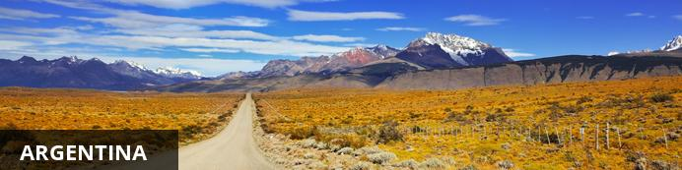
Ranging from balmy subtropical reaches in the north, to the frosty Antarctic shores of the Patagonian south, Argentina is one of the world’s most geographically diverse countries. Its kaleidoscope of landscapes offer myriad adventure and leisure opportunities, and this natural variety – coupled with its warm, animated locals, delectable carnivorous cuisine and fascinating history – make it a captivating and unforgettable travel destination. Whether you’re most likely to be spellbound by the spectacular torrents of Iguazu Falls, the sprawling ski slopes of Bariloche, the vibrant capital of Buenos Aires, or the age-old Inca city of Humahuaca, Argentina has something to delight and mesmerise even the most seasoned explorer.

Banking and Currency
Currency
Peso (ARS; symbol AR$) = 100 centavos. Peso notes are in denominations of AR$100, 50, 20, 10, 5 and 2. Coins are in denominations of AR$5, 2 and 1, and in 50, 25, 10, 5 and 1 centavos.
US Dollars are accepted in some hotels and tourist centres. Prices in US Dollars are typically marked with US$ to avoid confusion, but sometimes both peso and dollar prices are both preceded by just $, so check if unsure.
Banking
Banking hours: Mon-Fri 10h00-15h00.
Most major credit cards are accepted, but not as widely as in the US or Europe; even some major hotels do not have credit card facilities.
ATMs are available in most cities and have options in English, but it is still best to carry alternative forms of payment as daily withdrawal limits are low and machines don't always work. During national holidays ATMs can run out so it is wise to withdraw in advance.
Foreign tourists who are not resident in Argentina can no longer pay for tourism-related services (air tickets, bus travel, hotel rooms, all-inclusive tours etc) in Pesos. These services must be paid for with foreign credit and bank cards, money transfers (in foreign currencies) from abroad, in cash with foreign money (eg US Dollars) or with cheques from foreign accounts.
It is advised to bring traveller's cheques in US Dollars; these can be exchanged at banks, bureaux de change and some hotels. However, it is often difficult to exchange these in the smaller towns.

Travel, Transport and Getting Around
Argentina is huge, making air travel the most practical way to get around. However, airlines in Argentina operate a two-tier pricing structure, which means that foreign travellers pay twice, or even three times as much, as locals. Many flights are inconveniently (and expensively) routed through Buenos Aires, and delays are frequent. Aerolíneas Argentinas (AR) (www.aerolineas.com.ar) serves many domestic destinations from its key hubs in Buenos Aires, Cordoba and Bariloche.
The Visit Argentina Pass allows overseas visitors to buy reduced-fare coupons for flights within the country. These must be purchased in the visitor's country of origin and are not available once in Argentina.
Driving conditions in Argentina are a mixed bag. A 4x4 is recommended if venturing too far outside rural areas. When driving in cities keep windows closed and doors locked, especially when stopping at junctions. It is advisable that only confident drivers tackle Buenos Aires’ roads. Major roads are generally in good condition, although rural roads, composed of packed dirt, can become impassable after rain. The 'A' roads are the autopistas (motorways) and those labelled 'R' are rutas (roads) - tolls exist on all main roads.
Visitors aged 21 or over may hire a car in Argentina. Car hire is available in most towns and cities, and many international companies operate out of Buenos Aires and main tourist destinations. The maximum speed limit on motorways is 130kph (80mph), 80kph (50mph) on one-lane roads, while the speed limit in built-up areas varies (40-60kph/25-37mph). The wearing of seatbelts is compulsory. Although in theory an international driver's licence is required, in practice your driving licence from home is all that is needed, but must be carried with you while driving. Proof of vehicle ownership, proof of insurance and receipt for last tax payment must also be carried at all times whilst driving. Argentinians drive on the right side of the road. The Automóvil Club Argentino - ACA (tel: 0800 777 2894 in Argentina; www.aca.org.ar) offers breakdown cover and reciprocal benefits for members of motoring organisations in other countries.
In Buenos Aires the safest option is to telephone a radio taxi; a reputable company is Radio Taxi Pidalo (tel: (011) 4956 1200). Taxis are readily available and can be hailed from the side of the road but make sure the meter is used. It is advisable to use recommended remises (taxis) - which can only be booked by telephone and have fixed prices. Passengers should enquire beforehand.
Buenos Aires runs a cycle scheme. Register at www.mejorenbici.gob.ar for free, two-hour use of yellow city bikes.
Buenos Aires is the only Argentine city with an underground train service, known as the Subte (www.subte.com.ar). The Subte has six lines and is generally clean, safe, fast and efficient. Access to the subway operates under the card called SUBE. You can buy the card at any point of sale and recharge it at the underground ticket offices.Overland urban trains also serve the capital city and its suburbs.
Trains and trolleybuses operate in Argentina's second city, Rosario.
Colectivos (local buses) operate on main thoroughfares in all large towns and cities. Taxis are readily available and can be hailed from the side of the road but make sure the meter is used. It is advisable to use recommended remises (taxis) - which can only be booked by telephone and have fixed prices. Passengers should enquire beforehand.
Several rail companies operate in Argentina, including Ferrobaires (tel: (011) 4304 0028;www.ferrobaires.gba.gov.ar), serving destinations such as Mar del Plata and Bahia Blanca. Trenes del Litoral (tel: (011) 4554 8018; www.trenesdellitoral.com.ar) operates between Buenos Aires and Posadas, linking many little towns in the provinces of Entre Rios and Corrientes. El Tren a las Nubes (the Train to the Clouds) is running once again from Salta into the mountains in the north of the country, close to the Chilean border.
The Argempass: Gives travellers unlimited first-class train travel, for either 30, 60, or 90 days. Obtained only at railway booking offices.

Food, Drink and Cuisine Advice
Tap water is generally considered safe in main cities and towns, especially in Buenos Aires, but otherwise bottled water is recommended. If bottled water is unavailable then boil water for over a minute before drinking.
Argentina serves up an exceptional standard of food, although choices can often be restricted to meat, pasta and pizza. Buenos Aires, however, offers a wide selection of culinary genres, with Japanese, Thai and Asian-fusion food becoming increasingly popular. Vegetarians may struggle to find extensive veggie options, but most restaurants do serve vegetables and salads. Outside Buenos Aires, however, vegetarians may be faced with quite limited choices.
Wherever you are in the country, meat is the name of the game here, and if you fancy broadening your carnivorous horizons, then there is a weird and wonderful array of meat treats to get stuck into. The traditional Argentine parrilla (grill) is the very heart and soul of Argentina's cuisine. Sample morcilla (blood sausage), chinchulines (intestines), or simply go for a slab of prime Argentine beef - all sizzled to perfection. Don’t forget to liberally douse your chosen meats in delicious chimichurri – a sauce made from finely chopped parsley and oregano, garlic, olive oil and vinegar. Those after an authentic and reliably delicious meat experience in Buenos Aires, try El Trapiche in Palermo, and Desnivel in San Telmo.
For breakfast, head to a traditional confitería (café) and sample a few medialunas (small, croissant-like pastries) and a strong café con leche. In cities, fashionable resto-bars (restaurant-bars) are taking hold, offering more contemporary takes on traditional Argentine cuisine, and all manner of lunch options. A strong Italian influence means quality ice cream is also popular, and in summertime Buenos Aires the many gelaterias (ice cream parlours) are certainly worth making use of. In the evening, Argentines dine late - 9pm is considered early – and the feasts are typically massive.
Argentina's wines have flooded the international market in recent years, and are famed for their quality and value. Try a light pinot noir from Patagonia or an inky and smooth Malbec, and don’t miss Argentina’s celebrated white, the aromatic Torrontés.
Around 15% is acceptable in restaurants as well as bars (unless you were dissatisfied) which waiting staff rely on to survive.

Climate and Weather
Argentina's climate ranges from the great heat and extensive rains of the subtropical Chaco in the north, through to the pleasant climate of the central Pampas, and the sub-Antarctic cold of the Patagonian Sea in the south. The main central area is temperate, but can be very hot and humid during summer (December to February) and chilly in winter.
The most pleasant times to visit Buenos Aires are September-November and February- March. The city is best avoided in January, when the heat is at its most intense and many of its residents flee to the coast leaving behind a comparative ghost city. Exploring the wilds of Patagonia is best done in the late spring and summer months – between November and February – whilst the northern regions are at their most hospitable in the spring, autumn and winter. If heading to Argentina for a ski trip, hit the slopes during mid-June to October.

Clothing and Dress Recommendations
Lightweight clothing is generally all that is required in the north, whereas warm clothes are certainly necessary in the south, up in the mountains and during winter months in the central area. It is sensible to carry waterproofs in all areas and bring a good sunscreen, sun hat, sunglasses and good walking shoes.

Electricity and Plug Standards
The official standard for plugs and sockets (outlets) in Argentina is the "Type I" IRAM-2073 which is practically interchangeable with the standards in Australia and China. However, many non-grounded sockets in Argentina are the "Type C" Europlug type. If your appliance's plug doesn't match the shape of these sockets, you will need one or more travel plug adapters in order to plug in. Travel plug adapters simply change the shape of your appliance's plug to match whatever type of socket you need to plug into. If it is crucial to be able to plug in no matter what, bring an adapter for both types.
Electrical sockets (outlets) in Argentina usually supply electricity at between 220 and 240 volts AC. If you're plugging in an appliance that was built for 220-240 volt electrical input, or an appliance that is compatible with multiple voltages, then an adapter is all you need.
But travel plug adapters do not change the voltage, so the electricity coming through the adapter will still be the same 220-240 volts the socket is supplying. If your appliance is not compatible with 220-240 volts, you will need a voltage converter.

Terms and Conditions

Itinerary Terms and Conditions
This quote is only valid for 24 hours due to flights and availability at certain hotels.
Lorem ipsum dolor sit amet, consectetur adipiscing elit. Aenean efficitur elit sit amet arcu convallis molestie eu id risus. Nullam gravida tortor sed ligula hendrerit placerat. Cras vehicula turpis diam. Nunc eget mauris aliquet, dictum orci non, volutpat velit. Integer vitae metus vitae diam aliquam tempor id eu felis. Integer at laoreet tortor.

Wetu Terms and Conditions
This is where you would put your standard terms and conditions. This is a sample account for Wetu so we do not have any T & Cs

