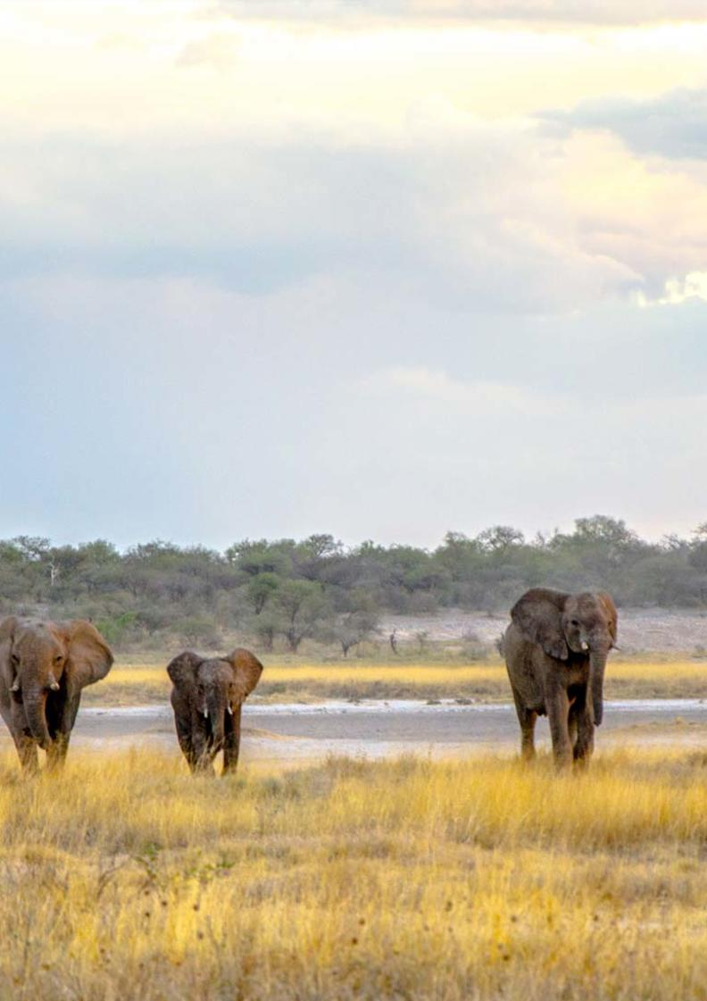

11-Day Namibia Photographic Highlights Self-drive Safari - Standard - RACK

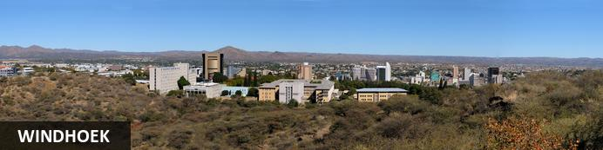
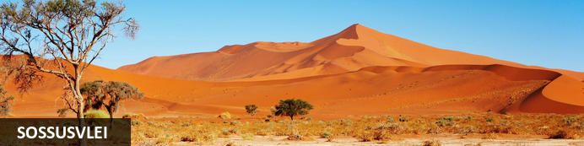
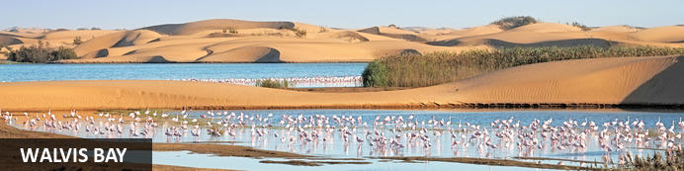
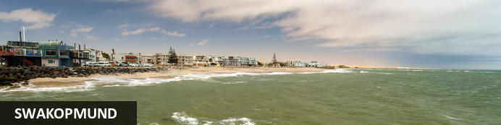
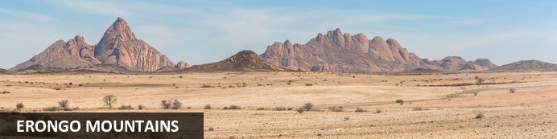
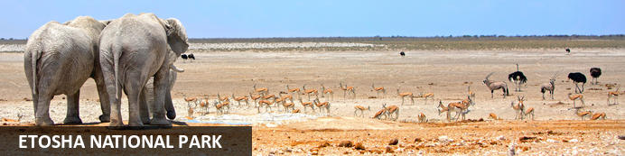
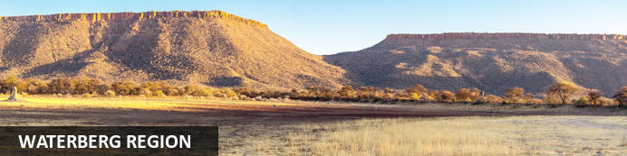

11-Day Namibia Photographic Highlights Self-drive Safari - Standard - RACK
Windhoek - Sossusvlei - Walvis Bay - Swakopmund - Erongo Mountains - Etosha National Park - Waterberg Region
11 Days / 10 Nights
Date of Issue: 05 August 2022

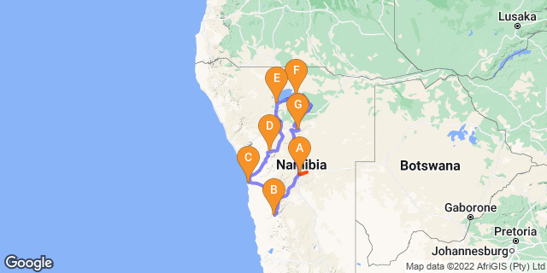

Click here to view your Digital Itinerary

Introduction
This 11-day Namibia Highlights Photographic Safari offers the best photo opportunities - the subjects are varied, interesting and rewarding including spectacular landscapes, fascinating macros, sensual abstracts, full-frontal wildlife, cultural detail and much more. Capture the ancient sand dunes of Sossusvlei, the lagoon and birdlife in Walvis Bay, the landscape at Spitzkoppe Mountain and incredible wildlife in Etosha plus a visit to the AfriCat Foundation.

Add a few nights to make this lovely itinerary even better:
- Venture further south to include the Quiver Tree Forest, Fish River Canyon and Kolmanskop Ghost Town near Lüderitz.
- Damaraland to search for the desert adapted elephants and other wildlife in this harsh environment
- Opuwo for a hint of culture and authentic Himba villages
- Tsumkwe for an authentic Bushman experience
- More wildlife - add the Caprivi strip, the Chobe National Park and the Okavango Delta in Botswana

Accommodation | Destination | Basis | Duration
The Elegant Guesthouse | Windhoek | B&B | 1 Night
Sossus Dune Lodge | Sossusvlei | B&B | 2 Nights
The Rez | Walvis Bay | B&B | 2 Nights
Ai Aiba Rock Painting Lodge | Erongo Mountains | D,B&B | 1 Night
Okaukuejo Resort | Etosha National Park | B&B | 2 Nights
Namutoni Resort | Etosha National Park | B&B | 1 Night
Cheetah View Lodge | Waterberg Region | D,B&B | 1 Night

Key
B&B: Bed and Breakfast
D,B&B: Dinner, Bed and Breakfast

Price
1st January – 30th June 2023 – Low Season
2 guests - ZAR 33 100 per person sharing
4 guests - ZAR 27 160 per person sharing
Single supplement - ZAR 7 725
1st July – 31st December 2023 – High Season
2 guests - ZAR 41 470 per person sharing
4 guests - ZAR 34 905 per person sharing
Single supplement - ZAR 10 580

Included
- Accommodation as indicated - can change depending on availability and request at time of booking
- Meals as indicated
- Meet and greet upon arrival
- Car hire : 4X4 Toyota Fortuner – Standard cover ZAR 50 000
- Airport transfers on arrival and for departure
- Activities as indicated
- Tour file with detailed itinerary, map with route descriptions, vouchers etc.
- 24 hour personal and friendly support
- Fast and efficient response to service providers

Excluded
- Items of a personal nature
- Optional extra activities
- International flights
- Holiday or personal insurance
- Staff gratuities
- Park entry fees
- Fuel for vehicle rental
- Visas and visa applications

Day 1: The Elegant Guesthouse, Windhoek

Windhoek
Surrounded by the stubble-covered Auas Mountains and the endless Khomas Hochland, Windhoek lies in a long valley fed by ancient hot springs in the central highlands. Namibia’s capital and bustling city. More often than not, the start or end place of your Namibia safari.
In Windhoek there are many interesting historical buildings, museums, galleries and craft shops. The city has several good restaurants and modern shops and services making it an excellent base camp from which to launch your Namibian adventure.

Day Itinerary
- You will be met by the car rental company representative on arrival and transferred to their offices in Windhoek to complete all rental procedures
- You will then meet with our representative to hand over your travel documents
- The remainder of the day can be spent relaxing at your own leisure
- For dinner tonight, you can head into town for a bite to eat at one of Windhoek's well known restaurants

Overnight: The Elegant Guesthouse View iBrochure
With easy access from Windhoek International and situated in Klein Windhoek - the Namibian capital's prototype leafy suburb - The Elegant Guesthouse makes for a comfortable overnight stop.
The Elegant, as she is known in these parts, is in a quiet neighbourhood, very secure and close to the shops, restaurants and attractions of northern Windhoek. Getting there from the airport requires two turns, getting to the rest of the country from here requires just three turns.
Modern design and fittings give The Elegant Guesthouse a sophisticated air. Once a small six-roomer, the Elegant has been upgraded and is ever more sophisticated now, offering 17 stylish and beautiful guest rooms. They didn't just add more rooms. They first acquired more space and then expanded, so the mood is still decidedly relaxed (if not more so than before): the perfect way to start or end your Namibia holiday.
All rooms have en suite bathrooms, twin beds (together making a king) and are fitted with air conditioners as well as fast WiFi, television and most open out onto a drought resistant garden or the swimming pool area surrounded by loungers and umbrellas.
Breakfast is served in the light and airy open-plan breakfast room or out in the garden on warm days, which is about 90% of the time in Namibia.
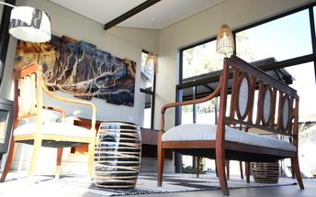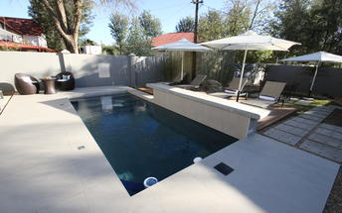

Meet and Greet
NTS Car Hire -Toyota Fortuner SUV Self-Drive
4x4 Toyota Fortuner
Adventure and luxury combine in this comfortable 4-wheel drive vehicle. This is the way to do a self-drive if you ask us. A lifestyle vehicle with the same "off road" performance as other 4x4's without feeling all the bumps along the way. Travel in style.
Includes:
- GPS navigation system
- 2nd spare tyre
- 24/7 Assistance
- Cooler box
- Vehicle GPS tracker
- Airport return transfers

Basis
Bed and Breakfast

Day 2-4: Sossus Dune Lodge, Sossusvlei

Sossusvlei
Star dunes with up to five crests rise 300m into the air and rank among the biggest in the world; the dune valleys are marked by vast clay pans where the Tsauchab River gave up its fight to reach the sea more than 60,000 years ago.
Besides the dunes and pans of Sossusvlei and Sesriem Canyon, a sideshow of activities and sights has developed around the region and there are plenty of game lodges that provide additional desert-adapted activities.Plants and birds are the dominant life form in this dessicated realm and they support a tiny world of mammals, reptiles and insects that, in the absence of coastal fog, seldom wander far from the rivercourse and its pans.

Day Itinerary
Windhoek - Sossusvlei 350km - approximately 5 to 6 hours
- After breakfast, you can still pop into town for anything you might need and then depart heading south from Windhoek to your lodge for the next 2 nights
- The route will take you either via the beautiful Spreetshoogte or Remhoogte Pass, both showcasing the natural beauty of Namibia
- Stay at Sossus Dune Lodge inside the park to be able to take photographs before sunrise and after sunset
- Wake up early for breakfast (Day 3) and then head south to Sossusvlei for some amazing pictures as the sun rises
- Spend the morning in the beautiful Sossusvlei area, exploring the highlights: Sossusvlei, Dead Vlei, Dune 45, Big Daddy, Elim Dune and the Sesriem Canyon
- Return to the lodge for lunch and then head back into the park to snap some photos at sunset
- Optional extra activities: Guided Sossusvlei excursion; Hot air balloon safari; Nature drives

Overnight: Sossus Dune Lodge
Sossus Dune Lodge sits in an enviable location as it is the first of only two lodges built inside the restricted Sossusvlei area.
Built against low lying mountains, Sossus Dune Lodge offers views across the plains to the dunes. It has a total of 25 chalets (including 2 honeymoon suites): 13 are on the left of the main area, with views of dunes; and the remaining 12 chalets, on the right of the main area, have mountain/canyon views.
All the chalets are very well linked by wooden walkways a few metres from the ground and each chalets is furnished in leather, dark wood and suede and has a large en-suite bathroom. The staggered chalets, looking like huts, ensure you can sit on your balcony in total privacy.
Situated within the park, guests benefit from being able to reach Sossusvlei before sunrise, and stay until after sunset. The lodge is also within walking distance of the Sesriem Canyon.
It's these privileges that sell this property. Although the lodge covers the basics, one should be prepared to sacrifice on standard for the added advantages of being the first or the last into the park.
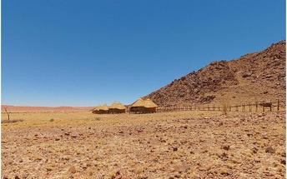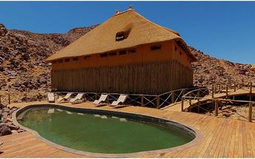

Basis
Bed and Breakfast

Day 4-6: The Rez, Walvis Bay

Walvis Bay
Walvis Bay is an industrial port which lies along the Atlantic Ocean, off Namibia's Skeleton Coast. The large bay and surrounding sand dunes help make Walvis Bay a tourist mecca with loads of activities on offer to explore it.
- Explore the Skeleton Coast where the dunes meet the sea at Sandwich Harbour‍
- Go on a dolphin boat cruise in the harbour. Enjoy champagne and oysters
- Kayak among the seals at Pelican Point
- Visit and climb the mighty Dune 7‍
- Visit the RAMSAR wetland birding site and the Walvis Bay Lagoon. Thousands of flamingos from October to April‍
- Explore the neighbouring town of Swakopmund. Activities abound and dining delights

Swakopmund
Surrounded by the ancient Namib desert and the inhospitable - but bounteous - Atlantic Ocean, Swakopmund is alive with activity and has a lot on offer for the adventure-seeker: quad-biking, sand-boarding, horse-riding, skydiving and more.
Swakopmund has many interesting German-influenced buildings from the early 1900s in a variety of styles and, for its size, Swakopmund has an astonishing array of restaurants that serve mainly seafood, steak and many German staples.

Day Itinerary
Sossusvlei - Walvis Bay 350km - approximately 5 to 6 hours
- Depart after breakfast and head north to Solitaire, then west crossing the Tropic of Capricorn, through the Gaub and Kuiseb Canyons via the Namib Gravel Plains to the coast
- Either direct to Walvis Bay or (recommended) detour via Ganab to the Welwitschia Plains, Moon Landscape and Swakopmund
- The Namibian coastline is generally known as The Skeleton Coast due to the barren areas, ship wrecks and, in days gone by, whale skeletons left on the beach
- 1 full day is set aside for this lovely area where Walvis Bay offers a wide range of activities such as: Dolphin cruise; Sandwich Harbour excursion (a real Skeleton Coast experience); Dune quad biking; Sand boarding; Sea kayaking; Lots more…
- Spend time at the lagoon photographing the sea birds, pelicans and flamingos
- Lunches and dinners can be enjoyed at a café or restaurant overlooking the sea

Overnight: The Rez
Exclusive. Eclectic. Elegant. The Rez is a luxury boutique guesthouse with a contemporary feel. Hands down one of the best places to stay in the coastal town of Walvis Bay. The only thing missing is a view out over the lagoon, but being just 2kms away it is close enough for a stroll.
Modern and well decorated with Moroccan touches, this guesthouse punches well above its weight in comparison to the majority of other accommodation options in Walvis Bay. With Jason and Hugo as your hosts, you’re guaranteed the attention to detail that this type of establishment commands. On point.
Cosy and homely yet still respected in its opulence. Relaxed yet revered for its sense of sovereignty. From the outside to every detail within, it is beautiful.
A touch of class along with an extensive full English and continental breakfast every day. There’s little more that can be desired of a guesthouse with this stature. It ticks all the boxes. Welcome to Walvis Bay.
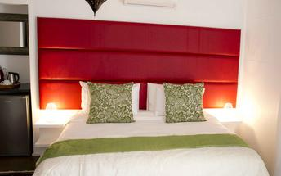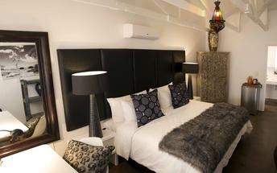

Basis
Bed and Breakfast

Day 6: Ai Aiba Rock Painting Lodge, Erongo Mountains

Erongo Mountains
The Erongo Mountains are a geographical and archaeological wonderland - a 130 million year old volcanic ruin with incredible San rock art to marvel at. There are many different species of game including rock hyrax, mountain zebra and different antelope like kudu, steenbuck, klipspringer, oryx and springbok and the rare black-faced impala. Lots of baboons, warthogs and birds too. Look out for black eagles and black breasted snake eagles, Mahali weavers, rosy-faced lovebirds and the Hartlaub francolin, which is endemic to the Erongo Mountains. If you’re incredibly lucky you might see a leopard.
Archaeological evidence suggests that this area was occupied by many prehistoric cultures over a long period of time. The engravings are mostly found on boulders on rocky outcrops, while the largest site is above a riverbed. There are literally hundreds of engraved animal figures.

Day Itinerary
Walvis Bay – Spitzkoppe - Ai Aiba Rock Painting Lodge 450km - approximately 5 to 6 hours
- Head north along the Skeleton Coast, via Henties Bay to visit the Cape Cross seal colony. Along the way, stop at the Lichen Fields as well as the ship wreck between the colourful small town of Wlotskasbaken and Henties Bay
- Backtrack to Henties Bay and head inland through wide open plains to Spitzkoppe
- Spend some time taking pictures of the incredible Spitzkoppe Mountain and landscape of the area including the Rock Arch and surrounds
- A chance to see some Bushman paintings
- Head to your lodge for the evening
- Enjoy the view at sunset… one of the most beautiful sunsets in Africa!

Overnight: Ai Aiba Rock Painting Lodge View iBrochure
Ai Aiba Lodge is a small, comfortable lodge at the foot of a picturesque granite outcrop looking south towards the Erongo Mountains.
The lodge has 20 rooms in blocks of two with thatched roofs, private patios and en suite bathrooms with showers. Refurbed, the decor went from gaudy African in style to classic and contemporary. It's distinct, modern and refined in light grays and neutrals with raw wood accents. It's really quite nice. A large pool is the focal point of the living area, itself an enormous open-fronted thatch building that houses the restaurant and bar. The view of the mountains from here is worth several gin and tonics.
A feature of the area, and indeed the lodge's own slogan, is the numerous ancient rock art sites that add to the atmosphere of timeless serenity at Ai Aiba Lodge. Guided tours, day trips and walking trails make the most of these fascinating petroglyphs.
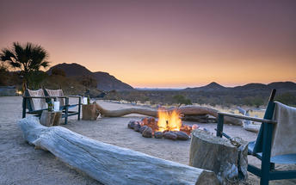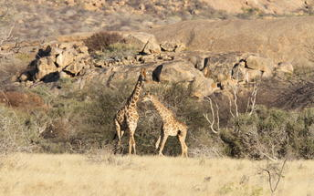

Basis
Dinner, Bed and Breakfast

Day 7-9: Okaukuejo Resort, Etosha National Park

Etosha National Park
Famous for its wildlife, Etosha Park supports 114 species of mammal and over 340 species of bird. At the heart of the park is a 4,800 square kilometre salt pan surrounded by sparse shrubs and grassy plains, the perfect haven for animals.
As vegetation in most areas is sparse, the animals have learnt to drink during the day when predators are inactive and it is the safest time to be out in the open. It is not uncommon to see up to 7 different species of game at any waterhole.Like everything in Namibia, the pan is ancient - 2 million years or so - and was formed when a great continental upheaval diverted the Kunene River towards the sea, leaving a massive inland lake that soon dried up. Usually a shimmering white horizon, the pan fills with water after a good rainy season and becomes a vast knee-deep lake.

Day Itinerary
Ai Aiba Rock Painting Lodge - Etosha (south) 325km - approximately 4 to 5 hours
- After breakfast, head via Usakos and Karibib before turning north via Omaruru to Outjo and further on to the southern entrance of Etosha, the Anderson Gate
- If time permits, enter Etosha for an afternoon game drive. Depending on how often you stop today, you should arrive at your lodge in time for lunch (optional extra)
- On entering the park, the first stop is Okaukuejo where you pay your entry fees (not included) and I suggest you pop in at the local shop to purchase some drinks and snacks and most importantly, a map of Etosha which will show you all the waterholes along the way. This is where you will spend the next 2 nights.
- 1 full day is set aside to enjoy game drives in the park or to enjoy the waterhole at the lodge inside the park… a great place to sit with your camera ready for sightings, even at night
- Etosha is one of Africa's great game parks. With 114 species of mammal and 340 species of birds you are sure to see a great variety of wildlife on your safari

Overnight: Okaukuejo Resort
Okaukuejo is one of only six lodges inside Etosha National Park. They are all in front of floodlit waterholes, the one at Okaukuejo being regarded as the best of the lot.
Okaukuejo (pronounced oka-KOO-yo) is a simple lodge with bungalows, a bar, a buffet restaurant, and a generous swimming pool. They have useful facilities like a filling station, a shop, and camping; it also houses the administrative and research offices of Etosha National Park.
One of only six lodges inside the park - all owned by the parastatal Namibia Wildlife Resorts - Okaukuejo has a floodlit waterhole that is famous for producing some spectacular wildlife action. Elephants, black rhino and lion frequent the permanent water source and they often do it at the same time.
You'll opt to stay here for the benefit of being inside the park, the accommodation and amenities are basic with the service and food fairly decent. Mind you if you're spending all your time enjoying the waterhole, then you'll happily overlook the rest.
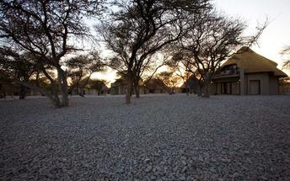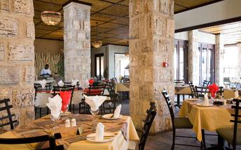

Basis
Bed and Breakfast

Day 9: Namutoni Resort, Etosha National Park

Etosha National Park
As previously described

Day Itinerary
Etosha (south) - Etosha (east) a full days game drive through the park
- From one side to the other side of the park is a full day game drive as you head slowly east stopping at numerous waterholes along the way
- Take a slow drive in the morning and then enjoy a packed lunch (optional extra) overlooking one of the waterholes before continuing on through the park for the afternoon to the eastern side

Overnight: Namutoni Resort
Namutoni is one of six safari lodges inside Etosha National Park. Overlooking a floodlit waterhole and Fisher's Pan, the game viewing comes first and the accommodation tries its best to catch up.
Namutoni is one of the few possible options to stay inside Etosha National Park and all of these lodges are owned and managed by the parastatal Namibia Wildlife Resorts.
Located on the eastern edge of the vast Etosha Pan and south of Fisher's Pan, Namutoni is a basic, no-frills lodge that overlooks a floodlit waterhole. The German fort around which it is built makes for a bizarre first encounter and the morning and evening bugle calls add to the surreality.
Accommodation is in bungalows of varying size or self-catering camping. The rooms are all air-conditioned and have en suite bathrooms. The large and popular pool is shaded by some grand Makalani palm trees and the lodge has a buffet restaurant and a well-stocked bar.

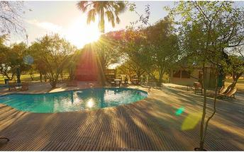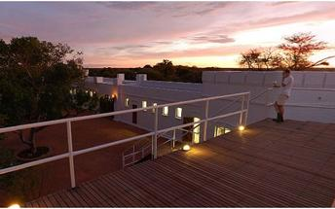

Basis
Bed and Breakfast

Day 10: Cheetah View Lodge, Waterberg Region

Waterberg Region
Namibia's Waterberg region is a wildlife haven en route to Etosha National Park. Several excellent game farms have developed over the years and offer exceptional private safaris with luxury accommodation and good numbers of Africa's big game. The Cheetah Conservation Fund is several amalgamated game farms with private lodges on the western side of the Waterberg Plateau Park. The AfriCat Foundation is on the private Okonjima Nature Reserve, where they rehabilitate animals such as cheetah to be re-released into the wild.
The Waterberg plateau rises 200m above the surrounding plains and creates a diversity of habitats. The Waterberg Plateau Park and surrounding game farms are the base for numerous conservation-related research projects.

Day Itinerary
Etosha (east) - Cheetah View Lodge 230km - approximately 3 to 4 hours
- Head south via Otavi to the Cheetah View Lodge
- A chance to capture some pictures of cheetahs from up close

Overnight: Cheetah View Lodge
This is the place to visit if you have any interest in the world's fastest land mammal. The one that gets to 100 km/h in three strides and in as few seconds. The one with it's melancholic tear-stained face (that's the easy way to know it's not a leopard). The name of this lodge gives it away. It's cheetah land.
Opened in June 2017 the lodge is run by the Cheetah Conservation Fund. It's the cheetah that's the lure here. These guys are a non-profit organisation dedicated to saving it from extinction. A world class research facility they study the biology, ecology and genetics. A pleasant and comfortable stay to be sure but the emphasis is definitely on the cat not the basket.
Your view is of the Waterberg Plateau, although it's quite far really. You aren't here for the plateau though, you're here for the cats, in case that wasn't made clear already. With only five rooms each with their own private entrance and porch, this is a small lodge comprised of two guestroom buildings. Four of the rooms have a double bed, en suite bathroom with a shower and a comfortable sofa for two. The fifth is a family room, which is larger to accommodate two adults and two children.
It's not much to look at from the outside, sand coloured and rather block-ish, but on the inside it is neat, clean and makes for a decent stay. A real plus - you get 15% off of all cheetah activities including the popular cheetah run and cheetah drives. Enjoy that's what you came for.
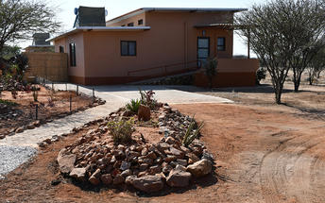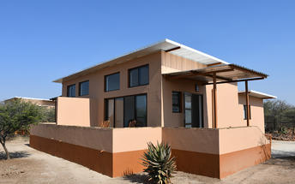

Basis
Dinner, Bed and Breakfast

Day 11: End of Itinerary

Day Itinerary
Cheetah View Lodge - Windhoek 300km - approximately 3 to 4 hours
- Early morning rise for a quick snack before joining the optional morning activity
- Back to the lodge for a hearty Namibian breakfast before departure
- Head back to Windhoek today, where the vehicle is dropped off and your holiday comes to an end
- Transfer to the airport to catch your departure flight. (Keep in mind that you need to be at the airport 2 hours prior and the airport is still a 45 minute to 1 hour drive from town)

Basis
Bed and Breakfast

Transport

Transfers
Date | Company | Pick Up | Drop Off | Time | Vehicle
 |  | Hosea Kutako International Airport [WDH] | Windhoek City |  | Fully Guided Trip
 |  | Windhoek City | Hosea Kutako International Airport [WDH] |  | Fully Guided Trip

Terms and Conditions

Namibia Tours & Safaris Terms and Conditions
Contract
1.1 The contract will become effective as from the date the invoice is completed and the deposit, referred to in Clause 2.1, is received by Africa Tours & Safaris CC (hereinafter known as the Company).
1.2 The contract is subject to the Namibian Law.
1.3 Any person making a reservation as per Clause 8.4 accepts the terms and conditions of this agreement set out hereunder.
How to Book
2.1 A 20% deposit of the full amount due is required to confirm any reservation and is to be done by the agent or client (see Clause 8.1) in writing or by e-mail.
2.2 The Company must receive the balance of the contract price no later than 42 days (6 weeks) prior to departure.
2.3 If the Company does not receive the full contract price 42 days (6 weeks) before the departure date, the Company may cancel the reservation and retain whatever deposit or other funds it has already received from the client or his agent.
How to Pay
3 The payment options will be provided upon confirmation of a booking.
Our Cancellation Policy
4.1 Any cancellation of a confirmed booking must be done in writing (email) to the Company whereupon cancellation charges as per Clause 4.2 will apply.
4.2 The following cancellation fees (as a percentage of the fully quoted price) are applicable to any cancelled travel:
Notice from date of travel:
Cancellation fee:
42 days or more 20% (deposit forfeited)
29 – 41 days 50%
15 – 28 days 75%
0 – 14 days 100%
Please note: the notice period is calculated from the date of cancellation to the start date of the tour/safari booking.
4.3 No refund will be made by the Company if, for any reason, inclusions or parts of the tour cannot be carried out / or utilised. These would include all facets such as meals, game drives, accommodation etc. This would also apply to any client who has booked a tour but fails to undertake the tour for any reason.
Our Changes Policy
5 If a booking is changed to an earlier date than originally reserved, the Company will endeavour to change it. If the booking is for a later date, charges as per Clause 4.2 could apply.
As things go, we've all had to adapt to changes during the Coronavirus pandemic and so too have we therefore amended our terms and conditions for travel during such times.
Price Changes
6.1 The Company reserves the right to increase the price of any tour prior to departure due to factors beyond the control of the Company, such as, without being limited to, and increase in fuel prices, new Government legislation, accommodation price increases, fluctuations in exchange rates, etc.
6.2 If the Company announces an in increase in the tour price in terms of this Clause, such addition amount must be paid to the Company before the departure of such tour or else the Company shall have the right to cancel the tour and the charges in Clause 4.2 will apply.
Changes to Itineraries
7 The Company shall at any time have the right, in its entire discretion, to alter the terms of the booking in relation to the route, timetable, itinerary and accommodation. The Company shall, however, make every effort to offer the client an alternative tour of a comparable standard.
Should the alternative be of a lesser standard, the client will be refunded the difference, but should there be an increase, the client shall have the right to either reject the alternative and obtain a refund of the relevant portion of the original contract sum, or to accept the alternative and pay the increased cost. In the event of the client rejecting the alternative tour and claiming a refund, such rejection will be treated as a cancellation and the refund will be calculated according to Clause 4.2 hereof. The client shall have no claim against the Company for any damages arising out of the alternative booking.
Responsibility and Liability
8.1 Neither the Company nor any person acting for through and on behalf of the Company shall be liable for any loss or damage whatsoever arising from any cause whatsoever and without restricting the generality of the aforegoing shall particularly not be responsible for the loss or damage arising from any errors or omissions contained in its brochure or other literature, late or non-confirmation or acceptance or bookings, loss or damage caused by delays, sickness, injury or death, whether occasioned by negligence or not.
8.2 The Company shall have the right at any time at is sole discretion, to cancel or the remainder thereof or to make an alteration in the route, accommodation price or other details. This would include any event of any tour being rendered impossible, illegal or inadvisable by weather, avalanches, strike, war, government or other interference or due to any other cause whatsoever. The extra expenses incurred as a result thereof shall be the responsibility of the client.
8.3 The Company may at its discretion and without liability or cost to itself at any time cancel, or terminate, a client's booking and in particular, without limiting the generality of the aforegoing, it shall be entitled to do so in the event of illness or the illegal or incompatible behaviour of any client undertaking the tour, who shall in such circumstances not be entitled to any refund.
8.4 Any person making a reservation with the Company (refer to Clause 1.1) warrants that her or she has the necessary authority to enter into this contract on behalf of the person or persons included in such a booking. The person making the reservation shall be liable for the total amount due to the Company.
Client's Obligations
9.1 It is the onus and responsibility of the client to obtain the necessary comprehensive insurance before departure for any possible cancellations, medical expenses, protection or personal property and money.
9.2 The onus is upon the client to ensure that passports and visas are valid for the duration of the safari. The Company cannot be held liable for any necessary visas or other travel documents not held by clients. In the event of a client not having the necessary documentation to enter any area or country the Company shall reserve the right to leave the client a the point of entry of such area or country. In such an event, the Company will not be held responsible to the client for further travel arrangements.
9.3 The onus is upon the client to ensure that the SARS-CoV-2 PCR tests are done prior to commencement of the safari and valid on arrival in accordance to the requirements of the country of intended travel and for the airline with which the client will travel. The same applies for any necessary testing for departure. The costs of any such COVID testing will be for the clients own account. While The Company can assist with arrangements for testing in-country, The Company will not be held responsible to the client for such arrangements and with regards to return time of test results.
9.4 Should the client need to undergo mandatory quarantine once in-country with regards to the SARS-CoV-2 virus, either on arrival as called for by the authorities or due to testing positive once in-country, this will be at the clients own expense.
Health and Personal Safety
10.1 The client shall be reasonably fit to undertake the tour.
10.2 Anti-malaria precautions should be commenced prior to tour departure. A medical doctor should be consulted for advice.
10.3 Tours offered by the Company cover a wide spectrum of the African wilds and neither the Company, its employees or agents can be held responsible for any injury or other related incidents whilst on the tour / safari.
10.4 The Company cannot be held responsible for any client who falls ill or contracts the SARS-CoV-2 virus while in-country. The client accepts that travel is at own risk.
Baggage
11.1 Clients are limited to one soft sports type bag per person with a maximum weight of 20 kilograms. This includes photographic equipment and hand luggage.
11.2 Due to the rugged terrain, the Company cannot be held responsible for damage or loss of any personal items including bags, contents of bags or photographic and related equipment. Due to extremely dusty conditions, please ensure all bags are dust proof.
Airline and Car Hire Clause
12.1 The Company will act as the agent of the client when booking the client with a car hire company, an airline or air charter service. The client therefore contracts with the car hire company, airline or charter service and not with the Company.
12.2 Charter flights are normally operated by smaller type aircraft such as Cessna 210. Luggage is strictly limited to 10-15 kgs (depending on terms of particular airline used) per person in soft hold all type bags. Due to the desert heat, it is not safe to overload aircraft thus this limit needs to be strictly controlled.

