7-Day Victoria Falls & Hwange Safari - Standard - NETT

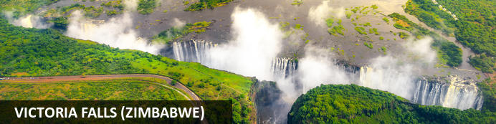
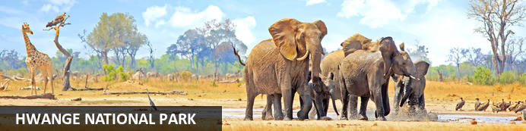

7-Day Victoria Falls & Hwange Safari - Standard - NETT
Victoria Falls (Zimbabwe) - Hwange National Park
7 Days / 6 Nights
Date of Issue: 13 March 2023

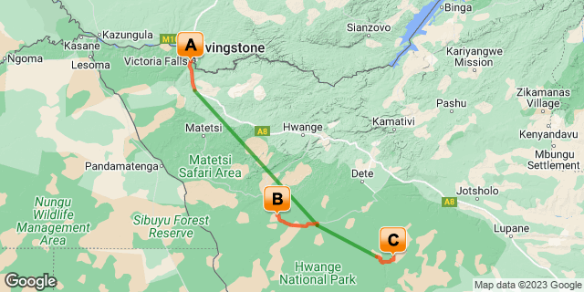

Click here to view your Digital Itinerary

Introduction
The perfect itinerary including two of Zimbabwe's main highlights. Enjoy activities and the view of Victoria Falls and then head to Hwange National Park for great game viewing.
Start with the magnificent Victoria Falls. A seventh world wonder worthy of a visit and to be ticked off your bucket list. Explore the falls. Activities abound. Then you're off to Zimbabwe's most famous game park, Hwange National Park. A big game safari with incredible sightings and the best thing, it's just a hop, skip and a jump away which makes for an easy combination using short light aircraft transfers. Experience some of Zimbabwe's prime wilderness and wildlife.

Accommodation | Destination | Basis | Duration
Batonka Guest Lodge | Victoria Falls (Zimbabwe) | B&B | 2 Nights
Camp Hwange | Hwange National Park | FI | 2 Nights
African Bush Camps Somalisa Expeditions | Hwange National Park | FI | 2 Nights

Key
B&B: Bed and Breakfast
FI: Fully Inclusive - Bed, All Meals, Fees and Activities

Price
NETT STO COSTS
1st December 2022 – 31st December 2022
2 or more guests - USD 2750 per person sharing
Single supplement - USD 85
1st January 20223 – 31st March 2023
2 or more guests - USD 3120 per person sharing
Single supplement - USD 100
1st April 2023 – 31st May 2023
2 or more guests - USD 3670 per person sharing
Single supplement - USD 1230
1st June 2023 – 30th June 2023
2 or more guests - USD 4170 per person sharing
Single supplement - USD 1230
1st July 2023 – 31st October 2023
2 or more guests - USD 4665 per person sharing
Single supplement - USD 1230
1st November 2023 – 30th November 2023
2 or more guests - USD 3570 per person sharing
Single supplement - USD 670
1st December 2023 – 31st December 2023
2 or more guests - USD 3350 per person sharing
Single supplement - USD 100
Note:
1st December 2022 - 31st March 2023 are quoted with shared road transfers to Hwange.
1st April 2023 - 31st December 2023 are quoted with Mack Air Flights.
** Rates are subject to change
Includes shared road & air transfers starting & ending from VFA on a seat basis

Included
- Accommodation as indicated – can change depending on availability and request at time of booking
- Meals as indicated
- Activities as indicated
- Shared road transfers as necessary
- Seat on internal flights as indicated
- Tour file with detailed itinerary, map with route descriptions, vouchers etc.
- 24 hour personal and friendly support
- Fast and efficient response to service providers

Excluded
- Items of a personal nature
- Optional extra activities
- International flights
- Holiday or personal insurance
- Staff gratuities
- Park entry fees (for optional extra activities in Victoria Falls)
- Excludes departure tax/levy from VFA or Hwange Airport
- Visas and visa applications

Day 1-3: Batonka Guest Lodge, Victoria Falls (Zimbabwe)

Victoria Falls (Zimbabwe)
A gazillion tonnes of water thundering over a sheer cliff drowns all other sounds. The swirling mist hides all sign of human activity. Beyond your rain forest sanctuary people are hurling themselves off bridges, across gorges, into walls of raging water and out of aircraft.
Victoria Falls is a paradox of tranquil beauty and exciting adventure.
Mosi-oa-Tunya, 'The Smoke that Thunders' is undoubtedly Zimbabwe's finest and most well-known attraction. It is or rather was (if you're keeping up with the latest list) one of the Seven World Wonders. We still believe it deserves the title. It truly is spectacular and not considered to be one of the world's largest waterfalls without good reason. It's not the widest or the highest , yet it is considered to the largest based on it's combined width, at 1,708 metres wide and height, at 108 metres. Impressively it takes the title for the largest sheet of falling water.

Day Itinerary
- Airport transfer from Victoria Falls Airport on arrival to your lodge in town.
Airport Transfer Time: 20 minutes from Victoria Falls Airport
- Visit to Victoria Falls this afternoon (if time allows), either on your own or arrange to go with a guide
- Recommended is a sunset Zambezi boat cruise to end the day (optional extra) or look to dine at The Boma Restaurant for a taste of the African flavours, action, music and atmosphere
- 1 full day is set aside to enjoy any of the many activities on offer

Overnight: Batonka Guest Lodge View iBrochure
Batonka Guest Lodge is a hybrid of a boutique hotel and owner-run guesthouse on the outskirts of Victoria Falls on the Zimbabwean side. In a quiet spot with immaculate gardens, you're close enough to explore the falls.
The Batonka has 27 rooms arranged around a swimming pool and an immaculate garden; a large living area houses the reception, curio shop, dining room, lounge, bar and huge shaded verandah.
Decor is simple and stylish with a nod to the elegance of colonial times and a full-on yodel to the sophistication of modern times. Mozzy-netted four-poster beds dominate the large rooms and the en suite bathrooms are enormous - all have extra-big shower units, some also have bathtubs. Tiled floors, ceiling fans and air conditioning take care of the temperatures and the water is solar-heated. A large flat-screen TV and Wi-Fi tick the downtime box as does the small balcony overlooking the garden.
Claire and Rowan and their delightful team make the difference between a well-priced, well-appointed guesthouse and the highlight accommodation of your holiday. Batonka quickly made its mark, which is hardly surprising given their pedigree. We have every confidence these high standards will be maintained.
So in Batonka Guest Lodge you’ve got a well-priced, comfortable and friendly place to stay. What more could you want? How about one of the Seven Wonders of the Natural World a pleasant half hour walk away?
Victoria Falls is one of those experiences that never gets old. Through a dense rainforest of its own making you hear the roar long before arriving at the sheer cliff opposite the thundering cascade. The power and scale of the world’s largest waterfalls are at once exhilarating and just that little bit terrifying. And of course, in addition to spending a day exploring the waterfalls from all angles, there is a silly amount of additional activities to choose from. Your hosts will book all your activities for you and even lay on a shuttle for the purpose, the only difficulty will be in choosing what to do.
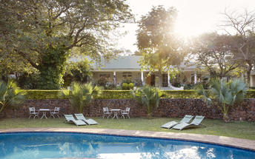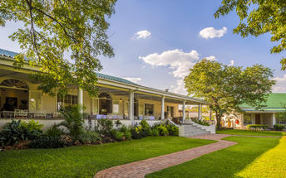

Basis
Bed and Breakfast

Included
- Bed & breakfast and 2/day Victoria Falls town shuttle

Excluded
- Drinks, additional meals, activities, additional transfers & laundry

Day 3-5: Camp Hwange, Hwange National Park

Hwange National Park
About an hour's drive from Victoria Falls, Hwange National Park is Zimbabwe's most famous game reserve and with good reason. The Kalahari biome reaches from central Botswana into the south and west regions characterised by level plains and sparse scrub land with great wildlife.
Hwange has many waterholes to ensure varied and reliable game viewing; it is home to great herds of elephant and buffalo; the largest population of the extremely rare African dog thrives here; and the birdlife is prolific.
Wildlife highlights in Hwange National Park include: elephant, wild dog, lion, leopard, cheetah, rhino, buffalo, spotted hyena, brown hyena, jackal, zebra, giraffe, waterbuck, gemsbok, eland, roan, sable, kudu and many smaller antelope and nocturnal mammals.

Day Itinerary
- After breakfast, enjoy a last activity in Victoria Falls (if time allows). You will be transferred to the airport for your onward internal flight from the Victoria Falls Airport to the Giraffe Springs Airstrip
Airport Transfer Time: 20 minutes to Victoria Falls Airport
Airstrip Transfer Time: 45 minutes to 1 hour transfer from Giraffe Springs Airstrip to the lodge
- Check in at the lodge and enjoy your activities as included
- Activities on offer are game drives, log pile hide and walking. Game likely to be encountered includes all of the cat family, wild dog, elephants and buffalo in huge numbers and the usual plain's game. Walks to the natural springs found in this area are a special highlight.
Activities: day & night game drives and walking safaris

Overnight: Camp Hwange View iBrochure
Pack your beige togs because Camp Hwange, deep in Zimbabwe's biggest and most diverse game reserve, is one of a few lodges in southern Africa where walking safaris are the main activity.
After a walking safari, a game drive will seem coarse and vulgar by comparison. You'll notice the bush smells less of diesel fumes and more of wild grasses and tree blossoms; that the trees are filled with birdsong and not engine clatter; you'll hear animals before you see them and a pride of lion encountered on foot, while perfectly safe, is a life-changing event.
Camp Hwange is an exceptional safari lodge in the centre of one of the largest and most diverse game reserves in Africa. Famous for its elephant and large mammals including lion, leopard, cheetah, buffalo, wild dog, hyena, giraffe, zebra and many antelope species, the game viewing is guaranteed to be amazing.
Facing a permanent waterhole, the lodge is spread along the edge of an ancient teak forest. Accommodation is in enormous chalets with thatched roofs and tented sides on a polished screed floor. En suite bathrooms have flushing toilets and hot running water and power is delivered to each unit by a silent solar panel.
The main living space is an unpretentious thatched area that follows the shape of the surrounding landscape and it ends exactly where the bush starts. In front of the lodge is a large sandy clearing with a campfire slab in the middle - here is where you'll spend most of your downtime between safaris.
The food is exceptional and not just considering your impossibly remote location; the service is top-notch Zimbabwean hospitality at its heartfelt best and the guides' the guides. The guides are amazing. With the most rigorous training anywhere in Africa, Zimbabwean guides have earned the claim to be among the continent's best. And here at Camp Hwange you quite possibly have the best of the best. And that's a good thing because a walking safari is, strangely, no walk in the park. Their knowledge and bush confidence will set you at ease in an instant, all you have to do is enjoy the experience. And you will.
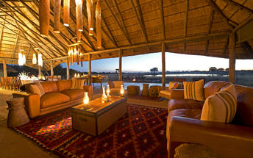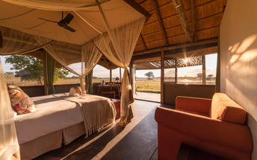

Basis
Fully Inclusive - Bed, All Meals, Fees and Activities
All Drinks (excl Premium Brands) Included

Included
- Meals, local drinks, activities, park fees, conservation & community levy and laundry

Excluded
- Transfers & premium drinks

Day 5-7: African Bush Camps Somalisa Expeditions, Hwange National Park

Hwange National Park
As previously described

Day Itinerary
- After breakfast, enjoy a last activity (to be determined by your scheduled onward flight time). You will be transferred on to your next lodge in a different area of the Hwange National Park.
Airstrip Transfer Times: 45 minutes to 1 hour transfer back to Giraffe Springs Airstrip and 30 minutes from Manga Airstrip to camp
- Enjoy the scheduled activities with your lodge guide as included. Activities include guided walks lead by qualified and passionate guides who will share their knowledge and love of the bush with you, game drives and night drives. Wildlife sightings include elephant, kudu, sable antelope, zebra, wildebeest, gemsbok, the rare and endangered roan antelope, buffalo, giraffe, lion, leopard, hyena and many other wildlife species
Activities: day & night game drives, walking, bird watching and evening spot lighting

Overnight: African Bush Camps Somalisa Expeditions View iBrochure
Somalisa Expeditions is a classic safari camp of old world charm. The essence of a mobile camp with all the additional comforts of a luxurious permanent lodge. In the heart of the Hwange National Park. In a private concession. A real safari adventure that immerses you in the bush and gets you up close with wildlife. Elephants are everywhere.
A sincere Serengeti-style tented camp with a vintage feel. The camp is spectacular, the people even more so and the wildlife continues to raise the bar. There’s more than just something special about this place. It’s everything that makes it what it is.
The way it’s designed to allow you to truly explore the bush. The elephants that come to quench their thirst daily at ‘elephant’s pool’. The service-minded staff and the finer details that make this camp authentic without compromising on comfort. You’ll be left in awe. It’s both humble and proud.
Wood, canvas with touches of copper and gold are a reminder of a bygone era. Perfectly transformed to the modern world without losing the essence of a classic safari camp. You’re in the African bush here and it’s incredible. From your private deck look out onto the dry grass and acacia savannah. You’re likely to spot the elephants and lions have been known to come close too.
This camp is for the wildlife enthusiast. The adventurer who wants it as real as it gets and real it is out here. It’s all about the raw Zimbabwean wilderness along the Kennedy Vlei Line. The seasonal Somalisa pans in a pristine private concession. A game rich area where the highlight is a guided walking safari. That says it all.
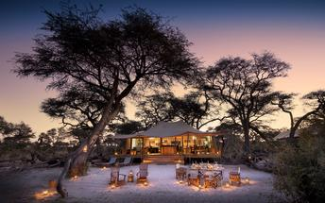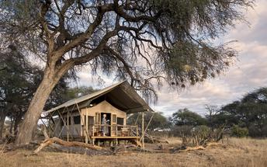

Basis
Fully Inclusive - Bed, All Meals, Fees and Activities
All Drinks (excl Premium Brands) Included

Included
- All meals, local drinks, activities, park fees and laundry

Excluded
- Premium drinks

Day 7: End of Itinerary

Day Itinerary
- After breakfast and a morning activity (if time allows depending on your departure flight time), you will depart back to Manga Airstrip and take your onward flight ending in Victoria Falls (VFA)
Airstrip Transfer Time: 30 minutes to Manga Airstrip
- Fly out directly from Victoria Falls (VFA) or spend a night in Victoria Falls before catching your onward flight the next day
- End of services

Basis
Bed and Breakfast

Transport

Flight Information
Date | Flight | Airline | Departure Airport | Time | Arrival Airport | Time | Class | Ref
 | Charter Flight |  | Victoria Falls International Airport [VFA] |  | Giraffe Springs Airstrip
 | Charter Flight |  | Giraffe Springs Airstrip |  | Manga Airstrip
 | Charter Flight |  | Manga Airstrip |  | Victoria Falls International Airport [VFA]

Transfers
Date | Company | Pick Up | Drop Off | Time | Vehicle
 |  | Victoria Falls International Airport [VFA] | Batonka Guest Lodge |  | Transfer
 |  | Batonka Guest Lodge | Victoria Falls International Airport [VFA] |  | Transfer
 |  | Giraffe Springs Airstrip | Camp Hwange |  | Transfer
 |  | Camp Hwange | Giraffe Springs Airstrip |  | Transfer
 |  | Manga Airstrip | African Bush Camps Somalisa Expeditions |  | Transfer
 |  | African Bush Camps Somalisa Expeditions | Manga Airstrip |  | Transfer

Urgent Contact Numbers
Company Name | Telephone | Email Address | Contact Person
Namibia Tours & Safaris | +264 64 40 6038 | tanya@namibia-tours-safaris.com | Tanya Coetzee
Namibia Tours & Safaris - Emergency Contact | +264 81 784 4315

Service Provider Directory
Service Provider | Ref. Number | Telephone | Address
Batonka Guest Lodge |  | +263832846923 | 1406 Reynard RoadVictoria Falls00000
Camp Hwange |  | +263 13 46924 | 231A Sopers Crescent  Victoria Falls  Zimbabwe

Terms and Conditions

Namibia Tours & Safaris Terms and Conditions
Contract
1.1 The contract will become effective as from the date the invoice is completed and the deposit, referred to in Clause 2.1, is received by Africa Tours & Safaris CC (hereinafter known as the Company).
1.2 The contract is subject to the Namibian Law.
1.3 Any person making a reservation as per Clause 8.4 accepts the terms and conditions of this agreement set out hereunder.
How to Book
2.1 A 20% deposit of the full amount due is required to confirm any reservation and is to be done by the agent or client (see Clause 8.1) in writing or by e-mail.
2.2 The Company must receive the balance of the contract price no later than 42 days (6 weeks) prior to departure.
2.3 If the Company does not receive the full contract price 42 days (6 weeks) before the departure date, the Company may cancel the reservation and retain whatever deposit or other funds it has already received from the client or his agent.
How to Pay
3 The payment options will be provided upon confirmation of a booking.
Our Cancellation Policy
4.1 Any cancellation of a confirmed booking must be done in writing (email) to the Company whereupon cancellation charges as per Clause 4.2 will apply.
4.2 The following cancellation fees (as a percentage of the fully quoted price) are applicable to any cancelled travel:
Notice from date of travel: Cancellation fee:
42 days or more 20% (deposit forfeited)
29 – 41 days 50%
15 – 28 days 75%
0 – 14 days 100%
Please note: the notice period is calculated from the date of cancellation to the start date of the tour/safari booking.
4.3 No refund will be made by the Company if, for any reason, inclusions or parts of the tour cannot be carried out / or utilised. These would include all facets such as meals, game drives, accommodation etc. This would also apply to any client who has booked a tour but fails to undertake the tour for any reason.
Our Changes Policy
5 If a booking is changed to an earlier date than originally reserved, the Company will endeavour to change it. If the booking is for a later date, charges as per Clause 4.2 could apply.
As things go, we've all had to adapt to changes during the Coronavirus pandemic and so too have we therefore amended our terms and conditions for travel during such times. Check out the Updated COVID Terms and Conditions here.
Price Changes
6.1 The Company reserves the right to increase the price of any tour prior to departure due to factors beyond the control of the Company, such as, without being limited to, and increase in fuel prices, new Government legislation, accommodation price increases, fluctuations in exchange rates, etc.
6.2 If the Company announces an in increase in the tour price in terms of this Clause, such addition amount must be paid to the Company before the departure of such tour or else the Company shall have the right to cancel the tour and the charges in Clause 4.2 will apply.
Changes to Itineraries
7 The Company shall at any time have the right, in its entire discretion, to alter the terms of the booking in relation to the route, timetable, itinerary and accommodation. The Company shall, however, make every effort to offer the client an alternative tour of a comparable standard.
Should the alternative be of a lesser standard, the client will be refunded the difference, but should there be an increase, the client shall have the right to either reject the alternative and obtain a refund of the relevant portion of the original contract sum, or to accept the alternative and pay the increased cost. In the event of the client rejecting the alternative tour and claiming a refund, such rejection will be treated as a cancellation and the refund will be calculated according to Clause 4.2 hereof. The client shall have no claim against the Company for any damages arising out of the alternative booking.
Responsibility and Liability
8.1 Neither the Company nor any person acting for through and on behalf of the Company shall be liable for any loss or damage whatsoever arising from any cause whatsoever and without restricting the generality of the aforegoing shall particularly not be responsible for the loss or damage arising from any errors or omissions contained in its brochure or other literature, late or non-confirmation or acceptance or bookings, loss or damage caused by delays, sickness, injury or death, whether occasioned by negligence or not.
8.2 The Company shall have the right at any time at is sole discretion, to cancel or the remainder thereof or to make an alteration in the route, accommodation price or other details. This would include any event of any tour being rendered impossible, illegal or inadvisable by weather, avalanches, strike, war, government or other interference or due to any other cause whatsoever. The extra expenses incurred as a result thereof shall be the responsibility of the client.
8.3 The Company may at its discretion and without liability or cost to itself at any time cancel, or terminate, a client's booking and in particular, without limiting the generality of the aforegoing, it shall be entitled to do so in the event of illness or the illegal or incompatible behaviour of any client undertaking the tour, who shall in such circumstances not be entitled to any refund.
8.4 Any person making a reservation with the Company (refer to Clause 1.1) warrants that her or she has the necessary authority to enter into this contract on behalf of the person or persons included in such a booking. The person making the reservation shall be liable for the total amount due to the Company.
Client's Obligations
9.1 It is the onus and responsibility of the client to obtain the necessary comprehensive insurance before departure for any possible cancellations, medical expenses, protection or personal property and money.
9.2 The onus is upon the client to ensure that passports and visas are valid for the duration of the safari. The Company cannot be held liable for any necessary visas or other travel documents not held by clients. In the event of a client not having the necessary documentation to enter any area or country the Company shall reserve the right to leave the client a the point of entry of such area or country. In such an event, the Company will not be held responsible to the client for further travel arrangements.
9.3 The onus is upon the client to ensure that the SARS-CoV-2 PCR tests are done prior to commencement of the safari and valid on arrival in accordance to the requirements of the country of intended travel and for the airline with which the client will travel. The same applies for any necessary testing for departure. The costs of any such COVID testing will be for the clients own account. While The Company can assist with arrangements for testing in-country, The Company will not be held responsible to the client for such arrangements and with regards to return time of test results.
9.4 Should the client need to undergo mandatory quarantine once in-country with regards to the SARS-CoV-2 virus, either on arrival as called for by the authorities or due to testing positive once in-country, this will be at the clients own expense.
Health and Personal Safety
10.1 The client shall be reasonably fit to undertake the tour.
10.2 Anti-malaria precautions should be commenced prior to tour departure. A medical doctor should be consulted for advice.
10.3 Tours offered by the Company cover a wide spectrum of the African wilds and neither the Company, its employees or agents can be held responsible for any injury or other related incidents whilst on the tour / safari.
10.4 The Company cannot be held responsible for any client who falls ill or contracts the SARS-CoV-2 virus while in-country. The client accepts that travel is at own risk.
Baggage
11.1 Clients are limited to one soft sports type bag per person with a maximum weight of 20 kilograms. This includes photographic equipment and hand luggage.
11.2 Due to the rugged terrain, the Company cannot be held responsible for damage or loss of any personal items including bags, contents of bags or photographic and related equipment. Due to extremely dusty conditions, please ensure all bags are dust proof.
Airline and Car Hire Clause
12.1 The Company will act as the agent of the client when booking the client with a car hire company, an airline or air charter service. The client therefore contracts with the car hire company, airline or charter service and not with the Company.
12.2 Charter flights are normally operated by smaller type aircraft such as Cessna 210. Luggage is strictly limited to 10-15 kgs (depending on terms of particular airline used) per person in soft hold all type bags. Due to the desert heat, it is not safe to overload aircraft thus this limit needs to be strictly controlled.
Travelling or thinking of travelling during the COVID-19 pandemic? Take a look at our COVID Terms and Conditions for more information on how this will work and differ from our standard terms and conditions as listed above.

