SOUTH AFRICAN SURPRISE

An expedition of surprise, our South African Surprise package is a collection of experiences unique to South Africa. South Africa is a country of vast contrasts of landscapes, a thrill-seekers paradise, a wildlife enthusiast dream, and a photographer’s canvas.

Beginning in Johannesburg, highlights include the Kruger National Park, where wildlife never seizes to amaze, and the Panorama Route is a wonder of natural sights. It’s then on to eSwatini and Zululand, two regions steeped in ancient culture and tradition. The Southern Drakensberg Mountains forms a great part of this package, where nature rejuvenates the soul. The last leg includes trips to the birthplace of Nelson Mandela, a world hero and revolutionary, and the famed Garden Route region, ending in the Mother City, Cape Town.
DATE | ROUTING
DAY 1 – Sunday | JOHANNESBURG
DAY 2 – Monday | JOHANNESBURG – MPUMALANGA
DAY 3 – Tuesday | MPUMALANGA
DAY 4 – Wednesday | MPUMALANGA – eSWATINI (SWAZILAND)
DAY 5 – Thursday | eSWATINI (SWAZILAND) – ST LUCIA AND SURROUNDS
DAY 6 – Friday | ST LUCIA AND SURROUNDS – DURBAN
DAY 7 – Saturday | DURBAN – DRAKENSBERG
DAY 8 – Sunday | DRAKENSBERG
DAY 9 – Monday | DRAKENSBERG – EASTERN CAPE COAST
DAY 10 – Tuesday | EASTERN CAPE COAST – TSITSIKAMMA
DAY 11 – Wednesday | TSITSIKAMMA – KNYSNA
DAY 12 – Thursday | KNYSNA – OUDTSHOORN
DAY 13 – Friday | OUDTSHOORN – CAPE TOWN
DAY 14 – Saturday | CAPE TOWN
DAY 15 – Sunday | CAPE TOWN
 | END OF TOUR
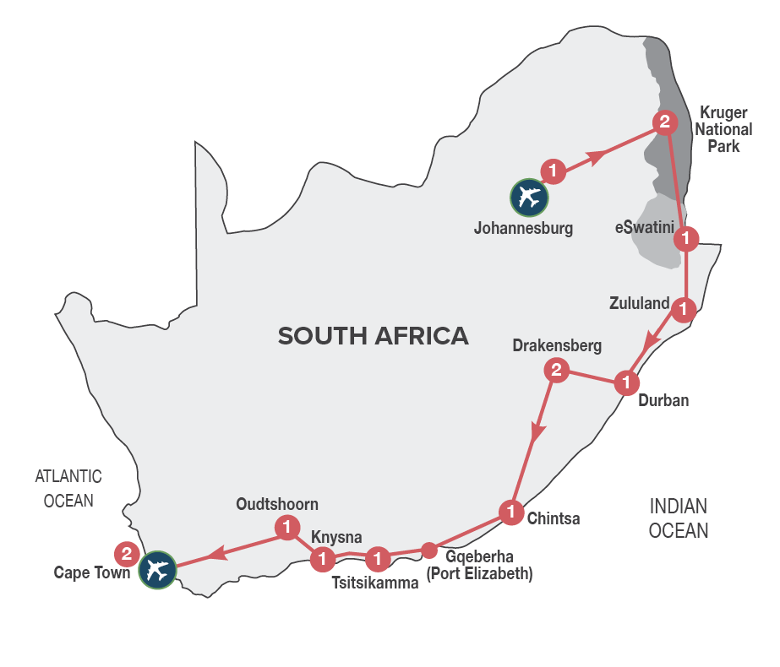
Group Tour
Minimum 2 guests / Maximum 40 guests

DURATION

15 Days/14 Nights

ROUTING
JOHANNESBURG - CAPE TOWN

INCLUDES
- 18 Meals: 14 breakfasts, 4 dinners including gratuities
- 14 Nights’ accommodation including porterage
- Transportation including toll fees in air-conditioned vehicles
- Services of a professional English-speaking tour guide
- Entrance fees as specified in the itinerary
TOUR HIGHLIGHTS
- Visit the spectacular scenic Three Rondavels, Bourke’s Luck Potholes and God’s Window
- Experience a game safari in the Kruger National Park
- Meet the friendly people of eSwatini (Swaziland) and experience their culture through singing and dancing
- Orientation tour of Durban including a visit to the Durban Botanic Gardens
- Visit to the charming village of Howick and its impressive waterfall
- Overnight in the magnificent Southern Drakensberg Mountains and experience the unspoilt Eastern Cape Coast
- Travel past Nelson Mandela’s birthplace and house
- Visit Tsitsikamma National Park and the scenic Storms River Mouth
- Overnight in Knysna, known as the oyster box of South Africa
- Guided tour of the Cango Caves and a guided tour of a working ostrich farm in Oudtshoorn
- Explore the small towns long the famous Route 62 between Cape Town and Oudtshoorn
- Sample top quality Port style wines in Calitzdorp, a town well known for its fortified wines
- Two overnights in Cape Town, spectacularly set at the foot of Table Mountain
- Enjoy a variety of carefully chosen optional MAKE TRAVEL MATTER® Experiences that positively impact our travellers and the communities we visit.

SELECTED DEPARTURE DATES
 | Jan24 | Feb24 | Mar24 | Apr24 | May24 | Jun24 | Jul24 | Aug24 | Sep24 | Oct24 | Nov24 | Dec24
English | 7 | 4 | 3 | 7 | 5 | 2 | 7 | 4 | 1 | 6 | 3 | 1

VISA REQUIREMENTS
This tour travels through eSwatini (Swaziland) and Lesotho. Please check visa requirements, as certain nationalities may require visas to travel through eSwatini (Swaziland) and Lesotho.

NOTE
Accommodation check-in on Day 1 is from 14h00. Shuttle service on Day 1 starts at 05h15 and ends at 23h00. If you are arriving on a very early morning or late evening flight, please inform your Travel Agent, to make alternative transfer arrangements.

RACK RATES valid 01/01/24-30/04/24
R 37 470.00 per person sharing twin/double accommodation
R 46 910.00 per single person

RACK RATES valid 01/05/24-31/07/24
R 34 500.00 per person sharing twin/double accommodation
R 43 330.00 per single person

RACK RATES valid 01/08/24-31/12/24
R 38 460.00 per person sharing twin/double accommodation
R 48 370.00 per single person

Accommodation included:
4* Protea Hotel OR Tambo or similar x 1 night
4* Hippo Hollow Country Estate or similar x 2 nights
3* Piggs Peak Hotel or similar x 1 night
3* Anew Hotel Hluhluwe or similar x 1 night
4* Protea Hotel Umhlanga Ridge or similar x 1 night
3* Drakensberg Gardens Hotel or similar x 2 nights
4* Crawford’s Beach Lodge or similar x 1 night
3* Tsitsikamma Village Inn or similar x 1 night
3* Premier Resort The Moorings or similar x 1 night
3* Protea Hotel Riempie Estate or similar x 1 night
3* SunSquare Cape Town Gardens or similar x 2 nights

Transportation:
Transportation is in air-conditioned touring vehicles appropriate to the requirements of the tour
- 2 guests will travel in a sedan vehicle
- 3-10 guests will travel in a 13-seater vehicle
- 11-12 guests will travel in a 15-seater vehicle
- 13-40 guests will travel in a coach

DAY 1 – SUNDAY JOHANNESBURG
On arrival in Johannesburg at OR Tambo International Airport, you’ll be met by your representative and assisted to your shuttle transfer service (unescorted, driver only) that will transfer you to your hotel. You have the remainder of the day at leisure until 19h00 when we all meet at the hotel reception for a welcome briefing on the tour and a chance to meet your fellow travellers.

DAY 2 – MONDAY JOHANNESBURG - MPUMALANGA
This morning we leave for Mpumalanga, dropping several hundred feet into the lush subtropical region of the Lowveld. Travel along the circular Panorama Route, visiting the view sites of the Blyde River Canyon, home to the Three Rondavels and one of the natural wonders of Africa; gasp at the glory of God’s Window, with a boundless view of mountains and fertile plains and visit Bourke’s Luck Potholes. [Breakfast]
Distance travelled today: 500 kms

DAY 3 – TUESDAY MPUMALANGA
We have a bright and early start to the day to experience the wonders of exploring the Kruger National Park in our closed vehicle. Why not join a thrilling open-vehicle game safari through the Kruger National Park (optional and for own account)? The Kruger National Park is an internationally renowned game reserve of nearly 2 million hectares that supports the largest variety of wildlife species on the African continent. Keep a lookout for the wonderful flora and bird life that abounds. We return to our hotel around lunch time and your afternoon is at leisure to relax. [Packed Breakfast]
Distance travelled today: 200 kms

DAY 4 – WEDNESDAY MPUMALANGA – eSWATINI (SWAZILAND)
This morning we travel to eSwatini (Swaziland), an independent Kingdom within the borders of South Africa, known for its lovely scenery, crafts and colourful indigenous culture. An interactive cultural experience introduces us to the charming people of eSwatini and their traditions. We travel south to our hotel, nestled in the mountainous peaks of eSwatini (Swaziland) for overnight. [Breakfast]
Distance travelled today: 200 kms

DAY 5 – THURSDAY eSWATINI (SWAZILAND) – ST LUCIA AND SURROUNDS
After breakfast we journey through eSwatini (Swaziland), visiting Ngwenya Glass, where a small group of eSwati craftsmen and women create beautifully handmade items from recycled glass. Our next stop is The Swazi Candles Centre where you will experience local artisans creating colourful, handmade candles. Our journey continues into the Kingdom of KwaZulu-Natal where ancient traditions and modern cultures of both Zulu and Settler have combined into a vibrant society living in peace and harmony. Arrive at your hotel in the late afternoon for overnight. [Breakfast]
Distance travelled today: 375 kms

DAY 6 – FRIDAY ST LUCIA AND SURROUNDS - DURBAN
Guests have the option to take a morning optional open vehicle game drive in the Hluhluwe-iMfolozi Game Reserve (optional and for own account), before heading off to Durban. An orientation tour of Durban, that travels along the Golden Mile, the beachfront promenade, The Point Waterfront, and harbour introduces us to this multicultural, vibrant seaside city. The orientation tour concludes with a visit to the Durban Botanic Gardens before arriving at our hotel late afternoon. [Breakfast]
Distance travelled today: 320 kms

DAY 7 – SATURDAY DURBAN - DRAKENSBERG
Enjoy a leisurely breakfast or perhaps explore the bustling Umhlanga Beach with a stroll along the Promenade mile that buzzes with energy as surfers, joggers and cyclists take to this seaside playground. Then we head into the majestic Southern Drakensberg Mountains. We visit the impressive 300-foot-high Howick Falls, located in the KwaZulu-Natal Midlands town of Howick. Our journey continues through the Southern Midlands Meander Route, arriving at our hotel, situated on a scenic World Heritage site, mid-afternoon. Your afternoon is at leisure to soak up the surroundings, or enjoy fishing, hiking and even horse riding in clean mountain air (all activities are optional and for own account). Sit down to a sumptuous dinner at your hotel. [Breakfast & Dinner]
Distance travelled today: 280 kms

DAY 8 – SUNDAY DRAKENSBERG
Enjoy a full day at leisure to soak up the surroundings of the magnificent Southern Drakensberg Mountains. There are also many leisure activities to be enjoyed at the Resort. Consider joining a thrilling 4x4 tour up the spectacular Sani Pass into the mountain Kingdom of Lesotho (optional and for own account). Enjoy an evening dinner at your hotel with a wide variety of local specialities to choose from. [Breakfast & Dinner]

DAY 9 – MONDAY DRAKENSBERG – EASTERN CAPE COAST
This morning we continue south to the Eastern Cape entering the fourth of the provinces and the birthplace of Nelson Mandela (fondly known as Madiba). En route we see the old traditional way of life in the former homeland area known as the Transkei and stop for lunch (own account) outside the capital of Mthata. We travel past Nelson Mandela’s birthplace and house, arriving late afternoon at our accommodation in Chinsta East, on the beautiful, unspoilt Eastern Cape Coast. A delicious dinner with local delicacies awaits you at your lodge. [Breakfast & Dinner]
Distance travelled today: 520 kms

DAY 10 – TUESDAY EASTERN CAPE COAST – TSITSIKAMMA
We awake to the sounds of the crashing waves and have the morning at leisure to unwind with beach sand between our toes. The beach stretches on uninterrupted for many kilometres and the thick indigenous beach forest is a haven for an amazing variety of birdlife. We set off heading south to the Tsitsikamma Forest. [Breakfast]
Distance travelled today: 510 kms

DAY 11 – WEDNESDAY TSITSIKAMMA - KNYSNA
After a leisurely breakfast, visit the spectacularly beautiful Tsitsikamma Forest, which provides scenic walking opportunities. A short walk to the Storms River Mouth offers some magnificent views of the gorge and river below. Arrive in Knysna, known as the oyster box of South Africa, for check in at your hotel. Enjoy a dinner filled with culinary delights at the hotel’s trendy restaurant. [Breakfast & Dinner]
Distance travelled today: 92 kms

DAY 12 – THURSDAY KNYSNA – OUDTSHOORN
After breakfast, we travel inland over the spectacular Outeniqua Pass to Oudtshoorn, known as the ‘feather capital of the world’ because of its ostrich industry. We visit a working ostrich farm and then explore the famous Cango Caves, with a walk around its magnificent dripstone formations of stalactites and stalagmites. Overnight in Oudtshoorn. [Breakfast]
Distance travelled today: 180 kms

DAY 13 – FRIDAY OUDTSHOORN – CAPE TOWN
Today’s journey travels along the famous Route 62 and through the Little Karoo, ending in Cape Town. On the way we stop off to sample top quality port style wines in Calitzdorp, before continuing via Worcester and the Huguenot Tunnel, arriving in Cape Town in the late afternoon. [Breakfast]
Distance travelled today: 420 kms

DAY 14 – SATURDAY CAPE TOWN (UNESCORTED)
Enjoy a full day at leisure. Perhaps join a sightseeing tour of Cape Town and Table Mountain (optional and for own account) or spend the day exploring the magnificent Cape Winelands on a full day winelands tour (optional and for own account) or join a full day tour of the Cape Peninsula, with its dramatic coastline and spectacular scenic beauty (optional and for own account). Although a small city, Cape Town is packed with sightseeing attractions, excellent bars, cafes, and restaurants as well as colourful craft markets. Alternatively relax on one of Cape Town’s many pristine beaches. Overnight in Cape Town. [Breakfast]

DAY 15 – SUNDAY CAPE TOWN (UNESCORTED)
This morning after breakfast, check out of the hotel by 11h00. The remainder of the day will be at leisure until your transfer to Cape Town International airport. [Breakfast]

OPTIONAL EXCURSIONS:
Enhance the journey with optional excursions on the tour, available for pre-booking, subject to minimum of 2 adults travelling:

** MAKE TRAVEL MATTER® Experiences seek to encourage the greatest community benefit from travel and tourism, while also educating guests about The UN Global Sustainable Development Goals and the local community actions being taken to advance them.

Rack Rates valid 01/01/24 – 31/12/24:

DAY 3 – TUESDAY - KRUGER NATIONAL PARK – FULL DAY OPEN VEHICLE GAME SAFARI – R 1 360.00 per person
Join a full day open vehicle safari with a highly qualified field guide who is eager to share their knowledge and passion for this unique wilderness area.

** DAY 3 – TUESDAY - KRUGER NATIONAL PARK – MAKE TRAVEL MATTER® Experience - FULL DAY OPEN VEHICLE GAME SAFARI including an introduction to the KNP Anti-Poaching Dog Unit– R 1 585.00 per person
Join a full day open vehicle safari with a highly qualified field guide who is eager to share their knowledge and passion for this unique wilderness area. The game safari includes an introduction to the KNP Anti-Poaching Dog Unit (Project Watchdog), that was established because of the increase in rhino poaching worldwide. Learn about the dogs that are trained to track poachers in the field, detect firearms, ammunition and wildlife products that enter and exit through the Kruger National Park gates. A portion of the trip price of this MAKE TRAVEL MATTER® Experience goes towards ensuring that these dogs receive the best possible care in support of the vital work they do. The experience directly advances UN Global Goal 15: Life on Land.

DAY 6 – FRIDAY - HLUHLUWE-IMFOLOZI PARK – MORNING OPEN VEHICLE GAME SAFARI – R 1 065.00 per person
Enjoy a morning, 3-hour open vehicle safari into the Hluhluwe-Imfolozi Park, Africa’s oldest game reserve and world renowned for its highly successful white rhino conservation programme.

DAY 8 – SUNDAY – SANI PASS 4X4 ADVENTURE TOUR – R 1 670.00 per person
Join a 4x4 tour up Sani Pass and into the tiny mountain Kingdom of Lesotho (passport required) which includes lunch at the highest pub in Africa.

DAY 14 – SATURDAY – CAPE TOWN – AFRICAN DINNER & DRUMMING – R 1 010.00 per person
Join a full filled evening of interactive entertainment and delectable food at Gold Restaurant.

DAY 14 – SATURDAY – CAPE TOWN – MORNING TABLE MOUNTAIN & CAPE TOWN CITY TOUR - R 745.00 per person excluding the cost of the Table Mountain cable way ticket.
Travel by cable car to the top of Table Mountain (weather permitting), then descend to further explore the city.

DAY 14 – SATURDAY – CAPE TOWN - FULL DAY CAPE PENINSULA TOUR – R 1 575.00 per person
Join this full day tour that explores the dramatic coastline of the Cape Peninsula including a visit to Boulders Beach penguin colony (entrance fee for own account) and Cape Point Nature Reserve.

DAY 14 – SATURDAY – CAPE TOWN – FULL DAY CAPE WINELANDS TOUR – R 1 415.00 per person
While South Africa's fertile valleys are world famous for their crisp white and classic French-style red wines, the area is also a treasury of rustic beauty and sprawling estates shaded by giant oak trees. Visit the country's principal wine routes of Paarl, Stellenbosch and Franschhoek.

** DAY 14 – SATURDAY – CAPE TOWN – MAKE TRAVEL MATTER® Experience - MARINE BIG FIVE SAFARI EXPERIENCE –

R 3 500.00 per person
Join us for a marine safari where you may see great white sharks, whales, Cape fur seals and a variety of seabirds. On a 2-hour cruise from Gansbaai, Marine Biologists will be on hand to explain more about the amazing animals that visit our shores. A portion of the monies paid by guests for this MAKE TRAVEL MATTER® Experience go towards the Dyer Island Conservation Trust that delivers conservation and research programmes to protect the biodiversity of the marine eco-system surrounding Dyer Island. The experience directly advances UN Global Goal 14: Life below Water.

