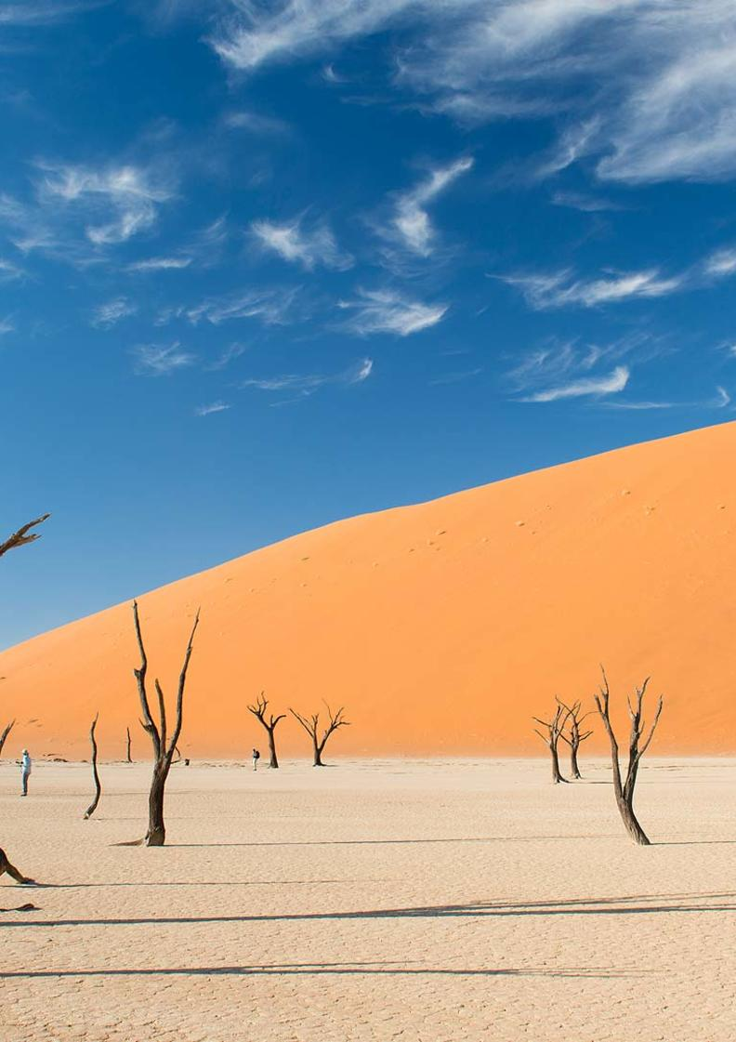

11-Day Extravagant Namibia Fly-in Safari - Superior - NETT

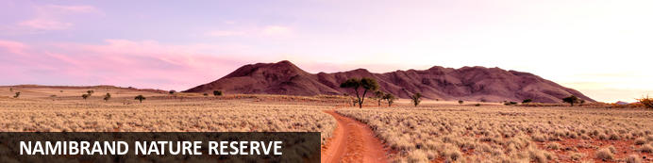
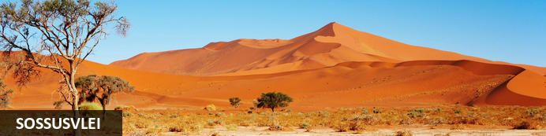
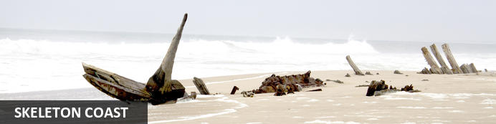
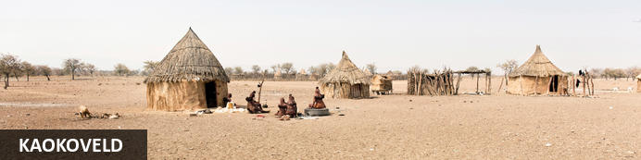
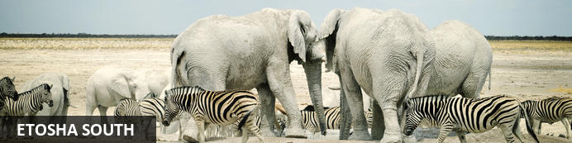

11-Day Extravagant Namibia Fly-in Safari - Superior - NETT
NamibRand Nature Reserve - Sossusvlei - Skeleton Coast - Kaokoveld - Etosha South
11 Days / 10 Nights
Date of Issue: 13 March 2023

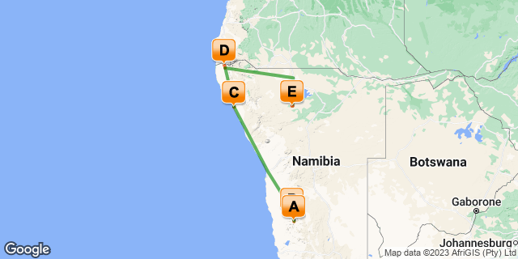

Click here to view your Digital Itinerary

Introduction
This 11-Day Extravagant Namibia Fly-in Safari is the ultimate trip to some of Namibia’s best highlights: Sossusvlei, Skeleton Coast, Kaokoland and Etosha National Park.
Visit the Namib Desert; a sea of dunes, a great sand sea. The only true African desert south of the equator. Then you’ll fly high along the Skeleton Coast to Swakopmund and onwards to your lodge further up the Skeleton Coast. From there you will head north to Kaokoland before exploring Etosha National Park to end.
This suggested itinerary can be changed and areas added to make it even better:
- And/or the rugged landscapes of the Damaraland area and the desert adapted wildlife.
- Even better, add the Caprivi Strip area whether around Popa Falls or the Kwando River.
- …. Many options available.

Accommodation | Destination | Basis | Duration
Wolwedans Dune Camp | NamibRand Nature Reserve | FB+ | 2 Nights
Sossusvlei Desert Lodge | Sossusvlei | FI | 2 Nights
Shipwreck Lodge | Skeleton Coast | FI | 2 Nights
Serra Cafema Camp | Kaokoveld | FI | 2 Nights
Little Ongava | Etosha South | FI | 2 Nights

Key
B&B: Bed and Breakfast
FB+: Full Board Plus - Dinner, Bed, Breakfast, Lunch and Activities
FI: Fully Inclusive - Bed, All Meals, Fees and Activities

Price
NETT STO COSTS
1st January – 30th June 2023 – Low Season
2 guests - ZAR 231 840 per person sharing
4 guests - ZAR 184 920 per person sharing
Single supplement - ZAR 60 925
1st July – 31st December 2023 – High Season
2 guests - ZAR 309 085 per person sharing
4 guests - ZAR 253 255 per person sharing
Single supplement - ZAR 87 330
Flight costs are calculated on a private charter basis in a Cessna 210 aircraft.
Prices subject to change according to fuel price fluctuations.

Included
- Accommodation as indicated – can change depending on availability and request at time of booking
- Meals as indicated
- Meet and greet upon arrival
- Activities as indicated including park entry fees
- Private charter flights as indicated
- Airstrip transfers as necessary
- Tour file with detailed itinerary, map with route descriptions, vouchers etc.
- 24 hour personal and friendly support
- Fast and efficient response to service providers

Excluded
- Items of a personal nature
- Optional extra activities
- International flights
- Holiday or personal insurance
- Staff gratuities
- Visas and visa applications

Day 1-3: Wolwedans Dune Camp, NamibRand Nature Reserve

NamibRand Nature Reserve
An area that epitomises wide open spaces of red sand, gravel plains, mountain ranges, dunes and savannas. One of the most beautiful and scenic in Namibia. Everywhere you look, the perfect panoramic photo. Pure wilderness. Untouched. Pristine.
The NamibRand Reserve, south of Sossusvlei in the southwest of Namibia is one of the largest private reserves in Southern Africa, covering an area of 215,000 hectares. It borders the Namib Naukluft Park to the west for 100 kilometres and the Nubib Mountains to the east.
Sleep out under the stars. Star gaze. Hike. Adopt a fairy circle. Make a difference. Simply relax and take in the natural beauty.

Day Itinerary
Flight: Windhoek – Wolwedans Dune Lodge 1 hour & 20 minutes
- You will be met on arrival by our representative to hand over your travel documents
- Meet your pilot and check in for your flight and briefing before taking to the Namibian skies
- Private charter flight from Windhoek to Namib Rand Nature Reserve
- Road transfer to the lodge on arrival
- Includes: All meals; 1st day arrival: Afternoon drive with sundowner on the dunes (Duration 2-3 hours pending on your arrival time) or sundowner drive.
- 2nd day: Full day drive with picnic lunch en- route (Duration 6-8 hours)

Overnight: Wolwedans Dune Camp
Wolwedans Dune Camp is a paired down, luxury camp on top of a large dune. Six tents and a 2-bedroomed family suite are pitched on enormous wooden decks and the en suite bathrooms look out over the desert. The main lodge is comfortable and relaxed with sublime views at every turn.
Wolwedans Dune Camp sits on the edge of a dune. A 250-metre behemoth of shifting red sand surrounded by soft blonde grass. Six luxurious tents sit atop the dune on raised platforms that are connected to the sublime main lodge by a series of elevated walkways and just a little further, but still a part of the camp, you'll find the private family suite.
The canvas tents are a flimsy barrier between the endless desert outside and the cosy luxury within. En suite bathrooms are enormous and your view from everywhere is astounding. The living area is all chunky leather couches, hefty wooden tables and rumpled books on weathered shelves.
From your private deck, there's plenty space to lounge around and marvel in the endless view, at night sleep out under the stars and in the heat of summer, enjoy the water-filled silo to cool off.
If the tents are a little too adventurous and the elements a little too close for comfort, go for the magnificent Wolwedans Desert Lodge which is a sturdier version.
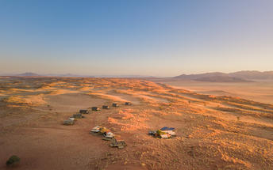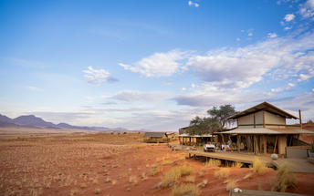

Basis
Full Board Plus - Dinner, Bed, Breakfast, Lunch and Activities

Day 3-5: Sossusvlei Desert Lodge, Sossusvlei

Sossusvlei
Star dunes with up to five crests rise 300m into the air and rank among the biggest in the world; the dune valleys are marked by vast clay pans where the Tsauchab River gave up its fight to reach the sea more than 60,000 years ago.
Besides the dunes and pans of Sossusvlei and Sesriem Canyon, a sideshow of activities and sights has developed around the region and there are plenty of game lodges that provide additional desert-adapted activities.Plants and birds are the dominant life form in this dessicated realm and they support a tiny world of mammals, reptiles and insects that, in the absence of coastal fog, seldom wander far from the rivercourse and its pans.

Day Itinerary
Flight: Wolwedans Dune Lodge – Sossusvlei Desert Lodge 20 minutes
- A short private charter flight from Wolwedans to Sossusvlei Desert Lodge over the sea of dunes
- Road transfer to the lodge on arrival
- Includes: All meals; 1x Nature drive,1x Excursion to Sossusvlei; Sesriem Canyon and Dead Vlei;
- 1x Guided nature walks; Hiking trail; 1x Quad bike excursion; San rock paintings; Stargazing at a state-of-the-art observatory; accompanied by a resident astronomer; Petrified dunes
- Highlights: Sossusvlei, Dead Vlei, Dune 45, Big Daddy, Elim Dune and the Sesriem Canyon

Overnight: Sossusvlei Desert Lodge View iBrochure
Sossusvlei Desert Lodge is in a league of its own for its elegance, unique features and activity offerings. It is modestly over the top. Yes that is possible. Every detail has been thought out, then topped with more and finished with a little extra. You’ll be left wanting for nothing except to stay longer.
On a private reserve bordering the Namib Rand Reserve (yet you're still close enough to include the highlights of Sossusvlei) , Sossusvlei Desert Lodge sits against an outcrop with an endless view onto open plains, distant mountains and sand dunes. It’s a view that looks as though it could only be photo shopped, it’s that surreal.
The architectural design of the lodge blends into the background when looking from afar, but as you near, its interesting angular design catches the eye. It’s elegant and sophisticated in its palette of neutrals, rust and ochres and finished with subtle nuances of varied textures in shades of pale greys and creams. It’s inviting in its rich opulence, so understated.
Your suite, extravagant and immaculate as you look out onto the seamlessly never ending vista ahead. Everything about your stay here is indulgent, but we’ll leave that up to you to discover before we divulge any further. It’s not a five star lodge, it’s worthy of a millions stars and you can see them all from the observatory, guided by a professional astronomer or laying in bed from your stargazing skylight.
What can we say? This is a place you have to experience to know what we are talking about. The pictures don’t do it justice. It’s beyond grand. There’s simply is nothing quite like that view from your private pool, sipping on your sundowner in revered silence. Overlooking a landscape that is frankly, out of this world, it seems far-fetched that a place like this even exists and there you have it, it’s the And Beyond Sossusvlei Desert Lodge.
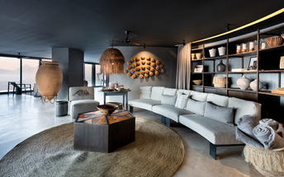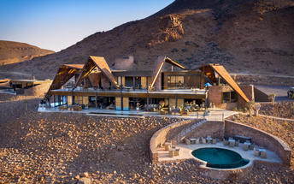

Basis
Fully Inclusive - Bed, All Meals, Fees and Activities

Day 5-7: Shipwreck Lodge, Skeleton Coast

Skeleton Coast
The Skeleton Coast National Park is the northern stretch, north of Ugab River Gate and beyond Terrace Bay. A vast, brooding and impenetrable national park. Bleak too and one of the most inhospitable places in the world. Cold water and an expanse of dunes, this is the driest place in sub- Saharan Africa and the final resting place of more than a thousand rusting shipwrecks. The turbulent Benguela Current causes strong winds, shifting sandbanks and powerful undertows that have led to many a sailor's demise. It’s a true testament to the humbling power of nature's forces.
Explore what is left of shipwreck skeletons that met their fate on the treacherous Atlantic Coast by the ever changing sandbanks, heavy fog and torrent currents. Take a scenic flight over the endless dunes, old diamond mines, shipwrecks and along the deserted coastline. Visit one of the largest Cape fur seal colonies in the world at the Cape Cross Seal Reserve.

Day Itinerary
Flight: Sossusvlei – Swakopmund 1 hour & 30 minutes (scenic) – refuel (30 minutes)
Swakopmund – Möwe Bay 1 hour & 30 minutes
- Road transfer to airstrip for departure flight
- Private charter scenic flight along the Skeleton Coast to Swakopmund to refuel
- Highlights: Sossusvlei, sand dunes, old diamond mines, shipwrecks & Sandwich Harbour
- Private charter flight from Swakopmund to Möwe Bay and road transfer to the lodge
- Includes: All meals, scheduled daily excursions, park fees & local branded drinks
- Activities: Game drives within the Skeleton Coast National Park, Sundowners and walks on the beach, fishing at the coastline (equipment provided), 4×4 excursions to the Clay Castles, the Hoanib River Delta and the Mowe Bay seal colony, visits to the Suiderkus and Karimona shipwrecks & drives along the Hoarusib River to track desert-adapted wildlife

Overnight: Shipwreck Lodge View iBrochure
Stranded in the middle of nowhere. Shipwrecked and isolated. Pure wilderness and not much else but endless views of rolling sand dunes and the cool Atlantic Ocean breeze to give you a true Skeleton Coast experience. There you are in the comfort of your cabin at Shipwreck Lodge, snuggled up against the window with a warm blanket, a book, glass of wine and the indoor fire stove adding a cosy romance.
Shipwreck Lodge is the only lodge situated inside the Skeleton Coast Central Concession an area of 146,600 hectares. Inside the Skeleton Coast National Park, between the Hoarusib and Hoanib Rivers, 10 eco-friendly cabins are found scattered amongst the sand dunes as if shipwrecked. With next to nothing close by, it's desolate, remote and the epitome of solitude, yet with all the comforts of a luxury lodge that would gladly have you "stranded" a little longer.
Built with a nautical feel with modern minimal elegance. Wooden finishes, neutral in congruence with the surrounding desert landscapes and distant Atlantic. Understated yet indulgent. Cosy and all conducive to an atmosphere of utmost relaxation and comfort, whether in your cabin or lounging in the main area, you'll feel right at home.
Perched on the sand dunes, don't expect to get far without getting sand in your shoes. Better yet, go barefoot and experience the sand between your toes, in touch with nature and all that surrounds you. Simply sit and enjoy the endless views. Be on the lookout for the desert adapted animals that inhabit the area and on a clear night enjoy the million starred sky. Just another reminder that there's little else around you but the untouched beauty of the Namibian coast.
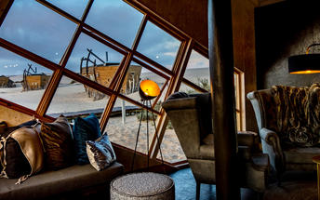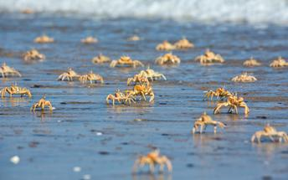

Basis
Fully Inclusive - Bed, All Meals, Fees and Activities

Day 7-9: Serra Cafema Camp, Kaokoveld

Kaokoveld
The Kaokoveld, a vast and empty wilderness occupying the north-western quarter of Namibia, is roughly divided in two by the Hoanib River. It’s harsh, remote, unpopulated and makes for some of Namibia’s finest scenic landscapes.
Kaokoland is a succession of hills and mountains punctuated by endless plains. This isolated rugged region is home to the nomadic Himba pastoralists who have remained unchanged for many generations. The attraction of Kaokoland lies in its wild and uncharted valleys and mountains. It is the most isolated and undeveloped region of this mostly isolated and undeveloped country.

Day Itinerary
Flight: Möwe Bay – Hartmans Valley 50 minutes
- Road transfer to airstrip for departure flight
- Private charter flight from Möwe Bay to Hartmans Valley
- Road transfer to the lodge on arrival
- Includes: All meals and local drinks - excludes premium imported brands and champagne; Nature drives in Hartmann's Valley; quad biking; boating on the Kunene River; walks in the valleys and at the waterfalls; visit to an authentic Himba village; full day outings with picnic lunches

Overnight: Serra Cafema Camp View iBrochure
Serra Cafema is a luxury camp with an idyllic setting in the riverine forest of the Kunene River far away from any hint of civilisation. With the exception of your luxurious accommodation.
Each en suite room is built using thatch, canvas and timber on a raised deck. Hovering above the water is your private verandah that looks across river to the Serra Cafema mountains of Angola. Elevated timber walkways wind through papyrus, palm and albida trees to the sublime living area of the main lodge, which has a swimming pool, lounge, dining area and a large open-air deck.
The landscape, flora, fauna, avifauna and customs of the local inhabitants combine to form an amazing Namibian experience. Activities - besides lazing on your private sunbed in the shade - include nature drives, interaction with the Himba villagers, walks, quad biking through the dunes, boating, birdwatching and fishing.
The region is inhabited by the Himba - hardy pastoralists who roam the desert and lead a life in harmony with the indigenous plants and animals that have adapted to the harsh conditions.
Large herds of gemsbok, springbok and wild ostrich are some of the more prominent animals; you may also see a number of endemic reptiles and the Kunene has plenty of hungry Nile crocodiles.
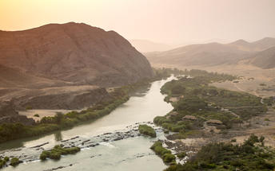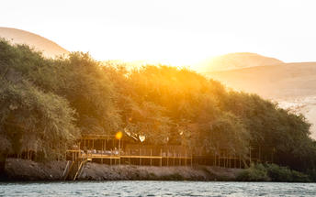

Basis
Fully Inclusive - Bed, All Meals, Fees and Activities

Day 9-11: Little Ongava, Etosha South

Etosha South
Located just south of the boundary of Etosha National Park in northwestern Namibia, Etosha South makes up the southern region of this wild paradise. The area is comprised of a collection of world class private game reserves. The national park can be accessed via the southern entrance at Andersson’s Gate. Visitors can catch a glimpse of a variety of wildlife including: lion, giraffe, elephant, white and black rhino, and a multitude of plains game. Popular activities include: enjoying an open 4x4 safari with an expert guide, half day or full day drives with the option of a picnic lunch with wine on the full day game drive.

Day Itinerary
Flight: Hartmans Valley - Ondangwa 1 hour & 25 minutes (refuel)
Ondangwa - Ongava Lodge 40 minutes
- Road transfer to airstrip for departure flight
- Private charter flight from Hartmans Valley to Ondangwa to refuel and then to Ongava Lodge
- Road transfer to the lodge on arrival
- Includes: All meals and local drinks - excludes premium imported brands and champagne;
- Activities include game drives into Etosha and walks and safaris in the private reserve, which also has several hides and waterholes
- Etosha is one of Africa's great game parks. With 114 species of mammal and 340 species of birds you are sure to see a great variety of wildlife on your safari

Overnight: Little Ongava View iBrochure
With a maximum of six guests Little Ongava is indeed little. There is nothing little about the scale of luxury or the footprint of the suites, however.
Little Ongava is an addition to the exclusive and luxurious Ongava Lodge that goes a stride or two further in every department - giraffe strides that is.
The lodge has three chalets of pachidermal proportions. Panoramic French doors add a large verandah to your already sizeable bedroom and lounge. Your private sala, plunge pool and en suite bathroom look out over the waterhole.
Your choice of dining venues are in the privacy of your own suite, under the stars or in the cosy thatched lodge. The main living area is stylish and really rather refined and it has a pool, lounge and game viewing deck.
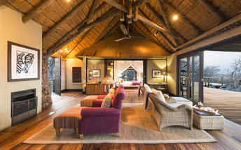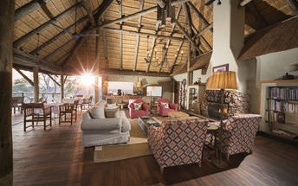

Basis
Fully Inclusive - Bed, All Meals, Fees and Activities

Day 11: End of Itinerary

Day Itinerary
Flight: Ongava Lodge – Windhoek 1 hour & 30 minutes
  - After your morning activity as included, you will road transfer to the airstrip for your departure flight.
  - Private charter flight from Etosha to Windhoek International Airport. Keeping in mind that you need to be at the airport 2 hours prior to your international departure flight time.
  - End of services

Basis
Bed and Breakfast

Transport

Flight Information
Date | Flight | Airline | Departure Airport | Time | Arrival Airport | Time | Class | Ref
 | Private Charter |  | Hosea Kutako International Airport [WDH] |  | Wolwedans Airstrip
 | Private Charter |  | Wolwedans Airstrip |  | Sossusvlei Airstrip
 | Private Charter |  | Sossusvlei Airstrip |  | Swakopmund Airport [SWP]
 | Private Charter |  | Swakopmund Airport [SWP] |  | Mowe Bay Airstrip
 | Private Charter |  | Mowe Bay Airstrip |  | Hartman Valley Airstrip
 | Private Charter |  | Hartman Valley Airstrip |  | Ondangwa Airport [OND]
 | Private Charter |  | Ondangwa Airport [OND] |  | Ongava Airstrip
 | Private Charter |  | Ongava Airstrip |  | Hosea Kutako International Airport [WDH]

Transfers
Date | Company | Pick Up | Drop Off | Time | Vehicle
 |  | Wolwedans Airstrip | Wolwedans Dune Camp |  | Fully Guided Trip
 |  | Wolwedans Dune Camp | Wolwedans Airstrip |  | Fully Guided Trip
 |  | Sossusvlei Airstrip | Sossusvlei Desert Lodge |  | Fully Guided Trip
 |  | Sossusvlei Desert Lodge | Sossusvlei Airstrip |  | Fully Guided Trip
 |  | Mowe Bay Airstrip | Shipwreck Lodge |  | Fully Guided Trip
 |  | Shipwreck Lodge | Mowe Bay Airstrip |  | Fully Guided Trip
 |  | Hartman Valley Airstrip | Serra Cafema Camp |  | Fully Guided Trip
 |  | Serra Cafema Camp | Hartman Valley Airstrip |  | Fully Guided Trip
 |  | Ongava Airstrip | Little Ongava |  | Fully Guided Trip
 |  | Little Ongava | Ongava Airstrip |  | Fully Guided Trip

Urgent Contact Numbers
Company Name | Telephone | Email Address | Contact Person
Namibia Tours & Safaris | +264 64 40 6038 | tanya@namibia-tours-safaris.com | Tanya Coetzee
Namibia Tours & Safaris - Emergency Contact | +264 81 784 4315

Service Provider Directory
Service Provider | Ref. Number | Telephone | Address
andBeyond Sossusvlei Desert Lodge |  | +27 11 809 4300
Little Ongava |  | +264 83 330 3920 | 102A Nelson Mandela Avenue |  Klein Windhoek |  Windhoek |  Namibia |  OFFICE OPEN: Monday-Friday | 8 AM - 5 PM
Shipwreck Lodge |  | +264 61 22 8104 | Skeleton Coast ParkMowe Bay9000
Wolwedans Dune Camp |  | +264 61 23 0616

Terms and Conditions

Namibia Tours & Safaris Terms and Conditions
Contract
1.1 The contract will become effective as from the date the invoice is completed and the deposit, referred to in Clause 2.1, is received by Africa Tours & Safaris CC (hereinafter known as the Company).
1.2 The contract is subject to the Namibian Law.
1.3 Any person making a reservation as per Clause 8.4 accepts the terms and conditions of this agreement set out hereunder.
How to Book
2.1 A 20% deposit of the full amount due is required to confirm any reservation and is to be done by the agent or client (see Clause 8.1) in writing or by e-mail.
2.2 The Company must receive the balance of the contract price no later than 42 days (6 weeks) prior to departure.
2.3 If the Company does not receive the full contract price 42 days (6 weeks) before the departure date, the Company may cancel the reservation and retain whatever deposit or other funds it has already received from the client or his agent.
How to Pay
3 The payment options will be provided upon confirmation of a booking.
Our Cancellation Policy
4.1 Any cancellation of a confirmed booking must be done in writing (email) to the Company whereupon cancellation charges as per Clause 4.2 will apply.
4.2 The following cancellation fees (as a percentage of the fully quoted price) are applicable to any cancelled travel:
Notice from date of travel: Cancellation fee:
42 days or more 20% (deposit forfeited)
29 – 41 days 50%
15 – 28 days 75%
0 – 14 days 100%
Please note: the notice period is calculated from the date of cancellation to the start date of the tour/safari booking.
4.3 No refund will be made by the Company if, for any reason, inclusions or parts of the tour cannot be carried out / or utilised. These would include all facets such as meals, game drives, accommodation etc. This would also apply to any client who has booked a tour but fails to undertake the tour for any reason.
Our Changes Policy
5 If a booking is changed to an earlier date than originally reserved, the Company will endeavour to change it. If the booking is for a later date, charges as per Clause 4.2 could apply.
As things go, we've all had to adapt to changes during the Coronavirus pandemic and so too have we therefore amended our terms and conditions for travel during such times. Check out the Updated COVID Terms and Conditions here.
Price Changes
6.1 The Company reserves the right to increase the price of any tour prior to departure due to factors beyond the control of the Company, such as, without being limited to, and increase in fuel prices, new Government legislation, accommodation price increases, fluctuations in exchange rates, etc.
6.2 If the Company announces an in increase in the tour price in terms of this Clause, such addition amount must be paid to the Company before the departure of such tour or else the Company shall have the right to cancel the tour and the charges in Clause 4.2 will apply.
Changes to Itineraries
7 The Company shall at any time have the right, in its entire discretion, to alter the terms of the booking in relation to the route, timetable, itinerary and accommodation. The Company shall, however, make every effort to offer the client an alternative tour of a comparable standard.
Should the alternative be of a lesser standard, the client will be refunded the difference, but should there be an increase, the client shall have the right to either reject the alternative and obtain a refund of the relevant portion of the original contract sum, or to accept the alternative and pay the increased cost. In the event of the client rejecting the alternative tour and claiming a refund, such rejection will be treated as a cancellation and the refund will be calculated according to Clause 4.2 hereof. The client shall have no claim against the Company for any damages arising out of the alternative booking.
Responsibility and Liability
8.1 Neither the Company nor any person acting for through and on behalf of the Company shall be liable for any loss or damage whatsoever arising from any cause whatsoever and without restricting the generality of the aforegoing shall particularly not be responsible for the loss or damage arising from any errors or omissions contained in its brochure or other literature, late or non-confirmation or acceptance or bookings, loss or damage caused by delays, sickness, injury or death, whether occasioned by negligence or not.
8.2 The Company shall have the right at any time at is sole discretion, to cancel or the remainder thereof or to make an alteration in the route, accommodation price or other details. This would include any event of any tour being rendered impossible, illegal or inadvisable by weather, avalanches, strike, war, government or other interference or due to any other cause whatsoever. The extra expenses incurred as a result thereof shall be the responsibility of the client.
8.3 The Company may at its discretion and without liability or cost to itself at any time cancel, or terminate, a client's booking and in particular, without limiting the generality of the aforegoing, it shall be entitled to do so in the event of illness or the illegal or incompatible behaviour of any client undertaking the tour, who shall in such circumstances not be entitled to any refund.
8.4 Any person making a reservation with the Company (refer to Clause 1.1) warrants that her or she has the necessary authority to enter into this contract on behalf of the person or persons included in such a booking. The person making the reservation shall be liable for the total amount due to the Company.
Client's Obligations
9.1 It is the onus and responsibility of the client to obtain the necessary comprehensive insurance before departure for any possible cancellations, medical expenses, protection or personal property and money.
9.2 The onus is upon the client to ensure that passports and visas are valid for the duration of the safari. The Company cannot be held liable for any necessary visas or other travel documents not held by clients. In the event of a client not having the necessary documentation to enter any area or country the Company shall reserve the right to leave the client a the point of entry of such area or country. In such an event, the Company will not be held responsible to the client for further travel arrangements.
9.3 The onus is upon the client to ensure that the SARS-CoV-2 PCR tests are done prior to commencement of the safari and valid on arrival in accordance to the requirements of the country of intended travel and for the airline with which the client will travel. The same applies for any necessary testing for departure. The costs of any such COVID testing will be for the clients own account. While The Company can assist with arrangements for testing in-country, The Company will not be held responsible to the client for such arrangements and with regards to return time of test results.
9.4 Should the client need to undergo mandatory quarantine once in-country with regards to the SARS-CoV-2 virus, either on arrival as called for by the authorities or due to testing positive once in-country, this will be at the clients own expense.
Health and Personal Safety
10.1 The client shall be reasonably fit to undertake the tour.
10.2 Anti-malaria precautions should be commenced prior to tour departure. A medical doctor should be consulted for advice.
10.3 Tours offered by the Company cover a wide spectrum of the African wilds and neither the Company, its employees or agents can be held responsible for any injury or other related incidents whilst on the tour / safari.
10.4 The Company cannot be held responsible for any client who falls ill or contracts the SARS-CoV-2 virus while in-country. The client accepts that travel is at own risk.
Baggage
11.1 Clients are limited to one soft sports type bag per person with a maximum weight of 20 kilograms. This includes photographic equipment and hand luggage.
11.2 Due to the rugged terrain, the Company cannot be held responsible for damage or loss of any personal items including bags, contents of bags or photographic and related equipment. Due to extremely dusty conditions, please ensure all bags are dust proof.
Airline and Car Hire Clause
12.1 The Company will act as the agent of the client when booking the client with a car hire company, an airline or air charter service. The client therefore contracts with the car hire company, airline or charter service and not with the Company.
12.2 Charter flights are normally operated by smaller type aircraft such as Cessna 210. Luggage is strictly limited to 10-15 kgs (depending on terms of particular airline used) per person in soft hold all type bags. Due to the desert heat, it is not safe to overload aircraft thus this limit needs to be strictly controlled.
Travelling or thinking of travelling during the COVID-19 pandemic? Take a look at our COVID Terms and Conditions for more information on how this will work and differ from our standard terms and conditions as listed above.

