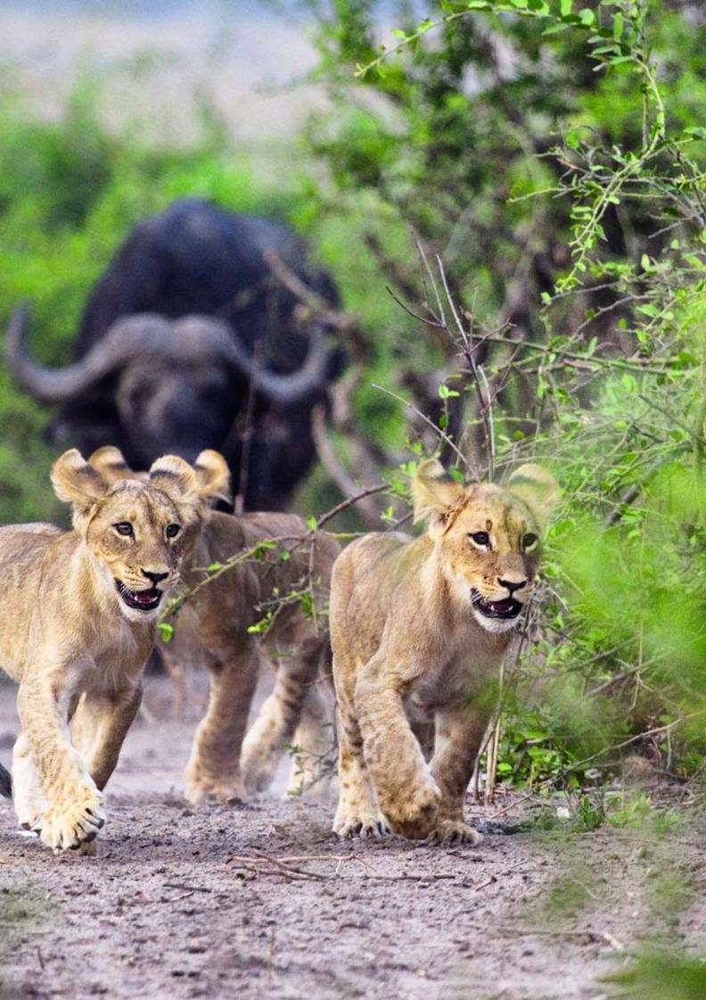

16-Day Namibia, Chobe & Victoria Falls Private Guided Safari - Standard - NETT

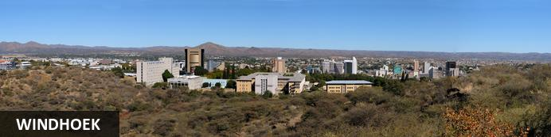
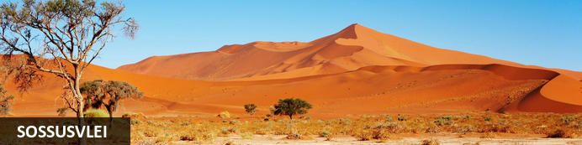
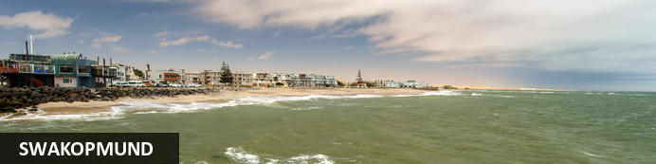
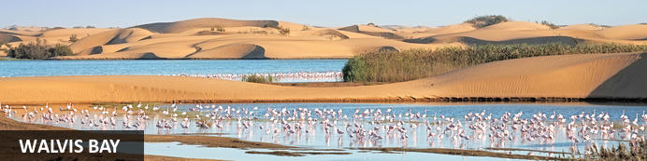
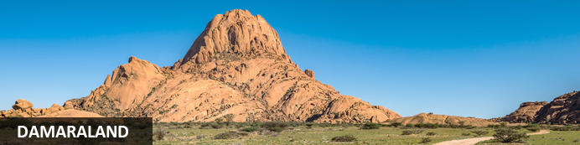
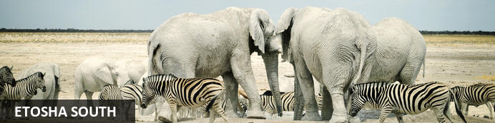
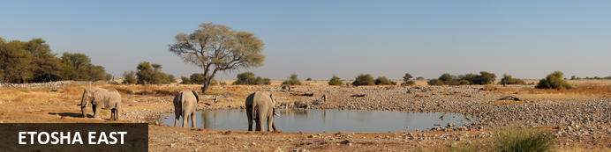
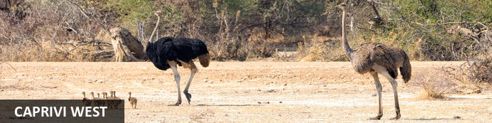
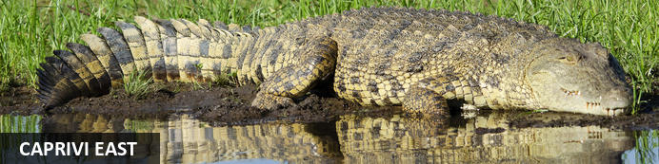
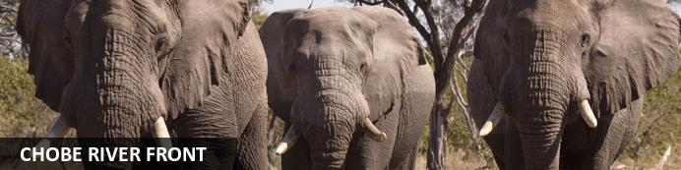
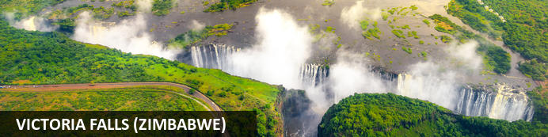

16-Day Namibia, Chobe & Victoria Falls Private Guided Safari - Standard - NETT
Windhoek - Sossusvlei - Swakopmund - Walvis Bay - Damaraland - Etosha South - Etosha East - Caprivi West - Caprivi East - Chobe River Front - Victoria Falls (Zimbabwe)
16 Days / 15 Nights
Date of Issue: 13 March 2023

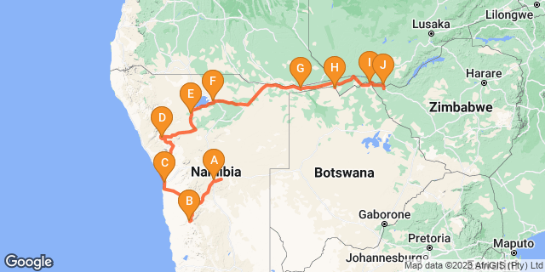

Click here to view your Digital Itinerary

Introduction
Taking in the astonishing contrasts from west to east, this 16-day Namibia, Chobe and Victoria Falls safari combines the best of Namibia with a safari in Botswana and a visit to the spectacular Victoria Falls.
This tour visits Namibia's famed attractions including the Namib Desert, the Skeleton Coast, Damaraland, Etosha National Park and the Caprivi wetlands. Top this fascinating voyage of discovery with a safari in Botswana's Chobe National Park and a visit to Victoria Falls and you really have the makings of an amazing holiday.

Accommodation | Destination | Basis | Duration
The Elegant Guesthouse | Windhoek | B&B | 1 Night
Desert Quiver Camp | Sossusvlei | D,B&B | 2 Nights
Swakopmund Luxury Suites | Swakopmund | B&B | 2 Nights
Twyfelfontein Adventure Camp | Damaraland | D,B&B | 1 Night
Etosha Village | Etosha South | D,B&B | 1 Night
Onguma Bush Camp | Etosha East | D,B&B | 2 Nights
Shametu River Lodge | Caprivi West | D,B&B | 2 Nights
Camp Kwando | Caprivi East | D,B&B | 1 Night
Chobe Safari Lodge | Chobe River Front | HB+ | 2 Nights
Batonka Guest Lodge | Victoria Falls (Zimbabwe) | B&B | 1 Night

Key
B&B: Bed and Breakfast
D,B&B: Dinner, Bed and Breakfast
HB+: Half Board Plus - Dinner, Bed, Breakfast and Activities

Price
NETT STO COSTS
1st January – 30th June 2023 – Low Season
Nam Section
2 guests - ZAR 80 985 per person sharing
4 guests - ZAR 52 860 per person sharing
6 guests - ZAR 44 285 per person sharing
Single supplement - ZAR 8 570
Bots/Zim Section
2 guests - USD 860 per person sharing
4 guests - USD 860 per person sharing
6 guests - USD 860 per person sharing
Single supplement - USD 305
1st July – 31st December 2023 – High Season
Nam Section
2 guests - ZAR 85 160 per person sharing
4 guests - ZAR 55 270 per person sharing
6 guests - ZAR 46 195 per person sharing
Single supplement - ZAR 8 855
Bots/Zim Section
2 guests - USD 860 per person sharing
4 guests - USD 860 per person sharing
6 guests - USD 860 per person sharing
Single supplement - USD 305

Included
- Accommodation as indicated – can change depending on availability and request at time of booking
- Meals as indicated
- Car hire for 2 & 4 pax – for 6 pax the vehicle is slightly larger
- All vehicle costs including fuel
- All park entry fees in Namibia
- Guide and guide costs
- Shared road transfers as indicated
- Water in the vehicle at all times
- Activities as shown in the itinerary … all activities that can be done with NTS guide and vehicle are included
- Tour file with detailed itinerary, map with route descriptions, vouchers etc.
- 24 hour personal and friendly support
- Fast and efficient response to service providers

Excluded
- Items of a personal nature
- Optional extra activities
- International flights
- Holiday or personal insurance
- Staff gratuities
- Visas and visa applications

Day 1: The Elegant Guesthouse, Windhoek

Windhoek
Surrounded by the stubble-covered Auas Mountains and the endless Khomas Hochland, Windhoek lies in a long valley fed by ancient hot springs in the central highlands. Namibia’s capital and bustling city. More often than not, the start or end place of your Namibia safari.
In Windhoek there are many interesting historical buildings, museums, galleries and craft shops. The city has several good restaurants and modern shops and services making it an excellent base camp from which to launch your Namibian adventure.

Day Itinerary
- You will be met by your guide on arrival in Windhoek and handed your travel documents
- City tour of Windhoek with your guide (if time permits)
- The remainder of the day can be spent relaxing at your own leisure
- For dinner tonight, you can head into town for a bite to eat at one of Windhoek’s well known restaurants

Overnight: The Elegant Guesthouse View iBrochure
With easy access from Windhoek International and situated in Klein Windhoek - the Namibian capital's prototype leafy suburb - The Elegant Guesthouse makes for a comfortable overnight stop.
The Elegant, as she is known in these parts, is in a quiet neighbourhood, very secure and close to the shops, restaurants and attractions of northern Windhoek. Getting there from the airport requires two turns, getting to the rest of the country from here requires just three turns.
Modern design and fittings give The Elegant Guesthouse a sophisticated air. Once a small six-roomer, the Elegant has been upgraded and is ever more sophisticated now, offering 17 stylish and beautiful guest rooms. They didn't just add more rooms. They first acquired more space and then expanded, so the mood is still decidedly relaxed (if not more so than before): the perfect way to start or end your Namibia holiday.
All rooms have en suite bathrooms, twin beds (together making a king) and are fitted with air conditioners as well as fast WiFi, television and most open out onto a drought resistant garden or the swimming pool area surrounded by loungers and umbrellas.
Breakfast is served in the light and airy open-plan breakfast room or out in the garden on warm days, which is about 90% of the time in Namibia.
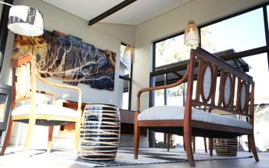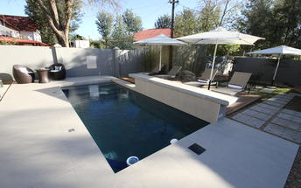

Meet and Greet
NTS Car Hire- Toyota Hilux Safari Private Guided
Toyota Hilux Safari Travelling as a small group of friends or as a family and need a bit more space than you get with an SUV? Is your focus on photography and you want to get the best shots? This is how you travel in true safari style.

Basis
Bed and Breakfast

Day 2-4: Desert Quiver Camp, Sossusvlei

Sossusvlei
Star dunes with up to five crests rise 300m into the air and rank among the biggest in the world; the dune valleys are marked by vast clay pans where the Tsauchab River gave up its fight to reach the sea more than 60,000 years ago.
Besides the dunes and pans of Sossusvlei and Sesriem Canyon, a sideshow of activities and sights has developed around the region and there are plenty of game lodges that provide additional desert-adapted activities.Plants and birds are the dominant life form in this dessicated realm and they support a tiny world of mammals, reptiles and insects that, in the absence of coastal fog, seldom wander far from the rivercourse and its pans.

Day Itinerary
Windhoek – Sossusvlei 350km - approximately 5 to 6 hours
- After breakfast, you can still pop into town for anything you might need and then depart heading south from Windhoek to your lodge for the next 2 nights
- The route will take you either via the beautiful Spreetshoogte or Remhoogte Pass, both showcasing the natural beauty of Namibia
- Wake up early for breakfast (Day 3) and then head to the entrance to Sossusvlei, the Sesriem Gate
- Spend the whole day in the beautiful Sossusvlei area, exploring the highlights: Sossusvlei, Dead Vlei, Dune 45, Big Daddy, Elim Dune and the Sesriem Canyon
- Return to the lodge for lunch or arrange a lunch pack to enjoy in the dunes and return late afternoon for a well-earned rest
- Optional extra activities: Hot air balloon safari, Nature drives

Overnight: Desert Quiver Camp View iBrochure
With its quirky yet somehow harmonious design Desert Quiver Camp, near the entrance to Sossusvlei, can be a luxury camping experience, a back-to-basics desert lodge or both. And the best part - it's entirely up to you.
The 24 units, built of poles and canvas and stone, look like A-frames adrift and subsiding into the desert. The natural construction and sympathetic choice of colours help these structures blend into the dramatic scenery and, after a short while, the striking asymmetry becomes rather pleasing.
Inside, the rooms are spacious, cool and spotless. An en suite bathroom with shower, toilet and wash basin lurks behind the dividing wall and while the doorless layout - oddly popular among the newer establishments in Namibia - may not be to everyone’s liking, the spacious shower and piping hot water is a sure thing.
The unit has a large shaded porch with a kitchenette cunningly tucked away behind a canvas roll-down; the picnic bench and barbecue set the scene for a classic campout under the stars beside a flickering fire. A nice feature is you can order in your fresh cooking supplies and have them delivered to your unit.
If you’re not up to the ordeal of ready-steady-cooking your own meal or you just fancy a treat the camp’s sister property, Sossusvlei Lodge - well known for excellent service and quality food - is a few km up the road. As a guest of Desert Quiver Camp, you have full access to their activity centre, wonderful buffet restaurant, bar and pool all overlooking a waterhole.
Back at camp, a huge and ever-sparkling pool and its companion lopsided A-frame bar provide an agreeable venue for a sunset cocktail and a refreshing dip - the ochre view across the plains towards the rocky mountains is pure Namibia.
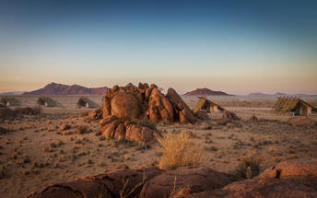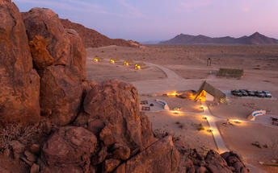

Basis
Dinner, Bed and Breakfast

Day 4-6: Swakopmund Luxury Suites, Swakopmund

Swakopmund
Surrounded by the ancient Namib desert and the inhospitable - but bounteous - Atlantic Ocean, Swakopmund is alive with activity and has a lot on offer for the adventure-seeker: quad-biking, sand-boarding, horse-riding, skydiving and more.
Swakopmund has many interesting German-influenced buildings from the early 1900s in a variety of styles and, for its size, Swakopmund has an astonishing array of restaurants that serve mainly seafood, steak and many German staples.

Walvis Bay
Walvis Bay is an industrial port which lies along the Atlantic Ocean, off Namibia's Skeleton Coast. The large bay and surrounding sand dunes help make Walvis Bay a tourist mecca with loads of activities on offer to explore it.
- Explore the Skeleton Coast where the dunes meet the sea at Sandwich Harbour‍
- Go on a dolphin boat cruise in the harbour. Enjoy champagne and oysters
- Kayak among the seals at Pelican Point
- Visit and climb the mighty Dune 7‍
- Visit the RAMSAR wetland birding site and the Walvis Bay Lagoon. Thousands of flamingos from October to April‍
- Explore the neighbouring town of Swakopmund. Activities abound and dining delights

Day Itinerary
Sossusvlei – Swakopmund 350km - approximately 5 to 6 hours
- Depart after breakfast and head north to Solitaire, then west crossing the Tropic of Capricorn, through the Gaub and Kuiseb Canyons via the Namib Gravel Plains to the coast
- Either via Walvis Bay to Swakopmund, or (recommended) detour via Ganab to the Welwitschia Plains and Moon Landscape
- The Namibian coastline is generally known as The Skeleton Coast due to the barren areas, ship wrecks and, in days gone by, whale skeletons left on the beach
- 1 full day is set aside for this lovely area where Swakopmund and Walvis Bay offer a wide range of activities such as: Dolphin cruise; Sandwich Harbour excursion (a real Skeleton Coast experience); Dune quad biking; Sand boarding; Sea kayaking; Lots more…
- Lunches and dinners can be enjoyed at any of the many great cafés or restaurants overlooking the sea

Overnight: Swakopmund Luxury Suites
Swakopmund Luxury Suites pack comfort and convenience into an elegant apartment-style accommodation option in the belly of Swakopmund's restaurant quarter.
Although “suites” is a bit of stretch size-wise, for comfort you can expect elegant, neutral décor that is easy on the senses and top quality linen with quite possibly the most comfortable bed you’ll encounter on your tour of Namibia. Attention to detail includes Nespresso machines with complimentary pods, bath robes, extra thick towels, wi-fi that actually works, climate control, mini-bar and that general air of purpose and cleanliness of a professional outfit.
For convenience you are a few minutes’ walk to the beach, restaurants, cafes and main attractions of central Swakopmund - a feature you will welcome after many hours’ in the car on Namibia’s long and dusty roads. And the day reception is staffed with the friendliest of friendly Namibians who add that personal touch and valuable insider’s information for making the most of your visit.
A secluded upper deck lined with comfortable recliners and deck chairs is a wonderful place to catch up with your digital life. Or escape it entirely with a good book and a glass of chardonnay. Parking out front is secure with 24-hour watch and CCTV and, occupying the first storey down a pedestrianised side street, the location is quiet and safe.
Breakfast at the Swakopmund Luxury Suites is a delight. The breakfast room is stunning and the food is delicious. A great way to start your day before you head off to explore where the dunes meet the sea. You are just a short walk to the main beach and the main streets of town. Splendid.
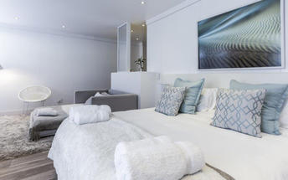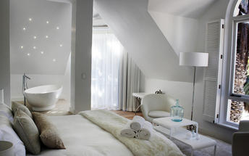

Basis
Bed and Breakfast

Day 6: Twyfelfontein Adventure Camp, Damaraland

Damaraland
Damaraland features vast khaki plains, sheer rocky mountains and incredible desert-adapted wildlife. Track rhino and desert elephant, explore the rugged land or sit back and enjoy the dramatic and endless scenery. Damaraland's hilly savannah supports a large number of species including lion, leopard, cheetah, hyena, eland, kudu, giraffe, klipspringer, steenbok, gemsbok and springbok. Birdlife is prolific with over 33 raptors recorded including cuckoo hawks, Egyptian vultures and peregrine falcons - the world's fastest animal.
Damaraland is divided into several enormous private game reserves, known as concessions, that support most species of Namibia's large game and provide some of the best birding and wildlife experiences in the country - and southern Africa for that matter.

Day Itinerary
Swakopmund – Damaraland 445km - approximately 7 to 8 hours
- Head north along the Skeleton Coast, via Henties Bay to visit the Cape Cross seal colony. Along the way, stop at the Lichen Fields as well as the ship wreck between the colourful small town of Wlotskasbaken and Henties Bay
- Backtrack to Henties Bay and head inland through wide open plains to Uis, then north to the Twyfelfontein area
- Visit to Namibia’s Open Air Museum, the Twyfelfontein Rock Engravings as well as the interesting Organ Pipes rock formations and Burnt Mountain
- Visit the Damara Living Museum for a hint of culture

Overnight: Twyfelfontein Adventure Camp View iBrochure
Against and among the granite boulders, Twyfelfontein Adventure Camp has prime location for visiting the highlights of the area. From here you can easily explore the heart of Damaraland, the sights of Twyfelfontein and track desert-adapted elephants.
Within walking distance of the Damara Living Museum, Twyfelfontein Adventure Camp (we'll call it TAC, shall we?) is a 10-minute drive from the Twyfelfontein Rock Engravings, Burnt Mountain and Organ Pipes. Situated in the Huab River Valley, there’s a chance the elephants could stroll past your tent at any moment or at the least, you won’t have to venture very far to find them.
Location is key and in that category TAC is a winner. It’s been a long day's drive from any direction to get here, so once you’ve arrived, it’s great knowing you won’t have to spend much time in the car to explore the area. Less time on the road means more time for adventure and to laze at the pool with a drink in hand. Of equal importance when on holiday.
The eco-friendly camp itself is basic, tasteful and really quite charming; add the view and the necessary comforts of a clean and decent stay and you’ll be delighted to call TAC your home for the next few nights. Two-night stays allow you to book a spectacular guided nature drive in an open safari vehicle.
Jumbled sandstone hills, platinum-blonde savannahs and olive-green shrublands make this landscape of incredible scale, colour and silence - so much silence - a marvel. See the many wildlife species that thrive here and learn how humans and wildlife including elephant, lion, rhino, antelope varieties and smaller predators have adapted to life in a land so hot and dry that it becomes ever more a wonder.
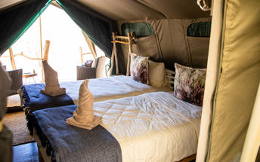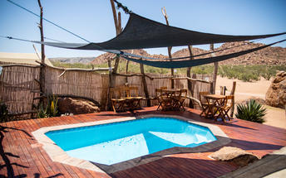

Basis
Dinner, Bed and Breakfast

Day 7: Etosha Village, Etosha South

Etosha South
Located just south of the boundary of Etosha National Park in northwestern Namibia, Etosha South makes up the southern region of this wild paradise. The area is comprised of a collection of world class private game reserves. The national park can be accessed via the southern entrance at Andersson’s Gate. Visitors can catch a glimpse of a variety of wildlife including: lion, giraffe, elephant, white and black rhino, and a multitude of plains game. Popular activities include: enjoying an open 4x4 safari with an expert guide, half day or full day drives with the option of a picnic lunch with wine on the full day game drive.

Day Itinerary
Damaraland – Etosha (south) 325km - approximately 4 to 5 hours
- After breakfast, drive east towards Khorixas stopping at the Petrified Forest en-route
- From Khorixas head further east along the tar road to Outjo and then north to your lodge which is situated very close to the southern entrance of Etosha, the Andersson Gate
- If time permits, enter Etosha for an afternoon game drive. Depending on how often you stop today, you should arrive at your lodge in time for lunch (optional extra)
- On entering the park, the first stop would be Okaukuejo where you pay your entry fee (included) and I suggest you pop in at the local shop to purchase some drinks and snacks and most importantly, a map of Etosha which will show you all the waterholes along the way
- Etosha is one of Africa’s great game parks. With 114 species of mammal and 340 species of birds you are sure to see a great variety of wildlife on your safari

Overnight: Etosha Village View iBrochure
Even before its hard refurb, Etosha Village was probably the best value safari lodge in Etosha. Replacing all tented accommodation with smart air-conditioned chalets, Etosha Village is now by far the best value safari lodge in Etosha.
Retaining its eco-conscious credentials - the bricks were salvaged from mining debris, grey water is filtered and re-used in the vegetable garden, water is solar heated and the kitchen produces a fair amount of high-quality composting material - Etosha Village had a major refurbishment in mid-2016 and what an upgrade.
Brick has replaced canvas, sleek tiles have replaced creaky wood decking and the en suite bathrooms are smart, shiny and functional. From the outside, the chalets are full of life and texture with gabion foundations, balustrades filled with pebbles, a gravelled forecourt and woven latte poles covering the roof. Inside, while a tad on the austere side, the rooms are spacious, practical and well-appointed with air conditioning, en suite bathroom, sofa bed good for two under-12s (the Village is one of a few child-friendly safari lodges in Etosha), fridge, tea/coffee, safe, balcony and a large gazebo to the side. Comfortable twin beds with soft cotton are a given.
The living areas have also retained their charm and casual comfort with a large swimming pool surrounded by loungers and parasols and a smaller pool adjacent to a third toddler-friendly pool. The food at Etosha Village is fresh and the staff here, recruited from the nearby village and trained in-house, are famous for their friendly and enthusiastic service.
Breakfast and dinner are sizeable buffet spreads and lunch is a small a la carte menu with local venison specialities. Tea, coffee, hot chocolate and juice are on the house all day and the open-air bar is a convivial spot to share a drink and a tale or just gaze into the night sky as is your want.
Being just minutes from the southern gate is ideal for daily access to Etosha National Park for guided game morning and evening drives in an open-sided safari vehicle. The vehicles accommodate up to 10 people and if that’s a bit crowded or constrained, Etosha is one of the easiest self-drive game reserves in Africa: arm yourself with a prepared breakfast and lunch or a picnic hamper from the well-stocked supply store and spend the day at any number of quiet waterholes. A good reference book, binoculars and of course your camera should be required equipment.
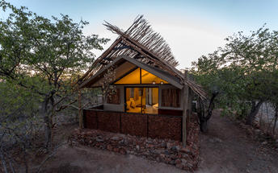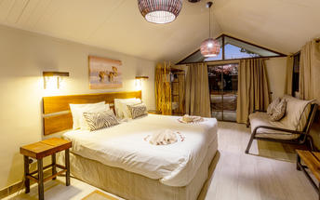

Basis
Dinner, Bed and Breakfast

Day 8-10: Onguma Bush Camp, Etosha East

Etosha East
On the eastern edge of Etosha National Park, the park itself is bordered by numerous private reserves and access into the park is via the Von Lindequist Gate, named after Dr. Friedrich von Lindequist who proclaimed it a game reserve in March 1907. This side of the park is characterised by flat endless plains, tree-savanna type of vegetation and fantastic waterholes, where you could easily spot any of the prolific wildlife Etosha is known for. There's an abundance of wildlife here.

Day Itinerary
Etosha (south) – Etosha (east) a full days game drive through the park
- From one side to the other side of the park is a full day game drive as you drive slowly east stopping at numerous waterholes along the way
- Take a slow drive in the morning and ending for lunch at the Halali Resort which is half way between Okaukuejo and the eastern exit gate or take a picnic lunch along and stop off at a waterhole
- 1 full day is set aside for game viewing, either all day or alternate with morning and afternoon drives in the area

Overnight: Onguma Bush Camp View iBrochure
Onguma Bush Camp is a comfortable, family-orientated lodge in a private reserve on the eastern edge of Etosha National Park. With 18 rooms including family suites as well as a small campsite, the atmosphere is tranquil and casual.
Onguma Bush Lodge is an alternative to staying inside Etosha National Park where your options are limited to three basic state-owned camps.
This comfortable lodge is located on the edge of the park near Fisher's Pan and the eastern entrance to Etosha. The rates are reasonable and the lodge is neat, small and an excellent base for families.
The en suite, air-conditioned rooms are built from local stone and have thatched roofs. The pool, open-air lapa and dining area provide the venues for some pleasant banter, spectacular sunsets and hearty meals. The lounge and dining area overlooks a waterhole for around-the-clock game viewing. The campsite has six sites with private ablutions and firewood; campers are welcome to make use of the bar, pool and restaurant.
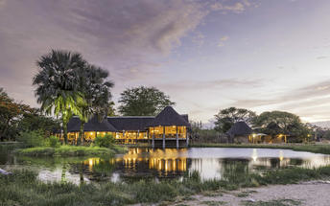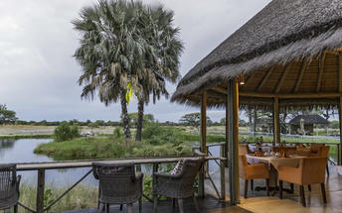

Basis
Dinner, Bed and Breakfast

Day 10-12: Shametu River Lodge, Caprivi West

Caprivi West
Caprivi West forms part of the Caprivi strip that protrudes from the northeastern corner of Namibia into Botswana and bordering on Angola. Here you're east of Rundu and on the western side of the Bwabwata National Park. The Caprivi is a lush, sub-tropical wetland offering a wealth of natural resources and serves as a haven for an abundance of wildlife, including the critically endangered African wild dog. This is the only spot in Namibia where one can spot the majestic Nile crocodile and the mighty hippo.
The Caprivi is a paradise for nature lovers with its free-roaming wildlife and postcard-perfect areas. Birdwatchers will be overjoyed as they keep an eye out for the 400 bird species that soar above. Visit the rapids of Popa Falls, go on game drives in the Mahango and Buffalo Core Areas of the greater Bwabwata National Park and enjoy the Okavango River.

Day Itinerary
Etosha (east) – West Caprivi 600km - approximately 7 to 8 hours
- Depart Etosha and drive east to Grootfontein, then north to Rundu before making your way east to Bagani, close to the Popa Falls
- A full day is set aside for a drive to the beautiful Mahango and Buffalo Game Parks, not very big but beautiful as you drive along the Okavango River
- Visit to Popa Falls
- Optional extra would be a sunset boat cruise or a Kavango Village visit in the area

Overnight: Shametu River Lodge
Picture yourself as The Mariner, Kevin Costner's anti hero, meandering through the water. Think mokoro rather than a trimaran, river rather than sea. This is for those of you that like the waterworld of Africa. But whereas the film's been described as a mess masquerading as a movie you'll exit this lodge feeling calm, chilled and chipper.
Louis and Amori fancied a retirement home in the Caprivi and this is it. Next to the Bwabwata National Park you're as close to the Kavango River you can get without actually sitting in it. The lodge literally peers out of the bushes like a lazy croc. It's an easy drive to access the small village of Divundu, which is approx 10km away - it's not much more than a petrol station and a shop of a place but it's rich in the culture of the Kavango people - locals fish with nothing more glamorous than a worm, children swim and Nguni cattle wander along. You'll also be close to the Popa Falls - more of a series of rapids running over the rocks than a waterfall but they're still stunning and popular.
Luxury chalets are big and bang on the banks of the river. You can see Popa Falls, you can hear hippos roaring. Brown leathery chairs, white bed linen. The standard chalets are not on the banks but you still get a view of the river. The luxury tents are permanent, sit on stilts and they're on the riverbanks. Definitely glamping you'll have the same ensuite, lounge area, coffee making facilities and mosquito nets as the two chalet options. The camping option's hardly slumming it either - you'll get your braai spruced up over night as well as your pots and pans washed up - when does that happen?! You'll also have your own ablution block and kitchen facilities. These have roofs so you're sheltered in the rainy season and shaded when it's hot. There's also a family style campsite if you want to share washing and cooking together. Each campsite also has access to electricity and running water.
The main lodge has a coffee shop which serves breakfast and light meals till 3pm. They also import decent coffee and the resident baker (yup, baker) bakes cakes and tarts which is extremely civilised of them.
There's a swimming pool by the river so you can watch the water flow without worrying about the crocs. Talking of predators, you can go fishing and try and snare the number one bad guy after the crocodile - the manically grinning and frankly terrifying looking tiger fish. This is a high speed killing machine and keen fishermen will know it's a source of pride to try and mess with this king. Local advice is, don't eat it, they do but apparently there are too many bones for the majority of our highly strung palates.
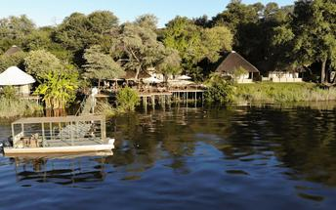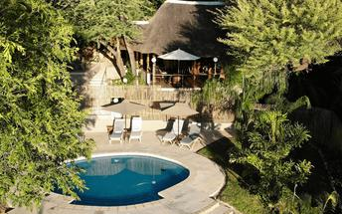

Basis
Dinner, Bed and Breakfast

Day 12: Camp Kwando, Caprivi East

Caprivi East
East Caprivi or Itenge, is situated in the corner of the Namibian panhandle known as the Caprivi Strip. Covering the eastern side of the Bwabwata National Park, the Kwando Core Area as well as the Mudumu National Park, the Nkasa Rupara National Park as far as Katima Mulilo before heading into Botswana.
This area consists of vast floodplains and lush swamplands. Wildlife is diverse and birding is excellent. Caprivi East is mostly river country, bounded by the Kwando, Zambezi, Linyanti, and Chobe rivers. The best time to spot a variety of game is the dry winter months from June to October. A chance to spot elephants, buffalo, hippo, zebra, kudu and impala, as well as crocodile, baboon and warthog. Caprivi East is an excellent destination for bird lovers to spot plovers, egrets, herons, and cranes.

Day Itinerary
Caprivi – East Caprivi 240km - approximately 3 to 4 hours
- Depart after breakfast and head east along the Caprivi strip, entering East Caprivi at the Kwando River Bridge
- Your drive today takes you through the Bwabwata National Park

Overnight: Camp Kwando
Camp Kwando is a rustic and relaxed riverside lodge with three types of accommodation: camping, island chalets and tree houses. The camp has a shaded swimming pool and a thatched lounge, restaurant and bar that open onto the river.
Despite the civilising effects of a well-tended lawn and a grand entrance, Camp Kwando (formerly Kwando River Lodge) remains a charming, rustic and remote riverside lodge that will not bowl you over for price or ostentation.
The camp is sandwiched between the Botswana border to the west - you'll need to look at our map to make sense of that - and the Mudumu National Park to the east. Eight thatched chalets line the bank of a small island in the Kwando River and there are three up-market tree houses on higher ground; a camping area with ten sites makes good use of the shaded area between lodge and island.
The island chalets have open-air bathrooms with hot showers and flushing toilets and you can fish from your balcony. While hurricane lamps set the mood, the lush African bush will do all the seducing. Although similar, the tree houses raise the bar in the style, romance and view departments. Camping facilities include communal ablutions with hot showers and a laundry and washing area.
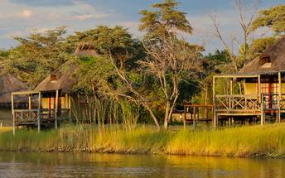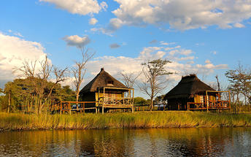

Basis
Dinner, Bed and Breakfast

Day 13-15: Chobe Safari Lodge, Chobe River Front

Chobe River Front
The Chobe River forms the northern boundary of the Chobe National Park which is renowned for its diverse and abundant game viewing opportunities. This section of the park is best known for its dense concentration of wildlife, including elephant and hippo populations, but the waters attract all manner of game including large herds of buffalo and the lions that prey on them - a visit to the Chobe River Front guarantees close encounters with an array of African wildlife. Visitors can look forward to a range of exciting activities such as 4WD along the banks; motorboat cruises; and rare birdlife spotting. For a unique, luxury safari experience, hire a houseboat.

Day Itinerary
East Caprivi – Katima Mulilo 140km - approximately 2 to 3 hours
- Head north to Katima Mulilo where your Namibia section of this holiday ends
- Your guide will drop you off at Caprivi Adventures in Katima Mulilo and then they will transfer you into Botswana. They will drop you off at your lodge in Kasane which is the town close to the Chobe National Park
- A full day is set aside to enjoy next to the Chobe River
- Activities included:
- 1 guided game drive into the Chobe National Park
- 1 game viewing boat ride on the Chobe River … an amazing experience
(Please note that Chobe National Park entry fees are not included and payable direct as this can change any time and cannot be arranged in advance)

Overnight: Chobe Safari Lodge View iBrochure
Under One Botswana Sky comprises eight safari lodges and camps and one of the lucky winners is Chobe Safari Lodge, in Kasane, Botswana.
Chobe Safari Lodge sits on the edge of the Chobe River (as the name would suggest), but that also means that it borders four countries! Yup, that means you can quickly run off to Zambia is you feel like it. Clearly, this is going to be the easiest cross-country road trip yet...
This is quite a romantic spot, while you can see it is decorated in a traditional safari style; the pool, room service and private cruises tell a different, more luxurious story.
Here you can stay in a variety of accommodation such as suites, rooms, bungalows and even camping. The accommodation is a little less fabulous than the private cruise waiting for you, but we can let it slide. The rooms are very simple with double beds, a desk and an en-suite, but unfortunately no mini-fridge and water (something you expect if you don't want to run to the bar each time for a glass of water.) However there is a TV, Wifi and as we mentioned before, room service.
But let's be fair, if you come all this way you are not going to be spending much of your time in the room anyway. Outside you have a huge pool waiting for you, an open plan restaurant overlooking the pool and that gorgeous view of the river and a small island opposite that would make anyone back at home jealous. When you go have dinner, make sure to dive into a Kudu steak, it's the best one you will ever have.
There is also a little shop, a health and beauty salon and cocktail bar for your to indulge in with gifts, a new holiday (or honeymoon) look and a fancy drink on top of it all just because you deserve it.
With this picture-perfect view and never-ending river, we won't forgive you if you are just sitting at the pool all day. Make sure to tackle land and water with that private boat cruise or a game drive to spot the iconic Chobe elephants. If you are tempted by what's around the corner you can even book an overnight or day trip to go to the Victoria Falls.
It is worth the mention that Chobe Safari Lodge is the oldest one in the region, so while some things might be out of date (and style) other things have just been perfected. Here it's all about the safari experience and you're bound to have one of the most memorable safari experiences by far.
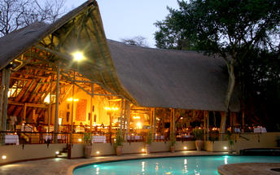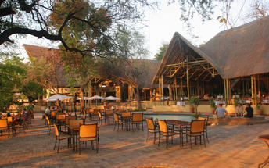

Basis
Half Board Plus - Dinner, Bed, Breakfast and Activities

Day 15: Batonka Guest Lodge, Victoria Falls (Zimbabwe)

Victoria Falls (Zimbabwe)
A gazillion tonnes of water thundering over a sheer cliff drowns all other sounds. The swirling mist hides all sign of human activity. Beyond your rain forest sanctuary people are hurling themselves off bridges, across gorges, into walls of raging water and out of aircraft.
Victoria Falls is a paradox of tranquil beauty and exciting adventure.
Mosi-oa-Tunya, 'The Smoke that Thunders' is undoubtedly Zimbabwe's finest and most well-known attraction. It is or rather was (if you're keeping up with the latest list) one of the Seven World Wonders. We still believe it deserves the title. It truly is spectacular and not considered to be one of the world's largest waterfalls without good reason. It's not the widest or the highest , yet it is considered to the largest based on it's combined width, at 1,708 metres wide and height, at 108 metres. Impressively it takes the title for the largest sheet of falling water.

Day Itinerary
- Enjoy breakfast and then you will be transferred to Victoria Falls into Zimbabwe … your driver will assist with the border crossing which is an experience in itself
- Visit to Victoria Falls this afternoon, either on your own or arrange to go with a guide
- Recommended is a sunset Zambezi boat cruise to end the day (optional extra) or look to dine at The Boma Restaurant for a taste of the African flavours, action, music and atmosphere

Overnight: Batonka Guest Lodge View iBrochure
Batonka Guest Lodge is a hybrid of a boutique hotel and owner-run guesthouse on the outskirts of Victoria Falls on the Zimbabwean side. In a quiet spot with immaculate gardens, you're close enough to explore the falls.
The Batonka has 27 rooms arranged around a swimming pool and an immaculate garden; a large living area houses the reception, curio shop, dining room, lounge, bar and huge shaded verandah.
Decor is simple and stylish with a nod to the elegance of colonial times and a full-on yodel to the sophistication of modern times. Mozzy-netted four-poster beds dominate the large rooms and the en suite bathrooms are enormous - all have extra-big shower units, some also have bathtubs. Tiled floors, ceiling fans and air conditioning take care of the temperatures and the water is solar-heated. A large flat-screen TV and Wi-Fi tick the downtime box as does the small balcony overlooking the garden.
Claire and Rowan and their delightful team make the difference between a well-priced, well-appointed guesthouse and the highlight accommodation of your holiday. Batonka quickly made its mark, which is hardly surprising given their pedigree. We have every confidence these high standards will be maintained.
So in Batonka Guest Lodge you’ve got a well-priced, comfortable and friendly place to stay. What more could you want? How about one of the Seven Wonders of the Natural World a pleasant half hour walk away?
Victoria Falls is one of those experiences that never gets old. Through a dense rainforest of its own making you hear the roar long before arriving at the sheer cliff opposite the thundering cascade. The power and scale of the world’s largest waterfalls are at once exhilarating and just that little bit terrifying. And of course, in addition to spending a day exploring the waterfalls from all angles, there is a silly amount of additional activities to choose from. Your hosts will book all your activities for you and even lay on a shuttle for the purpose, the only difficulty will be in choosing what to do.
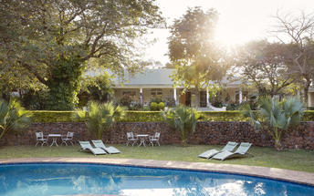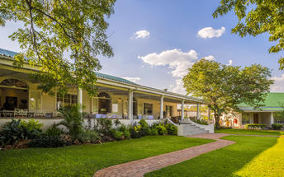

Basis
Bed and Breakfast

Day 16: End of Itinerary

Day Itinerary
- Squeeze in a morning activity if time allows. Choose from the many on offer.
- Road transfer from the lodge to the airport in time for your departure flight
- End of services

Basis
Bed and Breakfast

Transport

Transfers
Date | Company | Pick Up | Drop Off | Time | Vehicle
 |  | Hosea Kutako International Airport [WDH] | The Elegant Guesthouse |  | Fully Guided Trip
 |  | The Elegant Guesthouse | Desert Quiver Camp |  | Fully Guided Trip
 |  | Desert Quiver Camp | Swakopmund Luxury Suites |  | Fully Guided Trip
 |  | Swakopmund Luxury Suites | Twyfelfontein Adventure Camp |  | Fully Guided Trip
 |  | Twyfelfontein Adventure Camp | Etosha Village |  | Fully Guided Trip
 |  | Etosha Village | Onguma Bush Camp |  | Fully Guided Trip
 |  | Onguma Bush Camp | Shametu River Lodge |  | Fully Guided Trip
 |  | Shametu River Lodge | Camp Kwando |  | Fully Guided Trip
 |  | Camp Kwando | Caprivi Adventures |  | Fully Guided Trip
 |  | Caprivi Adventures | Chobe Safari Lodge |  | Transfer
 |  | Chobe Safari Lodge | Batonka Guest Lodge |  | Transfer
 |  | Batonka Guest Lodge | Victoria Falls International Airport [VFA] |  | Transfer

Urgent Contact Numbers
Company Name | Telephone | Email Address | Contact Person
Namibia Tours & Safaris | +264 64 40 6038 | tanya@namibia-tours-safaris.com | Tanya Coetzee
Namibia Tours & Safaris - Emergency Contact | +264 81 784 4315

Service Provider Directory
Service Provider | Ref. Number | Telephone | Address
Batonka Guest Lodge |  | +263832846923 | 1406 Reynard RoadVictoria Falls00000
Camp Kwando |  | +264 81 209 9033 | C49, KongolaKongola9000
Desert Quiver Camp |  | +27 21 930 4564 | On the D826 / C27 Road to Sossusvlei  Sesriem  Namibia
Onguma Bush Camp |  | +264 61 23 7055 | Onguma Game Reserve  Eastern Border of Etosha National Park,  Namibia
Shametu River Lodge |  | +264 66 25 9035 | 7 km on C48Divundu9000
Swakopmund Luxury Suites |  | +264-64-463298 | A. Tobias Hainyeko & Am Zoll Street, 228cSwakopmund9000
Taleni Etosha Village |  | +27 21 930 4564 | On C38 from Outjo to Okaukuejo (2 km from the entrance gate to Etosha National Park)
The Elegant Guesthouse |  | +264 61 23 7294 | Von Eckenbrecher StrKlein Windhoek9000
Twyfelfontein Adventure Camp |  | +264 81 288 4528 | 200m south of T-junction D 2612 / 3254(90km west of Khorixas)Twyfelfontein9000

Terms and Conditions

Namibia Tours & Safaris Terms and Conditions
Contract
1.1 The contract will become effective as from the date the invoice is completed and the deposit, referred to in Clause 2.1, is received by Africa Tours & Safaris CC (hereinafter known as the Company).
1.2 The contract is subject to the Namibian Law.
1.3 Any person making a reservation as per Clause 8.4 accepts the terms and conditions of this agreement set out hereunder.
How to Book
2.1 A 20% deposit of the full amount due is required to confirm any reservation and is to be done by the agent or client (see Clause 8.1) in writing or by e-mail.
2.2 The Company must receive the balance of the contract price no later than 42 days (6 weeks) prior to departure.
2.3 If the Company does not receive the full contract price 42 days (6 weeks) before the departure date, the Company may cancel the reservation and retain whatever deposit or other funds it has already received from the client or his agent.
How to Pay
3 The payment options will be provided upon confirmation of a booking.
Our Cancellation Policy
4.1 Any cancellation of a confirmed booking must be done in writing (email) to the Company whereupon cancellation charges as per Clause 4.2 will apply.
4.2 The following cancellation fees (as a percentage of the fully quoted price) are applicable to any cancelled travel:
Notice from date of travel: Cancellation fee:
42 days or more 20% (deposit forfeited)
29 – 41 days 50%
15 – 28 days 75%
0 – 14 days 100%
Please note: the notice period is calculated from the date of cancellation to the start date of the tour/safari booking.
4.3 No refund will be made by the Company if, for any reason, inclusions or parts of the tour cannot be carried out / or utilised. These would include all facets such as meals, game drives, accommodation etc. This would also apply to any client who has booked a tour but fails to undertake the tour for any reason.
Our Changes Policy
5 If a booking is changed to an earlier date than originally reserved, the Company will endeavour to change it. If the booking is for a later date, charges as per Clause 4.2 could apply.
As things go, we've all had to adapt to changes during the Coronavirus pandemic and so too have we therefore amended our terms and conditions for travel during such times. Check out the Updated COVID Terms and Conditions here.
Price Changes
6.1 The Company reserves the right to increase the price of any tour prior to departure due to factors beyond the control of the Company, such as, without being limited to, and increase in fuel prices, new Government legislation, accommodation price increases, fluctuations in exchange rates, etc.
6.2 If the Company announces an in increase in the tour price in terms of this Clause, such addition amount must be paid to the Company before the departure of such tour or else the Company shall have the right to cancel the tour and the charges in Clause 4.2 will apply.
Changes to Itineraries
7 The Company shall at any time have the right, in its entire discretion, to alter the terms of the booking in relation to the route, timetable, itinerary and accommodation. The Company shall, however, make every effort to offer the client an alternative tour of a comparable standard.
Should the alternative be of a lesser standard, the client will be refunded the difference, but should there be an increase, the client shall have the right to either reject the alternative and obtain a refund of the relevant portion of the original contract sum, or to accept the alternative and pay the increased cost. In the event of the client rejecting the alternative tour and claiming a refund, such rejection will be treated as a cancellation and the refund will be calculated according to Clause 4.2 hereof. The client shall have no claim against the Company for any damages arising out of the alternative booking.
Responsibility and Liability
8.1 Neither the Company nor any person acting for through and on behalf of the Company shall be liable for any loss or damage whatsoever arising from any cause whatsoever and without restricting the generality of the aforegoing shall particularly not be responsible for the loss or damage arising from any errors or omissions contained in its brochure or other literature, late or non-confirmation or acceptance or bookings, loss or damage caused by delays, sickness, injury or death, whether occasioned by negligence or not.
8.2 The Company shall have the right at any time at is sole discretion, to cancel or the remainder thereof or to make an alteration in the route, accommodation price or other details. This would include any event of any tour being rendered impossible, illegal or inadvisable by weather, avalanches, strike, war, government or other interference or due to any other cause whatsoever. The extra expenses incurred as a result thereof shall be the responsibility of the client.
8.3 The Company may at its discretion and without liability or cost to itself at any time cancel, or terminate, a client's booking and in particular, without limiting the generality of the aforegoing, it shall be entitled to do so in the event of illness or the illegal or incompatible behaviour of any client undertaking the tour, who shall in such circumstances not be entitled to any refund.
8.4 Any person making a reservation with the Company (refer to Clause 1.1) warrants that her or she has the necessary authority to enter into this contract on behalf of the person or persons included in such a booking. The person making the reservation shall be liable for the total amount due to the Company.
Client's Obligations
9.1 It is the onus and responsibility of the client to obtain the necessary comprehensive insurance before departure for any possible cancellations, medical expenses, protection or personal property and money.
9.2 The onus is upon the client to ensure that passports and visas are valid for the duration of the safari. The Company cannot be held liable for any necessary visas or other travel documents not held by clients. In the event of a client not having the necessary documentation to enter any area or country the Company shall reserve the right to leave the client a the point of entry of such area or country. In such an event, the Company will not be held responsible to the client for further travel arrangements.
9.3 The onus is upon the client to ensure that the SARS-CoV-2 PCR tests are done prior to commencement of the safari and valid on arrival in accordance to the requirements of the country of intended travel and for the airline with which the client will travel. The same applies for any necessary testing for departure. The costs of any such COVID testing will be for the clients own account. While The Company can assist with arrangements for testing in-country, The Company will not be held responsible to the client for such arrangements and with regards to return time of test results.
9.4 Should the client need to undergo mandatory quarantine once in-country with regards to the SARS-CoV-2 virus, either on arrival as called for by the authorities or due to testing positive once in-country, this will be at the clients own expense.
Health and Personal Safety
10.1 The client shall be reasonably fit to undertake the tour.
10.2 Anti-malaria precautions should be commenced prior to tour departure. A medical doctor should be consulted for advice.
10.3 Tours offered by the Company cover a wide spectrum of the African wilds and neither the Company, its employees or agents can be held responsible for any injury or other related incidents whilst on the tour / safari.
10.4 The Company cannot be held responsible for any client who falls ill or contracts the SARS-CoV-2 virus while in-country. The client accepts that travel is at own risk.
Baggage
11.1 Clients are limited to one soft sports type bag per person with a maximum weight of 20 kilograms. This includes photographic equipment and hand luggage.
11.2 Due to the rugged terrain, the Company cannot be held responsible for damage or loss of any personal items including bags, contents of bags or photographic and related equipment. Due to extremely dusty conditions, please ensure all bags are dust proof.
Airline and Car Hire Clause
12.1 The Company will act as the agent of the client when booking the client with a car hire company, an airline or air charter service. The client therefore contracts with the car hire company, airline or charter service and not with the Company.
12.2 Charter flights are normally operated by smaller type aircraft such as Cessna 210. Luggage is strictly limited to 10-15 kgs (depending on terms of particular airline used) per person in soft hold all type bags. Due to the desert heat, it is not safe to overload aircraft thus this limit needs to be strictly controlled.
Travelling or thinking of travelling during the COVID-19 pandemic? Take a look at our COVID Terms and Conditions for more information on how this will work and differ from our standard terms and conditions as listed above.

