TWALA TENEBO – DAY TRIP – IL POLEI

Twala-Tenebo is located in the semi-arid Laikipia plateau, near Mount Kenya in northern Kenya. There, a cooperative of over 200 women from six different Maasai groups coexist with the diverse wildlife and sustain themselves through aloe farming, beadwork, beekeeping and ecotourism—offering authentic Maasai cultural experiences and affordable eco-manyatta accommodations.
Twala’ is a Maasai word for a bell. ‘Tenebo’ means come together. In 2007, the “bell rang” as a symbol of calling the Maasai women to action for their capacity enhancement. They joined hands and established a cultural center together. The center works towards empowering women to work for themselves and preserve the rich cultural and historic heritage of the local Maasai people.

The women of Twala are involved in agro-tourism as they plant Aloe secundiflora, which they do without using any chemical fertilizers so as to avoid soil and water pollution. They also keep bees for honey production. They use the aloe for production of natural beauty products and sell it to beauty firms. At Twala, all profits go directly to the community and are utilized for the benefit of poverty reduction and sustainable development. 10% of the income earned in the center goes towards supporting girls’ education. The cultural center also empowers women as they get to work and provide for themselves.

Memorable baboon walks alongside troops to show that baboons and wildlife in general are a resource worth protecting; walks with the Maasai and their cattle to learn their authentic herding techniques; Landscape tours to learn about the medicinal plants and other importance of trees to the Maasai people. Learn how the people and their domestic animals as well as wildlife coexist in one environment in a sustainable manner.

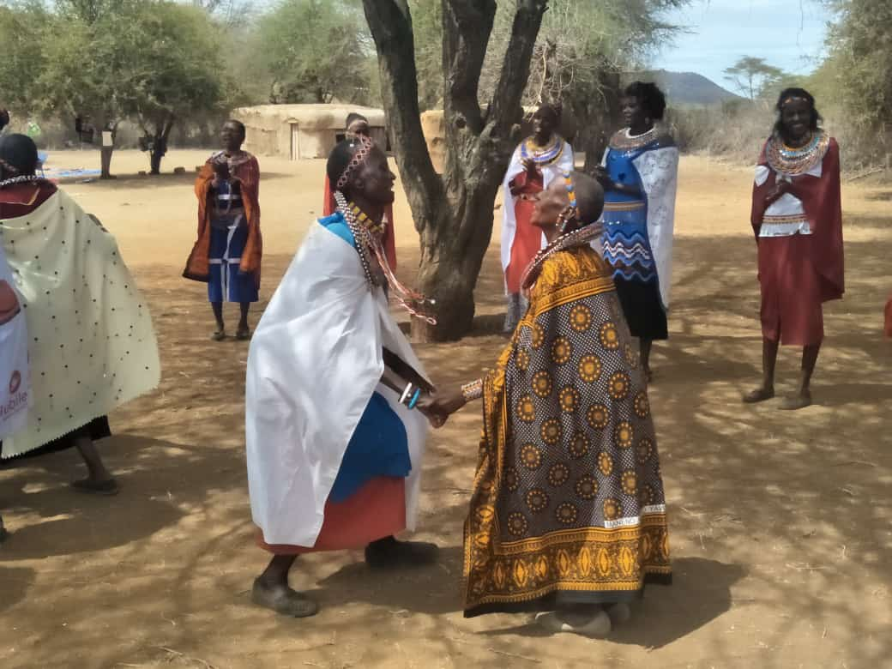

ITINERARY:
0530hrs Drive from Nanyuki to Il Polei
0700 hrs. Meet the baboons as they wake up and cross the river in trees overhead and then follow
them through their morning activities.
0930hrs Visit Twala Tenebo and learn about Maasai culture and the women project.
1230 hrs Return to Nanyuki

Or

1200hrs Drive from Nanyuki to Il Polei
1330hrs Visit Twala Tenebo and learn about Maasai culture and the women project.
1600hrs Follow the baboons as they wind up their day and return to the river & fig trees for the night.
1800hrs Return to Nanyuki

PRICE IN USD:
80 USD pp

RATE INCLUSIONS:

- Professional English-Speaking Guide
- Return ground transport: Pick-up & drop-off at hotel
- Sanitizers, Masks & Drinking Water during trip

