

11-Day Ultimate Zambia Safari - Luxury - NETT

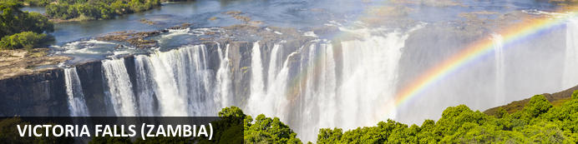
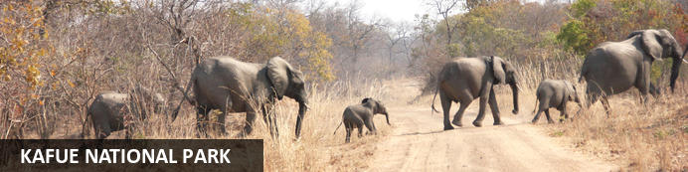
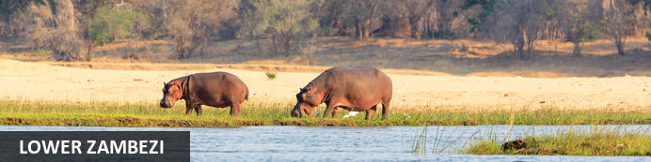
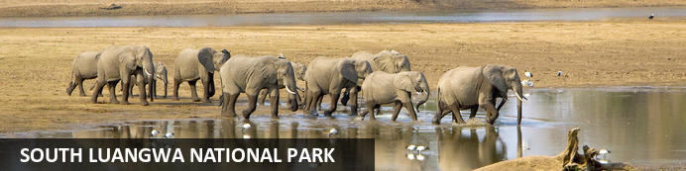

11-Day Ultimate Zambia Safari - Luxury - NETT
Victoria Falls (Zambia) - Kafue National Park - Lower Zambezi - South Luangwa National Park
11 Days / 10 Nights
Date of Issue: 13 March 2023

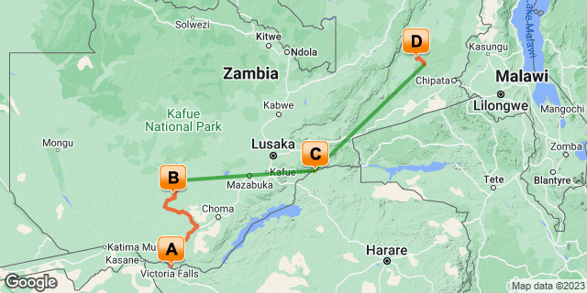

Click here to view your Digital Itinerary

Introduction
This 11-Day Ultimate Zambia Safari includes the very best of Zambia with a visit to the magnificent Victoria Falls, Kafue National Park, Lower Zambezi and South Luangwa. A wildlife and game viewing extravaganza!
If you wish to end in Livingstone again, this can be quoted additionally.

Accommodation | Destination | Basis | Duration
The Royal Livingstone Victoria Falls Zambia Hotel by Anantara | Victoria Falls (Zambia) | B&B | 2 Nights
Nanzhila Plains Safari Camp | Kafue National Park | FI | 3 Nights
Royal Zambezi Lodge | Lower Zambezi | FI | 2 Nights
Nkwali Camp | South Luangwa National Park | FI | 3 Nights

Key
B&B: Bed and Breakfast
FI: Fully Inclusive - Bed, All Meals, Fees and Activities

Price
NETT STO COSTS
1st January 2023 – 31st May 2023
2 guests - USD 6 030 per person sharing
Single Person - USD 7 720
1st June 2023 – 30th November 2023
2 guests - USD 7 210 per person sharing
Single Person - USD 8 760
1st December 2023 – 31st December 2023
2 guests - USD 6 030 per person sharing
Single Person - USD 7 720

**Rates are subject to change

Included
- Accommodation as indicated – can change depending on availability and request at time of booking
- Meals as indicated
- Activities as indicated
- Welcome services
- Road transfers as necessary
- Charter flights as indicated
- 1 x African Queen sunset cruise on the Zambezi River (Livingstone)
- 1 x Guided tour of the Falls
- 1 x Helicopter flight over the Falls (short flight)
- Tour file with detailed itinerary, map with route descriptions, vouchers etc.
- 24 hour personal and friendly support
- Fast and efficient response to service providers

Excluded
- Items of a personal nature
- Optional extra activities
- International flights
- Holiday or personal insurance
- Staff gratuities
- Park entry fees (unless stated)
- Visas and visa fees

Day 1-3: The Royal Livingstone Victoria Falls Zambia Hotel by Anantara, Victoria Falls (Zambia)

Victoria Falls (Zambia)
One of Zambia's main highlights, alongside all its incredible wildlife destinations, Victoria Falls about midway on the Zambezi River course is spectacular. The largest sheet of falling water in the world with a mean flow of 935 cubic metres per second. Crazy.
Cruise the Zambezi River, at sunset and for dinner is recommended. Take a helicopter flip over the falls, it's not called " The Flight of Angels" for nothing. It's well worth it. A chance to grasp just how incredible the falls really are. Meander the rain forests. Adrenaline activities abound, which of course Devil's Pool is front runner on the Zambian side from Livingstone Island. You will actually swim to the edge of the falls and plunge into the natural rock pool on the ledge. It's one for daredevils. Only conducted when the water levels are low enough, so if this is a must on your activity list then you'd best plan for travel between late August to early January. Even then this depends on rainfall so best to check in advance.

Day Itinerary
- Welcome services on arrival at Livingstone Airport
- Road transfer from Livingstone Airport to your hotel
- Airport Transfer Time: 20 minutes
- Enjoy the activities as included:
- 1 x African Queen sunset cruise on the Zambezi River
- 1 x Guided tour of the Falls (Zambian side)
- 1 x 15 minute Helicopter flight over the falls
- Enjoy additional meals in town or at the hotel (optional extra)

Overnight: The Royal Livingstone Victoria Falls Zambia Hotel by Anantara
The Royal Livingstone is an opulent and luxurious resort-hotel a short walk from Victoria Falls on the Zambian side of the Zambezi River.
A palatial and opulent ode to African extravagance, the Royal Livingstone is a plush and swanky-looking hotel on the edge of the Zambezi River a short walk from Victoria Falls on the Zambian side.
With personal bus-boys, spacious rooms with modern and luxurious amenities, the Royal Livingstone offers comfort and convenience with just a hint of Vegas-glitz. The rooms all have en suite bathrooms with shower and separate baths, private balconies and the gamut of in-room niceties you'd expect of a quality hotel.
Dining is a feature at the Royal Livingstone within the sound of Victoria Falls, its single cascade producing a constant rumble like the sound of the ocean - or traffic, depending on where you live. The dining room is a smart and sophisticated experience with a variety of meats and styles on an a la carte menu; and the sun deck and lounge look out over the river and serve light lunches and cocktails into the night.
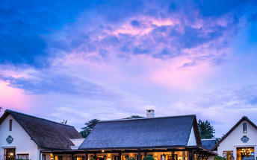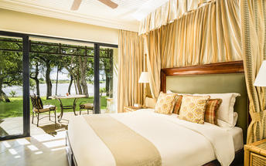

Basis
Bed and Breakfast

Day 3-6: Nanzhila Plains Safari Camp, Kafue National Park

Kafue National Park
Kafue National Park has an extraordinary diversity of habitats including dense forests along the perennial rivers, undulating miombo and mopane woodlands, grassy savannah plains and the 750sq km Busanga floodplains which attract various plains game and flocks of birds during its seasonal recession.
Kafue National Park has the highest species list of any park in Zambia. Kafue is probably the best place to see cheetah in Zambia; lion and leopard are also plentiful and the park has one of the widest range of antelope in the region.

Day Itinerary
- This morning you will be collected and transferred by private road transfer to Nanzhila Plains Safari Camp
- The transfer is roughly 3 hours from Livingstone to the Dundumwezi Gate. From here you will continue to enjoy an approximate 2 hours game drive into the camp
- 2 full days are set aside to enjoy any of the scheduled camp activities on offer:
- Day & night game drives
- Guided walking safaris
- Park excursions
- Visits to Lake Itezhi-Tezi
- Village tours

Overnight: Nanzhila Plains Safari Camp
Inside the southern section of Kafue National Park with access to an astonishing 3,000 sq km of unrivaled African wilderness, Nanzhila Plains Safari Camp is the real deal authentic Zambian safari.
With only three chalets and three safari tents, this intimate camp won’t have you sharing with more than 11 other guests at any given time. With a large area inside the park to itself and being one of only a small group with access to it, the odds here are in your favour.
The owners, your personal hosts, will ensure you are comfortable and their attention to detail is tangible. Enjoy their first-hand stories of the bush and then head off with your guide to create your own. Discover the diverse wildlife of the Kafue National Park. A chance to view four of the big five (you won’t see rhino but everything else and a whole lot more).
Along the tree line overlooking the natural water pan, the chalets and tents are found by forged path through the bush. Watch and wait as the elephant come to drink at the small grassy floodplain out front. Relax and immerse yourself in nature. That's what you're here for right? Well when you aren't on a game drive or bush walk that is.
A three hour drive or a mere hour flight from Livingstone or Lusaka and you are there. This is the closest bona fide safari camp to Victoria Falls on the Zambian side. And if you're flying, enjoy the 90-minute game drive from the Ngoma Airstrip to the lodge on arrival.
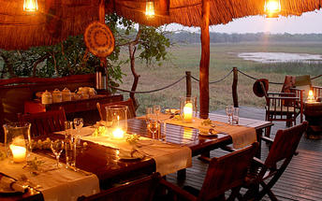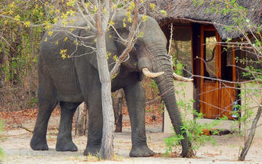

Basis
Fully Inclusive - Bed, All Meals, Fees and Activities

Included
- All meals, activities, local drinks, park fees & levies

Excluded
- Premium drinks

Day 6-8: Royal Zambezi Lodge, Lower Zambezi

Lower Zambezi
Zambia's Lower Zambezi is fast becoming a major game park in the region with excellent wildlife safaris. With about 120km of river frontage, this wild and undeveloped park is a vast floodplain of tributaries, islands and channels beyond which its grassy acacia plains rise up to a heavily wooded escarpment. Across the river is Zimbabwe and Mana Pools effectively making one large game reserve of quite magnificent constituents.
A safari on water is as relaxing and enchanting as a safari on foot is exciting. The ever-changing scenery is always magical with large heavy-limbed trees overhanging the water, lush islands and winding channels. The game viewing is excellent as you draw no attention and pose no threat in your silent, gliding vessel.
Game drives, walking safaris, sport fishing, canoeing and night drives all feature on your daily to-do list in the Lower Zambezi National Park with the variety of wildlife and birdlife never far from your binocular vision.

Day Itinerary
- This morning after breakfast and an activity (if time allows), you will be transferred to the airstrip for your onward flight
- Charter flight from Kafue to Royal Airstrip
- 1 full day is set aside to enjoy any of the scheduled camp activities on offer, which include:
- Day and night game drives
- Canoeing
- Fishing
- Boat cruises

Overnight: Royal Zambezi Lodge View iBrochure
With no fences around the lodge, you’re immersed into the African wilderness of the Lower Zambezi. Don’t be surprised, you could almost reach out to touch the passing elephant from your tent, the viewing deck or metres from the swimming pool. Don’t actually try it though.
Besides the other guests, you may even be lucky enough to welcome hippo, buffalo, lion and leopard into camp. (Don’t stress it. You’re perfectly safe.) Your lodge guides are well trained and will escort you to and from the main areas to your tent at all times. This is what being on safari is all about.
Inside the Chiawa Game Management Area, along the northern bank of the Zambezi River, you’re privy to 3,5km of unspoilt river frontage. Opposite the Mana Pools National Park and against a backdrop of the Zambezi Valley ridge. Ideally located, you are minutes away from the Lower Zambezi National Park and all the incredible sightings you are bound to experience. This is prime wildlife area. A whole 200 hectares of it. Wow!
All it takes is a 30 minute flight by small aircraft from Lusaka to Royal Airstrip and you are touching down for a safari the moment you arrive. Possible too by boat or by road if you're up to the 70km of sensationally slow-going jeep track. If this doesn't shout middle-of-nowhere then your hearing aid needs testing. This is one of Zambia’s best areas for game viewing.
Royal Zambezi Lodge is family owned and intimate. So if the abundance of wildlife isn’t enough to blow you away, the hospitality on offer sure will win you over. Head out into the bush on numerous activities with your lodge guide or simply do nothing, a strong recommendation here. Stay longer to do it all. You’ll be sorry if you don’t. Family friendly (for children from age 8), there’s loads to keep the kids busy too.
Stop during a boat cruise to play on a sand bank, angle for smaller species than the fierce tiger fish or custom your game drive to keep the young ones entertained. Want to enjoy a romantic dinner? No problem. You can leave the kids sound asleep in your suite watched over by security guards. Meal times can be tailored for the kids and the menu too. After a day of activities and a full belly, they'll sleep like a dream. Win win.
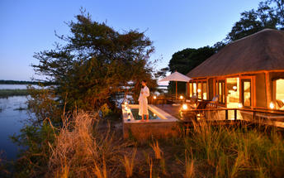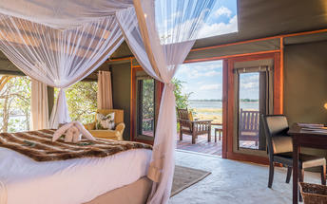

Basis
Fully Inclusive - Bed, All Meals, Fees and Activities

Included
- All meals, 2 activities per day, local drinks and airstrip transfers

Excluded
- park fees, laundry, spa treatments, premium drinks, fly fishing & private vehicle/ boat hire

Day 8-11: Nkwali Camp, South Luangwa National Park

South Luangwa National Park
While most of Zambia's parks are forced into hibernation over the rainy season, from November to March, the South Luangwa National Park shines as an exceptional green destination.
Discover abundant wildlife and unspoiled bush. This is Zambia's premier wildlife destination. A big game safari guaranteed. Largely unexplored and untouched, South Luangwa National Park is as raw and wild as it gets. Its the birthplace of guided walking safaris so explore the bush on foot, the guides here are some of the best.
Guided game drives and night drives deliver great sightings. Expect large elephant and buffalo herds and a high density of leopard. And phenomenal birding especially during rain season (November to April).

Day Itinerary
- This morning after breakfast and a morning activity (if possible), you will be transferred back to the airstrip for your onward flight
- Charter flight from Royal Airstrip to Mfuwe Airstrip
- You will be met by your lodge guide at the airstrip on arrival and enjoy your transfer into camp which is more of a 45 minute to 1 hour game drive
- 2 full days are set aside to enjoy your activities as included with the lodge, such as:
- Day and night drives
- Guided walking safaris
- Boating (seasonal)

Overnight: Nkwali Camp View iBrochure
Nkwali Camp is on a private game reserve on the edge of the Luangwa River and the South Luangwa National Park.
Nkwali Camp has six large suites with thatched roofs, cool stone floors and a private veranda with a view of the beautiful river and its stream of wildlife. The front of each suite opens to the view by day and closes to the creepy crawlies by night. Mosquito nets draped over the massive beds make a romantic scene of the interior and the bathrooms have twin basins and an indoor/outdoor shower.
The living area at Nkwali Camp lines the river with a wooden deck that hovers above the high water line in the deep shade of an old and well-nourished old ebony tree. Dinner venues vary from beneath the stars on the deck, beneath the stars and out in the open of the bush and in the cosy dining gazebo.
The convivial bar and lounge area makes a suitable show of the glorious sunsets over the river and the ox-bow lake that surround the lodge.
Access into the park from Nkwali Camp is usually by boat, though the river is fordable from about August to October. Mfue Airport is a 40-minute transfer away from the South Luangwa National Park, which is Zambia's foremost safari destination and one of the best in Africa.
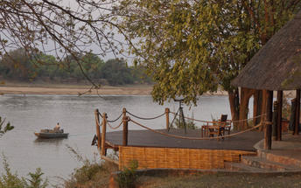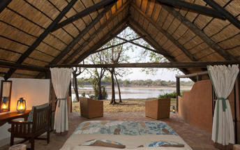

Basis
Fully Inclusive - Bed, All Meals, Fees and Activities

Included
- All meals, 2 activities per day, local drinks and airstrip transfers

Excluded
- Park fees, laundry, spa treatments, premium drinks, fly fishing & private vehicle/ boat hire

Day 11: End of Itinerary

Day Itinerary
- After a morning activity (if time allows) you will be transferred back to the Mfuwe Airstrip
- Charter flight from Mfuwe Airstrip to Lusaka International Airport where your tour comes to an end.
- This will be arranged so that you arrive in time for your departure flight.
- End of services

Basis
Bed and Breakfast

Transport

Flight Information
Date | Flight | Airline | Departure Airport | Time | Arrival Airport | Time | Class | Ref
 | Charter Flight |  | Ngoma Airstrip |  | Royal Airstrip
 | Charter Flight |  | Royal Airstrip |  | Mfuwe Airport [MFU]
 | Charter Flight |  | Mfuwe Airport [MFU] |  | Kenneth Kaunda International Airport [LUN]

Transfers
Date | Company | Pick Up | Drop Off | Time | Vehicle
 |  | Harry Mwanga Nkumbula International Airport [LVI] | The Royal Livingstone Victoria Falls Zambia Hotel by Anantara |  | Fully Guided Trip
 |  | The Royal Livingstone Victoria Falls Zambia Hotel by Anantara | Nanzhila Plains Safari Camp |  | Fully Guided Trip
 |  | Nanzhila Plains Safari Camp | Ngoma Airstrip |  | Fully Guided Trip
 |  | Royal Airstrip | Royal Zambezi Lodge |  | Fully Guided Trip
 |  | Royal Zambezi Lodge | Royal Airstrip |  | Fully Guided Trip
 |  | Mfuwe Airport [MFU] | Nkwali Camp |  | Fully Guided Trip
 |  | Nkwali Camp | Mfuwe Airport [MFU] |  | Fully Guided Trip

Urgent Contact Numbers
Company Name | Telephone | Email Address | Contact Person
Namibia Tours & Safaris | +264 64 40 6038 | tanya@namibia-tours-safaris.com | Tanya Coetzee
Namibia Tours & Safaris - Emergency Contact | +264 81 784 4315

Service Provider Directory
Service Provider | Ref. Number | Telephone | Address
Nanzhila Plains Safari Camp |  |  | Zambia
Nkwali Camp |  | +260 95 7090441 | South Luangwa National Park
Royal Zambezi Lodge |  | +260 96 6748249 | Chiawa GMALower ZambeziNo postal code for Location ID: 273
The Royal Livingstone Victoria Falls Zambia Hotel by Anantara |  | +260 21 3321122 | Mosi-oa-Tunya Road  Livingstone  Zambia

Terms and Conditions

Namibia Tours & Safaris Terms and Conditions
Contract
1.1 The contract will become effective as from the date the invoice is completed and the deposit, referred to in Clause 2.1, is received by Africa Tours & Safaris CC (hereinafter known as the Company).
1.2 The contract is subject to the Namibian Law.
1.3 Any person making a reservation as per Clause 8.4 accepts the terms and conditions of this agreement set out hereunder.
How to Book
2.1 A 20% deposit of the full amount due is required to confirm any reservation and is to be done by the agent or client (see Clause 8.1) in writing or by e-mail.
2.2 The Company must receive the balance of the contract price no later than 42 days (6 weeks) prior to departure.
2.3 If the Company does not receive the full contract price 42 days (6 weeks) before the departure date, the Company may cancel the reservation and retain whatever deposit or other funds it has already received from the client or his agent.
How to Pay
3 The payment options will be provided upon confirmation of a booking.
Our Cancellation Policy
4.1 Any cancellation of a confirmed booking must be done in writing (email) to the Company whereupon cancellation charges as per Clause 4.2 will apply.
4.2 The following cancellation fees (as a percentage of the fully quoted price) are applicable to any cancelled travel:
Notice from date of travel: Cancellation fee:
42 days or more 20% (deposit forfeited)
29 – 41 days 50%
15 – 28 days 75%
0 – 14 days 100%
Please note: the notice period is calculated from the date of cancellation to the start date of the tour/safari booking.
4.3 No refund will be made by the Company if, for any reason, inclusions or parts of the tour cannot be carried out / or utilised. These would include all facets such as meals, game drives, accommodation etc. This would also apply to any client who has booked a tour but fails to undertake the tour for any reason.
Our Changes Policy
5 If a booking is changed to an earlier date than originally reserved, the Company will endeavour to change it. If the booking is for a later date, charges as per Clause 4.2 could apply.
As things go, we've all had to adapt to changes during the Coronavirus pandemic and so too have we therefore amended our terms and conditions for travel during such times. Check out the Updated COVID Terms and Conditions here.
Price Changes
6.1 The Company reserves the right to increase the price of any tour prior to departure due to factors beyond the control of the Company, such as, without being limited to, and increase in fuel prices, new Government legislation, accommodation price increases, fluctuations in exchange rates, etc.
6.2 If the Company announces an in increase in the tour price in terms of this Clause, such addition amount must be paid to the Company before the departure of such tour or else the Company shall have the right to cancel the tour and the charges in Clause 4.2 will apply.
Changes to Itineraries
7 The Company shall at any time have the right, in its entire discretion, to alter the terms of the booking in relation to the route, timetable, itinerary and accommodation. The Company shall, however, make every effort to offer the client an alternative tour of a comparable standard.
Should the alternative be of a lesser standard, the client will be refunded the difference, but should there be an increase, the client shall have the right to either reject the alternative and obtain a refund of the relevant portion of the original contract sum, or to accept the alternative and pay the increased cost. In the event of the client rejecting the alternative tour and claiming a refund, such rejection will be treated as a cancellation and the refund will be calculated according to Clause 4.2 hereof. The client shall have no claim against the Company for any damages arising out of the alternative booking.
Responsibility and Liability
8.1 Neither the Company nor any person acting for through and on behalf of the Company shall be liable for any loss or damage whatsoever arising from any cause whatsoever and without restricting the generality of the aforegoing shall particularly not be responsible for the loss or damage arising from any errors or omissions contained in its brochure or other literature, late or non-confirmation or acceptance or bookings, loss or damage caused by delays, sickness, injury or death, whether occasioned by negligence or not.
8.2 The Company shall have the right at any time at is sole discretion, to cancel or the remainder thereof or to make an alteration in the route, accommodation price or other details. This would include any event of any tour being rendered impossible, illegal or inadvisable by weather, avalanches, strike, war, government or other interference or due to any other cause whatsoever. The extra expenses incurred as a result thereof shall be the responsibility of the client.
8.3 The Company may at its discretion and without liability or cost to itself at any time cancel, or terminate, a client's booking and in particular, without limiting the generality of the aforegoing, it shall be entitled to do so in the event of illness or the illegal or incompatible behaviour of any client undertaking the tour, who shall in such circumstances not be entitled to any refund.
8.4 Any person making a reservation with the Company (refer to Clause 1.1) warrants that her or she has the necessary authority to enter into this contract on behalf of the person or persons included in such a booking. The person making the reservation shall be liable for the total amount due to the Company.
Client's Obligations
9.1 It is the onus and responsibility of the client to obtain the necessary comprehensive insurance before departure for any possible cancellations, medical expenses, protection or personal property and money.
9.2 The onus is upon the client to ensure that passports and visas are valid for the duration of the safari. The Company cannot be held liable for any necessary visas or other travel documents not held by clients. In the event of a client not having the necessary documentation to enter any area or country the Company shall reserve the right to leave the client a the point of entry of such area or country. In such an event, the Company will not be held responsible to the client for further travel arrangements.
9.3 The onus is upon the client to ensure that the SARS-CoV-2 PCR tests are done prior to commencement of the safari and valid on arrival in accordance to the requirements of the country of intended travel and for the airline with which the client will travel. The same applies for any necessary testing for departure. The costs of any such COVID testing will be for the clients own account. While The Company can assist with arrangements for testing in-country, The Company will not be held responsible to the client for such arrangements and with regards to return time of test results.
9.4 Should the client need to undergo mandatory quarantine once in-country with regards to the SARS-CoV-2 virus, either on arrival as called for by the authorities or due to testing positive once in-country, this will be at the clients own expense.
Health and Personal Safety
10.1 The client shall be reasonably fit to undertake the tour.
10.2 Anti-malaria precautions should be commenced prior to tour departure. A medical doctor should be consulted for advice.
10.3 Tours offered by the Company cover a wide spectrum of the African wilds and neither the Company, its employees or agents can be held responsible for any injury or other related incidents whilst on the tour / safari.
10.4 The Company cannot be held responsible for any client who falls ill or contracts the SARS-CoV-2 virus while in-country. The client accepts that travel is at own risk.
Baggage
11.1 Clients are limited to one soft sports type bag per person with a maximum weight of 20 kilograms. This includes photographic equipment and hand luggage.
11.2 Due to the rugged terrain, the Company cannot be held responsible for damage or loss of any personal items including bags, contents of bags or photographic and related equipment. Due to extremely dusty conditions, please ensure all bags are dust proof.
Airline and Car Hire Clause
12.1 The Company will act as the agent of the client when booking the client with a car hire company, an airline or air charter service. The client therefore contracts with the car hire company, airline or charter service and not with the Company.
12.2 Charter flights are normally operated by smaller type aircraft such as Cessna 210. Luggage is strictly limited to 10-15 kgs (depending on terms of particular airline used) per person in soft hold all type bags. Due to the desert heat, it is not safe to overload aircraft thus this limit needs to be strictly controlled.
Travelling or thinking of travelling during the COVID-19 pandemic? Take a look at our COVID Terms and Conditions for more information on how this will work and differ from our standard terms and conditions as listed above.

