SOUTH AFRICA EXPLORER

South Africa is undoubtedly one of the most interesting countries in the world. People from all over the globe flock to its shores for its natural beauty, wildlife, and sunshine. South Africa’s immensely varied terrain supports a rich diversity of animals, birds, and plant life. It has an incomparable range of experiences.

The South Africa Explorer is a combination of the best of the best. It all starts in Cape Town, travelling through the celebrated Garden Route and experiencing its warm hospitality, quirky towns and then on to Johannesburg. In Johannesburg, a historical insight into the country’s apartheid struggle years and its liberation, is a fascinating and heart-wrenching narrative, a story that needs to be told. A trip to South Africa would be incomplete without visiting the Kruger National Park, where wildlife encounters will have the spirit of Africa coursing through your veins.

DATE | ROUTING
DAY 1 – Monday | CAPE TOWN – OUDTSHOORN
DAY 2 – Tuesday | OUDTSHOORN
DAY 3 – Wednesday | OUDTSHOORN - KNYSNA
DAY 4 – Thursday | KNYSNA
DAY 5 – Friday | KNYSNA - TSITSIKAMMA
DAY 6 – Saturday | TSITSIKAMMA – GQEBERHA (PORT ELIZABETH) - JOHANNESBURG
DAY 7 – Sunday | JOHANNESBURG
DAY 8 – Monday | JOHANNESBURG
DAY 9 – Tuesday | JOHANNESBURG – KRUGER NATIONAL PARK
DAY 10 – Wednesday | KRUGER NATIONAL PARK
DAY 11 – Thursday | MPUMALANGA
DAY 12 - Friday | MPUMALANGA – JOHANNESBURG
 | END OF TOUR
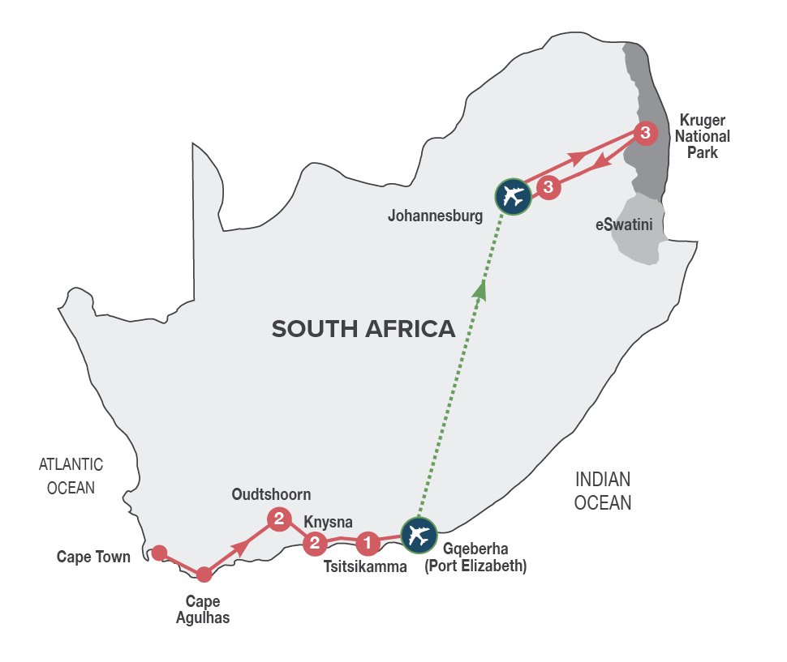
Small Group Tour
Minimum 2 guests / Maximum 10 guests

DURATION
12 days/11 nights

ROUTING
CAPE TOWN - JOHANNESBURG

INCLUDES
- 16 Meals: 11 breakfasts, 1 lunch, 4 dinners including gratuities
- 11 Nights’ accommodation including porterage
- Transportation including toll fees in air-conditioned vehicles
- Services of a professional English-speaking tour guide
- Entrance fees as specified in the itinerary
- Bottled water in eco-friendly packaging
TOUR HIGHLIGHTS
- Visit Dassiesfontein, a farmstall packed with locally produced products from the Overberg region
- Visit to Cape Agulhas (the southernmost tip of Africa)
- Travel via the scenic Tradouw Pass
- Sample top quality Port style wines in Calitzdorp, a town well known for its fortified wines
- Guided tour of the Cango Caves, wine tasting in the scenic Schoemanshoek Valley, guided tour of an ostrich farm in Oudtshoorn
- Immersive journey into the mythical Knysna Forests, discovering the legends build around woodcutters, elephants, steam trains and gold miners
- Visit Monkeyland Primate Sanctuary & Birds of Eden Sanctuary in Plettenberg Bay
- Visit to Tsitsikamma National Park and scenic Storms River Mouth
- Visit to vibrant Soweto, Apartheid Museum, and the Hector Pieterson Memorial & Museum
- Two days of game viewing in the Kruger National Park including a thrilling open vehicle game safari with packed breakfast
- Experience the spectacularly scenic Panorama Route with visits to God’s Window, Three Rondavels, Blyde River Canyon, and Bourke’s Luck Potholes
- Enjoy carefully chosen optional MAKE TRAVEL MATTER® Experiences that positively impact our travellers and the communities we visit
- Meals included in this trip support sustainable food production with at least 30% of the food on the menu being sourced locally (within 50-80km) of where it’s prepared

EXCLUDES
Flight and departure tax between Gqeberha (Port Elizabeth) and Johannesburg on Day 6
Recommended flight – FA376 departing Gqeberha (Port Elizabeth) at 15h40, arriving JNB at 17h20.

SELECTED DEPARTURE DATES
 | Jan24 | Feb24 | Mar24 | Apr24 | May24 | Jun24 | Jul24 | Aug24 | Sep24 | Oct24 | Nov24 | Dec24
English | 1;15;29 | 5;12;19;26 | 4;11;18;25 | 1;8 | 6;20 | 10 | 1;15 | 5;19;26 | 2;16;23 | 7;14;21;28 | 4;11;18;25 | 2

RACK RATES valid 01/01/24-30/04/24
R 48 190.00 per person sharing twin/double accommodation
R 56 620.00 per single person

RACK RATES valid 01/05/24-30/09/24
R 47 240.00 per person sharing twin/double accommodation
R 55 645.00 per single person

RACK RATES valid 01/10/24-31/12/24
R 48 980.00 per person sharing twin/double accommodation
R 57 500.00 per single person

Accommodation included:
4* La Plume Guest House or similar x 2 nights
4* Rex Hotel or similar x 2 nights
3* Tsitsikamma Village Inn or similar x 1 night
4* Southern Sun Sandton or similar x 3 nights
3* Hazyview Sun Hotel or similar x 3 nights

Transportation:
Transportation is in air-conditioned touring vehicles appropriate to the requirements of the tour
- 2 guests will travel in a sedan vehicle
- 3-10 guests will travel in a 13-seater vehicle

DAY 1 – MONDAY CAPE TOWN – CAPE AGULHAS - OUDTSHOORN
This morning you will be met by your local tour guide and depart for the scenic Garden Route. Travel along Sir Lowry’s Pass, with its magnificent views, to Grabouw and Elgin, a lush landscape surrounded by majestic mountains. Stop en route at a farmstall packed with locally produced products from the area. Our journey continues to Cape Agulhas, the southernmost tip of Africa, where the Atlantic and Indian Oceans meet. The area has largely been untouched and unexplored with its rugged coastline being the graveyard for many a ship. The historic Cape Agulhas Lighthouse is considered the icon that signifies the tip of Africa. After this thrilling experience, we continue via historic Swellendam and the Tradouw Pass to Barrydale and the famous Route 62. Sample top quality port style wines in Calitzdorp, before continuing to Oudtshoorn, the ‘ostrich feather capital’ and centre of the world’s Ostrich farming industry. Overnight in Oudtshoorn. Enjoy dinner at an Ostrich Farm, dining on local specialities such as Ostrich Steak. [Dinner]
Distance travelled today: 550 kms

DAY 2 – TUESDAY OUDTSHOORN
After a leisurely breakfast take a tour of the spectacular limestone caverns of the Cango Caves, one of the world’s great natural wonders, sculpted by nature through the ages. Afterwards enjoy a wine tasting at a local wine estate in the scenic Schoemanshoek Valley. Return to Oudtshoorn for a fun filled interactive guided tour at a working Ostrich Farm.
Overnight in Oudtshoorn. [Breakfast]
Distance travelled today: 90 kms

DAY 3 – WEDNESDAY OUDTSHOORN - KNYSNA
After breakfast, travel over the Outeniqua Pass to George, the sixth oldest town in South Africa, with many historical landmarks like the Slave Tree and King Edward VII Library building; said to be the best example of Edwardian architecture in the town. The tour travels via Wilderness, an attractive holiday resort, to Knysna, known as the oyster box of South Africa, nestling on the banks of a beautiful lagoon in the heart of the Garden Route. Journey into the magical Knysna Forests (weather & road conditions dependent), the stamping ground of the elusive Knysna elephants. Discover the stories of the woodcutters who worked the forests, the elephants that were hunted to extinction and the discovery of gold. Visit the Dalene Matthee Big Tree Memorial. The enormous Yellowwood tree of over 880 years was named after Matthee, best known author of four books on the Knysna Forest. Enjoy a delicious lunch en route of traditional cuisine and local treats. Overnight in Knysna. [Breakfast & Lunch]
Distance travelled today: 170 kms

DAY 4 – THURSDAY KNYSNA
Today you’ll have the opportunity to further explore the natural beauty of the Garden Route. Visit Monkeyland Primate Sanctuary, where you will be able to see a variety of primates, roaming free in the forest. This award-winning sanctuary is well known for its efforts to rehabilitate and free previously caged primates. A portion of the trip price of this MAKE TRAVEL MATTER® Experience, goes towards ensuring that these already endangered species can survive and reproduce for a future reintroduction into the wild. The experience directly advances UN Global Goal 15: Life on Land. The tour continues to the famous Eastern Head, where you will enjoy spectacular views of the Knysna Heads (weather permitting). Afterwards you’ll travel to Brenton on Sea, a breath-taking holiday location and a nature lover’s paradise with its unspoilt beaches and peaceful surroundings. The remainder of the afternoon will be at leisure. Overnight in Knysna. [Breakfast]
Distance travelled today: 110 kms

DAY 5 – FRIDAY KNYSNA - TSITSIKAMMA
Travel to Plettenberg Bay, considered the jewel of the Garden Route, for a visit to the Birds of Eden sanctuary, the biggest single free flight aviary in the world. The sanctuary was developed to create a safe environment in which to release a large collection of free-flight African birds. A portion of the trip price of this MAKE TRAVEL MATTER® Experience goes towards protecting genetically pure species of various Taxa in a semi-wild state and to hold the seeds of these Taxa for future reintroduction into the wild. The experience directly advances UN Global Goal 15: Life on Land. Our journey continues to Bloukrans Bridge, the highest single span arch bridge in the world, currently offering the highest commercially operated Bungy Jump in the world. Visit the Tsitsikamma National Park and Storms River Mouth (weather permitting). The Tsitsikamma National Park incorporates 80 km of rocky coastline with spectacular sea and landscapes, a remote mountainous region with secluded valleys covered in mountain Fynbos and temperate high forests with deep river gorges leading down to the sea.
Overnight in the Tsitsikamma area. [Breakfast]
Distance travelled today: 100 kms

DAY 6 – SATURDAY TSITSIKAMMA – GQEBERHA (PORT ELIZABETH) – JOHANNESBURG

Head eastwards along the Tsitsikamma Forest to Gqeberha (Port Elizabeth), affectionately known as the “friendly city”. Travel to Chief Dawid Stuurman Airport for an onward flight to Johannesburg, where you’ll be met and transferred to your hotel. The remainder of the day is yours to relax (unescorted). Overnight in Johannesburg. [Breakfast]
Distance travelled today: 185 kms

DAY 7 – SUNDAY JOHANNESBURG
Spend a full day exploring Soweto and surrounds, where some of the watershed events in the struggle against apartheid occurred. The tour starts with a drive past the FNB Stadium, also known as Soccer City and the venue for the 2010 FIFA World Cup Final. It was the site of Nelson Mandela’s first speech in Johannesburg after his release from prison in 1990. The drive continues through Diepkloof, home to Soweto’s richest and then to Kliptown, where the Freedom Charter was officially adopted in 1955. Drive past the Regina Mundi Church that played a pivotal role in the township’s history of resistance against apartheid. Then onto Vilakazi Street, the most famous street in Soweto, where two Nobel Prize winners once lived, Nelson Mandela and Desmond Tutu. The afternoon will conclude with visits to the Hector Pieterson Memorial and Museum that commemorate the role of the country’s students in the struggle against apartheid and the prestigious Apartheid Museum, that covers the full history of the Apartheid era in South Africa. Return to your hotel for overnight in Johannesburg. [Breakfast]
Distance travelled today: 100 kms

DAY 8 – MONDAY JOHANNESBURG
Enjoy a full day at leisure and unescorted. Perhaps join a tour to Maropeng, the Cradle of Mankind (optional and for own account) or enjoy some shopping at Nelson Mandela Square, home to a variety of shops and boutiques catering for all tastes and budgets. Overnight in Johannesburg. [Breakfast]

DAY 9 – TUESDAY JOHANNESBURG - KRUGER NATIONAL PARK
This morning you will be collected from your hotel, heading east to the Mpumalanga region. After freshening up at your lodge enter the world-famous Kruger National Park and spend the afternoon game viewing in your closed touring vehicle. The Park offers some of the best game viewing and wildlife opportunities in the world – and you’ll soon appreciate the challenges of managing this unique reserve. After an action-packed afternoon in the Kruger Park, enjoy authentic cuisine from the region at your hotel. [Breakfast & Dinner]
Distance travelled today: 430 kms

DAY 10 – WEDNESDAY KRUGER NATIONAL PARK
The day begins with early morning coffee or tea, followed by a thrilling open vehicle game drive (with English speaking game ranger) through the Kruger National Park with pre-packed breakfast. Your guide will endeavour to spoil you with sightings of the “Big Five”, general game and prolific bird life. There is an option (for own account and subject to availability) to learn more about the Kruger Park Anti-Poaching Dog Unit. This specialist unit trains dogs to track poachers in the field, detect firearms, ammunition and wildlife products that enter and exit through the Kruger National Park gates. A portion of the trip price of this MAKE TRAVEL MATTER® Experience goes towards ensuring that these dogs receive the best possible care in support of the vital work they do. The experience directly advances UN Global Goal 15: Life on Land. Return to the lodge for lunch (own account) and a short siesta. In the afternoon we will journey once again through the magnificent expanses of the Kruger National Park, unrivalled in its diversity of flora and fauna. Enjoy an afternoon of game viewing in your closed touring vehicle pursuing the Big Five and other rare and endangered species. Optional (own account) open vehicle game drives are available.
Return to your hotel for dinner and overnight. [Breakfast & Dinner]
Distance travelled today: 250 kms

DAY 11 – THURSDAY MPUMALANGA
Enjoy breakfast before setting out to explore the magnificent Panorama Route, one of the most scenic routes in the region, offering glorious views, spectacular landscapes, and exquisite waterfalls. Visit majestic sights including God’s Window, the Three Rondavels and Blyde River Canyon – the third largest canyon of its kind in the world, Bourke’s Luck Potholes, and the charming village of Graskop, one of the first gold mining camps in the country. Optional (own account) open vehicle game drives are available, should you prefer not to join the Panorama Route tour. Return for a delectable dinner at your hotel. [Breakfast & Dinner]
Distance travelled today: 260 kms

DAY 12 – FRIDAY MPUMALANGA – JOHANNESBURG
Enjoy breakfast before starting the return journey to Johannesburg. Arrive in Johannesburg, at OR Tambo International Airport, at approximately 14h30, where the tour ends on arrival. [Breakfast]
Distance travelled today: 400 kms

