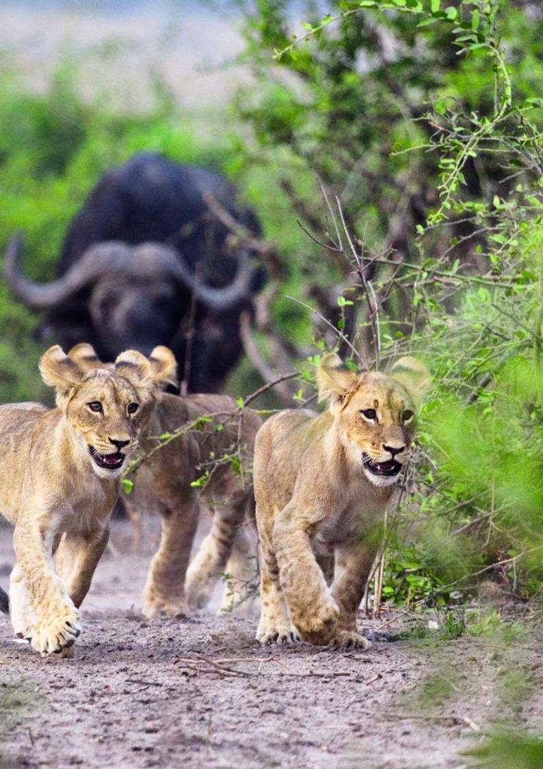


5-Day Victoria Falls & Chobe Safari - Luxury - NETT

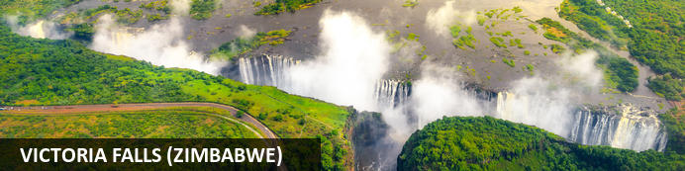
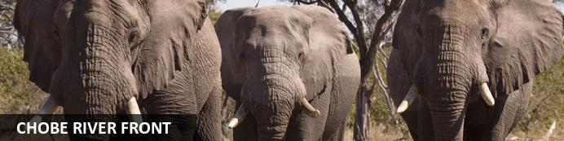

5-Day Victoria Falls & Chobe Safari - Luxury - NETT
Victoria Falls (Zimbabwe) - Chobe River Front
5 Days / 4 Nights
Date of Issue: 14 March 2023

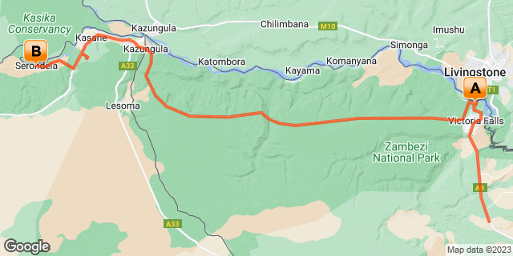

Click here to view your Digital Itinerary

Introduction
The five-day Victoria Falls & Chobe Safari is an excellent way to visit both Zimbabwe for Victoria Falls and cross the border into Botswana for Chobe National Park.
A chance to view the incredible Victoria Falls and enjoy any of the many activities on offer from here whether you are looking to take a helicopter flight over the falls or enjoy an adrenaline activity. There’s plenty to do here and loads to choose from. Then you’re off to Chobe National Park, which offers you incredible game viewing and a chance to view some of the largest herds of elephants from up close on game drives and boat cruises on the Chobe River.

Accommodation | Destination | Basis | Duration
Palm River Hotel | Victoria Falls (Zimbabwe) | B&B | 2 Nights
Chobe Game Lodge | Chobe River Front | FI | 2 Nights

Key
B&B: Bed and Breakfast
FI: Fully Inclusive - Bed, All Meals, Fees and Activities

Price
NETT STO COSTS
1st December 2022 – 31st December 2022
2 or more guests - USD 1690 per person sharing
Single supplement - USD 205
1st January 2023 – 31st March 2023
2 or more guests - USD 1770 per person sharing
Single supplement - USD 225
1st April 2023 – 30th June 2023
2 or more guests - USD 2320 per person sharing
Single supplement - USD 225
1st July 2023 – 31st October 2023
2 or more guests - USD 2610 per person sharing
Single supplement - USD 860
1st November 2023 – 30th November 2023
2 or more guests - USD 2320 per person sharing
Single supplement - USD 225
1st December 2023 – 31st December 2023
2 or more guests - USD 1770 per person sharing
Single supplement - USD 225

Itinerary runs one-way VFA – BBK on a seat rate basis. Surcharge to finish in Victoria Falls: USD 68 per person (one way)
** Rates are subject to change

Included
- Accommodation as indicated – can change depending on availability and request at time of booking
- Meals as indicated
- Activities as indicated
- Shared & private road transfers as mentioned
- Tour file with detailed itinerary, map with route descriptions, vouchers etc.
- 24 hour personal and friendly support
- Fast and efficient response to service providers

Excluded
- Items of a personal nature
- Optional extra activities
- International flights
- Holiday or personal insurance
- Staff gratuities
- Park entry fees (for optional extra activities in Victoria Falls)
- Visas and visa applications

Day 1-3: Palm River Hotel, Victoria Falls (Zimbabwe)

Victoria Falls (Zimbabwe)
A gazillion tonnes of water thundering over a sheer cliff drowns all other sounds. The swirling mist hides all sign of human activity. Beyond your rain forest sanctuary people are hurling themselves off bridges, across gorges, into walls of raging water and out of aircraft.
Victoria Falls is a paradox of tranquil beauty and exciting adventure.
Mosi-oa-Tunya, 'The Smoke that Thunders' is undoubtedly Zimbabwe's finest and most well-known attraction. It is or rather was (if you're keeping up with the latest list) one of the Seven World Wonders. We still believe it deserves the title. It truly is spectacular and not considered to be one of the world's largest waterfalls without good reason. It's not the widest or the highest , yet it is considered to the largest based on it's combined width, at 1,708 metres wide and height, at 108 metres. Impressively it takes the title for the largest sheet of falling water.

Day Itinerary
- Airport transfer from Victoria Falls Airport on arrival to your hotel in town.
- Airport Transfer Time: 30 minutes from Victoria Falls Airport
- Visit to Victoria Falls this afternoon (if time allows), either on your own or arrange to go with a guide
- Recommended is a sunset Zambezi boat cruise to end the day (optional extra) or look to dine at The Boma Restaurant for a taste of the African flavours, action, music and atmosphere
- 1 full day is set aside to enjoy any of the many activities on offer

Overnight: Palm River Hotel View iBrochure
The Palm River Hotel is truly magnificent from the architecture to the furnishings to the manicured gardens. It’s really quite something. The setting is idyllic and peaceful on the Zambezi River and just 4km from Victoria Falls. On a clear and quiet day you’ll even see the spray and hear the falls thunder.
It’s all new and modern with a colonial architectural air about it. It’s a hotel that is more than easy on the eye. It’s quite the marvel actually yet it’s also functional and well suited to the scene and surrounding nature.
It bridges the line between contemporary and timeless so elegantly, both in the main living areas and in the rooms, whether a deluxe room or suite and even through to the villa. Nestled in the treetops the honeymoon suites are spectacular with the indulgent balconies and starlit outdoor shower. Take it up a notch and go presidential and if you really want to up the ante, book the Palm River Villa.
Dine beneath a canopy of trees, there’s a future forward café bar and of course there’s an afternoon riverside tea to delight.
You’re well based here to explore the Falls, Victoria Falls town and all the other many activities on offer and when you’re ready to simply relax, there’s a luxurious spa to top it all. It almost seems too good to be true, but this place is real and the stay is well worth it. In this case, seeing is believing. You’ll see.
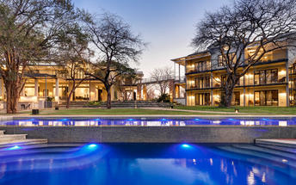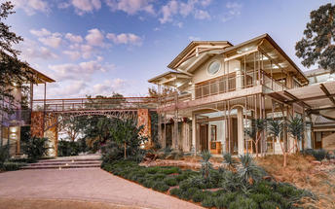

Basis
Bed and Breakfast

Included
- Bed & breakfast

Excluded
- Drinks, additional meals, activities, additional transfers & laundry

Day 3-5: Chobe Game Lodge, Chobe River Front

Chobe River Front
The Chobe River forms the northern boundary of the Chobe National Park which is renowned for its diverse and abundant game viewing opportunities. This section of the park is best known for its dense concentration of wildlife, including elephant and hippo populations, but the waters attract all manner of game including large herds of buffalo and the lions that prey on them - a visit to the Chobe River Front guarantees close encounters with an array of African wildlife. Visitors can look forward to a range of exciting activities such as 4WD along the banks; motorboat cruises; and rare birdlife spotting. For a unique, luxury safari experience, hire a houseboat.

Day Itinerary
- After breakfast, and a last morning activity in Victoria Falls (if time allows), you will be collected from the hotel and transferred across the border into Botswana. Your driver will assist with the border crossing which is an experience in itself
- Check in at the lodge and enjoy your activities as included
- A chance to see large herds of elephants from up close and plenty other wildlife from an open safari vehicle and the river
- This property is located within the Chobe National Park, providing the prime bush location for exploring the Chobe Riverfront. The location inside the park gives guests the advantage of a head start on vehicle traffic entering the Riverfront from Kasane for activities, and therefore a more exclusive Chobe safari.
Activities: game drives and boating

Overnight: Chobe Game Lodge View iBrochure
Chobe Game Lodge is a rough-clad vaulted maze of courtyards, passages and verandahs that face the Chobe River and its great flood plain.
The 44 rooms have barrel-vaulted ceilings and high archways that frame a delightful view of the river. All rooms have air conditioning, ceiling fans, complimentary mini bars and private terraces with river views.
Dining is either a high table bonanza on the river-facing terrace or a sumptuous buffet on the lawn beneath an ancient mahogany tree. The food is a Westerner's introduction to local ingredients and the wine list features some of South Africa's regular offerings.
One of the only lodges inside the Chobe National Park, you are on your game drive or boat cruise long before anyone else. In fact, by the time anyone else has ventured where you've already been, you are back at the lodge relaxing and enjoying a spa treatment.
As if you need any further selling on this superb safari lodge, most of the game drive vehicles and all of the boats are electric, which, apart from the obvious environmental benefit, means minimal noise so your sightings are a true bush experience. Something else for the win, the staff and all guides are female, which makes for a different experience compared to most safari lodges.
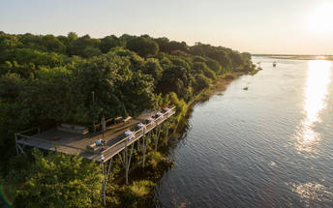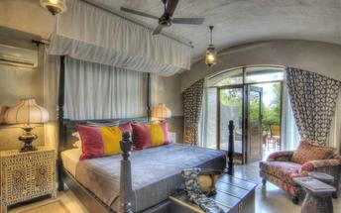

Basis
Fully Inclusive - Bed, All Meals, Fees and Activities
All Local Brands (excl Spirits) Included

Included
- Meals, local drinks, activities, park fees, laundry & intermittent WiFi

Excluded
- Premium imported wines, champagnes & spirits

Day 5: End of Itinerary

Day Itinerary
- After a morning activity (depending on the time of transfer and departure flight) you will be transferred to Kasane Airport where your tour ends
- Airport Transfer Time: 30 minutes to Kasane Airport
- End of services

Basis
Bed and Breakfast

Transport

Transfers
Date | Company | Pick Up | Drop Off | Time | Vehicle
 |  | Victoria Falls International Airport [VFA] | Palm River Hotel |  | Transfer
 |  | Palm River Hotel | Chobe Game Lodge |  | Transfer
 |  | Chobe Game Lodge | Kasane Airport [BBK] |  | Transfer

Urgent Contact Numbers
Company Name | Telephone | Email Address | Contact Person
Namibia Tours & Safaris | +264 64 40 6038 | tanya@namibia-tours-safaris.com | Tanya Coetzee
Namibia Tours & Safaris - Emergency Contact | +264 81 784 4315

Service Provider Directory
Service Provider | Ref. Number | Telephone | Address
Chobe Game Lodge |  | +267 625 0340 | Chobe National Park,  Serondela,  Botswana
Palm River Hotel |  | +263832844737 | Stand 1403 Parkway Drive, Victoria Falls, Zimbabwe

Terms and Conditions

Namibia Tours & Safaris Terms and Conditions
Contract
1.1 The contract will become effective as from the date the invoice is completed and the deposit, referred to in Clause 2.1, is received by Africa Tours & Safaris CC (hereinafter known as the Company).
1.2 The contract is subject to the Namibian Law.
1.3 Any person making a reservation as per Clause 8.4 accepts the terms and conditions of this agreement set out hereunder.
How to Book
2.1 A 20% deposit of the full amount due is required to confirm any reservation and is to be done by the agent or client (see Clause 8.1) in writing or by e-mail.
2.2 The Company must receive the balance of the contract price no later than 42 days (6 weeks) prior to departure.
2.3 If the Company does not receive the full contract price 42 days (6 weeks) before the departure date, the Company may cancel the reservation and retain whatever deposit or other funds it has already received from the client or his agent.
How to Pay
3 The payment options will be provided upon confirmation of a booking.
Our Cancellation Policy
4.1 Any cancellation of a confirmed booking must be done in writing (email) to the Company whereupon cancellation charges as per Clause 4.2 will apply.
4.2 The following cancellation fees (as a percentage of the fully quoted price) are applicable to any cancelled travel:
Notice from date of travel: Cancellation fee:
42 days or more 20% (deposit forfeited)
29 – 41 days 50%
15 – 28 days 75%
0 – 14 days 100%
Please note: the notice period is calculated from the date of cancellation to the start date of the tour/safari booking.
4.3 No refund will be made by the Company if, for any reason, inclusions or parts of the tour cannot be carried out / or utilised. These would include all facets such as meals, game drives, accommodation etc. This would also apply to any client who has booked a tour but fails to undertake the tour for any reason.
Our Changes Policy
5 If a booking is changed to an earlier date than originally reserved, the Company will endeavour to change it. If the booking is for a later date, charges as per Clause 4.2 could apply.
As things go, we've all had to adapt to changes during the Coronavirus pandemic and so too have we therefore amended our terms and conditions for travel during such times. Check out the Updated COVID Terms and Conditions here.
Price Changes
6.1 The Company reserves the right to increase the price of any tour prior to departure due to factors beyond the control of the Company, such as, without being limited to, and increase in fuel prices, new Government legislation, accommodation price increases, fluctuations in exchange rates, etc.
6.2 If the Company announces an in increase in the tour price in terms of this Clause, such addition amount must be paid to the Company before the departure of such tour or else the Company shall have the right to cancel the tour and the charges in Clause 4.2 will apply.
Changes to Itineraries
7 The Company shall at any time have the right, in its entire discretion, to alter the terms of the booking in relation to the route, timetable, itinerary and accommodation. The Company shall, however, make every effort to offer the client an alternative tour of a comparable standard.
Should the alternative be of a lesser standard, the client will be refunded the difference, but should there be an increase, the client shall have the right to either reject the alternative and obtain a refund of the relevant portion of the original contract sum, or to accept the alternative and pay the increased cost. In the event of the client rejecting the alternative tour and claiming a refund, such rejection will be treated as a cancellation and the refund will be calculated according to Clause 4.2 hereof. The client shall have no claim against the Company for any damages arising out of the alternative booking.
Responsibility and Liability
8.1 Neither the Company nor any person acting for through and on behalf of the Company shall be liable for any loss or damage whatsoever arising from any cause whatsoever and without restricting the generality of the aforegoing shall particularly not be responsible for the loss or damage arising from any errors or omissions contained in its brochure or other literature, late or non-confirmation or acceptance or bookings, loss or damage caused by delays, sickness, injury or death, whether occasioned by negligence or not.
8.2 The Company shall have the right at any time at is sole discretion, to cancel or the remainder thereof or to make an alteration in the route, accommodation price or other details. This would include any event of any tour being rendered impossible, illegal or inadvisable by weather, avalanches, strike, war, government or other interference or due to any other cause whatsoever. The extra expenses incurred as a result thereof shall be the responsibility of the client.
8.3 The Company may at its discretion and without liability or cost to itself at any time cancel, or terminate, a client's booking and in particular, without limiting the generality of the aforegoing, it shall be entitled to do so in the event of illness or the illegal or incompatible behaviour of any client undertaking the tour, who shall in such circumstances not be entitled to any refund.
8.4 Any person making a reservation with the Company (refer to Clause 1.1) warrants that her or she has the necessary authority to enter into this contract on behalf of the person or persons included in such a booking. The person making the reservation shall be liable for the total amount due to the Company.
Client's Obligations
9.1 It is the onus and responsibility of the client to obtain the necessary comprehensive insurance before departure for any possible cancellations, medical expenses, protection or personal property and money.
9.2 The onus is upon the client to ensure that passports and visas are valid for the duration of the safari. The Company cannot be held liable for any necessary visas or other travel documents not held by clients. In the event of a client not having the necessary documentation to enter any area or country the Company shall reserve the right to leave the client a the point of entry of such area or country. In such an event, the Company will not be held responsible to the client for further travel arrangements.
9.3 The onus is upon the client to ensure that the SARS-CoV-2 PCR tests are done prior to commencement of the safari and valid on arrival in accordance to the requirements of the country of intended travel and for the airline with which the client will travel. The same applies for any necessary testing for departure. The costs of any such COVID testing will be for the clients own account. While The Company can assist with arrangements for testing in-country, The Company will not be held responsible to the client for such arrangements and with regards to return time of test results.
9.4 Should the client need to undergo mandatory quarantine once in-country with regards to the SARS-CoV-2 virus, either on arrival as called for by the authorities or due to testing positive once in-country, this will be at the clients own expense.
Health and Personal Safety
10.1 The client shall be reasonably fit to undertake the tour.
10.2 Anti-malaria precautions should be commenced prior to tour departure. A medical doctor should be consulted for advice.
10.3 Tours offered by the Company cover a wide spectrum of the African wilds and neither the Company, its employees or agents can be held responsible for any injury or other related incidents whilst on the tour / safari.
10.4 The Company cannot be held responsible for any client who falls ill or contracts the SARS-CoV-2 virus while in-country. The client accepts that travel is at own risk.
Baggage
11.1 Clients are limited to one soft sports type bag per person with a maximum weight of 20 kilograms. This includes photographic equipment and hand luggage.
11.2 Due to the rugged terrain, the Company cannot be held responsible for damage or loss of any personal items including bags, contents of bags or photographic and related equipment. Due to extremely dusty conditions, please ensure all bags are dust proof.
Airline and Car Hire Clause
12.1 The Company will act as the agent of the client when booking the client with a car hire company, an airline or air charter service. The client therefore contracts with the car hire company, airline or charter service and not with the Company.
12.2 Charter flights are normally operated by smaller type aircraft such as Cessna 210. Luggage is strictly limited to 10-15 kgs (depending on terms of particular airline used) per person in soft hold all type bags. Due to the desert heat, it is not safe to overload aircraft thus this limit needs to be strictly controlled.
Travelling or thinking of travelling during the COVID-19 pandemic? Take a look at our COVID Terms and Conditions for more information on how this will work and differ from our standard terms and conditions as listed above.

