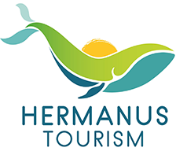

Hermanus Attractions
Hermanus Sightseeing Bus Rotary Way Lookout
Hermanus First Friday Art Walk Hoy’s Koppie
Grotto Blue Flag Beach SANSA Hermanus Wine Route Fernkloof Nature Reserve
Hermanus Cliff Path De Wet’s Huis Photo Museum
Whale Museum Old Harbour Museum
Abalone Tour Options
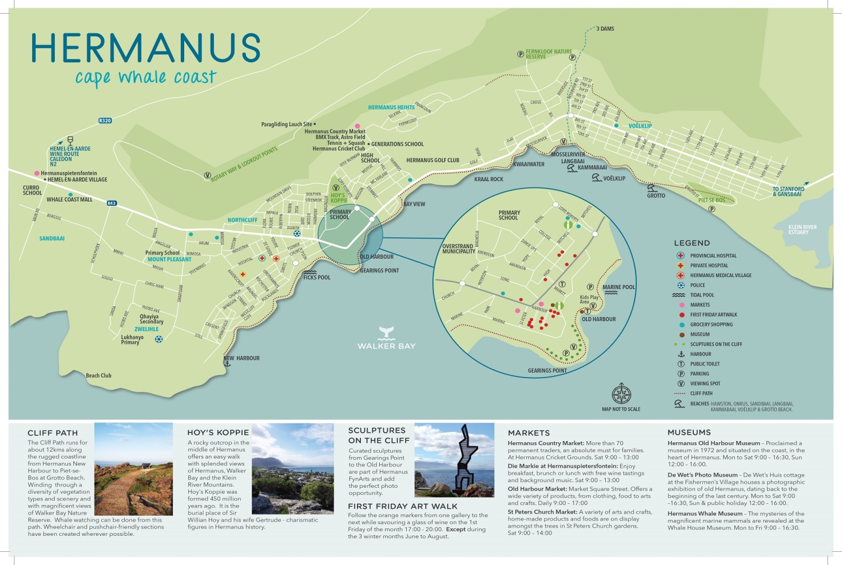
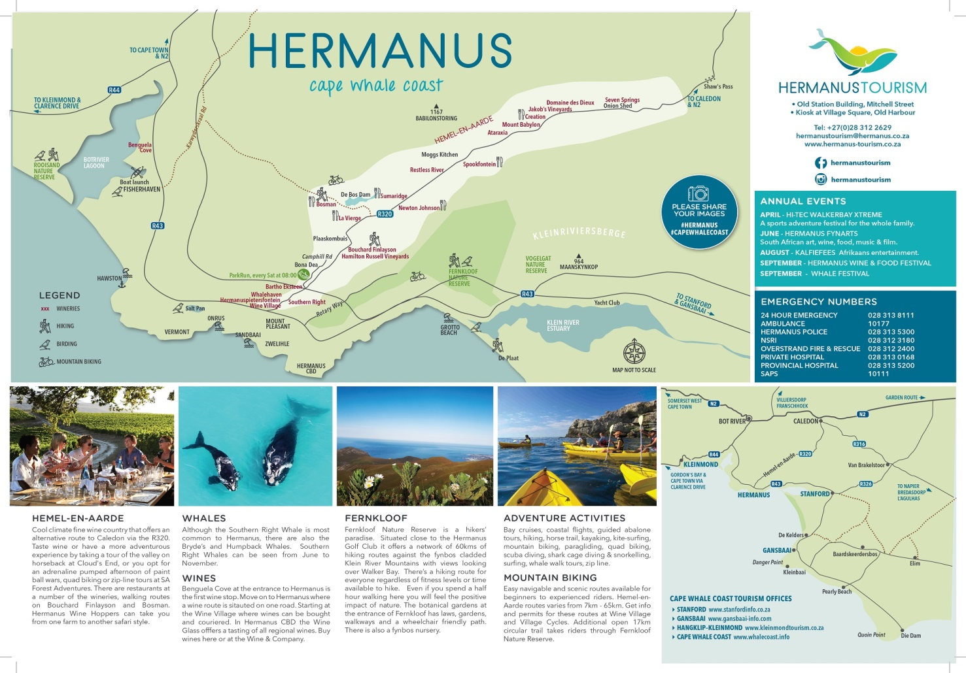
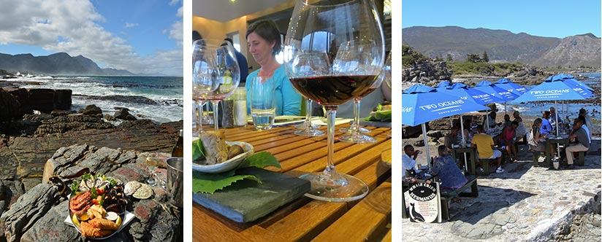
WHERE TO EAT IN HERMANUS There’s a restaurant in Hermanus that will satisfy anybody’s taste buds and dining style; whether you favour sushi, steak, seafood, great Italian, country-style breakfasts, late night cocktails and tapas or elegant fine dining, you will find an array of quality restaurants to choose from.
Decadent menus feature exotic international and local dishes with the beautiful Walker Bay as your backdrop or try your hand at authentic Italian cuisine where you will find so much more than just pizza and pasta!
Fish and seafood are freshly sourced from the Atlantic and menus are packed with exotic dishes as well as local dishes such as Bobotie and Milk tart. Various cosy street cafés, coffee shops, delis and eateries serve freshly baked cakes, pastries and tempting desserts as well as salads and afternoon tea.
Lunch or dinner at one of the many wine estates around Hermanus offers a great outdoor dining experience, delectable food with fine wines and phenomenal vineyard views.
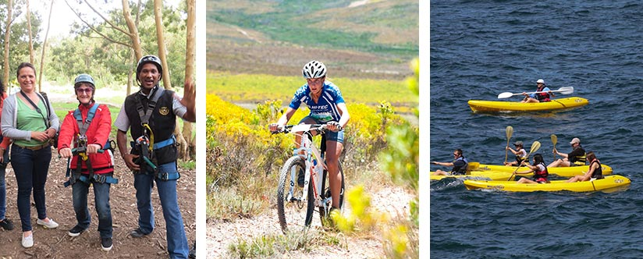
WHAT TO DO IN HERMANUS Discover a world of activities in one of the most scenic and welcoming villages in South Africa, nestled between mountain and sea, where you will be surrounded by awe-inspiring views of nature at any given time. Hermanus is world renowned for its phenomenal whale watching in season from June until November when the Southern Right whales make Walker Bay their home.
Add some action to your Hermanus holiday with sea-kayaking in Walker Bay with its abundant marine life, thrilling shark cage diving in Gansbaai, quad biking or zip-lining in the picturesque Hemel-en-Aarde Valley, hiking in the fynbos-covered Fernkloof Nature Reserve, mountain biking or horse-riding on the beach.
For wine enthusiasts the vineyards around Hermanus and the Overberg produce some of the finest wines in South Africa. Explore the local Hermanus wine route which passes through the Hemel-en-Aarde area valley, one of South Africa’s best hidden gems.

