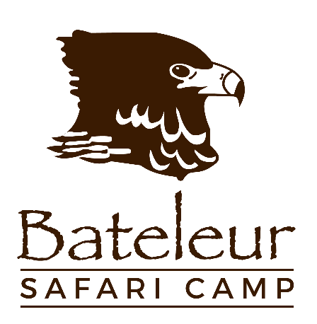

Green policy 🌿

Buildings/structures 🌳

Bateleur Safari Camp’s footprint was kept to a minimum.

Minimal impact on the surroundings was a key focus when Bateleur Safari Camp was built and renovated.

The camp is hidden amongst the trees in riverine vegetation.

If the entire camp would be broken down, within 12-18 months, the area would recover, as though no camp ever existed there.

No electricity ☀️

The entire camp and staff village run on solar power.
- A series of solar panels harvest energy from the sun, which is stored it in a 24-battery bank.
- Operation of the system is self-sufficient, with a silent generator automatically kicking in on poor solar absorption days (i.e. when it is cloudy/overcast).
- All tents are equipped with:
  - Indoor and outside lights
  - Multiple 220V power plugs including 3-prong, 2-prong & USB points
  - Ceiling fans
- The solar system has limitations with regards to how much power is drawn. As a
result, all kitchen appliances must meet certain specifications and all fridges/freezers are
specially sourced, drawing a maximum of 90W each.
- Light bulbs throughout the camp and staff village are 4W or less to ensure a low power
pull.
- Unfortunately, no hair dryers can be used as these will overload and trip the system
- The pressure pump for the water systems runs only when needed
- The swimming pool pump operates on a timer limiting the running time to just 4 hours a
day.
- Camp linen and laundry items are taken to a company in Hoedspruit to be cleaned. This
company only uses eco-friendly, biodegradable, hypo-allergenic products to wash
and care for guest and staff linen & towels.

Water 💧

Water supplied in the camp is derived from an underground aquifer. Tests have shown that this water is brilliantly clean, fresh & pathogen free, making it safe for all to drink.
- Microbes are used in the toilets and grey water to assist in breaking down waste.

The production & recycling of plastic water bottles involves a huge waste of water and adds to increased accumulation of litter. Bateleur Safari Camp does not use bottled water, opting instead to loan guests a stainless-steel water bottle, to be used for the duration of their stay. This bottle is cleaned, filled & refreshed twice a day and will keep water cold for up to 24 hours.
- All the camp’s water is heated by gas geysers.

Swimming Pool 🏊

- A salt water chlorination system is used. This is a natural way of converting salts into chlorine without the use of any harmful chemicals and with minimal to no impact on the surrounding area.
- Water drained from the pool is used to irrigate surrounding plants.

Eco-friendly cleaning products/soaps 🐞

- Store-bought, shower gels, dishwashing liquids & ammonia-based cleaning products are no longer used
- All cleaning products and shower gel/hand soaps are 100% eco-friendly
- These products use ‘beneficial bacteria' to actively biodegrade dirt in the process of cleaning, thereby eliminating chemical and dirt transfer to the environment.
- These products are locally produced and not tested on animals.

Sustainability 🍅🍋

- Bateleur Safari Camp has an animal-proof vegetable & herb garden, in which a variety of veggies are grown, including: leafy greens, herbs, berries, lemons & limes, cherry tomatoes.
- Natural garden compost is mulched on site.
- Future plans include an earthworm farm to be used in conjunction with the camp’s compost, to provide organic nutrients from the kitchen’s vegetable cuttings.
- Microbes are also used in the veggie garden, to prepare soil naturally without the use of chemicals & harsh fertilizers.

Wet waste & recycling ♻️

- An animal-proof rubbish cage stores waste, until it is removed from the property by a recycling company.
- Plastics, paper, tin & glass are separated as items are used. These recyclables are then removed for recycling at a local community-based plant.
- Besides cuttings required for the veggie garden earthworms, all kitchen wet-waste is collected and taken to surrounding communities, to assist in feeding their livestock.

Conservation Ethos 🐵

- Many of the roads on the property have been closed, to create large “wilderness blocks”.
- This creates undisturbed walking opportunities, through untouched bushveld, without the
hum of passing vehicles or the constant crossing of man-made roads.
- Much rehabilitation and field restoration work has been undertaken on man-induced erosion sites.
- There are no artificial water holes – game drives are conducted with minimal impact on the environment. No driving on sensitive soils, erosion areas, fragile riverbanks or sodic areas is permitted - regardless of game viewing opportunities.
- In these instances, the vehicle will be stopped, and guests will be guided in approaching the animal on foot.
- Bateleur Safari Camp promotes walking as much as possible, allowing guests the opportunity to track & trail animals.
- For big cats & other predators, a maximum 100-meter off-road policy is applied.

About the Owner and Founder of Bateleur

- Andreas has owned the property since 1991
- He developed Bateleur and evolved the product to its current shape and form
- Andreas was integral to the design, layout and vision of Bateleur
- Andreas leads specialist corporate, student and occasional private Safari groups
- Bateleur started out as guests arriving with backpacks and heading off into the wilderness for an unforgettable experience
- Andreas then ‘compromised’ to set up a minimalist camp under a large shady tree; the camp then evolved from there
- Great pride and responsibility is taken to maintain in keeping the property in pristine condition and keeping the impacts to a minimum; examples include the closure of all artificial waterholes that unnaturally distribute animals across the landscape which result in areas of high impact, the closure and re-routing of roads that cross sensitive soils or natural wetland areas, the rehabilitation of man induced soil erosion, strict guidelines re. off-road driving and maintaining a healthy respect for all life
- Andreas has been the recipients of the Timbavati Private Nature Reserve’s conservation award several times
- Andreas has a background in animal and man tracking and wilderness guiding
- Andreas conducts training and mentoring for rangers in the conservation security industry; subjects include man-tracking and tactical firearms training
- Andreas is a Scout qualified guide (only 9 exist in South Africa – this is a combination of the highest guiding and tracking qualification in SA), is a Senior qualified tracker and tracker assessor, man tracker trainer/assessor and firearms instructor
- Andreas’s vision for Bateleur is for visiting guests to have a hands-on Safari experience, to experience Nature and the wilderness as it is whilst recharging the body, mind and soul in a relaxed environment under the guidance of an experienced and passionate team, whilst generating an understanding for the necessity to protect the integrity of wild spaces

