General Protocol in the context of the COVID-19 pandemic
Barceló San José

Purpose of the protocol:

This protocol offers preventive measures for detection, in the context of the COVID-19 pandemic; these measures must be followed upon arrival at the hotel. This document describes a minimum set of standards, in terms of safety and sanitation, for the protection and well-being of our guests, business partners and visitors.

Basic concepts:
• For guests with previous reservations, all check in procedures will be completed online whenever possible, to reduce contact and time spent at the front desk.

• To watch over the safety of our guests, a form will be given at check in, in which, the guest must declare his/her health condition for the past 48 hours.

• Each guest will have its temperature taken upon entering the reception area, it must be below 37.78°C (100°F).

• Guests with any Covid-19 related symptoms or temperature above 37.78°C (100°F) will be redirected to a designated area in case medical attention is required.

Front desk (Check in/Check out):

• All our team members will wear their PPE (Personal Protection Equipment) for the execution of their duties and assistance to our guests.

• Physical distancing will be enforced with markings in the areas where clustering may occur.

• Hydroalcoholic gel has been placed in strategic points for disinfection.

• For the safety of our guests and visitors, the screens in the lobby will project the informative guidelines related to protection, disinfection, and social distancing.

• All points of contact with the guest will be disinfected after every transaction, including credit cards, points of payment, equipment, pens, and registration counters.

• The room keys will be disinfected before being stored and upon delivery.

• Wheelchairs and other guest amenities will be disinfected before and after every use.

• Electronic payment, preferably with no contact, will be encouraged.

• All guest luggage will be disinfected for protection; further precautionary measures will be taken when handling leather/delicate fabric luggage.

• All the desks/counters in the reception area/lobby will be cleaned every 30 minutes with a quaternary ammonium solution 200ppm; chairs and desks/counters will be cleaned at the beginning and at the end of every shift.

Elevators:

• Maximum capacity allowed in the elevator is two people or one social bubble.

• The use of the stairs will be encouraged in one direction.

• Doors, handrails, and elevator buttons will be cleaned every hour.

Guest rooms:

• The chambermaids must use PPE (gloves, face mask, and uniform, among others) in the cleaning and disinfection process; with special emphasis on the surfaces with greatest contact such as remote control, in-room telephones, door handles, closets and drawers, A/C unit control panel, light switches, lamps, and coffeemaker. Special consideration will be given to the bathroom area, including toilet, basin, shower, and doors, among others.

• The guest will decide whether he/she requires daily room service during their stay.

• Rooms and common areas will be completely disinfected daily, with products suggested under the disinfection criteria of the Ministry of Health.

• Employee and public restrooms will be disinfected every 30 minutes, compliance will be logged in.

• Upon each check out, the room will be completely disinfected with products suggested under the disinfection criteria of the Ministry of Health; special emphasis will be placed on high-contact areas/items.

• All employees who clean guestrooms must comply with the cleaning and disinfection checklist.

• The Laundry Department will work with PROQUIMIA for washing bedding, towels, and table linen, calibrating the wash and dry cycles to the equipment in the hotel and the products they provide.

Restaurants

• Menus will be digitally accessed through QR codes in each service area.

• The host stand will be cleaned every 30 minutes with a quaternary ammonium solution 200ppm. Chairs, tables, service areas, restaurants and bars will be cleaned after each guest use.

• Pens, note pads and all other reusable items that are used by employees and/or guests will be disinfected after each use.

• To meet the distancing measures and keep capacity at 50%, tables in use will have an information sign.

• Bulk products will be eliminated from the buffet; single doses or individually packaged portions will be offered. Assisted buffet or a la carte mode will be implemented. Napkins, coasters, or any other product needed for drinks will be delivered individually and not taken directly by the customer.

• The server will keep a distance of 80 cm (31.5 in) whenever bringing food or drinks to the table.

• Each entry point will have a sign with the protocols for handwashing, sneezing, greeting and physical distancing.

• PPE assigned to each employee, according to their position, will be verified.

Room Service:

• Whenever possible, exposure in guest rooms will be minimized; guests will be offered contactless delivery leaving tables/trays outside the room after knocking on the door and announcing the delivery. All the food will be covered during transit.

Banquets, Special Events, Conferences and Conventions:

• All shared equipment and meeting facilities will be disinfected before and after every use.

• All table linens will be replaced after each use.

• The guidelines issued by the Ministry of Health to maintain a 50% capacity and a distance of 1.8 meters between the tables will be fully complied with.

• Access to the building will be controlled by means of an infrared thermometer.

• Each entry point will have a sign with the protocols for handwashing, sneezing, greeting and physical distancing.

• PPE assigned to each employee, according to their position, will be verified.

• Common use items, such as napkin holders, sugar bowls, and salt and pepper shakers, will not be found on the tables.

• Attendees will be served in shifts previously arranged with the event organizer.

• Napkins, coasters, or any other product needed for drinks will be delivered individually and not taken directly by the customer.

• The server will keep a distance of 80 cm (31.5 in) whenever bringing food or drinks to the table.

Pool area:

• Lounge chairs, tables, chairs, and swimming pool will be cleaned after each guest use with a disinfectant solution for the proper elimination of virus and bacteria found on surfaces.

• Swimming pool handrails will be cleaned after each guest use.

• Counters will be disinfected at least once every hour.

• Life vests will be disinfected after each use.

• Access to antibacterial soap, alcohol gel in a composition no less than 60%, and disposable towels for hand drying, will be guaranteed in all public spaces.

• The guidelines issued by the Ministry of Health to maintain a 50% capacity and a distance of 1.8 meters between the tables will be fully complied with.

• Signs with the protocols for sneezing and coughing, handwashing, alternative ways of greeting, not touching the face, and population at risk will be placed in visible spaces, for knowledge of both employees and guests. These signs will be in the most common languages used for taking care of guests.

• Pool towels will be handed out in sterilized bags.

Gym:

• All exercise machines in the gym will be cleaned after each use with a disinfectant solution por the proper elimination of virus and bacteria found on surfaces.

• The guidelines issued by the Ministry of Health to maintain a 50% capacity and a distance of 1.8 meters between the tables will be fully complied with.

• Attendance to the gym must be previously programmed. In addition, common areas, bathrooms, jacuzzi, sauna and machines will be disinfected after each use.

• Signs with the protocols for sneezing and coughing, handwashing, alternative ways of greeting, not touching the face, and population at risk will be placed in visible spaces, for knowledge of both employees and guests. These signs will be in the most common languages used for taking care of guests.

• The steam room will be closed off to the public to avoid possible transmission of the Covid-19 virus.

• An appointment must be scheduled for the use of the jacuzzi and the sauna.

Transportation:

• The hotel will provide its drivers with a cleaning kit that includes an alcohol solution at 70% or disinfectant, disposable towels, and trash bags.

• Regular cleaning of the hotel vehicles will be scheduled, focusing on the keys, door handles, gear lever, and frequent contact surfaces.

• Information about the measures being taken to minimize the risk of contagion between passengers will be provided to each guest.

• All passengers using the hotel’s transportation service must always wear a mask when boarding the vehicle.

• Service will be cancelled if the passenger presents symptoms associated with the Covid-19 virus, such as coughing, sore throat, fever, or difficulty breathing.

• Upon completion of a trip, the vehicle will be fully disinfected with a quaternary ammonium solution 200ppm, taking special care of the surfaces with the greatest contact.

Additional Services:

Beauty Salon/Spa Souvenir Store
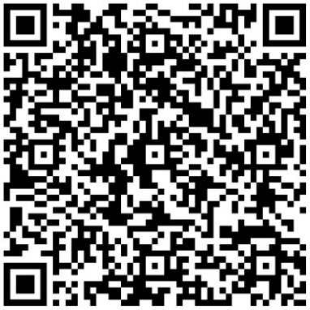
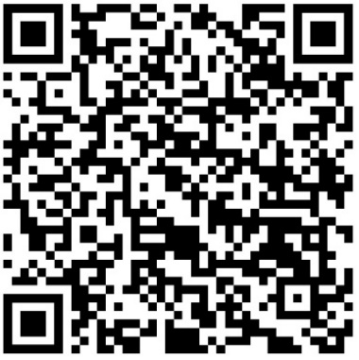
}

Tours

