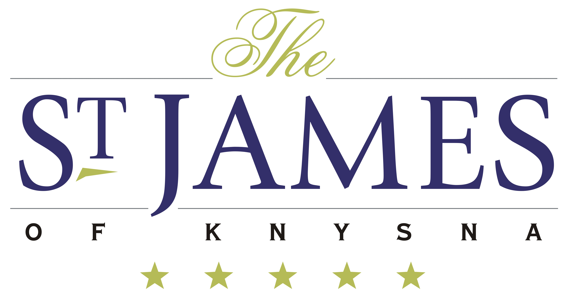

Room Rates

* All rates are guaranteed for the dates/period confirmed.
* All B & B rates include a Full English/Continental breakfast.
* All rates include 15% VAT. Should there be an increase, we reserve
the right to increase the rates accordingly.
* These rates do not include a Tourism Levy of R 10.00 per night per room.
* All rates are quoted nett and non-commissionable.
* All rates are quoted in South African Rands.
* No children under the age of 12 years, no 3rd person sharing.

Booking Procedures & Terms of Condition

* Reservations must be made in writing via e-mail.
* Reservations made by a contracted Standard Tour Operator will be deemed as a firm booking and will automatically be subject to the cancellation policy outlined below.
* All cancellations and/or amendments must be made in writing.
* All cancellations and/or amendments will attract the following charges, which will automatically be debited to the tour operator (this will include amendments, which cancel any given room nights reserved).

Cancellations

100% of the value of the total stay if cancelled 7 days or less prior to date of arrival, or if no show;
50% of the value of the total stay if cancelled less than 30 days prior to date of arrival;
25% of the value of the total stay if cancelled less than 60 days prior to date of arrival.

The full extent of the stay will be charged for in the event of a premature departure. This is not dependent on the hotel’s occupancy level. Guests are advised to take out travel insurance. Please note - NO verbal cancellations will be accepted. All cancellations are to be emailed directly to the hotel info@stjames.co.za

