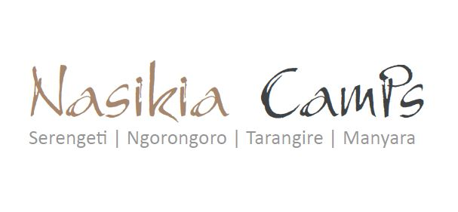

LUNCHBOXES & HAMPER PROTOCOL
Dear Partners and Friends,
In recent weeks and during the busy breakfast service, there has been an influx of demand for hot lunch offerings to fill Guest Hampers, at the same time as our standard lunch box items buffet which has resulted in some misunderstandings.
. In order to deliver better service for your guests, we offer a lunchbox buffet display each morning and guests choose what they prefer to snack on during game drives if they are unable to return to camp for lunch. They put these chosen items in their Guest Hamper directly from the buffet (or into our bio-degradable lunchboxes if they prefer).
Our takeaway lunch box buffet offerings are based on a 7-day rotating menu basis.
Guest Hampers: Safari Guides should bring their own Guest Hampers in their own vehicles and give to the front of house team if they would like assistance for their guests. If Safari Guides do not bring their own Guest Hampers, we unfortunately need to deliver the service in the standard bio-degradable lunchbox as we do not offer a supply of hampers for external use.
If guests and safari guide would like to enjoy a hot lunch menu, we kindly request to return to the camp for usual lunch service anytime from 12 noon – 2pm daily.
Please read the above Lunch Box vs Guest Hamper system to avoid misunderstandings.
This is valid for all of Nasikia Camps properties.
Thank you so much for your understanding and we look forward to continuing to build our business partnerships for many more years to come.
Best Regards,
The Nasikia Camps Team

