Day 1: Tamarind Tree Hotel Nairobi, Kenya
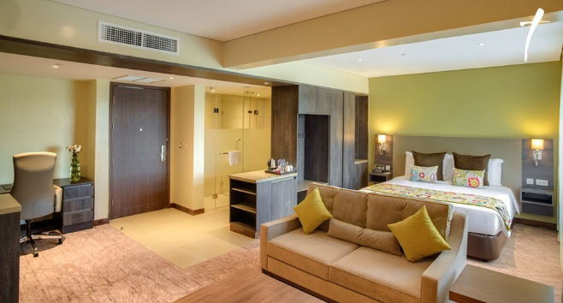
Touch down in Africa at Jomo Kenyatta International Airport. A representative from Tradewinds will be meeting you on arrival inside the airport after you have been screened by health officers. From there, they will fast track you through immigrations, customs and hand you over to your Sentinel driver who will transfer you to Tamarind Tree Hotel. (Bed and Breakfast)

Day 2 -7 Sentinel Mara Camp; Masai Mara National Reserve
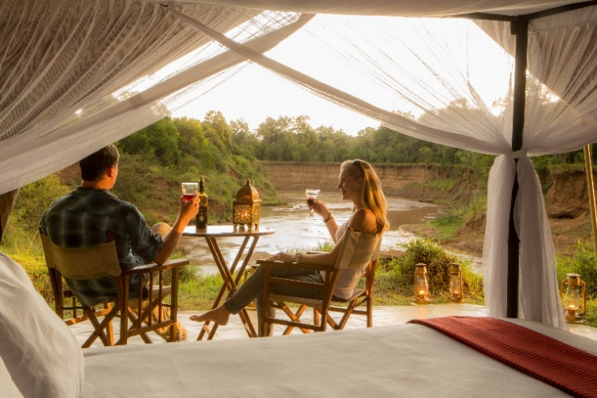
This morning, your driver will transfer you from Tamarind Tree hotel to Wilson airport where you shall take your mid-morning flight to The Mara.. A Sentinel guide will receive you at the Musiara airstrip as you disembark your flight. You will have a game drive en route to the camp where you will settle in at Sentinel Mara Camp. Sentinel Mara Camp is an exclusive tented eco camp set up in a forest along the banks of the Mara River within the Masai Mara Reserve offering guests an authentic close to nature experience. The feel is tastefully old fashioned with just 8 large en suite tents furnished with specially designed campaign furniture. It creates the ambience of the traditional East African safari while at the same time providing a high level of customer service and a significant measure of luxury. The abundance of wildlife and an excellent standard of guiding will have you enthralled.
Your days will be filled with various activities such as early morning and late afternoon game drives, nature walks, champagne bush breakfasts, sundowners, evening drinks by the campfire, starlit dinners and so much more! Our friendly staff will ensure you have an unforgettable experience. Our Masai staff will be available to talk about Masai customs and culture around the campfire in the evenings. Our bespoke approach ensures that your daily routine is flexible and tailored around the preferences of each group of guests. On the last day, after your breakfast, you will be transferred to the Musiara airstrip for your flight back to Nairobi.

Masai Mara National Reserve
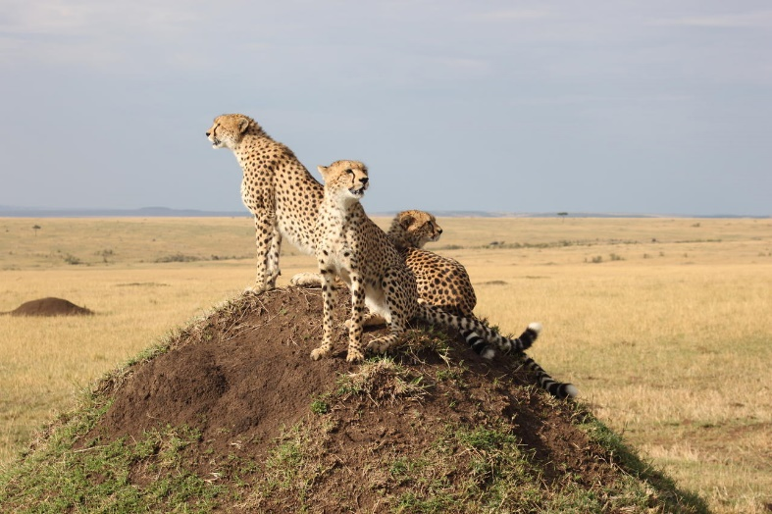
Masai Mara National Reserve is one of the most famous conservation areas in the world and has been referred to as the “the safari jewel”. It is home to much of the African animal kingdom. You can easily spot animals such as lion, hippo, crocodile, giraffe, wildebeest, zebra, buffalo, warthog, hyena, jackal, leopard, elephant, gazelle, impala and other antelope. In addition to the animals, the reserve also has diverse birdlife.

This popular safari offers the traveler a superb experience of seeing the amazing wildlife and scenery of the renowned Masai Mara as well as the opportunity to learn about the customs and culture of the Masai people who have lived alongside wildlife for centuries.

Day 7 -12: The Sands at Nomad- Diani, Kenya.
This morning, after your breakfast and checkout from The Mara, you will transfer to Nairobi and connect on the 14:00 flight to Ukunda Diani. On arrival, a representative from The Sands at Nomad shall be there to receive you and transfer you to The Sands at Nomad in Diani. You have been booked on Half Board package throughout your stay.
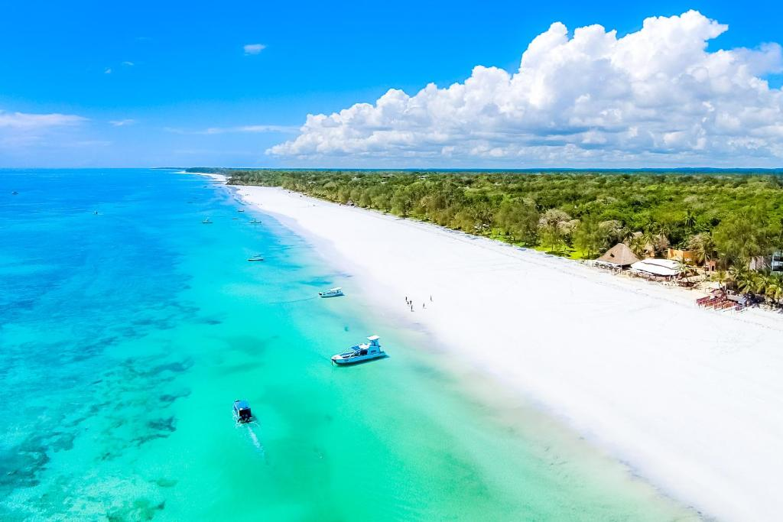
Nestled in an indigenous coastal forest with a garden and a palm-fringed beach, The Sands at Nomad is located in Ukunda. It features an outdoor pool, a spa area and restaurants. 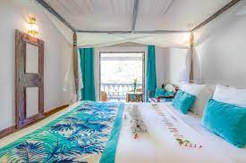
The spacious accommodations are individually designed and combine mahogany furniture with Swahili design. Each room is fitted with a mini-bar and air conditioning. Featuring a shower, private bathrooms also come with a hairdryer and towels. Some of the rooms have a spa bath.
A tropical breakfast is served at the main restaurant, which is also open for lunch and dinner. There is a sushi bar and a pizzeria. Cocktails, refreshments and snacks can be enjoyed at the pool bar.Other facilities at The Sands include a watersport center, a fitness center, a 24-hour front desk, a gift shop and a tour desk. An array of activities can be enjoyed on site or in the surroundings, including windsurfing, kitesurfing, diving and snorkeling. An 18-hole golf course is located 1.2 mi from the hotel.

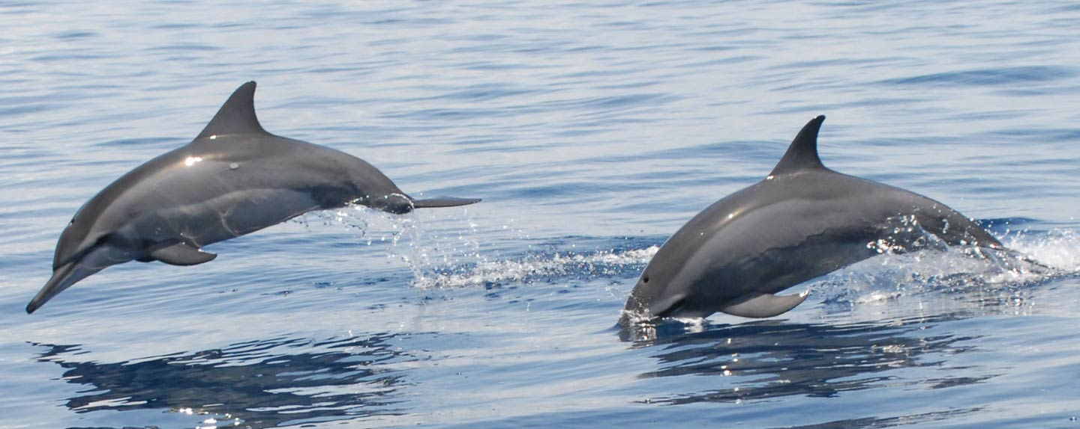
The following day, the hotel representative will pick you up from The Sands at 7.00 am and transfer you to Shimoni. The drive to Shimoni is about 1.5 hrs to the Jetty. As you drive to the historical small fishing village of Shimoni at the South Coast, you will have the opportunity to see rural villages, sugar cane plantations, tall palm trees and lush greenery.
The Slave Caves: On arrival, a local guide will lead you through the Shimoni caves where slaves were “stored” during the old slave trading days before shipment to the Zanzibar slave market.
After the visit to the caves, you’ll head to the Shimoni piers and board a traditional Swahili Dhow for a cruise to the Marine Park. Soft drinks, water, wine, beer and snacks on board as you sail.
As you cruise through the Indian Ocean, there is an approximately 90% chance to spot Dolphins. You then snorkel and marvel at the rich marine life where corals, exotic fish and sea plants are protected. You are provided with masks and snorkels and are accompanied by a certified and experienced guide. Assistance is also provided to first timers. Back on board, you can refresh yourself with fruits and soft drinks.
Lunch: Sail back towards our restaurant located at the Shimoni main land where a tropical seafood lunch is served. The four-course menu includes crab, fish, sea weed, and rice with coconuts sauce. You can also opt for a chicken or vegetarian menu. Beer, wine and soft drinks are included. The restaurant, built on coral architecture and located directly at the shores, overlooks the channel towards Shimoni.
After lunch, you have the option to take a discovery stroll through the Wasini Island and its Swahili culture, visiting the beautiful coral garden and the mangrove forest. Your guide will give you an in-depth oration throughout the tour. Alternatively, you can sunbath and relax at the restaurant, enjoying the sea view and the afternoon breeze. You will later be transferred back to your hotel for dinner and overnight.

On the last day, you shall be transferred from The Sands at Nomad to Ukunda airstrip for your midmorning flight to Nairobi. On arrival in Nairobi, our driver shall meet you at Wilson airport and transfer you to Jomo Kenyatta International airport for your flight home.

Included:
Nairobi airport transfers
1 night at Tamarind Tree Hotel (Bed and breakfast)
5 Nights all inclusive at Sentinel Mara Camp
5 Days park fees in The Mara
Diani airstrip Transfers
5 Nights at the Sands at Nomad on sea view room (Half board)
Wasini Island excursion
All government taxes
Service charge
Excludes
PCR Tests
Optional balloon safari in the Mara
Optional Masai village visit
Diani water sports

