

|  |  |  |
| --- | --- | --- |
| **Day** | **Location** | **Accommodation & Meal plan** |
| Day 1  Day 2  Day 3  Day 4  Day 5  Day 6  Day 7  Day 8  Day 9  Day 10 | Nairobi  Maasai Mara National Reserve  Maasai Mara National Reserve  Maasai Mara National Reserve  Maasai Mara National Reserve  Maasai Mara National Reserve  Lamu  Lamu  Lamu  Lamu | Tamarind Tree Hotel (Bed & Breakfast)  Sentinel Mara Camp (All Inclusive)  Sentinel Mara Camp (All Inclusive)  Sentinel Mara Camp (All Inclusive)  Sentinel Mara Camp (All Inclusive)  Sentinel Mara Camp (All Inclusive)  Peponi Hotel (Full Board)  Peponi Hotel (Full Board)  Peponi Hotel (Full Board)  Peponi Hotel (Full Board) |

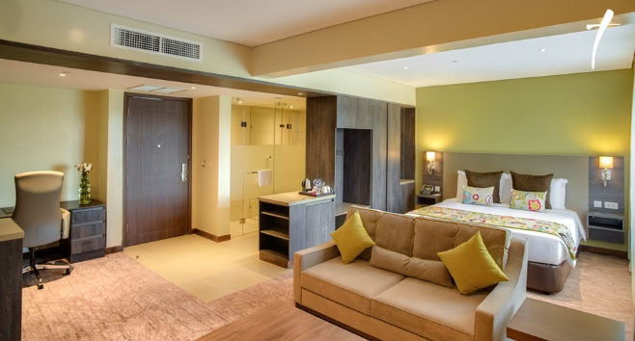**Tamarind Tree Hotel (1 Night)**

Touch down in Africa at Jomo Kenyatta International Airport. A Sentinel representative will be there to meet you and transfer you to Tamarind Tree Hotel. (B&B)

**Sentinel Mara Camp - Masai Mara National Reserve (5 Nights)**

This morning after your breakfast, you will be met and transferred to Nairobi Wilson airport for your flight to the Masai Mara National Reserve, often referred to as “the safari jewel.” Your Mara flight is scheduled to depart at 10:30 a.m. and the flight duration is around 1 hour depending on bush stopovers. A Sentinel guide will meet you at the airstrip as you disembark your flight.

You settle in at [Sentinel Mara Camp](http://www.sentinelmaracamp.com); an exclusive tented eco camp set up in a forest along the banks of the Mara River within the Masai Mara Reserve offering guests an authentic close to nature experience.

The feel is tastefully old fashioned with just 8 large en suite tents furnished with specially designed campaign furniture. It creates the ambience of the traditional East African safari while at the same time providing a high level of customer service and a significant measure of luxury. The abundance of wildlife and an excellent standard of guiding will have you enthralled. Your visit will coincide with the annual Great Migration when huge numbers of wildebeest and zebra migrate from the Serengeti in the Tanzania into the Masai Mara in Kenya.

Your days will be filled with various activities such as early morning and late afternoon game drives, nature walks, champagne bush breakfasts, sundowners, evening drinks by the campfire, starlit dinners and so much more! Our friendly staff will ensure you have an unforgettable experience. You will have the opportunity to visit a local Masai village to observe the traditional Masai way of life. Our Masai staff will be available to talk about Masai customs and culture around the campfire in the evenings. The more energetic can learn how to shoot with a bow and arrow as well as learn how to throw a spear or rungu.

For USD 25, you will have a chance to visit the local Maasai village to learn about the customs and way of life of the maa tribe. Our bespoke approach ensures that your daily routine is flexible and tailored around the particular preferences of each group of guests. On the last day, after your breakfast, your driver will collect and transfer you to Lake Nakuru National Park.

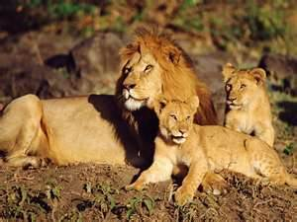***Masai Mara National Reserve***

*Masai Mara National Reserve is one of the most famous conservation areas in the world and has been referred to as the “the safari jewel”. It is home to much of the African animal kingdom. You can easily spot animals such as lion, hippo, crocodile, giraffe, wildebeest, zebra, buffalo, warthog, hyena, jackal, leopard, elephant, gazelle, impala and other antelope. In addition to the animals, the reserve also has diverse birdlife.*

*The most impressive feature is the annual migration with hundreds of thousands of wildebeest and zebra from the plains of the Serengeti in Tanzania crossing the border to reach the vast fertile plains of the Masai Mara. (This occurs between July and October.) They are stalked by predators including lion, cheetah and hyena with vultures awaiting their opportunity to feast on the kills. During the migration, you may be fortunate enough to witness a “river crossing” as masses of wildebeest and zebra plunge into the water while crocodile seek their chance to attack.*

*This popular safari offers the traveler a superb experience of seeing the amazing wildlife and scenery of the renowned Masai Mara as well as the opportunity to learn about the customs and culture of the Masai people who have lived alongside wildlife for centuries.*

**Peponi Hotel, Lamu (4 Nights)**

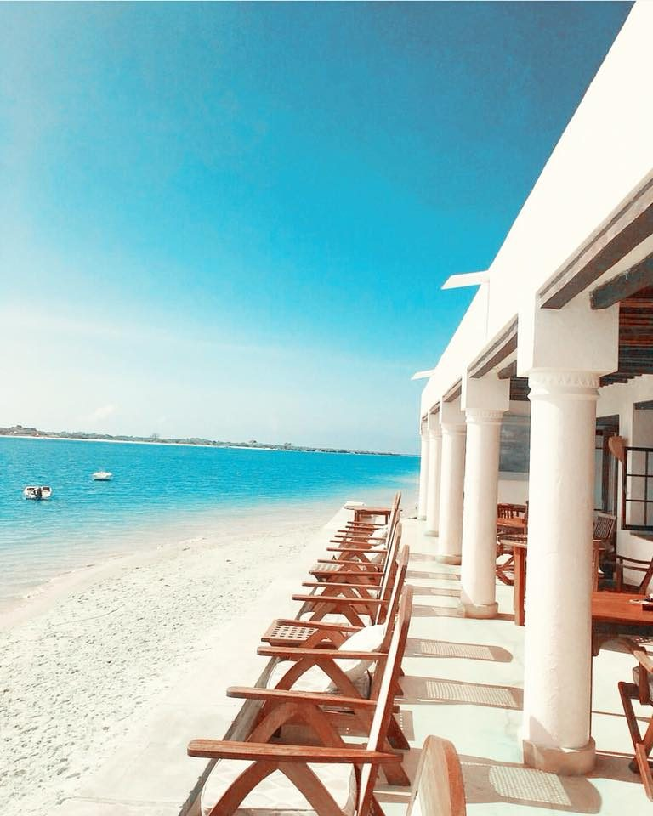On the last day, you will take the mid-morning flight to Nairobi after which you shall connect on the afternoon flight to Lamu. Touch down at Manda airport, a representative from Peponi Hotel will be there to meet and transfer you to the hotel which is approximately 10 minutes away by motorboat. Peponi Hotel is a small boutique hotel on the remote island of Lamu, situated in the Indian Ocean off the North Kenyan coast. The hotel is run by the Korschen family who stumbled upon the old building by chance in the 1960’s. The story begins on the family’s final holiday in Malindi, Aage and Wera Korschen had been farmers in upcountry Kenya until their land was acquired during independence. As Kenya had become home for them and their three children, Lars, Hanne and Nils, they tried to find a suitable replacement career. However after a few years and not much luck they solemnly come to the conclusion it was time to travel back to Denmark and continue their life there. During these last days Aage decided that, before leaving, he must visit a part of the coast he had always been drawn to, the Lamu Archipelago.

Early in 1966 the couple took a short flight up the coast for a day on Lamu Island ending in the small fishing village, Shella, where they happened upon an abandoned Arab style house, perched solitarily like the prow of a ship at the beginning of the long-secluded beach leading to the Indian Ocean. Within 10 days of seeing this building the young family had the keys and moved to the island to start a hotel and in 1967 they opened Peponi

The Lamu Archipelago lies two degrees south of the Equator along Kenya’s coast. The archipelago is a chain of islands separated from the mainland by a narrow channel bordered with dense mangrove forest and protected from the Indian Ocean by coral reefs and large sand dunes.

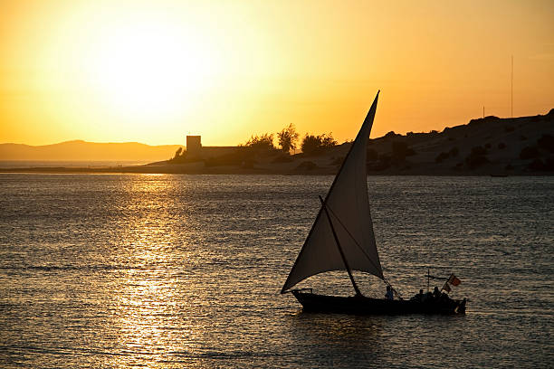Lamu Island has been a port of call for travellers for centuries. The many historical sites are proof of the area’s long and rich history which, when combined with all the natural attraction of its tropical setting, make Lamu a wonderful place to visit.

The streets of Lamu town are narrow, cool and quiet. They are surprisingly intimate spaces enclosed by massive stone buildings whose thick coral rag walls give the town its distinct colour and texture. In December 2001 Lamu Town became a world heritage site in order to protect the oldest inhabited Swahili settlement south of the Sahara.

The archipelago’s history is one of the main draws to the island, for thousands of years the islands provided a welcomed rest for many travellers. Historically trading sailors from Oman, Yemen, Portugal, China and many of the Arab countries visited the port town of Lamu, now a UNESCO World Heritage site. A tour through the main town takes you through a 14 Century Arab port town, where not much has changed since then. To continue with the historical tours there is Takwa Ruins, very well kept, ancient ruins dating back to around 1500 A.D. Further north the other islands of the archipelago can also be explored, each more remote than the last.

Peponi sits at the beginning of a 14km stretch of wild beach, where a gentle walk can clear the mind, you can lie on the sand and soak up the sun or get adventurous and explore the dunes and then dive into the ocean break. Watch the sunrise over the expanse of the Indian Ocean or the sunset over the rolling dunes. There are endless possibilities as well as beaches though the archipelago.

**Price Inclusions-**

* All airport transfers in Nairobi
* 1 Night at Tamarind Tree Hotel (Bed and Breakfast)
* 5 Nights at Sentinel Mara Camp (All inclusive)
* 5 Days Masai Mara park fees
* Round trip airfares between Nairobi and The Mara
* 4 Nights at Peponi Hotel Lamu (Full Board)
* Round trip airfares between Nairobi and Lamu
* All government taxes
* Service charge

**Not included**

* Optional Maasai village visit $25
* Covid-19 PCR Test
* Staff tips and gratuities.

*W:* [www.sentinelsafaris.com](http://www.sentinelsafaris.com) */ E:* [*info@sentinelsafaris.com*](mailto:info@sentinelsafaris.com) */ Trip Advisor Sentinel Mara Camp*

