

|  |  |  |
| --- | --- | --- |
| **Day** | **Location** | **Accommodation & Meal plan** |
| Day 1  Day 2  Day 3  Day 4  Day 5  Day 6  Day 7  Day 8  Day 9  Day 10 | Nairobi  Maasai Mara National Reserve  Maasai Mara National Reserve  Maasai Mara National Reserve  Maasai Mara National Reserve  Maasai Mara National Reserve  Watamu  Watamu  Watamu  Watamu | Tamarind Tree Hotel (Bed & Breakfast)  Sentinel Mara Camp (All Inclusive)  Sentinel Mara Camp (All Inclusive)  Sentinel Mara Camp (All Inclusive)  Sentinel Mara Camp (All Inclusive)  Sentinel Mara Camp (All Inclusive)  Medina Palms  Medina Palms  Medina Palms  Medina Palms |

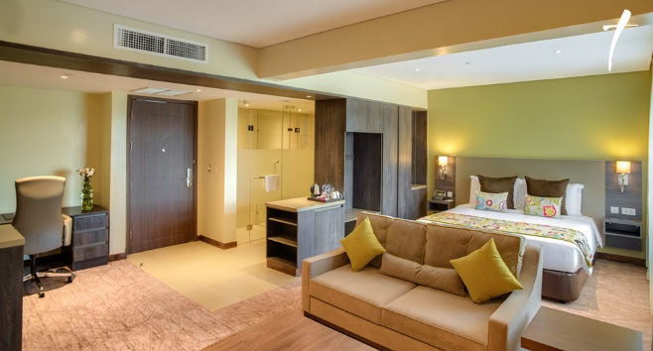**Tamarind Tree Hotel (1 Night)**

Touch down in Africa at Jomo Kenyatta International Airport. A Sentinel representative will be there to meet you and transfer you to Tamarind Tree Hotel. (B&B)

**Sentinel Mara Camp - Masai Mara National Reserve (5 Nights)**

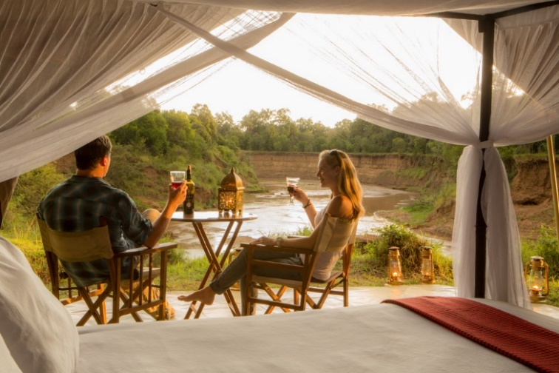This morning after your breakfast, you will be met and transferred to Nairobi Wilson airport for your flight to the Masai Mara National Reserve, often referred to as “the safari jewel.” Your Mara flight is scheduled to depart at 10:00 a.m. and the flight duration is around 1 hour depending on bush stopovers. A Sentinel guide will meet you at the airstrip as you disembark your flight. You shall settle at [Sentinel Mara Camp](http://www.sentinelmaracamp.com); an exclusive tented eco camp set up in a forest along the banks of the Mara River within the Masai Mara Reserve offering guests an authentic close to nature experience.

The feel is tastefully old fashioned with just 8 large en suite tents furnished with specially designed campaign furniture. It creates the ambience of the traditional East African safari while at the same time providing a high level of customer service and a significant measure of luxury. The abundance of wildlife and an excellent standard of guiding will have you enthralled. Your visit will coincide with the annual Great Migration when huge numbers of wildebeest and zebra migrate from the Serengeti in the Tanzania into the Masai Mara in Kenya.

Your days will be filled with various activities such as early morning and late afternoon game drives, nature walks, champagne bush breakfasts, sundowners, evening drinks by the campfire, starlit dinners and so much more! Our friendly staff will ensure you have an unforgettable experience. You will have the opportunity to visit a local Masai village to observe the traditional Masai way of life. Our Masai staff will be available to talk about Masai customs and culture around the campfire in the evenings. The more energetic can learn how to shoot with a bow and arrow as well as learn how to throw a spear or rungu.

For USD 25, you will have a chance to visit the local Maasai village to learn about the customs and way of life of the maa tribe. Our bespoke approach ensures that your daily routine is flexible and tailored around the particular preferences of each group of guests. On the last day, after your breakfast, your driver will collect and transfer you to Lake Nakuru National Park.

***Masai Mara National Reserve***

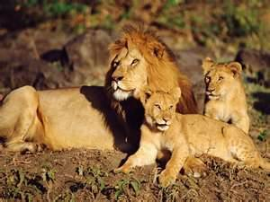*Masai Mara National Reserve is one of the most famous conservation areas in the world and has been referred to as the “the safari jewel”. It is home to much of the African animal kingdom. You can easily spot animals such as lion, hippo, crocodile, giraffe, wildebeest, zebra, buffalo, warthog, hyena, jackal, leopard, elephant, gazelle, impala and other antelope. In addition to the animals, the reserve also has diverse birdlife.*

*The most impressive feature is the annual migration with hundreds of thousands of wildebeest and zebra from the plains of the Serengeti in Tanzania crossing the border to reach the vast fertile plains of the Masai Mara. (This occurs between July and October.) They are stalked by predators including lion, cheetah and hyena with vultures awaiting their opportunity to feast on the kills. During the migration, you may be fortunate enough to witness a “river crossing” as masses of wildebeest and zebra plunge into the water while crocodile seek their chance to attack.*

*This popular safari offers the traveler a superb experience of seeing the amazing wildlife and scenery of the renowned Masai Mara as well as the opportunity to learn about the customs and culture of the Masai people who have lived alongside wildlife for centuries.* *Next day, after your lunch and one last look at the African savanna, you shall wing your way to Malindi, Kenyan coast, where you shall check in at Medina Palms.*

**Medina Palms, Malindi (4 Nights)**

Located on Watamu beach, the luxury [Medina Palms](http://medinapalms.com/) features unique architecture and a tropical garden, outdoor swimming pool with sun loungers and views of the Indian Ocean. With a huge range of accommodation options, including a luxurious private villa, Medina Palms is an ideal spot for families, couples and groups.

The property offers a tranquil hideaway from the hustle and bustle of Watamu. There are fifty suites at Medina Palms and the hotel has been cleverly designed so as to create a sense of complete privacy and exclusivity. The suites range from comfortable one bedroom suites to a luxurious private villa which can accommodate up to ten guests.

Medina Palms also has a world class watersports facility which has East Africa's only British Kitesurfing association approved school.

With views of the garden and pool, the elegant and spacious suites come complete with air conditioning and feature a lounge and dining area, flat-screen satellite TV and kitchenette. Each have a private entrance and some suites offer a hot tub.

At Medina Palms there is the à la carte Amandina Restaurant, Star Lounge which offers shisha, cocktails and sunsets views towards the distant Tsavo National Park.

Other facilities at the resort include a kids' club, fitness center and the Sakina Spa which offers an array of treatments and massages.

The resort is 16 mins from the Malindi Airport and 78 mins from the Moi International Airport.

**Price Inclusions-**

* Nairobi airport transfers
* 1 Night at Tamarind Tree Hotel (Bed and breakfast)
* 5 Nights at Sentinel Mara Camp (All inclusive)
* Maasai Mara Park fees
* Nairobi – Mara round trip airfares
* Nairobi to Malindi round trip airfares
* 4 Nights at Medina Palms (Full Board)
* All government taxes
* Service charge

**Not included**

* Optional Maasai village visit $25
* Covid-19 PCR Test
* Optional watersports in The Coast
* Staff tips and gratuities.

*Website* [www.sentinelsafaris.com](http://www.sentinelsafaris.com) */ Email* [*info@sentinelsafaris.com*](mailto:info@sentinelsafaris.com) */ Trip Advisor Sentinel Mara Camp*

