Volcanoes Safaris Bwindi Lodge, Uganda
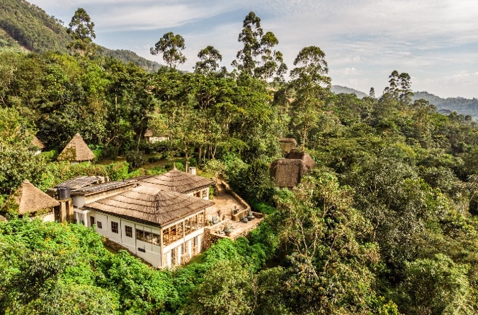
Fact Sheet

The Lodge
- 10 newly renovated luxury bandas. 8 standard rooms (6 doubles and 2 twins) and 2 deluxe bandas (2 doubles). All rooms offer spectacular views of the forest. No guide/tour leader rooms available at the lodge.
- All bandas are complete with en-suite bathrooms with flushing toilet, double vanity and shower with hot & cold running water.
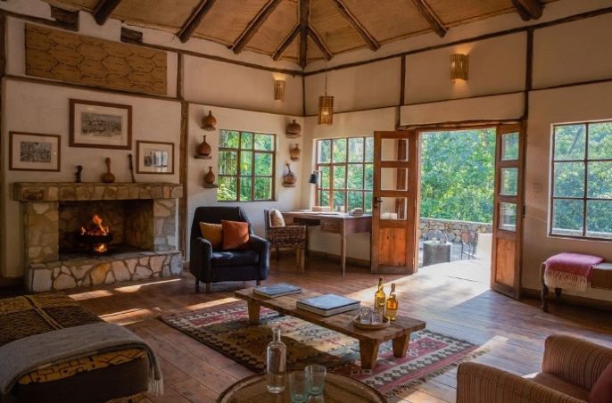
- Each banda has a private terrace overlooking the Bwindi Impenetrable Forest with scenic panoramic views.
- Personal butler service for all guests.
- ​The Forest Spa Humula mw' Ishamba has two massage rooms, and a sauna. All massages are complimentary and subject to booking and availability.
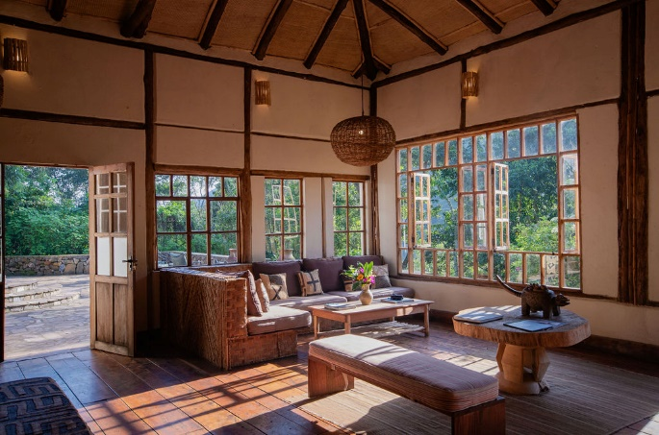
- Full board accommodation including all soft drinks and regular and premium alcoholic beverages including cocktails, cellar collection wines and single malt whiskies. Guests pay for French champagne only.
- Complimentary laundry service.
- Power sockets/charging facilities and hair dryer in the rooms. No air conditioners.
- Wi-Fi is available in the main lodge and all guest bandas.
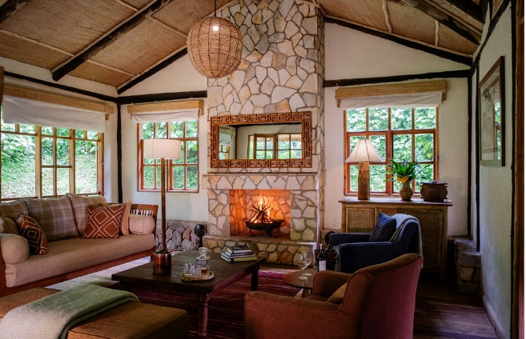
Safari & Lodge Activities
- Gorilla tracking (exclusive gorilla tracking available).
- Visit the award-winning Bwindi Bar.
- Take a tour around the tea plantations.
- Take a walk to the river below the lodge.
- Waterfall walk and Munyanga River Trail.
- Rushurra Hill/Border Trail.
- Muzabajirro Loop Trail.
- Visit Bwindi Community Hospital.
- Visit Conservation Through Public Health headquarters (Dr. Gladys Kalema’s laboratory).

Getting to the Lodge
- From Entebbe: 1-hour flight.
- From Kisoro (for Mount Gahinga Lodge): 15-minute flight or a 4-hour walk through the forest, with both including a +2-hour drive.
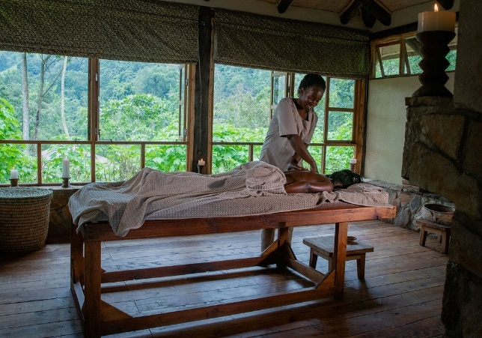
- From Kasese (for Kyambura Gorge Lodge and Kibale Lodge): 25-minute flight + total 2-hour drive or a 6-hour drive from Kyambura Gorge Lodge through Queen Elizabeth National Park.
Seasons & Climate
- Average daytime temperatures: 15-27 celsius, at night: 7-17 celsius.
- Uganda is located on the equator and is an all- year- round destination. High season: 15 Dec - 28 Feb / 1 Jun - 30 Sep. Low season: 1 Oct - 14 Dec / 1 Mar - 31 May.
Useful Information
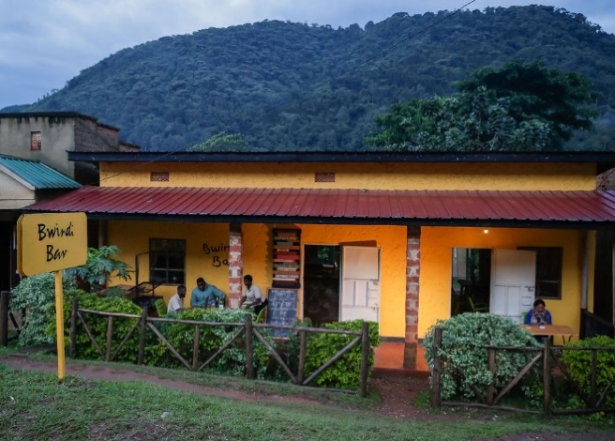
- Lodge altitude: 1,475m. GPS coordinates: 0.9835° S, 29.6174° E.
- Credit card payments are accepted at the lodge (Amex, Visa and MasterCard). Cash payments or cheques are not accepted.
- Gratuities are at the discretion of the guest. For lodge staff and guides we suggest $5-10 or more per day. For park guides $5-10 and for trackers $15 per guest. All tips go directly to staff.
- Children under 15 years of age are not permitted to track the gorillas. They are very welcome at the lodge, but please be advised we do not have childcare facilities.
- Check out time for all guests is 11am.

Website | Instagram | Twitter | Facebook | Youtube
Images | Videos | Maps | Rates

