Volcanoes Safaris Kyambura Gorge Lodge, Uganda
Fact Sheet

The Lodge
- 8 unique handbuilt bandas (4 deluxe and 4 standard) of which 6 doubles and 2 twins. All with a private balcony offering spectacular views of the park or gorge. 1 guide/tour leader room available.
- All rooms are complete with en-suite bathrooms with flushing toilet, double vanity and indoor and outdoor shower with hot & cold running water.
- Swimming pool with stunning views over the park and the Rwenzori Mountains on the horizon.
- Personal butler service for all guests.
- ​2 tranquil massage rooms available. One 50-minute complimentary massage per guest per stay. Extra massages are available at $50 for a 50- minute massage.
- Full board accommodation including all soft drinks and regular and premium alcoholic beverages including cocktails, cellar collection wines and single malt whiskies. Guests pay for French champagne only.
- Complimentary laundry service.
- Power sockets/charging facilities and hair dryer in the rooms. Fans are provided but no air conditioners.
- Wi-Fi available in the main lodge and bandas.
- Sales Tool Kit with images, videos, rates, etc can be viewed at this link.
Safari & Lodge Activities
- Chimpanzee tracking at Kyambura Gorge Lodge, with direct access on foot along the Fig Tree Walk. Trek in Kalinzu Forest (20 minutes drive from lodge).
- Game drives and tree-climbing lions in Queen Elizabeth National Park.
- Kazinga Channel Boat Cruise.
- Hike the Rwenzori Mountains.

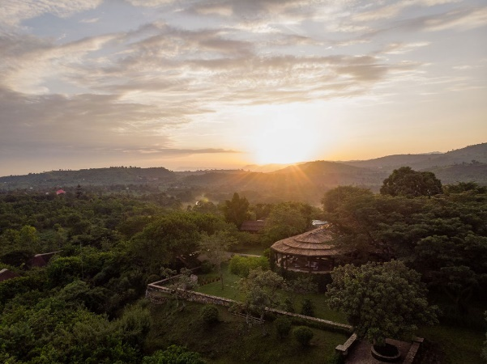
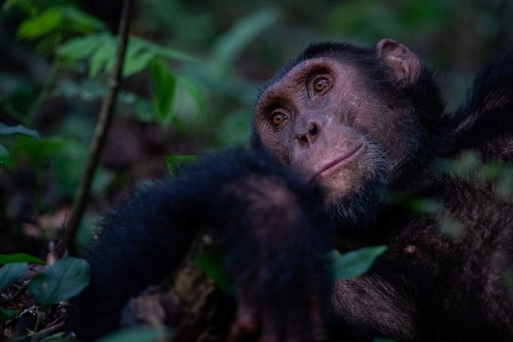
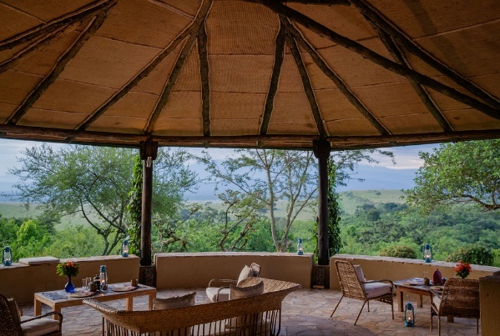
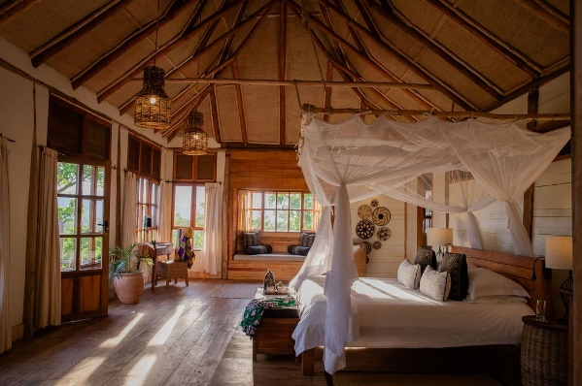
- Visit the Kyambura Coffee Cooperative.
- Go birding in the Kyambura wetland.
- Plant tree in the buffer zone.
- Gorge walk at the lodge.
Getting to the Lodge
- From Entebbe: 1-hour flight + 2-hour drive
- From Bwindi Lodge (Kihihi): 15-minute flight or a 5-hour drive through the park.
- From Mount Gahinga Lodge (Kisoro): 15-minute flight + 2-hour drive.
Seasons & Climate
- Average daytime temperatures: 15-35 celsius, at night: 10-25 celsius.
- Uganda is located on the Equator and is an all- year-round destination. High season: 15 Dec - 28 Feb / 1 Jun - 30 Sep. Low season: 1 Oct - 14 Dec / 1 Mar - 31 May.
Useful Information
- Lodge altitude: 1,060m. GPS coordinates: - 0.208354, 30.104324.
- Credit card payments are accepted at the lodge (Amex, Visa and MasterCard). Cash payments or cheques are not accepted.
- Gratuities are at the discretion of the guest. For lodge staff and guides we suggest $5-10 or more per day. For park guides $5-10 and for trackers $15 per guest.
- Children under 15 years of age are not permitted to track the chimps. They are welcome at the lodge, but please be advised we do not have childcare facilities.
- Check out time for all guests is 11am on the day of departure.

