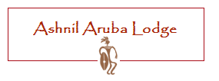

Road Directions from Nairobi to Aruba Lodge

*** The drive from Nairobi to Ashnil Aruba Lodge is 360 KM, and takes approximately 5 – 6 hours

Leave Nairobi using Mombasa Rd (A109), and travel through past Mtito Andei and onto Voi. Once in Voi, turn left into the Voi Town, and roughly 3 Km in, turn left again towards the KWS Voi Gate. From there, the directional sign posts are visible up-to The Lodge. The distance from Voi Town to the Lodge is roughly 35 km.

