Directions from Johannesburg & Pretoria
(5 to 6 hours’ drive)
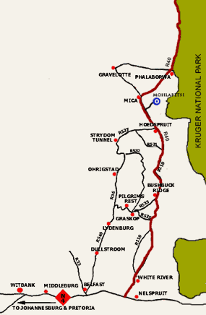 |  | The Lodge is centrally situated and is thus an ideal base from which to explore the area. We are easy to find, just 7km off the tarred R40, slightly north of Hoedspruit. We are en-route to or from the Panorama Route and the Blyde River Canyon, via the Abel Erasmus Pass. The Kruger Park is also close by: both Orpen & Phalaborwa Gates are about 80km from us.  From Johannesburg take the N12  From Pretoria take the N4 towards eMalahleni (Witbank)  - N12 joins the N4 at eMalahleni (Witbank) and continue to Belfast.  - At Belfast take the R540 to Dullstroom & Mashishing (Lydenburg).  - The road deteriorates here & there are many potholes. Please drive carefully!  - Continue through Mashishing (Lydenburg) and towards Ohrigstad along the R36.  - Pass through the Abel Erasmus Pass and through the JG Strydom Tunnel towards Hoedspruit along the R527.  - At Hoedspruit the R527 will intersect with the R40.  - Turn left and travel along the R530 (R40) for 10kms and turn right at the Mohlabetsi signboard.  - Enter the manned security gates – there is a R200 per vehicle plus R50 per person entrance fee payable in cash or by card - and travel 7kms and drive straight into the camp, where a warm welcome awaits you.

