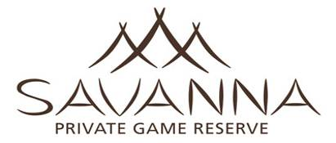
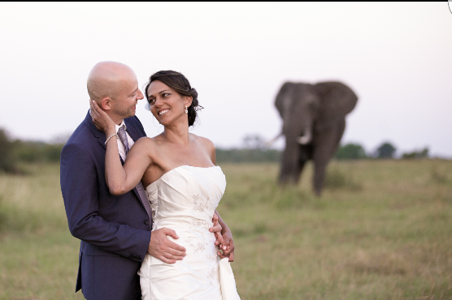

Intimate Weddings at Savanna Private Game Reserve

R23 650 nett, valid from 01 January - 31 December 2022

Includes the following:

Minister,

Legal Documents,

Bouquet for the bride,

Buttonhole for groom,

Extra flowers,

Small wedding cake,

A complimentary bottle of sparkling wine for the bridal couple.

Venue:

Choice of the following:-
- In the middle of bush,
- By the swimming pool with a view of the waterhole in the background,
- Or on the decking/lounge area.

Information required-
Wedding couple will need to submit the following at least three weeks prior to the wedding:
- Birth certificates
- Certified copies of Divorce and/or Death Certificates (where applicable)
- Declaration for the Purpose of a Marriage.
(ONE MUST BE COMPLETED FOR EACH PARTNER)
- Particulars of Marriage Form.
- Certified copies of Passports.

This will be a Religious Ceremony, or it can be a Civil Ceremony if preferred.

The above fee is applicable over and above the accommodation charges and utilises the standard Lodge facilities. Any special hire in items (white chairs, marquee etc.) would be at an additional charge. Make up, hairdressing and photography is not included in the fee. Please note that additional fees may apply for same sex marriage services due to no local available ministers. The above fee is subject to change and best confirmed at time of enquiry.

