A BRIEF HISTORY OF MOUNT MERU GAME LODGE
In 1959, Dr. Andreas Von Nagy (Endre Nagy) bought a piece of land in Usa River with the intention of establishing a home for himself and his family.
Dr. Von Nagy, who graduated from the College of Hunting & Wildlife Management in Hannover-Muenden, Germany in the 1950’s, had previously worked in a number of hunting and wildlife related positions in both Austria and Germany. Prior to that, he had been very active in the rehabilitation of wildlife in Hungary (where he was born) after the Second World War. It was therefore no surprise that he became a renowned personality in Hunting and Wildlife Conservation in Tanzania during the 1960’s and 1970’s.
Initially, Dr. Von Nagy made a meager living collecting specimens of animals, insects and birds for various European Museums. In order to supplement his income for the family, he started conducting professional safaris. The additional income which he generated through these safaris allowed him slowly to develop his property in Usa River which, up until then, was very basic indeed consisting of an old shack and just two small rooms. Supplies of both electricity and water were added and cottages built around the main house in order to accommodate family members, friends and of course clients of his growing safari business.
It was not long before his home became a very popular stop-over for everyone travelling to and within Tanzania. Hunters, conservationists, researchers and tourists from all over the world considered it a must to stay with the family in Usa River.

As the tourist Industry in Tanzania grew and accommodation facilities became more and more limited, additional cottages were added to the property in the late 1960's and slowly but surely, the family home took on the role of a small Lodge.
Due to his by now widely known and respected work in the area of Wildlife Conservation, Dr. Von Nagy and his family were brought an ever growing number of orphaned or wounded animals in need of care. Wherever possible, these animals were rehabilitated into the wild once they were fully grown and it was believed that they could once again survive on their own. In the meantime however, it was not unusual in those days to see small lions strolling around the property or to have Chimpanzees join in a tea party!
At this time, it occurred to Dr. von Nagy that many of the local Tanzanian population living in towns had never seen the Wildlife of their country and indeed had no opportunity to do so. In co-operation with the Wildlife Department, he therefore established an Animal Orphanage and Sanctuary on his property which he opened to the public for a small fee. It soon became a very popular destination for Sunday outings and school visits. Even today, it is common to meet Tanzanians in all walks of life whose first contact with their wildlife heritage was as a child at the Animal Sanctuary.
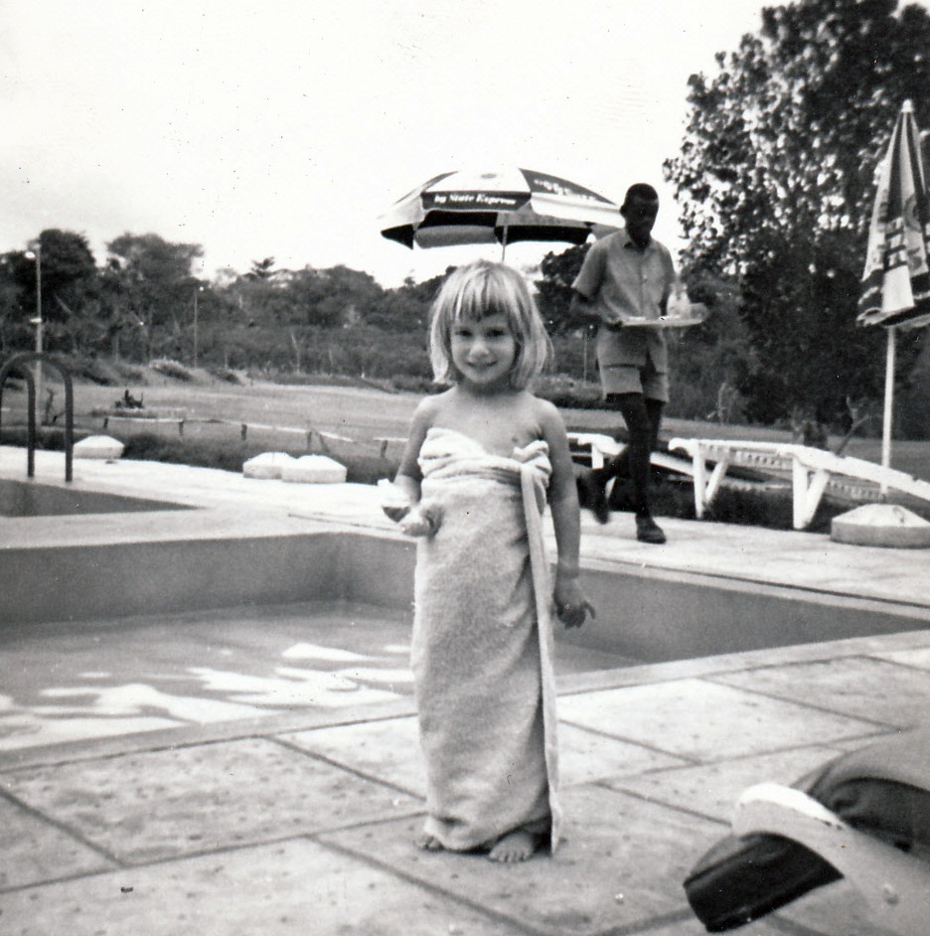
The Lodge and Sanctuary (as well as the continuing Safari business) were run by Dr. Von Nagy and members of his family. They became a very popular stop over for many VIP’s and Government visitors. Various Presidents of African Countries, celebrities, and members of European Royal families have stayed at the Lodge and a visit to the Sanctuary was always included in the official itineraries of Government visitors when in Arusha.
In 1985 Dr. von Nagy, now in his seventies, established a small Museum in Hungary for his trophies and large collection of original African artifacts. The Museum exists to this day and is very popular indeed with the Hungarian public.
Dr. Von Nagy passed away in Hungary in 1994. The lodge remains in family hands and is now run by Dr. Von Nagy’s grandson.

