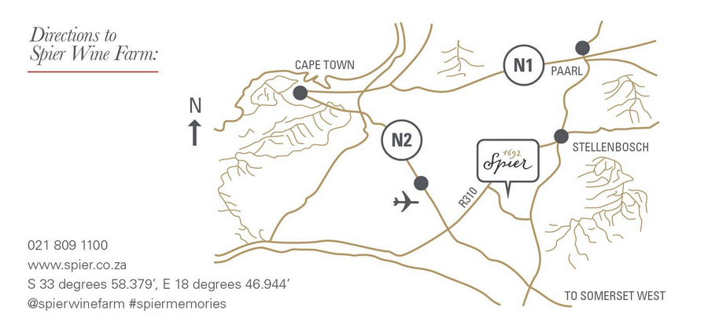

From Stellenbosch
- From Adam Tas road (railway on right) go past Simonsberg Cheeses and Bergkelder
- Turn right at the sign for Cape Town and Kuils River – R310
- At sign for Muizenberg – R310 turn left
- Spier will be on your left hand side in 4km
- If you go past Neethlingshof turn back - Spier is +- 5 km down the road on the left

From Cape Town (N2)
- Take the N2 towards Cape Town International Airport
- Continue past the Airport turnoff
- Take exit 33 which is the Baden Powell Drive/ R310 Stellenbosch turn off
- Turn left in the direction of Stellenbosch
- Spier is 9 km down the road on the right

From Durbanville (N1)
- Take N1 and exit 47
- Turn right at the stop sign and continue to Stellenbosch on the R44
- As you drive into Stellenbosch keep straight and you will get into Adam Tas road which has the railway line on its right. Go past Simonsberg Cheeses and Bergkelder
- Turn right at the sign for Cape Town and Kuils River – R310
- At sign for Muizenberg – R310 turn left
- If you go past Neethlingshof turn back - Spier is +- 5 km down the road on the left

