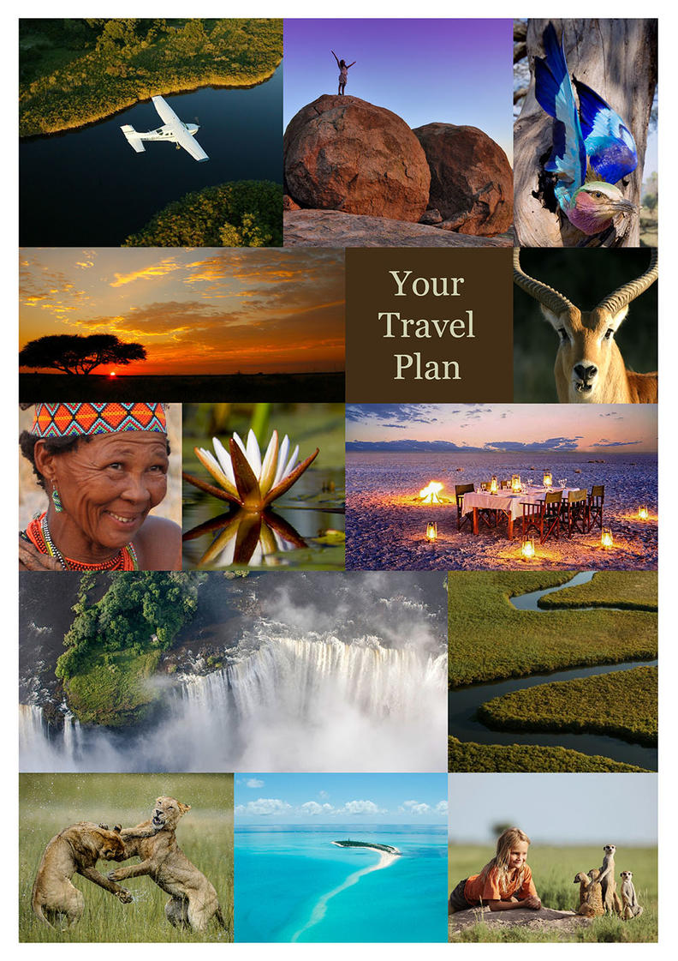
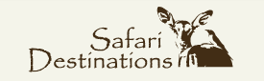

10N Desert & Delta_OPT B
Victoria Falls, Zimbabwe - Chobe River Front - Okavango Delta - Khwai Community Area - Makgadikgadi Salt Pans
11 Days / 10 Nights
2 Persons

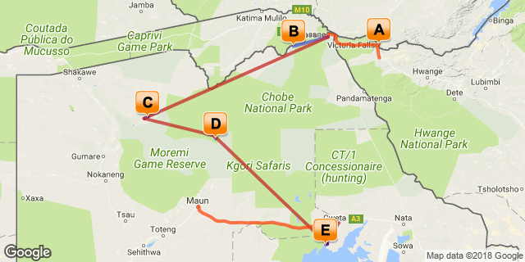

Click here to view your Digital Itinerary

Introduction

Start | Accommodation | Destination | Duration
Day 1 | Ilala Lodge | Victoria Falls, Zimbabwe | 2 Nights
Day 3 | Chobe Elephant Camp | Chobe River Front | 2 Nights
Day 5 | Mapula Lodge | Okavango Delta | 2 Nights
Day 7 | Sable Alley | Khwai Community Area | 2 Nights
Day 9 | Camp Kalahari | Makgadikgadi Salt Pans | 2 Nights

Transport

Flight Information
Date | Flight | Details | Class | Ref
Day 5 | Major Blue (Natural Selection) | Kasane Airport - Mapula Airstrip
Day 7 | Major Blue (Natural Selection) | Mapula Airstrip - Banoka Airstrip
Day 9 | Major Blue (Natural Selection) | Banoka Airstrip - Tsigaro

Transfers
Date | Company | Details
Day 1 | Wild Horizons | Victoria Falls Airport - Ilala Lodge
Day 3 | Wild Horizons | Ilala Lodge - Kasane Airport
Day 3 | Chobe Elephant Camp | Kasane - Chobe Elephant Camp
Day 5 | Chobe Elephant Camp | Chobe Elephant Camp - Kasane
Day 11 | Camp Kalahari | Camp Kalahari - Planet Baobab
Day 11 | Letsapa Tour Transport | Planet Baobab - Maun Airport

Day 1-3
Ilala Lodge, Victoria Falls, Zimbabwe

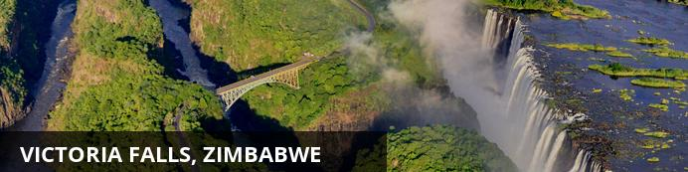
At Victoria Falls, the earth splits open and swallows one of Africa’s greatest rivers, the mighty Zambezi, creating the largest sheet of falling water on earth. As the water hits the narrow depths of the Batoka Gorge beneath, it blasts a cloud of mist skywards, lending the falls their local name ‘mosi-oa-tunya’ (the smoke that thunders). When the Zambezi is its fullest, the mist hangs a permanent raincloud above the falls, showering visitors on even the sunniest of days and visible for miles around.
Above the falls on the upper Zambezi, boats cruise the tranquil water at sunset while the distant spray catches the fading light downstream. Below the falls, the Batoka Gorge’s rocky walls funnel the lower Zambezi into a chain of world-class rapids, prime for white water rafting.
Aside from being a UNESCO world heritage site and a natural world wonder, Victoria Falls also forms a natural border between Zimbabwe and Zambia. The falls can be seen from both countries, and for the most part the same activities are offered on both sides, from helicopter scenic flights to village visits and souvenir shopping.
Whether your idea of getting away from it all is a relaxed high tea in colonial grandeur or a heart-stopping bungee jump off a bridge, Victoria Falls keeps both the faint of heart and the most insatiable of adrenalin junkies busy for days.
From Zambia, a side on view of the falls is on offer with views into the Batoka Gorge, as well as the possibility of perching yourself at the edge of the falls on the vertigo-inducing Livingstone Island.
From Zimbabwe, you’ll get a full-frontal view of three quarters of the falls’ 1.7km wide curtain of water from viewpoints and footpaths meandering through a rainforest kept hot and humid by the spray of the falls.

Overnight: Ilala Lodge View iBrochure
Includes: bed & breakfast (please see detailed itinerary for additional meals and activities booked)
Ilala Lodge is situated close to the Victoria Falls, Zimbabwe as well as to the town centre. Wild animals are often seen grazing the hotel lawns as the National Park borders the front of the property.
In the central wing, the Lodge offers 34 rooms: 30 standard twins, 2 standard doubles and 2 standard suites. All rooms have an ensuite bathroom with separate shower, wireless internet, in-room safe, tea/coffee self service, air-conditioning, overhead fans and satellite television. The rooms are spacious with railway sleeper teak furnishings and patio doors leading onto either an open lawn or a balcony facing the Victoria Falls.
The new extension wing offers 8 deluxe twin rooms, 12 deluxe double rooms and 2 executive suites. All rooms have a private balcony, mini bar fridges, international plugs/ adaptors, wireless internet, in-room safe, tea/ coffee self service, air conditioning, overhead fans and satellite television.
Conveniently located, the central and extension wing rooms provide easy access to the restaurants, pool and adventure booking centre.
There is an à la carte restaurant which serves breakfast, lunch and dinner and offers a comprehensive wine list and cocktails. Dining outside under the African night sky amidst the sound of the mighty waterfall makes for a very romantic evening.
Airport Transfer Time: 30 minutes
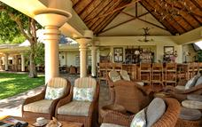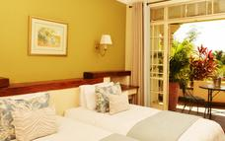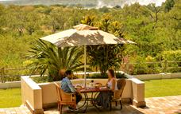

Day 3-5
Chobe Elephant Camp, Chobe River Front

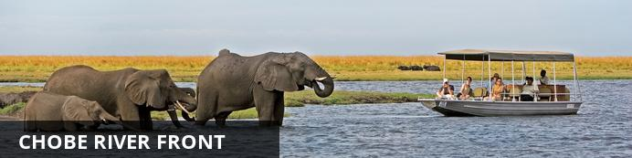
The Chobe Riverfront is an elephant mecca; home to the largest density of African elephants in the world. Travel here during winter and you’ll fast run out of fingers and toes while you count them drinking at the riverbanks and socialising out on the floodplains.
Thanks to its ease of access from Victoria Falls, the Chobe Riverfront is the busiest part of Botswana (though still a much quieter affair than most South or East African safaris). What Chobe lacks in solitude during the busier months, it more than makes up for with quality game viewing.
Chobe will leave you feeling tiny as giant elephant bulls stroll up next to your vehicle or snorkel alongside your boat. It will make you feel lost as hundreds of hippos and buffaloes crowd you out on the floodplains. It will put your heart in your throat as prides of lions stalk antelopes by the water’s edge, and it will leave you alone with your thoughts while the classic red sunsets melt over the river to a soundtrack of whistling fish eagles.
Chobe is not just a great introduction to Botswana. It also makes a rewarding repeat journey once you’ve ticked off the big stuff. It’s a place to search for the rare sable antelope, to spot that gem from the birders’ bucket list and to explore the remoter corners.
Where you stay in Chobe makes a huge difference to your safari experience. The most affordable options are at bigger hotels in a town setting where you’ll share your game drives with a few more vehicles. On the more exclusive end, stay in a wilder area in or around the park, listen to the sounds of the bush at night and get a head start on accessing the park for activities.

Overnight: Chobe Elephant Camp
Includes: meals, local drinks, activities, laundry and park fees.
Excludes: premium drinks
Activities: game drives, boating and canoe excursions (stays of 2 nights or longer) and cultural village visit
Located high on the edge of a rocky ridge overlooking the famous Chobe River is Chobe Elephant Camp. This uniquely designed lodge has been built to take advantage of the incredible views overlooking the sweeping floodplains while offering a comfortable refuge from the harsh African conditions.
The lodge has been entirely constructed from sandbags, the thick sand-filled walls create a natural insulating barrier between the inhabitants and the harsh African climate and enhance the old farm-style feel of the camp. It houses ten rooms, one family room and can sleep 24 guests at a time.
With a variety of activities that include viewing the region’s spectacular wildlife from open safari vehicles, by boat on the Chobe River or experiencing life in the village, a visit to Chobe Elephant Camp offers a wide range of experiences to our guests. Tranquil canoe excursions ranging from 1.5 to 2.5 hours duration offer guests the opportunity to paddle their own canoes – safely following their canoe guide – to discover the wonders of the Chobe River floodplain system in quiet harmony with these remarkable surroundings.(Depends on water levels)
Chobe / Ngoma Gate
This property is located near the Ngoma Gate for entry to the Chobe Riverfront. Very few lodges are located at this end of the park and few people utilize this entry point, creating a more remote and exclusive experience than at the properties around Kasane. Although outside the park, this option is located in a bush setting where wildlife frequently passes through.
Airport transfer time: 50 minutes
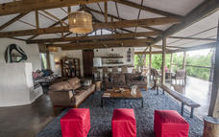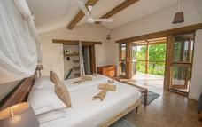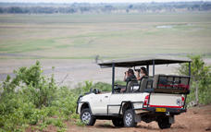

Day 5-7
Mapula Lodge, Okavango Delta

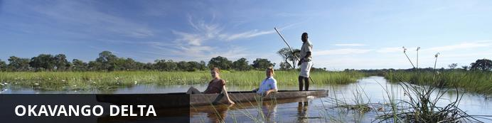
The Okavango Delta is where the wild things are: an immense, waterlogged oasis alive with elephants and birdlife, adrift in the middle of Kalahari sands. The real magic of the Delta lies in its water, trickling through from far away highlands, and spreading across the channels and floodplains.
During winter in the Kalahari, when the sun has baked the earth bare and turned the desert its driest, water fills the Okavango; transforming the floodplains into a Noah’s Ark of African wildlife.
As the water brings life to the delta, its local residents shape and recreate it. Termites slowly build mounds into islands, germinated with palm trees by passing elephants. Waterways open and close on the whim of wide-bottomed hippos, carving out channels where they crash through reeds, and leaving room behind them for exploration by mokoro.
The Okavango has many faces, which change throughout the year, prompted by that most unpredictable diva of all: the weather. Water levels rise and drop, expanding and shrinking islands, while animals move where the life is easiest and the grass greenest. In a few days, a sandy road driven by vehicle can become a waterway of unknowable depth, prompting a safari by boat instead.
Where and when you stay in the Okavango Delta will hugely influence what you do in the bush each day, the animals you’re most likely to see and finally, the safari experience you’ll have.
The delta’s watery heart is best discovered by mokoro through shallow channels and floodplains, as well as crossing the islands on foot. For less water and more of the big game, visit a camp on its drier edges (including Moremi Game Reserve and the Khwai Community Area), jump on a vehicle and seek out the animals hiding in the woodlands.

Overnight: Mapula Lodge
Includes: meals, local drinks, activities, park fees & laundry
Excludes: premium brand drinks and additional activities
Activities: day and night game drives, walking safaris, boat trips & mokoro excursions (subject to water levels)
Mapula Lodge is situated in the north-western floodplains of the Okavango Delta in a vast private concession offering 12 000 hectares of prime game viewing area. The lodge occupies a stunning position set on the edge of seasonal floodplains and overlooks a permanent lagoon complete with resident hippos.
Positioned well apart from one another, Mapula Lodge has nine thatch-and-canvas tented rooms including one family room. All rooms have an ensuite bathroom with flush loo plus indoor and outdoor shower. Classy touches in each room include metal four poster king side beds, plush bedding, floor kilims and brass lanterns.
The chic main lodge is a spacious public area under thatch with a comfy lounge, small library, dining tent and generous swimming pool. A distinctive outdoor sunken lounge offers awe-inspiring views of the pristine lagoon and lodge surroundings. Fresh, original plated meals are a trademark of Mapula Lodge.
Activities include game drives, boat trips, mokoro excursions, walking safaris with experienced guides and night drives in search of nocturnal animals. Early morning and late afternoon game drives are conducted in open 4x4 safari vehicles. Due to its location in the Delta, Mapula Lodge not only offers a big game experience but also the unique delta mokoro activity on the seasonal floodplains almost all year round depending on water levels. An optional sleep out on a 3 nights stay is available, subject to weather conditions and availability. The camp also offers hot air ballooning as an optional activity - at an additional cost (seasonal and weather dependent)
Airstrip Transfer Time: 45 minutes
Please note that during the annual floods, when water levels are at their peak, alternative routes may be used. Please confirm what may be expected.
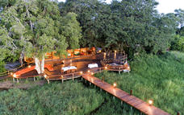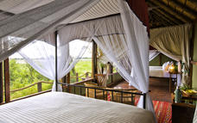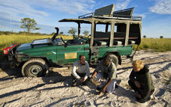

Day 7-9
Sable Alley, Khwai Community Area

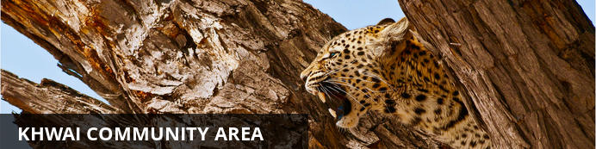
Looking at a map of Botswana, you’d miss Khwai completely if you didn’t know it was there. Wedged between the big-ticket attractions of Chobe National Park to the east and Moremi Game Reserve to the south, Khwai exists as a significant big game destination of its own.
Lying on the eastern fringes of the Okavango Delta with a rich wildlife population and no borders drawn around it on the map, Khwai is often overlooked in favour of its more famous neighbours, though in the winter months it can hold its own for the quality of big game viewing.
During your time here, you’ll spend most days exploring the narrow Khwai River, which forms the natural boundary to the Moremi Game Reserve on the south. The Khwai River is a beacon for wildlife and plays host to leopards stalking lechwe in the long grass, lions swimming from the banks to save their cubs’ during territorial disputes and crocodiles competing with wild dogs for a midday meal of impala.
As Khwai lies outside the parks, it offers the freedom and flexibility normally only possible with the heavier price tag of a private concession. Go off-road for a closer look at sightings, night drive in search of nocturnal species, and, with a little advance planning, head out on game walks to track wildlife on foot.
Khwai is also home to a village community where people live side by side with the resident wildlife. Some camps will offer village visits for a dose of cultural insight to go with your safari. For those not visiting the water camps of the delta, many camps in Khwai offer the chance to get out on a mokoro (traditional canoe), although excursions are less traditional in nature, skirting the riverbanks, rather than open delta floodplains.

Overnight: Sable Alley View iBrochure
Includes: meals, local drinks, activities, and park fees
Excludes: premium drinks
Activities: day & night game drives, nature walks (on request) and mokoro excursions (dependent on water levels)
Sable Alley Camp lies along the Khwai River, in the north of Botswana's Okavango Delta, where a multiplicity of habitats - from forest to riverine - is home to a plethora of wildlife. The Khwai Channel offers fantastic game viewing opportunities and is home to hippo, crocodile, red lechwe, roan and sable antelope species as well as zebra, kudu and blue wildebeest. Predators include lion, leopard, wild dog and spotted hyena.
Accommodation consists of twelve tented units with en-suite bathrooms as well as outdoor showers. The main camp area boasts a lounge as well as a dining area and plunge pool, offering beautiful views.
Sable Alley Camp is located in the Khwai Community Concession, one of the most diverse areas in northern Botswana, which seldom disappoints when it comes to producing extraordinary wildlife experiences. The life source for this area is the Khwai River - the northernmost "finger" of the Okavango Delta alluvial fan. Guided game drives explore the Khwai Concession and adjoining Moremi Game Reserve with nature walks as an optional activity on request, which requires a special guide. Mokoro excursions provide the opportunity to float down the Khwai's secretive channels to provide that classic Delta experience.
Airstrip Transfer Time: 15 minutes
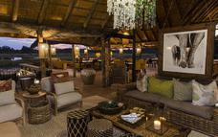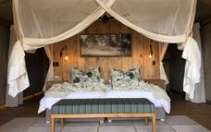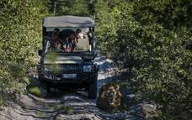

Day 9-11
Camp Kalahari, Makgadikgadi Salt Pans

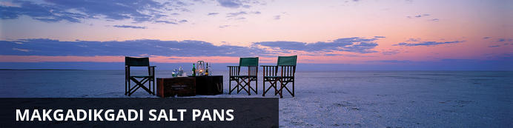
The Makgadikgadi Salt Pans are all that remains of a great lake which once covered most of northern Botswana, fed by rivers carrying salts. The most iconic pans, Ntwetwe and Sua Pan provide vistas of blinding white salt flats reaching far into the horizon where pans sleep-outs are experienced. No vegetation grows on the salty surface of the pans, but the fringes are covered with grasslands. No animals live on the pans, save a few populations of desert species and the elusive brown hyena living near the fringes. The result is that the salt pans provide an unforgettable landscape experience of incredible sunsets and sunrises and a bewildering lack of perspective rather than a game experience. Africa’s famous explorer Dr. David Livingstone crossed these pans in the 19th century, using two massive baobabs, believed to be 3,000 to 4,000 years old as a navigation tool.
All camps on the salt pans are situated on or next to Ntwetwe Pan in the west of the pans complex and offer quad biking on the pans, visits to habituated meerkats, archaeological walks as well as cultural insight into the lives of the San people. More recently horse-riding expeditions have been made possible, providing a unique way to explore the landscape. All activities in this area are subject to favourable conditions as the slightest rainfall can make the pans completely inaccessible. During the rainy season, the main attraction of these camps is the zebra and wildebeest migration passing through during the early months of the year with other activities during this season being very limited. During years of good rains, the pans can be transformed into a powder blue lake with waters gently lapping the shorelines – a clear indication of the gigantic lake the Makgadikgadi once was. The floods attract flamingos with numbers running into the tens or even hundreds of thousands but the spectacle is fleeting and difficult to catch. Camps located on and next to the pans are Camp Kalahari, Jacks Camp and the seasonal San Camp, operating only during dry season. Accommodations in Gweta also access this part of the pans, running overnight trips to the area.
Sua Pan is the eastern-most of the large pans and is separated from Ntwetwe Pan by a thin strip of grass. One of the most striking destinations in this area is Kubu island, a rocky outcrop near the south-western edge of Sua Pan accessible only by quad bike expeditions of several days from Camp Kalahari, Jack’s Camp and San Camp or by self-drivers. This crescent-shaped island is about one kilometer long and apart from its eerie isolation and breathtaking beauty, Kubu is rich in archaeological and historical remains. Stone age tools and arrowheads can still be found today along the shorelines of this tiny island and a circular stone wall and stone cairns suggest that Kubu may have been part of the outer-reaches of the Great Zimbabwe Empire that was based at Masvingo, in modern-day Zimbabwe.

Overnight: Camp Kalahari View iBrochure
Includes: meals, drinks, activities, park fees & laundry
Excludes: premium imported wines, champagnes & spirits
Activities: game drives, Bushmen Walks, Chapman’s Baobab, Meerkat Visit and Quad Biking
Camp Kalahari is a return to the traditional safari style of the old explorers and is the best way to experience the Makgadikgadi in a fresh and affordable way. It is the ideal camp for those who want fun, comfort, style and adventure. Camp Kalahari accepts children of all ages and makes for a fantastic family safari destination. The camp is nestled amongst the acacia’s and Mokolwane palms of Brown Hyena Island, on the edge of the Makgadikgadi Salt Pans, adjacent to the Makgadikgadi – Nxai Pans National Park.
Camp Kalahari has ten Meru tents: six twin tents, three double tents and one family unit comprising two twin tents with an inter-leading bathroom. All tents have en-suite outdoor bathrooms, flush toilets and the hottest, wettest showers in the Kalahari. The tent interiors are classic old safari style, replete with comfy beds, crunchy cotton sheets, duvet and hot water bottles in winter. The main area, in the style of original explorer camps, comprises a large and comfortable thatched library, lounge and dining area; here guests can relax and enjoy the serenity and peace of this enchanting place.
Activities included at Camp Kalahari all year round are getting up close and personal with a visit to their resident family of habituated Meerkats, walking with a group of Zu/’hoasi Bushmen for a glimpse into their ancient culture as they teach guests how they have survived in the vast area, game drives to experience unique desert wildlife and a visit to the fallen Chapman’s Baobab, campsite of famed explorers including Livingstone, Selous, Chapman and Baines. Prior to its fall, Chapman’s Baobab was one of the three largest, oldest living trees in Africa. The fallen tree is still awe-inspiring sight.
The best adventure of all is to travel across the pans on quad bikes during the dry season (April to October) to experience the vast Makgadikgadi Salt Pans as well as sleep outs on the pans as the sun sets and guests can watch the planetarium show unfold with horizon-to horizon stars. In the wet season (Nov to March) guests can experience the spectacular migration of zebra and wildebeest. This is the second biggest in Africa and the last remaining in Southern Africa.
Please note: All activities are subject to seasonal availability and weather conditions during the month of travel. Pans sleep outs and quad bike activities do not operate in the wet season and may also be halted after unexpected rains, when wet conditions prevent access to the pans. Some activities will need to be pre-booked before travel. Quad bike trips run with TWO guests per quad bike. Children under 12 must be accompanied by an adult.
Airstrip Transfer Time: 20 minutes
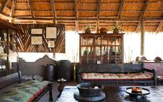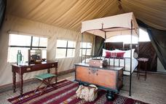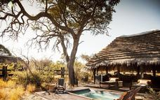

Day 11
End of Itinerary

Activities
Travel For Impact SD

Travel For Impact
Travel for Impact – Responsible Travel
By booking this itinerary USD$1 is contributed for every night of travel per person on the booking. The contribution goes to Travel for Impact (TFI) and ensures that your safari has a meaningful impact on the people who live locally.
TFI believes in changing lives through travel and provides the link between donors and beneficiaries. They assess NGO's (Non Government Organisations) at various levels, including their effectiveness and financial integrity. They provide a mentorship for the organisations in being sustainable and ultimately to grow the impact and reach of each organisation.
Thank you for contributing towards Responsible Tourism Botswana.
For more information you can visit www.travelforimpact.com
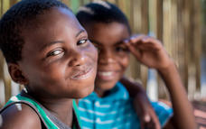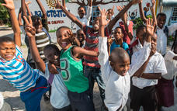

Travel Information
• Please take note of our Booking Terms & Conditions. It will be understood that these have been read and accepted by you on receipt of confirmation of the booking.
• For your safety and peace of mind, on confirmation of your booking, we strongly recommend that Travel Insurance is arranged to cover cancellation, curtailment, emergency evacuation, medical and repatriation expenses, damage/theft/loss of personal luggage, money and goods.
• Road and air transfers and activities are quoted on a seat basis (shared) unless otherwise requested or specified. Passengers may have various stops en-route to a destination. The transfer or charter company reserves the right to specify departure and arrival times. Private charters can be requested at an additional cost.
• Passengers weighing over 100kg should please advise us at the time of booking, as we may need to cost in an additional seat on internal flights for your safety and comfort.
• The costs are subject to change at any time due to fluctuations in fuel costs, taxes, levies, government regulations, rate of exchange and factors that are imposed upon us by our suppliers that are beyond or control.
• Please advise us of the ages of children (under 18) travelling, together with their date of birth, at the time of booking as not all lodges accept children and there may be restrictions or conditions which can affect pricing.
• We recommend that optional activities be booked in advance at time of confirmation to guarantee availability e.g. Elephant Back Safari in Victoria Falls
• Please allow a minimum 2-3 hours connection time in Johannesburg for international flights. It is important that you check that your flight tickets have been issued in your full names as per your passport.
• We require full payment for international and domestic scheduled flights at the time of confirmation e.g. Air Botswana JNB/MUB, Proflight LIV/LUS. We are not able to guarantee any flights before receipt of payment as seats are often held for a limited period before ticketing is required so this is a time sensitive issue. Air tickets are considered non refundable unless otherwise specified. Please confirm the details with your consultant at the time of booking.
Passports, Visas and Travel Documentation
Your passport must have at least 6 months validity before the expiry date and 6 empty pages (not including the endorsement pages). The onus is upon the guests to ensure that passports and visas are valid for the countries visited. Please note that certain visas can take up to 3 months to be processed so please consider this when booking.
If you are travelling with children through Southern Africa please be aware that you will be required to have certified copies of their unabridged birth certificates, and passports on hand. If you are not their legal parents, or if only one of you is travelling – you will need to have consent in the form of an affidavit giving you permission to travel with the child.
Inter-camp transfers
Due to the vast distances involved in travelling in the remote areas of Southern Africa - your itinerary may include road, boat and air transfers in small aircraft.
On shared air transfers, all the flight times between lodges are arranged a few days before the flights take place to avoid endless schedule changes. The lodge or camp where you are staying will be advised of your departure time the day before travel and will ensure that you are at the airstrip on time. Although every effort will be made to ensure that guests are transferred together in one vehicle / aircraft, this cannot be guaranteed, especially with larger groups. The aircraft used for inter-camp transfers vary in size from 3, 5, 7 and 12 seater aircraft. We recommend that guests susceptible to motion sickness take appropriate precautions due to flying conditions.
Weight & Luggage Restrictions
There are strict luggage restrictions in place on any itinerary, which includes light aircraft transfers for safety reasons. Luggage, including camera equipment and hand luggage, is restricted to 20 kg per person travelling on seat rates. Only soft bags will be accepted - no hard suitcases or bags with wheels can be transported, as they physically cannot fit into the aircraft.
The maximum dimensions of the soft bags that can be accommodated are as follows: 25cm/10 inches wide x 30cm/11 inches high and 62cm/24 inches long. Please keep in mind that the baggage compartments on the light aircraft are only 25cm high, so the pilots must have the ability to manipulate the bag into the compartment. Note that laundry can be done on a daily basis at most camps and lodges.
Should you arrive with excess baggage without prior warning, your baggage could be delayed, as we may have to fly the baggage into camp at a later stage at considerable extra cost to you. However, should you notify us in advance that your baggage will exceed the limit; we may be able to assist you with alternative arrangements e.g. storage or purchase of additional luggage allowance.
For bookings including flights within Zambia & Mozambique, please note luggage weight exceptions under destination information.
Lost Luggage
Lost luggage on international flights is a common problem facing travellers today. We suggest that you pack a small bag with your essentials, including any life sustaining medication, which can be carried with you as hand luggage. If travelling as a couple or family we suggest that you split your clothing between bags so that if one bag gets lost, you will have basic items on hand to see you through the first couple of days while we try and recover your lost baggage.
Please note that whilst we try our utmost to locate and re-unite you with your bags, that there may be charges involved in getting your bags to remote areas, which would be for your cost. Please remember to report the lost luggage to the airline as soon as you make the discovery - the airline will issue you with a Baggage Claim Form, which you will need in order for us to trace the bag.
Health and Dietary
Please note that you are travelling to a Malaria-risk area. Please consult your doctor for medical advice prior to travel.
Although usually safe to drink, we do not recommend that you drink the tap water. Filtered water is available at the camps and lodges.
The camps are isolated and generally have limited power supply and access to supplies. Please notify us in advance of any special dietary requirements, medical conditions and medical equipment you may need with you. Please carry critical medication in your hand luggage.
Yellow Fever Certificates - are only required if you have travelled to a Yellow Fever area as designated by the World Health Organisation. Please check with your Travel Clinic or doctor well in advance of your departure date.
General Travel Information
• There is no or limited electricity and cell phone coverage in the camps and lodges excluding major towns and cities. All camps do make provision for charging cameras and electronic devices.
• Please ensure that you do not pack any valuables, cameras, cash, laptops in your checked in luggage – these should be kept on your person at all times.
• Please notify us immediately of any changes to flight arrival and departure details as this affects onward transfer arrangements.
• Please note that most camps & lodges in Botswana do not have double beds. Twin beds are pushed together to make up a double room.
• Although every effort is made to adhere to schedules the company reserves the right and in fact is obliged to occasionally change routes and camps on safaris as dictated by changing conditions or unforeseen circumstances.
• By confirmation of the booking, you acknowledge that you have been made aware and accept that the tour carries inherent risks, and that you voluntarily assume all risks which are associated with the tour. You will be required to sign indemnities at the various camps, lodges and service providers, and abide by their operators code of conduct in order to ensure your safety.
• If you have any cause for complaint while travelling, you should immediately bring it to the attention of the camp manager and / or our Maun office that will attempt to resolve the situation immediately.
• Do not remove any animal artefacts, flora or fauna from any of the areas you visit, as there are strict international regulations on the export of such items.
Please refer to the Safari Information (https://dl.dropboxusercontent.com/u/44362671/safari-information.pdf) for further details on preparing for your safari.
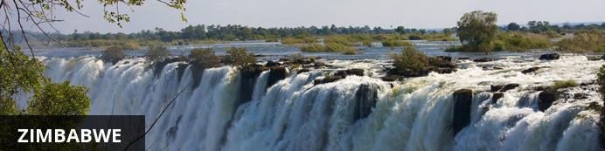
Currency
The currency of Zimbabwe is the American Dollar (US$). US$ Dollar notes (2007 Series onwards), and Visa and MasterCard are accepted. Always have enough US$ cash available in smaller denominations in the event where ATM's and Credit Card facilities are not operational.
Visa
Fees for Visitors to Zimbabwe who are eligible to receive their visa on entry
Europe and USA: US$ 30.00 for single entry/ US$ 45.00 for double entry.
UK & Ireland: US$ 55.00 for single entry/ US$ 70.00 for double entry.
Canada: US$ 75.00 for single entry/ double entry to be obtained from local embassy prior to travel
Some visitors need to apply for visas before arrival - please check with your Embassy, Zimbabwe Government Visa Requirements. ALWAYS have cash available in the correct US$ amount at ALL ports of entry.
Kaza Univisa – Zimbabwe and Zambia
Travellers planning to visit both Zimbabwe and Zambia should apply for a UniVisa (also known as KAZA visa). The visa can be obtained in advance, as well as at ports of entry, but cannot be guaranteed.
The UniVisa allows travellers 30 days travel within both Zambia and Zimbabwe, and is also valid for daytrips to Botswana. Travellers must remain within Zambia & Zimbabwe for the visa to stay valid. Visiting Botswana as a daytrip will not affect the visa’s validity, provided travellers return to Zambia or Zimbabwe the same day.
Internal Flights and Transfers
Due to the remote areas the camps and lodges are based in, transfers between camps may take place by boat, train, game drive vehicle or light aircraft.
Departure Taxes
International departure taxes are included in the scheduled flight rates. However light aircraft transfers from Victoria Falls Airport to Livingstone or Kasane require an International Departure tax of US$35 per person & AIDF Levy of US$15 = US$50 per person to be paid in cash.
Domestic departure taxes are payable in cash at the airport, for any flights departing internally from any registered, manned airport. These include Harare, Bulawayo, Kariba, Hwange and Victoria Falls Airport. The amount is US$10 departure tax + US$5 AIDF Levy = US$15 per person. We recommend small denominations for easier and quicker transactions as change is not always available. Traveller’s cheques and credit cards are NOT accepted.
Weight & Luggage Restrictions
See Booking Information

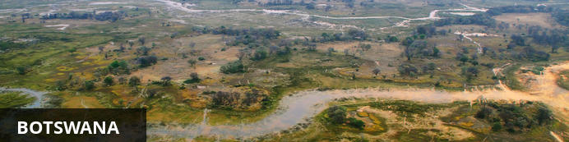
Visa
Some visitors need to apply for visas before arrival please check with your Embassy.
For more information on visas please visit the following address:
Botswana Government - Visa Requirements
BORDER CROSSINGS
Currency
The currency of Botswana is the Pula (BWP). US$ Dollar notes (2007 Series onwards), and Visa and MasterCard are accepted.
Internal Flights and Transfers
Due to the remote areas the camps and lodges are based in, transfers between camps may take place by boat, mekoro, game drive vehicle or light aircraft.
Flight times around Botswana | Approximate flying times
Flight duration times (as listed below), are to be used as an average guideline. They are based on actual flying time, and passengers may have various stops en-route to a destination affecting the total travel time. Your pilot will brief you of your flight route and duration during the safety briefing.
Maun - Delta: 15 to 30 minutes
Delta – Delta: 10 to 20 minutes
Delta - Linyanti: 30 to 40 minutes
Maun – Linyanti: 50 to 60 minutes
Linyanti - Kasane: 40 to 60 minutes
Maun/Delta - Kasane: 60 to 80 minutes
Maun - Makgadikgadi/Desert: 40 to 60 minutes
Departure Taxes
Departure taxes are included in ticket prices.
Weight & Luggage Restrictions
See Booking Information

