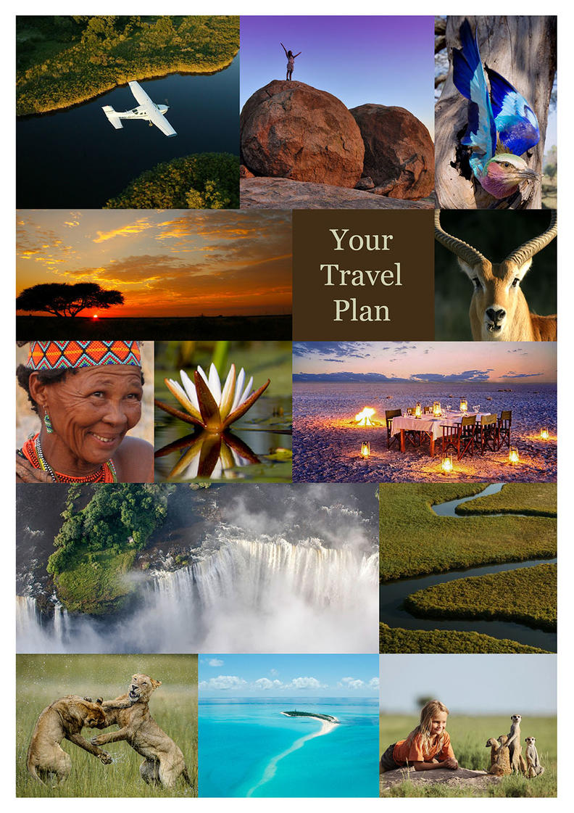
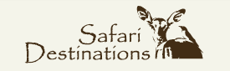

10N Northern Highlights Superior
Victoria Falls, Zimbabwe - Selinda Reserve - Khwai Community Area - Okavango Delta
11 Days / 10 Nights
2 Persons

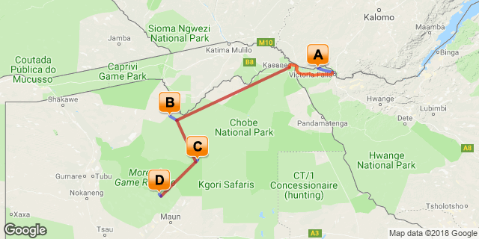

Click here to view your Digital Itinerary

Introduction

Start | Accommodation | Destination | Duration
Day 1 | Zambezi Sands River Camp | Victoria Falls, Zimbabwe | 3 Nights
Day 4 | Selinda Explorers Camp | Selinda Reserve | 2 Nights
Day 6 | Machaba Camp | Khwai Community Area | 3 Nights
Day 9 | Sanctuary Stanley's Camp | Okavango Delta | 2 Nights

Transport

Flight Information
Date | Flight | Details | Class | Ref
Day 4 | Mack Air | Kasane Airport - Selinda Airstrip
Day 6 | Mack Air | Selinda Airstrip - Khwai Airstrip
Day 9 | Mack Air | Khwai Airstrip - Stanley's Airstrip
Day 11 | Mack Air | Stanley's Airstrip - Maun Airport

Transfers
Date | Company | Details
Day 1 | Zambezi Sands River Camp | Victoria Falls Airport - Zambezi Sands River Camp
Day 4 | Zambezi Sands River Camp | Zambezi Sands - Victoria Falls Town
Day 4 | Wild Horizons | Zambezi National Park Gate - Kasane Airport

Day 1-4
Zambezi Sands River Camp, Victoria Falls, Zimbabwe

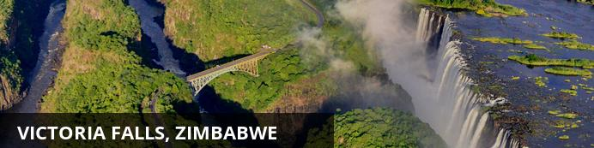
At Victoria Falls, the earth splits open and swallows one of Africa’s greatest rivers, the mighty Zambezi, creating the largest sheet of falling water on earth. As the water hits the narrow depths of the Batoka Gorge beneath, it blasts a cloud of mist skywards, lending the falls their local name ‘mosi-oa-tunya’ (the smoke that thunders). When the Zambezi is its fullest, the mist hangs a permanent raincloud above the falls, showering visitors on even the sunniest of days and visible for miles around.
Above the falls on the upper Zambezi, boats cruise the tranquil water at sunset while the distant spray catches the fading light downstream. Below the falls, the Batoka Gorge’s rocky walls funnel the lower Zambezi into a chain of world-class rapids, prime for white water rafting.
Aside from being a UNESCO world heritage site and a natural world wonder, Victoria Falls also forms a natural border between Zimbabwe and Zambia. The falls can be seen from both countries, and for the most part the same activities are offered on both sides, from helicopter scenic flights to village visits and souvenir shopping.
Whether your idea of getting away from it all is a relaxed high tea in colonial grandeur or a heart-stopping bungee jump off a bridge, Victoria Falls keeps both the faint of heart and the most insatiable of adrenalin junkies busy for days.
From Zambia, a side on view of the falls is on offer with views into the Batoka Gorge, as well as the possibility of perching yourself at the edge of the falls on the vertigo-inducing Livingstone Island.
From Zimbabwe, you’ll get a full-frontal view of three quarters of the falls’ 1.7km wide curtain of water from viewpoints and footpaths meandering through a rainforest kept hot and humid by the spray of the falls.

Overnight: Zambezi Sands River Camp View iBrochure
Includes: meals, local drinks, 2 activities per night of stay, laundry, Victoria Falls airport transfers, one return Victoria Falls town transfer & Zambezi National Park fee
Excludes: premium drinks and Victoria Falls Rainforest fee
Activities: game drives, game walks, guided tour of Victoria Falls, canoeing, fishing, boat cruises and village visits
Zambezi Sands River Camp is situated in the Zambezi National Park on the banks of the Zambezi River, upstream from the Victoria Falls.
The camp has ten tastefully-appointed Bedouin-style tents, adding to the unique flavour of the camp. All are built on raised platforms with exceptional river views. Each tent features a lounge, bathroom, outdoor shower and private plunge pool.
The main camp area includes a dining room, lounge and bar. There is a shaded outdoor deck for enjoying alfresco dining with a view of the riverElephant can be found loitering on the mainland or in the river, while hippo, waterbuck and bushbuck frequent the reed banks and islands. Birdlife is prolific - African finfoot, African skimmer, pratincoles and Pel’s fishing owl all occur here.
Two activities are included for each night of the stay and include a guided tour of Victoria Falls (the Rainforest Fee is at additional cost), a visit to the curio market, sunset cruises, guided canoe trips, a village visit and school tour, game drives, guided game walks and fishing. One return transfer to Victoria Falls Town is also included per stay.
Airport Transfer Time: 90 minutes from Victoria Falls Airport
GPS Coordinates: S 17° 50’802” E 25° 35’066”
Zambezi National Park is a national park located upstream, just 5km from Victoria Falls on the Zambezi River in Zimbabwe and comprises 40km of Zambezi River frontage. It was split off from Victoria Falls National Park in 1979 and is 56,000 hectares (140,000 acres) in size. The park is bisected by a road to Kazungula, dividing it into a riverine side and a Chamabonda Vlei side. Most of the park is within the ecoregion of Zambezian and Mopane woodlands, while a small portion in the south is within the Zambezian Baikiaea woodlands.
The Zambezi National Park plays host to a wide variety of larger mammals including African elephant, lion, Cape buffalo and leopard. In addition to these charismatic members of the "big 5" there are herds of sable antelope, common eland, common zebra, Southern giraffe, greater kudu, waterbuck and impala. In addition, many species of smaller wildlife can be seen here.
Over 400 species of birds have been recorded within the Zambezi National Park. Pel's fishing owl, African skimmer, collared palm thrush, lanner falcon, goliath heron, African finfoot, rock pratincole and long-toed lapwing are considered to be among the speciality birds of the park. Aside from birds and land animals, there are 75 species of fish located in the park, including the famous tiger fish.
The easiest way to access the Zambezi National Park is via the Zambezi River Game Drive, which is extensive network of roads along the banks of the Zambezi and is accessed through the main gate. There is a 25-kilometre Chamabondo Game Drive that can take the visitor into the wilder the southern part of the Park, and which starts 5 kilometres south of Victoria Falls town; just off the main Victoria Falls to Bulawayo road.
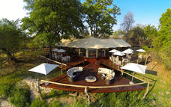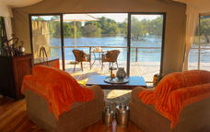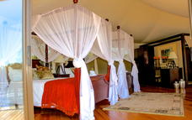

Day 4-6
Selinda Explorers Camp, Selinda Reserve

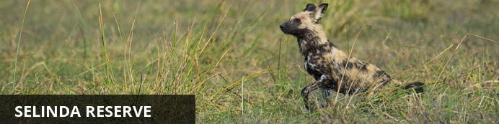
The Linyanti is a safari addict’s bush nirvana. One of the most remote and exclusive pockets of Botswana, this pristine wilderness is what great game viewing and wildlife documentaries are made of.
Only private concessions are on offer here, where the rules are flexible and the crowds can’t go. The Linyanti is not just for ticking off the big game; it also has a knack for delivering lesser-spotted bucket list items, whether it’s a rare bush pig or that long-searched-for wild dog.
Very few camps operate in the Linyanti. Each offers different habitats and landscapes with one common theme: a strong track record for game viewing during Botswana’s drier winter months. Together with the Chobe Riverfront, the Linyanti homes the highest density of African elephants in the world. Many camps also offer seasonally dependent water-based experiences, be it on a spillway, river, lagoon or channel to break up the game drive routine.
Just one of the Linyanti’s concessions alone is twenty times the size of Manhattan, yet only forty people can stay during any night of the year. If Botswana puts a heavy emphasis on preserving the wild and taking only a handful of people into the bush, then the Linyanti is where this concept is taken to the extreme.
Here, you can follow the big game off-road, whether in a white-knuckled pursuit of a lioness chasing buffaloes, or during a quiet crawl off-track to see wild dog puppies emerging from their den for the first time.
Possibilities exist for exploring the bush on foot for adrenaline-pumping game approaches, and many camps offer game viewing hides for a more relaxed approach to wildlife sightings, or even overnight sleep outs.

Overnight: Selinda Explorers Camp View iBrochure
Includes: meals, local drinks, activities and park fees
Excludes: premium drinks
Activities: day & night game drives and walking
Selinda Explorers Camp is poised in a remote, treasured location on the famous Selinda Spillway, under canopies of jackelberry and mangosteen trees. As the lifeline of the Selinda Reserve, the Selinda Spillway is a crucial gathering point for the wildlife of this pristine 320,000-acre Reserve.
This classic camp, consisting of four custom-designed tents, transports guests back to authentic safaris, but with a modern twist and hospitality. Each of the four walk-in tents is expansive; however, in keeping with a bit of traditional safari, the en-suite flush loo and shower are attached and enclosed, but under the stars. Hot/cold water is provided by jug on demand. The double-vanity copper vanities and dressing make for spacious accommodation. Stylishly decorated with campaign-style furniture, decanters of cognac, Persian rugs brass hipbaths and persona hammocks adorn each varandah, the décor pays homage to the roots of safari.
The Selinda Reserve is centred on the famous (seasonal) Selinda Spillway, which connects the Okavango Delta in the south with the Linyanti systems in the east. In years of abundant water, It flows into the Zibadianja lagoon, then through the Savute channel and eventually ends at the Savute marsh.
In balance with the wild location of Selinda Explorer’s, the camp is ecologically sensitive with 100% solar power, grey water treatment and bore-hole water for drinking. Activities concentrate on getting back to nature with an emphasis on guided walking, with day and night game drives also available. It is wildlife hot spot, with huge herds of elephants and buffalo, lion, wild dog, sable and roan antelope all frequently spotted. On safari it is possible to see a tremendous diversity of species, with particular emphasis on the smaller things only seen outside of a vehicle.
It is closed December to February and access via light aircraft to Selinda airstrip.
Activities are focused on game drives. During periods of high water levels, canoeing may be possible but not guaranteed.
Airstrip Transfer Time: 45 minutes
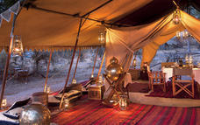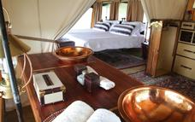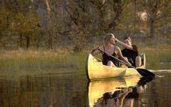

Day 6-9
Machaba Camp, Khwai Community Area

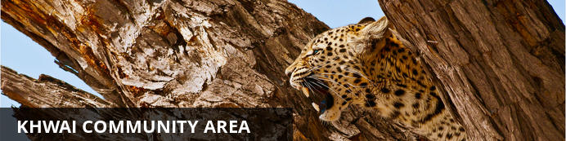
Looking at a map of Botswana, you’d miss Khwai completely if you didn’t know it was there. Wedged between the big-ticket attractions of Chobe National Park to the east and Moremi Game Reserve to the south, Khwai exists as a significant big game destination of its own.
Lying on the eastern fringes of the Okavango Delta with a rich wildlife population and no borders drawn around it on the map, Khwai is often overlooked in favour of its more famous neighbours, though in the winter months it can hold its own for the quality of big game viewing.
During your time here, you’ll spend most days exploring the narrow Khwai River, which forms the natural boundary to the Moremi Game Reserve on the south. The Khwai River is a beacon for wildlife and plays host to leopards stalking lechwe in the long grass, lions swimming from the banks to save their cubs’ during territorial disputes and crocodiles competing with wild dogs for a midday meal of impala.
As Khwai lies outside the parks, it offers the freedom and flexibility normally only possible with the heavier price tag of a private concession. Go off-road for a closer look at sightings, night drive in search of nocturnal species, and, with a little advance planning, head out on game walks to track wildlife on foot.
Khwai is also home to a village community where people live side by side with the resident wildlife. Some camps will offer village visits for a dose of cultural insight to go with your safari. For those not visiting the water camps of the delta, many camps in Khwai offer the chance to get out on a mokoro (traditional canoe), although excursions are less traditional in nature, skirting the riverbanks, rather than open delta floodplains.

Overnight: Machaba Camp View iBrochure
Includes: meals, local drinks, activities, park fees, laundry & return airstrip transfers
Excludes: premium drinks
Activities: day &night game drives and mokoro (seasonal). Walking safaris on request
Machaba Camp is situated in the game rich Khwai area, on the eastern tongue of the Okavango Delta, and is constructed on the same site as the previous Machaba camp. The name Machaba is the local Setswana name for the Sycamore Fig Tree, the tree of life.
The camp is built in the classic 1950’s style, with luxury safari tents, en-suite bathrooms and romantic outdoor showers. All the tents are situated on the ground and the pathways to the tents meander between the large riverine trees.
All 10 luxury tents are situated in the beautiful riverine tree line on the Khwai River, overlooking the famous Moremi Game Reserve. From these tented verandas one can watch the daily parade of animals coming down to drink at the river in front of camp. The camp consists of 8 luxury twin tents and 2 luxury family tents.
Activities offered include night and day game drives as well as mokoro excursions. Walking safaris are available subject to prior arrangements.
Airport Transfer Time: 20 minutes
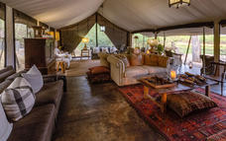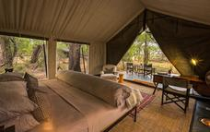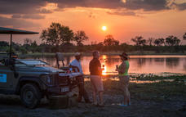

Day 9-11
Sanctuary Stanley's Camp, Okavango Delta

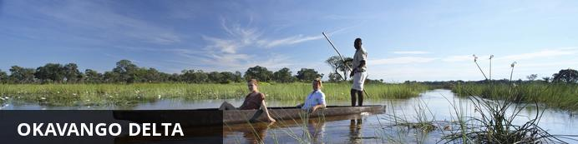
The Okavango Delta is where the wild things are: an immense, waterlogged oasis alive with elephants and birdlife, adrift in the middle of Kalahari sands. The real magic of the Delta lies in its water, trickling through from far away highlands, and spreading across the channels and floodplains.
During winter in the Kalahari, when the sun has baked the earth bare and turned the desert its driest, water fills the Okavango; transforming the floodplains into a Noah’s Ark of African wildlife.
As the water brings life to the delta, its local residents shape and recreate it. Termites slowly build mounds into islands, germinated with palm trees by passing elephants. Waterways open and close on the whim of wide-bottomed hippos, carving out channels where they crash through reeds, and leaving room behind them for exploration by mokoro.
The Okavango has many faces, which change throughout the year, prompted by that most unpredictable diva of all: the weather. Water levels rise and drop, expanding and shrinking islands, while animals move where the life is easiest and the grass greenest. In a few days, a sandy road driven by vehicle can become a waterway of unknowable depth, prompting a safari by boat instead.
Where and when you stay in the Okavango Delta will hugely influence what you do in the bush each day, the animals you’re most likely to see and finally, the safari experience you’ll have.
The delta’s watery heart is best discovered by mokoro through shallow channels and floodplains, as well as crossing the islands on foot. For less water and more of the big game, visit a camp on its drier edges (including Moremi Game Reserve and the Khwai Community Area), jump on a vehicle and seek out the animals hiding in the woodlands.

Activities
Walking With Elephants

Sanctuary Stanley's Camp
Includes: meals, drinks, activities, park fees, laundry, emergency evacuation & return airstrip transfers
Excludes: premium imported wines, champagnes & spirits. Elephant interaction activity
Activities: day & night game drives, walking safari and mokoro (water level dependant)
Stanley's Camp is situated on a 260,000 acre private concession in the Okavango Delta, bordering the southern section of Moremi Game Reserve. The camp is situated in an exclusive community area and works with the local community creating an awareness and commitment to conservation, whilst offering a wealth of wildlife activities.
Guest accommodation consists of eight elegantly styled safari tents. The comfortable spacious tents exude classic Africa; handcrafted beds dressed with the finest linen, antique furniture individually selected and oriental carpets that transport you to early 19th century Africa. Each unit offers an en suite bathroom and a private balcony. Hammocks and Morris chairs on the balcony are perfect for relaxation in the African sunshine. Stanley's main lodge is on raised decking with expansive views over the surrounding floodplains and has been carefully blended into the existing tree line, its main support being a large sausage tree.
The camp offers a wide variety of game viewing in the Okavango Delta, exploring a variety of habitats. Guests can enjoy game drives in open sided safari vehicles, including night drives and walking safaris with an armed professional guide. Seasonal mokoro excursions are taken from the lodge, a serene and tranquil experience.
A particular highlight at Stanleys is the unique and educational elephant experience with a group of semi-habituated African elephants. Spend a morning walking with the elephants to observe and interact with them in their natural environment, awe inspiring and humbling experience. Please note that this is an optional activity at an additional surcharge. advance booking is highly recommended as spaces are limited.
Airstrip Transfer Time: 30 - 40 minutes
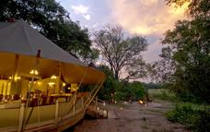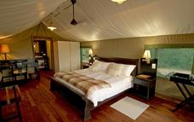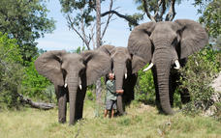

Overnight: Sanctuary Stanley's Camp View iBrochure
Includes: meals, drinks, activities, park fees, laundry, emergency evacuation & return airstrip transfers
Excludes: premium imported wines, champagnes & spirits. Elephant interaction activity
Activities: day & night game drives, walking safari and mokoro (water level dependant)
Stanley's Camp is situated on a 260,000 acre private concession in the Okavango Delta, bordering the southern section of Moremi Game Reserve. The camp is situated in an exclusive community area and works with the local community creating an awareness and commitment to conservation, whilst offering a wealth of wildlife activities.
Guest accommodation consists of eight elegantly styled safari tents. The comfortable spacious tents exude classic Africa; handcrafted beds dressed with the finest linen, antique furniture individually selected and oriental carpets that transport you to early 19th century Africa. Each unit offers an en suite bathroom and a private balcony. Hammocks and Morris chairs on the balcony are perfect for relaxation in the African sunshine. Stanley's main lodge is on raised decking with expansive views over the surrounding floodplains and has been carefully blended into the existing tree line, its main support being a large sausage tree.
The camp offers a wide variety of game viewing in the Okavango Delta, exploring a variety of habitats. Guests can enjoy game drives in open sided safari vehicles, including night drives and walking safaris with an armed professional guide. Seasonal mokoro excursions are taken from the lodge, a serene and tranquil experience.
A particular highlight at Stanleys is the unique and educational elephant experience with a group of semi-habituated African elephants. Spend a morning walking with the elephants to observe and interact with them in their natural environment, awe inspiring and humbling experience. Please note that this is an optional activity at an additional surcharge. advance booking is highly recommended as spaces are limited.
Airstrip Transfer Time: 30 - 40 minutes

Day 11
End of Itinerary

Activities
Travel For Impact SD

Travel For Impact
Travel for Impact – Responsible Travel
By booking this itinerary USD$1 is contributed for every night of travel per person on the booking. The contribution goes to Travel for Impact (TFI) and ensures that your safari has a meaningful impact on the people who live locally.
TFI believes in changing lives through travel and provides the link between donors and beneficiaries. They assess NGO's (Non Government Organisations) at various levels, including their effectiveness and financial integrity. They provide a mentorship for the organisations in being sustainable and ultimately to grow the impact and reach of each organisation.
Thank you for contributing towards Responsible Tourism Botswana.
For more information you can visit www.travelforimpact.com
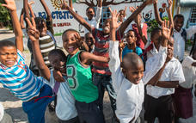

Travel Information
• Please take note of our Booking Terms & Conditions. It will be understood that these have been read and accepted by you on receipt of confirmation of the booking.
• For your safety and peace of mind, on confirmation of your booking, we strongly recommend that Travel Insurance is arranged to cover cancellation, curtailment, emergency evacuation, medical and repatriation expenses, damage/theft/loss of personal luggage, money and goods.
• Road and air transfers and activities are quoted on a seat basis (shared) unless otherwise requested or specified. Passengers may have various stops en-route to a destination. The transfer or charter company reserves the right to specify departure and arrival times. Private charters can be requested at an additional cost.
• Passengers weighing over 100kg should please advise us at the time of booking, as we may need to cost in an additional seat on internal flights for your safety and comfort.
• The costs are subject to change at any time due to fluctuations in fuel costs, taxes, levies, government regulations, rate of exchange and factors that are imposed upon us by our suppliers that are beyond or control.
• Please advise us of the ages of children (under 18) travelling, together with their date of birth, at the time of booking as not all lodges accept children and there may be restrictions or conditions which can affect pricing.
• We recommend that optional activities be booked in advance at time of confirmation to guarantee availability e.g. Elephant Back Safari in Victoria Falls
• Please allow a minimum 2-3 hours connection time in Johannesburg for international flights. It is important that you check that your flight tickets have been issued in your full names as per your passport.
• We require full payment for international and domestic scheduled flights at the time of confirmation e.g. Air Botswana JNB/MUB, Proflight LIV/LUS. We are not able to guarantee any flights before receipt of payment as seats are often held for a limited period before ticketing is required so this is a time sensitive issue. Air tickets are considered non refundable unless otherwise specified. Please confirm the details with your consultant at the time of booking.
Passports, Visas and Travel Documentation
Your passport must have at least 6 months validity before the expiry date and 6 empty pages (not including the endorsement pages). The onus is upon the guests to ensure that passports and visas are valid for the countries visited. Please note that certain visas can take up to 3 months to be processed so please consider this when booking.
If you are travelling with children through Southern Africa please be aware that you will be required to have certified copies of their unabridged birth certificates, and passports on hand. If you are not their legal parents, or if only one of you is travelling – you will need to have consent in the form of an affidavit giving you permission to travel with the child.
Inter-camp transfers
Due to the vast distances involved in travelling in the remote areas of Southern Africa - your itinerary may include road, boat and air transfers in small aircraft.
On shared air transfers, all the flight times between lodges are arranged a few days before the flights take place to avoid endless schedule changes. The lodge or camp where you are staying will be advised of your departure time the day before travel and will ensure that you are at the airstrip on time. Although every effort will be made to ensure that guests are transferred together in one vehicle / aircraft, this cannot be guaranteed, especially with larger groups. The aircraft used for inter-camp transfers vary in size from 3, 5, 7 and 12 seater aircraft. We recommend that guests susceptible to motion sickness take appropriate precautions due to flying conditions.
Weight & Luggage Restrictions
There are strict luggage restrictions in place on any itinerary, which includes light aircraft transfers for safety reasons. Luggage, including camera equipment and hand luggage, is restricted to 20 kg per person travelling on seat rates. Only soft bags will be accepted - no hard suitcases or bags with wheels can be transported, as they physically cannot fit into the aircraft.
The maximum dimensions of the soft bags that can be accommodated are as follows: 25cm/10 inches wide x 30cm/11 inches high and 62cm/24 inches long. Please keep in mind that the baggage compartments on the light aircraft are only 25cm high, so the pilots must have the ability to manipulate the bag into the compartment. Note that laundry can be done on a daily basis at most camps and lodges.
Should you arrive with excess baggage without prior warning, your baggage could be delayed, as we may have to fly the baggage into camp at a later stage at considerable extra cost to you. However, should you notify us in advance that your baggage will exceed the limit; we may be able to assist you with alternative arrangements e.g. storage or purchase of additional luggage allowance.
For bookings including flights within Zambia & Mozambique, please note luggage weight exceptions under destination information.
Lost Luggage
Lost luggage on international flights is a common problem facing travellers today. We suggest that you pack a small bag with your essentials, including any life sustaining medication, which can be carried with you as hand luggage. If travelling as a couple or family we suggest that you split your clothing between bags so that if one bag gets lost, you will have basic items on hand to see you through the first couple of days while we try and recover your lost baggage.
Please note that whilst we try our utmost to locate and re-unite you with your bags, that there may be charges involved in getting your bags to remote areas, which would be for your cost. Please remember to report the lost luggage to the airline as soon as you make the discovery - the airline will issue you with a Baggage Claim Form, which you will need in order for us to trace the bag.
Health and Dietary
Please note that you are travelling to a Malaria-risk area. Please consult your doctor for medical advice prior to travel.
Although usually safe to drink, we do not recommend that you drink the tap water. Filtered water is available at the camps and lodges.
The camps are isolated and generally have limited power supply and access to supplies. Please notify us in advance of any special dietary requirements, medical conditions and medical equipment you may need with you. Please carry critical medication in your hand luggage.
Yellow Fever Certificates - are only required if you have travelled to a Yellow Fever area as designated by the World Health Organisation. Please check with your Travel Clinic or doctor well in advance of your departure date.
General Travel Information
• There is no or limited electricity and cell phone coverage in the camps and lodges excluding major towns and cities. All camps do make provision for charging cameras and electronic devices.
• Please ensure that you do not pack any valuables, cameras, cash, laptops in your checked in luggage – these should be kept on your person at all times.
• Please notify us immediately of any changes to flight arrival and departure details as this affects onward transfer arrangements.
• Please note that most camps & lodges in Botswana do not have double beds. Twin beds are pushed together to make up a double room.
• Although every effort is made to adhere to schedules the company reserves the right and in fact is obliged to occasionally change routes and camps on safaris as dictated by changing conditions or unforeseen circumstances.
• By confirmation of the booking, you acknowledge that you have been made aware and accept that the tour carries inherent risks, and that you voluntarily assume all risks which are associated with the tour. You will be required to sign indemnities at the various camps, lodges and service providers, and abide by their operators code of conduct in order to ensure your safety.
• If you have any cause for complaint while travelling, you should immediately bring it to the attention of the camp manager and / or our Maun office that will attempt to resolve the situation immediately.
• Do not remove any animal artefacts, flora or fauna from any of the areas you visit, as there are strict international regulations on the export of such items.
Please refer to the Safari Information (https://dl.dropboxusercontent.com/u/44362671/safari-information.pdf) for further details on preparing for your safari.
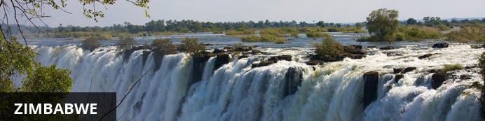
Currency
The currency of Zimbabwe is the American Dollar (US$). US$ Dollar notes (2007 Series onwards), and Visa and MasterCard are accepted. Always have enough US$ cash available in smaller denominations in the event where ATM's and Credit Card facilities are not operational.
Visa
Fees for Visitors to Zimbabwe who are eligible to receive their visa on entry
Europe and USA: US$ 30.00 for single entry/ US$ 45.00 for double entry.
UK & Ireland: US$ 55.00 for single entry/ US$ 70.00 for double entry.
Canada: US$ 75.00 for single entry/ double entry to be obtained from local embassy prior to travel
Some visitors need to apply for visas before arrival - please check with your Embassy, Zimbabwe Government Visa Requirements. ALWAYS have cash available in the correct US$ amount at ALL ports of entry.
Kaza Univisa – Zimbabwe and Zambia
Travellers planning to visit both Zimbabwe and Zambia should apply for a UniVisa (also known as KAZA visa). The visa can be obtained in advance, as well as at ports of entry, but cannot be guaranteed.
The UniVisa allows travellers 30 days travel within both Zambia and Zimbabwe, and is also valid for daytrips to Botswana. Travellers must remain within Zambia & Zimbabwe for the visa to stay valid. Visiting Botswana as a daytrip will not affect the visa’s validity, provided travellers return to Zambia or Zimbabwe the same day.
Internal Flights and Transfers
Due to the remote areas the camps and lodges are based in, transfers between camps may take place by boat, train, game drive vehicle or light aircraft.
Departure Taxes
International departure taxes are included in the scheduled flight rates. However light aircraft transfers from Victoria Falls Airport to Livingstone or Kasane require an International Departure tax of US$35 per person & AIDF Levy of US$15 = US$50 per person to be paid in cash.
Domestic departure taxes are payable in cash at the airport, for any flights departing internally from any registered, manned airport. These include Harare, Bulawayo, Kariba, Hwange and Victoria Falls Airport. The amount is US$10 departure tax + US$5 AIDF Levy = US$15 per person. We recommend small denominations for easier and quicker transactions as change is not always available. Traveller’s cheques and credit cards are NOT accepted.
Weight & Luggage Restrictions
See Booking Information

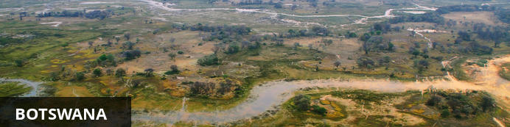
Visa
Some visitors need to apply for visas before arrival please check with your Embassy.
For more information on visas please visit the following address:
Botswana Government - Visa Requirements
BORDER CROSSINGS
Currency
The currency of Botswana is the Pula (BWP). US$ Dollar notes (2007 Series onwards), and Visa and MasterCard are accepted.
Internal Flights and Transfers
Due to the remote areas the camps and lodges are based in, transfers between camps may take place by boat, mekoro, game drive vehicle or light aircraft.
Flight times around Botswana | Approximate flying times
Flight duration times (as listed below), are to be used as an average guideline. They are based on actual flying time, and passengers may have various stops en-route to a destination affecting the total travel time. Your pilot will brief you of your flight route and duration during the safety briefing.
Maun - Delta: 15 to 30 minutes
Delta – Delta: 10 to 20 minutes
Delta - Linyanti: 30 to 40 minutes
Maun – Linyanti: 50 to 60 minutes
Linyanti - Kasane: 40 to 60 minutes
Maun/Delta - Kasane: 60 to 80 minutes
Maun - Makgadikgadi/Desert: 40 to 60 minutes
Departure Taxes
Departure taxes are included in ticket prices.
Weight & Luggage Restrictions
See Booking Information

