The Best of Namibia

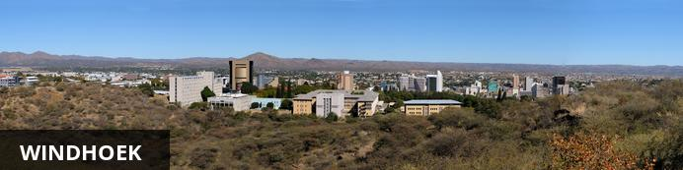
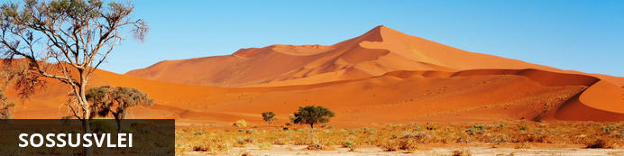
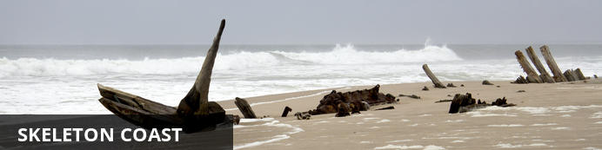
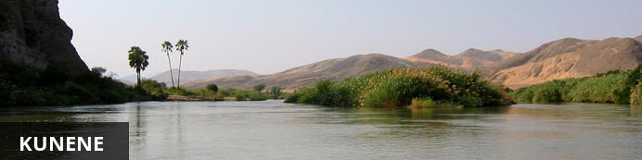

The Best of Namibia
Windhoek - Sossusvlei - Skeleton Coast - Kunene
11 Days / 10 Nights
Date of Issue: 02 March 2018

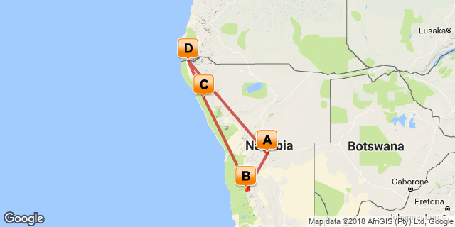

Click here to view your Digital Itinerary

Introduction

Accommodation | Destination | Nights | Basis | Room Type
Olive Grove Guesthouse | Windhoek | 1 | D, B&B
Little Kulala | Sossusvlei | 2 | FI
Hoanib Skeleton Coast Camp | Skeleton Coast | 3 | FI
Serra Cafema Camp | Kunene | 3 | FI
Olive Grove Guesthouse | Windhoek | 1 | B, B&L

Key
B, B&L: Bed, breakfast and lunch
D, B&B: Dinner, bed and breakfast
FI: Fully inclusive

Price

Included
Accommodation and meals as specified, air and road transfers as specified, park and conservation fees, game activities, laundry and drinks.

Excluded
International flights, fine wines, champagne and liquers, spa treatments and other items of a personal nature such as tips.

Additional Information

Day 1: Olive Grove Guesthouse, Windhoek

Windhoek
Situated in Central Namibia, the cosmopolitan city of Windhoek serves as the capital of the country. It is home to an international airport and a plethora of restaurants, shops, entertainment venues and accommodation options. The city is clean, safe and well-organised, with a colonial legacy that is reflected in its many German eateries and shops, and the widespread use of the German language. Windhoek has an interesting mix of historical architecture and modern buildings, many of which are worth a look, including the Alte Feste an old fort, the 1896 Christuskirche Christ Church, and the more contemporary Supreme Court.

Day Itinerary
Scheduled road transfer from Windhoek Airport to Olive Grove Guesthouse. Olive Grove is a small upmarket accommodation establishment situated close to the city centre in a quiet, peaceful area.

Consultant Notes
No Notes Available

Overnight: Olive Grove Guesthouse
Olive Grove is a small upmarket accommodation establishment situated close to the city centre in a quiet, peaceful area. The Olive Exclusive, the guesthouse takes homely atmosphere to a different level. Recently completely refurbished, each room has been decorated and painted with new colour schemes allowing a different feel, but with the same elegant and simplistic emphasis on décor.
The newly renovated, open-plan kitchen allows guests to see how meals are prepared, while they enjoy a drink in the lounge. The menu was also reinvented and is now fully a la carte, quite unique for a guesthouse. Home-style food is rounded off with great presentation, pushing up the level of the guesthouse dining experience. The upper deck has been revamped into a private dining corner, with two Moroccan-style sections, for guests to get comfy on the large pillows and enjoy the ambience and view from the top.
The on-site Wellness Room offers a selection of professional services, to assist guests on their journey towards inner and outer well-being.
Whilst each of the ten rooms and one suite cater for every need of the most discerning traveller, the emphasis remains one of simplicity and elegance.
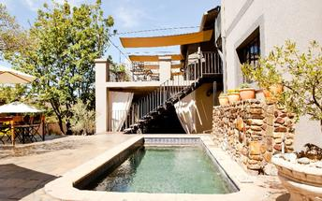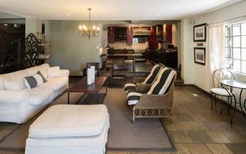

Activities

Optional

Recommended

Included
Dinner, Bed and Breakfast
Drinks (Local Brands) Included

Excluded
Excluded Not Available

Day 2: Little Kulala, Sossusvlei

Sossusvlei
Located in the scenic Namib-Naukluft National Park, Sossusvlei is where you will find the iconic red sand dunes of the Namib. The clear blue skies contrast with the giant red dunes to make this one of the most scenic natural wonders of Africa and a photographer's heaven. This awe-inspiring destination is possibly Namibia's premier attraction, with its unique dunes rising to almost 400 metres-some of the highest in the world. These iconic dunes come alive in morning and evening light and draw photography enthusiasts from around the globe. Sossusvlei is home to a variety desert wildlife including oryx, springbok, ostrich and a variety of reptiles. Visitors can climb 'Big Daddy', one of Sossusvlei’s tallest dunes; explore Deadvlei, a white, salt, claypan dotted with ancient trees; or for the more extravagant, scenic flights and hot air ballooning are on offer, followed by a once-in-a-lifetime champagne breakfast amidst these majestic dunes.

Day Itinerary
Today your guide will collect you from Olive Grove Guesthouse and take you to Windhoek Airport for your scheduled flight from to Geluk Airstrip. From there you will be met by your new guide at Geluk Airstrip and driven to Little Kulala Camp.

Consultant Notes
No Notes Available

Overnight: Little Kulala View iBrochure
Little Kulala is the closest luxury desert retreat to the famous, seen-from-space Sossusvlei dunes. Guests enjoy exclusive private concession access, and the camp’s location makes early morning dune visits (to see Sossusvlei at its best) very easy.
Eleven climate-controlled thatched ‘kulalas’ each have a private plunge pool, rooftop ‘star bed’ and luxury fittings including indoor and outdoor showers. In terms of colour and form, Little Kulala blends seamlessly into the desert landscape. Activities make the most of the solitude and stark beauty of the Namib Desert, with nature drives and guided walks revealing the majesty and mystery of the sand sea.
INSIDER TIP: Experience the desert from new heights… A hot air balloon ride provides awe-inspiring views of the dramatic scenery below.
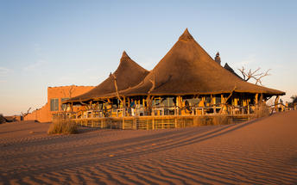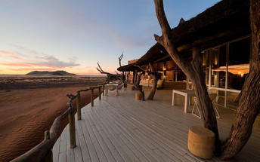

Activities

Optional

Recommended

Included
All meals, twice daily scheduled camp activities, park fees, laundry, Namibian VAT & Tourism Levy, and local drinks excludes premium imported brands and champagne.

Excluded
Excluded Not Available

Day 3: Little Kulala, Sossusvlei

Day Itinerary
Activities make the most of the solitude and stark beauty of the Namib Desert, with nature drives and guided walks revealing the majesty and mystery of the sand and sea.

Consultant Notes
Sossusvlei is where you will find the iconic red sand dunes of the Namib. The clear blue skies contrast with the giant red sand dunes to make this one of the natural wonders of Africa and a photographers heaven. Aside from the attractions at Sossusvlei - Dune 45, Hiddenvlei, Big Daddy and Deadvlei - other attractions in the area include the Sesriem Canyon and Namib-Naukluft National Park, where the mountains of the Namib meet its plains.

Activities

Optional

Recommended

Included
All meals, twice daily scheduled camp activities, park fees, laundry, Namibian VAT & Tourism Levy, and local drinks excludes premium imported brands and champagne.

Excluded
Excluded Not Available

Day 4: Hoanib Skeleton Coast Camp, Skeleton Coast

Skeleton Coast
Stretching from the Swakop River to southern Angola, the Skeleton Coast is known as the 'Land God Made in Anger' and is remoteness at its best. Thousands of miles of sandy desert dotted with shipwrecks meet with the cold waters of the Atlantic and somehow an amazing array of wildlife and flora manages to survive in this harsh but beautiful environment. Ocean fog creeps over the shoreline caused by the warm dry air of the Namib Desert colliding with the cold Benguela current. This otherworldly area is home to a diversity of wildlife including seabird colonies, Cape fur seals, zebra, gemsbok, desert-adapted elephant, lion and much more. Surfing enthusiasts are drawn to these powerful waves and photographers flock from around the globe to snap a shot of this eerie shipwreck graveyard and for the unrivalled maritime photographic opportunities. This coast is desolate but breathtakingly beautiful.

Day Itinerary
Transfer by Road from Little Kulala Camp to Kulala Airstrip for your flight to Hoanib Skeleton Coast.

Consultant Notes
Known by the Bushmen as the "land God made in anger" the Skeleton Coast is remoteness at its best. Thousands of miles of sandy desert dotted with shipwrecks meet with the cold waters on the Atlantic and somehow an amazing array of wildlife and flora manages to survive in this harsh but beautiful environment.

Overnight: Hoanib Skeleton Coast Camp View iBrochure
The name “Skeleton Coast” conjures up romantic images of desolate beauty, and proudly remote Hoanib in the Kaokoveld does not disappoint. The dry bed of the Hoanib River supports a thin green ribbon of vegetation and the wild beaches of the Atlantic coast are within reach, with their noisy seal colonies and eerily quiet shipwreck remnants.
Eight large en-suite tents (including one family unit) and the main area provide shady viewpoints, while nature drives into the surrounding area reveal a wealth of desert-adapted wildlife. Desert-adapted lion and brown hyaena may also be glimpsed in this vast but far from lifeless landscape.
INSIDER TIP: Take a drive down to the Skeleton Coast and a scenic flight back to camp to see such a diverse area both on the ground and in the air.
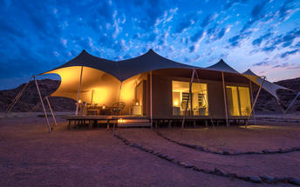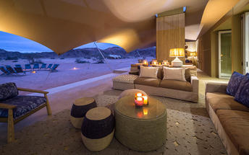

Activities

Optional

Recommended

Included
Fully Inclusive
Drinks (Local Brands) Included

Excluded
Excluded Not Available

Day 5: Hoanib Skeleton Coast Camp, Skeleton Coast

Day Itinerary
Experience the desert from new heights… A hot air balloon ride provides aweinspiring views of the dramatic scenery below.

Consultant Notes
The name “Skeleton Coast” conjures up romantic images of desolate beauty, and proudly remote Hoanib in the Kaokoveld does not disappoint. The dry bed of the Hoanib River supports a thin green ribbon of vegetation and the wild beaches of the Atlantic coast are within reach, with their noisy seal colonies and eerily quiet shipwreck remnants.

Activities

Optional

Recommended

Included
Fully Inclusive
Drinks (Local Brands) Included

Excluded
Excluded Not Available

Day 6: Hoanib Skeleton Coast Camp, Skeleton Coast

Day Itinerary
Take a drive down to the Skeleton Coast and a scenic flight back to camp to see such a diverse area both on the ground and in the air.

Consultant Notes
No Notes Available

Activities

Optional

Recommended

Included
All meals, twice daily scheduled camp activities, park fees, laundry, Namibian VAT & Tourism Levy, and local drinks excludes premium imported brands and champagne. On a stay of 3 nights or more at Hoanib Skeleton Coast, a coastal excursion to the Skeleton Coast is included (applicable to our standard and long stay rates only).

Excluded
Excluded Not Available

Day 7: Serra Cafema Camp, Kunene

Kunene
Bordering Angola in northern Namibia, Kunene is a region as well as the name of a river, which is one of just five perennial rivers in Namibia. The Kunene River is an invaluable source of water for the local Himba people, and it has been the mainstay of their existence for hundreds of years. For travellers, the river’s most striking feature is the magnificent Epupa Falls, which cascade over a distance of more than a kilometre downstream, with an impressive vertical drop of around 60 metres. Whitewater rafting and kayaking are both popular pursuits in this areas. Visitors can look forward to an array of exciting activities including: learning about local culture with a trip to a traditional Himba village, hiking, sundowner cruises, canoeing, kayaking, game viewing and excellent bird watching.

Day Itinerary
Transfer by Road from Hoanib Skeleton Coast Camp to the Airstrip and fly on scheduled flight to Serra Cafema Airstrip where your guide will meet you and drive you to Serra Cafema Camp.

Consultant Notes
One of just five perennial rivers in Namibia, the Kunene is an invaluable source of water for the local Himba people, and it has been the mainstay of their existence for hundreds of years. For travellers, the river’s most striking feature is the Epupa Falls, which cascade over a distance of more than a kilometre downstream, with a total vertical drop of around 60 metres. White water rafting and kayaking are both popular pursuits on the Kunene.

Overnight: Serra Cafema Camp View iBrochure
Set amongst shady trees on the banks of the Kunene River, Serra Cafema is one of the most remote camps in southern Africa, its Portuguese name originating from the mountains that dominate the northern skyline. Guests fall asleep to the sound of rushing water, while by day they explore one of the driest deserts in the world.
The camp’s eight unique canvas and thatched chalets, each with its own en-suite bathroom, show great attention to detail; the elevated decks and simple structures of wood, canvas and thatch create a camp that is at one with its surroundings. The Ozonganda, or main area, comprises indoor and outdoor dining areas, sunken lounge, library, curio shop and swimming pool, all with their own spectacular views.
Activities here are varied, including boating (water levels permitting), walking, viewing breathtaking landscapes, as well as carefully guided quad-bike excursions that tread lightly on the dunes. In this isolated region, the Himba people continue their nomadic, traditional way of life and when in the area, guests have the opportunity to meet them and learn about their lifestyle and traditions.
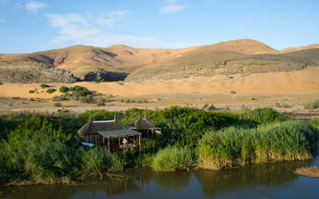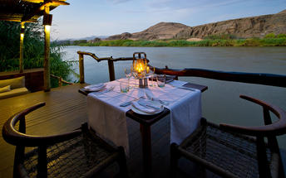

Activities

Optional

Recommended

Included
Fully Inclusive
Drinks (Local Brands) Included

Excluded
Excluded Not Available

Day 8: Serra Cafema Camp, Kunene

Day Itinerary
Activities here are varied, including boating (water levels permitting), walking, viewing breathtaking landscapes, as well as carefully guided quad-bike excursions that tread lightly on the dunes. In this isolated region, the Himba people continue their nomadic, traditional way of life and when in the area, guests have the opportunity to meet them and learn about their lifestyle and traditions.

Consultant Notes
No Notes Available

Activities

Optional

Recommended

Included
Fully Inclusive
Drinks (Local Brands) Included

Excluded
Excluded Not Available

Day 9: Serra Cafema Camp, Kunene

Day Itinerary
No Notes Available

Consultant Notes
Set amongst shady trees on the banks of the Kunene River, Serra Cafema is one of the most remote camps in southern Africa, its Portuguese name originating from the mountains that dominate the northern skyline. Guests fall asleep to the sound of rushing water, while by day they explore one of the driest deserts in the world.

Activities

Optional

Recommended

Included
All meals, twice daily scheduled camp activities, park fees, laundry, Namibian VAT & Tourism Levy, and local drinks excludes premium imported brands and champagne.

Excluded
Excluded Not Available

Day 10: Olive Grove Guesthouse, Windhoek

Windhoek
See Above

Day Itinerary
Transfer by Road from Serra Cafema Camp to Airstrip to catch your flight to Windhoek Airport. Your guide will again meet you to take you to Olive Grove Guesthouse.

Consultant Notes
No Notes Available

Overnight: Olive Grove Guesthouse
Olive Grove is a small upmarket accommodation establishment situated close to the city centre in a quiet, peaceful area. The Olive Exclusive, the guesthouse takes homely atmosphere to a different level. Recently completely refurbished, each room has been decorated and painted with new colour schemes allowing a different feel, but with the same elegant and simplistic emphasis on décor.
The newly renovated, open-plan kitchen allows guests to see how meals are prepared, while they enjoy a drink in the lounge. The menu was also reinvented and is now fully a la carte, quite unique for a guesthouse. Home-style food is rounded off with great presentation, pushing up the level of the guesthouse dining experience. The upper deck has been revamped into a private dining corner, with two Moroccan-style sections, for guests to get comfy on the large pillows and enjoy the ambience and view from the top.
The on-site Wellness Room offers a selection of professional services, to assist guests on their journey towards inner and outer well-being.
Whilst each of the ten rooms and one suite cater for every need of the most discerning traveller, the emphasis remains one of simplicity and elegance.

Activities

Optional

Recommended

Included
Bed, Breakfast & Lunch
Drinks (Local Brands) Included

Excluded
Excluded Not Available

Day 11: Departure

Day Itinerary
Transfer from Olive Grove Guesthouse to Windhoek Airport and get checked in for your onward flight home.

Consultant Notes
No Notes Available

Activities

Optional

Recommended

Included
Included Not Available

Excluded
Excluded Not Available

Transport

Flight Information
Date | Flight | Airline | Departure Airport | Time | Arrival Airport | Time | Class | Ref
 | Scheduled |  | Windhoek Eros Airport [ERS] |  | Geluk Airstrip
 | Scheduled |  | Kulala Airstrip |  | Hoanib Skeleton Coast Camp
 | Scheduled |  | Hoanib Skeleton Coast Airstrip |  | Serra Cafema Camp
 | Scheduled |  | Serra Cafema Camp |  | Windhoek Eros Airport [ERS]

Transfers
Date | Company | Pick Up | Drop Off | Time | Vehicle
 |  | Olive Grove Guesthouse | Windhoek Eros Airport [ERS] |  | Transfer
 |  | Geluk Airstrip | Little Kulala |  | Transfer
 |  | Little Kulala | Kulala Airstrip |  | Transfer
 |  | Hoanib Skeleton Coast Camp | Hoanib Skeleton Coast Airstrip |  | Transfer
 |  | Windhoek Eros Airport [ERS] | Olive Grove Guesthouse |  | Transfer
 |  | Olive Grove Guesthouse | Windhoek Eros Airport [ERS] |  | Transfer

Urgent Contact Numbers
Company Name | Telephone | Email Address | Contact Person
Safari Adventures Worldwide | (303)447-1195 | charles@safariadventuresworldwide.com | Charles Williams

Contact Details & Reference Numbers
Service Provider | Ref. Number | Telephone | Address
Olive Grove Guesthouse |  | +264 61 23 9199 | 20 Promenaden Road  Windhoek  Namibia

Terms and Conditions

Safari Adventures Worldwide Terms and Conditions
Payment Terms
o Arrangements are booked and confirmed on receipt of a 30% Nonrefundable Deposit.
o There shall be no binding contract until the deposit has been paid in full.
o Failure to remit your deposit on time may result in an automatic release of the confirmed space and the possible inability to reinstate your reservation.
o When the Company acknowledges, in writing to you, receipt of the deposit shall be deemed to constitute acceptance and confirmation of the reservation.
o By paying a deposit you, the client, The Company and any applicable operating company are deemed to be under contract for the dates quoted and your safari.
o The balance is due no later than 60 days before commencement of your trip.
o If the balance due has not been received by this date, The Company shall be entitled, at its discretion, to treat your reservation as cancelled and consequently your deposit will be forfeited.
Cancellation Policy
o Any cancellation of reservation must be in writing and shall only be effective upon its acknowledged receipt by The Company.
o In the event of a cancellation you will forfeit the deposit in total.
o If you cancel your trip after the final balance has been paid, the Safari rate is forfeited in full.

