The Best of Southern Africa

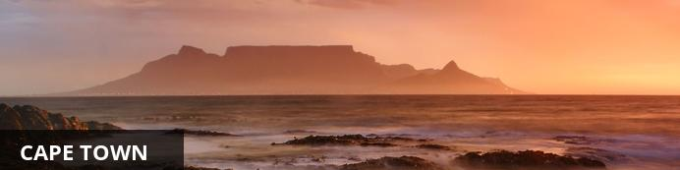
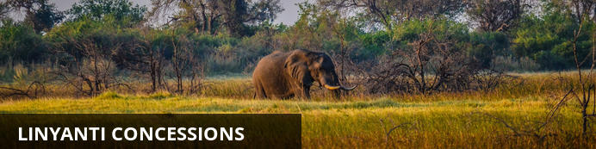
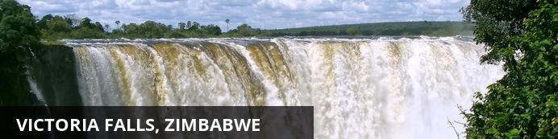

The Best of Southern Africa
Cape Town - Okavango Delta - Linyanti Concessions - Victoria Falls, Zimbabwe
15 Days / 14 Nights
Date of Issue: 21 May 2018

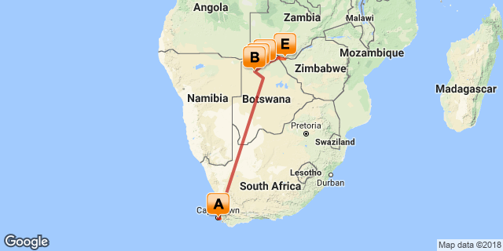

Click here to view your Digital Itinerary

Introduction
THE BEST OF SOUTHERN AFRICA - 14 Nights
Cape Town, Okavango Delta, Linyanti Concessions and Victoria Falls, Zimbabwe

Accommodation | Destination | Basis | Duration
Cape Cadogan Boutique Hotel | Cape Town | B&B | 3 Nights
Tubu Tree Camp | Okavango Delta | FI | 3 Nights
Vumbura Plains | Okavango Delta | FI | 3 Nights
DumaTau Camp | Linyanti Concessions | FI | 3 Nights
Victoria Falls Hotel | Victoria Falls, Zimbabwe | B&B | 2 Nights

Key
B&B: Bed and breakfast
FI: Fully inclusive

Price

Included

Excluded

Additional Information

Day 1-3: Cape Cadogan Boutique Hotel, Cape Town

Cape Town
Resting at the confluence of the Indian and Atlantic Ocean, sandwiched between the slopes of the iconic Table Mountain and the glistening sapphire waters of Table Bay, the exceptionally scenic city of Cape Town is in a class of its own. Some cities boast rich culture, vibrant nightlife, a cosmopolitan atmosphere and extraordinary architecture, while others boast breathtaking landscapes and extraordinary natural wonders. Cape Town is lucky enough to be blessed with all of these attractions and so much more. With its bustling harbour, world-class beaches, top-notch vineyards, and its mountainous surroundings brimming with diverse flora and fauna, Cape Town consistently captivates the hearts of all who visit.

Day Itinerary
You will be met at the Cape Town Interanational airport and transfered to your hotel in Cape Town. Over the next 3 days you will enjoy a trip to the Cape Winelands, a visit to Table Mountain (in which you will walk up, take in the beautiful view and catch the cable car down), and a tour of the Peninsula. For each of these outings, you will be met at your hotel in the morning by your driver and guide and driven to your activity for the day.

Consultant Notes
No Notes Available

Overnight: Cape Cadogan Boutique Hotel View iBrochure
Ideally located just off bustling Kloof Street in a scenic suburb of Cape Town, Cape Cadogan Boutique Hotel is authentic Cape Town at its loveliest. With beauty, sophisticated charm and quirky personality in equal measure, this intimate hotel offers fifteen individually decorated bedrooms which marry a touch of yesteryear with contemporary chic and bohemian influence. Visitors can enjoy a comfortable lounge, a cozy breakfast room, as well as a peaceful in-house library and poolside area. This exceptionally unique boutique hotel boasts all the luxury you could hope for combined with some refreshingly warm, welcoming and personal hospitality.
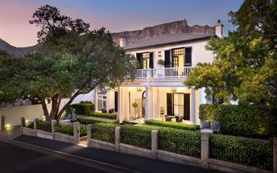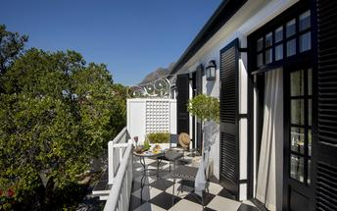

Activities

Optional

Recommended

Basis
Bed & Breakfast

Included
Included Not Available

Excluded
Excluded Not Available

Day 4-6: Tubu Tree Camp, Okavango Delta

Okavango Delta
Situated in the northwestern corner of Botswana, the Okavango Delta is a World Heritage Site as it is the largest inland delta in the world. The magnificent Okavango River sprawls out over the dry sands of the Kalahari Desert forming this flourishing waterlogged oasis featuring countless meandering waterways and crystal clear lagoons studded with water lilies, as well as fertile floodplains and reeded islands inhabited with abundant wildlife. The Okavango Delta stretches over 15000 square kilometres. Visitors can enjoy a number of wonderful activities such as game viewing, fishing, bird watching or taking an authentic guided Mokoro excursion through this wetland paradise in a traditional dugout canoe. Commonly spotted animals include: lion, rhino, leopard, giraffe, hippos, elephants, crocodiles and countless species of bird.

Day Itinerary
On the morning of day 4, you will be met at your hotel and driven to the Cape Town Airport to catch your onward flight to Botswana. Upon arrival into Maun International Airport, you will be met and taken to check-in for your short flight into the Okavango Delta, and then driven to Tubu Tree water camp, where you will spend the next 3 days viewing wildlife via dugout canoes, boats, day and night game drives and maybe even some walking if you so desire.

Consultant Notes
No Notes Available

Overnight: Tubu Tree Camp View iBrochure
From its location on the western side of remote Hunda Island, Tubu Tree has easy access to a diverse range of habitats. Day and night game drives explore productive mopane and acacia woodlands, with Tubu Tree being well known for its leopard sightings. Wildlife movements vary with seasonal water levels, meaning that no two Tubu experiences are ever the same – but all are equally wonderful.
Eight guest tents (including one designed for families) offer breathtaking floodplain views from their elevated positions. In addition to the drama and excitement of game drives, seasonally-available water activities facilitate a different pace and perspective.
INSIDER'S TIP: Enjoy a drink at Tubu’s famous open-air bar under the shade of a marula tree.
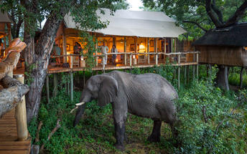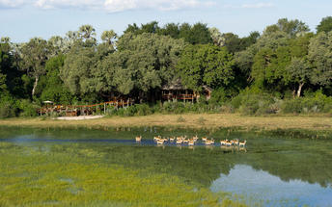

Activities

Optional

Recommended

Basis
Fully Inclusive
Drinks (Local Brands) Included

Included
Included Not Available

Excluded
Excluded Not Available

Day 7-9: Vumbura Plains, Okavango Delta

Okavango Delta
See Above

Day Itinerary
On the morning of day 7, you will be driven to the airstrip and board your flight to the Vumbura Plains area where you will spend the next 3 days and nights on safari.

Consultant Notes
No Notes Available

Overnight: Vumbura Plains View iBrochure
A modern-style safari camp that wouldn’t look out of place in an architecture magazine, Vumbura Plains is designed and operated in total empathy with its diverse surroundings. Partnerships with local communities in this region of the Okavango Delta have created empowerment opportunities while allowing guests access to its many treasures.
Fourteen light, airy guest rooms feature designer fittings and touches of unabashed luxury, including private plunge pools and salas, and indoor and outdoor showers. Safari activities focus on day and night game drives through a variety of game-rich terrains. Seasonal water activities can be very rewarding, to say nothing of a hot air balloon safari.
INSIDER'S TIP: Secure a spot at the telescope for exceptional viewing of birds and wildlife. If you are lucky you may even catch a glimpse of the resident otter family!
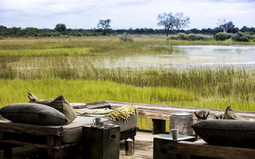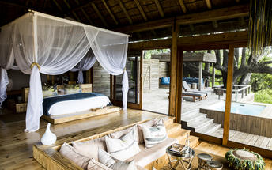

Activities

Optional

Recommended

Basis
Fully Inclusive
Drinks (Local Brands) Included

Included
Included Not Available

Excluded
Excluded Not Available

Day 10-12: DumaTau Camp, Linyanti Concessions

Linyanti Concessions
The Kwando-Linyanti river system is home to a series of private game reserves, known for their exotic animal species and luxury safari options. An abundance of wildlife roams freely between the woodland habitats, ancient floodplains and forests that make up these lush, unfenced reserves. The big game in this area increases dramatically during the dry season when the area hosts large herds of impala, blue wildebeest, giraffe and buffalo as well as the world’s highest density of elephant. Several packs of wild dog are found in the area and lion, leopard and cheetah are frequently sighted. Night drives allow for the discovery of nocturnal creatures such as civets, genets, honey badgers and spring hares. This vast, untamed wilderness is the perfect location for those seeking a unique African adventure in an exclusive and remote big game habitat.

Day Itinerary
On the morning of day 10, you will be driven to the airstrip and catch your flight to the Linyanti Concession. Upon arrival you will be met by your guide and then transferred to DumaTau Camp.

Consultant Notes
No Notes Available

Overnight: DumaTau Camp View iBrochure
‘DumaTau’ means ‘roar of the lion,’ but it is likely to be the elephants which make the greatest impression here. Its location in the Linyanti and on the banks of Osprey Lagoon position it squarely at the epicentre of Botswana’s elephant herds that are dotted across the northern regions. Other wildlife abounds, and there is a great variety of species to be seen in the contrasting habitats.
Eight twin guest tents and two family tents have views over the lagoon, and the floating sundowner deck symbolises the light footprint of a camp run solely on solar power.
INSIDER'S TIP: The Linyanti is recognised as an IBA (Important Bird Area), so the hides and platforms in the area are ideal for bird watching and photographing wildlife.
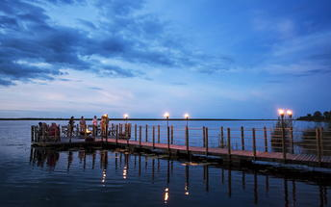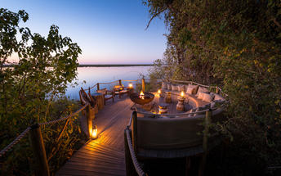

Activities

Optional

Recommended

Basis
Fully Inclusive
Drinks (Local Brands) Included

Included
Included Not Available

Excluded
Excluded Not Available

Day 13: Victoria Falls Hotel, Victoria Falls, Zimbabwe

Victoria Falls, Zimbabwe
Resting on the southern banks of the Zambezi River at the western end of the eponymous falls, this popular tourist town is compact enough to walk around and makes an ideal base for travellers exploring the seventh wonder of the world, the unfathomably vast Victoria Falls. About two thirds of the falls can be viewed from the Zimbabwean side and, while the falls are undoubtedly the star attraction, the area provides both adventure seekers and sightseers with plenty of opportunities to warrant a longer stay. Popular activities include scenic flights over the falls in helicopters or micro lights, bungee jumping off the Victoria Falls Bridge, white-water rafting (seasonal), and day trips to Chobe National Park. The town itself offers some excellent accommodation and restaurant options as well as an eclectic variety of African curios and authentic art sold by friendly Zimbabwean locals who are wonderfully welcoming and eager to help you enjoy your stay.

Day Itinerary
On the morning of day 13 you will return to the airstrip and board your flight for Kasane Airport. In Kasane you will go through customs and immigration, meet your guide and be diven to the Victoria Falls Hotel where you will be staying for the next 2 nights. In Victoria Falls we will organize a private tour of the falls and a sunset cruise on the Zambezi River. Your hotel will be within a short walk to the falls, so you can return and visit the falls at anytime you wish during your stay.

Consultant Notes
No Notes Available

Overnight: Victoria Falls Hotel View iBrochure
The Victoria Falls Hotel, popularly known as “the grand old lady of the Falls”, is situated in the Victoria Falls National Park, and is a member of the exclusive Leading Hotels of the World group. It is one of only three IS0-accredited hotels in Zimbabwe. The Edwardian-style five-star hotel combines the charm of the old with the convenience of the new. Set in lush tropical gardens with lily ponds, palm trees and semi-tropical shrubs, it provides the tranquillity and seclusion that many guests seek. The famous Victoria Falls are just a ten-minute walk away using the hotel’s private pathway, and “the smoke that thunders” or “Mosi-O-Tunya” in the local dialect, is clearly audible and visible from this luxurious landmark.
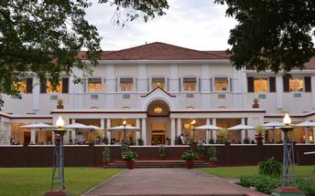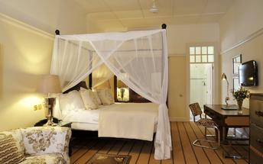

Activities

Optional

Recommended

Basis
Bed & Breakfast

Included
Included Not Available

Excluded
Excluded Not Available

Day 14: Victoria Falls Hotel, Victoria Falls, Zimbabwe

Day Itinerary
No Notes Available

Consultant Notes
No Notes Available

Activities

Optional

Recommended

Basis
Bed & Breakfast

Included
Included Not Available

Excluded
Excluded Not Available

Day 15: End of Itinerary

Day Itinerary
On day 15 you will be driven by your guide to the Victoria Falls International Airport where you will check-in for your flight to Johannesburg and onward flight home.

Consultant Notes
No Notes Available

Activities

Optional

Recommended

Basis
Bed & Breakfast

Included
Included Not Available

Excluded
Excluded Not Available

Transport

Flight Information
Date | Flight | Airline | Departure Airport | Time | Arrival Airport | Time | Class | Ref
 | Scheduled |  | Cape Cadogan Boutique Hotel |  | Maun Airport [MUB]
 | Scheduled |  | Maun Airport [MUB] |  | Tubu Tree Camp
 | Scheduled |  | Tubu Tree Camp |  | Vumbura Plains
 | Scheduled |  | Vumbura Plains |  | DumaTau Camp
 | Scheduled |  | DumaTau Camp |  | Kasane Airport [BBK]
 | Scheduled |  | Victoria Falls International Airport [VFA] |  | OR Tambo International Airport [JNB]

Transfers
Date | Company | Pick Up | Drop Off | Time | Vehicle
 |  | Cape Town International Airport [CPT] | Cape Cadogan Boutique Hotel |  | Transfer
 |  | Kasane Airport [BBK] | Victoria Falls Hotel |  | Transfer
 |  | Victoria Falls Hotel | Victoria Falls International Airport [VFA] |  | Transfer

Urgent Contact Numbers
Company Name | Telephone | Email Address | Contact Person
Safari Adventures Worldwide | (303)447-1195 | charles@safariadventuresworldwide.com | Charles Williams

Service Provider Directory
Service Provider | Ref. Number | Telephone | Address
Cape Cadogan Boutique Hotel |  | +27 11 880 9992 | 5 Upper Union Street, Gardens Cape Town
Victoria Falls Hotel |  |  | Mallett Drive,  Victoria Falls  Zimbabwe

Terms and Conditions

Safari Adventures Worldwide Terms and Conditions
PAYMENT OPTIONS
We accept payment via:
- wire transfer
- check
PAYMENT TERMS
- 35% non-refundable deposit at time of confirmation*
- Final balance is due 60 days prior to arrival
CANCELLATION POLICY
- Any cancellation of reservation must be in writing and shall only be effective upon its acknowledged receipt by The Company.
- In the event of a cancellation you will forfeit the deposit in total.
- If you cancel your trip after the final balance has been paid, the Safari rate is forfeited in full.

