MENU
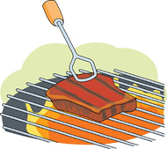  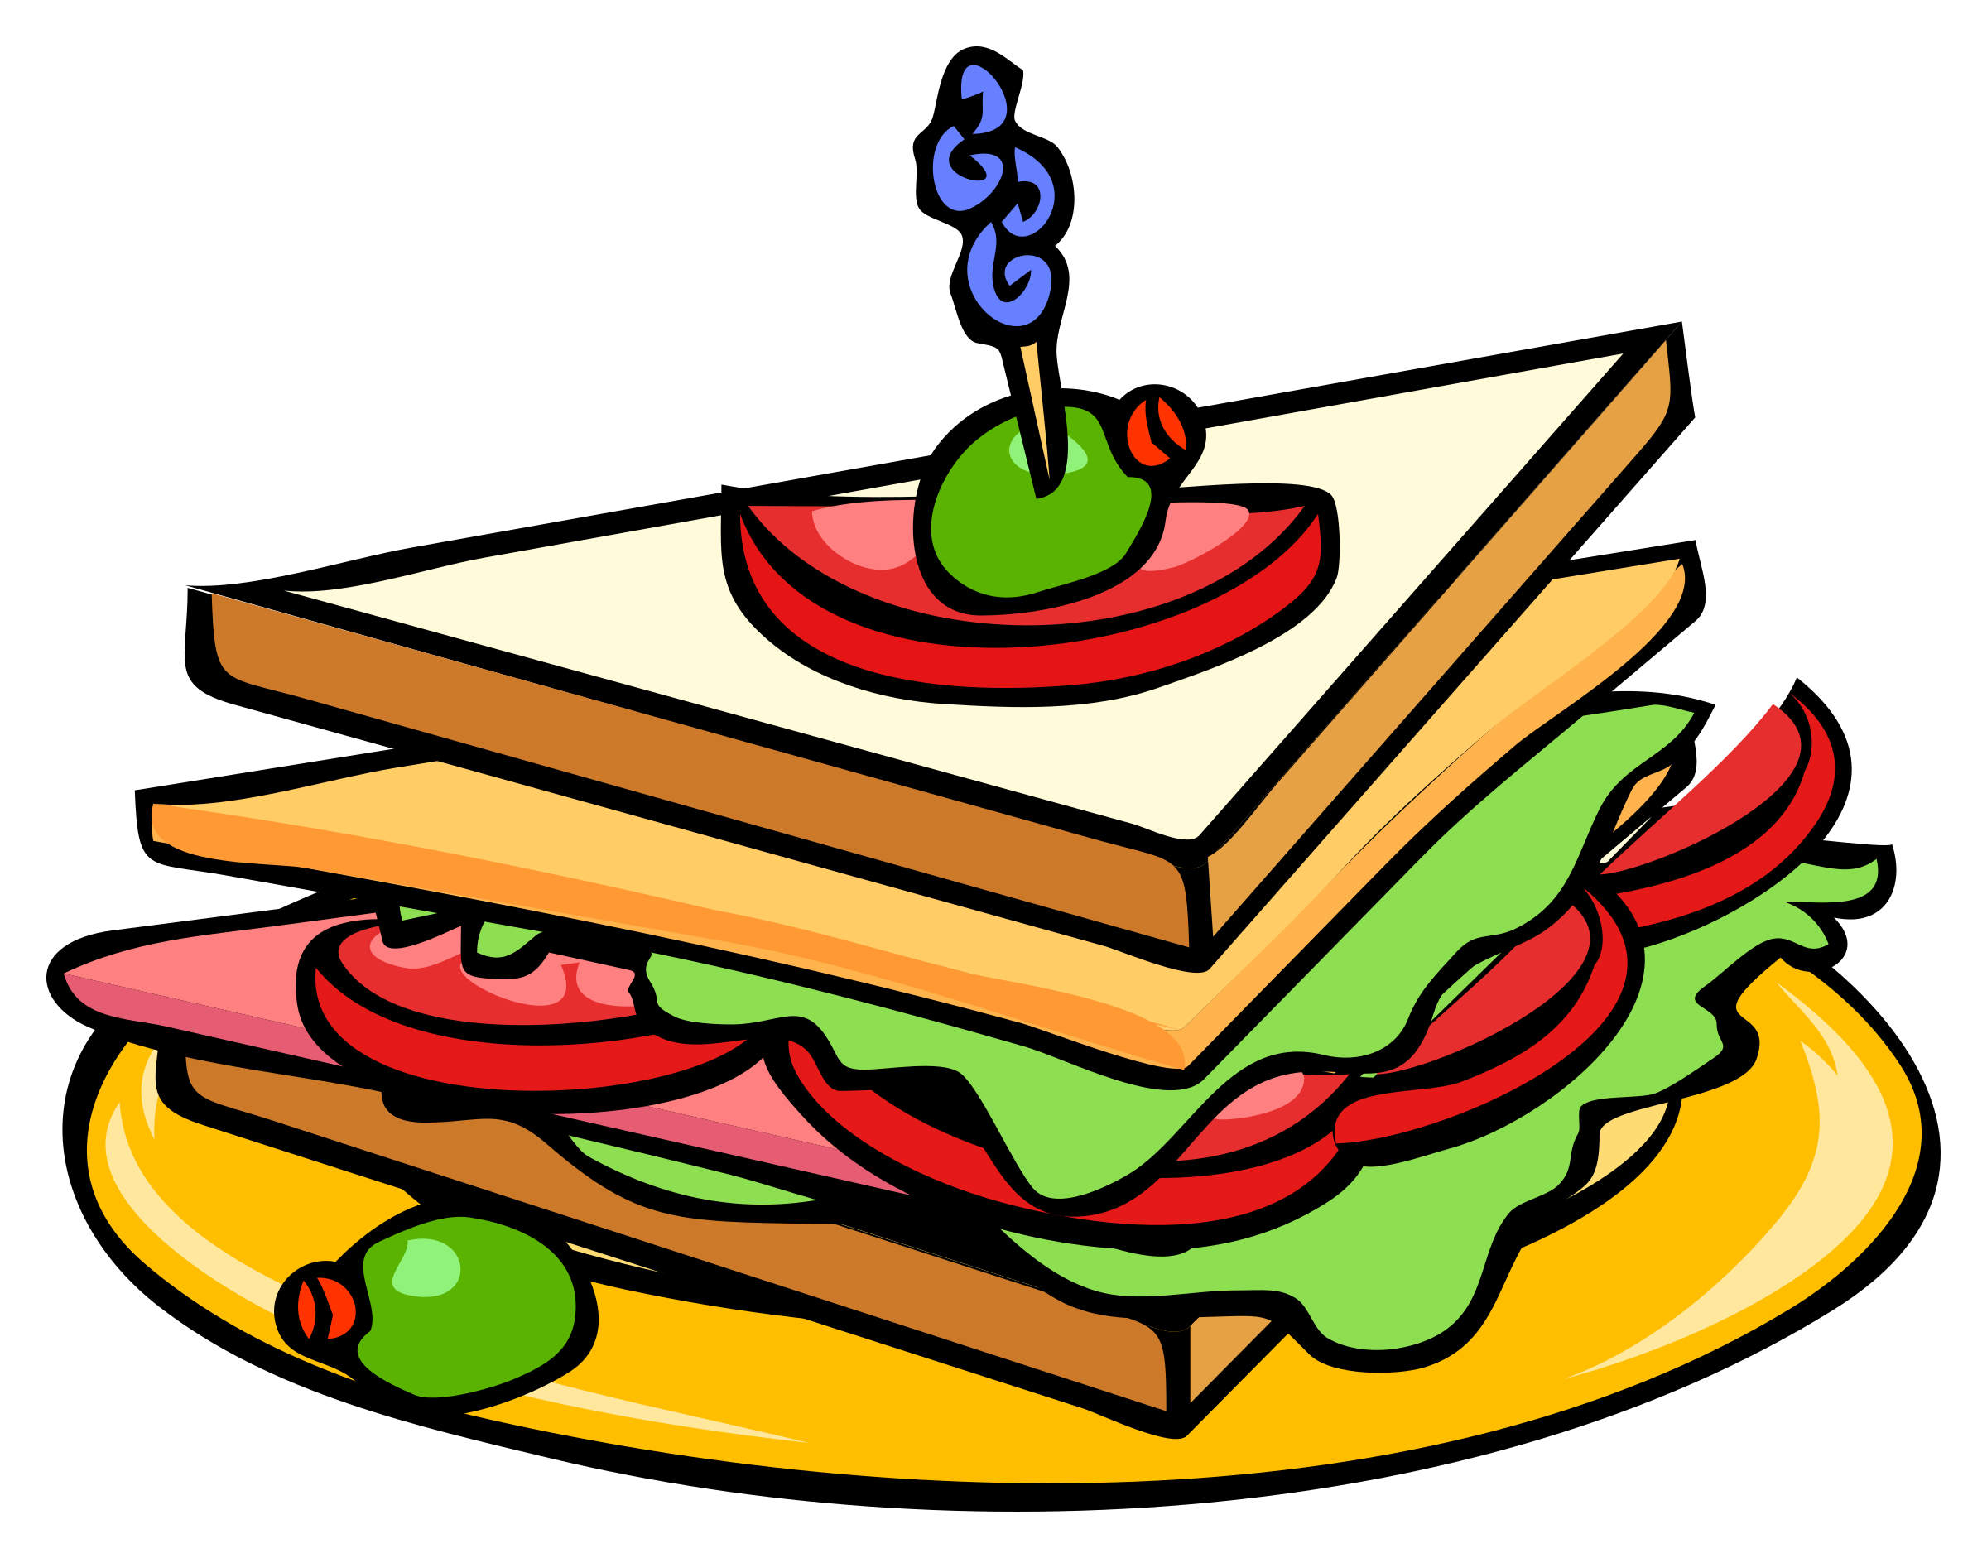  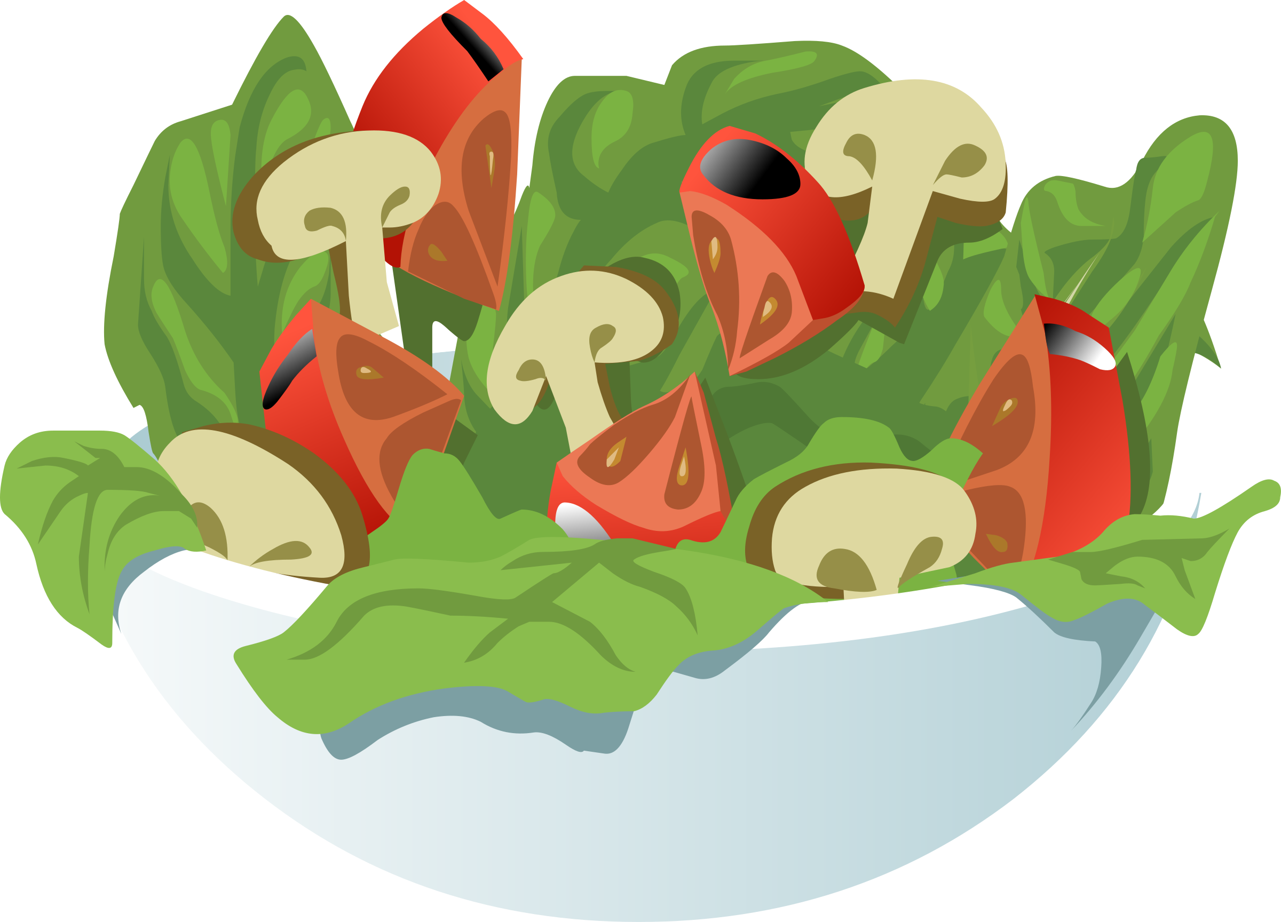 | Small Meals  Hunters Toast N$ 85.00  (Steak, sautéed onions & mushrooms on home baked bread)  Schnitzel with an option of: Chips & Mixed salad or Potato salad N$ 105.00  Pancake filled with Mince N$ 65.00  Pancake filled with sweet chilli  Chicken strips N$ 65.00  Steak with Chips, Mixed salad N$ 120.00  & Garlic butter  Toasted sandwiches:  Tomato & Cheese N$ 40.00  Ham, Cheese & Tomato N$ 45.00  Toast Hawaii N$ 53.00  Chicken mayonnaise on toast N$ 60.00  Salads  Mixed salad with game strips N$ 75.00  Greek salad N$ 75.00  Crunchy Beef salad (Steak strips on a bed of coleslaw) N$ 85.00  Something sweet  Apple crumble with whipped cream N$ 45.00  Melktert N$ 35.00  Schwarzwaelder Kirschtorte N$ 55.00  (Black forest cake)  Variety of Homemade cakes N$ 35.00  Waffle with ice-cream & syrup N$ 45.00  Ice-cream with Chocolate sauce N$ 33.00

