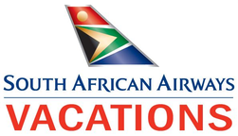

KwaZulu-Natal Beach & Bush
KwaZulu Natal North Coast - andBeyond Phinda Private Game Reserve
9 Days / 8 Nights
Date of Issue: March 16, 2016

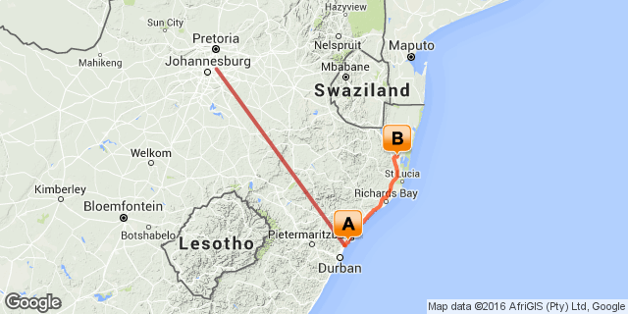

Click here to view your Digital Itinerary

Overview
Discover the natural wonders of KwaZulu-Natal, from the unspoiled shoreline of Fairmont Zimbali on the Dolphin Coast to the thrill of a Big 5 safari in the Phinda Private Game Reserve plus so much more...

Destination | Accommodation | Nights | Basis | Room Type
KwaZulu Natal North Coast | Fairmont Zimbali Resort | 2 | B&B
andBeyond Phinda Private Game Reserve | andBeyond Phinda Mountain Lodge | 4 | FB+

Key
RO: Room only
SC: Self Catering
HB: Half Board
B&B: Bed and breakfast
D, B&B: Dinner, bed and breakfast
FB: Dinner, bed, breakfast and lunch
FB+: Dinner, bed, breakfast, lunch and activities daily
FI: Fully inclusive

Included
Round trip coach air on South African Airways from New York (JFK) or Washington (IAD) Airport to South Africa OR Tambo International Airport
Regional coach air in South Africa as per the itinerary (Johannesburg - Durban, Richards Bay - Johannesburg)
Accommodation as per the itinerary
Most meals as per the itinerary (6 x breakfast, 4 x lunch, 4 x dinner)
Ground transfers as per the itinerary
All park fees and safari activities.

Excluded
Add on air from other US cities
Any meals or services not mentioned above (adventures at Phinda and excursions at Fairmont Zimbali Lodge)
Any items of personal expense - i.e. drinks, telephone calls, laundry etc
Gratuities for rangers/guides/drivers

Day 1: Travelling

Depart from New York (JFK) or Washington Dulles (IAD) for your South African Airways flight to South Africa.

Day 2
Fairmont Zimbali Resort, KwaZulu Natal North Coast

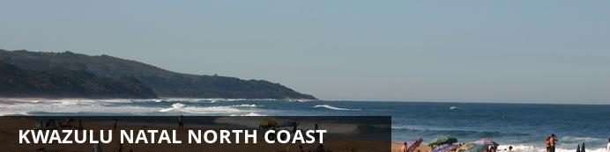
The KwaZulu Natal North Coast offers spectacular beaches all along its coastline and is divided into two distinct sections. Just north of Durban are the well developed beach resorts and golf courses, while the far north provides miles and miles of unspoilt beaches, wetlands and lake systems. So whether you’re after a 5-star hotel overlooking a beach, or camping in the dunes and diving with dolphins, the KwaZulu Natal coastline has it all and more.

Day Notes
On arrival in Johannesburg you will connect onwards for your 1 hour flight on South African Airways to Durban.
You will be met upon arrival and transferred to the unspoiled shoreline of Zimbali Coastal Resort.
Overnight on a bed and breakfast basis at Zimbali Resort

Overnight: Fairmont Zimbali Resort View iBrochure
An unspoiled shoreline, rolling hills and lush flora have come to define the Zimbali Coastal Resort region. Set along South Africa’s sublime east coast, nestled between a forest reserve and a shimmering sea, the resort’s exquisite natural beauty is dotted with pockets of urban flair and enhanced by the rich Zulu heritage of the KwaZulu-Natal province.
Part cultural wonderland, the region boasts thousand-year-old battlefields and renowned eco-parks; part natural playground, it offers unique game-viewing and safari opportunities. And it’s yours to enjoy—in comfort and with world-renowned service—at Fairmont Zimbali Resort, an exclusive and elegant gateway to nature.
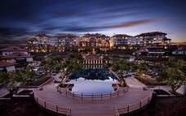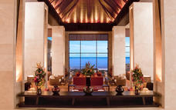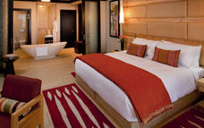

Included
Bed & Breakfast

Day 3
Fairmont Zimbali Resort, KwaZulu Natal North Coast

Day Notes
Today is at leisure.
Perhaps explore the wonders of this coastal resort or partake in one of the optional day excursions available from the lodge (at an additional cost)
Why not visit the nearby Zulu Battlefields? Fly back in time, to a spellbinding period and place in time. Accompanied by an accomplished storyteller, historian, researcher and battlefields guide, we relive all the drama that took place at Rorke's Drift and Isandlwana.
Overnight on a bed and breakfast basis at Zimbali Resort

Included
Bed & Breakfast

Day 4-8
andBeyond Phinda Mountain Lodge, andBeyond Phinda Private Game Reserve

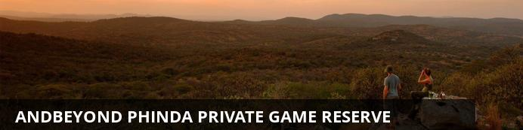
Described as “Seven Worlds of Wonder”, &Beyond Phinda encompasses an impressive 23 000 hectares (56 800 acres) of prime Big Five wilderness in KwaZulu-Natal. This Reserve comprises seven distinct habitats – from dry sand forest to wetland systems and mountain ranges. Catch a glimpse of the shy suni antelope, track rhino in the bushveld, observe breeding herds of elephant in fever tree forests, hold your breath as a cheetah teaches her cubs to hunt, glide past hippo on the Mzinene River and marvel at the gracious nyala. Phinda is home to more than 3 000 of these rare antelope.

Notes
After breakfast you will be transferred to Pinda Private Game reserve where you will spend the next 4 nights on safari.
At Phinda, the days are designed to thrill you with intimate wildlife encounters and the nights to delight you with the indulgence and romance of Africa.
As dawn breaks over the African bush, a gentle tap on your door will wake you to the delights of a new day. Your ranger will discuss what you hope to see that day over fragrant tea or coffee and morning biscuits or rusks. Phinda is renowned for its exceptional sightings of the elusive cheetah and the rare black rhino. There is also a number of resident lion prides and rangers will do their best to provide guests with a glimpse of all of these animals.
Return to your lodge for a delicious breakfast and some time to relax until lunch.
If you wish, you can walk off your breakfast near your lodge, accompanied by your ranger, who will share his insight into the smaller animals and vegetation in the area, before returning in time for lunch.
Cool off with a refreshing dip in the pool, indulge in an afternoon siesta or simply watch the wildlife from your private veranda. Over a late afternoon tea, your ranger will discuss what you hope to see during the afternoon game drive.
The game drive begins in the late afternoon and lasts until after dark, when spotlights are used for a glimpse into the nocturnal bush life. Listen to lions roar in the dark or admire the small nocturnal animals. Enjoy sundowners in a scenic location as the sun slowly sinks beneath the horizon. Return for a mouthwatering dinner which will be waiting for you at your lodge's boma or in a surprising bush location.
Overnight at a full board basis at Phinda Mountain Lodge for 4 nights

Overnight: andBeyond Phinda Mountain Lodge View iBrochure
With wraparound views of the spectacular Ubombo mountain range and the surrounding Zululand bush, andBeyond Phinda Mountain Lodge is a dramatic safari destination. Its 16 suites, 3 family cottages and the family suite crest the mountain’s edge, offering breath-taking raptor’s-eye views of the reserve below. Guests are greeted in the sheltered and welcoming open-air courtyard, which opens out onto a magnificent horseshoe-shaped building that holds the guest areas. The intimate sitting areas are filled with sunlight and the open decks make the most of the magnificent views. Each luxurious suite boasts an elegant ensuite bathroom, private sitting area and a spacious veranda with a plunge pool and outdoor shower. Delicious meals are served in the dining area, which overlooks the reserve and the Ubombo Mountains or in the traditional stone and reed boma, theatrically illuminated by dozens of candles and lanterns. Phinda is renowned for its bush banquets in natural, unexpected settings and guests may well find themselves savouring their meal in a spectacular clearing in the bush beneath an umbrella of twinkling stars.
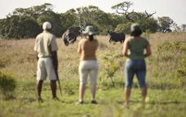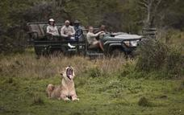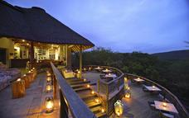

Included
Full Board and Activities
Drinks (Local Brands) Included

Day 8
Departure

Day Notes
An early morning wake up call, followed by breakfast, then depart the African bush, and transfer to Richards Bay Airport for your flight to Johannesburg and onward connection to the United States.

Day 9: Travelling

Arrival in the United States at New York JFK or Washington Dulles airports.

Transport

Flight Information
Date | Flight | Departure Airport | Time | Arrival Airport | Time | Class | Ref
 |  | JFK International Airport [JFK] |  | OR Tambo International Airport [JNB]
 |  | OR Tambo International Airport [JNB] |  | King Shaka International Airport [DUR]
 |  | Richards Bay Airport [RCB] |  | OR Tambo International Airport [JNB]
 |  | OR Tambo International Airport [JNB] |  | JFK International Airport [JFK]

Transfers
Date | Pick Up | Drop Off | Time | Vehicle
 | King Shaka International Airport [DUR] | Fairmont Zimbali Resort
 | Fairmont Zimbali Resort | andBeyond Phinda Mountain Lodge
 | andBeyond Phinda Mountain Lodge | Richards Bay Airport [RCB]

Travel Information
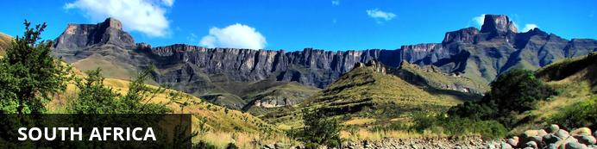
While wildlife safaris are reason enough to visit this exquisite country, South Africa offers even more to see and do. For one, the city of Cape Town is a jewel that is well worth visiting. Set against the iconic Table Mountain, C.T. offers lots to explore, including the V&A Waterfront, Chapman’s Peak, Boulders Penguin Colony and several beautiful beaches — just to give you an idea. Not to mention the delicious food and fabulous shopping, which can all be enjoyed at a favorable exchange rate.
One of the biggest attractions in the Western Cape is the towns of Stellenbosch, Paarl and Franschoek . Boasting some of the best wine tours in the world, they offer picturesque vineyards, fantastic art galleries and gourmet food.
Furthermore, South Africans are some of the most upbeat, welcoming and humorous people you’ll ever encounter. You will be exposed to different cultures, languages and traditions that will certainly enhance your experience.
With so much diversity, South Africa has something for everyone to enjoy!

Visa Regulations and Guidance
As for all international travel, the visitor to South Africa is required to be in possession of a valid passport. U.S. citizens (US passport holders) traveling to the Republic of South Africa for 90 days or less for tourism or business purposes do not need visas. U.S. green card holders (non-US passport holders) require visas to visit South Africa. Nationals of other countries must check the list of visa exempt countries to see if they need to apply for visas.
Please note that all foreigners who wish to visit South Africa must have a passport that is valid for at least 6 months after his/her intended return date. The passport must have a minimum of four blank (unstamped) visa pages in the passport to enter the country. It is preferred these are facing pages. Your international carrier can deny boarding if you do not have the blank (unstamped) visa pages. Travellers should make sure there are sufficient pages for visas and immigration stamps to enter into South Africa and other countries to be visited. These blank pages cannot be endorsement or amendment pages.
As a general precaution, all travellers are advised to carry a photocopy of the photo/bio information page of their passport and keep it in a location separate from their passport.

Banking and Currency
Currency
South Africa's currency is the Rand, which offers visitors great value for their money. The rand comes in a range of coins (R1 = 100 cents) and note denominations of R10, R20, R50, R100. With the exchange rate in your favor, you'll find South Africa offers great value.
It is advisable to exchange US Dollars into Rands upon arrival for tips and small purchases where credit cards are not normally used.
Exchanging large denominations of US Dollars at game lodges can be challenging so come prepared.
Banking
Banks are found in most towns, and are generally open from 09h00 to 15h30 on weekdays and 08h30 to 11h00 on Saturdays (Closed Sundays and Public Holidays). Most of them offer foreign exchange services - with cash, bank & credit cards as well as travellers cheques. You can also obtain cash from automatic teller machines (ATMs). Several international banks have branches in the main city centres. Always advise your bank that you are travelling outside of the country as they might block your purchases if they are not informed.

Travel, Transport and Getting Around
Travelling around South Africa is relatively easy by air, road and rail.
Principal air routes are serviced by SAA and British Airways, operated by Comair. There are 2 low-cost carriers on main routes, namely Kulula.com and Mango.
Facilitating travel around South Africa are 10 airports managed by the Airports Company South Africa (Acsa). In addition, there are some 90 regional airports, including the Kruger Mpumalanga International Airport in Nelspruit and the Skukuza Airport, offering access to the Kruger National Park.
An extensive tarred road system makes travelling in South Africa by vehicle convenient and easy. You will find gravel roads in rural areas though. Note:

Another means of getting around South Africa are luxury inter-city bus services such as Greyhound and Trans-Lux. Metrobus buses are available for in-city transport. Metered taxis must be ordered by telephone. There is a hop-on-hop-off bus in Cape Town and Johannesburg.
Our rail system includes the long-haul, inexpensive Shosholoza Meyl Metrorail trains. More luxurious options are the Blue Train, Premier Classe and the steam train Rovos Rail. There is also the new Gautrain rapid transit railway system in Gauteng Province which links Johannesburg, Pretoria, Ekhuruleni and OR Tambo International Airport.

Health / Medical Information
Many of the main tourist areas are malaria-free, so you need not worry at all. However, the Kruger National Park, the Lowveld of Mpumalanga and Limpopo, and the northern part of KwaZulu-Natal do pose a malaria risk in the summer months.
Many local people and some travelers do not take anti-malaria prophylaxis, but most health professionals recommend that you do. All guests must consult their own medical doctor or health authorities regarding the use of anti-malarial tablets prior to departure.
Whether you take oral prophylaxis or not, always use mosquito repellent, wear long pants, closed shoes, light long-sleeved shirts at night, and sleep under a mosquito net in endemic areas (the anopheles mosquito, which carries malaria, operates almost exclusively after dark). Mosquito repellent containing “deet” is best. It is advisable to avoid malarial areas if you are pregnant.

Safety Notices
If you have lost your passport or wallet, please contact the local police department and file a report. Once you have done this, contact one of South Africa’s U.S. Embassies or Consulates (located in Pretoria, Johannesburg, Cape Town, and Durban).
Contact Information:
Cape Town Consulate General
Telephone : (021) 702 - 7300
Email: americanscapetown@state.gov
Durban Consulate General
Telephone: (031) 305 – 7600
Email: consulardurban@state.gov
Johannesburg Consulate General
Telephone: (011) 290 - 3000
Email: consularjohannesburg@state.gov
Alternately, you can obtain information online at http://southafrica.usembassy.gov/.

Food, Drink and Cuisine Advice
Standards of hygiene in relation to food health and safety in South Africa, are generally high in hotels, restaurants, pubs and nightspots. Tap water in South Africa is safe to drink and cook with when taken from taps in urban areas. Not all tap water in rural areas is safe for consumption, so take precautions if necessary.
It is safe to eat fresh fruit, vegetables and salads, and put ice in your drinks. South Africa's fish, meat and chicken are of excellent quality, so there is no need to limit yourself when enjoying the local cuisine.
Restaurants are subject to South Africa's food safety control legislation, which is implemented by local government. Regulations include certification and regular inspections by health inspectors to ensure hygienic standards are maintained.
Street food is not as common in South Africa as it is in other countries, although vendors selling traditional snacks and meals can be found in city centres and townships. Food safety in such instances cannot always be guaranteed.

Climate and Weather
In the Western Cape, the average rainfall is highest in the winter months, while in other provinces, the average rainfall is highest during the summer. Overall South Africa enjoys a temperate and pleasant climate, with lovely warm sunny days most of the year. KwaZulu-Natal has a sub tropical climate with high humidity in Summer. The Southern Gauteng region has hot summers with occasional thundershowers and frosty winters, while the Eastern part of this region (known as the Lowveld) enjoys mild winters. The Cape interior and the Free State have similar weather conditions to the Southern Gauteng region. The Western Cape region has a Mediterranean climate with warm, dry summers and cold, wet winters.
Spring: September – October
Summer: November - February
Autumn: March – April
Winter: May – August

Clothing / Dress Recommendations
Summer
Bring clothes that are cool, light and comfortable because summer temperatures can get well into the 30 - 40 degree Celsius range in some areas.Also bring an umbrella or raincoat during summer as this is when most of the country gets its rain, but don't forget a swimming costume (bathing suit).
Winter
The winters are generally mild, comparing favourably with European summers. But there are days when temperatures dive, especially in high-lying areas such as the Drakensberg, so be prepared with jerseys and jackets. Cape Town gets its rain during the winter season so it’s advisable to bring rain gear along.
General
Always bring a hat, sunglasses and sunblock as the sun can be strong even in the winter months.
Walking shoes are a good idea all year-round, with warm socks in the winter.
If you are doing business in the country, business attire (suit and tie) is generally called for in the corporate sector, but media for example generally dress more casually.
For game viewing, a couple of neutral-toned items will be useful, but there's no need to go overboard. A good pair of walking shoes is also advisable.
For the evening, if you are dining at an upmarket restaurant or seeing a show, smart-casual attire is recommended.

Electricity and Plug Standards
The South African electricity supply is 220/230 volts AC 50 HZ. With a few exceptions (in deep rural areas) electricity is available almost everywhere. However, you will need to purchase or bring adapters for the outlets. You can purchase the adapters in many US stores, online, or from a store while in South Africa. Adapters are usually available on loan at major hotels in South Africa. Three to five star hotels usually have 110 volt outlets for electric shavers in bathrooms and often provide hair dryers and irons. An NW 4 plug with two prongs, 0.19 inches in diameter is required for compatibility.

