

# Unrivaled Botswana

*Chobe River Front - Savute - Chobe National Park - Okavango Delta - Makgadikgadi Pans National Park*  
*9 Days / 8 Nights*  
*0 Persons*  
*Date of Issue: October 23, 2015*

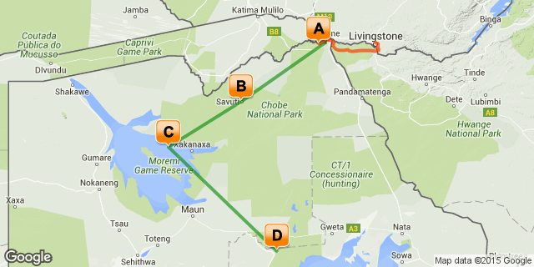

# [Click here to view your Digital Itinerary](http://travel.flysaavacations.com/Itinerary/Landing/b54b929a-96b2-4711-b9e0-6e9c3d27d40b)

## Overview

Discover Botswana with Desert & Delta Safaris, experiencing spectacular locations and a diverse safari experience. From the iconic Chobe Game Lodge, to the predator renowned area of Savute Safari Lodge, Camp Okavango in the heart of the Okavango Delta and Leroo La Tau rising majestically above the Boteti River in the Makgadikgadi Pans National Park, this package will offer you an unrivalled safari experience throughout Botswana...

|  |  |  |  |  |
| --- | --- | --- | --- | --- |
| **Destination** | **Accommodation** | **Nights** | **Basis** | **Room Type** |
| Chobe River Front | [Chobe Game Lodge](http://travel.flysaavacations.com/iBrochure/702_1149_9828) | 2 | FI |  |
| Savute - Chobe National Park | [Savute Safari Lodge](http://travel.flysaavacations.com/iBrochure/702_1149_18117) | 2 | FI |  |
| Okavango Delta | [Camp Okavango](http://travel.flysaavacations.com/iBrochure/702_1149_10099) | 2 | FI |  |
| Makgadikgadi Pans National Park | [Leroo La Tau](http://travel.flysaavacations.com/iBrochure/702_1149_18115) | 2 | FI |  |

**Key**  
RO: Room only  
SC: Self Catering  
HB: Half Board  
B&B: Bed and breakfast  
D, B&B: Dinner, bed and breakfast  
FB: Dinner, bed, breakfast and lunch  
FB+: Dinner, bed, breakfast, lunch and activities daily  
FI: Fully inclusive

## Day 1 Chobe Game Lodge, Chobe River Front

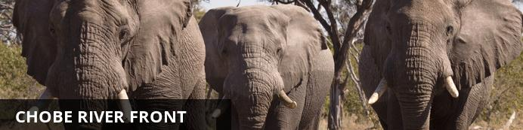

The Chobe River forms the northern boundary of the Chobe National Park, renowned for its reliable and diverse game viewing. Safaris are conducted both by boat and on land. This section of the park is best known for its elephant and hippo populations but the waters attract all manner of game including large herds of buffalo and the lions that prey on them.

### Day Notes

On arrival at Livingstone Airport, a Wild Horizons representative will meet and transfer you to your lodge.

Picturesquely situated 100 km west of the Victoria Falls, overlooking the Chobe River and the Caprivi floodplains, the iconic Chobe Game Lodge is the only permanent safari lodge within the Chobe National Park.   
The lodge accommodates up to 94 guests in absolute luxury. Rooms are river-facing, and include minibars, en-suite bathrooms, tea and coffee making facilities as well as private terraces. Other facilities include a stylish cigar bar overlooking the Chobe River, a large terraced swimming pool and riverside boma area.   
Meals are catered for at the terrace restaurant, and themed BBQs are regularly held at the boma on the Chobe River’s grassy banks.  
Chobe Game Lodge offers a choice of land or water-based activities and the most complete game experience in the Chobe National Park. Early morning and late afternoon game drives are conducted by expert guides in open sided 4x4 vehicles to ensure maximum visibility of Chobe National Park’s spectacular scenery and abundant wildlife. Meanwhile, riverside game viewing is conducted by small and highly manoeuvrable boats, perfect for morning or sunset cruises.  
Guests can also enjoy the wide expanses of the Chobe River with sundowners and snacks courtesy of our double-decker river cruiser, the Mosi-oa-Tunya. Pofessional guides and a resident environmentalist also offer the chance to spot some of the Southern Hemisphere’s most beautiful constellations on our stargazing deck.   
The afternoon is at leisure to enjoy the game viewing activity on offer.

### Overnight: Chobe Game Lodge [View iBrochure](http://travel.flysaavacations.com/iBrochure/702_1149_9828)

Counter-balancing the wilderness are restful, air conditioned, en-suite lodgings. Graceful high arches, quarry tiled floors and barrel vaulted ceilings create an atmosphere of cool tranquillity.   
Other facilities include a large swimming pool with terrace, a riverside boma area, a fully equipped conference room, a business centre for those guests needing to keep in touch, a stylish bar with an outside terrace overlooking the Chobe River and a cigar bar with a full sized billiard table. Meals are catered for at the terrace restaurant overlooking the Chobe River. Each of Chobe Game Lodge's 4 luxury suites has an individual plunge pool set on a private terrace with breathtaking panoramic views of the endless landscape and open plains. Graceful high arches, quarry tiled floors and barrel vaulted ceilings create an atmosphere of cool tranquillity. All 46 rooms are tastefully furnished, each room with hand crafted Rhodesian teak furniture and walls decorated with original African carvings and paintings.

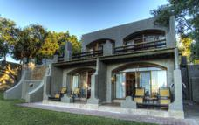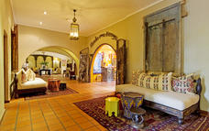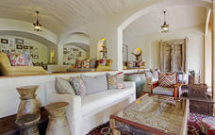

### Included

Fully Inclusive

## Day 2 Chobe Game Lodge, Chobe River Front

### Day Notes

The day is at leisure to enjoy the game viewing activities on offer.

### Included

Fully Inclusive

## Day 3 Savute Safari Lodge, Savute - Chobe National Park

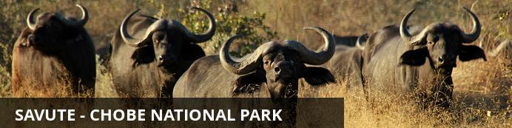

In the heart of Botswana’s Chobe National Park lies a dynamic wilderness, a sweeping expanse of savannah brooded over by several rocky outcrops which guard a relic marsh and the dry channel that was once its lifeline. This is Savute, where mysterious wet and dry cycles mould the landscape and dictate the nature of its wild inhabitants. Currently it is dry, and wild dogs hunt in the channel where crocodiles swam only twenty years ago.   
The Gubatsa Hills shelter leopard and klipspringer and rock paintings of early man’s wildlife sightings. During the arid winter months game viewing concentrates on Savute’s resident bull elephants, antelope and lion prides, and black-backed jackal, bat-eared foxes, tsessebe, and kudu, abound.  
The summer rains bring a feast for lion, hyena and cheetah as thousands of migrating zebra and wildebeest assemble in a chaotic pattern on the marsh. Cape buffalo herds arrive and migrant birds swell Savute’s 300 resident species, thrilling bird-watchers with their spectacular antics.

### Day Notes

The morning is at leisure to enjoy the game viewing activities on offer. After breakfast a camp representative will transfer you to Kasane Airport. Depart on a Safari Air shared light aircraft charter flight to Savute Safari Lodge.  
Located on the banks of the Savute channel, Savute Safari Lodge is intimate, accommodating only 24 guests in cool thatched timber and glass suites.   
The area is renowned for its population of bull elephant and for the unique interaction of the resident predator species. The close proximity of wildlife translates itself into the recently refurbished, modern African décor.   
All suites have private decks, combined bedroom and sitting areas and en-suite facilities. The sitting area, library and cocktail bar are situated in an exquisite thatch and timber main building.   
Savute boasts a viewing deck, an al fresco dining area and swimming pool – which is ideal for watching game at the waterhole. These features set the lodge apart from other typical safari destinations.   
Open 4x4 game drives are conducted in the Savute area, including the famous Savute Marsh, and the ancient San rock paintings at Gubatsa Hills, add magic to a delightful African safari.   
The afternoon is at leisure to enjoy the game viewing activity on offer.

### Overnight: Savute Safari Lodge [View iBrochure](http://travel.flysaavacations.com/iBrochure/702_1149_18117)

Located on the banks of the Savute channel, Savute Safari Lodge is intimate, accommodating only 24 guests in cool thatched timber and glass suites.   
The area is renowned for its population of bull elephant and for the unique interaction of the resident predator species. The close proximity of wildlife translates itself into the recently refurbished, modern African décor.

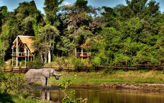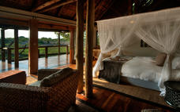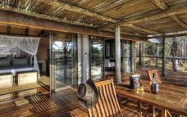

### Included

Fully Inclusive

## Day 4 Savute Safari Lodge, Savute - Chobe National Park

### Day Notes

The day is at leisure to enjoy the game viewing activities on offer.

### Included

Fully Inclusive

## Day 5 Camp Okavango, Okavango Delta

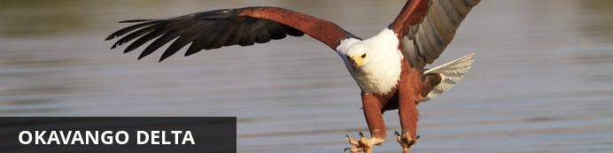

Lying in the middle of the largest expanse of sand on earth the Okavango Delta is one of Africa’s most amazing, sensitive and complex environments supporting a spectacle of wilderness and wildlife. Unique as one of the world’s few inland deltas, the placid waters and lush indigenous forests offer a safe haven for innumerable bird and wildlife species. The Okavango Delta offers a number of activities for the visitor; game viewing, birding and fishing are all on offer. One can experience this magical world of islands and waterways from land, air and water.

Highlights include the elusive Sitatunga antelope which has found refuge in this pristine wetland ecosystem, while birds such as the African fish eagle, Pel's fishing owl and many others provide a spectacular display.

### Day Notes

The morning is at leisure to enjoy the game viewing activities on offer. After breakfast a camp representative will transfer you to the airstrip. Depart Savute Safari Lodge on a Safari Air shared light aircraft charter flight to Camp Okavango.   
Enchanting Camp Okavango sits at the heart of the Okavango Delta on Nxaragha Island. Its main lodge features a cocktail bar, sitting area and wildlife reference library, with the dining room leading onto an expansive open-air patio where evenings around the fire can be enjoyed.   
Other facilities include a secluded bird-viewing hide and sundeck with plunge pool. Accommodating just 24 guests in custom African-style safari tents on raised teak platforms, Camp Okavango offers guests en-suite facilities and private viewing decks.   
All game-viewing activities are conducted by experienced guides and include exploring the Okavango Delta by mokoro or motorboat and tracking the larger game species on guided nature walks on the many surrounding islands.   
The afternoon is at leisure to enjoy the game viewing activity on offer.

### Overnight: Camp Okavango [View iBrochure](http://travel.flysaavacations.com/iBrochure/702_1149_10099)

Enchanting Camp Okavango sits at the heart of the Okavango Delta on Nxaragha Island. Its main lodge features a cocktail bar, sitting area and wildlife reference library, with the dining room leading onto an expansive open-air patio where evenings around the fire can be enjoyed.   
Other facilities include a secluded bird-viewing hide and sundeck with plunge pool. Accommodating just 24 guests in custom African-style safari tents on raised teak platforms, Camp Okavango offers guests en-suite facilities and private viewing decks.   
For guests who demand the ultimate in exclusivity, Camp Okavango has the Okavango Suite, a thatched cottage offering complete privacy.  
All game-viewing activities are conducted by experienced guides and include exploring the Okavango Delta by mokoro or motorboat and tracking the larger game species on guided nature walks on the many surrounding islands.

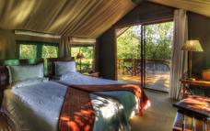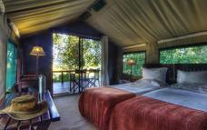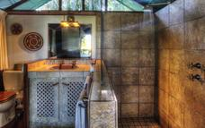

### Included

Fully Inclusive

## Day 6 Camp Okavango, Okavango Delta

### Day Notes

The day is at leisure to enjoy the game viewing activities on offer.

### Included

Fully Inclusive

## Day 7 Leroo La Tau, Makgadikgadi Pans National Park

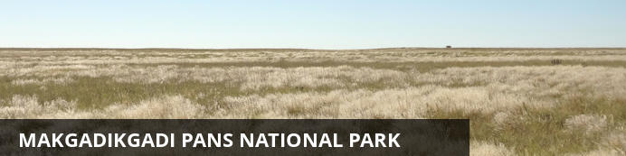

This ancient lake turned salt pan still manages to sustain life and awe visitors.

### Day Notes

The morning is at leisure to enjoy the game viewing activities on offer. After breakfast a camp representative will transfer you to the airstrip. Depart Camp Okavango on a Safari Air shared light aircraft charter flight to Leroo La Tau.  
Leroo La Tau rises majestically above the Boteti River which stretches across the western border of the Makgadikgadi Pans National Park.  
The park, populated by up to 30,000 zebra and wildebeest closely accompanied by predators, offers guests the chance to experience the exhilaration of seeing large concentrations of game and the resultant predator interaction. The lodge offers a raised hide above the river where guests can enjoy the spectacular wildlife sightings that we’ve come to expect in this part of Botswana.   
With just 12 thatched chalets, each with en-suite bathrooms, a dining room, reading room and bar in the main lodge, expansive wooden decks and a plunge pool, guests can immerse themselves seamlessly into the ultimate wildlife experience in Botswana.   
Leroo La Tau translates as ‘lion’s paw’, but although the surrounding area features abundant lion, zebra and wildebeest, it also boasts Chobe bushbuck, leopard, cheetah, brown- and spotted-hyena, impala, kudu, jackal, porcupine, genet and caracal, to name but a few. In addition, there is also the possibility of seeing the rare white rhinoceros.  
Having explored the area and enjoyed a spectacular wildlife phenomenon on guided day and night game drives, guests can retire after dinner to a splendid fireplace overlooking the river.   
The afternoon is at leisure to enjoy the game viewing activity on offer.

### Overnight: Leroo La Tau [View iBrochure](http://travel.flysaavacations.com/iBrochure/702_1149_18115)

Leroo La Tau rises majestically above the Boteti River which stretches across the western border of the Makgadikgadi Pans National Park.  
The park, populated by up to 30,000 zebra and wildebeest closely accompanied by predators, offers guests the chance to experience the exhilaration of seeing large concentrations of game and the resultant predator interaction. The lodge offers a raised hide above the river where guests can enjoy the spectacular wildlife sightings that we’ve come to expect in this part of Botswana.  
With just 12 thatched luxury chalets all overlooking the magnificent Makgadikgadi Pans National Park, each with en-suite bathrooms. There is a dining room, reading room and bar in the main lodge, expansive wooden decks and a plunge pool, where guests can immerse themselves seamlessly into the ultimate wildlife experience in Botswana.   
Having explored the area and enjoyed a spectacular wildlife phenomenon on guided day and night game drives, guests can retire after dinner to a splendid fireplace overlooking the river.

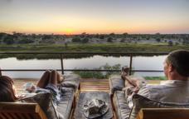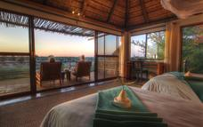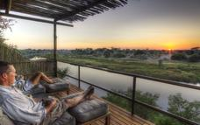

### Included

Fully Inclusive

## Day 8 Leroo La Tau, Makgadikgadi Pans National Park

### Day Notes

The day is at leisure to enjoy the game viewing activities on offer.  
The lodge offers both scheduled guided day and night game drives. Depending on the water levels of the Boteti River, boat activities can also be provided. Optional cultural excursions can be arranged to visit Khumaga Village, as can guided nature walks in the area surrounding the lodge.

### Included

Fully Inclusive

## Day 9 Departure

### Day Notes

Enjoy a morning game viewing activity followed by breakfast. You will depart on a shared light aircraft charter flight to Maun airport.

# Transport

## Flight Information

|  |  |  |  |  |  |  |  |
| --- | --- | --- | --- | --- | --- | --- | --- |
| **Date** | **Flight** | **Departure Airport** | **Time** | **Arrival Airport** | **Time** | **Class** | **Ref** |
|  |  | Kasane Airport [BBK] |  | Savute Safari Lodge |  |  |  |
|  |  | Savute Safari Lodge |  | Camp Okavango |  |  |  |
|  |  | Camp Okavango |  | Leroo La Tau |  |  |  |
|  |  | Leroo La Tau |  | Maun Airport [MUB] |  |  |  |

## Transfers

|  |  |  |  |  |
| --- | --- | --- | --- | --- |
| **Date** | **Pick Up** | **Drop Off** | **Time** | **Vehicle** |
|  | Harry Mwanga Nkumbula International Airport [LVI] | Chobe Game Lodge |  |  |
|  | Chobe Game Lodge | Kasane Airport [BBK] |  |  |

## Travel Information

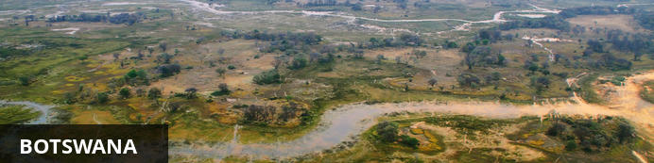

Botswana is well known for having some of the best wilderness and wildlife areas on the African continent. With almost 40% of its land area devoted to national parks, reserves and wildlife management areas you can travel through many parts of the country has the feeling of moving through an immense Nature wonderland.

The first – and most lasting impressions – will be of vast expanses of uninhabited wilderness stretching from horizon to horizon, the sensation of limitless space, astoundingly rich wildlife and bird viewing, night skies littered with stars and heavenly bodies of an unimaginable brilliance, and stunning sunsets of unearthly beauty.

Experience here the stunning beauty of the world’s largest intact inland Delta – the Okavango; the unimaginable vastness of the world’s second largest game reserve – the Central Kalahari Game Reserve; the isolation and other-worldliness of the Makgadikgadi – uninhabited pans the size of Portugal; and the astoundingly prolific wildlife of the Chobe National Park.

Botswana is the last stronghold for a number of endangered bird and mammal species, making your safari experience even more memorable, and at times you will feel simply surrounded by wild animals.

#### Banking and Currency

**Currency**

Botswana's currency is Pula (which means 'rain' in Setswana). It is divided into 100 thebe (which means 'shield' in Setswana). Travellers' cheques and foreign currency may be changed at banks, bureaux de change and authorised hotels.

The US dollar, Euros, British Pound and the South African Rand are the most easily convertible currencies (and accepted by some estabishments - but, generally, then an inflated rate of exchange will be used).

**Banking**

Full banking services are available on in major towns, although ATMs are sprouting up all over the country. Most credit cards are accepted at hotels and restaurants. Cultural sites and community art and craft outlets usually only accept cash.

Seven main commercial banks, as well as a number of foregin exchange bureaux, operate in Botswana. Operating hours are Monday to Friday 08h30 to 15h30 and Saturday 08h30 to 10h45.

#### Travel, Transport and Getting Around

Public transport in Botswana is geared towards the needs of the local populace and is confined to main roads between major population centres. Although cheap and reliable, it is of little use to the traveller as most of Botswana’s tourist attractions lie off the beaten track.

Driving off the main roads in Botswana is only recommended to expects in 4x4 vehicles, that are equipped correctly. Most lodges offer transfers or they can be arranged. If, however, you will be driving in Botswana:

**Be sure to watch out for wild animals on the roads!**

There are major airports in Maun, Kasane and Gaborone, while smaller charter flights are used to get to the other top attractions and camps.

#### Food, Drink and Cuisine Advice

Indigenous Botswana cuisine is similar to the rest of southern Africa. Beef is taken seriously and can be of exceptional quality. Throughout Botswana the tap water is safe for showering and brushing teeth, but it is not advised to drink the tap water. Filtered water is available at most camps and shops offer bottled water - it is advised to be well stocked of bottled water if you are travelling off the beaten track. The national beer is St Louis, and is worth a try, however there are US lagers as well as Namibian or South African imports usually available as well.

#### Clothing / Dress Recommendations

**Summer**

In summer, lightweight, lightcoloured cottons are preferable. Avoid synthetic materials and black clothing, as they increase perspiration and discomfort.

**Winter**

In winter, wear trousers, longsleeved shirts / blouses and jerseys.

From May – August, night temperatures can fall below zero degrees celsius, so warm jerseys and jackets are vital, especially on morning and evening game drives.

**General**

Garments of neutral colours that blend with the bush and forest are advisable for safaris and game viewing.

Bring a lightweight jacket and/or jersey for unexpected temperature changes or rain.

Closed, comfortable walking shoesor gym shoes are a must in all seasons.

Special attention should be given to protection from the sun. Bring a sunhat, good quality sunscreen, sun lotion and polarised sunglasses.

Wide brimmed hats are preferable to baseball caps.

#### Electricity and Plug Standards

Current is 220/240 volts at 50 cycles per second. Both square and round wall plugs are used.