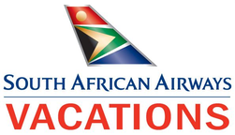

Opulent South Africa
Sabi Sand Private Game Reserve - KwaZulu Natal Midlands - Cape Town
15 Days / 14 Nights
Date of Issue: March 09, 2016

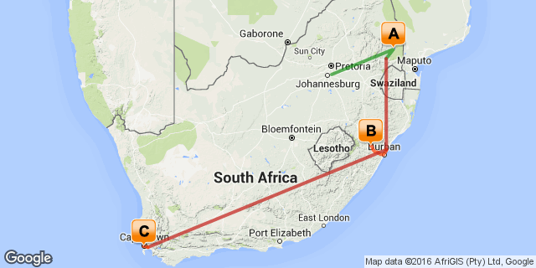

Click here to view your Digital Itinerary

Overview
Indulge in South Africa's ultimate opulence. Experiencing the best Kruger, KwaZulu-Natal and Cape Town has to offer. This package includes Business Class flights from New York (JFK) or Washington Dulles (IAD), with SAA’s Skytrax 5-star comfort-rated flat-bed seats, award-winning wines, cuisine and entertainment. Premium Business Class passengers are also invited to relax prior to their flights in the business class lounges in Washington Dulles, New York and Johannesburg.

Destination | Accommodation | Nights | Basis | Room Type
Sabi Sand Private Game Reserve | Sabi Sabi Earth Lodge | 4 | FI
KwaZulu Natal Midlands | Karkloof Safari Spa | 4 | FB
Cape Town | Ellerman House | 4 | B&B

Key
RO: Room only
SC: Self Catering
HB: Half Board
B&B: Bed and breakfast
D, B&B: Dinner, bed and breakfast
FB: Dinner, bed, breakfast and lunch
FB+: Dinner, bed, breakfast, lunch and activities daily
FI: Fully inclusive

Included
Round trip Business Class air on South African Airways from New York (JFK) or Washington(IAD) Airport to South Africa OR Tambo International Airport
Domestic Economy air and scheduled charters in South Africa as per the itinerary (Johannesburg-Sabi Sabi-KrugerMpumalanga-Durban-Cape Town-Johannesburg)
Accommodation as per the itinerary
Most meals as per the itinerary (12x breakfast, 8x lunch, 8x dinner)
Ground transfers as per the itinerary
All park fees and safari activities

Excluded
Add on air from other US cities
Any meals or services not mentioned above
Any items of personal expense - i.e. beverages, telephone calls, laundry, etc
Gratuities for rangers/guides/drivers

Day 1: Travelling

Depart from New York (JFK) on your South African Airways flight to South Africa.

Day 2-6
Sabi Sabi Earth Lodge, Sabi Sand Private Game Reserve

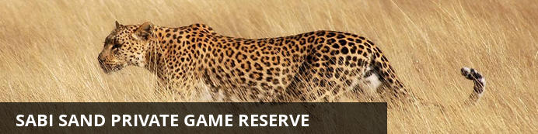
The Sabi Sands is South Africa's premier private game viewing destination. It was here that the southern African safari began and today this famous reserve offers exceptional game viewing and equally exceptional accommodations. Two perennial rivers, the Sabi and the Sand flow through this Game Park, sustaining the diverse fauna and flora of the area.
The success of leopard viewing within the Sabi Sands is legendary. Elephants, lion, rhino, buffalo, cheetah, giraffe, zebra and a vast variety of antelope and other species can be closely observed in their natural environment.

Notes
On arrival in Johannesburg, you will be met and assisted to the Federal Air lounge for your scheduled flight to Sabi Sabi Earth Lodge.
The reserve is home to the ‘Big Five’ (elephant, rhino, lion, leopard and buffalo), as well as cheetah, wild dog and hundreds of other species of animals, birds and plants indigenous to the area. Highly trained and experienced rangers and trackers ensure that your safari experience ranks amongst the best in the world. You can look forward to fantastic close-up experiences with Africa’s wildlife on every game drive.
Overnight on a fully inclusive basis at Sabi Sabi Earth Lodge for 4 nights

Overnight: Sabi Sabi Earth Lodge View iBrochure
Sculpted deep into the natural landscape, Earth Lodge takes its cue from nature – textures, colours, light, space all reflecting the lodge’s surrounding bushveld. Thirteen magnificent suites break with traditional safari style to showcase hand-carved furniture sculptures, rich linens and earthy colours. Enormous en-suite bathrooms feature natural stone baths and indoor and outdoor showers; and each suite has a private plunge pool and patio. The lodge has a wine cellar, spa, boma, library and pool.
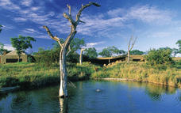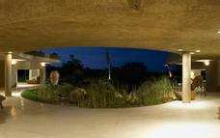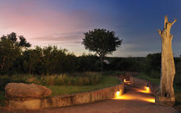

Included
Fully Inclusive

Day 6-10
Karkloof Safari Spa, KwaZulu Natal Midlands

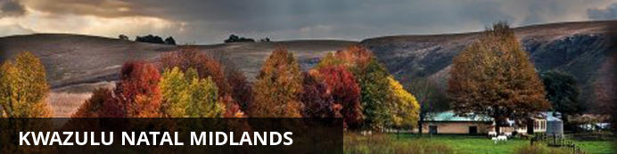
The KwaZulu Natal Midlands form the temperate zone between the subtropical coast and the Drakensberg Mountains. A favourite of the early colonial settlers their mark still remains in the names and the areas agricultural legacy.

Notes
After your breakfast you will be transferred to the airstrip for your scheduled light aircraft transfer to Kruger-Mpumalanga International Airport where you will board your connecting flight to Durban's King Shaka International Airport.
On arrival in Durban, you will be met and transferred by luxury car to Karkloof Safari Spa.
All guests benefit from a private guide and private game drive vehicle when choosing to visit Karkloof Safari Spa in Kwa-Zulu Natal. This further ensures that you have a relaxed and personalised experience that can be enjoyed at your own pace. With over 3500 hectares of vast and varied terrain to explore, Karkloof Safari Spa offers a safari experience like no other. Abundantly stocked with game including black and white Rhino, Buffalo, Hippo, Giraffe, Zebra, Wildebeest and a multitude of Antelope, Warthog and Monkeys, it is hard to believe that one is only 30 minutes from Pietermaritzburg.
Overnight on a fully inclusive basis at Karkloof Safari Spa for 4 nights

Overnight: Karkloof Safari Spa View iBrochure
Recently nominated Best Luxury Safari Spa in the World 2012.
Karkloof Safari Spa is a place of healing, inspiration and luxurious indulgence.
Surrounded by massive vistas of savannah plains, forests, Acacia trees, waterfalls and rivers, among herds of Rhino, Buffalo, Giraffe, Zebra, Wildebeest and other antelope.
The Spa is the centre of the Karkloof universe in this heavenly setting. Founded on traditional Thai beliefs and practices, the 17 sumptuous treatment rooms are embraced by the nurturing powers of nature, where water is the catalyst for the ultimate seduction of the senses.
Choose from a deliciously exotic list of pampering treatments, including a flotation room, saunas and steam rooms, a hydrotherapy open-air arena and an incomparable menu of wellness Thai Massages, some dating back to the 14th century.
- Karkloof Safari Spa has a unique payment structure and an original 36 hours a night guest-centric philosophy.
- You can check in at 8am and leave at 8pm the following day.
- You pay a once-off fee for the night, which includes UNLIMITED:
. Spa treatments
. Game Drives
. Every activity
. Every meal and every drink you enjoy during your stay (excluding French Champagne).
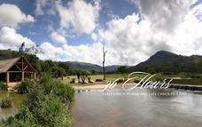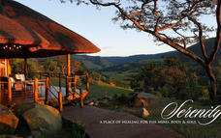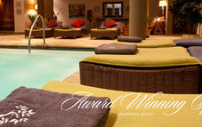

Included
Full Board

Day 10-14
Ellerman House, Cape Town

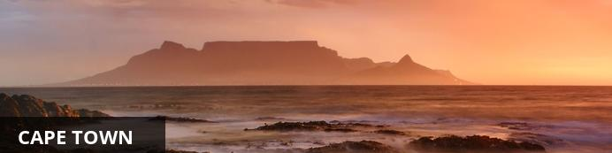
Cape Town is one of the world's most beautiful cities and a top international destination. Large numbers of tourists flock to Cape Town to enjoy this unique city with its fascinating history, interesting culture, natural beauty, award winning wines and laidback lifestyle. Whether you are a serious tourist or just want to lie on the beach and enjoy life, Cape Town will satisfy your needs.

Notes
After breakfast you will be transferred to Durban's King Shaka International Airport for your flight to Cape Town.
On arrival at Cape Town International Airport you will be met and transferred by luxury car to Ellerman House.
Spend your days relaxing or indulging in the multitude of optional activities Cape Town has to offer.
Overnight on a bed and breakfast basis at Ellerman House for 4 nights

Overnight: Ellerman House View iBrochure
With 13 rooms and suites, two ultra-modern villas and a tranquil spa, Ellerman House is the quintessential urban retreat for discerning luxury travellers wanting complete exclusivity and privacy in Cape Town. Located in Bantry Bay, the hotel offers spectacular Atlantic Ocean views and easy access to beaches and local attractions. Highlights include the owner’s extensive South African art collection and the Ellerman House Wine Gallery, offering an interactive wine experience amid a vast collection of South African vintage wines. Modern, locally inspired cuisine, generous-hearted hospitality and a tailor-made concierge service enhance a world-class guest experience that remains authentically South African.
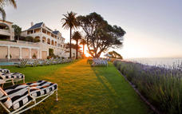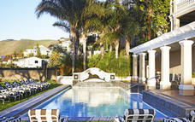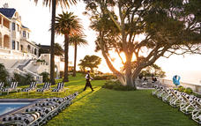

Included
Bed & Breakfast

Day 14
Departure

Day Notes
You will be transferred to Cape Town International Airport for your flight to Johannesburg and onward connecting flight to the USA.

Day 15: Travelling

Arrive in the United States at New York (JFK) airport.

Travel Information
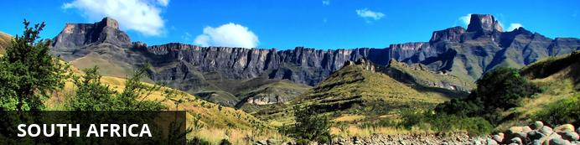
While wildlife safaris are reason enough to visit this exquisite country, South Africa offers even more to see and do. For one, the city of Cape Town is a jewel that is well worth visiting. Set against the iconic Table Mountain, C.T. offers lots to explore, including the V&A Waterfront, Chapman’s Peak, Boulders Penguin Colony and several beautiful beaches — just to give you an idea. Not to mention the delicious food and fabulous shopping, which can all be enjoyed at a favorable exchange rate.
One of the biggest attractions in the Western Cape is the towns of Stellenbosch, Paarl and Franschoek . Boasting some of the best wine tours in the world, they offer picturesque vineyards, fantastic art galleries and gourmet food.
Furthermore, South Africans are some of the most upbeat, welcoming and humorous people you’ll ever encounter. You will be exposed to different cultures, languages and traditions that will certainly enhance your experience.
With so much diversity, South Africa has something for everyone to enjoy!

Visa Regulations and Guidance
As for all international travel, the visitor to South Africa is required to be in possession of a valid passport. U.S. citizens (US passport holders) traveling to the Republic of South Africa for 90 days or less for tourism or business purposes do not need visas. U.S. green card holders (non-US passport holders) require visas to visit South Africa. Nationals of other countries must check the list of visa exempt countries to see if they need to apply for visas.
Please note that all foreigners who wish to visit South Africa must have a passport that is valid for at least 6 months after his/her intended return date. The passport must have a minimum of four blank (unstamped) visa pages in the passport to enter the country. It is preferred these are facing pages. Your international carrier can deny boarding if you do not have the blank (unstamped) visa pages. Travellers should make sure there are sufficient pages for visas and immigration stamps to enter into South Africa and other countries to be visited. These blank pages cannot be endorsement or amendment pages.
As a general precaution, all travellers are advised to carry a photocopy of the photo/bio information page of their passport and keep it in a location separate from their passport.

Banking and Currency
Currency
South Africa's currency is the Rand, which offers visitors great value for their money. The rand comes in a range of coins (R1 = 100 cents) and note denominations of R10, R20, R50, R100. With the exchange rate in your favor, you'll find South Africa offers great value.
It is advisable to exchange US Dollars into Rands upon arrival for tips and small purchases where credit cards are not normally used.
Exchanging large denominations of US Dollars at game lodges can be challenging so come prepared.
Banking
Banks are found in most towns, and are generally open from 09h00 to 15h30 on weekdays and 08h30 to 11h00 on Saturdays (Closed Sundays and Public Holidays). Most of them offer foreign exchange services - with cash, bank & credit cards as well as travellers cheques. You can also obtain cash from automatic teller machines (ATMs). Several international banks have branches in the main city centres. Always advise your bank that you are travelling outside of the country as they might block your purchases if they are not informed.

Travel, Transport and Getting Around
Travelling around South Africa is relatively easy by air, road and rail.
Principal air routes are serviced by SAA and British Airways, operated by Comair. There are 2 low-cost carriers on main routes, namely Kulula.com and Mango.
Facilitating travel around South Africa are 10 airports managed by the Airports Company South Africa (Acsa). In addition, there are some 90 regional airports, including the Kruger Mpumalanga International Airport in Nelspruit and the Skukuza Airport, offering access to the Kruger National Park.
An extensive tarred road system makes travelling in South Africa by vehicle convenient and easy. You will find gravel roads in rural areas though. Note:

Another means of getting around South Africa are luxury inter-city bus services such as Greyhound and Trans-Lux. Metrobus buses are available for in-city transport. Metered taxis must be ordered by telephone. There is a hop-on-hop-off bus in Cape Town and Johannesburg.
Our rail system includes the long-haul, inexpensive Shosholoza Meyl Metrorail trains. More luxurious options are the Blue Train, Premier Classe and the steam train Rovos Rail. There is also the new Gautrain rapid transit railway system in Gauteng Province which links Johannesburg, Pretoria, Ekhuruleni and OR Tambo International Airport.

Health / Medical Information
Many of the main tourist areas are malaria-free, so you need not worry at all. However, the Kruger National Park, the Lowveld of Mpumalanga and Limpopo, and the northern part of KwaZulu-Natal do pose a malaria risk in the summer months.
Many local people and some travelers do not take anti-malaria prophylaxis, but most health professionals recommend that you do. All guests must consult their own medical doctor or health authorities regarding the use of anti-malarial tablets prior to departure.
Whether you take oral prophylaxis or not, always use mosquito repellent, wear long pants, closed shoes, light long-sleeved shirts at night, and sleep under a mosquito net in endemic areas (the anopheles mosquito, which carries malaria, operates almost exclusively after dark). Mosquito repellent containing “deet” is best. It is advisable to avoid malarial areas if you are pregnant.

Safety Notices
If you have lost your passport or wallet, please contact the local police department and file a report. Once you have done this, contact one of South Africa’s U.S. Embassies or Consulates (located in Pretoria, Johannesburg, Cape Town, and Durban).
Contact Information:
Cape Town Consulate General
Telephone : (021) 702 - 7300
Email: americanscapetown@state.gov
Durban Consulate General
Telephone: (031) 305 – 7600
Email: consulardurban@state.gov
Johannesburg Consulate General
Telephone: (011) 290 - 3000
Email: consularjohannesburg@state.gov
Alternately, you can obtain information online at http://southafrica.usembassy.gov/.

Food, Drink and Cuisine Advice
Standards of hygiene in relation to food health and safety in South Africa, are generally high in hotels, restaurants, pubs and nightspots. Tap water in South Africa is safe to drink and cook with when taken from taps in urban areas. Not all tap water in rural areas is safe for consumption, so take precautions if necessary.
It is safe to eat fresh fruit, vegetables and salads, and put ice in your drinks. South Africa's fish, meat and chicken are of excellent quality, so there is no need to limit yourself when enjoying the local cuisine.
Restaurants are subject to South Africa's food safety control legislation, which is implemented by local government. Regulations include certification and regular inspections by health inspectors to ensure hygienic standards are maintained.
Street food is not as common in South Africa as it is in other countries, although vendors selling traditional snacks and meals can be found in city centres and townships. Food safety in such instances cannot always be guaranteed.

Climate and Weather
In the Western Cape, the average rainfall is highest in the winter months, while in other provinces, the average rainfall is highest during the summer. Overall South Africa enjoys a temperate and pleasant climate, with lovely warm sunny days most of the year. KwaZulu-Natal has a sub tropical climate with high humidity in Summer. The Southern Gauteng region has hot summers with occasional thundershowers and frosty winters, while the Eastern part of this region (known as the Lowveld) enjoys mild winters. The Cape interior and the Free State have similar weather conditions to the Southern Gauteng region. The Western Cape region has a Mediterranean climate with warm, dry summers and cold, wet winters.
Spring: September – October
Summer: November - February
Autumn: March – April
Winter: May – August

Clothing / Dress Recommendations
Summer
Bring clothes that are cool, light and comfortable because summer temperatures can get well into the 30 - 40 degree Celsius range in some areas.Also bring an umbrella or raincoat during summer as this is when most of the country gets its rain, but don't forget a swimming costume (bathing suit).
Winter
The winters are generally mild, comparing favourably with European summers. But there are days when temperatures dive, especially in high-lying areas such as the Drakensberg, so be prepared with jerseys and jackets. Cape Town gets its rain during the winter season so it’s advisable to bring rain gear along.
General
Always bring a hat, sunglasses and sunblock as the sun can be strong even in the winter months.
Walking shoes are a good idea all year-round, with warm socks in the winter.
If you are doing business in the country, business attire (suit and tie) is generally called for in the corporate sector, but media for example generally dress more casually.
For game viewing, a couple of neutral-toned items will be useful, but there's no need to go overboard. A good pair of walking shoes is also advisable.
For the evening, if you are dining at an upmarket restaurant or seeing a show, smart-casual attire is recommended.

Electricity and Plug Standards
The South African electricity supply is 220/230 volts AC 50 HZ. With a few exceptions (in deep rural areas) electricity is available almost everywhere. However, you will need to purchase or bring adapters for the outlets. You can purchase the adapters in many US stores, online, or from a store while in South Africa. Adapters are usually available on loan at major hotels in South Africa. Three to five star hotels usually have 110 volt outlets for electric shavers in bathrooms and often provide hair dryers and irons. An NW 4 plug with two prongs, 0.19 inches in diameter is required for compatibility.

