Exclusive Gourmet Experience
Cape Town - Franschhoek - Whale Coast - Sabi Sands Private Game Reserve
10 Days / 9 Nights
Date of Issue: July 14, 2016

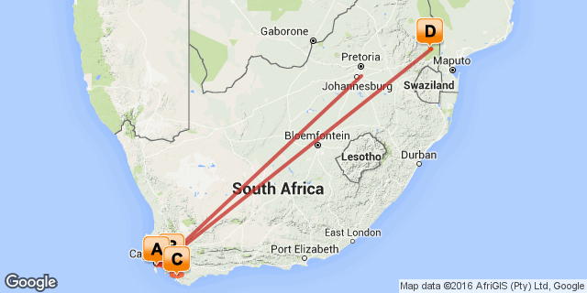

Click here to view your Digital Itinerary

Overview
This exclusive indulgence package entices travellers with the very best gourmet cuisine Cape Town has to offer...

Accommodation | Destination | Nights | Basis | Room Type
The Alphen Boutique Hotel | Cape Town | 2 | B&B
Le Quartier Français | Franschhoek | 1 | B&B
Mosaic Private Sanctuary - Lagoon Lodge | Whale Coast | 2 | FB+
Sabi Sabi Bush Lodge | Sabi Sands Private Game Reserve | 2 | FB+

Key
RO: Room only
SC: Self Catering
HB: Half Board
B&B: Bed and breakfast
D, B&B: Dinner, bed and breakfast
FB: Dinner, bed, breakfast and lunch
FB+: Dinner, bed, breakfast, lunch and activities daily
FI: Fully inclusive

Included
Round trip coach air on South African Airways from New York (JFK) or Washington (IAD) Airport to South Africa OR Tambo International Airport
Domestic coach air in South Africa as per the itinerary (Johannesburg - Cape Town – Skukuza - Johannesburg)
Accommodation as per the itinerary
Most meals (7 x breakfast, 6 x lunch, 7 x dinner)
Ground Transfers
All park fees and safari activities
Cape Peninsula Tour
Winelands Tour

Excluded
Add on air from other US cities
Any meals or services not mentioned above
Any items of personal expense - i.e. drinks, telephone calls, laundry etc
Gratuities for rangers/guides/drivers
wine pairing at Reuben's Restaurant

Day 1: Traveling

Depart from New York (JFK) or Washington Dulles (IAD) for your South African Airways flight to South Africa.

Day 2
The Alphen Boutique Hotel, Cape Town

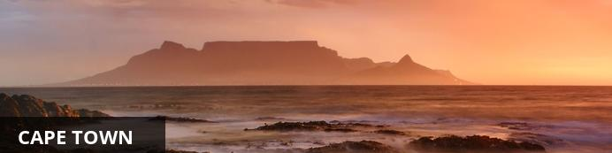
Resting at the confluence of the Indian and Atlantic Ocean, sandwiched between the slopes of the iconic Table Mountain and the glistening sapphire waters of Table Bay, the exceptionally scenic city of Cape Town is in a class of its own. Some cities boast rich culture, vibrant nightlife, a cosmopolitan atmosphere and extraordinary architecture, while others boast breathtaking landscapes and extraordinary natural wonders. Cape Town, is lucky enough to be blessed with all of these attractions and so much more. With its bustling harbour, world-class beaches, top-notch vineyards, and its mountainous surroundings brimming with diverse flora and fauna, Cape Town consistently captivates the hearts of all who visit.

Day Itinerary
On arrival in Johannesburg connect with your domestic flight to Cape Town where you will be met on arrival and transfered to your hotel.
Dinner tonight is at the 5 Rooms Restaurant
Overnight on a bed and breakfast basis at the Alphen Boutique Hotel

Activities
Dinner 5 ROOMS RESTAURANT

5 ROOMS RESTAURANT
with 4 Dining Rooms, Bar, Lounge & Terrace
Incorporating the Constantia Valley’s heritage into the menu, 5 Rooms presents cosmopolitan cuisine - a fusion of tastes, flavours & styles - not your typical hotel fine dining.
• Placed within the centuries old Manor House with
a warm, intimate atmosphere
• Dark, rich colours, heavy fabrics & dramatic décor
• Individually styled dining rooms
• Extensive food, wine, cocktail & liquor menus
• Champagne and wine served in Riedel crystal ware
• Seats 100 indoors, 60 outdoors
• Open for dinner Monday to Saturday from 6pm
• Sunday lunch from 12pm

Overnight: The Alphen Boutique Hotel View iBrochure
The Alphen Boutique Hotel offers a 5 star spread of elegant riches, swathed in history and splashed with flair & colour.
This 17th century historical treasure across 11.5 acres of wonderland gardens offers 19 indulgent avant-garde luxury suites, complete with modern amenities, plush comforts, high-tech facilities & exceptional service.
Located 15km's from Cape Town City Centre and golden beaches offer a culinary playground nestled in the timeless Constantia Valley in Cape Town, famed globally for wine routes and degustation.
3 unique on-site hospitality venues: la Belle Bistro & Bakery, The Rose Bar outdoor garden lounge and the 5 Rooms Restaurant.
The Alphen 5 star Boutique Hotel offers guests a full flavoured and authentic Western Cape culinary journey. With sister venues dotted across prime locations on the world famous Camps Bay strip and Clifton Beach, The Alphen Boutique Hotel ensures one is able to tap in and out of the very best Cape-Town has to offer.
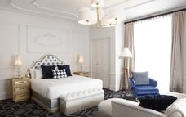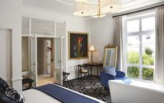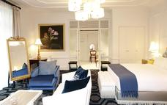

Included
Bed & Breakfast

Day 3
The Alphen Boutique Hotel, Cape Town

Day Itinerary
Over the next two days, you will explore and discover the scenic beauty of the Cape Peninsula and winelands of the Western Cape. You will taste the best of South African wine and food in an amazing variety of superb restaurants, a region which is an epicurean’s dream, given the availability of both fresh ingredients and spellbinding settings.
Today enjoy a tour of the Cape Peninsula, which allows visitors the opportunity to experience the variety of landscapes and scenery Cape Town has to offer. Experience the majestic beauty of the Atlantic seaboard and Chapman's Peak. Continue to the quaint fishing village of Hout Bay and visit Cape Point and the colony of Jackass penguins at Bouders Beach.
Lunch today is enjoyed at the Foodbarn, where the food is civilized without being pretentious ... that is to say it has natural taste, smells and textures, and much character... often it looks beautiful too! What is paramount is that it is prepared with respect, savvy and love.
This evening enjoy dinner at Constantia Uitsig's original Cape Dutch Homestead, which offers breathtaking views of the surrounding mountains and vineyards. Under the expert hand of Head Chef, Clayton Bell, Constanita Uitsig Restaurant has earned an international reputation for an elegant, yet relaxed atmosphere, promising a memorable dining experience.
Overnight on a bed and breakfast basis at the Alphen Boutique Hotel

Activities
Chapman's Peak
Cape Point Nature Reserve
Lunch Foodbarn
Boulders Penguin Colony
Dinner Constantia Uitsig

Chapman's Peak
Chapman’s Peak Drive winds it way between Noordhoek and Hout Bay. Situated on the Atlantic Coast, at the south-western tip of South Africa, it is one of the most spectacular marine drives anywhere in the world. The 9km route, with its 114 curves, skirts the rocky coastline of Chapman's Peak. The drive offers stunning 180° views with many areas along the route where you can stop and take in the scenery or sit down for a relaxing picnic.
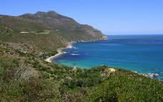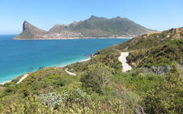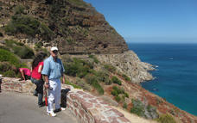

Cape Point Nature Reserve
Cape Point lies at the south-western tip of Africa and offers great views, a restaurant and a funicular which takes you up to the old lighthouse. The spectacular scenery coupled with zebras, baboons, deserted beaches and plenty of fynbos to make this one of the Cape’s must see destinations.
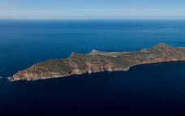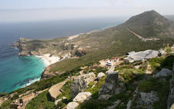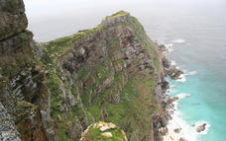

The Foodbarn Restaurant
At the Foodbarn Restaurant, we serve the food that Franck is famous for … delicious and decadent ‘fine-dining’ style food but in a super relaxed and characterful old barn.
At the Deli during the day, you are invited into our ‘home-from-home’ by the tantalizing aroma’s of the fresh bread and the best coffee in the Valley, the uber friendly and caring service, chef Lana’s delicious creations, and more.
At night the Deli is transformed into a delightful tapas bar serving inspired dishes with amazing textures and flavours.
Whichever Foodbarn you are in … we look forward to spoiling you.
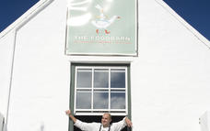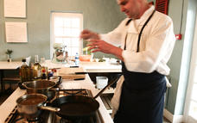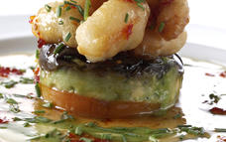

Boulders Penguin Colony
The Boulders Visitor Centre is home to the famous colony of Jackass Penguins, so called for their hilarious braying call. This is a truly special experience and Table Mountain National Park staff are knowledgeable and offer guided tours. After you have fallen in love with the penguins head to the secluded Boulders Beach and take a swim in the comparatively warm waters of the False Bay.
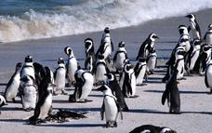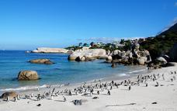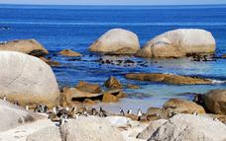

Constantia Uitsig
Constantia Uitsig, known until 1940 as Constantia View, was the home of the Lategan family for five generations. Their ancestors arrived in this country in 1735.
Constantia Uitsig had been a portion of Simon van der Stel’s original grant of Groot Constantia. In 1894 Willem Lategan married Antoinette Bredell of Schoemanshoek, and with her inheritance he built the present homestead of Constantia Uitsig.
In 1988 the farm was purchased by David and Marlene McCay. Together they have restored the farm to its former glory, and Constantia Uitsig now boasts award winning wines, three world-renowned restaurants, a private cricket oval, Spa and a 16-roomed luxury hotel. In 2006 fifty percent of the wine estate was bought by a consortium.
Just 20 minutes from the heart of the city, Constantia Uitsig is truly Cape Town’s own Vineyard. The breathtaking rural beauty of a valley, where vineyard rows stretch up the mountainside, is unique in today’s overcrowded world.

Included
Bed & Breakfast

Day 4
Le Quartier Français, Franschhoek

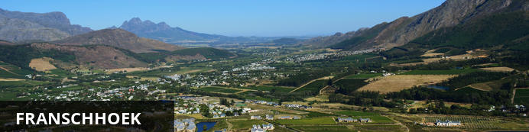
Idyllically situated in the Cape Winelands, this peaceful country retreat is one of the oldest towns in South Africa. The once sleepy little village was named Franschhoek, meaning “French Corner” as it was founded by French Huguenots who fled Europe and were seeking a secluded hide-out. They found it in the fertile valley of Franschhoek and this heritage is showcased at the fascinating Huguenot Memorial Museum. The Cape Dutch architecture in much of the village remains remarkably well preserved as restrictions have been placed on the extent of renovations and new construction in order to preserve the spirit of the original settlers. The town’s proximity to Cape Town allows for pleasant day trips during which visitors can explore the area’s many world-class wine estates and impressive range of excellent restaurants or simply browse the quaint, upmarket boutiques strewn along the town’s lovely tree-lined avenues.

Day Itinerary
Today depart on a full day tour of the Winelands.
Here you get to taste the good life! The marriage of fine wine with appropriately fine food is an indescribable experience. You will enjoy wine tasting at two specially selected wine estates and lunch in the winelands.
In the late afternoon, make your way to Franschoek for your overnight.
In The Tasting Room the journey extends further than just phenomenal cuisine; it moves fearlessly into the captivating realm of stories and magic. A place where each plate, and its African inspired elements, have the ability to captivate the hearts and minds of diners.
Overnight on a bed and breakfast basis at Le Quartier Français

Activities
Paarl Wine Region
Stellenbosch
Lunch Governor's Hall Restaurant
Franschhoek
Dinner The Tasting Room

Paarl Wine Region
One of the Western Cape’s premier wine regions, Paarl is home to a number of well-respected wine producers, including KWV, Laborie, Nederburg, Fairview and Plaisir de Merle.
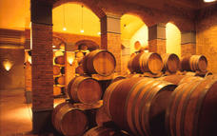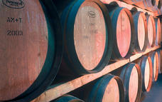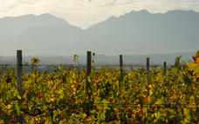

Stellenbosch
A blend of historical architecture, student life, epicurean delights and oak-lined avenues, Stellenbosch is a picturesque university town surrounded by mountains and vineyards. A walking tour of the town centre allows visitors to take in its beautifully preserved Cape Dutch and Victorian architecture, as well as the many enticing art galleries, craft shops, clothing boutiques and gift stores, while foodies may prefer indulging in mouth-watering cuisine and fine wines at one of the chic restaurants or buzzing bistros. Stellenbosch is also the ideal base from which to explore the renowned local wine route, boasting a high proportion of the country’s leading wine estates.
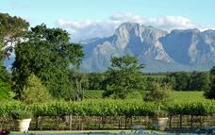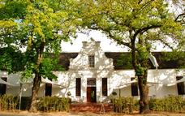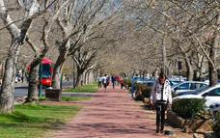

Governor's Hall Restaurant
The well-renowned chef Stephen Fraser, of Welsh decent, decided to expand his horizon by joining The Lanzerac Hotel as the Executive Chef. This young go-getter has travelled the globe, cooking up a culinary storm at some of the finest 5 star hotels in the world. Some of the patrons who have enjoyed the honour of sampling his delicious food include celebrities as Sir Sean Connery, David and Victoria Beckham, Gordon Ramsay and Calvin Klein.
All the experience he gathered over the years, has prepared him to enter a life and atmosphere of old world charm, and marry it with his food, which is young, hip and vibrant. His youth, zest for life and passion can be seen in the food and creations sent to the table. From starter to dessert, your taste buds are tantalized by every bite.
Whether you seek a relaxed picnic underneath the old oak trees, an alfresco lunch on the shaded Terrace, a fine dining experience in the elegant Governors Hall Restaurant or sophisticated drinks at the chic Esquire Bar Lounge, the Lanzerac Hotel offers the perfect setting, views and cuisine for any occasion.
Come and experience our chef’s culinary genius and 5 star service – all in the perfect location of the Winelands.
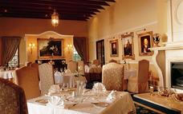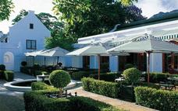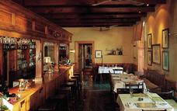

Franschhoek
Idyllically situated in the Cape Winelands, this peaceful country retreat is one of the oldest towns in South Africa. The once sleepy little village was named Franschhoek, meaning “French Corner” as it was founded by French Huguenots who fled Europe and were seeking a secluded hide-out. They found it in the fertile valley of Franschhoek and this heritage is showcased at the fascinating Huguenot Memorial Museum. The Cape Dutch architecture in much of the village remains remarkably well preserved as restrictions have been placed on the extent of renovations and new construction in order to preserve the spirit of the original settlers. The town’s proximity to Cape Town allows for pleasant day trips during which visitors can explore the area’s many world-class wine estates and impressive range of excellent restaurants or simply browse the quaint, upmarket boutiques strewn along the town’s lovely tree-lined avenues.
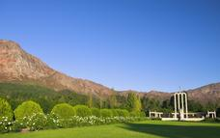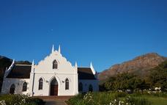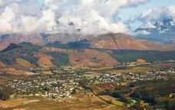

The Tasting Room
The Tasting Room at Le Quartier Français is South Africa's most lauded fine-dining restaurant. It is the stage to award-winning Chef, Margot Janse, and her unique African Inspired Surprise Tasting Menu.
Here, in this intimate setting, serious diners have the opportunity to experience a true journey of taste. With a menu that continues to evolve and astonish The Tasting Room, and its African Inspired cuisine, creates a dining experience unlike any other. One where surprise and nostalgia take centre stage.
In The Tasting Room every African Inspired dish is exceptional and engaging. Truly refined with a distinct feminine touch and, at the same time, unexpectedly exciting ... exhilarating in fact. It is this contradiction that results in The Tasting Room menu's outstanding balance and ensures that the cuisine is nothing short of a theatrical masterpiece.
In The Tasting Room the journey extends further than just phenomenal cuisine; it moves fearlessly into the captivating realm of stories and magic. A place where each plate, and its African inspired elements, have the ability to captivate the hearts and minds of diners.
THE TASTING ROOM IS OPEN TUESDAY TO SATURDAY EVENINGS ONLY
The Tasting Room’s Guiding Principles:
Please allow 3½ hours for this menu.
We do not have a dress code, you dress for the experience you want to have.
We are a mobile free zone, for your enjoyment and diners around you.
We have kicked the habit – we are now totally non-smoking inside and outside, but have a dedicated smoking section on our front terrace.
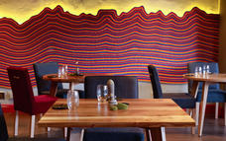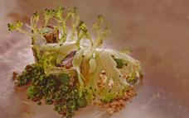

Overnight: Le Quartier Français View iBrochure
Le Quartier Français, part of Leeu Collection, is situated in the heart of the Franschhoek Wine Valley. Guests can either relax in the tranquil gardens or walk out of the hotel into the main road with its array of delightful shops and galleries; a perfect base from which to explore the Wine lands.
The essence of Le Quartier Français is its vibrant decor - fun and locally sourced. With 5 room types, it offers spacious comfortable Auberge Rooms to Grande Rooms with high ceilings and oversized chairs. Followed by the Petite Garden Suites with their private courtyards leading up to the Pool and House Suites that feature their own gardens with swimming pools and then the extra-large Four Quarters Suites, which leave nothing to be desired.
Families are catered for in the Pool and House suites offering complimentary loft rooms for children with their own amenities; we treat them like VIK's (very important kids!)!
Home to two restaurants, award winning "The Tasting Room" (having featured in the top 50 restaurants in the world) and The Living Room, Le Quartier Français is a gourmet destination.
The Tasting Room is the stage to Chef Margot Janse's unique African inspired, surprise Tasting Menu. In the eclectic setting, serious diners have the opportunity to experience a menu that continues to evolve and astonish the biggest critics.
Open for dinners only, Tuesday through to Saturday.
In the Living Room, breakfast is served until late morning after which a menu packed full of lip smacking tapas designed to serve as small bites or the building blocks of a more substantial meal is served.
Guests have the opportunity to mingle with the locals in the onsite Mullineux & Leeu Family Wines Screening Room (the only movie house in town) featuring some of the latest movies, or choose a classic from our library of over 200 DVD’s and book this 30 seater cinema for their private use. Also on offer at Le Quartier Français is B.Gorgeous – our hair, beauty and shopping emporium. Here guests can browse through the boutique for the perfect gift or spend some time being pampered in the spa
A morning could also be spent giving back to Isabelo. Isabelo is a feeding scheme started by Margot Janse, where originally Le Quartier Français, along with the help of a dietician, baked a muffin that would supply all the vitamins needed for a school day. Due to the generosity of our guests and fans of Le Quartier Français, Margot along with her brigade from The Tasting Room, are now able to cook a healthy meal for 130 children each day of the school week straight from The Tasting Room kitchen. Each morning our team delivers the food to our three crèches and guests are more than welcome to join us in delivering the meals and spoiling these children for a few precious moments.
It is the extra- ordinary staff; the opulently comfortable rooms and the attention to detail that ensure that this Auberge is the ultimate spoiling.
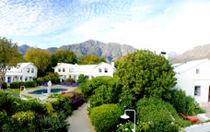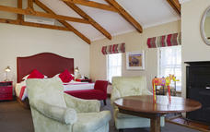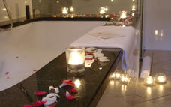

Included
Bed & Breakfast

Day 5
Mosaic Private Sanctuary - Lagoon Lodge, Whale Coast

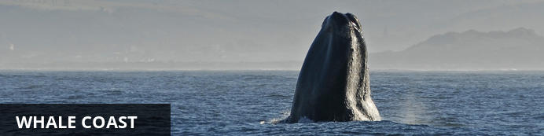
This rugged stretch of South African coastline snakes along the Atlantic Ocean, with magnificent mountains rising up on the other side. The spectacular scenery is made up of charming seaside villages, farms, rivers, coves and valleys, and during the right season, the region’s namesake – whales – can be seen cruising and wallowing in the coastal waters.

Day Itinerary
Travel along the dramatic Cape coastline to Hermanus, for arguably the best shore-based whale watching in the world and the chance to see a magnificent Southern Right Whale breaching.
Overnight on a full board basis at Mosaic Private Sanctuary

Overnight: Mosaic Private Sanctuary - Lagoon Lodge View iBrochure
On the Water + By the Sea + Magnificent Mountain Views. Place yourself between ocean, lagoon and glistening mountains and you will arrive at Mosaic, a secluded gem on the famous Whale Coast, 2 hours SE of Cape Town, South Africa.
For the ultimate private getaway, Lagoon Lodge captures the essence of tranquility with just five safari style suites woven into an ancient milkwood grove on the edge of the Hermanus Lagoon. A pampered stay here is all-inclusive of meals, adventure activities and house beverages/wine/beer/spirits. Fabulous massage, skin and nail treatments can be indulged in at the Mosaic Spa (either indoor or outdoor), using organic Rain Africa products (additional charges apply).
Mosaic offers the most multifaceted experience in the area with 1000 hectares of conservation land on the beautiful Hermanus Lagoon. Activities at Mosaic include being immersed in awesome fynbos flowers and bird-life of the Cape Floral Kingdom, lagoon cruises, stunning beaches, fascinating marine life and some of the world’s most beautiful wine lands. This is topped off with warm smiling staff serving fresh cuisine paired with delicious South African wine. Mosaic is centrally located to whale watching, marine tours, shark cage diving and exploring the Overberg Wine Region. It is the perfect location for nature and activity lovers.
At Lagoon Lodge, stone and glass walls open onto private decks for spectacular mountain views and bird watching. Soft bedding lies beneath romantic netting where one falls asleep listing to owls and wakes up to the sound of the African Fish Eagle. Each room has a bathtub large enough for two and a private outdoor shower for an African bush experience. Lagoon Lodge has only five chalets beautifully built safari style with stone and thatch harvested from Mosaic. A king bed or two twins can be accommodated. Rooms include pure linen & cotton towels, organic Rain bath amenities, ultra soft bathrobes, coffee plunger, bar refrigerator, wine, sherry and fireplace.
Boardwalks under a canopy of ancient Milkwood trees lead to the lounge where drinks and meals are shared outdoors or by a fireplace that will warm your soul. A heated plunge pool overlooking the mountains is a favorite place to spot favorite water birds. And as evening falls, exquisite colors of the sun setting over the lagoon and the glorious expanse of the star-filled South African sky are witnessed.
The cuisine at Mosaic is fresh, delicious and the creative mastery of our chef, our baker, our gardener, and local producers. Breakfast is a hearty fare with freshly baked muffins, homemade jams, fresh fruit and a hot meal. Lunch is served gourmet picnic style outdoors or around blazing fires when there is a chill in the air, at the Lagoon Cafe in the historic 1892 Spookhuis. Sumptuous dinners are prepared by our chef and built around organic vegetables from our garden and local seasonal ingredients…and best paired with fine South African wine from the Mosaic cellar!
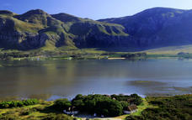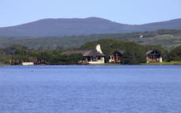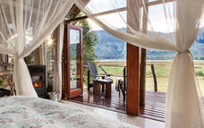

Included
Full Board and Activities

Day 6
Mosaic Private Sanctuary - Lagoon Lodge, Whale Coast

Day Itinerary
Spend the day taking part on one of the many activities available at Mosaic Sanctuary
Overnight on a full board basis at Mosaic Private Sanctuary

Optional
4x4 Beach Excursions
Quad Biking
Boat Cruise on the Lagoon
Kayaking on the Lagoon
Guided Nature Walk
Bird Watching

4x4 Beach Excursions
LOCATION sets Mosaic apart from all others, with Walker Bay next door. From Lagoon Lodge, hop onto an open 4x4 vehicle and discover fynbos, birds and the pristine Walker Bay Beach and Nature Reserve and enjoy beautiful sunsets over the ocean. Canapes and beverages are enjoyed while watching for sights of fascinating marine life.
Between June and December, Southern Right Whales migrate from Antarctica to the shelter of Walker Bay to court, mate and calf. Whales can be viewed from the top of sand dunes while sipping a favorite drink. September through November is the height of whale season.
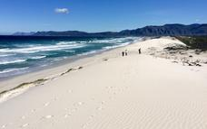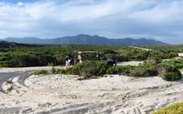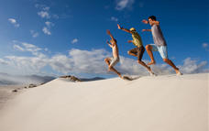

Quad Biking
Guided quad-bike tours will take you exploring through fynbos clad hills, lagoon wetlands and spotting fantastic birds. Ride along the edge of the lagoon or up to high points on Mosaic with 360-degree views of the ocean, lagoon, and mountains. Mosaic's professional guides make the intricacies of creation come alive.
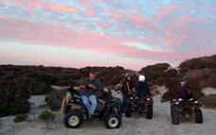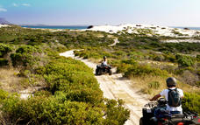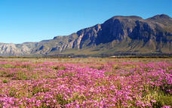

Boat Cruise on the Lagoon
Board the "Spirit of Agnus" from the shores of Mosaic on the Hermanus Lagoon for an excursion among water birds and the towering Overberg Mountains. The cruise goes to a bird sanctuary that is part of Mosaic (in front of Lagoon Lodge), or to the mouth of the lagoon where it opens into the Atlantic Ocean. Drinks and snacks are enjoyed while cruising.
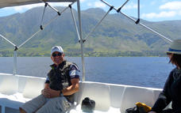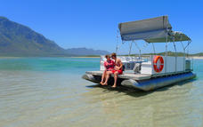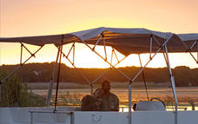

Kayaking on the Lagoon
Glide in a kayak on the lagoon to encounter the stunning blue cranes and water birds in the natural wetland at Mosaic, which is a proclaimed bird sanctuary. Or kayak to the mouth of the lagoon to the beautiful white sand of Grotto Beach.
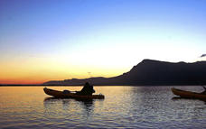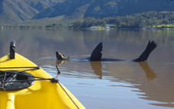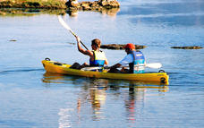

Guided Nature Walk
The Cape Floral Kingdom is a true wonder of the world, having the richest density of plant species on earth ∙ 8,600 with almost 6,000 occurring nowhere else on earth. Fynbos, Afrikaans for “fine bush”, is the unique type of vegetation that formed millions of years ago from ashes of drought-stressed forests. You will be guided along the lagoon edge and wetlands to discover intricate plant-animal relationships and the importance of conserving this unique floral kingdom.
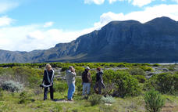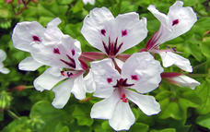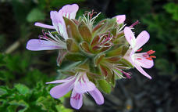

Bird Watching
Whether bird watching from a private deck or on a guided walk or quad bike trip, the birds at Mosaic delight enthusiasts. Over 140 bird species are home to Mosaic. Water birds along the shoreline are as numerous as the species that are found on fynbos covered limestone ridges. Blue cranes nest in the bird sanctuary at Lagoon Lodge, flamingos traverse the lagoon is mass, pied kingfishers can be watched hunting for food and owls are spotted day and night. Check out our full list of birds.
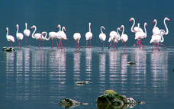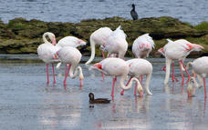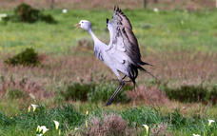

Included
Full Board and Activities

Day 7-9
Sabi Sabi Bush Lodge, Sabi Sands Private Game Reserve

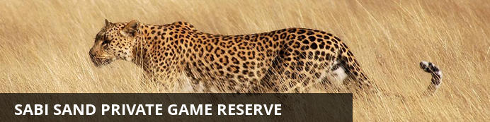
The Sabi Sands is South Africa's premier private game viewing destination. It was here that the southern African safari began and today this famous reserve offers exceptional game viewing and equally exceptional accommodations. Two perennial rivers, the Sabi and the Sand flow through this Game Park, sustaining the diverse fauna and flora of the area.
The success of leopard viewing within the Sabi Sands is legendary. Elephants, lion, rhino, buffalo, cheetah, giraffe, zebra and a vast variety of antelope and other species can be closely observed in their natural environment.

Notes
After breakfast, transfer to Cape Town International Airport for your flight to Skukuza. On arrival, you will be met and transferred to your lodge where you will spend the next 2 nights on safari at Sabi Sabi Private Game Reserve.
Overnight on a full board basis at Sabi Sabi Bush Lodge

Overnight: Sabi Sabi Bush Lodge View iBrochure
Deep in the bushveld overlooking a waterhole and an open plain, lies a lodge that pulses to the rhythm of Africa’s heartbeat. Bush Lodge has earned a reputation of a “luxury home in the bush”, service excellence, personalised attention and offers an unrivalled 5-Star family safari.
Each stunning air-conditioned suite features sumptuous linens and fabrics, beautiful leather and wood furnishings, and an en-suite glass fronted bathroom with indoor and al-fresco shower leading onto a private patio.
Families with children of all ages are welcome and well-catered for at Bush Lodge and at the EleFun Centre where fun and games with trained caregivers are aimed at nurturing a deeper understanding and love for the surrounding bush.
There is ample space to relax, unwind and savour the tranquility of the bush. The two swimming pools and enormous covered viewing decks overhanging the Msuthlu riverbed are an invitation to cool off in the filtered water or sit in comfort while spotting game at the nearby pan. An exquisitely furnished lounge, atrium and intimate bar area are perfect meeting places for friends old and new. As an extra indulgence, the Amani Spa at Bush Lodge offers the ultimate African spa experience.
Sabi Sabi is home to an astonishing variety of wildlife - including over 200 mammal and 300 bird species. Morning and evening safaris are enjoyed in open safari vehicles where close encounters with the Big 5 are a regular occurrence.
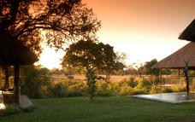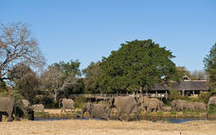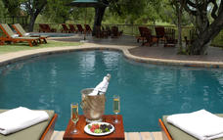

Included
Full Board and Activities
Drinks (Local Brands) Included

Day 9
Departure

Day Itinerary
After breakfast, transfer to Skukuza Airport for your flight to Johannesburg and onwards connection to the United States.

Day 10: Traveling

Arrival in the United States at New York (JFK) or Washington Dulles (IAD) airports.

Travel Information
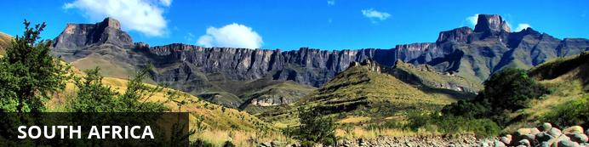
While wildlife safaris are reason enough to visit this exquisite country, South Africa offers even more to see and do. For one, the city of Cape Town is a jewel that is well worth visiting. Set against the iconic Table Mountain, C.T. offers lots to explore, including the V&A Waterfront, Chapman’s Peak, Boulders Penguin Colony and several beautiful beaches — just to give you an idea. Not to mention the delicious food and fabulous shopping, which can all be enjoyed at a favorable exchange rate.
One of the biggest attractions in the Western Cape is the towns of Stellenbosch, Paarl and Franschoek . Boasting some of the best wine tours in the world, they offer picturesque vineyards, fantastic art galleries and gourmet food.
Furthermore, South Africans are some of the most upbeat, welcoming and humorous people you’ll ever encounter. You will be exposed to different cultures, languages and traditions that will certainly enhance your experience.
With so much diversity, South Africa has something for everyone to enjoy!

Visa Regulations and Guidance
As for all international travel, the visitor to South Africa is required to be in possession of a valid passport. U.S. citizens (US passport holders) traveling to the Republic of South Africa for 90 days or less for tourism or business purposes do not need visas. U.S. green card holders (non-US passport holders) require visas to visit South Africa. Nationals of other countries must check the list of visa exempt countries to see if they need to apply for visas.
Please note that all foreigners who wish to visit South Africa must have a passport that is valid for at least 6 months after his/her intended return date. The passport must have a minimum of four blank (unstamped) visa pages in the passport to enter the country. It is preferred these are facing pages. Your international carrier can deny boarding if you do not have the blank (unstamped) visa pages. Travellers should make sure there are sufficient pages for visas and immigration stamps to enter into South Africa and other countries to be visited. These blank pages cannot be endorsement or amendment pages.
As a general precaution, all travellers are advised to carry a photocopy of the photo/bio information page of their passport and keep it in a location separate from their passport.

Banking and Currency
Currency
South Africa's currency is the Rand, which offers visitors great value for their money. The rand comes in a range of coins (R1 = 100 cents) and note denominations of R10, R20, R50, R100. With the exchange rate in your favor, you'll find South Africa offers great value.
It is advisable to exchange US Dollars into Rands upon arrival for tips and small purchases where credit cards are not normally used.
Exchanging large denominations of US Dollars at game lodges can be challenging so come prepared.
Banking
Banks are found in most towns, and are generally open from 09h00 to 15h30 on weekdays and 08h30 to 11h00 on Saturdays (Closed Sundays and Public Holidays). Most of them offer foreign exchange services - with cash, bank & credit cards as well as travellers cheques. You can also obtain cash from automatic teller machines (ATMs). Several international banks have branches in the main city centres. Always advise your bank that you are travelling outside of the country as they might block your purchases if they are not informed.

Travel, Transport and Getting Around
Travelling around South Africa is relatively easy by air, road and rail.
Principal air routes are serviced by SAA and British Airways, operated by Comair. There are 2 low-cost carriers on main routes, namely Kulula.com and Mango.
Facilitating travel around South Africa are 10 airports managed by the Airports Company South Africa (Acsa). In addition, there are some 90 regional airports, including the Kruger Mpumalanga International Airport in Nelspruit and the Skukuza Airport, offering access to the Kruger National Park.
An extensive tarred road system makes travelling in South Africa by vehicle convenient and easy. You will find gravel roads in rural areas though. Note:

Another means of getting around South Africa are luxury inter-city bus services such as Greyhound and Trans-Lux. Metrobus buses are available for in-city transport. Metered taxis must be ordered by telephone. There is a hop-on-hop-off bus in Cape Town and Johannesburg.
Our rail system includes the long-haul, inexpensive Shosholoza Meyl Metrorail trains. More luxurious options are the Blue Train, Premier Classe and the steam train Rovos Rail. There is also the new Gautrain rapid transit railway system in Gauteng Province which links Johannesburg, Pretoria, Ekhuruleni and OR Tambo International Airport.

Health / Medical Information
Many of the main tourist areas are malaria-free, so you need not worry at all. However, the Kruger National Park, the Lowveld of Mpumalanga and Limpopo, and the northern part of KwaZulu-Natal do pose a malaria risk in the summer months.
Many local people and some travelers do not take anti-malaria prophylaxis, but most health professionals recommend that you do. All guests must consult their own medical doctor or health authorities regarding the use of anti-malarial tablets prior to departure.
Whether you take oral prophylaxis or not, always use mosquito repellent, wear long pants, closed shoes, light long-sleeved shirts at night, and sleep under a mosquito net in endemic areas (the anopheles mosquito, which carries malaria, operates almost exclusively after dark). Mosquito repellent containing “deet” is best. It is advisable to avoid malarial areas if you are pregnant.

Safety Notices
If you have lost your passport or wallet, please contact the local police department and file a report. Once you have done this, contact one of South Africa’s U.S. Embassies or Consulates (located in Pretoria, Johannesburg, Cape Town, and Durban).
Contact Information:
Cape Town Consulate General
Telephone : (021) 702 - 7300
Email: americanscapetown@state.gov
Durban Consulate General
Telephone: (031) 305 – 7600
Email: consulardurban@state.gov
Johannesburg Consulate General
Telephone: (011) 290 - 3000
Email: consularjohannesburg@state.gov
Alternately, you can obtain information online at http://southafrica.usembassy.gov/.

Food, Drink and Cuisine Advice
Standards of hygiene in relation to food health and safety in South Africa, are generally high in hotels, restaurants, pubs and nightspots. Tap water in South Africa is safe to drink and cook with when taken from taps in urban areas. Not all tap water in rural areas is safe for consumption, so take precautions if necessary.
It is safe to eat fresh fruit, vegetables and salads, and put ice in your drinks. South Africa's fish, meat and chicken are of excellent quality, so there is no need to limit yourself when enjoying the local cuisine.
Restaurants are subject to South Africa's food safety control legislation, which is implemented by local government. Regulations include certification and regular inspections by health inspectors to ensure hygienic standards are maintained.
Street food is not as common in South Africa as it is in other countries, although vendors selling traditional snacks and meals can be found in city centres and townships. Food safety in such instances cannot always be guaranteed.

Climate and Weather
In the Western Cape, the average rainfall is highest in the winter months, while in other provinces, the average rainfall is highest during the summer. Overall South Africa enjoys a temperate and pleasant climate, with lovely warm sunny days most of the year. KwaZulu-Natal has a sub tropical climate with high humidity in Summer. The Southern Gauteng region has hot summers with occasional thundershowers and frosty winters, while the Eastern part of this region (known as the Lowveld) enjoys mild winters. The Cape interior and the Free State have similar weather conditions to the Southern Gauteng region. The Western Cape region has a Mediterranean climate with warm, dry summers and cold, wet winters.
Spring: September – October
Summer: November - February
Autumn: March – April
Winter: May – August

Clothing / Dress Recommendations
Summer
Bring clothes that are cool, light and comfortable because summer temperatures can get well into the 30 - 40 degree Celsius range in some areas.Also bring an umbrella or raincoat during summer as this is when most of the country gets its rain, but don't forget a swimming costume (bathing suit).
Winter
The winters are generally mild, comparing favourably with European summers. But there are days when temperatures dive, especially in high-lying areas such as the Drakensberg, so be prepared with jerseys and jackets. Cape Town gets its rain during the winter season so it’s advisable to bring rain gear along.
General
Always bring a hat, sunglasses and sunblock as the sun can be strong even in the winter months.
Walking shoes are a good idea all year-round, with warm socks in the winter.
If you are doing business in the country, business attire (suit and tie) is generally called for in the corporate sector, but media for example generally dress more casually.
For game viewing, a couple of neutral-toned items will be useful, but there's no need to go overboard. A good pair of walking shoes is also advisable.
For the evening, if you are dining at an upmarket restaurant or seeing a show, smart-casual attire is recommended.

Electricity and Plug Standards
The South African electricity supply is 220/230 volts AC 50 HZ. With a few exceptions (in deep rural areas) electricity is available almost everywhere. However, you will need to purchase or bring adapters for the outlets. You can purchase the adapters in many US stores, online, or from a store while in South Africa. Adapters are usually available on loan at major hotels in South Africa. Three to five star hotels usually have 110 volt outlets for electric shavers in bathrooms and often provide hair dryers and irons. An NW 4 plug with two prongs, 0.19 inches in diameter is required for compatibility.

