Affordable Botswana
Moremi Game Reserve - Okavango Delta - Savute - Chobe National Park
9 Days / 8 Nights
0 Persons
Date of Issue: October 23, 2015

Click here to view your Digital Itinerary

Overview
Spend 6 nights in Botswana covering the country's most celebrated game viewing destinations, the Okavango Delta, the Moremi Game Reserve and Savute in the Chobe Game Reserve.

Destination | Accommodation | Nights | Basis | Room Type
Moremi Game Reserve | Camp Moremi | 2
Okavango Delta | Xugana Island Lodge | 2
Savute - Chobe National Park | Savute Safari Lodge | 2

Key
RO: Room only
SC: Self Catering
HB: Half Board
B&B: Bed and breakfast
D, B&B: Dinner, bed and breakfast
FB: Dinner, bed, breakfast and lunch
FB+: Dinner, bed, breakfast, lunch and activities daily
FI: Fully inclusive

Included
Round trip coach air on South African Airways from New York (JFK) or Washington(IAD) Airport to South Africa OR Tambo International AirportRegional coach air from Johannesburg - Maun - JohannesburgSeat in charter flights from Maun - Camp Moremi - Camp Okavango - Savute - MaunAccommodation as per the itineraryMeals as per the itinerary (6 x breakfast, 6 x lunch, 6 x dinner)Local drinks on safari (excludes premium brands)All safari activities as per the itineraryAll park fees

Excluded
Add on air from other US citiesAny meals or services not mentioned aboveAny items of personal expense - i.e. drinks (except as mentioned above), telephone calls, laundry etcGratuities for rangers/guides/drivers

Day 1: Travelling

Travelling

Day 2Camp Moremi, Moremi Game Reserve

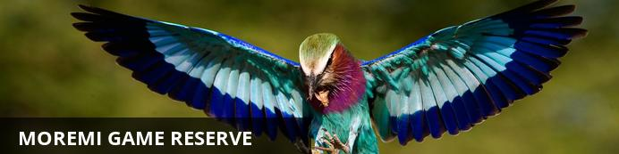
The amazing foresight of Chief Moremi created one of the world's most famous reserves, conserving part of the Okavango Delta and the plains to its east. The reserve covers more than 4871 square kilometres of pristine wilderness, and the varied terrain includes savannah, winding waterways, and thick forest.This diversity supports an incredibly wide spectrum of wildlife, ranging from large herds of buffalo, wildebeest and zebra, to the rare sitatunga and lechwe antelope, and lion, cheetah and packs of wild dog in the open grasslands. The birdlife is prolific and includes most of the 550 bird species recorded on the Botswana national bird list. A range of luxury lodges in the reserve offer visitors the perfect base to experience this corner of paradise.

Day Notes
On arrival at Johannesburg International Airport, connect with your onward flight on South African Airways to Maun in Botswana. You will be met on arrival at Maun Airport by the Desert & Delta representative. Leaving Maun behind, you will head to the Moremi Game Reserve where you will spend the first 2 nights of your vacation. Check in at the lodge and refresh before departing on an afternoon / evening game drive. You will return in time for dinner.

Overnight: Camp Moremi View iBrochure
Peering out beneath giant ebony trees, Camp Moremi brings true meaning to the word safari in the Xaxanaka area of the Moremi Game Reserve. Game drives in open 4x4 vehicles, both in the morning and late afternoons, offer frequent sightings of lion, leopard and cheetah as well as wild dog. Alternatively, guest can explore the Xaxanaka Lagoon and surrounding Okavango channels by motorboat.
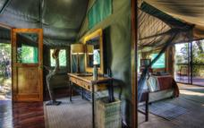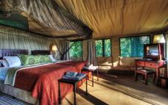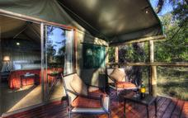

Day 3Camp Moremi, Moremi Game Reserve

Day Notes
Enjoy full day of game viewing at Camp Moremi. Game drives are conducted in open 4x4 vehicles, both in the morning and late afternoons. Moremi Game Reserve covers a sizeable portion of the Okavango Delta and is considered by many as Africa’s most beautiful wildlife sanctuary. Established by the Tawana people to protect the wildlife that was being decimated by hunters,making the reserve unique in Africa. Named after the Tawana chief Moremi, the reserve today consists of a wide variety of habitats that support one of Africa’s greatest concentrations of wildlife including one of the largest populations of the endangered wild dogs in Africa

Day 4-6Xugana Island Lodge, Okavango Delta

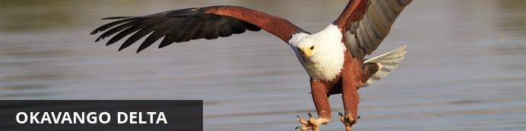
Lying in the middle of the largest expanse of sand on earth the Okavango Delta is one of Africa’s most amazing, sensitive and complex environments supporting a spectacle of wilderness and wildlife. Unique as one of the world’s few inland deltas, the placid waters and lush indigenous forests offer a safe haven for innumerable bird and wildlife species. The Okavango Delta offers a number of activities for the visitor; game viewing, birding and fishing are all on offer. One can experience this magical world of islands and waterways from land, air and water.
Highlights include the elusive Sitatunga antelope which has found refuge in this pristine wetland ecosystem, while birds such as the African fish eagle, Pel's fishing owl and many others provide a spectacular display.

Overnight: Xugana Island Lodge View iBrochure
Xugana Lagoon is widely accepted as being the most spectacular permanent water site in the entire Okavango Delta. Xugana Island Lodge, situated on a wooded island abutting the lagoon, takes full advantage of this magnificent site. The thatched common area, comprising cocktail bar, lounge and curio shop, is still the original building put up in 1974, when Xugana became only the second tourist lodge ever built in the Okavango Delta. Meals, for which the lodge is justly famous, are taken alfresco on the edge of the lagoon, except on those rare occasions of rain when the lounge doubles as the dining-room. Tea is often served in the garden inside the island, where quiet, secluded reading benches can also be found.Mokoro trips in eco-friendly dugout canoes built to the traditional design, boat safaris to lagoons and islands and wilderness walks give guests the chance to see the Delta denizens such as sitatunga and lechwe antelope, crocodile and hippo, as well as the other big game that frequents the islands and riverine fringes. Bird-watching opportunities are outstanding, and the bream and tiger fishing can be excellent at certain times of the year. The peaceful boat ride back across Xugana Lagoon during the spectacular African sunset provides a lifelong memory. All activities are conducted by our experienced naturalist guides, who, as well as ensuring that guests come to no harm, are keen to impart their vast knowledge and love of this unique area.
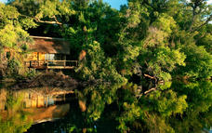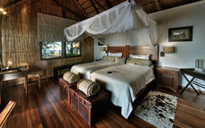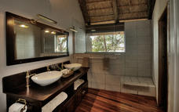

Alternate: Camp Okavango View iBrochure
Enchanting Camp Okavango sits at the heart of the Okavango Delta on Nxaragha Island. Its main lodge features a cocktail bar, sitting area and wildlife reference library, with the dining room leading onto an expansive open-air patio where evenings around the fire can be enjoyed. Other facilities include a secluded bird-viewing hide and sundeck with plunge pool. Accommodating just 24 guests in custom African-style safari tents on raised teak platforms, Camp Okavango offers guests en-suite facilities and private viewing decks. For guests who demand the ultimate in exclusivity, Camp Okavango has the Okavango Suite, a thatched cottage offering complete privacy.All game-viewing activities are conducted by experienced guides and include exploring the Okavango Delta by mokoro or motorboat and tracking the larger game species on guided nature walks on the many surrounding islands.
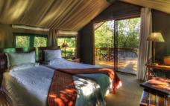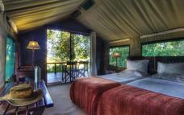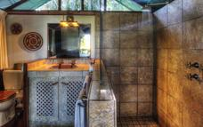

Day 6Savute Safari Lodge, Savute - Chobe National Park

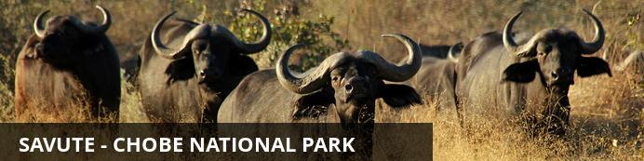
In the heart of Botswana’s Chobe National Park lies a dynamic wilderness, a sweeping expanse of savannah brooded over by several rocky outcrops which guard a relic marsh and the dry channel that was once its lifeline. This is Savute, where mysterious wet and dry cycles mould the landscape and dictate the nature of its wild inhabitants. Currently it is dry, and wild dogs hunt in the channel where crocodiles swam only twenty years ago. The Gubatsa Hills shelter leopard and klipspringer and rock paintings of early man’s wildlife sightings. During the arid winter months game viewing concentrates on Savute’s resident bull elephants, antelope and lion prides, and black-backed jackal, bat-eared foxes, tsessebe, and kudu, abound.The summer rains bring a feast for lion, hyena and cheetah as thousands of migrating zebra and wildebeest assemble in a chaotic pattern on the marsh. Cape buffalo herds arrive and migrant birds swell Savute’s 300 resident species, thrilling bird-watchers with their spectacular antics.

Day Notes
Enjoy a morning activity & brunch before departing on a scheduled charter flight to the Savute channel. You will arrive in time for the afternoon / evening game drive. Enjoy the activity after which you will return to the lodge for dinner.

Overnight: Savute Safari Lodge View iBrochure
Located on the banks of the Savute channel, Savute Safari Lodge is intimate, accommodating only 24 guests in cool thatched timber and glass suites. The area is renowned for its population of bull elephant and for the unique interaction of the resident predator species. The close proximity of wildlife translates itself into the recently refurbished, modern African décor.
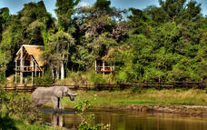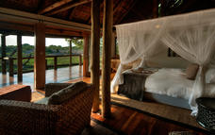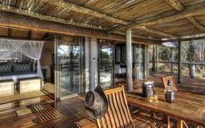

Day 7Savute Safari Lodge, Savute - Chobe National Park

Day Notes
Spend the full day game viewing in the Savute Channel. Open 4x4 game drives are conducted in the Savute area, including the famous Savute Marsh, and the ancient San rock paintings at Gubatsa Hills, add magic to a delightful African safari. The grasslands of the Savute spring to life following the rains from November to march and attract huge numbers of zebras and plains game, as well as many elephants that migrate from the lush Linyanti to take advantage of the fresh grass. However, Savute is most famous for its great predator population, especially lion and hyena and their ongoing battle for supremacy as documented in the celebrated film "Eternal Enemies" filmed in Savite.

Day 8Departure

Day 9: Travelling

Travelling

Transport

Flight Information
Date | Flight | Departure Airport | Time | Arrival Airport | Time | Class | Ref
 |  | JFK International Airport [JFK] |  | OR Tambo International Airport [JNB]
 |  | OR Tambo International Airport [JNB] |  | Maun Airport [MUB]
 |  | Maun Airport [MUB] |  | Camp Moremi
 |  | Camp Moremi |  | Xugana Island Lodge
 |  | Xugana Island Lodge |  | Savute Safari Lodge
 |  | Savute Safari Lodge |  | Maun Airport [MUB]
 |  | Maun Airport [MUB] |  | OR Tambo International Airport [JNB]
 |  | OR Tambo International Airport [JNB] |  | JFK International Airport [JFK]

Travel Information
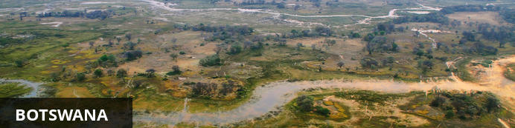
Botswana is well known for having some of the best wilderness and wildlife areas on the African continent. With almost 40% of its land area devoted to national parks, reserves and wildlife management areas you can travel through many parts of the country has the feeling of moving through an immense Nature wonderland.
The first – and most lasting impressions – will be of vast expanses of uninhabited wilderness stretching from horizon to horizon, the sensation of limitless space, astoundingly rich wildlife and bird viewing, night skies littered with stars and heavenly bodies of an unimaginable brilliance, and stunning sunsets of unearthly beauty.
Experience here the stunning beauty of the world’s largest intact inland Delta – the Okavango; the unimaginable vastness of the world’s second largest game reserve – the Central Kalahari Game Reserve; the isolation and other-worldliness of the Makgadikgadi – uninhabited pans the size of Portugal; and the astoundingly prolific wildlife of the Chobe National Park.
Botswana is the last stronghold for a number of endangered bird and mammal species, making your safari experience even more memorable, and at times you will feel simply surrounded by wild animals.

Banking and Currency
Currency
Botswana's currency is Pula (which means 'rain' in Setswana). It is divided into 100 thebe (which means 'shield' in Setswana). Travellers' cheques and foreign currency may be changed at banks, bureaux de change and authorised hotels.
The US dollar, Euros, British Pound and the South African Rand are the most easily convertible currencies (and accepted by some estabishments - but, generally, then an inflated rate of exchange will be used).
Banking
Full banking services are available on in major towns, although ATMs are sprouting up all over the country. Most credit cards are accepted at hotels and restaurants. Cultural sites and community art and craft outlets usually only accept cash.
Seven main commercial banks, as well as a number of foregin exchange bureaux, operate in Botswana. Operating hours are Monday to Friday 08h30 to 15h30 and Saturday 08h30 to 10h45.

Travel, Transport and Getting Around
Public transport in Botswana is geared towards the needs of the local populace and is confined to main roads between major population centres. Although cheap and reliable, it is of little use to the traveller as most of Botswana’s tourist attractions lie off the beaten track.
Driving off the main roads in Botswana is only recommended to expects in 4x4 vehicles, that are equipped correctly. Most lodges offer transfers or they can be arranged. If, however, you will be driving in Botswana:

Be sure to watch out for wild animals on the roads!
There are major airports in Maun, Kasane and Gaborone, while smaller charter flights are used to get to the other top attractions and camps.

Food, Drink and Cuisine Advice
Indigenous Botswana cuisine is similar to the rest of southern Africa. Beef is taken seriously and can be of exceptional quality. Throughout Botswana the tap water is safe for showering and brushing teeth, but it is not advised to drink the tap water. Filtered water is available at most camps and shops offer bottled water - it is advised to be well stocked of bottled water if you are travelling off the beaten track. The national beer is St Louis, and is worth a try, however there are US lagers as well as Namibian or South African imports usually available as well.

Clothing / Dress Recommendations
Summer
In summer, lightweight, lightcoloured cottons are preferable. Avoid synthetic materials and black clothing, as they increase perspiration and discomfort.
Winter
In winter, wear trousers, longsleeved shirts / blouses and jerseys.
From May – August, night temperatures can fall below zero degrees celsius, so warm jerseys and jackets are vital, especially on morning and evening game drives.
General
Garments of neutral colours that blend with the bush and forest are advisable for safaris and game viewing.
Bring a lightweight jacket and/or jersey for unexpected temperature changes or rain.
Closed, comfortable walking shoesor gym shoes are a must in all seasons.
Special attention should be given to protection from the sun. Bring a sunhat, good quality sunscreen, sun lotion and polarised sunglasses.
Wide brimmed hats are preferable to baseball caps.

Electricity and Plug Standards
Current is 220/240 volts at 50 cycles per second. Both square and round wall plugs are used.

