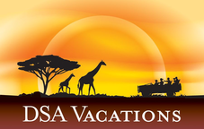

Falls & Floodplains
Victoria Falls, Zimbabwe - Unknown Area - Chobe National Park
7 Days / 6 Nights
0 Persons
Date of Issue: October 23, 2015

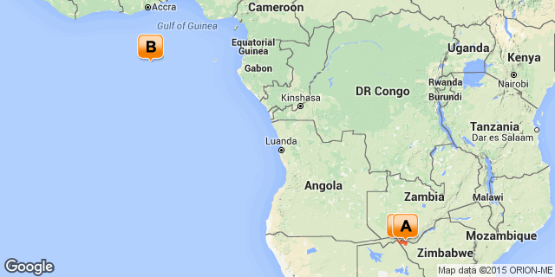

Click here to view your Digital Itinerary

Overview
Discover the gems of one of Southern Africa's most sought after photographic destinations. This package explores the Victoria Falls, and Chobe by river and Chobe by land.

Destination | Accommodation | Nights | Basis | Room Type
Victoria Falls, Zimbabwe | Ilala Lodge | 2 | B&B
Unknown Area | Missing Point | 2 | FB+
Chobe National Park | Elephant Valley Lodge | 2 | FB+

Key
RO: Room only
SC: Self Catering
HB: Half Board
B&B: Bed and breakfast
D, B&B: Dinner, bed and breakfast
FB: Dinner, bed, breakfast and lunch
FB+: Dinner, bed, breakfast, lunch and activities daily
FI: Fully inclusive

Day 1Ilala Lodge, Victoria Falls, Zimbabwe

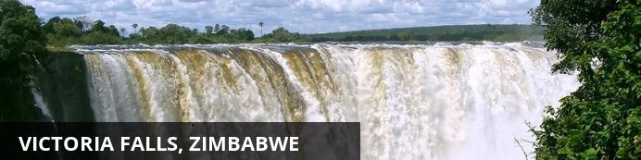
One of the original natural wonders of the world, the Victoria Falls is a World Heritage Site and an extremely popular tourism attraction. Known locally as ‘The Smoke that Thunders’ this spectacle is accessible from both Zambia and Zimbabwe and it is an ideal place to combine a game viewing and water sports. There is excellent fishing, a terrifying bungee jump and arguably the best commercial white water rafting in the world.

Day Notes
On arrival in Victoria Falls you will be met by your local English speaking representative on arrival who will transfer you to your hotel.
Overnight on a bed and breakfast basis at Ilala Lodge

Overnight: Ilala Lodge View iBrochure
The warmest of welcomes awaits you at Ilala Lodge Hotel. A gracefully distinguished ambiance. Attentive yet discrete service that always comes with a smile. The sublime surroundings of our boutique hotel will reawaken your senses while the power of the majestic Victoria Falls renews your spirit.
Relax in luxurious style. Listen to the meditative rhythm of the great Zambezi as you drift off to sleep.As morning comes, gently awake and lift your head to see the spray of the majestic Victoria Falls across the unspoiled horizon – and let your soul sigh.
Feel at ease in our elegant and spacious rooms with African Teak furniture, soft, crisp linen – all en-suite facilities, bathroom with separate shower, air conditioning, overhead fan, satellite TV, hair dryer, tea & coffee making facilities, free WiFi and a safe. 56 rooms in total including 2 Executive Suites, 2 Standard Suites, 10 x Standard double rooms with a king-size bed in each and 42 other standard rooms that have 2 x ¾ beds in each.
The view from your room looks across the lawns to the National Parks where elephant, warthog, impala or the occasional buffalo might be passing by or simply grazing on the lawn or in the tree line.
Experience new tastes, indulge in unusual flavours and enjoy delectable dishes at our award winning restaurant "The Palm”; dine in view of the spray of the majestic Victoria Falls!
We have a tours desk in the hotel where you can book all you’re activities. Ilala Lodge also has a spa, where you can spoil yourself after that long safari!
Cruise down the river of time and follow the route that ancient explorers took, on the luxurious Ra-Ikane. She is the only one of her kind in Victoria Falls; The Ra-Ikane is a small luxury cruise boat that is out-fitted to suggest, in exquisite detail, an ambiance of a bygone era. Sip chilled white wine, or Gin & Tonics whilst nibbling on canapes, as well as the sumptuous high tea, whilst you glide up to Elephants feeding on the shoreline.
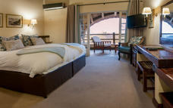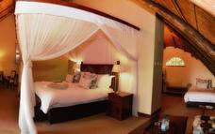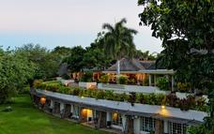

Included
Bed & Breakfast

Day 2Ilala Lodge, Victoria Falls, Zimbabwe

Day Notes
This morning you will collected for a guided tour of the mighty Victoria Falls, one of the great natural wonders of the world. Described as "Mosi-oa-Tunya" (the Smoke that Thunders) by the locals, at peak flow the spray from the falls can reach 1,300 feet into the air!
The afternoon is at leisure to explore the town, or participate in one of the many activities Victoria Falls has to offer. From bungi-jumping to helicopter flips, or perhaps a sunset cruise for the not-so-brave-at-heart.
Overnight on a bed and breakfast basis at Ilala Lodge

Included
Bed & Breakfast

Day 3Missing Point

Day Notes
After a morning at leisure, you will be transferred to Kasane Immigration.
On arrival at Kasane immigration office on the banks of the Chobe River in Botswana, you will be met and assist you in exiting out of Botswana and then take you by tender boat across the Chobe River to Impalila Island (about ten minutes) where you will enter into Namibia. Both of these border controls merely entails filling out a form and getting a stamp in your passport.
Once you have entered into Namibia it is a short boat ride to Ichobezi Safari-boat
Dinner is served at 20h00 on the entertainment deck with the sounds of the African bushveld providing the evenings entertainment.
Overnight on a fully inclusive basis on Ichobezi Safari-Boat

Overnight: Missing Point

Included
Full Board and Activities

Day 4Missing Point

Day Notes
The day is entirely yours and you are free to spend it as you like. You can laze around the sun deck just watching the constant coming and goings of the wildlife and birds around you. You can take a tender boat with a guide and go looking for up close and personal sightings of the game and get extraordinary photo opportunities. Or you can go off fishing to try and catch (and then release) the elusive Tiger fish.
Overnight on a fully inclusive basis on Ichobezi Safari-Boat

Included
Full Board and Activities

Day 5Elephant Valley Lodge, Chobe National Park

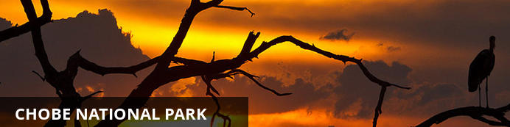
Elephants, elephants and more elephants, there are few places that can beat Chobe for elephant viewing, be from land or a boat.

Day Notes
Transfer by tender boat from the Ichobezi Safariboat at 09h00 to the customs office on Impalila Island to exit out of Namibia. From there you will again cross the Chobe River to enter into Botswana at the Kasane immigration.
On arrival in Kasane, you will be met and transferred to Elephant Valley Lodge.
Overnight on a fully inclusive basis at Elephant Valley Lodge

Overnight: Elephant Valley Lodge
The Chobe National Park is home to largest population of elephants in the world, with the population numbering approximately 85 000. In addition to these majestic giants, there is also an abundance of wildlife.
Elephant Valley Lodge lies south of the Kazangula border crossing within the Kasane Forest Reserve which is adjacent to the Chobe National Park. The camp comprises 20 'meru' style luxury safari tents and can accommodate a maximum of 40 guests. The lodge is situated in the Lesoma Valley and overlooks an extremely productive water hole.
Elephant Valley Lodge features 20 'meru style' safari tents, each of the tents is able to accommodate two adults. The tents also feature en-suite shower and toilet.
Guests at Elephant Valley are encouraged to join our qualified guides on both daily activities, these include a river cruise along the Chobe River in one of our spacious skimmers and an afternoon safari from the comfort of a custom bult game viewer in the Chobe National Park.
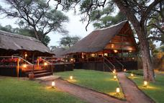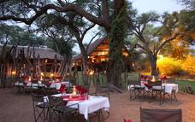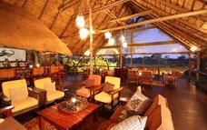

Included
Full Board and Activities

Day 6Elephant Valley Lodge, Chobe National Park

Day Notes
Spend the day experiencing intimate encounters with Africa's wildlife with a morning river cruise and afternoon game drives in Chobe National Park.
Overnight on a fully inclusive basis at Elephant Valley Lodge

Included
Full Board and Activities

Day 7Departure

Day Notes
Time permitting enjoy an early morning activity before your road transfer to Victoria Falls Airport.

Transport

Transfers
Date | Pick Up | Drop Off | Time | Vehicle
 | Victoria Falls International Airport [VFA] | Ilala Lodge
 | Ilala Lodge | Missing Point
 | Missing Point | Elephant Valley Lodge
 | Elephant Valley Lodge | Victoria Falls International Airport [VFA]

Travel Information
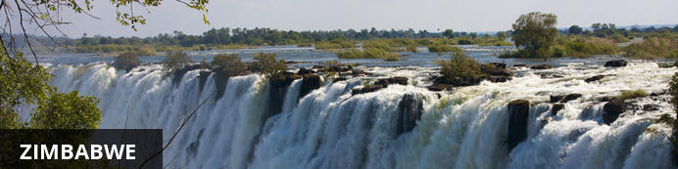
A nation of spectacular natural beauty, friendly people and rich culture, Zimbabwe’s status as one of Africa’s leading safari destinations was dampened for years by its political instability. But now that the country is transcending its strife and returning to a state of equilibrium, it is once again emerging as a vacation highlight of the continent. Victoria Falls – known to locals as ‘The Smoke That Thunders’ – is one of the seven natural wonders of the world and the sheer power of this massive body of water plunging into the Zambezi Gorge is awe-inspiring and unforgettable. Lake Kariba, with its game-rich shores and islands, is an idyllic safari spot featuring mind-blowing sunsets; Hwange National Park is known for its huge herds of elephants; and a kayak trip down the Zambezi through the Mana Pools National Park will appeal to the intrepid traveller, providing close encounters with crocodiles, hippos and a host of other wildlife.

Banking and Currency
Currency
Zimbabwe uses US$ as it's own unit of currency (the Zimbabwe Dollar) is suspended. South African Rands and Euros are also widely accepted. It is advised to carry small denominations of change with you, however it is best to pay for as much as possible outside of the country.
South African Rands work well in supermarkets, whle US$ are proferred for curios, accommodation and activities.
Banking
Banks in Zimbabwe are open for business Monday, Tuesday, Thursday and Friday from 08h00 to 15h00, on Wednesdays from 08h00 to 13h00 and Fridays from 08h00 to 11h30. They are closed on Sundays and Public Holidays.

Travel, Transport and Getting Around
Taxis are safe and reliable, and can be booked through your hotel front desk. Taxis in cities travel within a 40km radius of the city. Always take a taxi at night.
Major airlines fly into Victoria Falls, Harare and Bulawayo. Charter flights are available to most attractions and camps.
Zimbabwe has a good road infrastructure, by African standards, although potholed. Between major towns, there are frequent road blocks. Traffic drives on the left side of the road.

Food, Drink and Cuisine Advice
Zimbabwe's native cuisine is based on sadza, a cooked porridge made from ground maize. This is usually made thin, perhaps with sugar, for breakfast, then eaten thicker – the consistency of mashed potatoes – for lunch and dinner. For these main meals it will normally be accompanied by some tasty relish, perhaps made of meat and tomatoes, or dried fish.
You should taste this at some stage when visiting. Safari camps will often prepare it if requested, and it is always available in small restaurants in the towns.
Camps, hotels and lodges that cater to overseas visitors will serve a very international fare, and the quality of food prepared in the most remote bushcamps amazes visitors. Coming to Zimbabwe on safari your biggest problem with food is likely to be the temptation to eat too much.
If you are driving yourself around and plan to cook, then get most of your supplies in main towns. Shoprite stores have revolutionised what's available, and really have all that you will need.
Water in the main towns is usually purified, provided there are no shortages of chlorine, breakdowns, or other mishaps. The locals drink it, and are used to the relatively innocuous bugs that it may harbour. If you are in the country for a long time, then it may be worth acclimatising yourself to it. However, if you are in Zimbabwe a for just a few weeks, then try to drink only bottled, boiled, or treated water available in towns and from all camps, lodges and hotels.

Clothing / Dress Recommendations
When in Zimbabwe the cardinal rule is to wear casual, comfortable clothes during the day as temperaturs could be boiling hot. It is advisable to wear light loose fitting clothing, such as cotton or linen, as they are cool and easy to wash. Warmer clothes are advised for the evenings and rainwear for the wet season.
A brimmed hat and sunglasses are a good idea year round. Long sleeved shirts and long trousers will also guard against the scourching sun rays. It is recommended you wear light shoes, especially if your itinerary entails a lot of walking.
For safaris, please remember to wear appropriate clothing and shoes. Earth colour clothes, such as browns, greens and tans are advisable.

Electricity and Plug Standards
Current is 220/240 volts at 50 cycles per second. Both square and round plugs are used.

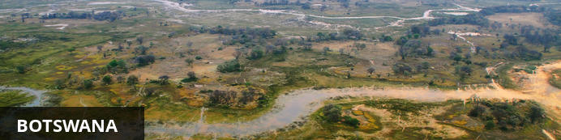
Botswana is well known for having some of the best wilderness and wildlife areas on the African continent. With almost 40% of its land area devoted to national parks, reserves and wildlife management areas you can travel through many parts of the country has the feeling of moving through an immense Nature wonderland.
The first – and most lasting impressions – will be of vast expanses of uninhabited wilderness stretching from horizon to horizon, the sensation of limitless space, astoundingly rich wildlife and bird viewing, night skies littered with stars and heavenly bodies of an unimaginable brilliance, and stunning sunsets of unearthly beauty.
Experience here the stunning beauty of the world’s largest intact inland Delta – the Okavango; the unimaginable vastness of the world’s second largest game reserve – the Central Kalahari Game Reserve; the isolation and other-worldliness of the Makgadikgadi – uninhabited pans the size of Portugal; and the astoundingly prolific wildlife of the Chobe National Park.
Botswana is the last stronghold for a number of endangered bird and mammal species, making your safari experience even more memorable, and at times you will feel simply surrounded by wild animals.

Banking and Currency
Currency
Botswana's currency is Pula (which means 'rain' in Setswana). It is divided into 100 thebe (which means 'shield' in Setswana). Travellers' cheques and foreign currency may be changed at banks, bureaux de change and authorised hotels.
The US dollar, Euros, British Pound and the South African Rand are the most easily convertible currencies (and accepted by some estabishments - but, generally, then an inflated rate of exchange will be used).
Banking
Full banking services are available on in major towns, although ATMs are sprouting up all over the country. Most credit cards are accepted at hotels and restaurants. Cultural sites and community art and craft outlets usually only accept cash.
Seven main commercial banks, as well as a number of foregin exchange bureaux, operate in Botswana. Operating hours are Monday to Friday 08h30 to 15h30 and Saturday 08h30 to 10h45.

Travel, Transport and Getting Around
Public transport in Botswana is geared towards the needs of the local populace and is confined to main roads between major population centres. Although cheap and reliable, it is of little use to the traveller as most of Botswana’s tourist attractions lie off the beaten track.
Driving off the main roads in Botswana is only recommended to expects in 4x4 vehicles, that are equipped correctly. Most lodges offer transfers or they can be arranged. If, however, you will be driving in Botswana:

Be sure to watch out for wild animals on the roads!
There are major airports in Maun, Kasane and Gaborone, while smaller charter flights are used to get to the other top attractions and camps.

Food, Drink and Cuisine Advice
Indigenous Botswana cuisine is similar to the rest of southern Africa. Beef is taken seriously and can be of exceptional quality. Throughout Botswana the tap water is safe for showering and brushing teeth, but it is not advised to drink the tap water. Filtered water is available at most camps and shops offer bottled water - it is advised to be well stocked of bottled water if you are travelling off the beaten track. The national beer is St Louis, and is worth a try, however there are US lagers as well as Namibian or South African imports usually available as well.

Clothing / Dress Recommendations
Summer
In summer, lightweight, lightcoloured cottons are preferable. Avoid synthetic materials and black clothing, as they increase perspiration and discomfort.
Winter
In winter, wear trousers, longsleeved shirts / blouses and jerseys.
From May – August, night temperatures can fall below zero degrees celsius, so warm jerseys and jackets are vital, especially on morning and evening game drives.
General
Garments of neutral colours that blend with the bush and forest are advisable for safaris and game viewing.
Bring a lightweight jacket and/or jersey for unexpected temperature changes or rain.
Closed, comfortable walking shoesor gym shoes are a must in all seasons.
Special attention should be given to protection from the sun. Bring a sunhat, good quality sunscreen, sun lotion and polarised sunglasses.
Wide brimmed hats are preferable to baseball caps.

Electricity and Plug Standards
Current is 220/240 volts at 50 cycles per second. Both square and round wall plugs are used.

