Eastern Cape Safari Explorer
Cape Town - Kariega Private Game Reserve
10 Days / 9 Nights
Date of Issue: July 14, 2016

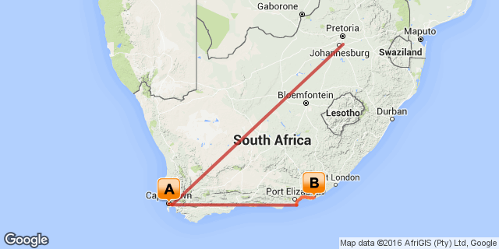

Click here to view your Digital Itinerary

Overview
This package includes 4 nights in Cape Town at the Southern Sun Cullinan followed by 3 nights on Safari along the East Coast at Kariega Game Lodge

Accommodation | Destination | Nights | Basis | Room Type
Southern Sun Cullinan Hotel | Cape Town | 4
Kariega Private Game Reserve | Kariega Private Game Reserve | 3 | FB+

Key
RO: Room only
SC: Self Catering
HB: Half Board
B&B: Bed and breakfast
D, B&B: Dinner, bed and breakfast
FB: Dinner, bed, breakfast and lunch
FB+: Dinner, bed, breakfast, lunch and activities daily
FI: Fully inclusive

Included
Round trip coach air on South African Airways from New York (JFK) or Washington(IAD) Airport to South Africa OR Tambo International Airport
Domestic coach air in South Africa as per the itinerary (Johannesburg - Cape Town – Port Elizabeth - Johannesburg)
Accommodation as per the itinerary
Most meals as per the itinerary (7x breakfast, 3x lunches, 3x dinners)
Ground transfers as per the itinerary
Scheduled Cape Peninsula tour
Scheduled Winelands Tour
All park fees and safari activities

Excluded
Add on air from other US cities
Any meals or services not mentioned above
Entrance fees on Cape Peninsula tour to Boulders penguins, Seal Island cruise
Any items of personal expense - i.e. drinks, telephone calls, laundry etc
Gratuities for rangers/guides/drivers

Day 1: Traveling

Depart from New York (JFK) or Washington Dulles (IAD) for your South African Airways flight to South Africa.

Day 2
Southern Sun Cullinan Hotel, Cape Town

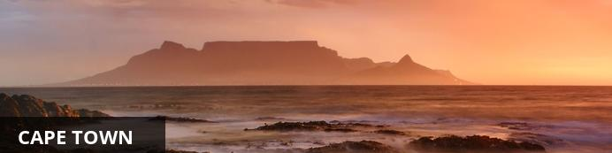
Resting at the confluence of the Indian and Atlantic Ocean, sandwiched between the slopes of the iconic Table Mountain and the glistening sapphire waters of Table Bay, the exceptionally scenic city of Cape Town is in a class of its own. Some cities boast rich culture, vibrant nightlife, a cosmopolitan atmosphere and extraordinary architecture, while others boast breathtaking landscapes and extraordinary natural wonders. Cape Town, is lucky enough to be blessed with all of these attractions and so much more. With its bustling harbour, world-class beaches, top-notch vineyards, and its mountainous surroundings brimming with diverse flora and fauna, Cape Town consistently captivates the hearts of all who visit.

Day Itinerary
On arrival in Johannesburg you will connect onwards for your 2 hour flight on South African Airways to Cape Town. On arrival you will be met for your transfer to your hotel.
Overnight on a bed and breakfast basis at the Southern Sun Cullinan

Overnight: Southern Sun Cullinan Hotel View iBrochure
Boasting a total of 394 rooms, each befitted with a host of amenities such as direct-dial phones, free WiFi, tea and coffee stations, electronic safes, en-suite facilities and supremely comfortable double or queen beds. Additional touches such as porter service, 24-hour room service and a wake-up service ensure that you sleep even more deeply each night, while beautiful furnishings and décor are a treat for the rest of your senses too.
As for the hotel itself, you can expect to be treated like royalty throughout your stay. Take a dip in our large outdoor pool, relax on the spacious deck, work up a sweat in our fully-equipped fitness centre, savour delicious food and fine wine at our outstanding dining options such as The Star Bar and Terrace and The Peach Tree Restaurant. Conferencing facilities, loyalty specials and many other perks also await as a guest at the hotel.
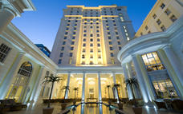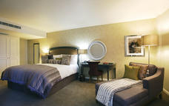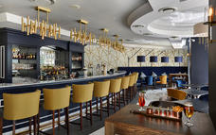

Included
Bed & Breakfast

Day 3
Southern Sun Cullinan Hotel, Cape Town

Day Itinerary
After breakfast you will be met by your local English speaking driver-guide for your full day tour of the Cape Peninsula. Depart the hotel and flank the colder Atlantic Ocean en route to Hout Bay. Once a fishing community, now one of the most popular residential areas, the harbor still has a charm of days gone by. A chance to join the M.V "Circe" for a half hour cruise to "Seal Island" or for the not so adventurous, the fish market "Mariners Wharf" is a must. The tour now continues over the famous Chapman’s Peak drive – if open, with a 200 meter drop on one side and a 200 meter rise on the other, as we make our way south, following the Atlantic Ocean until we reach Cape Point and the Cape of Good Hope. Said to be the romantic meeting place of the two mighty oceans, the Atlantic and the Indian, Sir Francis Drake the Explorer once called it "the fairest Cape that we saw in the whole circumference of the Globe". And rightly so, it must be the highlight of any visit to the Mother City, if not South Africa. Our optional lunch stop today is at the Fish Hoek Galley. We pass the naval base of Simonstown as we continue along the Indian Ocean, en route to see the Jackass penguin colony which has become well established at Boulders Beach near Simonstown. Our last stop of the day is at the Kirstenbosch Botanical Gardens, home of some 3 500 species of Southern African fauna and flora. We return to the hotel in the late afternoon, having seen some of the best the Cape has to offer.
Overnight on a bed and breakfast basis at the Southern Sun Cullinan

Activities
Chapman's Peak
Cape Point
Kirstenbosch Botanical Gardens

Optional
Boulders Penguin Colony

Chapman's Peak
Chapman’s Peak Drive winds it way between Noordhoek and Hout Bay. Situated on the Atlantic Coast, at the south-western tip of South Africa, it is one of the most spectacular marine drives anywhere in the world. The 9km route, with its 114 curves, skirts the rocky coastline of Chapman's Peak. The drive offers stunning 180° views with many areas along the route where you can stop and take in the scenery or sit down for a relaxing picnic.
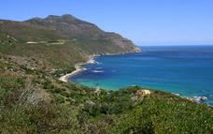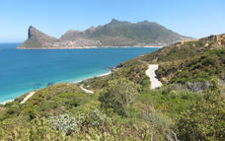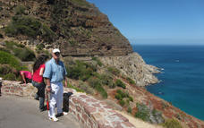

Cape Point
Cape Point is a spectacular sight, covered in endemic fynbos and home to breathtaking bays, beaches and rolling green hills and valleys, just 60km outside of Cape Town. Cape Point falls within the Cape Floral Region, a World Heritage Site. The Cape Floral Region is one of the richest areas for plants in the world – it is home to nearly 20% of Africa’s flora. Cape Point is open daily and is a must-see.
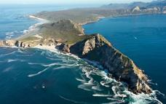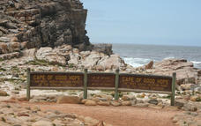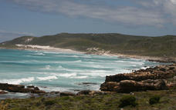

Kirstenbosch Botanical Gardens
On the lower slopes of Table Mountain, the beautiful Kirstenbosch Botanical Gardens showcases some of the Cape’s rich flora. Taking centre stage here is the unique ‘fynbos’ vegetation. Those who work up an appetite while exploring this garden paradise can visit the restaurant or tea room, which are fully stocked with delicious meals, yummy treats and refreshing beverages. In summer, Sunday music concerts provide sunset entertainment. Kirstenbosch is rated as the seventh best of its kind in the world.
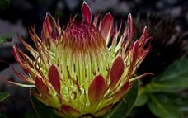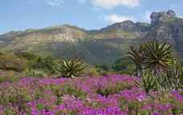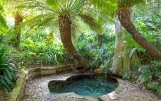

Boulders Penguin Colony
The Boulders Visitor Centre is home to the famous colony of Jackass Penguins, so called for their hilarious braying call. This is a truly special experience and Table Mountain National Park staff are knowledgeable and offer guided tours. After you have fallen in love with the penguins head to the secluded Boulders Beach and take a swim in the comparatively warm waters of the False Bay.
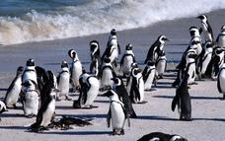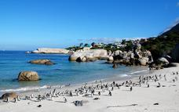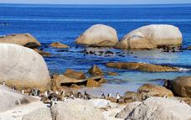

Day 4
Southern Sun Cullinan Hotel, Cape Town

Day Itinerary
After breakfast your local English-speaking driver-guide will meet you at the hotel for a tour of the Cape wine region.
We will depart from the hotel and head north to Paarl. Our first stop is for our morning wine tasting at Nelsons Creek Estate. After a tour through their cellars, there is a chance to sample some of their local wines as well as a cheese tasting. A brief city tour of Paarl follows, before we make our way to Franschhoek with a photo stop at the Groot Drakenstein Prison where Nelson Mandela was released in 1990. This little village nestled amongst the mountains, can easily be mistaken for a little Switzerland. After a short tour of the town, a second wine tasting will be enjoyed in Franschhoek followed by a lunch stop and perhaps a chance to savor some of the fresh trout for which Franschhoek is renowned. After lunch the tour continues to the university town of Stellenbosch. It is easy to understand why Simon van der Stel decided to settle a village amongst the mountains. The backdrop of the Hottentots Holland Mountains, the white gabled Cape Dutch homesteads and the oak lined streets and lanes all blend in to give this place a charm that will not be quickly forgotten. Time permitting we will include a third and final wine tasting. Then we set off for our return to the Mother City.
Overnight on a bed and breakfast basis at the Southern Sun Cullinan

Activities
Paarl Wine Region
Franschhoek Valley
Stellenbosch Wine Route

Paarl Wine Region
One of the Western Cape’s premier wine regions, Paarl is home to a number of well-respected wine producers, including KWV, Laborie, Nederburg, Fairview and Plaisir de Merle.
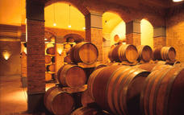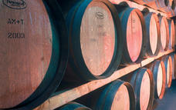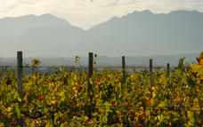

Franschhoek Valley
Famous for its beautiful mountains, excellent wines and unforgettable restaurants.
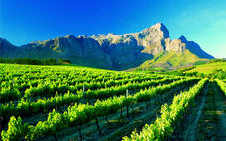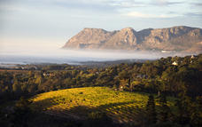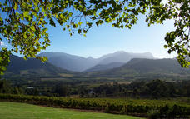

Stellenbosch Wine Route
Stellenbosch is South Africa's premiere wine producing area and is packed with cellars offering excellent wines, great meals and breattaking vistas.
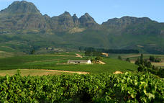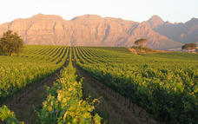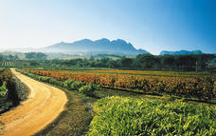

Included
Bed & Breakfast

Day 5
Southern Sun Cullinan Hotel, Cape Town

Day Itinerary
A full day at leisure to explore the beautiful city of Cape Town.
Maybe take a trip in the cable car up Table Mountain or a boat ride for a poignant visit to Robben Island where Nelson Mandela was imprisoned for many years. Perhaps take time to explore the vibrant V&A Waterfront with its many shops, restaurants and activities available as well as the fascinating Two Oceans Aquarium. In the summer months maybe head for the white sand beaches of Clifton and Camps Bay for people watching and soaking up the African Sun. Whatever else, you will not be at a loss for things to do!
Overnight on a bed and breakfast basis at the Southern Sun Cullinan

Recommended
Table Mountain
Robben Island
Two Oceans Aquarium

Table Mountain
Without a doubt it is Table Mountain that makes Cape Town the unique city it is. Rising up over 1000m above sea level, it is the icon that makes Cape Town instantly recognizable. It is a symbol, a playground, a spiritual retreat and a big draw card for tourists. So intertwined with the identity of Cape Town is Table Mountain that a visit to the city isn’t complete without having walked or taken the cable car to the top.
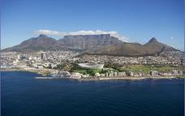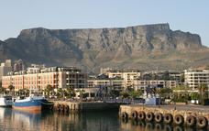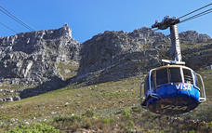

Robben Island
An icon of struggle, freedom and hope made famous by Nelson Mandela's imprisonment here.
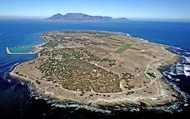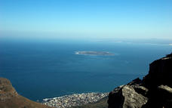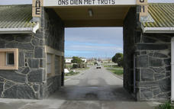

Two Oceans Aquarium
The Two Oceans Aquarium is home to more than 3000 marine animals including sharks, fishes, turtles, and penguins.
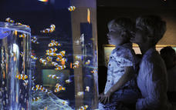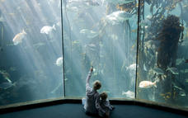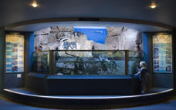

Included
Bed & Breakfast

Day 6
Kariega Private Game Reserve, Kariega Private Game Reserve

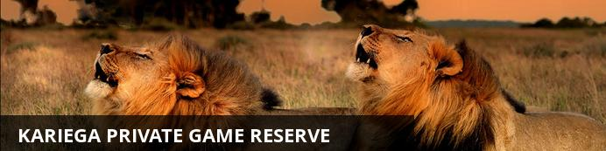
As a family owned and operated private game reserve, Kariega Game Reserve offers a warm and friendly environment where guests can experience a real connection with all that Africa has to offer, including its rich culture. Local cuisine, traditional braaivleis (barbeque), and outdoor dining in the African boma are all part of the authentic African journey at Kariega.
Of course, your African safari would not be complete without the big game experience offered at Kariega. Comprising 10,000 hectares of rich biodiversity and lush landscapes, Kariega is a malaria-free safari destination home to the Big 5 (lion, elephant, rhino, buffalo, cape leopard) and much more. Twice daily game viewing from open game vehicles is the center of your safari experience but other safari activities on offer include walking safaris, river cruises, canoeing and fishing. Also available is a tranquil health spa, and a well-equipped gym.

Day Itinerary
After breakfast you will be met for your transfer to Cape Town Airport for your scheduled flight to Port Elizabeth.
On arrival at Port Elizabeth Airport you will be met and transferred to Kariega Game Reserve, an easy 1 1/2 hours drive from Port Elizabeth.
The Reserve is situated along the Eastern Cape Coast, making it the perfect Big 5 South African safari destination to compliment a Cape Town visit. This malaria-free South African game park is home to some of the richest biodiversity in Southern Africa, as well as two abundant rivers – the picturesque Kariega and Bushman's Rivers.
Overnight on a full board basis at Kariega Private Game Reserve

Overnight: Kariega Private Game Reserve
As a family owned and operated private game reserve, Kariega Game Reserve offers a warm and friendly environment where guests can experience a real connection with all that Africa has to offer, including its rich culture. Local cuisine, traditional braaivleis (barbeque), and outdoor dining in the African boma are all part of the authentic African journey at Kariega.
Of course, your African safari would not be complete without the big game experience offered at Kariega. Comprising 10,000 hectares of rich biodiversity and lush landscapes, Kariega is a malaria-free safari destination home to the Big 5 (lion, elephant, rhino, buffalo, cape leopard) and much more. Twice daily game viewing from open game vehicles is the center of your safari experience but other safari activities on offer include walking safaris, river cruises, canoeing and fishing. Also available is a tranquil health spa, and a well-equipped gym.
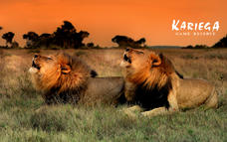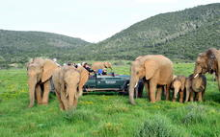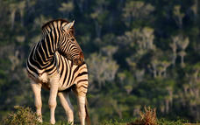

Alternate: Kariega River Lodge View iBrochure
River Lodge at Kariega Game Reserve is located along the banks of the Bushman's River, offering guests the tranquility of river life combined with the ultimate safari experience. This unique African safari combination makes for the experience of a lifetime - including twice daily game drives on Kariega Game Reserve (close up experiences with lion, elephant, rhino and more!), cruises up the river to the beaches of Kenton-on-Sea spotting magnificent birdlife on the way, as well as other activities such as guided safari walks, fishing and canoeing. With only 10 private suites, River Lodge guarantees exclusivity and luxury making it the ideal safari destination for discerning guests.
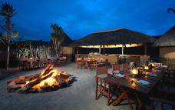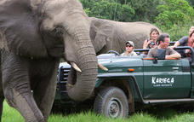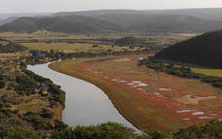

Alternate: Kariega Ukhozi Lodge View iBrochure
Ukhozi Lodge at Kariega Game Reserve is located overlooking the rolling green hills and valleys of the Eastern Cape bushveld. Guests enjoy exclusive use of this private game reserve where they can experience close up viewing of lion, elephant, rhino and more! This luxury safari lodge offers 10 exclusive suites - each with its own private plunge pool and spacious living area, as well as a range of lodge facilities including luxurious safari-style lounges, restaurant, pool area, and boma for romantic outdoor dining under the African sky.
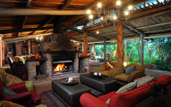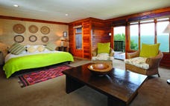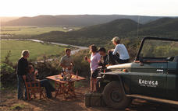

Included
Full Board and Activities

Day 7
Kariega Private Game Reserve, Kariega Private Game Reserve

Day Itinerary
At Kariega, everything revolves around the twice-daily safari drives and river cruises - the close-up encounters with African wildlife are the centre of your unforgettable safari holiday. The experienced game rangers will drive you out on safari every morning and afternoon/evening in open game-drive vehicles, traversing the valleys, grassy plains and African bushveld to bring you close to the Big 5 and other game roaming freely in their natural habitat. If you are fortunate, you may witness the lion hunting or feeding, or even the heartwarming social interactions of an elephant herd.
Overnight on a full board basis at Kariega Private Game Reserve

Included
Full Board and Activities

Day 8
Kariega Private Game Reserve, Kariega Private Game Reserve

Day Itinerary
The game reserve is bordered in the east and west by the vast and dramatic Kariega and Bushman's River Valleys. On safari drives you will explore many different habitats - riverine forests, rich grassland plains and typical African bushveld. The awe-inspiring African landscape will captivate your senses and the trees, grasses and plants of the Eastern Cape will divulge their secrets. Sometimes it is the hidden secrets of the bush which you will treasure most as memories of your safari, the amazing intricacy of a spider's web or the monumental work of a dung beetle. There is never a dull moment on safari drives; you never know what African bush experience awaits around the next corner of the track.
Overnight on a full board basis at Kariega Private Game Reserve

Included
Full Board and Activities

Day 9
Departure

Day Itinerary
After breakfast and an early morning game drive you will be transferred to Port Elizabeth Airport for your flight to Johannesburg. On arrival you will connect with your flight to the United States

Day 10: Traveling

Arrival in the United States at New York JFK or Washington Dulles airports.

Travel Information
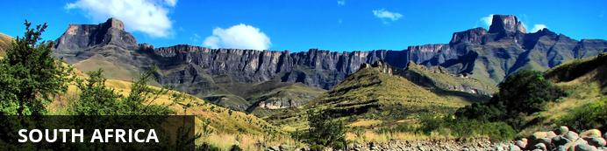
While wildlife safaris are reason enough to visit this exquisite country, South Africa offers even more to see and do. For one, the city of Cape Town is a jewel that is well worth visiting. Set against the iconic Table Mountain, C.T. offers lots to explore, including the V&A Waterfront, Chapman’s Peak, Boulders Penguin Colony and several beautiful beaches — just to give you an idea. Not to mention the delicious food and fabulous shopping, which can all be enjoyed at a favorable exchange rate.
One of the biggest attractions in the Western Cape is the towns of Stellenbosch, Paarl and Franschoek . Boasting some of the best wine tours in the world, they offer picturesque vineyards, fantastic art galleries and gourmet food.
Furthermore, South Africans are some of the most upbeat, welcoming and humorous people you’ll ever encounter. You will be exposed to different cultures, languages and traditions that will certainly enhance your experience.
With so much diversity, South Africa has something for everyone to enjoy!

Visa Regulations and Guidance
As for all international travel, the visitor to South Africa is required to be in possession of a valid passport. U.S. citizens (US passport holders) traveling to the Republic of South Africa for 90 days or less for tourism or business purposes do not need visas. U.S. green card holders (non-US passport holders) require visas to visit South Africa. Nationals of other countries must check the list of visa exempt countries to see if they need to apply for visas.
Please note that all foreigners who wish to visit South Africa must have a passport that is valid for at least 6 months after his/her intended return date. The passport must have a minimum of four blank (unstamped) visa pages in the passport to enter the country. It is preferred these are facing pages. Your international carrier can deny boarding if you do not have the blank (unstamped) visa pages. Travellers should make sure there are sufficient pages for visas and immigration stamps to enter into South Africa and other countries to be visited. These blank pages cannot be endorsement or amendment pages.
As a general precaution, all travellers are advised to carry a photocopy of the photo/bio information page of their passport and keep it in a location separate from their passport.

Banking and Currency
Currency
South Africa's currency is the Rand, which offers visitors great value for their money. The rand comes in a range of coins (R1 = 100 cents) and note denominations of R10, R20, R50, R100. With the exchange rate in your favor, you'll find South Africa offers great value.
It is advisable to exchange US Dollars into Rands upon arrival for tips and small purchases where credit cards are not normally used.
Exchanging large denominations of US Dollars at game lodges can be challenging so come prepared.
Banking
Banks are found in most towns, and are generally open from 09h00 to 15h30 on weekdays and 08h30 to 11h00 on Saturdays (Closed Sundays and Public Holidays). Most of them offer foreign exchange services - with cash, bank & credit cards as well as travellers cheques. You can also obtain cash from automatic teller machines (ATMs). Several international banks have branches in the main city centres. Always advise your bank that you are travelling outside of the country as they might block your purchases if they are not informed.

Travel, Transport and Getting Around
Travelling around South Africa is relatively easy by air, road and rail.
Principal air routes are serviced by SAA and British Airways, operated by Comair. There are 2 low-cost carriers on main routes, namely Kulula.com and Mango.
Facilitating travel around South Africa are 10 airports managed by the Airports Company South Africa (Acsa). In addition, there are some 90 regional airports, including the Kruger Mpumalanga International Airport in Nelspruit and the Skukuza Airport, offering access to the Kruger National Park.
An extensive tarred road system makes travelling in South Africa by vehicle convenient and easy. You will find gravel roads in rural areas though. Note:

Another means of getting around South Africa are luxury inter-city bus services such as Greyhound and Trans-Lux. Metrobus buses are available for in-city transport. Metered taxis must be ordered by telephone. There is a hop-on-hop-off bus in Cape Town and Johannesburg.
Our rail system includes the long-haul, inexpensive Shosholoza Meyl Metrorail trains. More luxurious options are the Blue Train, Premier Classe and the steam train Rovos Rail. There is also the new Gautrain rapid transit railway system in Gauteng Province which links Johannesburg, Pretoria, Ekhuruleni and OR Tambo International Airport.

Health / Medical Information
Many of the main tourist areas are malaria-free, so you need not worry at all. However, the Kruger National Park, the Lowveld of Mpumalanga and Limpopo, and the northern part of KwaZulu-Natal do pose a malaria risk in the summer months.
Many local people and some travelers do not take anti-malaria prophylaxis, but most health professionals recommend that you do. All guests must consult their own medical doctor or health authorities regarding the use of anti-malarial tablets prior to departure.
Whether you take oral prophylaxis or not, always use mosquito repellent, wear long pants, closed shoes, light long-sleeved shirts at night, and sleep under a mosquito net in endemic areas (the anopheles mosquito, which carries malaria, operates almost exclusively after dark). Mosquito repellent containing “deet” is best. It is advisable to avoid malarial areas if you are pregnant.

Safety Notices
If you have lost your passport or wallet, please contact the local police department and file a report. Once you have done this, contact one of South Africa’s U.S. Embassies or Consulates (located in Pretoria, Johannesburg, Cape Town, and Durban).
Contact Information:
Cape Town Consulate General
Telephone : (021) 702 - 7300
Email: americanscapetown@state.gov
Durban Consulate General
Telephone: (031) 305 – 7600
Email: consulardurban@state.gov
Johannesburg Consulate General
Telephone: (011) 290 - 3000
Email: consularjohannesburg@state.gov
Alternately, you can obtain information online at http://southafrica.usembassy.gov/.

Food, Drink and Cuisine Advice
Standards of hygiene in relation to food health and safety in South Africa, are generally high in hotels, restaurants, pubs and nightspots. Tap water in South Africa is safe to drink and cook with when taken from taps in urban areas. Not all tap water in rural areas is safe for consumption, so take precautions if necessary.
It is safe to eat fresh fruit, vegetables and salads, and put ice in your drinks. South Africa's fish, meat and chicken are of excellent quality, so there is no need to limit yourself when enjoying the local cuisine.
Restaurants are subject to South Africa's food safety control legislation, which is implemented by local government. Regulations include certification and regular inspections by health inspectors to ensure hygienic standards are maintained.
Street food is not as common in South Africa as it is in other countries, although vendors selling traditional snacks and meals can be found in city centres and townships. Food safety in such instances cannot always be guaranteed.

Climate and Weather
In the Western Cape, the average rainfall is highest in the winter months, while in other provinces, the average rainfall is highest during the summer. Overall South Africa enjoys a temperate and pleasant climate, with lovely warm sunny days most of the year. KwaZulu-Natal has a sub tropical climate with high humidity in Summer. The Southern Gauteng region has hot summers with occasional thundershowers and frosty winters, while the Eastern part of this region (known as the Lowveld) enjoys mild winters. The Cape interior and the Free State have similar weather conditions to the Southern Gauteng region. The Western Cape region has a Mediterranean climate with warm, dry summers and cold, wet winters.
Spring: September – October
Summer: November - February
Autumn: March – April
Winter: May – August

Clothing / Dress Recommendations
Summer
Bring clothes that are cool, light and comfortable because summer temperatures can get well into the 30 - 40 degree Celsius range in some areas.Also bring an umbrella or raincoat during summer as this is when most of the country gets its rain, but don't forget a swimming costume (bathing suit).
Winter
The winters are generally mild, comparing favourably with European summers. But there are days when temperatures dive, especially in high-lying areas such as the Drakensberg, so be prepared with jerseys and jackets. Cape Town gets its rain during the winter season so it’s advisable to bring rain gear along.
General
Always bring a hat, sunglasses and sunblock as the sun can be strong even in the winter months.
Walking shoes are a good idea all year-round, with warm socks in the winter.
If you are doing business in the country, business attire (suit and tie) is generally called for in the corporate sector, but media for example generally dress more casually.
For game viewing, a couple of neutral-toned items will be useful, but there's no need to go overboard. A good pair of walking shoes is also advisable.
For the evening, if you are dining at an upmarket restaurant or seeing a show, smart-casual attire is recommended.

Electricity and Plug Standards
The South African electricity supply is 220/230 volts AC 50 HZ. With a few exceptions (in deep rural areas) electricity is available almost everywhere. However, you will need to purchase or bring adapters for the outlets. You can purchase the adapters in many US stores, online, or from a store while in South Africa. Adapters are usually available on loan at major hotels in South Africa. Three to five star hotels usually have 110 volt outlets for electric shavers in bathrooms and often provide hair dryers and irons. An NW 4 plug with two prongs, 0.19 inches in diameter is required for compatibility.

