Volcanoes Safaris Mount Gahinga Lodge, Uganda
Fact Sheet

The Lodge
- 8 unique handbuilt bandas (2 deluxe and standard) of which 6 doubles and 2 twins. All with a private veranda offering spectacular views of the Virunga volcanoes. No guide/tour leader rooms available at the lodge.
- All rooms are complete with en-suite bathrooms with flushing toilet, double vanity and shower with hot & cold running water.
- Personal butler service for all guests.
- ​The Gahinga Lodge Gushimisha Spa available to every guest. One 50-minute complimentary massage per guest per stay. Extra massages are available at $50 per 50-minute massage.
- Full board accommodation including all soft drinks and regular and premium alcoholic beverages including cocktails, cellar collection wines and single malt whiskies. Guests pay for French champagne only.
- Complimentary laundry service.
- Power sockets/charging facilities available in the main lodge and guest bandas. Hair dryers available in the rooms. No air conditioners.
- Wi-Fi in the main lodge and guest bandas.
- Sales Tool Kit with images, videos, rates, etc can be viewed at this link.
Safari & Lodge Activities
- Gorilla tracking with direct access on foot from the lodge to the park. Exclusive gorilla tracking available.
- Golden monkey tracking.
- Visit the Gahinga Batwa Village, the Batwa Cultural Heritage Tour and visit the Batwa Vocational Centre.
- Hike Mount Sabinyo, Mount Gahinga, or Mount Muhavura volcanoes.
- Hike the Kisozi caldera.

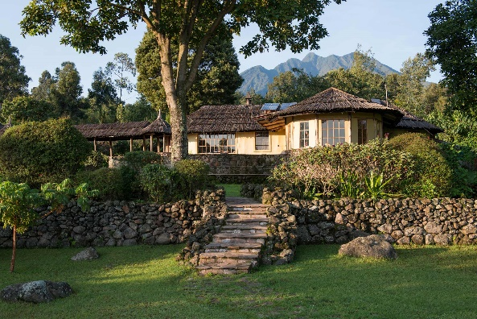

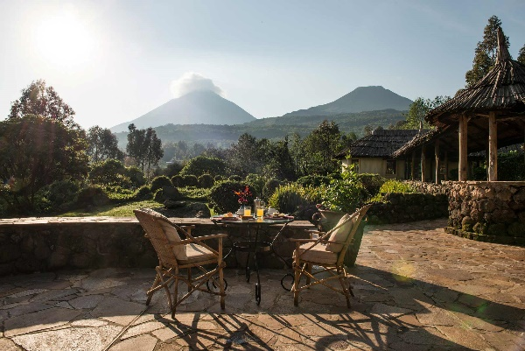

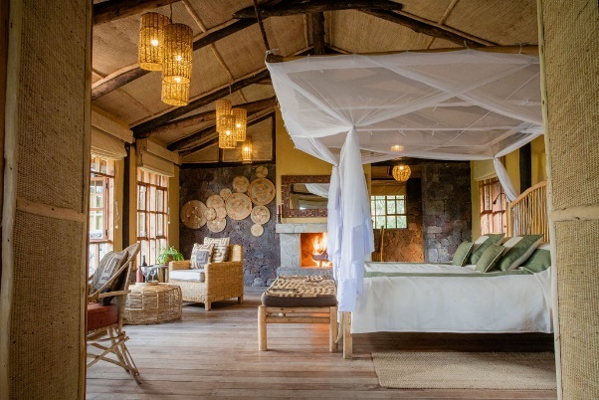

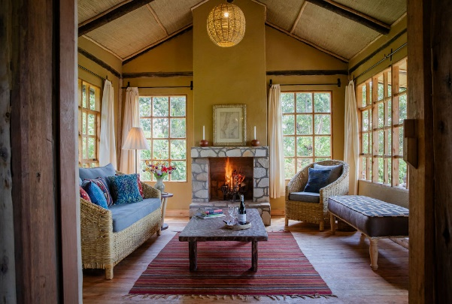

Getting to the Lodge
- From Entebbe: 1-hour flight.
- From Bwindi Lodge (Kihihi): 15-minute flight or a 4-hour walk through the forest + 2-hour drive.
- From Kyambura Gorge Lodge (Kasese): 15-minute flight or a 6-hour drive through Queen Elizabeth National Park.
Seasons & Climate
- Average daytime temperatures: 15-25 celsius, at night: 7-15 celsius.
- Uganda is located on the equator and is an all- year- round destination. High season: 15 Dec - 28 Feb / 1 Jun - 30 Sep. Low season: 1 Oct - 14 Dec / 1 Mar - 31 May.
Useful Information
- Lodge altitude: 2,285m. GPS coordinates: 1.3517° S, 29.6206° E.
- Credit card payments are accepted at the lodge (Amex, Visa and MasterCard). Cash payments or cheques are not accepted.
- Gratuities are at the discretion of the guest. For lodge staff and guides we suggest $5-10 or more per day. For park guides $5-10 and for trackers $15 per guest.
- Children under 15 years of age are not permitted to track the gorillas. They are very welcome at the lodge, but please be advised we do not have childcare facilities.
- Check out time for all guests is 11am.

