Newly designed Belmond Savute Elephant Lodge launches this summer
Timeless Explorers Lodge in the heart of wild Africa
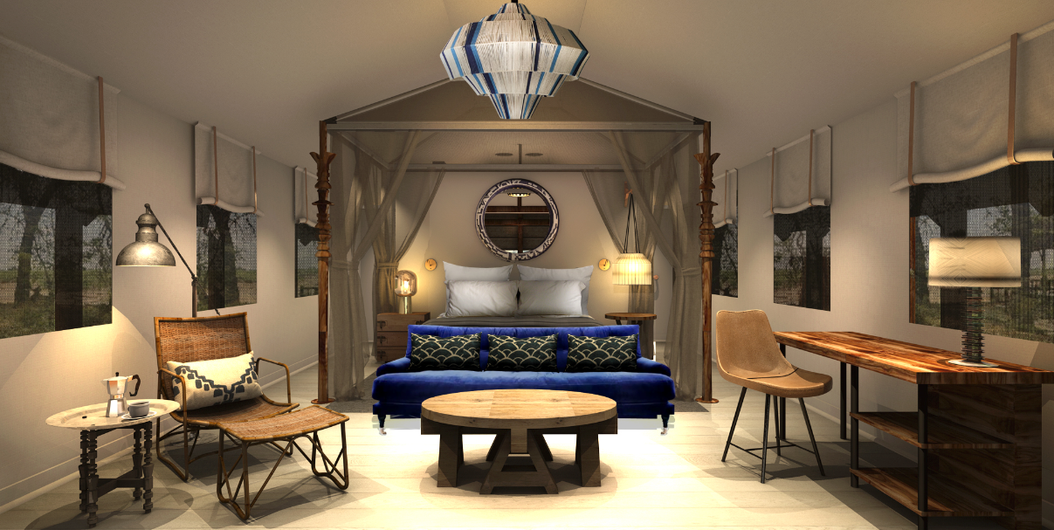
11 June 2018 -This summer, Belmond unveils its new-look Belmond Savute Elephant Lodge in the Chobe National Park, following a full redesign.
Belmond Savute Elephant Lodge, one of Belmond’s three safari experiences in the heart of Botswana, reopens this June as a Timeless Explorers Lodge, connecting its guests to nature. Surrounded by abundant flora and fauna, the lodge includes 12 tented rooms, spa, lounge, bar, open deck with pool, firepit and wildlife viewing hide overlooking the watering hole, a first in the area.
BREAKFAST WITH ELEPHANTS
The lodge’s unique viewing hide allows guests to connect with the wildlife at eye-level, giving them a front row seat on nature’s drama. From first light to dusk, lions, elephants, cheetahs, hyenas and antelope gather for a refreshing drink.
To celebrate the reopening of the lodge, Belmond has commissioned acclaimed wildlife photographer Stephen Tuengler to capture the playful spirit of the animals in the Savute region, one of the world’s true natural wildernesses. The very essence of Belmond Savute Elephant Lodge is to allow guests to experience timeless exploration in the heart of wild Africa.
AN EXPLORERS REMOTE RETREAT
The Savute region has long been associated with some of the world’s greatest explorers, including David Livingstone who arrived in the area in 1851 and observed the dramatic surroundings of one of Africa’s greatest wildlife spots, whilst observing and documenting every detail.
Belmond’s tented oasis, set beside the mysterious Savute Channel, will offer an exploratory base for guests in the heart of the national park. The newly designed interiors by Inge Moore of Muza Lab are visually calming, yet dramatic, filled with rich textures and colours, reflecting the earthy and dynamic surroundings. The contemporary lounge and bar connects with the open deck and the eye is drawn straight to the vast view across the plains. Curved and textured rattan chairs with leather detailing and furniture made of local materials fill the public spaces, allowing guests to sit and relax and document their memories following daily safari adventures.
Bedrooms feature writing desks and impressive four-poster beds, vibrant pops of colour can be found throughout the rooms as well as in the bathrooms, contrasting with the natural tones of the savannah.
Respecting the nature and the wilderness of the region, sustainable design features include the removal of all concrete; the use of eco-friendly composite bamboo decking in the principal areas and the lodge will function on a 95% solar grid system.
“I have a huge love and respect for nature and the wilderness; it’s something we as humans need to cherish and protect – so being able to design a project in the Savute is a real passion; honour and huge responsibility. I aim my design to be sensitive to the surroundings but to also create spaces where people can really cherish nature and each other and take home memories without leaving scars on nature. I work on creating spaces that feel innovative; of the time and place; yet layered and relaxing to be in,” Comments Inge Moore of Muza Lab.

Prices start from $970 per person per night, based on two sharing on a fully inclusive basis. Rate includes two daily game drives, all meals, drinks, laundry, insurance and park fees and VAT. For bookings visit belmond.com or call 0845 077 2222
Wildlife images by Stephen Tuengler can be found via this link - Access Lightbox (password is Belmond)
-Ends-
Notes to Editors:
For more information, please contact the Belmond Press Office:

Emma Wylde, PR Manager, Europe and Africa
emma.wylde@belmond.com / +44 (0) 203 117 1379
Gaby Palmer, PR Manager, Africa
gabrielle.palmer@belmond.com / +27 (0) 21 4821593
About Belmond:

Belmond (belmond.com) is a global collection of exceptional hotel and luxury travel adventures in some of the world’s most inspiring and enriching destinations. Established almost 40 years ago with the acquisition of Belmond Hotel Cipriani in Venice, its unique and distinctive portfolio now embraces 47 hotel, rail and river cruise experiences, including one scheduled for a 2018 opening in London, in many of the world’s most celebrated destinations. From city landmarks to intimate resorts, the collection includes Belmond Grand Hotel Europe, St. Petersburg; Belmond Copacabana Palace, Rio de Janeiro; Belmond Maroma Resort & Spa, Riviera Maya; and Belmond El Encanto, Santa Barbara. Belmond also encompasses safaris, eight luxury tourist trains, including the Venice Simplon-Orient-Express, and three river cruises. Belmond also operates ‘21’ Club, one of New York’s most storied restaurants. belmond.com

Follow Belmond: Twitter • Facebook • Instagram

