Smith Couple

Southern Africa Extravaganza
Cape Town - Sabi Sand Private Game Reserve - Victoria Falls, Zimbabwe - Chobe River Front - Okavango Delta - Makgadikgadi Pans National Park
16 Days / 15 Nights
2 Persons
Reference: QU01234
Date of Issue: 04 July 2016
15 June 2016 - 30 June 2016

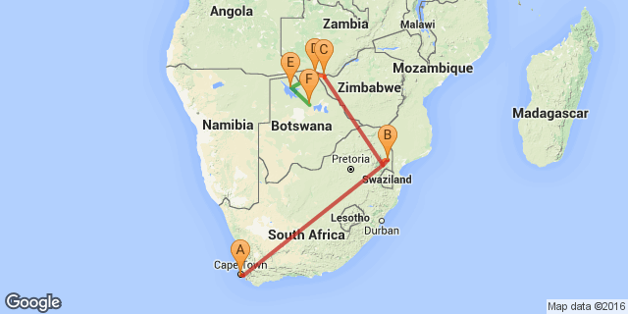

Click here to view your Digital Itinerary

Overview

Accommodation | Destination | Arr. | Dep. | Nights | Basis | Room Type
Ellerman House | Cape Town | 15 Jun | 18 Jun | 3 | D, B&B | 1x Deluxe House Room
Lion Sands Ivory Lodge | Sabi Sand Private Game Reserve | 18 Jun | 20 Jun | 2 | FB+ | 1x Villa Suite
Victoria Falls Hotel | Victoria Falls, Zimbabwe | 20 Jun | 23 Jun | 3 | D, B&B | 1x Central Deluxe Room
Chobe Game Lodge | Chobe River Front | 23 Jun | 26 Jun | 3 | FI | 1x Suite
Vumbura Plains | Okavango Delta | 26 Jun | 28 Jun | 2 | FI | 1x Family Tent(s)
Leroo La Tau | Makgadikgadi Pans National Park | 28 Jun | 30 Jun | 2 | FI | 1x Luxury Safari Room

Key
RO: Room only
SC: Self Catering
HB: Half Board
B&B: Bed and breakfast
D, B&B: Dinner, bed and breakfast
FB: Dinner, bed, breakfast and lunch
FB+: Dinner, bed, breakfast, lunch and activities daily
FI: Fully inclusive

Price
ZAR34240 Per person sharing

Included
Accommodation as per the itinerary Activities as specifiedAll road transfersAll charter flights (scheduled)

Excluded
Items of a personal natureScheduled Flights Levies other than specifiedTravel Insurance

Day 1: Wednesday, 15 JuneEllerman House, Cape Town

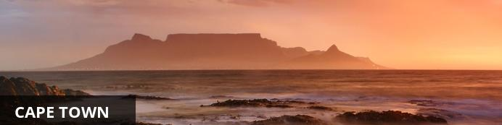
Resting at the confluence of the Indian and Atlantic Ocean, sandwiched between the slopes of the iconic Table Mountain and the glistening sapphire waters of Table Bay, the exceptionally scenic city of Cape Town is in a class of its own. Some cities boast rich culture, vibrant nightlife, a cosmopolitan atmosphere and extraordinary architecture, while others boast breathtaking landscapes and extraordinary natural wonders. Cape Town, is lucky enough to be blessed with all of these attractions and so much more. With its bustling harbour, world-class beaches, top-notch vineyards, and its mountainous surroundings brimming with diverse flora and fauna, Cape Town consistently captivates the hearts of all who visit.

Day Notes
Welcome to Africa! On arrival in Cape Town, you will be met by your driver and transferred to Ellerman House. After freshening up, you will be transferred to town for a short city sightseeing tour before returning to the hotel for dinner.

Overnight: Ellerman House View iBrochure
With 13 rooms and suites, two ultra-modern villas and a tranquil spa, Ellerman House is the quintessential urban retreat for discerning luxury travellers wanting complete exclusivity and privacy in Cape Town. Located in Bantry Bay, the hotel offers spectacular Atlantic Ocean views and easy access to beaches and local attractions. Highlights include the owner’s extensive South African art collection and the Ellerman House Wine Gallery, offering an interactive wine experience amid a vast collection of South African vintage wines. Modern, locally inspired cuisine, generous-hearted hospitality and a tailor-made concierge service enhance a world-class guest experience that remains authentically South African.
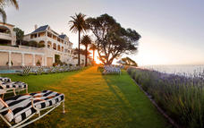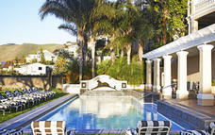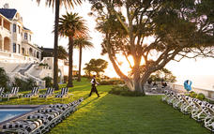

Alternate: One&Only Cape Town View iBrochure
Welcome to One&Only Cape Town, South Africa's premiere urban chic resort bringing an unprecedented level of luxury and style to one of the world's most fascinating cities.
With captivating views of Table Mountain from its enviable location in the Victoria & Alfred Waterfront, the resort is a destination unto itself. Discerning travellers are invited to discover the celebrated cuisines of Nobuyuki “Nobu” Matsuhisa and Reuben Riffel, socialise in the high-energy vibe of Vista Bar & Lounge and sample rare and undiscovered vintages at the stunning Wine Loft. The sublime calm of the city's most expansive and sophisticated spa offers an indulgent escape, while NEO Boutique debuts an enviable collection of designer fashions, some available for the first time in South Africa.
As the first luxury hotel to open in Cape Town in nearly a decade, the resort is designed to celebrate the city's wine, art, design and spirit, balancing contemporary glamour with an authentic South African style.
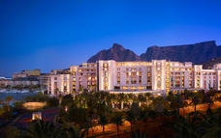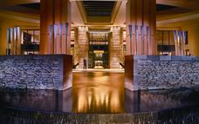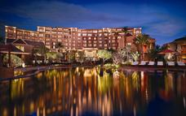

Activities
Cape Town Sightseeing Tour

Transfers
Date | Pick Up | Drop Off | Time | Vehicle
15 Jun | Cape Town International Airport [CPT] | Ellerman House | 0:00 | People Carrier

Included
Airport Transfer
Cape Town City Sightseeing
Dinner

Day 2: Thursday, 16 JuneEllerman House, Cape Town

Day Notes
During today, you will experience some of the highlights Cape Town has to offer. This morning you will be transferred to Table Mountain and enjoy a cable car ride up to the top of the famous mountain. In the afternoon, we you will travel by ferry to Robben Island and have a cultural tour of the island. The rest of the afternoon will be free to spend at your own leisure.

Activities
Table Mountain
Robben Island

Table Mountain
Without a doubt it is Table Mountain that makes Cape Town the unique city it is. Rising up over 1000m above sea level, it is the icon that makes Cape Town instantly recognizable. It is a symbol, a playground, a spiritual retreat and a big draw card for tourists. So intertwined with the identity of Cape Town is Table Mountain that a visit to the city isn’t complete without having walked or taken the cable car to the top.
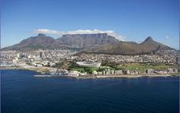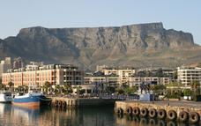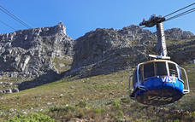

Robben Island
An icon of struggle, freedom and hope made famous by Nelson Mandela's imprisonment here.
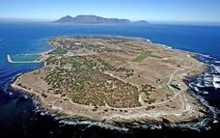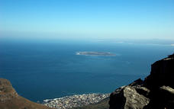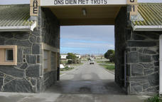

Included
Dinner, Bed and Breakfast

Day 3: Friday, 17 JuneEllerman House, Cape Town

Day Notes
You have the day free at leisure.

Private Cape Point Experience
Explore the 2 oceans
“This cape is the stateliest thing, and the fairest cape we saw in the whole circumference of the earth.” – Sir Francis Drake
In one day travel over 100 miles, traversing the coastlines of two oceans, the Atlantic and Indian, to pass along some of the most picturesque places in South Africa. Along the drive, find out how the peninsula became known as the “The Fairest Cape in the world" discovering the many ways there are to enjoy it.
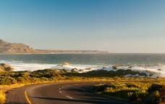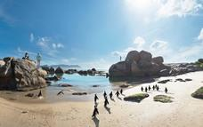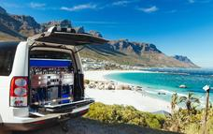

Atlantintic Dune Experience
Experience the awesome capability of a Land Rover Discovery (LR4), as you pilot yourself over white sand dunes! Savour a luxurious Luxury Africa picnic in the dunes and even try your hand at sand boarding. All-in-all it's a fun-filled day of luxurious adventure.
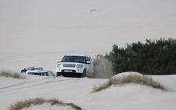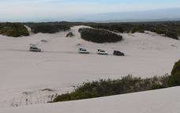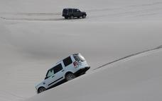

Included
Dinner, Bed and Breakfast

Day 4-6: Saturday, 18 June to Monday, 20 JuneLion Sands Ivory Lodge, Sabi Sand Private Game Reserve

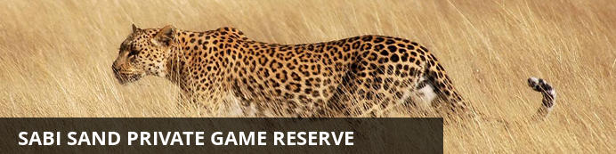
The Sabi Sands is South Africa's premier private game viewing destination. It was here that the southern African safari began and today this famous reserve offers exceptional game viewing and equally exceptional accommodations. Two perennial rivers, the Sabi and the Sand flow through this Game Park, sustaining the diverse fauna and flora of the area.
The success of leopard viewing within the Sabi Sands is legendary. Elephants, lion, rhino, buffalo, cheetah, giraffe, zebra and a vast variety of antelope and other species can be closely observed in their natural environment.

Notes
Depart on a transfer to the airport for a scheduled flight to Kruger National Park, via Johannesburg. On arrival, you will be transferred to the lodge. The next 2 nights will be spent at the lodge in the Sabi Sand Private Game Reserve, including game activities.

Overnight: Lion Sands Ivory Lodge View iBrochure
The Lion Sands Ivory Lodge is situated in the Lion Sands Game Reserve, one of Africa’s truly unspoiled wilderness areas, in the heart of the game-rich Sabi Sand Reserve adjacent to the world-renowned Kruger National Park. This international award winning lodge is ultra luxurious, yet simple and uncluttered. The lodge offers exclusivity and complete privacy, with each suite operated as a private villa. The public areas at Ivory Lodge provide: a private bar with fireplace, a library lounge, well stocked wine cellar, viewing decks, a magnificent River Island Deck built on the river, Africology Health Spa & gymnasium, and both an indoor and open-air (Boma) dining area
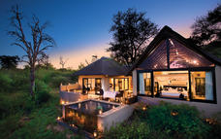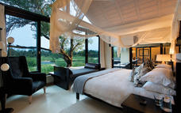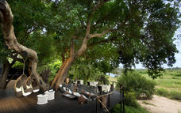

Flight Information
Date | Flight | Departure Airport | Time | Arrival Airport | Time | Class | Ref
18 Jun | SA123 | Cape Town International Airport [CPT] |  | Kruger Mpumalanga International Airport [MQP] |  |  | E1234567

Transfers
Date | Pick Up | Drop Off | Time | Vehicle
18 Jun | Ellerman House | Cape Town International Airport [CPT] | 0:00 | Perople Carrier
18 Jun | Kruger Mpumalanga International Airport [MQP] | Lion Sands Ivory Lodge |  | Opern Safari Vehicle

Included
Full Board and Activities

Day 6: Monday, 20 JuneVictoria Falls Hotel, Victoria Falls, Zimbabwe

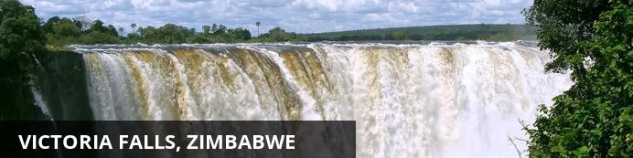
One of the original natural wonders of the world, the Victoria Falls is a World Heritage Site and an extremely popular tourism attraction. Known locally as ‘The Smoke that Thunders’ this spectacle is accessible from both Zambia and Zimbabwe and it is an ideal place to combine game viewing and water sports. There is excellent fishing, a terrifying bungee jump and arguably the best commercial white water rafting in the world.

Day Notes
Welcome to the world renowned Victoria Falls - the Smoke that Thunders! While here you will enjoy a variety of exciting activities. Just after check in, you will be taken on a cruise on the Zambezi River before returning to the hotel for dinner.

Overnight: Victoria Falls Hotel View iBrochure
The Victoria Falls Hotel, popularly known as “the grand old lady of the Falls”, is situated in the Victoria Falls National Park, a world heritage site, and is a member of the exclusive Leading Hotels of the World group. It is one of only three IS0-accredited hotels in Zimbabwe.The Edwardian-style five-star hotel, built in 1904, combines the charm of the old with the convenience of the new. Set in lush tropical gardens with lily ponds, palm trees and semi-tropical shrubs, it provides the tranquillity and seclusion that many guests seek. The famous Victoria Falls are just a ten-minute walk away using the hotel’s private pathway, and “the smoke that thunders” or “Mosi-O-Tunya” in the local dialect, is clearly audible and visible from this luxurious landmark.World-class service, and food and beverage choice and preparation second to none, make the hotel a magnet for international visitors and locals alike. The opulent Livingstone Room for fine dining and dancing, the Jungle Junction with its famous breakfast and dinner buffets and ethnic entertainment in the evenings, offer variety and wide choice. Stanley’s Terrace, with its clear view of the Victoria Falls Bridge, connecting Zimbabwe and Zambia, is renowned for its cocktails and afternoon teas. The Terrace has been a rendezvous for adventurers in Africa for over a century.The ambience of the hotel is steeped in that history with all suites decorated in the gracious Edwardian style of Zimbabwe’s colonial era. Small executive meetings and private dining facilities are easily arranged for those who wish to combine a little business with a lot of pleasure, and all in a secluded and discreet environment.It is the Victoria Falls Hotel that remains the major attraction for visitors. Waking up to the sound of “the smoke that thunders”, seeing the sun rise beneath the mist of one of the seven natural wonders of the world and the lunar rainbow at night, all the while soaking up the history and ambience of a bygone era, is more than unforgettable – it is unique.
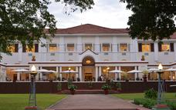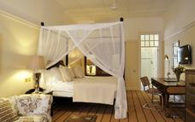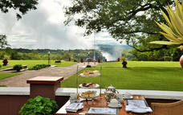

Central Deluxe Room
Furnished in traditional Edwardian style with an “Out of Africa” ambiance, the 46 Central Deluxe Rooms are situated in the main section of the hotel and are tastefully furnished with soft fabrics and warm colours in tune with Zimbabwe’s celebrated climate and diverse beauty. The Central deluxe rooms have a spectacular view of the perfectly manicured gardens and some overlooks the Batoka Gorge and the Victoria Falls Bridge. That spans the legendary Zambezi River.

Activities
Wild Horizons Sundowner Cruise
Dinner Jungle Junction

Wild Horizons Sundowner Cruise
The Zambezi River cruise is a superb way to relax and enjoy the beauty of the River. You may have the opportunity to see a variety of game; including hippo, crocodile and elephant in their home environment, as well as enjoy the many different bird species.
The Sunset cruise is very popular and includes finger snacks, beer, wine, local spirits and soft drinks. There are great photo opportunities against often-spectacular African sunsets.Flocks of birds skim the waterline as the sun sets behind the African skyline.Departures: Daily
Minimum / Maximum participants: Minimum: 2 Maximum: Unlimited
Times: 16h00 – 18h30
Duration: 2 hours
Language: English (French, German, Italian & Spanish available on private tours, at supplement cost – subject to availability)
Transfers: Transfers are included in the rate and guests are collected from all hotels and B&B’s in Victoria Falls town.
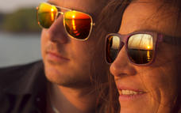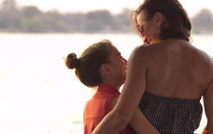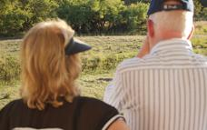

Jungle Junction
Dining at the Jungle Junction offers an unforgettable experience with a fusion of African flavours. Entertainment from ethnic groups epitomises the spirit of Africa. Jungle Junction is the ideal venue for incentives groups. The Jungle Junction has a maximum seating capacity of 140 pax.
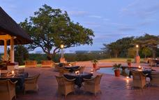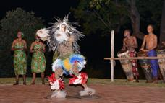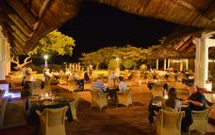

Flight Information
Date | Flight | Departure Airport | Time | Arrival Airport | Time | Class | Ref
20 Jun | SA123 | Lion Sands Ivory Lodge |  | Kruger Mpumalanga International Airport [MQP]
20 Jun | SA123 | Kruger Mpumalanga International Airport [MQP] |  | Victoria Falls International Airport [VFA]

Transfers
Date | Pick Up | Drop Off | Time | Vehicle
20 Jun | Victoria Falls International Airport [VFA] | Victoria Falls Hotel |  | Shuttle

Included
Dinner, Bed and Breakfast

Day 7: Tuesday, 21 JuneVictoria Falls Hotel, Victoria Falls, Zimbabwe

Day Notes
This morning you are up before breakfast, for a transfer to meet the elephants! After an unforgettable morning with the elephants, you will be taken on another close encounter - with the Falls themselves. Enjoy the rest of the morning meandering through the rainforest before returning to the hotel. You have the afternoon free to spend as you wish - enjoy any of the wide variety of activities available.

Activities
Wild Horizons Elephant Back Safari
Wild Horizons Tour of the Falls Zimbabwe
Dinner Jungle Junction

Optional
Wild Horizons Helicopter Flight (13 min)
Wild Horizons Zip Line
Wild Horizons Flying Fox
Wild Horizons Gorge Swing
Stanley’s Terrace
Livingstone Room

Wild Horizons Elephant Back Safari
• Departures: Daily
• Minimum / Maximum participantsMinimum: 1Maximum: 22
• Times:Morning Rides: 06h00 to 06h30 departure in summer and 06h30 to 07h00 in winter.Afternoon Rides: Between 15h00 and 15h20 departure in summer and 14h50 in winter
• Duration: 3 hours
• Language: English (French, German, Italian & Spanish available on private tours, atsupplement cost – subject to availability)
• Transfers: Transfers are included in the rate
• Please note: * Children below the age of 6 years will, not be able to partake in theElephant back Safaris. A Guardian must accompany children between 6 and 18 years.
Highlights & General Information:
Join Wild Horizons for an extraordinary and exhilarating journey along the edge of theZambezi gorges following ancient game trails. Seated comfortably on the back of naturestrue "king of the beasts", experience an age old tradition whilst silently exploring the majesticgrasslands of Victoria Falls National Park and marvel at the spectacular scenery of MasuieRiver plunging 120 m into the Zambezi River below.
Be witness to this mutually enriching and rewarding relationship between man and elephantin a modern day Africa. Sunrise safaris are run daily, promising you much more than just agame-viewing experience, but rather a closer insight into the world’s largest land mammal,the African Elephant. The Morning Safari includes a full English breakfast. The evening safariincludes complimentary drinks and snacks.
Our Ethics
All the elephants within our care are orphans for one reason or another, and we work closelywith the Parks and Wildlife management authority, offering haven to elephants in distresswithin the country. Our initial operations started in 1993 with a group of 4 young orphanedelephants requiring a home, having derived from a population reduction exercise carriedout in the late 1980’s by the Parks and Wildlife. Fortunately these methods of managingelephant populations are no longer practiced within the country. Since that time ourcomplement has grown, to at one stage 23 elephants, some of which have since beensuccessfully released into the wild.
Feeding and raising a young orphaned elephant is an extremely complex business with aspecially adapted milk formula being required as well as 24 hour supervision from staff.Young elephants will drink between 40 and 60 litres of milk formula per day which comes withsome large costs, however we are proud to say we have successfully raised a fair number ofthese orphans over the years. In addition we have cared for numerous young animals thathave been injured in poachers snares over the years, and through the Victoria Falls WildlifeTrust which we founded in 2007, we have assisted numerous other animals in distress bothwithin our reserve and indeed throughout Zimbabwe when required.
Our elephant back safari operation is controlled by an extremely comprehensive code ofconduct, and all our staff are trained at the highest level using a training manual developedover 20 years of operations. No form of abuse is tolerated when working with the elephantsand our elephant managers are pioneers in the industry who have been working withorphaned elephants since our operations began. Without the commercial side of ouroperations, it would be impossible to care for these animals with the very large input costsrequired for their care. Our elephants work for a maximum of 3 hours per day with guests, theremainder of their day spent free ranging on our sanctuary property, interacting with eachother and other wildlife as they would do naturally in the wild. Great care is taken to ensurethe welfare of the elephants within our care comes before any commercial gain.
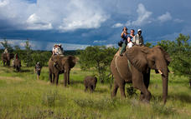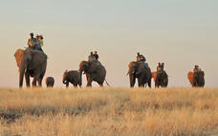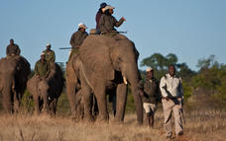

Wild Horizons Tour of the Falls Zimbabwe
The Victoria Falls – Now In Its 150 Millionth Fantastic Year - Reaches Its Zenith In About May each year. It's a truly awe-inspiring experience – the sight, the sound, the smell; the humbling feeling that here indeed is Nature's Supreme Masterpiece. No photograph can begin to depict the reality…and nothing prepares you for your first sight.
This tour is conducted in the morning and afternoon. En route, clients may be taken past the 'Big Tree' where they may stop and take photos. Clients will be accompanied through the Rainforest by one of our qualified Guides who will give a brief history of the Falls themselves as well as detailing the flora, fauna, bird & wildlife and other points of interest. Guides are also happy to assist clients with photographs whilst visiting this most spectacular of waterfalls. Raincoats are provided when needed.
Departures: Daily
Minimum / Maximum participants
Minimum: N.A
Maximum: Unlimited
Departure Times:
AM between 08h00 and 08h30 from hotels and B&B's in Victoria Falls TownPM between 13h20 and 13h45 from hotels and B&B's in Victoria Falls Town
Duration: 2 hours
Age Restrictions:
Minimum age: * Child Policies are available upon request
Maximum age: N.A
Language: English (French, German, Italian & Spanish available on private tours, at supplement cost – subject to availability)
Transfers: Included
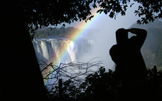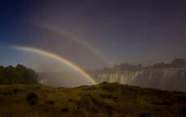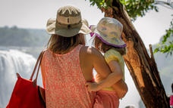

Jungle Junction
Dining at the Jungle Junction offers an unforgettable experience with a fusion of African flavours. Entertainment from ethnic groups epitomises the spirit of Africa. Jungle Junction is the ideal venue for incentives groups. The Jungle Junction has a maximum seating capacity of 140 pax.

Stanley’s Terrace
Stanleys Terrace is a must for light meals throughout the day. Traditional high tea is served every afternoon, with spectacular views of The Victoria Falls Bridge and the Victoria Falls themselves. Stanleys Terrace is the ideal location for sundowners and offers a table d'hôte menu with an a la carte menu on offer after 1100hrs. Stanleys Terrace has a maximum seating capacity of 100 pax.
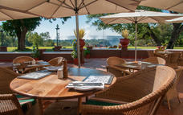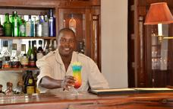

Wild Horizons Helicopter Flight (13 min)
The 13 minute and 28 minute flights depart regularly throughout the day and offer spectacular photographic opportunities. Guests are collected from their hotels 30 minutes prior to their flight departure time and are given a safety talk on arrival at the Helipad, near the Elephant Hills Inter-Continental Hotel. After take-off on the 13 minute Flight of Angels, the helicopter turns out towards the Victoria Falls.The pilot will fly circuits over The Falls in both directions giving guests the best viewing and photographic opportunities. A trip up river and back over the Zambezi National Park completes your flight.
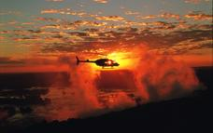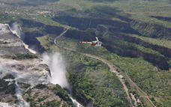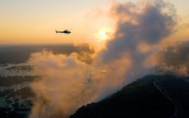

Wild Horizons Zip Line
Zip Line (Foofie Slide)
Hurtle at 106 km’s across the 425m gorge. Experience the adrenalin rush traveling a speed of 106 km’s hurtling 425m across the gorge, while suspended 120m above the breathtaking beauty of the Zambezi water below!
As the river zigzags down the Batoka Gorges, our cable is suspended across from one side to the other. For this product you are harnessed and attached to a pulley, then launched over the edge picking up speed as you descend over the water and reaching a speed of 106 km an hour.
This activity is totally safe for children above 2 years of age. Smaller children are harnessed with their parent/guardian and can enjoy high wire.
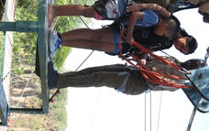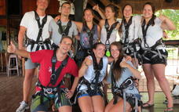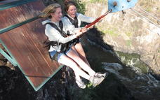

Wild Horizons Flying Fox
﻿The Flying Fox: Fly over the gorge! Take a running jump into thin air over the chasm, soaring horizontally through the air over the turmoil of the Zambezi below.
The Minimum age is 2 years old. This activity is totally safe for children of all ages. Smaller children are harnessed with their parent/guardian and can enjoy high wire.﻿
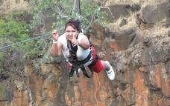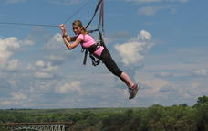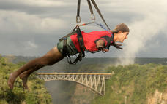

Wild Horizons Gorge Swing
Zero GravityImagine swinging in a child's swing in the playground...now imagine a giant swing 95m long and 120m high above water...now imagine a 70m free fall before you begin swinging. Stop imagining and test your courage!
Our Gorge Swing is suspended across the gorge at a point where the width is 316m and 120m deep. A harness is attached to the jumper and then the jumping ropes, the other end of which is pivoted to the middle of the cable. The jumper leaps off the edge of the gorge, free falling about 70m before going into a 95m long pendulum type swing.
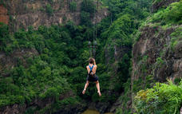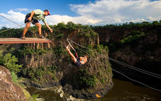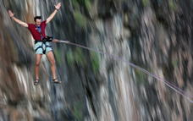

Livingstone Room
Enjoy dinner and dancing in the elegant Edwardian Livingstone Room, with classic a la carte and tables d'hote menus. Whilst the Livingstone Room reflects the century old hotel's style of grandeur and opulence, the dress code has been relaxed for the convenience of the guest. A fine selection of wine and liqueurs are available. Maximum seating capacity of 120 pax
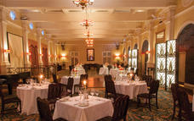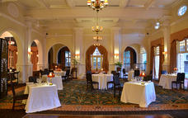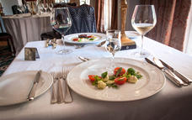

Included
Elephant back Safari
Tour of the Falls - Guided
Dinner at Jungle Junction

Excluded
Optional Activities

Day 8: Wednesday, 22 JuneVictoria Falls Hotel, Victoria Falls, Zimbabwe

Day Notes
Another early morning and onto the Zambezi River for a relaxing paddle. You have this afternoon free again to spend as you wish - relax at the hotel, soak in the local culture or enjoy more activities. This evening you will be transferred to The Boma Restaurant for an exhilarating dining experience to end of your time at the Falls.

Activities
Wild Horizons Upper Zambezi Canoe Trip
Dinner The Boma Restaurant

Optional
Wild Horizons Local Shopping Tour
Stanley’s Terrace

Wild Horizons Upper Zambezi Canoe Trip
Take a canoe safari with Wild Horizons and experience everything the stunning and charming Upper Zambezi River has to offer.
Depending on the choice of trip, you can get to experience some small but exciting rapids, lunches taken on remote sandbanks, overnighting in the pristine Zambezi National Park, drifting down seldom seen channels and all the excitement of the great African outdoors with its rich diversity of mammal, bird, fish and reptile life.
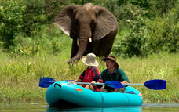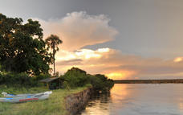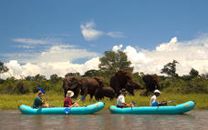

The Boma Restaurant
Described as an unforgettable African experience infused with Zimbabwean cuisine, spirited performances and traditional storytelling, The Boma – Dinner & Drum show has firmly established itself as a Victoria Falls highlight.
Partially open to the skies, The Boma specialises in a superb selection of Zimbabwean dishes. A four-course meal combines a choice of starters with a barbecue buffet. The adventurous are enticed with local delicacies such as mopani worms and potjiekos (hunter’s game stew), whilst those wishing to enjoy beef, pork, fish and chicken or a variety of vegetarian meals are welcome to do so.
The sights and sounds of the evening are accentuated by a feast of nightly entertainment, incorporating traditional dancers, who captivate guests with their vibrant songs and dance. The acclaimed Zambezi Drumbeat provides a wonderful interactive drumming experience.
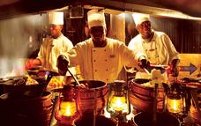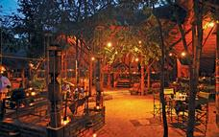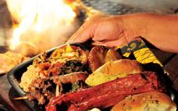

Stanley’s Terrace
Stanleys Terrace is a must for light meals throughout the day. Traditional high tea is served every afternoon, with spectacular views of The Victoria Falls Bridge and the Victoria Falls themselves. Stanleys Terrace is the ideal location for sundowners and offers a table d'hôte menu with an a la carte menu on offer after 1100hrs. Stanleys Terrace has a maximum seating capacity of 100 pax.

Wild Horizons Local Shopping Tour
Shopping in Victoria FallsThe Victoria Falls craft market offers varied shopping The goods on offer include colourful zimbabwe textilesA daily tour designed for those enthusiastic shoppers on the look out for bargains and keen to try their hand at the African system of 'barter-trade'. The tour visits open-air markets & crochet halls as well as a variety of gallery's & shops selling everything under the sun - almost!
Items on offer include all sorts of stone sculptures and authentic African art, local crochet, zimbabwe hand-made textiles, wooden carvings, Zimbabwean jewellery and more.
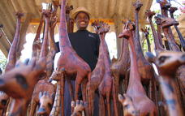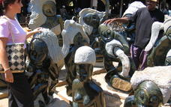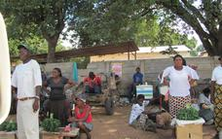

Included
Upper Zambezi Cruise - Guided
Dinner at The Boma Restaurant

Excluded
Optional Activities

Day 9-12: Thursday, 23 June to Sunday, 26 JuneChobe Game Lodge, Chobe River Front

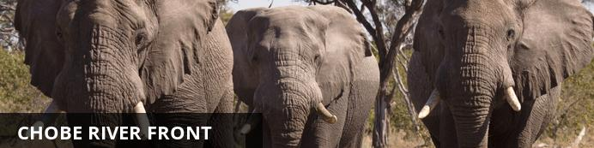
The Chobe River forms the northern boundary of the Chobe National Park, renowned for its reliable and diverse game viewing. Safaris are conducted both by boat and on land. This section of the park is best known for its elephant and hippo populations but the waters attract all manner of game including large herds of buffalo and the lions that prey on them.

Overnight: Chobe Game Lodge View iBrochure
Counter-balancing the wilderness are restful, air conditioned, en-suite lodgings. Graceful high arches, quarry tiled floors and barrel vaulted ceilings create an atmosphere of cool tranquillity. Other facilities include a large swimming pool with terrace, a riverside boma area, a stylish bar with an outside terrace, an expansive deck offering magnificent views over the Chobe River as well as conference facilities for business travellers. All meals are catered for in various locations throughout the lodge including the terrace, boma and riverfront deck.
Each of Chobe Game Lodge's 4 luxury suites has an individual plunge pool set on a private terrace with breathtaking panoramic views of the endless landscape and open plains. Graceful high arches, quarry tiled floors and barrel vaulted ceilings create an atmosphere of cool tranquillity. All 46 rooms are tastefully furnished, each room with hand crafted Rhodesian teak furniture and walls decorated with original African carvings and paintings.
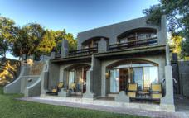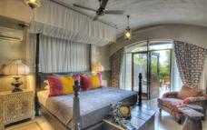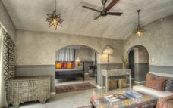

Suite
All the rooms at the lodge are river facing and air conditionedKing size beds Large private terrace and plunge poolEn-suite bathroom comprising of a bath, shower, hand basin and toiletCeiling fans in all guest rooms220V plug points for charging equipmentA range of Eco friendly products from shower gel, shampoo, hand wash, body lotion, shower caps and insect repellent are supplied in each roomA hairdryer is supplied in each roomTea and coffee facilitiesGowns and slippers supplied in each roomUmbrella’s for the rainy seasonSmall safe for valuablesTelephone in each guest rooms for wake up calls and guest convenience

Activities
Chobe Game Lodge game viewing
Chobe Game Lodge boat cruises
The Boma

Optional
Chobe Game Lodge birding experience

Chobe Game Lodge game viewing
Chobe's wildlife roams in abundance and diversity and is home to the largest concentration of elephant in Africa. During the dry season these large herds, as well as vast herds of buffalo, congregate along the fertile flood plains of the Chobe River where the animals come to drink, bathe and play. Lion, leopard, African wild dog, puku, red lechwe, sable, giraffe and roan antelope are often seen

Chobe Game Lodge boat cruises
Our professional all female guiding team and resident environmentalist conduct game drives and boat cruises

The Boma
Boma dining on the bank of the Chobe River

Chobe Game Lodge birding experience
Birding is spectacular with Schalows turaco, barred owlet and white-browed coucal resident in the gardens as well as rosythroated longclaw, western-banded snake-eagle and hooded vulture among a few of the 450 species of the Chobe region.

Transfers
Date | Pick Up | Drop Off | Time | Vehicle
23 Jun | Victoria Falls Hotel | Kazungula Ferry - Botswana |  | Shuttle
23 Jun | Kazungula Ferry - Botswana | Chobe Game Lodge |  | Open Safari Vehcile

Included
Fully InclusiveDrinks (Local Brands) Included

Day 12-14: Sunday, 26 June to Tuesday, 28 JuneVumbura Plains, Okavango Delta

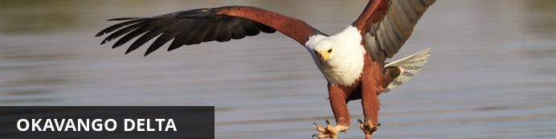
Lying in the middle of the largest expanse of sand on earth the Okavango Delta is one of Africa’s most amazing, sensitive and complex environments supporting a spectacle of wilderness and wildlife. Unique as one of the world’s few inland deltas, the placid waters and lush indigenous forests offer a safe haven for innumerable bird and wildlife species. The Okavango Delta offers a number of activities for the visitor; game viewing, birding and fishing are all on offer. One can experience this magical world of islands and waterways from land, air and water.
Highlights include the elusive Sitatunga antelope which has found refuge in this pristine wetland ecosystem, while birds such as the African fish eagle, Pel's fishing owl and many others provide a spectacular display.

Overnight: Vumbura Plains View iBrochure
Vumbura Plains is a luxury camp situated in the northern Okavango Delta, comprising two separate satellite camps, each with its own raised dining, lounge and bar area with a vista across the floodplains. The main area emphasises relaxation, furnished as it is with soft sofas and idiosyncratic objets d’art.
The 14 rooms, raised off the ground, are unique in contemporary design; the dimensions are square, with extensive use of light, wood and space. Each suite has a large, comfortable bedroom, sunken lounge with cushions, sala, en-suite facilities, an outdoor shower, private deck and plunge pool. Two family suites are also on offer with private decks linking the two separate rooms. Vumbura Plains offers both land and water activities, principally game viewing in varied habitats on open vehicles, mekoro and boats, providing an excellent all-round experience. The concession is leased from five villages through the Okavango Community Trust in a partnership that ensures that the benefits of ecotourism are shared with rural stakeholders.
NOTE: Ballooning offered from mid-April to September.
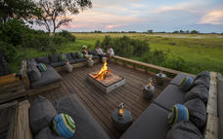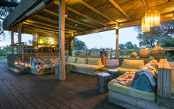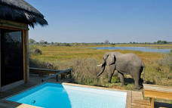

Family Tent(s)
There are two family tents at Vumbura North each accommodating four guests comprising two bedrooms each with own bathroom facilities. The main adult room has a large sunken lounge and spacious showers whilst the second child’s room is smaller and has standard facilities.
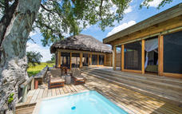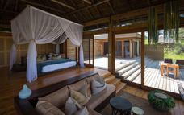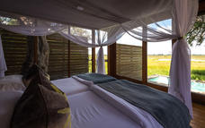

Activities
Vumbura Plains Camp - Game Drives
Vumbura Plains Camp - Night Drives
Vumbura Plains Camp - Mokoro Excursions

Optional
Vumbura Plains Camp - Boating
Vumbura Plains Camp - Nature Walks
Vumbura Plains Camp - Fishing
Vumbura Plains Camp - Birding
Vumbura Plains Camp - Cultural Visits*

Vumbura Plains Camp - Game Drives
Morning and afternoon game drives are offered in open 4x4 Land Rovers each accommodating a maximum of seven people allowing each guest a 'window' seat.

Vumbura Plains Camp - Night Drives
Night drives with spotlights allow you to find those nocturnal animals you might not see during the day.

Vumbura Plains Camp - Mokoro Excursions
There is no better way of viewing game and exploring the Okavango than by traditional mokoro (dugout canoe). These excursions reveal the fascinating smaller creatures of the Delta including colourful frogs and lively waterbirds.

Vumbura Plains Camp - Boating
Water-level dependent, boating is another idyllic form of water wildlife viewing. Vumbura has two boats seating six guests comfortably.

Vumbura Plains Camp - Nature Walks
On request, and depending on qualified guide availability, nature walks with skilled guides are wonderful ways of getting close to nature and observing the smaller things you miss when travelling by vehicle.

Vumbura Plains Camp - Fishing
Fishing is on offer seasonally on a catch-and-release basis. A limited supply of basic equipment is available at camp.

Vumbura Plains Camp - Birding
The birding around Vumbura Plains is exceptional all year round, with migrant species present in the summer. Pel's fishing-owl is regularly seen, with other specials like wattled crane and slaty egret.

Vumbura Plains Camp - Cultural Visits*
Visit one of the villages of the Okavango Community Trust, meet the people and learn about the local culture. *This activity is at extra cost.

Flight Information
Date | Flight | Departure Airport | Time | Arrival Airport | Time | Class | Ref
26 Jun | Scheduled Charter | Kasane Airport [BBK] |  | Vumbura Plains

Transfers
Date | Pick Up | Drop Off | Time | Vehicle
26 Jun | Chobe Game Lodge | Kasane Airport [BBK] |  | Open Safari Vehicle

Included
Fully InclusiveDrinks (Local Brands) Included

Day 14-16: Tuesday, 28 June to Thursday, 30 JuneLeroo La Tau, Makgadikgadi Pans National Park

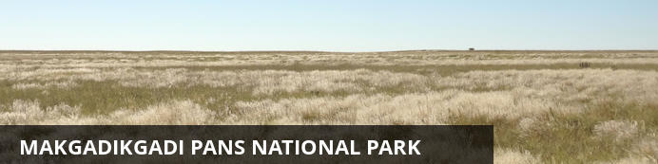
The Makgadikgadi Pans National Park covers an impressive 4900 square kilometer area and is brimming with natural wonders including the largest tree in Africa, a world famous 5300-year-old Baobab. Game viewing is at its best during the wet season when the plains teem with an extraordinary diversity of wildlife. The rains transform the salt pans into a magnificent lake attracting an abundance of wildlife and, most spectacularly, large flocks of gloriously pink flamingos. The area is renowned for its massive herds of wildebeest and zebra which migrate to the park en masse followed by a variety of predators including lion, cheetah and hyena. Popular activities include game drives, bird watching, exploring the salt pans on 4WD or quad bikes, tours of Gweta Village, and fascinating bush walks to historic sites guided by experiences Bushmen trackers.

Overnight: Leroo La Tau View iBrochure
Leroo La Tau rises majestically above the Boteti River which stretches across the western border of the Makgadikgadi Pans National Park.The park, populated by up to 30,000 zebra and wildebeest closely accompanied by predators, offers guests the chance to experience the exhilaration of seeing large concentrations of game and the resultant predator interaction. The lodge offers a raised hide above the river where guests can enjoy the spectacular wildlife sightings that we’ve come to expect in this part of Botswana.With just 12 thatched luxury chalets all overlooking the magnificent Makgadikgadi Pans National Park, each with en-suite bathrooms. There is a dining room, reading room and bar in the main lodge, expansive wooden decks and a plunge pool, where guests can immerse themselves seamlessly into the ultimate wildlife experience in Botswana. Having explored the area and enjoyed a spectacular wildlife phenomenon on guided day and night game drives, guests can retire after dinner to a splendid fireplace overlooking the river.
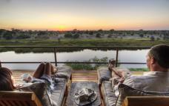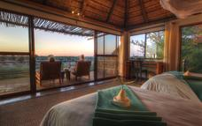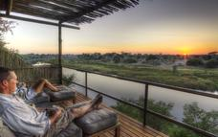

Luxury Safari Room
Luxurious thatched and glass fronted suites raised on wooden platformsAll raised on the high banks of the Boteti River with 270 degree panoramic view of the Makgadikgadi Pans National ParkEn-suite bathroom comprising of a shower, double hand basin and toiletFans in all guest rooms220V Plug points for charging equipmentA range of African bio degradable soaps, conditioning shampoo, hand wash, body lotion with insect repellent and shower caps are supplied in each roomA hairdryer is available from the lodge receptionTea and coffee making facilities in each roomFlashlight available in each roomGowns supplied in each roomUmbrella’s for the rainy seasonBattery operated reading lights and bathroom light at nightSmall safe for valuables

Flight Information
Date | Flight | Departure Airport | Time | Arrival Airport | Time | Class | Ref
28 Jun | Private Charter | Vumbura Plains |  | Leroo La Tau

Included
Fully InclusiveDrinks (Local Brands) Included

Day 16: Thursday, 30 JuneDeparture

Day Notes
The final day of your trip has arrived,

Flight Information
Date | Flight | Departure Airport | Time | Arrival Airport | Time | Class | Ref
30 Jun | Scheduled Charter | Leroo La Tau |  | Maun Airport [MUB]

Urgent Contact Numbers
Company Name | Telephone | Email Address | Contact Person
Wetu | +27 (0)21 674 5390 | terri@wetu.com | Terri Boshoff

Contact Details & Reference Numbers
Service Provider | Ref. Number | Telephone | Address
Cape Town International Airport [CPT] |  | 3333333
Chobe Game Lodge |  | +27 11 394 3873
Ellerman House |  | 0214303200 | 180 Kloof Road  Bantry Bay Cape Town 8005
Ellerman House | 1234
Leroo La Tau |  | +267 686 1243
Lion Sands Ivory Lodge |  | +27 11 880 9992
SAA Airways | E1234567
The Boma Restaurant |  | +263 13 43211 | 471 Squire Cummings Stand,  Victoria Falls  Zimbabwe
Wild Horizons Flying Fox |  | +263 13 44571 | 310 Parkway Dr  Victoria Falls
Wild Horizons Gorge Swing |  | +263 13 44571 | 310 Parkway Dr  Victoria Falls
Wild Horizons Helicopter Flight (13 min) |  | +263 13 44571
Wild Horizons Sundowner Cruise |  | +263 13 445 714 | POBox 156
Wild Horizons Zip Line |  | +263 13 44571 | 310 Parkway Drive  Victoria Falls

Travel Information
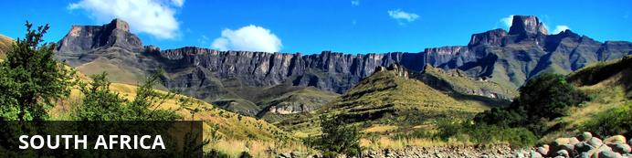
This vast country is undoubtedly one of the most culturally and geographically diverse places on earth. Fondly known by locals as the 'Rainbow Nation', South Africa has 11 official languages and its multicultural inhabitants are influenced by a fascinating mix of African, Asian and European cultures. Spend your days: discovering the gourmet restaurants, impressive art and nightlife scenes and fine beaches of Cape Town; enjoying a typical local braai (barbecue) in the Soweto township; browsing the bustling Indian markets in Durban; or sampling some of the world’s finest wines at the myriad wine estates dotted around the picturesque Cape Winelands. Due to its rich and turbulent history there are plenty of historical attractions to explore including the Zululand battlefields of KwaZulu-Natal, the Apartheid Museum in Johannesburg and Robben Island, just off the coast of Cape Town. Above all else, South Africa’s attraction lies in its remarkably untamed wilderness with its astonishing range of wildlife roaming freely across massive unfenced game reserves such as the world famous Kruger National Park. With all of this variety on offer, it is little wonder that South Africa has fast become Africa’s most popular tourist destination.

Banking and Currency
Currency
The currency is the Rand, which is divided into 100 cents. There are R200, R100, R50, R20 and R10 notes. Coins come in R5, R2, R1, 50c, 20c, 10c and 5c.
Banking
Banks are found in most towns, and are generally open from 09h00 to 15h30 on weekdays and 08h30 to 11h00 on Saturdays (Closed Sundays and Public Holidays). Most of them offer foreign exchange services - with cash, bank & credit cards as well as travellers cheques. You can also obtain cash from automatic teller machines (ATMs). Several international banks have branches in the main city centres. Always advise your bank that you are travelling outside of the country as they might block your purchases if they are not informed.

Travel, Transport and Getting Around
Travelling around South Africa is relatively easy by air, road and rail.
Principal air routes are serviced by SAA and British Airways, operated by Comair. There are 2 low-cost carriers on main routes, namely Kulula.com and Mango.
Facilitating travel around South Africa are 10 airports managed by the Airports Company South Africa (Acsa). In addition, there are some 90 regional airports, including the Kruger Mpumalanga International Airport in Nelspruit and the Skukuza Airport, offering access to the Kruger National Park.
An extensive tarred road system makes travelling in South Africa by vehicle convenient and easy. You will find gravel roads in rural areas though. Note:

Another means of getting around South Africa are luxury inter-city bus services such as Greyhound and Trans-Lux. Metrobus buses are available for in-city transport. Metered taxis must be ordered by telephone. There is a hop-on-hop-off bus in Cape Town and Johannesburg.
Our rail system includes the long-haul, inexpensive Shosholoza Meyl Metrorail trains. More luxurious options are the Blue Train, Premier Classe and the steam train Rovos Rail. There is also the new Gautrain rapid transit railway system in Gauteng Province which links Johannesburg, Pretoria, Ekhuruleni and OR Tambo International Airport.

Food, Drink and Cuisine Advice
Standards of hygiene in relation to food health and safety in South Africa, are generally high in hotels, restaurants, pubs and nightspots. Tap water in South Africa is safe to drink and cook with when taken from taps in urban areas. Not all tap water in rural areas is safe for consumption, so take precautions if necessary.
It is safe to eat fresh fruit, vegetables and salads, and put ice in your drinks. South Africa's fish, meat and chicken are of excellent quality, so there is no need to limit yourself when enjoying the local cuisine.
Restaurants are subject to South Africa's food safety control legislation, which is implemented by local government. Regulations include certification and regular inspections by health inspectors to ensure hygienic standards are maintained.
Street food is not as common in South Africa as it is in other countries, although vendors selling traditional snacks and meals can be found in city centres and townships. Food safety in such instances cannot always be guaranteed.

Climate and Weather
South African temperatures, which are measured in centigrade, average at highs of 28°C to average lows of 8°C in the summer months while winter temperatures range from 1°C at night to around 18°C in the day. Average annual rainfall is on the low side at under 500mm a year, making the country somewhat dry. Much of the rain falls in the Western Cape in the winter, differing from the rest of the country, which experiences summer rainfall. On the plus side, the South African climate boasts more than its fair share of sunshine, recording an average of 8.5 hours a day.

Clothing / Dress Recommendations
Summer
Bring clothes that are cool, light and comfortable because summer temperatures can get well into the 30 - 40 degree Celsius range in some areas.Also bring an umbrella or raincoat during summer as this is when most of the country gets its rain, but don't forget a swimming costume (bathing suit).
Winter
The winters are generally mild, comparing favourably with European summers. But there are days when temperatures dive, especially in high-lying areas such as the Drakensberg, so be prepared with jerseys and jackets. Cape Town gets its rain during the winter season so it’s advisable to bring rain gear along.
General
Always bring a hat, sunglasses and sunblock as the sun can be strong even in the winter months.
Walking shoes are a good idea all year-round, with warm socks in the winter.
If you are doing business in the country, business attire (suit and tie) is generally called for in the corporate sector, but media for example generally dress more casually.
For game viewing, a couple of neutral-toned items will be useful, but there's no need to go overboard. A good pair of walking shoes is also advisable.
For the evening, if you are dining at an upmarket restaurant or seeing a show, smart-casual attire is recommended.

Electricity and Plug Standards
Current is 220/240 volts at 50 cycles per second. A three-point round-pin adapter plug should be brought for your electrical appliances - such adapters are also available at major airports.

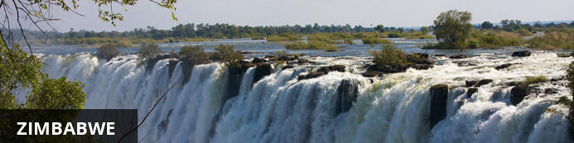
A nation of spectacular natural beauty, friendly people and rich culture, Zimbabwe’s status as one of Africa’s leading safari destinations was dampened for years by its political instability. But now that the country is transcending its strife and returning to a state of equilibrium, it is once again emerging as a vacation highlight of the continent. Victoria Falls – known to locals as ‘The Smoke That Thunders’ – is one of the seven natural wonders of the world and the sheer power of this massive body of water plunging into the Zambezi Gorge is awe-inspiring and unforgettable. Lake Kariba, with its game-rich shores and islands, is an idyllic safari spot featuring mind-blowing sunsets; Hwange National Park is known for its huge herds of elephants; and a kayak trip down the Zambezi through the Mana Pools National Park will appeal to the intrepid traveller, providing close encounters with crocodiles, hippos and a host of other wildlife.

Banking and Currency
Currency
Zimbabwe uses US$ as it's own unit of currency (the Zimbabwe Dollar) is suspended. South African Rands and Euros are also widely accepted. It is advised to carry small denominations of change with you, however it is best to pay for as much as possible outside of the country.
South African Rands work well in supermarkets, while US$ are preferred for curios, accommodation and activities.
Banking
Banks in Zimbabwe are open for business Monday, Tuesday, Thursday and Friday from 08h00 to 15h00, on Wednesdays from 08h00 to 13h00 and Saturdays from 08h00 to 11h30. They are closed on Sundays and Public Holidays.

Travel, Transport and Getting Around
Taxis are safe and reliable, and can be booked through your hotel front desk. Taxis in cities travel within a 40km radius of the city. Always take a taxi at night.
Major airlines fly into Victoria Falls, Harare and Bulawayo. Charter flights are available to most attractions and camps.
Zimbabwe has a good road infrastructure, by African standards, although potholed. Between major towns, there are frequent road blocks. Traffic drives on the left side of the road.

Food, Drink and Cuisine Advice
Zimbabwe's native cuisine is based on sadza, a cooked porridge made from ground maize which is normally be accompanied by some tasty relish, perhaps made of meat and tomatoes, or dried fish. Safari camps will often prepare sadza if requested, and it is almost always available in small restaurants in the towns.
Camps, hotels and lodges that cater to overseas typically serve a variety international fare, and the quality of food prepared in the most remote bush camps is usually excellent.
If you are driving yourself around and plan to cook, then get most of your supplies in main towns. Shoprite stores have revolutionised what's available, and really have all that you will need.
Water in the main towns is usually purified.. The locals drink it, and are used to the relatively innocuous bugs that it may harbour. If you are in the country for a long time, then it may be worth acclimatising yourself to it. However, if you are in Zimbabwe for just a short period of time, then try to drink only bottled, boiled, or treated water available in towns and from all camps, lodges and hotels.

Climate and Weather
In Zimbabwe, the rains come principally in December, January,February and March; the further north you are, the earlier the precipitation arrives and the later it leaves. Zimbabwe's higher eastern areas usually receive more rainfall than the lower-lying western ones.
By April and May most of the rain is gone, leaving a verdant setting, which is starting to dry out. Especially in more southerly and higher locations, the night-time temperatures start to drop.
The nights in June, July and August become much cooler, so don't forget to bring some warmer clothes, in case you want to spend an evening outside; the days are still clear and warm. For Zimbabwe, this is the start of the 'peak season'– days are often cloudless and game sightings continually increase.
Into September and October the temperatures rise once again: Zimbabwe's lower-lying rift valley – Mana Pools – can get very hot in October. During this time, you'll see some fantastic game, as the Zimbabwe's wildlife concentrates around the limited water sources.
November is unpredictable; it can be hot and dry, it can also see the season's first rainfalls – and in this respect it's a very interesting month, as on successive days, you can see both weather patterns.

Clothing / Dress Recommendations
When in Zimbabwe the cardinal rule is to wear casual, comfortable clothes during the day as temperatures can get very hot. It is advisable to wear light loose fitting clothing, such as cotton or linen, as they are cool and easy to wash. Warmer clothes are advised for the evenings and rainwear for the wet season.
A brimmed hat and sunglasses are a good idea year round. Long sleeved shirts and long trousers will also guard against the scourching sun rays. It is recommended you wear light shoes, especially if your itinerary entails a lot of walking.
For safaris, please remember to wear appropriate clothing and shoes. Earth colour clothes, such as browns, greens and tans are advisable.

Electricity and Plug Standards
Current is 220/240 volts at 50 cycles per second. Both square and round plugs are used.

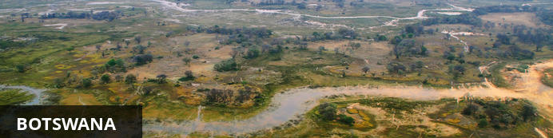
Despite recent and surprisingly rapid modernization, Botswana’s cities provide little in the way of tourist attractions. However, what the cities lack in excitement, the surrounding wilderness areas more than make up for in outstanding natural beauty. The country’s primary tourist draw card is undoubtedly the vast red expanse of the Kalahari desert and its remarkably beautiful Okavango Delta - the largest inland delta in the world provide a haven for an abundance of African wildlife. Other highlights include the impressive Makgadikgadi salt pans where visitors are privy to massive zebra migrations during the flood season; the Savuti plains which host large prides of lions; and the Tsodilo Hills where 4500 rock paintings form a unique record of human settlement over many millennia.

Banking and Currency
Currency
Botswana's currency is Pula (which means 'rain' in Setswana). It is divided into 100 thebe (which means 'shield' in Setswana). Travellers' cheques and foreign currency may be changed at banks, bureaux de change and authorised hotels.
The US dollar, Euros, British Pound and the South African Rand are the most easily convertible currencies (and accepted by some estabishments - but, generally, then an inflated rate of exchange will be applied).
Banking
Seven main commercial banks, as well as a number of foregin exchange bureaux, operate in Botswana. Operating hours are Monday to Friday 08h30 to 15h30 and Saturday 08h30 to 10h45.
Full banking services are available in major towns, although ATMs are sprouting up all over the country. Most credit cards are accepted at hotels and restaurants. Cultural sites and community art and craft outlets usually only accept cash.

Travel, Transport and Getting Around
Public transport in Botswana is geared towards the needs of the local populace and is confined to main roads between major population centres. Although cheap and reliable, it is of little use to the traveller as most of Botswana’s tourist attractions lie off the beaten track.
Driving off the main roads in Botswana is only recommended to expects in 4x4 vehicles, that are equipped correctly. Most lodges offer transfers or they can be arranged. If, however, you will be driving in Botswana: your home driving licence will be accepted (with an official English translation if necessary; driving is on the left side of the road; and the national speed limit is on tarred roads is 120km/h and 60km/h in towns and villages.
Be sure to watch out for wild animals on the roads!
There are major airports in Maun, Kasane and Gaborone, while smaller charter flights are used to get to the other top attractions and camps.

Food, Drink and Cuisine Advice
Tap water is considered safe to drink, although outside main cities and towns, visitors are advised to check first and sterilise water if in any doubt. Bottled water is available in most tourist centres. Filtered water is available at most camps and shops offer bottled water - it is advised to be well stocked of bottled water if you are travelling off the beaten track. Milk is pasteurised, and dairy products, local meat, poultry, seafood, fruit and vegetables are generally safe.
Safari lodges and camps serve international-style cuisine, generally of an extremely high standard, along with local beer and imported wine and spirits. Good restaurants and bars can be found in main towns, often within hotels. Beef and goat are very popular meats. Elsewhere, food is more basic: millet and sorghum porridge are the local staples.
A discretionary 5 to 10% tip is typical for restaurant bills. In many places, a service charge is automatically added. It is customary to tip the game guide and lodge staff while on safari.

Climate and Weather
Botswana's climatic pattern is typical of southern Africa, although its rainfall is less than countries further east. The rains in Botswana come mostly between December and March, when average minimum temperatures are in the low 20°s. Some days will be bright and sunny, some will have afternoon thunderstorms, and some will just be grey.
As with Namibia, April and May in Botswana are generally lovely, with the sky clear and the landscape green. Night temperatures start to drop during these months, especially in the Kalahari. Note that places in and around the Okavango tend to have less extreme, more moderate temperatures than the drier areas of the Kalahari.
From June to August the night-time temperatures in drier areas can be close to freezing, but it warms up rapidly during the day, when the sky is usually clear and blue. It's now very much 'peak season' for most safari areas: the land is dry in most areas so the animals congregate around the few available water sources.
This continues into September and October, when temperatures climb again, drying the landscapes and concentrating the game even more. This is the best time for big game safaris – although October can feel very hot, with maximum temperatures sometimes approaching 40°C.
November is difficult to predict, as it can sometimes be a continuation of October's heat, whilst sometimes it's cooled by the first rains; it's always an interesting month.

Clothing / Dress Recommendations
In summer, lightweight, lightcoloured cottons are preferable. Avoid synthetic materials and black clothing, as they increase perspiration and discomfort. In winter, wear trousers, longsleeved shirts / blouses and jerseys. From May – August, night temperatures can fall below zero degrees celsius, so warm jerseys and jackets are vital, especially on morning and evening game drives. Garments of neutral colours that blend with the bush and forest are advisable for safaris and game viewing. Bring a lightweight jacket and/or jersey for unexpected temperature changes or rain. Closed, comfortable walking shoesor gym shoes are a must in all seasons. Special attention should be given to protection from the sun. Bring a sunhat, good quality sunscreen, sun lotion and polarised sunglasses. Wide brimmed sun hats are essential.

Electricity and Plug Standards
Electrical sockets (outlets) in Botswana are the "Type M " South African SABS1661 ("Large" 15 amp BS-546) sockets. This is actually an old British standard. The "Type M " South African plug and socket is not to be confused with the "Type D " Indian plug and socket. In pictures, they look very similar, but the South African type is much larger than the Indian type, and they are physically incompatible. If your appliance's plug doesn't match the shape of these sockets, you will need a travel plug adapter in order to plug in. Travel plug adapters simply change the shape of your appliance's plug to match whatever type of socket you need to plug into.
Electrical sockets (outlets) in Botswana usually supply electricity at between 220 and 240 volts AC. If you're plugging in an appliance that was built for 220-240 volt electrical input, or an appliance that is compatible with multiple voltages, then an adapter is all you need.
But travel plug adapters do not change the voltage, so the electricity coming through the adapter will still be the same 220-240 volts the socket is supplying. If you need to use appliances that are not compatible with 220-240 volt electrical input, you will need a voltage converter.

Terms and Conditions
This is where you would put your standard terms and conditions. This is a sample account for Wetu so we do not have any T & Cs

