South African Surprise

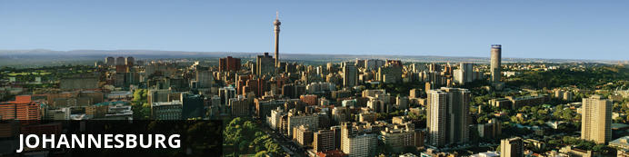
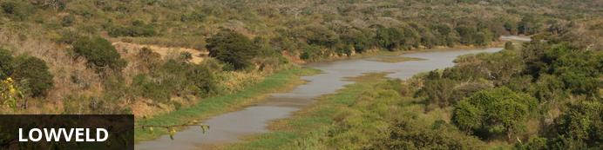
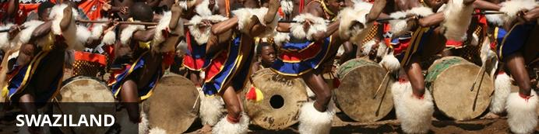
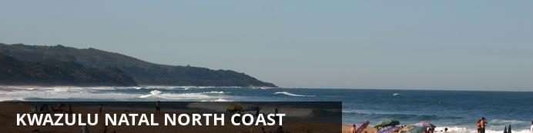
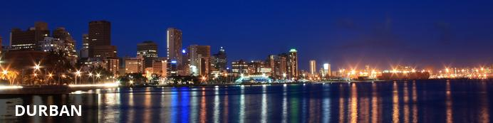
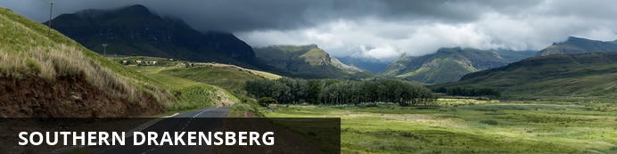
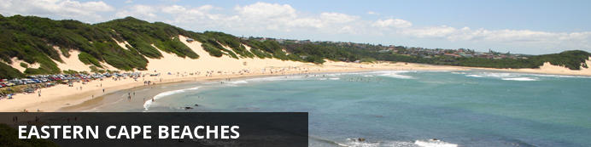
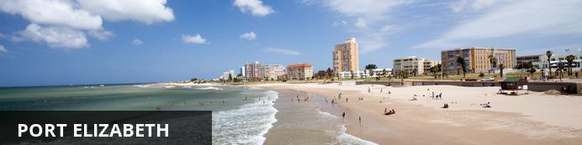
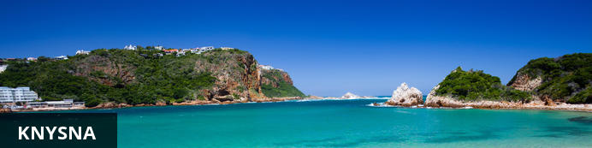
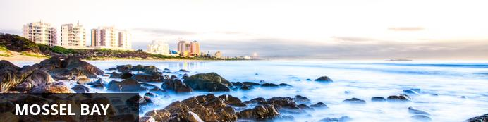
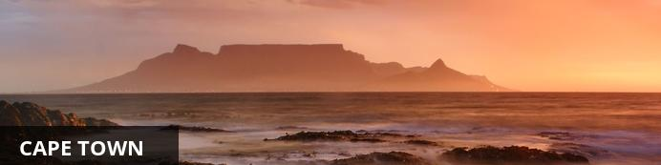

South African Surprise
Johannesburg - Lowveld - Swaziland - KwaZulu Natal North Coast - Durban - Southern Drakensberg - Eastern Cape Beaches - Port Elizabeth - Knysna - Mossel Bay - Cape Town
15 Days / 14 Nights
Min-02 Persons/ Max-40
Reference: 2016 FUNDAMENTALS

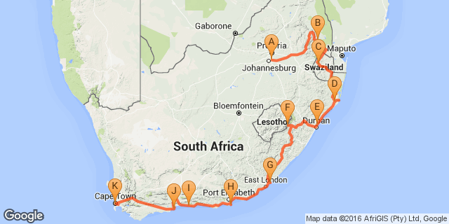

Overview
SOUTH AFRICAN SURPRISE
15 days Fully Guided Iconic Highlights Journey- Fundamentals
Johannesburg | Hazyview | Kruger National Park | Swaziland | Zululand | Durban | Drakensberg | Eastern Cape | Port Elizabeth |Knysna | Mossel Bay | Cape Town
It’s an adventure unlike any other - South Africa is a vast land of unimaginable beauty and diversity of experiences. Our Journey is set to take your breath away.

Accommodation | Destination | Nights | Basis | Room Type
Protea Hotel OR Tambo International | Johannesburg | 1 | B&B
Hippo Hollow Country Estate | Lowveld | 2 | B&B
Lugogo Sun | Swaziland | 1 | B&B
Protea Hotel Umfolozi River | KwaZulu Natal North Coast | 1 | B&B
Protea Hotel Umhlanga Ridge | Durban | 1 | B&B
Drakensberg Gardens Golf & Spa Resort | Southern Drakensberg | 2 | D, B&B
Crawford's Beach Lodge | Eastern Cape Beaches | 1 | D, B&B
Garden Court King's Beach | Port Elizabeth | 1 | B&B
Knysna Hollow Country Estate | Knysna | 1 | B&B
Garden Court Mossel Bay | Mossel Bay | 1 | B&B
SunSquare Cape Town | Cape Town | 2 | B&B

Key
RO: Room only
SC: Self Catering
HB: Half Board
B&B: Bed and breakfast
D, B&B: Dinner, bed and breakfast
FB: Dinner, bed, breakfast and lunch
FB+: Dinner, bed, breakfast, lunch and activities daily
FI: Fully inclusive

Included
Dining Inclusions
14 Breakfasts | 4 Dinners
Plus
Arrival airport shuttle transfer and departure transfer included.
Kruger National Park Conservation Levy included.
Hotel porterage included.
(Please note that conservation levies are subject to increase without prior notice and is at the discretion of the game park.)

Excluded
Optional Touring Activities
Meals and beverages where unspecified
Gratuities
Items of a personal nature

Day 1: Protea Hotel OR Tambo International, Johannesburg

South Africa
This vast country is undoubtedly one of the most culturally and geographically diverse places on earth. Fondly known by locals as the 'Rainbow Nation', South Africa has 11 official languages and its multicultural inhabitants are influenced by a fascinating mix of African, Asian and European cultures. Spend your days: discovering the gourmet restaurants, impressive art and nightlife scenes and fine beaches of Cape Town; enjoying a typical local braai (barbecue) in the Soweto township; browsing the bustling Indian markets in Durban; or sampling some of the world’s finest wines at the myriad wine estates dotted around the picturesque Cape Winelands. Due to its rich and turbulent history there are plenty of historical attractions to explore including the Zululand battlefields of KwaZulu-Natal, the Apartheid Museum in Johannesburg and Robben Island, just off the coast of Cape Town. Above all else, South Africa’s attraction lies in its remarkably untamed wilderness with its astonishing range of wildlife roaming freely across massive unfenced game reserves such as the world famous Kruger National Park. With all of this variety on offer, it is little wonder that South Africa has fast become Africa’s most popular tourist destination.

Johannesburg
Johannesburg is one of Africa’s biggest and most vibrant cities. It is the economic capital of Africa and the gateway to Southern Africa. Although not as famous as other South African destinations, there is plenty to do in Johannesburg and nearby Pretoria. The old city is a multi-cultural mixture of traditional medicine shops, Chinese restaurants, taxi ranks and ultra modern skyscrapers. There are excellent museums, art galleries and organised tours of historical and political interest. The shopping is Southern Africa’s best and the many restaurants cater for all tastes. The nearby township of Soweto is Johannesburg’s most popular tourist attraction.

Day Notes
Day 1: (Sun) Johannesburg
Upon arrival you will be met and assisted to your shuttle transfer service to the hotel. You have the remainder of the day at leisure until 19h00 when we all meet at the hotel reception for a briefing on the tour and a chance to meet up with your fellow travellers.
Accommodation: Protea Hotel OR Tambo or similar

Consultant Notes
Accommodation check in on Day 1 is from 14h00.
Shuttle service on Day 1 starts at 06h15 and ends at 22h45. If you are arriving on a very early morning flight or late evening flight please inform your tour operator in order to make alternative transfer arrangements.

Overnight: Protea Hotel OR Tambo International
Time-conscious local and international business travelers will enjoy this convenient hotel located 35 minutes from Sandton and Pretoria, and situated just 800m from the Rhodesfield Gautrain Station. Whether stopping over or have an extended business stay ahead, Protea Hotel O.R. Tambo Airport has everything travelers need. Here, no detail has been spared to ensure that business travelers can conduct their day-to-day business efficiently and comfortable, with each room provides a direct dial telephone, large executive work desk and a laptop safe. There’s also the vibrant á la carte restaurant, relaxing bar with free Wi-Fi, swimming pool and health club. If you’re conducting business, ask about our state-of-the-art conference facilities.
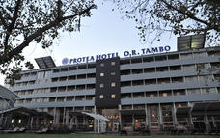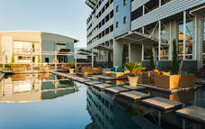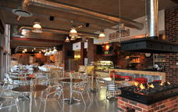

Activities
Thompsons Africa 15-Seater Mini Coach
Thompsons Africa Guest Services
Thompsons Africa Tour Guides

Optional
Soweto Day Tour
Johannesburg Tour

Thompsons Africa 15-Seater Mini Coach
15-Seater Touring Midi Coach – Mercedes Sprinter LWB
• Cloth bucket seats (reclining)
• Air Conditioning/ Climate Control
• Radio/ CD/ MP3 Player
• Multi AV public address system
• Individual reading lights
• Parcel shelves
• Seatback storage net & tray table
• Compact refrigerator
• Blinds or curtains
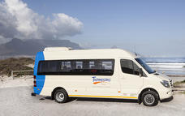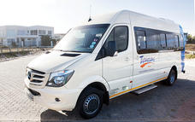

Thompsons Africa Guest Services
Traditionally, airport meet & greet services involve a friendly welcome and possibly some explaining of documentation and directing towards transport services. Over the years travellers have higher expectations of the companies they travel with. In our efforts to exceed expectations on modern travel demands, our Guest Service experience has expanded its offerings to its international guests and now plays an important role in assisting travellers in various situations. From escorting guests to foreign exchange or cellular rental outlets, to tracing and returning lost luggage, assisting with document explanations, as well as minor to serious emergency situations – we cover it all. Our team of Guest Service Officers are strategically located in all major centres in Southern Africa. They are easily recognisable, carrying branded sign boards, and are available 24 hours a day – even visiting guests in hospital should they fall ill on their journey. Offering comfort and support to travelling companions of indisposed, sick or injured guests is also a vital part of our service
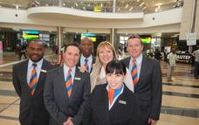

Thompsons Africa Tour Guides
Journeys with Our Specialist Guides The very best calibre of staff has been employed as our permanent specialist guides. Consistently being awarded as winners in various Guiding categories such as Western Cape Guide, Tour Guiding Excellence and Best Tour Guide of the Year, many of these passionate staff members hold university degrees in marketing, photography, tourism and education but have chosen to place their focus on realising the dreams of our guests. Join them on one of our exciting guided journeys – you will be completely blown away by their knowledge, excitement and passion! They speak English, German and Spanish, and our wider network of guides speak most other languages.
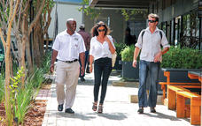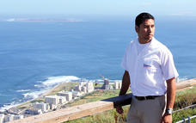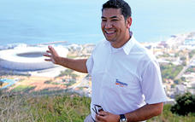

Soweto Day Tour
A Soweto Day Tours takes in the highlights of this iconic township including Nelson Mandela’s former home and the Hector Pieterson museum (he was one of the school children who was shot in the 1976 Soweto Uprising).
You will get close to Soweto Culture, meeting the people, trying local foods and maybe even some Omqombothi (our traditional beer) at a shebeen.
This tour is one of a kind, the smell of pavement cooked meals and the buzz in the streets of people going about their daily chores. Come and experience township life, the humanity, hospitality and warmth of the people, the "Ubuntu" as it is known in South Africa.
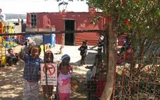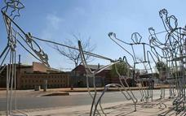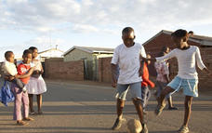

Johannesburg Tour
Johannesburg Southern Africa's economic powerhouse and although it is the city of gold there are many attractions aside from mining. Much of the big business has moved from the old town but the fascinating stories and historical buildings remain. Major sites include the Carlton Centre (Africa’s tallest building), the iconic Brixton Tower, Newtown, the Constitutional Court, the Nelson Mandela Bridge and the Origins Centre.
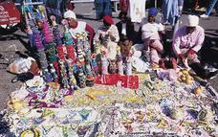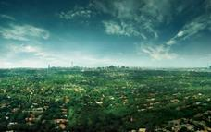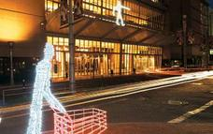

Included
Accommodation

Day 2: Hippo Hollow Country Estate, Lowveld

Lowveld
The Mpumalanga Lowveld lies between the northernmost reaches of the Drakensberg Escarpment and the Kruger National Park. It is renowned for its sub-tropical climate, excellent farming areas and great access to the game reserves and attractions of the Panorama Route.

Day Notes
Day 2: (Mon) Hazyview (BB)
This morning we leave for Mpumalanga, dropping several hundred feet into the lush subtropical region of the Lowveld. Travel along the circular Panorama Route via Graskop, visiting the view sites of the Blyde River Canyon, one of the natural wonders of Africa; gasp at the glory of God’s Window, with a boundless view of mountains and fertile plains and finally a visit to Bourke’s Luck Potholes before heading to Hazyview.
Accommodation: Hippo Hollow Country Estate
Distance travelled today: 500 kms

Overnight: Hippo Hollow Country Estate
Hippo Hollow Country Estate is situated outside Hazyview on the Sabi River between the Drakensberg Mountains to the west and the low-lying bushveld to the west. It is the ideal destination from which to access the reserves of the Lowveld and the sights of Mpumalanga. Hippo Hollows is only ten minutes from the Kruger National Park and the panoramic route which includes Pilgrim's Rest, Graskop, Bourkes Luck Potholes, God's Window, the Blyde River Canyon, and the many fantastic waterfalls of the escarpment is close by. Hippo Hollow Country Estate provides the ideal breakaway from the rigorous of city life. The hotel has an 'Out of Africa ' feel about it, and leaves you feeling totally relaxed and refreshed.
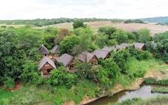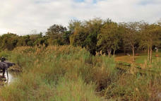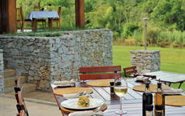

Activities
Panorama Route
Blyde River Canyon
Bourke's Luck Potholes
God's Window

Panorama Route
The Panorama Route is one of the most beautiful parts of South Africa connecting the Lowveld and the amazing geological features of the Mpumalanga Drakensberg. One of the major highlights of the region is the Blyde River Canyon Reserve, the third largest canyon of its kind in the world and home to spectacular wildlife and birdlife. Other highlights include the breathtaking waterfalls in Graskop and Sabie, Lisbon and Berlin Falls, Gods Window and the Gold Rush territory, Pilgrim’s Rest, home to the early gold prospectors.
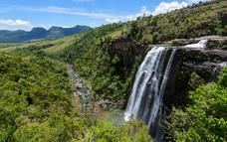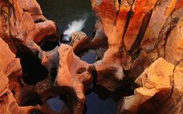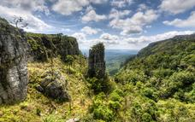

Blyde River Canyon
The third largest canyon in the world, the Blyde River Canyon is exceptional for being the largest forested canyon in the world. The views from the rim are spectacular, especially the renowned view that includes the Three Rondavels. There are mountain reedbucks on the escarpment, dassies on the canyon walls, hippo and crocodile in the Blyde Dam and a rich selection of birdlife throughout, including a breeding colony of the rare bald ibis.
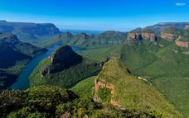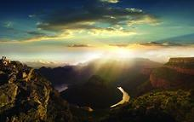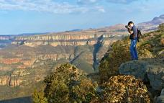

Bourke's Luck Potholes
The Treur River plunging into the Blyde River has caused waterborne sand and rock to create huge potholes, some six metres deep, into the bedrock of the river. This natural water feature is known as Bourke’s Luck. There is a well-developed picnic area here and a series of walkways and bridges that enable visitors to get great views of this amazing geological feature. Another attraction at Bourke's Luck is the visitors' centre, which has numerous interesting displays. A newly developed, 180 m circular trail, accessible to the physically disabled, starts at the visitors' centre and has as its main theme the lichens found in the area.
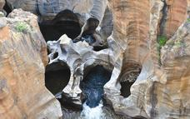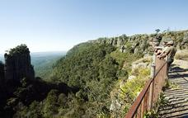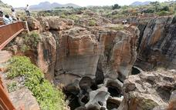

God's Window
God’s Window looks out over the Drakensberg escarpment dropping 1000m below, offering a view of the lowveld stretching out towards the Kruger National Park. Magnificent montane forest, canyons, rock formations and waterfalls can all be seen.

Included
Accommodation & Breakfast

Day 3: Hippo Hollow Country Estate, Lowveld

Day Notes
Day 3: (Tue) Kruger National Park (PB)
We have a bright and early start to the day in order to experience the wonders of exploring the Kruger National Park in our closed vehicle. Spend a morning with the Big Five in the Kruger National Park. The Kruger National Park is an internationally renowned game reserve of nearly 2 million hectares and supports the largest variety of wildlife species on the African continent. Keep a lookout for the wonderful flora and bird life that abounds. We return to our hotel around lunch time and your afternoon is at leisure.
Accommodation: Hippo Hollow Country Estate

Activities
Kruger National Park

Optional
Elephant Whispers
Shangaan River Club
Thompsons Africa Kruger Game Drive

Kruger National Park
At more than 2 million hectares the Kruger National Park is one of the world’s largest game reserves and a truly remarkable destination. Because of its exceptional size you can experience amazing diversity – from the scenery and ecosystems to the correspondingly amazing array of animals, trees and birds. A trip to the Kruger National Park is an unforgettable and potentially life changing experience.
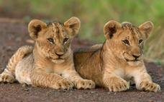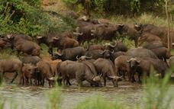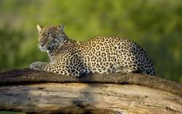

Elephant Whispers
WE INVITE YOU TO EXPERIENCE...
The thrill of close encounters with the Majestic African Elephant.
Witness their intelligence, compassionate nature and the sheer delight the elephant experience when interacting with their human counterparts. The Elephant Interaction offers you the opportunity to feel their constantly curious trunks, touch their rough skin, exchange trunk greetings and offer tasty treats, while learning about their behaviour and history from the Elephant Handlers. An Elephant Back Ride offers a different perspective; embark on a journey which was once a privilege reserved only for kings!
For those seeking a unique and memorable wildlife encounter, an Elephant Interaction and Ride at Elephant Whispers is an exciting and touching experience not to be missed.
Situated in the Sandford Conservancy on the banks of the Sabie River in Hazyview, Mpumalanga, Elephant Whispers offers an Elephant Experience of a lifetime which will leave you with a renewed respect and admiration for these gentle giants of Africa.
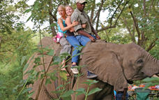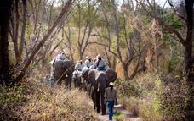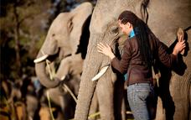

Shangaan River Club
Immerse yourself in a Feast of Culture, with a night of Shangaan song and dance, and an unforgettable African Banquet at the Shangaan River Club based at Hippo Hollow Hotel in Hazyview.
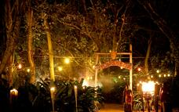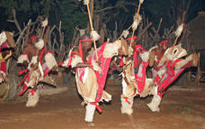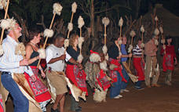

Thompsons Africa Kruger Game Drive
Kruger National Park 4x4 Open Safari Game Drives
10-Seater Open Safari Vehicle
• Bucket seats with lap belts
• Two-way communication radios
• Retractable waterproof side flaps
• Seatback ‘grab’ bars
• Non slip foot stirrups for easy boarding & disembarking
A safari in an open vehicle into Kruger National Park isn’t to be taken lightly. It’s a privilege beyond imagination, for this, one of the world’s most famous game reserves, is not only vast with a glorious diversity of wildlife and birdlife, it’s also renowned for its ever-changing African landscapes. For photographers, it’s a dream destination, with no fewer than 147 mammals and over 500 species of bird waiting for the click of your camera. Our qualified, experienced field guides know the terrain and the protocol intimately, and their skills, combined with the superb visibility afforded by our specially modified safari vehicles, guarantee you’re in the pound seats for a wonderfully wild experience. Kruger is teaming with game, big and small, and you’ll be as spellbound by the Big Five as the Little. Come on a real safari, and feel the difference.
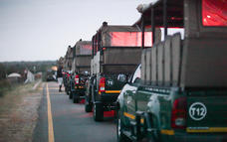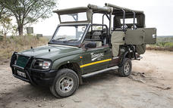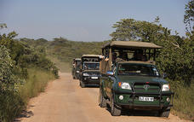

Included
Accommodation & Breakfast

Day 4: Lugogo Sun, Swaziland

Swaziland
This tiny, land-locked nation boasts a rich historical and cultural heritage. Swaziland encompasses a diverse array of ecosystems – towering mountains and low-lying savannah, tangled rainforests and lush river valleys. Highlights of this laid-back land include the mesmerizingly beautiful ‘Valley of Heaven’, the handicraft haven of the Malkerns Valley and the Hlane Royal National Park, famed for its white rhinos, antelopes and lions.

Swaziland
This tiny, land-locked nation boasts a rich historical and cultural heritage. Swaziland encompasses a diverse array of ecosystems – towering mountains and low-lying savannah, tangled rainforests and lush river valleys. Highlights of this laid-back land include the mesmerizingly beautiful ‘Valley of Heaven’, the handicraft haven of the Malkerns Valley and the Hlane Royal National Park, famed for its white rhinos, antelopes and lions.

Day Notes
Day 4: (Wed) Swaziland (BB)
This morning after breakfast, we check out and depart on our journey to Swaziland. We proceed south to Malalane and then onto Swaziland where this afternoon you will visit a real Chief’s village and have the fantastic opportunity to gain an authentic knowledge of traditional Swazi culture
Accommodation: Lugogo Sun
Distance travelled today: 290 kms

Overnight: Lugogo Sun
The Lugogo Sun hotel is one of the fine Swaziland hotels that make up the Royal Swazi Spa Valley resort . The hotel’s location takes full advantage of the tranquillity of the surrounding Ezulwini Valley, allowing guests to feel completely relaxed upon driving onto the grounds. Surrounded by nature, mountains and a host of activities and facilities make for a memorable holiday. The hotel overlooks a sub-tropical garden and 72-par golf course landscape and numerous in-house activities, as well as external things to do you’ll never be short of things to do.
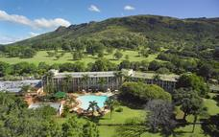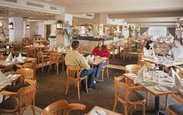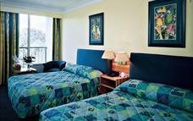

Activities
Swaziland
The Mantenga Cultural Village

Swaziland
This tiny, land-locked nation boasts a rich historical and cultural heritage. Swaziland encompasses a diverse array of ecosystems – towering mountains and low-lying savannah, tangled rainforests and lush river valleys. Highlights of this laid-back land include the mesmerizingly beautiful ‘Valley of Heaven’, the handicraft haven of the Malkerns Valley and the Hlane Royal National Park, famed for its white rhinos, antelopes and lions.
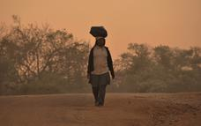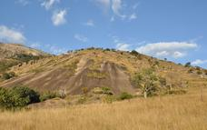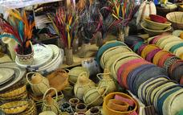

Included
Accommodation & Breakfast

Day 5: Protea Hotel Umfolozi River, KwaZulu Natal North Coast

KwaZulu Natal North Coast
The KwaZulu Natal North Coast offers spectacular beaches all along its coastline and is divided into two distinct sections. Just north of Durban are the well developed beach resorts and golf courses, while the far north provides miles and miles of unspoilt beaches, wetlands and lake systems. So whether you’re after a 5-star hotel overlooking a beach, or camping in the dunes and diving with dolphins, the KwaZulu Natal coastline has it all and more.

Day Notes
Day 5: (Thu) St Lucia and surrounds (BB)
This morning we journey through Swaziland into Zululand. Our journey continues into the Kingdom of KwaZulu-Natal where ancient traditions and modern cultures of both Zulu and Settler have combined into a vibrant society living in peace and harmony. Arrive this afternoon in the Umfolozi area for your overnight stay.
Accommodation: Protea Hotel Umfolozi
Distance travelled today: 435 kms

Overnight: Protea Hotel Umfolozi River
This hotel is ideally located in the Greater Hluhluwe/Umfolozi Game Reserve area, just 40km north of Richards Bay. Activities near Protea Hotel Umfolozi River include the Greater St. Lucia Wetlands Park, Hluhluwe/Umfolozi Game Reserve, world-renowned birding spots, whale and dolphin watching, boat cruises, horse riding, golf, fishing, kayaking, beaches and quad bike trails. It’s a hotel that complements your travel style. Dining facilities at the hotel include a restaurant and bar, with conference facilities available for up to 400 delegates seated in school-room style, while banqueting facilities for weddings, launches or cocktail parties are available for up to 240 guests.
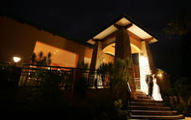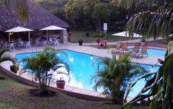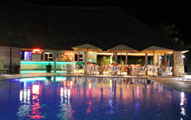

Activities
Zululand
Swazi Candles

Optional
Hluhluwe Imfolozi Game Reserve
Thompsons Africa Hluhluwe Game Drive

Zululand
The well watered valleys have been home to the Zulus, their cattle and wildlife for centuries and today Zululand is a fascinating mix of tribal lands, game reserves and commercial agriculture.
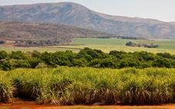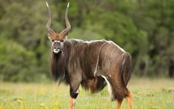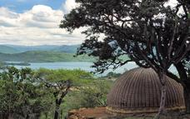

Hluhluwe Imfolozi Game Reserve
The Hluhluwe-Umfolozi Game Reserve is the jewel in the crown of the KwaZulu Natal game reserves. Proclaimed in 1895, it is also the oldest game reserve in Africa. Initially two separate reserves, they were joined to create a single 94 000 hectare reserve which is home to one fifth of the world's black and white rhino population. It was here that the internationally acclaimed Operation Rhino started in the 1960s, successfully capturing and relocating white rhino to havens within South Africa and abroad. As a result, this country's white rhino population is now 12 times the 1960 count of 500. Today Hluhluwe-Umfolozi is focusing its efforts on saving the endangered black rhino, whose number in Africa dwindled from 14 000 to a pitiful 2 550 in the 1990s. The Hluhluwe-Umfolozi Game Reserve was the first reserve to introduce walking safaris and its Wilderness Trails are internationally renowned.
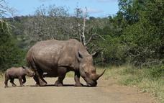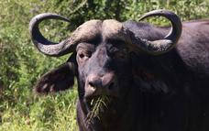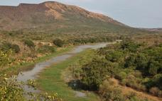

Thompsons Africa Hluhluwe Game Drive
If you visit Kwazulu-Natal, you can’t leave without visiting Big Five country in the oldest park in South Africa: Hluhluwe-Imfolozi. This is the legendary park where a dedicated team made worldwide conservation history with their successful efforts to bring the white rhino back from the brink of extinction. You won’t simply be enthralled with this game-rich reserve and the extraordinary beauty of the terrain, but also with the sense of history having been made here. Our specialist tours are all conducted in specially modified open safari vehicles to enhance your game viewing, and give photographers the very best vantage point to capture that perfect image.
We only tour with qualified, experienced guides, so you will not only be one step ahead because of their intimate knowledge of the animal movements and habitats, but you’ll learn more than you could have imagined possible about everything from trees, to animal spoor, to the rich bird life.
You’ll be in awe of the Big Five, but with increased knowledge, you’ll be equally spellbound by the smallest of creatures, the most beautiful of trees. You’ll be hooked on the camaraderie of being together when you meet that elephant, or spot that lion, and you’ll be back. That’s for sure.
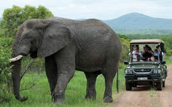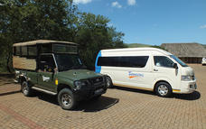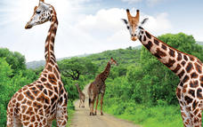

Included
Accommodation & Breakfast

Day 6: Protea Hotel Umhlanga Ridge, Durban

Durban
With its beautiful beaches, lively wining and dining scene, and rich cultural heritage, Durban is KwaZulu Natal’s the tourist hub. The swimming and surfing is rated the best of any major city across the world and because of the sub-tropical climate the water is warm all year round. Known as the Golden Mile, this stretch of beaches and amusement parks is Durban’s major attraction with the recently developed UShaka Marine World at the southern end providing a world class aquarium and other entertainments.

Day Notes
Day 6: (Fri) St Lucia and surrounds / Durban (BB)
Guests have the option to lie in or take an optional morning boat cruise (own account) or simply soak up the atmosphere of this tourist town St Lucia before heading off later in the morning towards Durban. An orientation tour introduces us to this multicultural, vibrant seaside city before arriving at our hotel late afternoon.
Accommodation: Protea Hotel Umhlanga Ridge
Distance travelled: 290 kms

Overnight: Protea Hotel Umhlanga Ridge
Explore some of the many attractions located along the KwaZulu Natal Coastline and discover an area rich in Zulu heritage, game parks and beautiful beaches. Conveniently located opposite the Gateway Theatre of Shopping and just minutes from the uMhlanga Beach and King Shaka International Airport, the Protea Hotel Umhlanga Ridge exudes urban tranquillity. Our leisure GUESTS have the freedom to indulge in a number of entertainment activities near the hotel, while business GUESTS can get everything done using our conferencing facilities. Equipped with modern furnishings and facilities, the hotel has an excellent restaurant that serves delicious meals in a relaxed atmosphere and a roof-level pool with stunning views over Gateway and uMhlanga. Each contemporary, Colonial-style room boasts laminated timber floors and a light, serene atmosphere perfectly suited to Durban’s climate. One look at the view will leave you wishing you could stay just one more day.
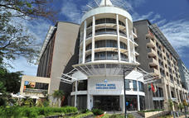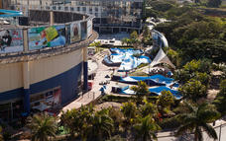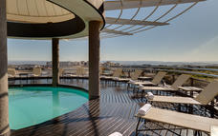

Activities
Durban Botanical Gardens
Durban
Gateway Shopping Mall
Umhlanga
St Lucia
Moses Mabhida Stadium

Optional
Thompsons Africa St Lucia Boat Cruise

Durban
With its beautiful beaches, lively wining and dining scene, and rich cultural heritage, Durban is KwaZulu Natal’s the tourist hub. The swimming and surfing is rated the best of any major city across the world and because of the sub-tropical climate the water is warm all year round. Known as the Golden Mile, this stretch of beaches and amusement parks is Durban’s major attraction with the recently developed UShaka Marine World at the southern end providing a world class aquarium and other entertainments.
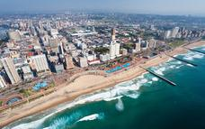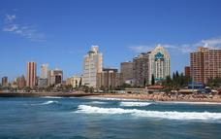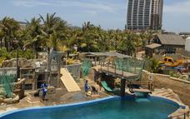

Gateway Shopping Mall
Gateway Shopping Centre comprises of 380 shops and various forms of entertainment, including an indoor and outdoor climbing wall, wave pool, skateboard rink, movie theatres and more. The centre makes up Kwazulu Natal’s largest shopping experience.

Umhlanga
Just outside of Durban is the seaside resort town of Umhlanga Rocks. The tropical weather and lush vegetation make this an enticing holiday destination, attracting visitors from all over the world. It is the perfect location for ocean enthusiasts and outdoor adventurers alike, with great opportunities for diving, swimming, scuba diving, whale watching, dolphin viewing, deep sea fishing and kite boarding. Umhlanga Rocks also offers some excellent golf courses for the avid golfer.
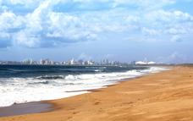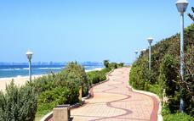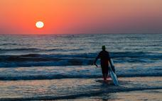

St Lucia
St Lucia lies on the St Lucia estuary, and is a haven of tranquillity that only unspoilt nature can provide. Entirely surrounded by the iSimangaliso Wetlands Park, the residents of little village are protective of their beautiful environment. Mountain biking, hiking, bird watching and deep-sea fishing present opportunities to enjoy the surroundings. From the town, you can catch the Santa Lucia ferry and take a trip around the lower reaches of the lake where you can view water birds, crocodiles and hippos wallowing in the shallows.
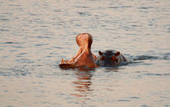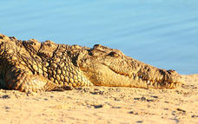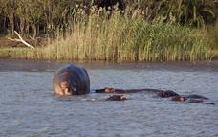

Moses Mabhida Stadium
Named after a former General Secretary of the South African Communist Party, the Moses Mabhida 2010 Stadium is set to be a world-class, multi-use stadium. The stadium was one of the host stadiums for the 2010 FIFA World Cup, thus its facilities are top of the line. An adjoining indoor area, football museum, sports institute and transmodal transport station are included on the stadium’s grounds.
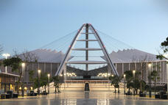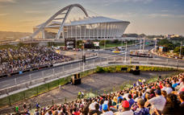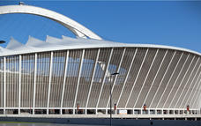

Thompsons Africa St Lucia Boat Cruise
All aboard the comfortable Santa Lucia, a spacious double-decker boat on St Lucia Estuary, with ample room for everybody to have the best view possible. We’re off on a two-hour relaxed interpretative cruise from the smartest vantage point – the water. We’ll get up close to the sight and sounds of hippo, crocodiles and other game species, and if we’re lucky, we’ll be serenaded by the haunting cry of the fish eagle...perhaps even watch one catch a fish. The boat has a coffee, snack and full bar on board, so relaxation is the order of the day.
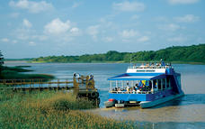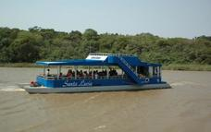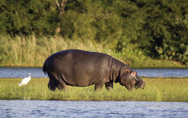

Included
Accommodation & Breakfast

Day 7: Drakensberg Gardens Golf & Spa Resort, Southern Drakensberg

Southern Drakensberg
The Southern Drakensburg is a wonderland of woodlands, forests, lakes and rivers, all set against the dramatic backdrop of this spectacular mountain range. Several nature reserves fall into the area and protect a wide variety of flora and fauna, including some rare antelope species and, at Kamberg, a network of beautiful hiking trails lead to caves decorated with ancient Khoisan art. Trout thrive in the region’s reservoirs and waterways, making it a magnet for fly-fishermen, while horse riding and mountain biking are also popular pursuits in this scenic part of the world. The ultimate highlight of the Southern Drakenburg, however, is the Sani Pass, which – at almost 3,000 metres above sea level – is South Africa’s highest pass, leading all the way to the Lesotho border and offering magnificent vistas along the way.

Day Notes
Day 7: (Sat) Drakensberg (BB,BD)
This morning, enjoy a leisurely breakfast or perhaps take an early morning cab ride to the bustling for a stroll along the Umhlanga Beach Promenade which buzzes with energy as surfers, joggers and cyclists take to this seaside playground. Then we head into the majestic Southern Drakensberg Mountains. We proceed on a visit to the 300 foot high Howick Falls, continuing through the Southern Midlands Meander Route, arriving at our hotel mid-afternoon. Your afternoon is at leisure to soak up the surroundings, or go fishing, hiking and even horse riding in clean mountain air (own account).
Accommodation: Drakensberg Gardens Resort Hotel & Spa or similar
Distance travelled today: 255 kms

Overnight: Drakensberg Gardens Golf & Spa Resort
In the foothills of the scenic southern Drakensberg, which forms part of the uKhahlamba World Heritage site, is the Drakensberg Gardens Hotel. This is Nature in all its glory - grandiose scenery composed of the Drakensberg mountain chain, rivers and lakes. The mountains form an immense amphitheatre dominated by the highest peak - Mont-aux-Sources (3248m). Wonderful diversity of flora and fauna await discovery. The resort is conveniently located on an 860-acre estate bordering KwaZulu Natal Wildlife land, allowing access to spectacular walks and hikes - the most strenuous being a 9 hour hike up the Rhino Horn 9842.4 ft (3000 metres) above sea level.
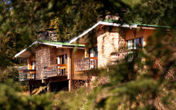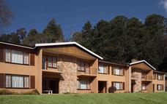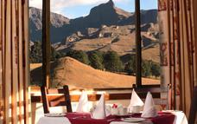

Activities
Howick Falls
Underberg
Nelson Mandela Capture Site
Central Drakensberg

Howick Falls
Howick Falls has a drop of about 95 m (311 feet) and their natural beauty and easy access combine with legends of suicide and murder making them into a popular attraction.

Underberg
Shaded by the majestic mountains of southern Drakensberg, the quaint little town of Underberg offers stunning natural beauty and fun activities. Forming part of the Sani Saunter, Underberg has access to a multitude of hikes.

Central Drakensberg
An imposing wall of rock that rises to 3000m, creating untold inspiring views and hikes. Known to the Zulus as the Barrier of Spears and to the first European settlers as the Dragon's Mountains. The Ukhahlamba Drakensberg is 1 of 8 South African UNESCO World Heritage sites, uniquely being on for both its significance as a natural resource and for the heritage of the San Paintings. For 1000s of years they hosted the San people and they in turn left their record on the walls on numerous sandstone caves. Today most of the Drakenberg is protected as a National Park and it is a major attraction for the lover of the outdoors.
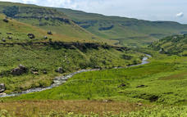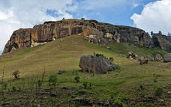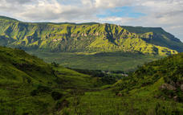

Included
Accommodation, Dinner & Breakfast

Day 8: Drakensberg Gardens Golf & Spa Resort, Southern Drakensberg

Day Notes
Day 8: (Sun) Drakensberg (BB, BD)
Full day at leisure to soak up the surroundings of the magnificent Southern Drakensberg Mountains. Today a host of leisure activities awaits you against a breath taking back drop of tranquil beauty.
Accommodation: Drakensberg Gardens Resort Hotel & Spa or similar

Activities
Southern Drakensberg

Optional
Sani Pass

Southern Drakensberg
The Southern Drakensburg is a wonderland of woodlands, forests, lakes and rivers, all set against the dramatic backdrop of this spectacular mountain range. Several nature reserves fall into the area and protect a wide variety of flora and fauna, including some rare antelope species and, at Kamberg, a network of beautiful hiking trails lead to caves decorated with ancient Khoisan art. Trout thrive in the region’s reservoirs and waterways, making it a magnet for fly-fishermen, while horse riding and mountain biking are also popular pursuits in this scenic part of the world. The ultimate highlight of the Southern Drakenburg, however, is the Sani Pass, which – at almost 3,000 metres above sea level – is South Africa’s highest pass, leading all the way to the Lesotho border and offering magnificent vistas along the way.
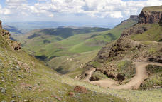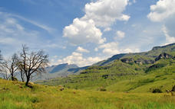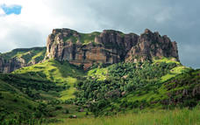

Sani Pass
The only driveable pass over the Ukhahlamba-Drakensberg Mountains.
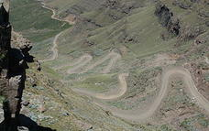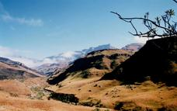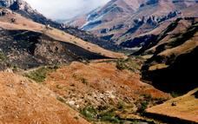

Included
Accommodation, Dinner & Breakfast

Day 9: Crawford's Beach Lodge, Eastern Cape Beaches

Eastern Cape Beaches
The Eastern Cape is endowed with some of the best beaches in South Africa – long stretches of fine white sand backed by hills blanketed with lush subtropical vegetation and, for the most part, blissfully uncrowded. The Indian Ocean waters that fringe this coast are mild throughout the year and support a myriad of marine life, including a wide array of fish species that make the region an angler’s idyll. South Africa’s most legendary surfing destination is located along the Eastern Cape coast: Jeffrey’s Bay, renowned for its long rides and world class barrels.

Day Notes
Day 9: (Mon) Eastern Cape Coast (BB, BD)
This morning we continue south to the Eastern Cape entering the fourth of the provinces and the birth place of Nelson Mandela (fondly known as Madiba). En route we see the old traditional way of life in the homeland area known as the Transkei and stop for lunch outside the capital of Umtata. We continue via Nelson Mandela’s birth place and house, arriving late afternoon at our accommodation in Chinsta East, on the beautiful, unspoilt Eastern Cape Coast.
Accommodation: Crawford’s Beach Lodge
Distance travelled today: 520 kms

Overnight: Crawford's Beach Lodge View iBrochure
Crawford's Beach Lodge, set along the magical Wild Coast, offers rustic luxury accommodation for the most discerning of travellers, who are looking for fun, sun and relaxation.
Crawford's is nestled in the middle of the beautiful Chintsa Bay on the Wild Coast, surrounded by rolling hills, lush tropical beach forests and overlooks the warm Indian Ocean. A romantic getaway to explore the many beautiful treasures the Wild Coast has to offer.
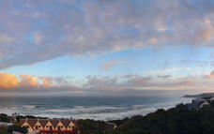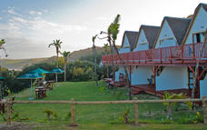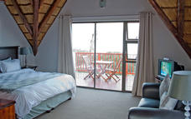

Activities
Mthatha
Qunu
Eastern Cape History
Eastern Cape Beaches

Mthatha
The most important urban centre in the Transkei, Umtata is a bustling city set on the Mtata River, named for the sneezewood (umtati) trees that grow along its banks. Once the capital of the Transkei homeland, Umtata now forms part of the Eastern Cape, but is still the economic and commercial hub of the region. Attractions include the Umtata Dam, with its picnic sites and water sports opportunities, and the Nelson Mandela Museum, which documents the life and times of this phenomenal man – South Africa’s most famous hero and freedom fighter – who grew up in a nearby village.

Eastern Cape History
The Eastern Cape has a rich history as it was here that black Africa in the form of the Xhosas, met with Afrikaners & English colonists met for the first time. From the late 1700s the Xhosa and the eastward moving Afrikaner Trek Boers clashed over cattle and land. This volatile situation was made worse by the arrival of the British 1820 Settlers the end result being 9 Frontier Wars. A portend of things to come as the colonists moved further north.

Eastern Cape Beaches
The Eastern Cape is endowed with some of the best beaches in South Africa – long stretches of fine white sand backed by hills blanketed with lush subtropical vegetation and, for the most part, blissfully uncrowded. The Indian Ocean waters that fringe this coast are mild throughout the year and support a myriad of marine life, including a wide array of fish species that make the region an angler’s idyll. South Africa’s most legendary surfing destination is located along the Eastern Cape coast: Jeffrey’s Bay, renowned for its long rides and world class barrels.
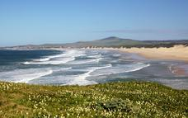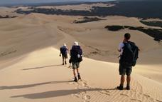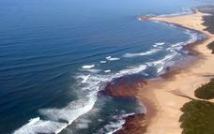

Included
Accommodation, Dinner & Breakfast

Day 10: Garden Court King's Beach, Port Elizabeth

Port Elizabeth
Port Elizabeth or PE is known as the Friendly City and the Windy City and hopefully if you stay here you will get a chance to experience the former and not the latter. Port Elizabeth was established to accommodate British settlers who were bought out on a government sponsored programme to provide a buffer between the warring Cape Dutch and the Xhosa. The little port grew from there and today it is the gateway to the Garden Route, as well as the Eastern Cape’s game reserves and beaches.

Day Notes
Day 10: (Tue) Eastern Cape Coast (BB)
We awake to the sounds of the crashing waves and have the morning at leisure to unwind with beach sand between our toes. The beach stretches on uninterrupted for many kilometres and the thick indigenous beach forest is a haven for an amazing variety of birdlife. We set off heading south to Port Elizabeth.
Accommodation: Garden Court Kings Beach
Distance travelled today: 340 kms

Overnight: Garden Court King's Beach
With spectacular views of Algoa Bay, Garden Court King’s Beach exposes guests to the scenic beauty of Port Elizabeth. For business travellers, the hotel’s proximity to the airport, harbour and national highway assure convenience.
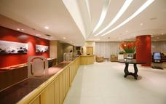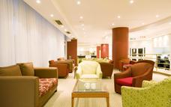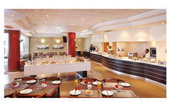

Activities
Port Elizabeth
Port Alfred
Port Elizabeth Beaches

Port Elizabeth
Port Elizabeth or PE is known as the Friendly City and the Windy City and hopefully if you stay here you will get a chance to experience the former and not the latter. Port Elizabeth was established to accommodate British settlers who were bought out on a government sponsored programme to provide a buffer between the warring Cape Dutch and the Xhosa. The little port grew from there and today it is the gateway to the Garden Route, as well as the Eastern Cape’s game reserves and beaches.
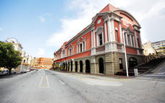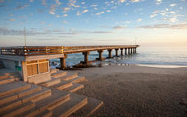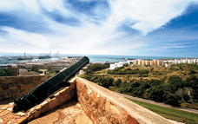

Port Alfred
Port Alfred boasts a great climate, warm water beaches, a Royal golf course, intimate small-boat harbour, and interestingly a world-class training facility for pilots and air traffic controllers. Visitors Royal Alfred Marina can enjoy boat cruises through the Marina canals and if you feel energetic you can hire a water pedalo or canoe to make the trip. The warm Indian Ocean and many inland water surfaces offer endless opportunities for bathing, boating, water-skiing, surfing, windsurfing, angling, diving, canoeing and bird watching.
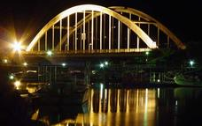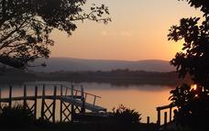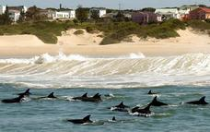

Included
Accommodation & Breakfast

Day 11: Knysna Hollow Country Estate, Knysna

Knysna
Nestled between the imposing Outeniqua Mountains and the Indian Ocean and surrounded by world-renowned forests, Knysna offers a wealth of activities for visitors. The beautiful lagoon and more than eight beaches provide opportunities to swim, surf, canoe, yacht, jet-ski, boat, fish, walk on soft sand and take ferry rides. Various markets offer organic goods, delicious food, indigenous plants and a social atmosphere. Mountains, valleys, lakes, forests and streams are ready to be explored. The region isn’t known as the “Garden of Eden” for nothing! A birding route is available for avid bird watchers. World class golf courses are at your doorstep. And of course the area is famous for the Knysna Heads and delicious oysters.

Day Notes
Day 11: (Wed) Knysna (BB, D)
Today our journey continues towards the Cape. Visit the Tsitsikamma Forest, which provides scenic walking opportunities. A short walk to the Storms River Mouth offers some magnificent views of the gorge and river below. Arrive in Knysna late afternoon for check in at our hotel.
Accommodation: Knysna Hollow Country Estate
Distance travelled today: 300 kms

Overnight: Knysna Hollow Country Estate View iBrochure
Knysna Hollow is beautifully set on a secluded old country estate near Knysna's famous lagoon. Set amongst timeless oaks and pecan trees, the gracious old manor house forms the focal point of the lodge. Built in a bygone era, it is finished with pressed ceilings, yellowwood floors and indigenous furniture. The Knysna Hollow Restaurant is situated in the Manor House and serves fine food in relaxed and warm surroundings. The scintillating, yet refined menu reflects flavours and influences from around the globe, with a selection of dishes sure to stimulate the senses. Choose between ocean-fresh seafood such as Cape Crayfish and linefish, South African specialties such as Karoo Lamb and Venison dishes or decadent desserts. Enjoy pre-dinner drinks next to a roaring fire in wintertime or in the yellowwood-panelled pub, "The Rutland Arms". Your Hosts, Clive, Danie & Grant, provide Cape hospitality at it's personal best and will assist in your selection of a fine wine.
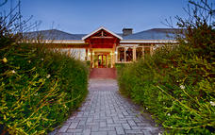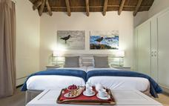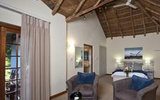

Activities
Tsitsikamma National Park
Storms River Mouth
Knysna Waterfront
Bloukrans Bungee Jump

Optional
Featherbed John Benn

Tsitsikamma National Park
Much of the indigenous forest in this eastern part of the Garden Route falls within the Tsitsikamma National Park. The park is not only a breathtaking haven for indigenous flora and fauna but also for marine life. A marine conservation belt forms part of the park, stretching five and a half kilometres out into the ocean.
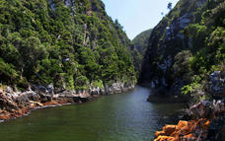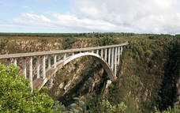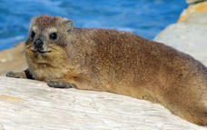

Storms River Mouth
The mouth of the Storms River is surrounded by national parks and accommodation, and offers plenty of fun activities. This is where the Otter Trail and Dolphin Trail start as well as numerous smaller hikes. Other activities include crossing the mouth via a suspension bridge, dining at the restaurant overlooking this beautiful site, and swimming and snorkelling in the sea.

Knysna Waterfront
The Waterfront is a central point of activity in Knysna. From here one can board a sunset cruise or ferry ride around the lagoon, do some shopping, enjoy a meal in one of the many restaurants and find accommodation for your stay in Knysna.
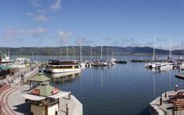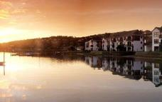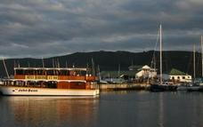

Bloukrans Bungee Jump
If it’s adrenalin you’re after, look no further than the Bloukrans Bridge. At 216 metres high and with a 7 second free fall, Bloukrans is the world’s highest bungy jump. Your experience of the highest bridge in Africa doesn’t have to include a bungy jump, however, as you can also participate in a walking tour of the structure.
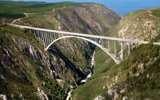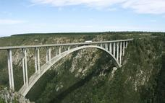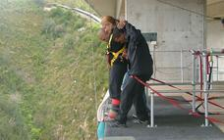

Featherbed John Benn
The Featherbed Eco tour offers our guests an UNFORGETTABLE, NATURAL and REAL experience!!
This pristine piece of paradise situated on the Western Head of Knysna is a privately-owned, registered Nature Reserve and a South African Heritage Site.
In order to protect the splendour of the natural beauty, access to the reserve is controlled. Visits are only permitted in the company of the reserve's specialist guides.
The nature reserve offers a Knysna adventure activity not to be missed. The eco tour begins with a cruise across the knysna estuary. On arrival at the nature reserve guests will enjoy a 4x4 trailer ride to the top of the Western Head. Here the optional 2.2 kilometre downhill guided walk will begin, passing through Milkwood forests onto the steep sandstone cliffs, into ancient Khoi-San sea caves and along a scenic coastal path fringed with aromatic fynbos.
Your guide will inform you on the fauna, flora and bird life in the reserve.
On the coastal walk back, you can often spot the resident Black African Oyster Catcher, one of the rarest coastal birds in South Africa.
The Food Forest Restaurant is situated on the edge of the Lagoon under a canopy of Milkwood trees where we serve the most sumptuous buffet lunch fit for a king.
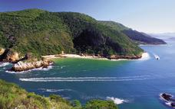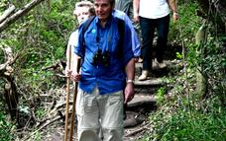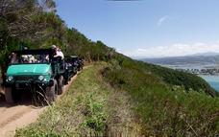

Included
Accommodation & Breakfast

Day 12: Garden Court Mossel Bay, Mossel Bay

Mossel Bay
Mossel Bay has rapidly grown from its days as a little fishing village and holiday resort. The big bay has long sandy beaches and the old town has plenty of historic and recreational attractions – not least of which is the Mossel Bay Golf Course. The course boasts a view of the sea from every tee and the chance to whale watch as you line up your next shot.

Day Notes
Day 12: (Thu) Oudtshoorn (BB)
After breakfast, we travel inland over the spectacular Outeniqua Pass to Oudtshoorn, known as the ‘feather capital of the world’ because of its ostrich industry. We visit a working ostrich farm and then explore the famous Cango Caves. Walk (the more adventurous may crawl!) around the famous Cango Caves with their magnificent dripstone formations of stalactites and stalagmites. Travelling back to the Eastern seaboard, we arrive in Mossel Bay in the late afternoon.
Accommodation: Garden Court Mossel Bay or similar
Distance travelled today: 315 kms

Overnight: Garden Court Mossel Bay
The historic town of Mossel Bay was crowned Town of the Year 2007/2008, and offers a number of local attractions for visitors to enjoy. These include beautiful beaches, a waterfront area with harbour, historical landmarks such as the Post Office Tree, and many coastal highlights that lie within the greater Garden Route too.
With just 42 en-suite rooms, accommodation is intimate and tastefully furnished. Furnishings are stylish with a classic yet modern design, while a host of comforts are included in each room to ensure a peaceful stay. These include tea and coffee making facilities, air-conditioning, television with DSTV, electronic safe, complimentary Wi Fi, writing desk, direct-dial telephones, 18-hour room service and other touches to put you at ease.
You will also be able to take advantage of our many services and facilities, including the Wellness Spa that provides plenty of pampering treatments. Dining is enjoyed at The Blue Hibiscus Restaurant, which is open for daily buffet breakfasts and all-day drinks from the bar; lunch and dinner is served at Red Cherry Restaurant (A la Carte) or The Admirals Restaurant (Buffet) while light snacks and drinks are offered at Bravo Lounge. Conferencing is also available for business guests.
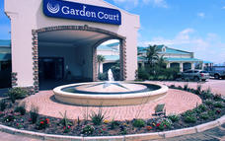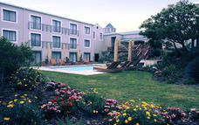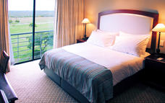

Activities
Outeniqua Pass
Cango Caves
Safari Ostrich Showfarm
Klein Karoo

Optional
Cango Wildlife Ranch

Outeniqua Pass
The road between George and Outshoorn has been upgraded four times and the Outeniqua Pass is the most modern and popular version. One of the world’s grandest road passes, the views are incredible.

Cango Caves
The spectacular Cango Caves are a subterranean wonderland of magnificent stalactite and stalagmite rock formations that attracts thousands of visitors annually. They extend more than two kilometres into the Swartberg Mountains and visitors can take guided tours that wind through narrow passageways and steep stairways linking the massive caverns.
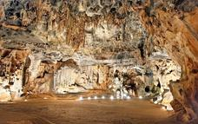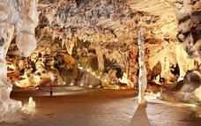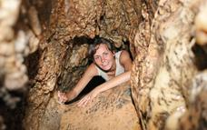

Safari Ostrich Showfarm
Safari Ostrich Show Farm is an operating farm where visitors will see large flocks of ostriches at different stages of development in the surrounding fields. Visitors are assured of personal attention and upon their arrival are greeted by one of our multi-lingual guides who will, during the course of the tour explain every aspect of ostrich farming, from breeding to rearing. The tour starts in the breeding camp, with a nest of ostrich eggs, where the first stage of the ostrich life cycle is explained. Visitors will get the opportunity to test the strength of the eggs by standing on them - a great photo opportunity. During the breeding season visitors get to see ostrich eggs hatching in the incubator rooms. Visitors get to sit on an ostrich and those who are brave enough can even try their hand at riding one. Every tour ends with an "Ostrich Derby" where local jockeys display their riding skills. A highly entertaining and educational tour is guaranteed.
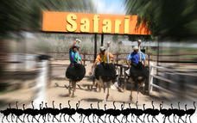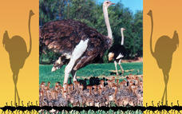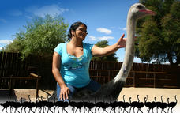

Klein Karoo
Towering mountains provide an awe-inspiring backdrop throughout the Klein Karoo and their rivers and stream give the fertile valleys a lush greenery which forms a stark contrast against the surrounding semi-desert landscape. Some of the renowned attractions of the Klein Karoo are the majestic Swartberg mountains with awe inspiring passes and gorges, the Cango Caves and ostrich farms of Oudtshoorn, and the fruit orchards of the Langkloof Valley.
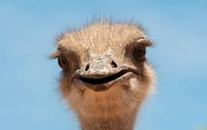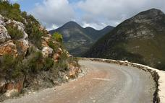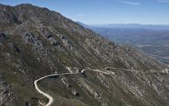

Cango Wildlife Ranch
The Cango Wildlife Ranch promotes awareness and conservation of endangered species, while encouraging supervised interaction – making this a wonderful destination for children of all ages. Housing the oldest and largest cheetah contact centre worldwide, visitors can view these powerful, speedy cats in a natural bushveld environment from elevated walkways. From predators of the land to predators of the water, visitors can then move on to the crocodile and alligator enclosures to study more of the world’s most dangerous beasts.
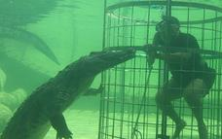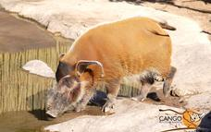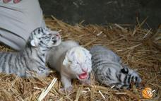

Included
Accommodation & Breakfast

Day 13: SunSquare Cape Town, Cape Town

Cape Town
Cape Town is one of the world's most beautiful cities and a top international destination. Large numbers of tourists flock to Cape Town to enjoy this unique city with its fascinating history, interesting culture, natural beauty, award winning wines and laidback lifestyle. Whether you are a serious tourist or just want to lie on the beach and enjoy life, Cape Town will satisfy your needs.

Day Notes
Day 13: (Fri) Cape Town (BB)
Today’s journey ends in Cape Town. After breakfast we explore Mossel Bay, visiting the famous Post Office Tree, the Bartholomeus Diaz museum and shell museum. In whale season (August to November) we travel to Hermanus and try to catch a glimpse of these majestic mammals from the world’s most famous land based whale watching site. Out of whale season, we drive via the towns of Swellendam, Robertson and Worcester (Route 62), then through the Huguenot Tunnel. Iconic Table Mountain greets us as we arrive in Cape Town in the late afternoon.
Accommodation: Sun Square Hotel – Cape Town or similar
Distance travelled today: 540 kms

Overnight: SunSquare Cape Town View iBrochure
For leisure travellers, it is beautifully positioned at the base of Table Mountain – one of the new ‘Seven Wonders of Nature’ and is close to Long Street, with its vast selection of chic restaurants and boutique shops, offering an array of daytime and night time activities. The hotel is also located within close proximity to main attractions in the area such as the V&A Waterfront, South African National Museum, VOC Company Gardens, Table Mountain Cable Stations and the gorgeous beaches of Camps Bay and Bloubergstrand. The hotel bedrooms are refreshingly modern and offer comfort and style, featuring stylish furnishings, warm lighting, contemporary flat-screen televisions, ultra-modern writing desks, electronic safes, as well as in-room fridges and super-cool new air conditioning. The en suite bathrooms also sport a new look with beautiful chrome and ceramic tile finishes. The hotel has 136 beautifully-appointed rooms that have been refurbished to deliver simple comfort and contemporary style. Rooms all have great views of Table Mountain or the vibrant city centre and come with en suite shower-bath combination or a shower only as well as a telephone, DSTV with a wide range of channels and individually-controlled air conditioning units. Other features in the rooms include ultra-modern writing desks, an in-room bar fridge and an electronic safe
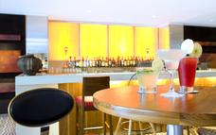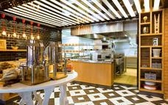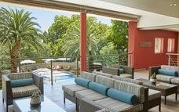

Activities
Diaz Museum
Aloe Factory Shop
Worcester
Huguenot Tunnel
Hermanus

Diaz Museum
The Bartolomeu Dias museum complex was officially opened on 3 February 1989, however the Mossel Bay museum industry can be traced back to the 1960’s when the Mossel Bay museum was first opened. The museum later became known as the Post Tree museum complex before being renamed again in 1989.
The Dias Museum Complex is situated near the beach, shops, restaurants, banks and the tourist information center. Inside the Maritime Museum is a shop where postcards, stamps, books, souvenirs and small gifts can be bought. On the grounds of the Dias Museum Complex are mountain tortoises, ducks and museum cat. In the Granary there are conference facilities available for 48 people or if used in cinema style, seating for up to 100 people. Catering can be arranged. Mail from the shoe is collected twice a day (once a day out of season) by the Post Office. Whales can be observed from the museum grounds during June to November.
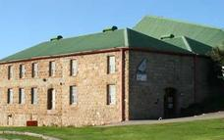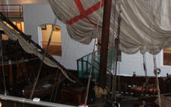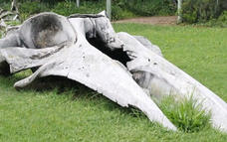

Aloe Factory Shop
The House of Aloes is the original aloe factory, established in 1986 with the close co-operation of local farmers in Albertinia, South Africa.

Hermanus
Built along the beautiful shores and cliffs of Walker Bay, Hermanus has grown from a small seaside resort town to become possibly the best-known place for whale watching in the world. Today, this busy town is more than just a popular holiday destination and offers visitors all kinds of activities, both energetic and relaxing.
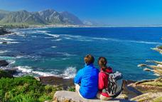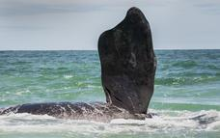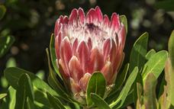

Included
Accommodation & Breakfast

Day 14: SunSquare Cape Town, Cape Town

Day Notes
Day 14: (Sat) Cape Town (BB)
Enjoy a day at leisure in the ‘Mother City’ where a visit to the V&A Waterfront is recommended. Enjoy quality time exploring this iconic beautiful city with its many world acclaimed attractions.
Accommodation: Sun Square Hotel – Cape Town or similar

Optional
Cape Point Tour Full Day
Cape Winelands Day Tour
Marine Dynamics

Cape Point Tour Full Day
Highlights of a trip down to Cape Point include; one of the world’s most spectacular drives, Hout Bay, Chapman’s Peak, Noordhoek Beach, the Cape Point Nature Reserve, two lighthouses on the tip of Africa, Boulders Penguin Colony, Simonstown, Kalk Bay and the Kirstenbosch Botanical Gardens.
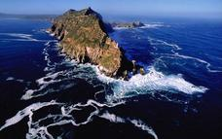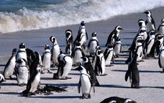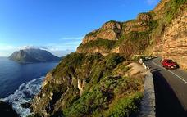

Cape Winelands Day Tour
From Cape Town make your way out into the picturesque winelands visiting South Africa’s most famous wine regions – Paarl, Franschoek and Stellenbosch. Aside from the excellent wines the area is renowned for its food and is steeped in history such as the Taal monument, various museums and the contribution of the French Huguenots. There are also many attractions you wouldn’t expect to find on a wine route, from butterflies to cheetahs and pretty much everything in between.
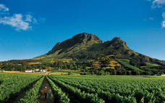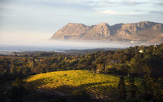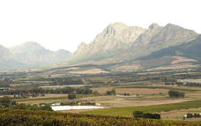

Marine Dynamics
Marine Dynamics is a company, which specialises in white shark diving and its sister company; Dyer Island Cruises does boat based whale watching tours.
MARINE DYNAMICS SHARK CAGE DIVING:
Marine Dynamics, operating in Gansbaai, Western Cape, South Africa, a world hot spot for the great white shark - you will experience an incredible cage diving adventure on board our custom designed boat, Slashfin, (named after one of our visiting sharks). An on board marine biologist will educate you as you get up close and personal with this amazing apex predator in the famous Shark Alley. We are certified by Fair Trade in Tourism, live by our motto of ‘Discover and Protect’ and work together with the Dyer Island Conservation Trust. We are involved in shark research which includes shark fin identification and tagging and tracking the great white. You will leave with great memories and a deep appreciation of this majestic animal. And along the way, you can view the rest of our Marine Big 5 – whales, dolphins, seals and the African penguin, as well as incredible seabirds. We are only 2 hours drive from Cape Town along a scenic route. The trip includes an educational briefing, breakfast or lunch; refreshments on board; a complimentary drink on return; towels, clean wetsuits, goggles. Enjoy your trip with our very experienced crew and share your memories via our on board wireless streaming or purchase a professional video.
DYER ISLAND CRUISES BOAT BASED WHALE WATCHING:
Operating around the world famous Dyer Island, Gansbaai, Western Cape, enjoy an incredible experience viewing our Southern right whales. Every year from June to December, the Southern right whales arrive to mate and calve. Witness mating displays, breaching, tail slapping, spy-hopping and more. We may also see Bryde’s whales, Humpback whales, the elusive Humpback dolphin, Common dolphin, an incredible array of seabirds and we guarantee a sighting of our almost 60 000 strong Cape fur seal colony on Geyser Rock as we cruise down the famous Shark Alley. Our on board marine biologist will be on hand to teach you more about the amazing animals that visit our shores. We are certified by Fair Trade in Tourism, live by our motto ‘Discover and Protect’ and work together with the Dyer Island Conservation Trust. We are only 2 hours drive from Cape Town along a scenic route. The trip includes an educational briefing, water on board and a complimentary drink on return. Enjoy your trip with our very experienced crew and leave with great memories. Professional video available for purchase.

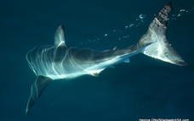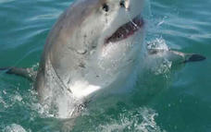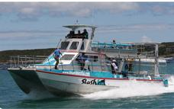

Included
Accommodation & Breakfast

Day 15: Departure

Day Notes
Day 15: (Sun) Cape Town (BB)
This morning after breakfast, check out of the hotel by 11h00. The remainder of the day will be at leisure until your transfer to Cape Town International airport where your Journey concludes

Optional
Robben Island
Robben Island Ferry
Cape Town City Tour Half Day
Table Mountain Cableway
V&A Waterfront
Cape Wheel
Helicopter Rides @ V&A Waterfront

Robben Island
An icon of struggle, freedom and hope made famous by Nelson Mandela's imprisonment here.
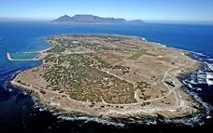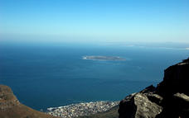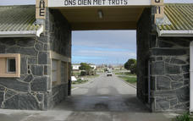

Robben Island Ferry
This is where the ferry for Robben Island leaves from. The ticket office also has a little museum and a curio shop.

Cape Town City Tour Half Day
On a clear day from the summit of Table Mountain you get spectacular views of the City, its Waterfront, Camps Bay, the majestic Hottentots Holland Mountains to the East and the mountains of the Cape Peninsula all the way down to Cape Point to the south.
The Table Mountain cableway, a must for all visitors to the Cape, boasts revolving floors, giving passengers a 360 degree view. After descending the mountain, you will depart on a tour of the “Mother City” taking in Signal Hill – where the Noon Day Gun is fired at midday, every day except Sunday – through the colourful Bo-Kaap or Cape Malay Quarter, past the Grand Parade, City Hall and the Castle of Good Hope and South African Cultural History Museum.
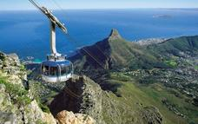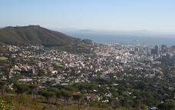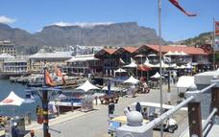

Table Mountain Cableway
A trip up Table Mountain is quite rightly one of the first things a tourist wants to do when arriving in Cape Town. Once on the top, a 1000m above the city below, you are rewarded with spectacular 360 views. Take your time and enjoy this unique environment, go for a walk or have a bit to eat at the restaurant with arguably one of the best views possible.
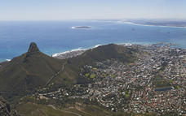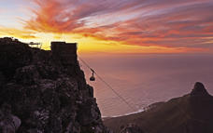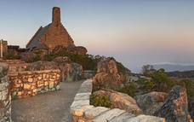

V&A Waterfront
Situated between Robben Island and Table Mountain in the heart of Cape Town's working harbour, the V&A Waterfront has become South Africa's most visited destination. Set against a backdrop of magnificent sea and mountain views, exciting shopping and entertainment venues are intermingled with imaginative office locations, world-class hotels and luxury apartments. The Waterfront is the heart of the tourist industry in Cape Town.
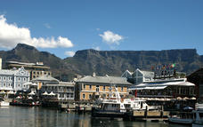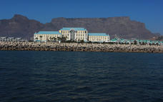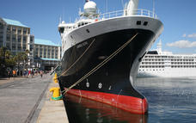

Cape Wheel
Experience Spectacular Cape Town Views from the Cape Wheel - a giant observation wheel that offers a spectacular 360 degree panoramic view of Cape Town from the iconic and vibrant V&A Waterfront.
Your viewing experience across the Mother City includes Table Mountain, Robben Island, Cape Town City skyline, Paarl Mountains, and the Cape Town Stadium. The Cape Wheel offers 30 fully enclosed air conditioned cabins that will take you 40 metres above the ground in safety and comfort on the 12 - 15 minute, 4 revolution ride. The wheel also offers two wheelchair friendly and accessible cabins.
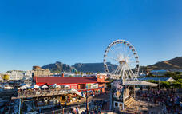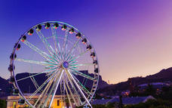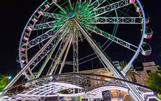

Helicopter Rides @ V&A Waterfront
This is where helicopter rides over Table Bay and down the peninsula leave from.
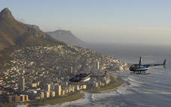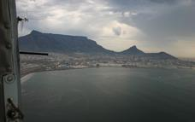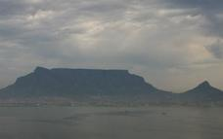

Included
Breakfast

Transport

Transfers
Date | Pick Up | Drop Off | Time | Vehicle
 | OR Tambo International Airport [JNB] | Protea Hotel OR Tambo International
 | Protea Hotel OR Tambo International | Lydenburg
 | Lydenburg | Blyde River Canyon
 | Blyde River Canyon | Hippo Hollow Country Estate
 | Hippo Hollow Country Estate | Jeppe's Reef Border Post
 | Jeppe's Reef Border Post | Lugogo Sun
 | Lugogo Sun | Hluhluwe Imfolozi Game Reserve
 | Hluhluwe Imfolozi Game Reserve | Protea Hotel Umfolozi River
 | Protea Hotel Umfolozi River | St Lucia
 | St Lucia | Protea Hotel Umhlanga Ridge
 | Protea Hotel Umhlanga Ridge | Howick
 | Howick | Drakensberg Gardens Golf & Spa Resort
 | Drakensberg Gardens Golf & Spa Resort | Mthatha
 | Mthatha | Qunu
 | Qunu | Crawford's Beach Lodge
 | Crawford's Beach Lodge | Port Alfred
 | Port Alfred | Garden Court King's Beach
 | Garden Court King's Beach | Tsitsikamma National Park
 | Tsitsikamma National Park | Knysna Hollow Country Estate
 | Knysna Hollow Country Estate | Oudtshoorn Town
 | Oudtshoorn Town | Robertson Pass
 | Robertson Pass | Garden Court Mossel Bay
 | Garden Court Mossel Bay | Albertinia
 | Albertinia | Robertson
 | Robertson | SunSquare Cape Town
 | SunSquare Cape Town | Cape Town International Airport [CPT]

Terms and Conditions
Terms & Conditions, Bookings & General Information Definitions In this agreement, unless inconsistent with the text: • THOMPSONS AFRICA shall mean a division of CULLINAN HOLDINGS LIMITED (trading as THOMPSONS AFRICA and/or all its subsidiary companies from time to time which trade under the THOMPSONS brand in Southern Africa); • THE TOUR OPERATOR shall mean any tour operator or travel agent which deals with THOMPSONS AFRICA; • FIT RESERVATION shall mean a booking for a Free Independent Traveler; • GROUP RESERVATION shall mean a booking concluded on behalf of a group of tourists; • BOOKING shall mean any FIT or GROUP RESERVATION; • COMMENCEMENT DATE shall mean the first day of arrival in Southern Africa; • TARIFF shall mean the confidential price list issued by THOMPSONS AFRICA to TOUR OPERATORS from time to time. Recordal These terms and conditions will limit the liability of THOMPSONS AFRICA to the TOUR OPERATOR and the guest of the TOUR OPERATOR and any BOOKING made with THOMPSONS AFRICA by the TOUR OPERATOR are subject to these terms and conditions. Tariff • THOMPSONS AFRICA shall be entitled, from time to time, to alter at its discretion the TARIFF by amending the prices listed in the TARIFF and while THOMPSONS AFRICA will endeavor to notify all interested parties of any such change, they cannot warrant that this will take place and THE TOUR OPERATOR is accordingly advised to check prices before confirming any BOOKING; • Certain services, but not limited to, entrance fees, airport taxes and fuel levies are subject to adjustment without any notification to the TOUR OPERATOR; • The rates quoted in the TARIFF are strictly private and confidential and must not be disclosed by the TOUR OPERATOR to any other party. FIT Reservation • All bookings will be confirmed to THE TOUR OPERATOR by THOMPSONS AFRICA in writing; • On confirmation of booking, THE TOUR OPERATOR is required to make full payment not less than thirty days prior to COMMENCEMENT DATE; • Payment is to be made in the currency of the invoice. THOMPSONS AFRICA invoice in either South African Rand or United States dollars. Should THE TOUR OPERATOR want to make payment in a currency different from that of invoice, THOMPSONS AFRICA reserve the right to obtain and advise the applicable exchange rate which shall be valid for 3 working days from date of notification of advised exchange rate; • If the TOUR OPERATOR wishes to cancel any FIT BOOKING it shall do so, in writing, and no cancellation shall be confirmed unless and until such time as it has been acknowledged and accepted by THOMPSONS AFRICA, in writing, and shall always be subject to the applicable supplier cancellation policy / fees; • THOMPSONS AFRICA shall not be under any obligation to issue any travel documents to THE TOUR OPERATOR or any of its guest until such time as full payment has been received. Group Reservation • All GROUP BOOKINGS will be confirmed to the TOUR OPERATOR by THOMPSONS AFRICA in writing; • On confirmation of the BOOKING a deposit is required as per the suppliers required payment terms and conditions; • Balance of payment is due 45 days prior to COMMENCEMENT DATE alternatively as per suppliers required terms and conditions; • Payment is to be made in the currency of the invoice. THOMPSONS AFRICA invoice in either South African Rand or United States dollars. Should THE TOUR OPERATOR want to make payment in a currency different from that of invoice, THOMPSONS AFRICA reserve the right to obtain and stipulate the applicable exchange rate which shall be valid for 3 working days from date of notification of stipulated exchange rate; • If the TOUR OPERATOR wishes to cancel any GROUP BOOKING it shall only be entitled to do so, in writing, and no cancellation shall be confirmed unless and until such time as it has been acknowledged and accepted by THOMPSONS AFRICA, in writing, and shall always be subject to the applicable supplier cancellation policy / fees; • THOMPSONS AFRICA shall not be under any obligation whatsoever to issue any travel documents to THE TOUR OPERATOR or any of its guest until such time as full payment has been received. Cancellation By Thompsons Africa • THE TOUR OPERATOR acknowledges that in keeping with the policy adopted by tour operators world-wide, THOMPSONS AFRICA shall be entitled at its sole discretion to cancel any BOOKING prior to the commencement of the first activity booked in terms of such BOOKING, and in any such case the entire amount paid by THE TOUR OPERATOR shall be refunded by THOMPSONS AFRICA to THE TOUR OPERATOR and THE TOUR OPERATOR shall not have any further claim of whatsoever nature against THOMPSONS AFRICA as a result of such cancellation; • THOMPSONS AFRICA shall be entitled at its sole discretion, should it deem it necessary for whatsoever reason, to change any BOOKING by providing alternate accommodation or other services to the GUEST concerned provided the alternate is of at least of the same quality and standard as that in respect of which the BOOKING was originally made. Exclusion of Liability • THE TOUR OPERATOR acknowledges and accepts that THOMPSONS AFRICA at all times acts only as an agent on behalf of its suppliers and will not be liable for any loss or damages, whether to persons, their luggage or other items in their possession, or arising as a result of the exercise by THOMPSONS AFRICA of any of its rights in terms hereof and irrespective of whether such loss or damage has arisen as a result of disease, ill health, adverse weather conditions or any other cause including any loss which may be occasioned by the negligence of THOMPSONS AFRICA or any of its personnel or agents and THE TOUR OPERATOR hereby indemnifies THOMPSONS AFRICA and absolves it from any liability in respect of any claims which may be made against THOMPSONS AFRICA in respect of any such loss or damage which is brought by or through any guest of THE TOUR OPERATOR; • THE TOUR OPERATOR shall ensure that it and/or its guests take out adequate insurance, including medical insurance, to cover against any and all such loss or damages. Acknowledgements by Tour Operator THE TOUR OPERATOR acknowledges that: • If any accommodation, excursion or other service which has been booked is not available for any reason whatsoever, THOMPSONS AFRICA shall be entitled to make similar alternative arrangements at the same price as that which is not available and no claim whatsoever shall arise against THOMPSONS AFRICA as a result of such unavailability; • Transportation used on scheduled and day tours will be determined by Thompsons Africa based upon the number of passengers on tour, and THOMPSONS AFRICA reserve the right to use either smaller or larger vehicles at their discretion; • Airlines and most vehicle operators limit the weight of the luggage which can be carried by any guest and that no claim shall arise against THOMPSONS AFRICA in the event of any guest not being allowed to carry any luggage or being required to effect payment for any such excess luggage; • The obligation to obtain a current and valid passport, all necessary visas and vaccinations is that of the guest and THOMPSONS AFRICA shall not be liable in any matter whatsoever; • Any arrangements, whether for air travel, accommodation or other services which are made by THOMPSONS AFRICA on behalf of any guest of THE TOUR OPERATOR may be made subject to the standard terms and conditions of the service provider which will be applicable to and shall bind the TOUR OPERATOR and the guest of the TOUR OPERATOR; • THOMPSONS AFRICA will not be obliged to refund any amount paid for any un-utilized service which may have been made for any guest; • The guest of THE TOUR OPERATOR shall be liable to pay, in advance, for any new and additional services whilst traveling on the ground which are not included in the original itinerary. Variations THE TOUR OPERATOR acknowledges that these terms and conditions are incorporated in and form part of THE TARIFF and that they may be altered from time to time at the sole discretion of Thompsons Africa. THE TOUR OPERATOR accordingly acknowledges that the provisions of this agreement shall be deemed to be amended from time to time as and when the terms and conditions on which THOMPSONS AFRICA trades are amended and to such extent this agreement shall be deemed to be varied from time to time as reflected in the tariff. Jurisdiction and Applicable Law Any booking, made by THE TOUR OPERATOR with THOMPSONS and any dispute of whatsoever nature which may arise there from shall be subject to South African law and THE TOUR OPERATOR consents to the exclusive jurisdiction of the High Court of South Africa for the resolution of any such dispute. Amendments This agreement embodies the entire understanding of the parties and there are no terms, conditions or warranties, whether express or implied, other than those contained herein, and any amendment to this agreement shall, subject to the provisions of the VARIATIONS clause above, not be binding on the parties unless reduced to writing and signed by all parties affected by such amendments. Indulgences In the event of any party hereto allowing any other party any leniency, extension of time or indulgence, this shall be without prejudice to the rights of the party granting such leniency, extension of time or indulgence, who shall be entitled to enforce his rights in terms hereof at any time.

